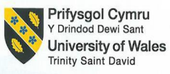
Academic Discipline of Hospitality and Tourism
Management

BA (Hons) International Hotel Management

Module Handbook Autumn Term 2024
BMIH5006
Sustainable Hospitality & Tourism
Management
LEVEL 5

Module Lead: Charlotte Joyner
Lecturers: Lisa-Marie Bassler
Student name: Diana Adriana Les
Student no: 2222995

I confirm that I have not used any AI tools in the research and creation of this assignment. I confirm that I have not presented any AI generated materials as my own work. I confirm I have copies of my drafts, notes, and other resources I used, which I may be asked to provide in evidence.

Implementing a Green Initiative at The Hilton London Hotel

Table of Contents
Table of Contents 1
Executive Summary 1
Introduction 2
Greener Practices in the Hotel Industry 2
Identified Green Practice Initiative: Water Conservation 3
What Does It Entail? 3
Implementation in Other Hotels 4
Benefits of the Initiative 5
Challenges of Implementation 5
Realistic Implementation 6
Environmental Benefits 6
Operational and financial benefits 6
Conclusion 7
Recommendations 7
Reference list 8

Executive Summary

The report examines the implementation of green practices at The Hilton London Hotel situated on Park Lane. Nowadays, concerns for the environment are constantly increasing, and the hotel industry is facing the pressure to adopt as many ecological practices as possible to reduce the negative impact on the environment. The green practice initiative identified is water conservation, as The Hilton London faces a lack of a proper water conservation strategy. The initiative involves the installation of low-flow fixtures, some rainwater collection systems and programs to promote water-saving habits for guests. The report details the benefits of this initiative and its reduced costs. The report also presents possible challenges that may arise after the implementation of the initiative. The main recommendations for The Hilton London Hotel are a feasibility study to determine the potential savings that the water conservation will bring, and a training program for employees because it is very important that they know the details of implementing a water conservation policy.

Introduction

In recent years, the hospitality industry has registered a great increase in interest in the environment, and in the desire to reduce the negative impact that hotels have on the environment, so that many hotels have started to adopt ecological practices. Ecological practices refer to reducing the consumption of resources, reducing waste, reducing food waste. This report focuses on The Hilton London Hotel for the implementation of an ecological initiative.
The Hilton London Hotel is known in the hotel industry for the fact that it offers luxury rooms and exceptional services for its customers. The Hilton London Hotel has made a lot of progress in implementing ecological practices, but still there remains a problem in water conservation. In this report, a solution for this problem, its advantages and disadvantages will be presented, thus increasing the efforts made by Hilton London to integrate sustainability into the company's processes.

Greener Practices in the Hotel Industry

Green practices in the hotel industry refer primarily to the creation of a comfortable and luxurious experience for the hotel's customers, but still by reducing the negative impact on the environment. This presupposes the adoption of sustainable practices that protect the environment. (Jauhari, 2009)
The methods by which the negative impact can be reduced are the following:
Energy efficiency: The hotel can be much more attentive to energy consumption, a first step can be the replacement of ordinary light bulbs with LED ones and careful monitoring of energy consumption. An advantage is the reduction of energy costs. (Nick ,2023)
Renewable energy: Hotels can use solar or wind energy to generate green energy. The benefits are enormous, they help hotels reduce their energy costs, and help protect the environment. (GreenOrg, 2024)
Water usage: It is very important to introduce systems that help save water. Hotels install combinations of toilets and shower heads with low flow. (Chemmanur ,2024)
Waste management: Hotels must pay attention to food waste and waste reduction. Many hotels practise donating surplus food or practising composting. Reducing food waste is especially important for reducing greenhouse gas emissions because they contribute to global warming.(Business Waste,2024)

Identified Green Practice Initiative: Water Conservation

What Does It Entail?

The water deficit is a problem that everyone faces, and the hotel industry feels the pressure to reduce water consumption, so the green practice initiative for The Hilton London Hotel is water conservation. This initiative focuses on several water conservation strategies, but the most important thing is the creation of a water management plan, a plan that contains the desired target, the time, and the resources needed to reach the target. (Smarter Business Editorial,2020)
The installation of low-flow fixtures involves the replacement of taps, shower heads and toilets with alternative fixtures specially created with low flow, thus reducing water consumption without sacrificing customer comfort. In the kitchen and in the laundry area, start the washing machines only when they are full to avoid extra water consumption.(Vinnie,2014)
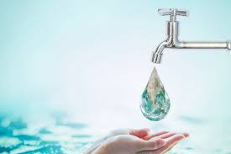

Rainwater Harvesting Systems: The implementation of these systems with the help of which rainwater can be collected and used can help to reduce water consumption from municipal water.(Kristen ,2018)
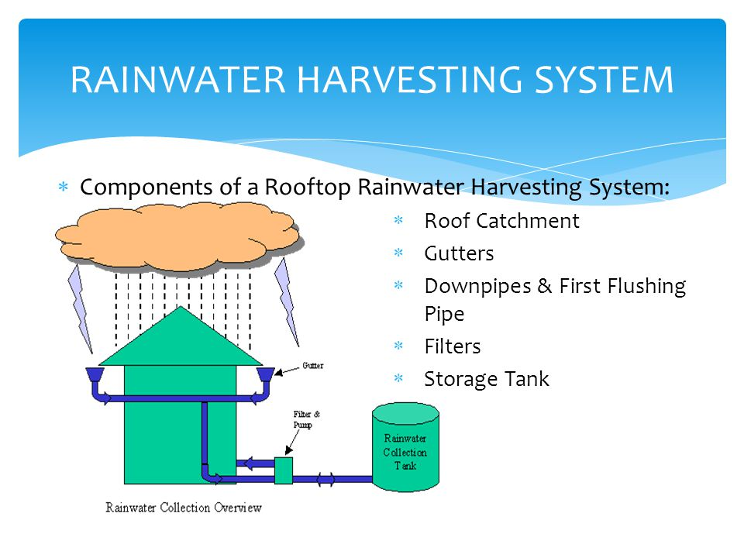
Guest Awareness Programs: Educating guests is very important, this can help them to pay attention even to how they consume water in their own homes. It is important to inform customers about the things that are put into practice at the hotel to reduce water consumption.(Smarter Business Editorial,2020)



Implementation in Other Hotels

Many hotels have understood how important water conservation is so they have successfully implemented water conservation initiatives. One of the examples is the Marriott International hotel has implemented many water conservation strategies and has set itself the goal of reducing water intensity by 15% by 2025 compared to 2016. (CDP Water, 2023)
Another example is Casa Hotel, which states that they understand the importance of water conservation for the environment. They have taken several water conservation initiatives, installed water-saving devices, employees are trained on how to use water efficiently, and customers are encouraged to participate in their towel and bed linen reuse program. (Casa Hotels, 2024)

Benefits of the Initiative

The benefits of the initiative depend on the water conservation systems that are introduced in the hotel, so that in the case of fixtures and toilets with reduced flow, the benefit consists in reducing costs in the hotel and saving water, and in obtaining environmental certificates more easily. Water recycling systems involve the reuse of water used for non-potable purposes, and this helps to reduce the amount of water used that goes back into the municipal sewer system and to reduce sewerage fees. Rainwater harvesting helps to reduce the amount of rainwater, to reduce pollution and to reduce costs. (Michalis B.,2024)
So, in general, the benefits include saving facts for water and sustainability, and protecting the environment. But another important benefit is attracting more customers who are passionate about ecological accommodations. Studies show that more and more customers prefer hotels that operate with sustainability initiatives ,because the implementation of sustainable practices can have a big impact on how The Hilton London Hotel is perceived. (Michalis B., 2024)

Challenges of Implementation

Even if the progress of water conservation is praised, hotels are still facing full implementation. The challenges consist in the fact that the initial investment costs can be quite high, there can be interruptions in the customer experience during the installation of the systems and another challenge is the continuous maintenance. Even if there are some challenges, the opportunities for innovation, collaboration and planning manage to motivate the hotel to continue with the implementation of the water conservation initiative.(Zahid R.,2023)
Because the hotel is in an urban location, there may be some limitations regarding the implementation of the initiative. For example, a limitation is the space in urban locations, the hotel will not be able to use a large rainwater collection system. Another limitation of the urban location is the high occupancy rate of the hotel, because in urban areas the flow of travellers is higher, so the consumption is also higher, reducing water consumption could be quite difficult without affecting the customer experience. The advantages of positioning the hotel in the urban area are represented by greater access to technology.

Realistic Implementation

The proposed initiative is a real one because it has been implemented in other hotels successfully and the benefits have been seen by the hotels. To implement this initiative, The Hilton London Hotel must follow some important and effective steps. To begin with, it is important to create a water management plan, that is, the hotel must set a water-saving target, the time in which it wants to achieve this target and, of course, the resources necessary for this initiative. They must then identify the amount of water currently used and the costs over the three-month period. After these two steps, a water conservation plan is created, which involves the identification of water-consuming areas, where reductions can be made, to check if there are government aids for the initial costs of the systems. (Smarter Business,2020)
The next step is the training of the staff because by getting them involved, you are closer to success. Water consumption policies and procedures can be introduced, induction is offered for all employees. Water conservation systems, water recycling systems and rainwater collection systems are installed.
The last constant step in continuous monitoring of progress but of course educating the guests is very important, this can help them to be careful even about how they use water in their own homes. It is important to inform customers about the things that are put into practice at the hotel to reduce water consumption.(The Sustainable Restaurant Association,2024)

Environmental Benefits

The most important thing in reducing water consumption is the conservation of local water resources, and this is very important especially nowadays when we are facing a huge water deficit. Another important thing is that when water is conserved, energy is also saved, when water is filtered or for heating, energy is needed, so reducing water consumption helps reduce the carbon footprint. The fact that more water is used also helps to preserve ecosystems in wetland habitats where many animals live. Reducing water consumption is very important for periods of drought in areas such as the south-east of England where there have always been problems with water supply. (The Wildlife Trusts,2024)

Operational and financial benefits

The implementation of water conservation initiatives has both operational and financial benefits. Reducing water consumption helps lower water bills, that is, operational costs. Reducing water consumption also helps to reduce energy costs, because it is necessary for heating water for laundry or cleaning. A Waterwise study states that hotels can reduce water consumption by up to 50% just by introducing conservation systems, so the cost of utilities is considerably reduced. (Wodr, 2024)
The introduction of sustainability practices can help The Hilton London hotel and help to recognize the brand, to increase the number of customers. More and more eco-conscious guests are looking for sustainable accommodations with ecological practices. (Hospitality Net, 2024)
Sustainability is becoming an important thing for travellers, a sustainable travel report from 2022 shows that 81% of travellers confirm that sustainable accommodations are important to them and 50% of them say that they have made more sustainable travel choices. (Chan T., 2022)

Conclusion

The implementation of the water conservation initiative brings many benefits for The Hilton London Hotel and for the environment. The initiative involves the installation of low-flow systems, rainwater collection systems and a customer engagement program, all these things help The Hilton London Hotel to overcome the gap found in current operations. The benefits of this initiative consist in reducing the costs of bills, water and energy, the recognition of the hotel by customers, because with this initiative The Hilton London Hotel will attract more customers for whom ecological practices are very important and prioritise sustainable accommodation.

Recommendations

Once the proposal is made and the steps to implement the initiative are fixed, there are some recommendations for The Hilton London Hotel:
The hotel must carry out a feasibility study to determine the potential savings it will achieve after the implementation of the water conservation initiative. Another recommendation is a training program for employees, it is very important that they know the details of this project and what water conservation means. The hotel must promote the fact that it adopts the sustainability initiative and that the hotel will implement water conservation practices, so potential customers are informed.
If. The Hilton London Hotel will follow the steps of the initiative and these recommendations, the positioning as a leader in this industry will be secure, and of course the positive effects on the environment will appear. (Nielsen N.,2024)

Reference list

1. Business Waste (2024) How to reduce waste in hotels and the hospitality industry, Business Waste. Available at: https://www.businesswaste.co.uk/reduce-waste/how-to-reduce-waste-in-hotels-and-the-hospitality-industry/ (Accessed: 07 November 2024).
2. Casa Hotels (2024) Sustainability statement, Casa Hotels. Available at: https://www.casahotels.co.uk/sustainability-statement/ (Accessed: 04 November 2024).
3. CDP Water (2023) Marriott International, Inc. - Water Security 2023. Available at: https://serve360.marriott.com/wp-content/uploads/2023/09/CDP-Water-2023-vHsM.pdf (Accessed: 04 November 2024).
4. Chan, T. (2022) Booking.com 2022 sustainable travel report, GSTC. Available at: https://www.gstcouncil.org/booking-com-2022-sustainable-travel-report/ (Accessed: 07 November 2024).
5. Chemmanur, A. (2024) Sustainability in the hospitality industry: Deloitte UK, Deloitte United Kingdom. Available at: https://www.deloitte.com/uk/en/Industries/consumer/blogs/sustainability-in-the-hospitality-industry.html (Accessed: 03 November 2024).
6. Connected Sensors (2024) What can be done to conserve water in hotels, Connected Sensors - Water Management Solution. Available at: https://connectedsensors.com/blog/what-can-be-done-to-conserve-water-in-hotels/#:~:text=Install%20Low%2DFlow%20Fixtures&text=Low%2Dflow%20showerheads%2C%20faucets%2C,any%20hotel’s%20water%20conservation%20strategy. (Accessed: 07 November 2024).
7. Ecobnb (2023) Green hospitality: Sustainable practices for hotels, Ecobnb. Available at: https://ecobnb.com/blog/2023/05/green-hospitality-sustainable-practices-hotels-resorts/ (Accessed: 03 November 2024).
8. GreeenOrg (2024) Solar energy in the hospitality industry, Green.org. Available at: https://green.org/2024/01/30/solar-energy-in-the-hospitality-industry/ (Accessed: 07 November 2024).
9. Hospitality Net (2024) Hotel Sustainability: A full guide for hotel owners, Hospitality Net. Available at: https://www.hospitalitynet.org/explainer/4120392.html (Accessed: 07 November 2024).
10.Jauhari, V. (2009), "The hospitality and tourism industry in India: conclusions and solutions", Worldwide Hospitality and Tourism Themes, Vol. 1 No. 1, pp. 75-80.
11. Kristen (2018) Rainwater harvesting in the hotel industry, Soulful Concepts. Available at: https://soulfulconcepts.com/2018/06/04/rainwater-harvesting-hotel-industry/ (Accessed: 07 November 2024).
12. Michalis, B. (2024) Sustainability in hotels: Creating a greener future for hospitality: Canary Technologies, RSS. Available at: https://www.canarytechnologies.com/post/sustainability-in-hotels (Accessed: 04 November 2024).
13. Nick C. (2023) How energy efficiency in the hotel industry is reshaping the guest experience, BDC Magazine. Available at: https://bdcmagazine.com/2023/11/how-energy-efficiency-in-the-hotel-industry-is-reshaping-the-guest-experience/ (Accessed: 07 November 2024).
14. Nielsen, N. (2024) How to reduce water consumption in hotels: Eco-friendly strategies, Limepack. Available at: https://www.limepack.co.uk/blog/hotel-gb/how-to-reduce-water-consumption-in-hotels-eco-friendly-strategies (Accessed: 07 November 2024).
15. Smarter Business Editorial (2020) How hotels can reduce water consumption, Smarter Business. Available at: https://smarterbusiness.co.uk/blogs/how-hotels-can-reduce-water-consumption/#:~:text=Encourage%20guests%20to%20shower%20instead,water%20consumption%20in%20other%20areas (Accessed: 04 November 2024).
16. Smarter Business (2020) How Hotels Can Reduce Water Consumption. Available at: https://smarterbusiness.co.uk/blogs/how-hotels-can-reduce-water-consumption/ (Accessed: 06 November 2024).
17. The Sustainable Restaurant Association (2024) How to reduce water use in your restaurant or Hotel, Home. Available at: https://thesra.org/news-insights/insights/how-to-reduce-water-use-in-your-restaurant-or-hotel/#:~:text=While%20potentially%20expensive%20to%20install,functions%20such%20as%20toilet%20flushing. (Accessed: 06 November 2024).
18. The Wildlife Trusts (2024) How to conserve water, The Wildlife Trusts. Available at: https://www.wildlifetrusts.org/actions/how-conserve-water#:~:text=Energy%20is%20needed%20to%20filter,water%20voles%2C%20herons%20and%20fish (Accessed: 06 November 2024).
19.Vinnie J.(2014) Managing Sustainability in the Hospitality and Tourism Industry: Paradigms and Directions for the Future , pp 101-137
20. Wodr (2024) Water usage in the UK hospitality industry, wodr. Available at: https://makeitwodr.com/blogs/water-usage-in-the-uk-hospitality-industry/ (Accessed: 07 November 2024).
21. Wright, K.(2024) Why hotels should prioritise water conservation, Smart Water Magazine. Available at: https://smartwatermagazine.com/blogs/kevin-wright/why-hotels-should-prioritise-water-conservation (Accessed: 06 November 2024).
22. Zahid, R. (2023) Water conservation in hospitality: How hotels are taking the plunge, IIPS. Available at: https://iips.com.pk/water-conservation-in-hospitality-how-hotels-are-taking-the-plunge/ (Accessed: 06 November 2024).

I confirm that I have not used any AI tools in the research and creation of this assignment. I confirm that I have not presented any AI generated materials as my own work. I confirm I have copies of my drafts, notes, and other resources I used, which I may be asked to provide in evidence.

