Student Name: Michael Nugent | ID Number: 2520530

Construction Material Concrete Frame

1. Trellick Tower Elements of Original Design
The concrete framed building named the trellick tower is based in London and was completed in 1972 it's a reinforced concrete residential tower designed in the brutalist style and created by the architect Erno Goldfinger, this building features a distinct structural system that consists of main residential block and a separate service tower.
The primary element of the trellick tower is the reinforced concrete frame that consists of vertical columns, horizontal beams and reinforced concrete slabs. The main load bearing structure of the building is formed by the frame which transfers vertical loads from the floors through the columns and down into the foundations. This allows the structure to resist both tensile and compressive forces which provides strength and durability.
The separate service tower is another important design feature that houses lifts, staircases and service ducts. The structure is structurally independent from the main residential block and is intertwined with access walkways at various levels. The efficient organisation of the building services is due to the separation and allows improved fire safety as well as reduced noises and vibration within flats.
Shear walls are incorporated into the trellike tower due to the importance of lateral stability. The reinforced concrete shear walls resist horizontal forces such as wind loads that potentially cause sway due to the height of the tower ensuring the structure stability and safety of the tower.
The modular layout is another element of the design with residential units arranged in a repetitive pattern. The improvement of efficiency in both designs and building processes is caused by the modular layout, the modular approach simplifies construction and allows for standardisation of components. Additionally, the design of the trellike tower applies precast concrete elements for external walls panels, these components are manufactured off site and installed on the building then improving construction speed and quality control while reducing labour on site.
Lastly the structure is supported by reinforced concrete foundations that are desired to transport significant loads of high rise building towards the ground ensuring stability and efficiency in high rise residential building.
Altogether a clear integration of structural and functional elements is demonstrated through the trellick tower and reinforced concrete is used to achieve strength, efficiency and stability in high rise residential building
1. Trellick Tower Method of Construction
The construction of the trellick tower was mainly based on positional reinforced concrete that is casted on site using temporary formwork. The structural frame, beams, floor slabs and columns are constructed as a continuous rigid system from this method. The construction process lead with the installation of concrete foundation designed to support significant loads of high-rise structure. Next was the main structural frame and service tower was constructed upwards.
Vertical elements were enabled like walls and cores were to be casted in stages as the building increased in height because of the utilization of climbing footwork techniques. Structural continuity was ensured and improved efficiency due to this method.
The method of construction combined traditional positional concrete techniques alongside elements, allowing for efficient and systematic construction of the trellick tower. Additionally, the option of reinforced concrete directly impacted the method of construction which required the use formwork and staged concrete building.
2a) The main framing material used when constructing the trellick tower is reinforced concrete its highly suitable for a high-rise structure in urban environments for instance London it also provides a combination of strength durability and resistance to environmental conditions. With respect to strength reinforced concrete tends to perform remarkably especially under compressive forces which is ideal for supporting the important vertical loads generated by tall residential buildings. Tensile forces are resisted by the inclusion of steel reinforcement inside the concrete; this then prevents cracking and structural failures. The verification that the material can safely transfer loads of slabs and beams through the column and into the foundation is through this combination.
Another key factor during selection is the durability of the reinforced concrete. Concrete is highly resistant to weathering, corrosion and general wear overtime, specifically when designed and constructed. In the trellick tower dense concrete and steel reinforcement is used to protect against moisture ingress and the corrosion of steel, which potentially compromises structural integrity this also contributes to the long service of residential building like the trellick tower.
Given the environmental conditions in London climatic resistance becomes essential which consists of frequent rainfall, temperature fluctuations, and exposure to wind. Reinforced concrete is used since it does not rot or degrade like some materials it also provides good resistance to moisture as well as thermal mass which allows absorption of the heat and to slowly release it over time. Additionally, the mass and stiffness of reinforced concrete is effective when resisting wind loads acting on tall buildings.
Long term structural performance can be ensured by the strength, durability and climatic resistance of reinforced concrete which inevitably makes it suited for environmental conditions that the trellick tower experiences. However, carbonation can occur from the exposure to moisture and pollutants in urban environments which can potentially lead to altercations over time.
2b) Reinforced concrete is used as the main framing material in the trellick tower since it has significant implications for construction timing, overall programme, labour requirements and cost in comparison to steel framing systems
In respects to construction time, steel framing is quicker to complete when compared to reinforced concrete structures this is due to the involvement of several sequential processes which consists of placement of reinforcement, pouring concrete, erection of formwork and curing time prior to additional loads being applied. Steel framing allows for faster erection since prefabricated steel components rapidly assemble with minimal waiting time.
Labour requirements tend to be higher for reinforced concrete construction in comparison to steel framing. This is because of the intensive labour of concrete construction and the need for formwork assembly, finishing processes and reinforcement placement in retrospect steel construction relies on prefabrication, mechanised lifting and reducing the amount of on-site labour.
Regarding construction programme there's more sequential and longer results with reinforced concrete due to the dependency of curing times and staged construction. Steel framing is more flexible and accelerated since different parts of the structure can be erected in unison and does not depend on time delays between stages.
Conversely reinforced can be more economical when considering the cost especially for high rise residential buildings such as the trellick tower. Concrete tends to offer great acoustic and thermal properties which reduces final costs and the materials used in concrete construction is less expensive than structural steel while also providing inherit fire resistance and reducing the additional fire protection that is need for steel construction.
Even with the advantages and disadvantages reduced construction time lowers the whole project cost including labour, steel framing offers cost benefits in projects where speed of construction is critical.
Overall longer construction times and higher labour input occur with reinforced concrete construction that is used in trellick tower compared to steel framing but reinforced concrete construction can offer costs advantages and material efficiencies in high rise residential applications
2c) Advantages and limitations are presented in reinforced concrete frame that is used in the trellick tower in terms of ease of assemble and adaptability in comparison to steel framing. Reinforced concrete construction is normally complex and time consuming than steel framing when regarding the ease of assembly. Sequential activities occur during the process such as the initialisation of formwork, placement of steel reinforcement, pouring and curing of concrete which makes the assembly slower and more intensive labour. Whereas steel framing is significantly faster and more efficient to erect due to steel frames being prefabricated off site and being delivered in sections for rapid enabling assembly.
Regarding the adaptability to different building shapes reinforced a degree of flexibility is offered by reinforced concrete during the design stage since it can be cast into wide variety forms this allows architects to create unique and complex geometries, once constructed, reinforced concrete is rigid and difficult to modify.
Reinforced concrete provides strength and design flexibility during initial construction, normally less efficient with assembling and long-term adaptability in comparison to steel framing. Steel structure offers faster assembly and greater flexibility for future modifications turning it more suitable for buildings that require adaptability during their life cycle.
2d) The Trellick tower presents several challenges with the integration of building services inside a reinforced concrete frame because of the monolithic nature of the material. Challenges like these are mainly related to accessibility, initialisation and future modifications for instance electrical systems, ventilation and plumbing. reinforced concrete structure restricts alterations once constructed which is a main problem. Consequently, service is carefully planned and integrated during the design process since cutting into concrete to install or modify service may weaken structural element then compromising the integrity of the frame. Retro lifting or upgrading service becomes difficult compared to steel framing.
Another issue that occurs through structural elements like beams, slabs and columns is the routing of services. Reinforced concrete relies on preformed openings or ducts to be included into the design. The incapability to plan these routes can potentially result in costly modifications.
Structural disruption and simplified maintenance by using separate service towers and isolating services from the main residential structure therefore reducing the need for route services through the primary structure frame. Additionally, the use of vertical service risers guarantees that utilises can be distributed to each floor systematically consequently improving both installation and long-term accessibility
Even so reinforced concrete frames offer challenges for integration services due to limited flexibility and its rigidity. The separation of service functions, planned routing and the use of service zones are overcome by the effectiveness of the trellick design
2e) A few significant challenges are presented in the demolition of the trellick tower due to the material properties and structural systems. These challenges link to structural complexity, waste management, safety and environmental impact.
Strength and mass of reinforced concrete is a main challenge that's presented, the material is hard to break down and move since its designed to be resistant to compressive and tensile forces. Embedded steel reinforcement further complicates demolition as specialised equipment such as hydraulic breakers are essential to separate or process both materials.
Another considerable challenge is the structural form and height of the trellick tower. Top-down demolition technique is required when building is dismantled floor by floor. This process is time consuming and labour intensive compared to steel framing which is disassembled easily. Environmental challenges are also presented due to reinforced concrete generating large volumes of heavy waste material also the complexity of the separation of steel reinforcement increases time and cost
Lastly, the protection of surrounding building and infrastructure, noise restrictions and limited spacing are presented in urban location for instance London further complexing demolition and requiring risk management and future planning
3.There are significant negative impacts in concrete production in both local and environmental communities due to raw material extraction. Carbon dioxide emission is released during cement production causing the most critical environmental issues, mainly from the heating 0f limestone. Also, habitat destruction and landscape damage is caused by quarrying for aggregates.
This process requires large amount of water and is highly energy intensive which increases pressure on natural resources. Environmental concerns are also added by the difficulty of recycling forms of concrete and waste generation.
The local communities are impacted by health and the quality of life due to dust and noise as well as increased heavy vehicles associated with transporting materials leading to congestion, safety concerns and road damage
Ultimately, there are considerable social and environmental impacts particularly in terms of emission and disturbance to surrounding community even though concrete is essential in construction

4a)
Sieve size (mm) | Mass (g) | % on sieve | % passing
125 | 0 | 0 | 100
75 | 0 | 0 | 100
63 | 0 | 0 | 100
37.5 | 120 | 9.6 | 90.40
20 | 137 | 10.96 | 79.44
10 | 143 | 11.44 | 68.00
6.3 | 105 | 8.40 | 59.60
3.35 | 45 | 3.6 | 56
2 | 130 | 10.4 | 45.60
1.18 | 63 | 5.04 | 40.56
0.6 | 105 | 8.4 | 32.16
0.3 | 102 | 8.16 | 24
0.212 | 109 | 8.72 | 15.28

% in sieve = mass/1250 * 100
4b) The fine aggregate = 6.3mm % passing = 59.6% making the sum of aggerate =100 – 59.6 = 40.4%
4c)
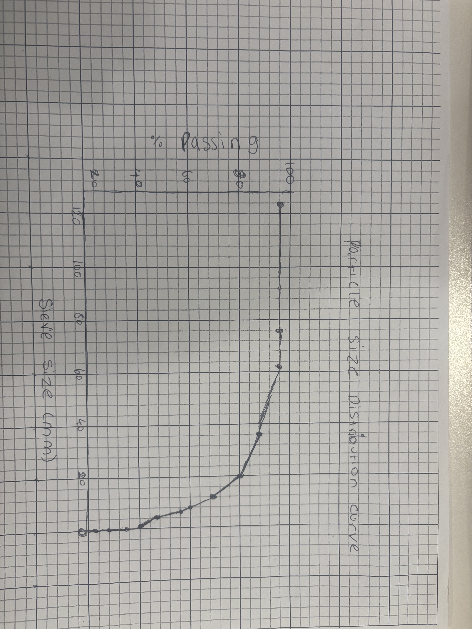

4d) Well graded distribution is shown through the aggregates and there is a good range of particle sizes, improving density and strength. Although water content may increase due to high fine content. Adjustment may be required for example adding coarse aggregates but generally suitable for concrete

References:
"In Brutal Presence"
"Architecture: Goldfinger. He's the man with the modern touch"
Effects of bond deterioration on hysteretic behavior of reinforced concrete joints
https://www.concretecentre.com › What-is-Concrete › A...

Science Museum
The concrete centre 2025 Aggregates used in Concrete – Definitions

