Component 2 - Research Report
Student Helena Guerin. Student 2212220 Number: Lecturer Name:Julius Azasoo LCHS4002_BIRM

Digital Skills and Research Methods.

- Introduction 3
- Research design 3
  - Research Question 3
  - Method 3
  - Ethical Considerations 3
- Results 3
- Discussion 4
- Conclusion 4
- Reference List 4
- Appendix A – A blank copy questionnaire 4

Introduction

We live in a digital world were its growing fast year by year, Communication between students and their tutors is crucial to their progression through their learning. It is important that digital tools are used in our universities and teaching to help deliver essential skills for all study programmes and are accepted by students for them in this work. I will do a survey to show how UWTSD students use digital tools, and how confident they are in using technology in their place of learning and how important it is to the work of all students and for the functionality of the university to allow the progression of its facilities for their courses, enabling growth and communication between the students and teachers. Digital tools are useful as they can strengthen the students’ work in many areas, through zooms, presentations, data collections, algorithms, software, preparing them to go out into the working world, which uses digital tools in all areas of the workplace.

Research design

My question in the research project was: How do students use technology to collaborate at UWTSD? I chose this question because I thought it would be enlightening to see how other students feel about the use of digital skills in their learning environment. It was interesting to see what other students thought about technology and using different tools to aid their collaborative and learning at UWTSD. Firstly, I had a research method then used data to decide which was most common. The research questions enabled me to let other students give their opinion and then the processing of the results could begin. My research method was quantitative research, and I used this method for my research at UWTSD.

Research Questions

Method

My research questions I used was: Do you consent to take part in this survey voluntary? My next question was, are you confident in using tools to collaborate with UWTSD? Number three was, I feel confident using zoom to collaborate with my university? Rank these technological programs in order, to explain how confident you are in using them? Last question was, do you see the value of using technology to collaborate? I found these questions important to see how people understand technology and what was most popular for students in UWTSD.

The methods used in our research survey was quantitively research based on percentage on our charts. We did a survey study we also did analytical research, we got a conclusion on the quantitively methodology. We used students at UWTSD to give their opinions who students use technology to collaborate at UWTSD.

Ethical consideration.

Ethical consideration in research is valuable as many areas need to be included such as the persons voluntary interaction, their consent for their data to be used, also for there to be a trustworthy and honest approach, fully remembering and respecting confidentiality, respecting their privacy, confidentiality, and their choice to remain anonymous. These principles and guidelines should always be met by the researchers, to keep the results fair and to collect the essential information for the research process. This is relevant even if it is animal research, it is important to keep within codes, regulations and privacy acts that will safeguard those included in the research.

“The goals of human research often include understanding real – life phenomena, studying effective treatments, investigating behaviours, and improving lives in other ways “.

2.4. Results.

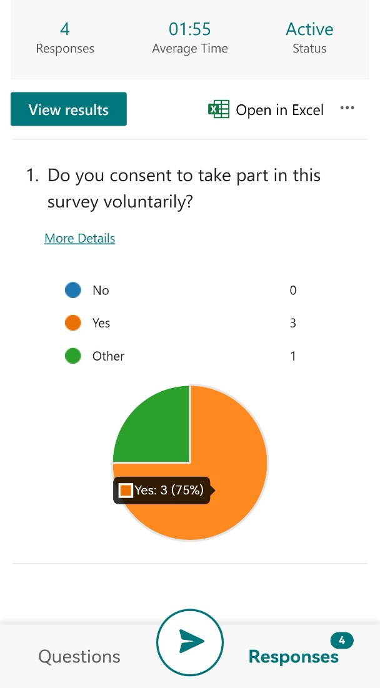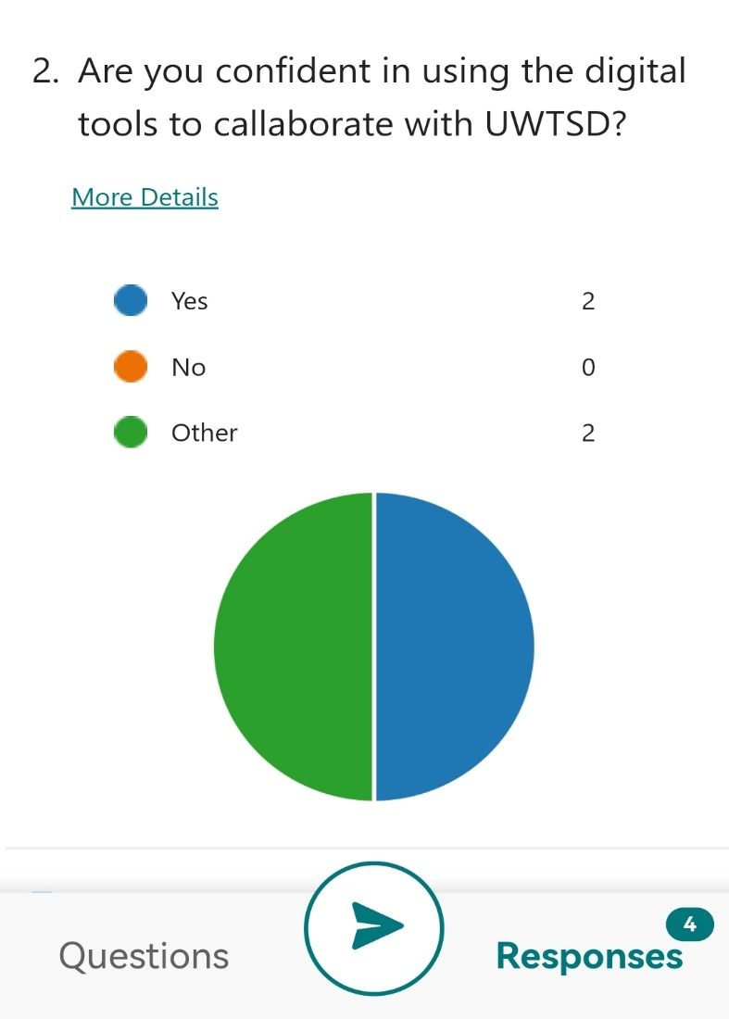

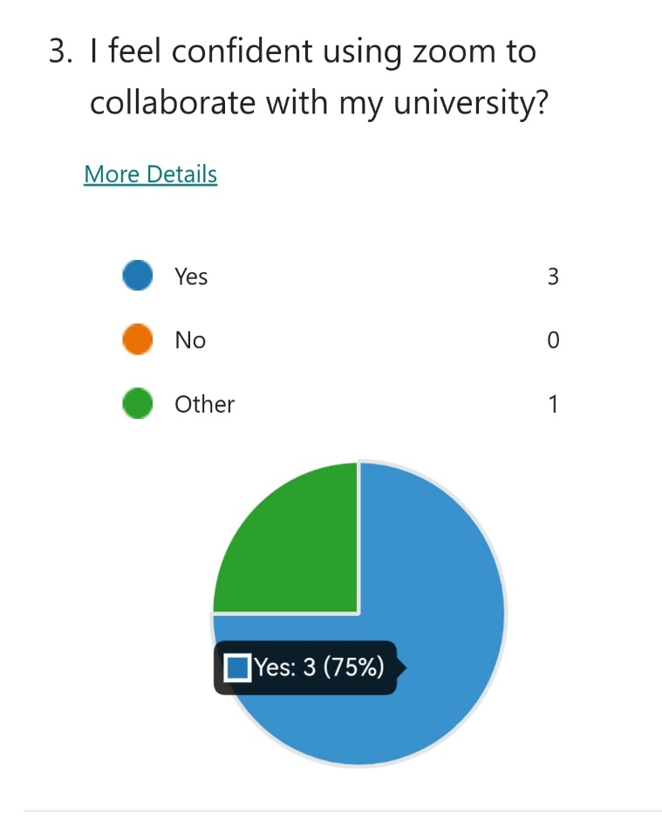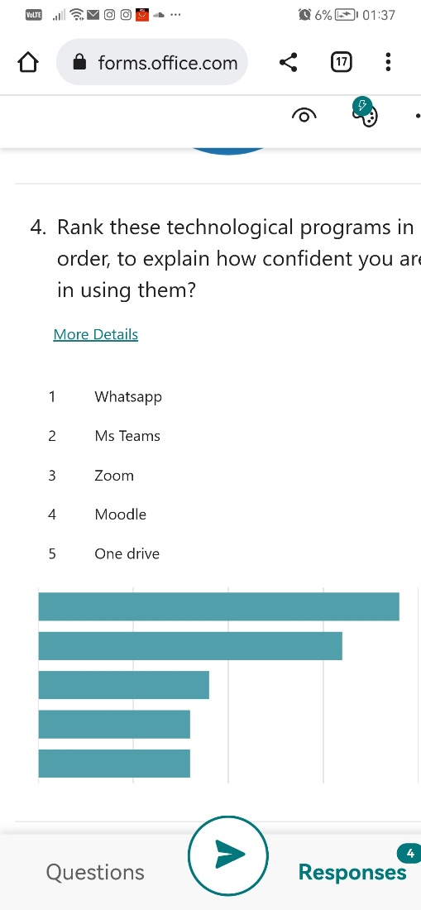

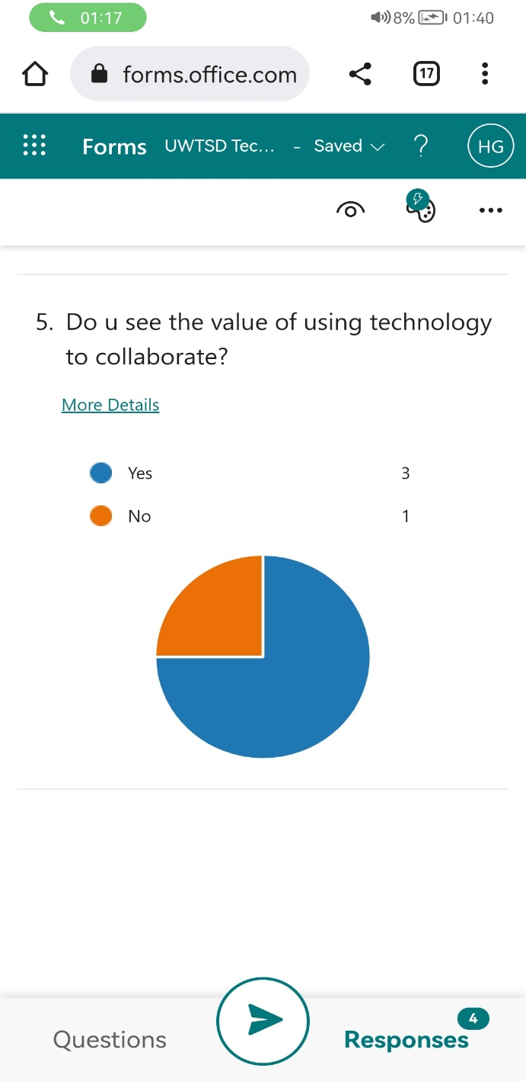

The results show that
1. A large majority of the participants consented to voluntarily taking part in the survey.
2. At least half of the participants were confident in using digital tools to collaborate with UWTSD.
3. Over 75% of the Participants felt confident in using zoom to collaborate with the university.
4. The participants ranked What's app as the most used digital tool, followed by MS Teams, Zoom, Moodle and One Drive.
5. 75% of the participants saw the value of using technology to collaborate and help their work.

Discussion

The results of the survey show that the majority of students appreciate and are using digital means to access, learn and share work. With a slight minority not being confident in using digital tools for their work. It showed that even though digital tools are used more abundantly in modern universities and colleges, there is still a learning curve for students, but even so, there are a majority that are using these tools in their work and research.

Also not forgetting that the pandemic created a big move towards online learning and participation for students and learners, with a great deal of courses being partially run by digital means and even today, many are still being run partially physically and partially online and digitally.

The use of digital tools, with the new innovations in modern learning, is something that needs to be included at all levels of learning, as technology continues to progress in learning and within society.

It is essential in work throughout universities, colleges and places of learning, to access resources and facilities by digital means, which helps the learner to complete their learning satisfactorily. This not only strengthens their research and collaboration skills but aids their ability to document and analyse data efficiently.

The development and the use of digital learning, not only helps the individual learner with their own progression, but it helps to establish more flexibility in their learning, as well as bringing together people to work together and to gain access to more resources.

“In the workplace in 2022 and beyond, we are continually having to learn and adapt to new technology. The incorporation of digital learning and teaching, as well as engagement methods, can be a great way to prepare students for working life, both in the technology that they are using and also in the ability to learn how to use new digital tools”.

Conclusion
The ethical considerations throughout the research process are really important to protecting the participants and giving them the security in having their data and information used securely. All of the information gathered, helps to provide crucial, analytical information to many areas of the health and Social Care, in its learning and data processing.
My overall findings show that students do in fact prosper in their learning and collaboration in using digital tools technological tools which helps them and guides them for their futures in Health and Social Care. The education, social and world of work, is ever embracing the digital techniques and technology, which is why enabling the questionnaire to take place not only was valuable feedback, but also shows the need for digital tools to be used now and in the future.

Reference List

Walters, Hannah. The Top 10 Benefits Of Digital Learning. Jan 30, 2022
Bhandari, Pritha. Ethical Considerations in Research/Types & Example. May 7, 2022

- Appendix A –



