Effective team Working and Communication
BMSW4002
Saqib Shamim
Dalanda Diallo
2025163

Effective Teamwork and Communication
Introduction
Throughout our daily lives and at work, communication plays a vital role. Every Company, every workplace receives, sends, and processes a considerable amount of news and information. Communication is defined as an act of using words, sounds, tone, body language or behavior to express or exchange information also to express ideas. The aim of this report is to demonstrate my understanding of efficient communication skills and the three models of communications. This report will discuss a case of study and Illustrate examples of poor communication and it will discuss each model and give a clear definition of each of them.

Communication in the workplace
Communication can be verbal, non-verbal, written, visual and listening, Communication is essential to the workplace and communication can have a substantial impact on the results of the work. When communicating within a company, it can be helpful to use signs or symbols that the company’s employees are familiar with, which may not always be language, but sometimes pictures, gestures that spring from the company’s collective morale and experience. An employee’s understanding of the message can be better communicated using body language or images. To accomplish success in the workplace, communication needs to be better planned and purposefully presented. Therefore, understanding communication skills is essential for success. If the person has the conversation planned out, thoroughly, and structured what to say and get out of the conversation, it will be more effective. According to (R Prabavathi and P.C. Nagasubramani 2018) there are some universal facts concerning communication that people should know.

Verbal communication: The use of voice and words enhances verbal communication. Words, sound languages, and the physical act of speaking are all important components in communication through speech. In oral communication, there seems to be simple and explicit communication between transmitter and receptor. Verbal problems include poor language, physical disabilities, ineffective transmission strategies, and different perceptions. communication. Verbal communication is very important in a workplace e.g. A manager’s words of encouragement and recognition delivered at the proper time enhance employee's confidence, which helps them be more productive because motivation has a direct impact on productivity.

Non oral communication: Signs that express a set of messages or reflect distinct feelings and emotions without utilizing written or spoken words are referred to as nonverbal cues. They require, amongst many other factors, the use of movement, facial expressions, and eye contact to transmit particular signals. Interaction that is not verbal. addition to verbal communication, provides additional information, meaning and clues. Nonverbal communication skills are valuable at each stage of an individual's work since they enable a person to read circumstances correctly. Nonverbal communication skills can help a person to communicate more effectively in the job. E.g., you may just nod the head to show a sign of agreement or understanding of what is being stated by a colleague or manager.

Written communication: Assist people in effectively sending messages and writing reports at work. It enables you to write in a clear and condensed manner, with solid messages that are understandable to all recipients. Any interaction that involves the writing is referred to as written communication. Writing is essential in today’s environment, and it is becoming extremely relevant as we enter the information era. Company managers must practice good communication skills and encourage their employees to do that as well. The digital age has changed the way it is communicated, with a greater reliance on unwritten rather than oral communication.

Listening in communication
The aptitude to correctly acquire and process communication is referred to as having to listen. The competence to listen is required for successful interaction. If an individual does not know how well to listen attentively, information can frequently misconstrued. As a result, dialogue breaks down, and the transmitter may become dissatisfied or furious. People should strive to learn listening skills as it is beneficial. According to (Yavuz, F. and Celik, O. 2017) listening skills comprise a major portion of the input and are a crucial component of the learning process. Because output is strongly dependent on intake, listening skills are also critical in the output system. When evaluating this point, listening abilities might be a crucial agent in vocabulary development by providing a foundation for interaction.

Linear Model of Communication
According to Shraddha., (2018) linear model of communication is viewed as one-way process in which the sender is the only one who transmits the message, and the receiver does not respond or provide feedback. In the presence of noise, the message signal is decoded and transmitted via the channel. In a linear communication model, the sender is more important. Shannon and Weaver created the linear model, which was eventually refined by David Berlo into the SMCR (source, Message, Channel, Receiver) Model Communication. In global media, including broadcast media, the linear method is contracted. Because interaction necessitates input and answers, this technique is unsuitable to shared human conversation. The linear model contains a predetermined set of components that must be present to initiate communication.
- After encoding, the Transmitter would be sending the message.
- Encryption is the method of converting a text into codes which are suitable with the route and understandable by the recipient.
- Decoding is the process of converting an encoded message into a language that the recipient can understand.
- The information transmitted from the sender to the receiver is referred to as a Message.
- The Route refers to the mechanism by which communication is caried.
- After the communication has been deciphered, the Recipient is the person who gets it.
- Noise refers to interruptions in the communication process, whether in the channel or in the message’s comprehension.

Shannon Weaver model
According to (Al-Fedaghi, S., 2012) Shannon is an American mathematician, electronic engineer, and Weaver, an American physicist, collaborated in 1948 to publish A mathematical theory of communication, commonly known as the Shannon-Weaver model of communication. This model was created with the purpose of improving the sender-to-receiver communication. Initially, the model was created in order to better technical communication. Later, it was widely used in communication industry. The model covers the notions of source of news, emitter, disturbance, route, text, receptor, information passage, destination, code, and decode. The brain e.g., could be the transmitter, the mouth, the coder that changes directly to a target language, and airflow the passage. Somebody’s ears would be the responder, and his brain the processor, and the recipient. Likewise, air is the conduit, and sound is the disturbance in their surroundings. However, Shannon-Weaver model of 1949 in the other hand lacked feedback. The feedback was added later. It is referred as the mother of all models.

Benefits of Shannon Weaver
- The idea of sound aids effective communication by decreasing sound and sound difficulties.
- It allows the model to be used in variety of situations.
- In the Shannon Weaver model, communication is considered as quantitative.

Complaints of Shannon Weaver Model
- The recipient is a disinterested party in the communication process, whereas the transmitter is the one who delivers the messages.
- It is better for social communications than for groups or information dissemination.
- In contrast to the transmitter’s contents, feedback is regarded as less important
- Because verbal interaction is not theoretical in nature, some opponents believe the model is a misrepresentation of the subject.
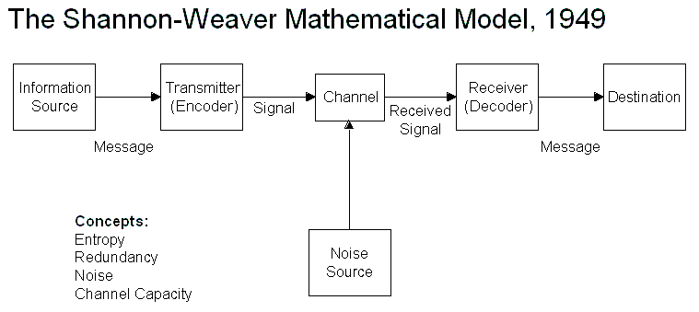

Berlo model SMCR
According to (Businesstopia, 2018) David Berlo developed the sender-message-channel-receiver (SMCR) style of interaction in 1960, relying on Shannon weaver’s concept. He exanimated factors that can affect several aspects of communication, due to resulting in more efficient information exchange. The model accounts for encrypting and decrypting, which occur just before text is sent and viewed by the receiver. Berlo’s types of formats describes the communication flow through four phases. The five pillars are transmitter, information, transport, and recipient.



Components of Berol’s model:
Transmitter
The transmitter is the origin of the information or the individual who delivers it. The person or provider transmits the information to the receivers. The elements that influenced the broadcaster are like those that informed the recipient.

- Communication skills
E.g., whether the person has great interaction abilities, the content would be conveyed greater than if the person has a poor communication skill.
- Point of view
- Skill
- Social structure
- Traditions
Content
The data sent by the originator to the recipient. Audio, wording, video, or any form of media may be used. These successive are the primary factors that have an impact on the text:
- Text
E.g., the content is referred to what is mentioned in the text. It would be as vocal, sound, content, and tape.
- Constituent
- Behavioral
- Form
- Cipher

Passage
The passage is the way through which the data is transmitted.
- Hearing
- Seeing
- Messages
- Touching
- Smelling
- Tasting
e.g., taste specifies the data that will be transmitted as a message.

Receptor
The recipient who gets the communication delivered throughout the procedure other aspects are like the sender’s one.

Critics of Berol’s SMCR model
- Since there seems to be no input to the system, and the impact is overlooked.
- The procedure of communication, there should be no such things as sound or some other kind of obstacle.
- Plus, there are not 2 different communications in that approach.
- All individuals must be equivalent based on all of the above-mentioned variables.
Schramms Model
Wilbur Schamm, a famous communications scientist, devised a simple communications protocol. The origin, content, and direction are all important forms of verbal, According to Schamm’s approach. Through an ideal world, the provider encrypting a data and transit it across some routes towards its intended recipient, who receives and decodes it. However, notion is likewise at the heart of Schramm’s model. Coding and decoding are two basic steps of efficient communication, according to Schramm’s concept. He underlines that communication is uncomplete until the sender gets response from the recipient (Overo., O, 2010). Schramms claimed communication is influenced by a person’s knowledge, experience, and cultural background because people with different cultures, religions, and background interpret the message in a different way.

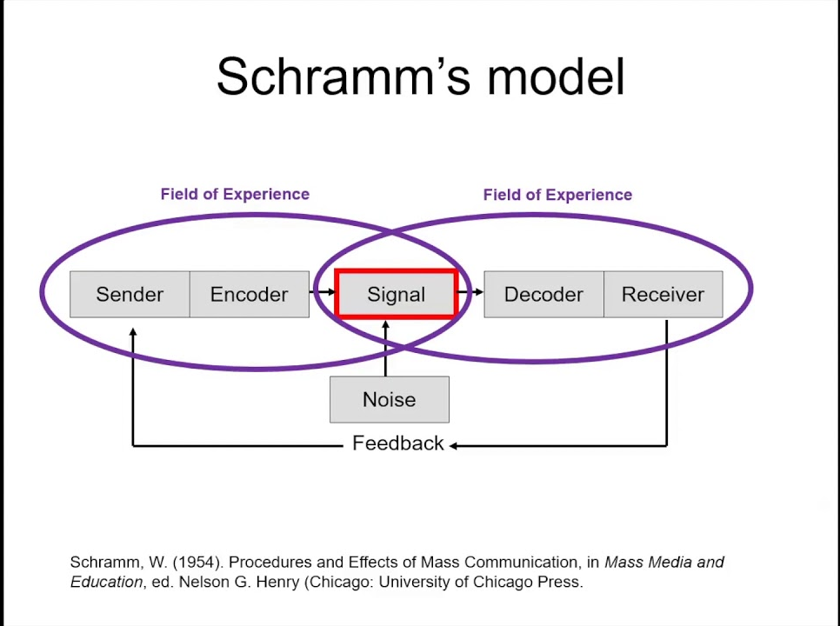

Case of study
In my workplace there’s a terrace that’s why sometimes some of us start our shift at 10am instead of 12pm and when you start your shift at 10am usually the manager let you leave at 11pm instead of 12pm. So that day my manager told me to clean the terrace instead of the inside the restaurant. So, I left at 11pm but in the manager changed his mind and didn’t communicate it to me as I had already left, and I didn’t receive any message from him telling me that he changed his mind. So, naturally in the morning I arrived and the floor inside the restaurant was not clean, so I sent him a message to double check if I still needed to clean the terrace and he replied to me “Yes, please do the terrace” so I thought I needed to clean it then I first started inside and by the time I finished it was 11am and the opening time was approaching. I started to clean terrace with bleach as usual and my manager appeared few minutes after, he told me “What are you doing?” and I send “I am doing what you told me to do” and he said “I meant to take out the tables and carpet outside and to set up the tables” and then he added “we don’t have enough time to open the restaurant is almost 12pm”. I said, “you didn’t tell me that I was meant to do that, so I thought you were talking about cleaning the terrace”. My manager was looking upset, and we stared to rush, and he started to help me finish quickly. If my manager had come late, I would not be able to finish on time and the restaurant would not open on time because of a misunderstanding.

Conclusion
All the models of communication have been covered and other important factors of communication well. The report discussed about some factors of information and shows how important is all the models and forms of communication not only in the workplace but also in our daily life.

- Al-Fedaghi, S., (2012), A conceptual foundation for the Shannon-Weaver model of communication. International Journal of Soft Computing, 7(1), pp.12-19. https://www.researchgate.net/profile/Sabah-Al-Fedaghi/publication/272964534_A_Conceptual_Foundation_for_the_Shannon-Weaver_Model_of_Communication/links/5644461708aef646e6ca787b/A-Conceptual-Foundation-for-the-Shannon-Weaver-Model-of-Communication.pdf (Accessed:23 December 2021)
- Businesstopia, (2018), Berol’s SMCR Model of Communication, Businesstopia, Available at:https://www.businesstopia.net/communication/berlo-model-communication Accessed: 23 December 2021

- Businesstopia, (2018), Shannon and Weaver Model Of Communication, Businesstopia, Available at: https://www.businesstopia.net/communication/shannon-and-weaver-model-communication Accessed: 23 December 2021

- Celik, O., (2017), The importance of listening in communication. Global Journal of Psychology Research: New Trends and Issues, 7(1), pp.8-11.

- Indeed, (2021), Nonverbal Communication Skills: Definitions and Examples, indeed, Available at:https://uk.indeed.com/career-advice/career-development/nonverbal-communication-skills Accessed: 23 December 2021
- Marcella, P., (2018), Verbal Communication in Workplace, University Binus, [article] Available at: https://communication.binus.ac.id/2018/10/17/verbal-communication-in-workplace/ Accessed:12 December 2021
- Prabavathi, R., (2018), Effective Oral and Written Communication, Journal of Applied and Advanced Research, Available at:https://www.researchgate.net/publication/325087759_Effective_oral_and_written_communication Accessed:23 December 2021

- Shraddha, B., (2018), Linear Model of Communication, Businesstopia, Available at: https://www.businesstopia.net/communication/linear-model-communication Accessed: 23 December 2021
- Narula, U., 2006. Communication models. Atlantic Publishers & Dist.

- Overo, O., (2010) From ‘one-to-one'to'many-to-many': A new model of communication. Mass Communication A Book of Readings. http://eprints.covenantuniversity.edu.ng/1008/1/From%20'One-To-One'%20To'Many-To-Many'.pdf

