
Motorcycle Engineering
Motorcycle Dynamics
ACHA4003
James Minton
2204900
Date of report: 16/12/2023

Contents
1 Introduction 3
2 Literature Review/Background/Research 4
3 Discussion 14
4 Conclusion 16
5 References 17

Introduction
This report will show the different characteristics and dynamics of motorcycles and how these effect the handling and responsiveness of the vehicle.

Literature Review/Background/Research
Motorcycle Geometry:
Motorcycle Geometry (ZXR750/RS660)
Rake is the angle of the steering head measured agaist the vertical axis
Trail is the horizontal measurement from the line through the front axel intersects the line through the sterring head.
To find the length of the Trail use the formula, Trail= (R*SinQ-O)/CosQ
Where:
Q = Rake Angle
O = Clamp Offset
R = Wheel Radius
ZXR 750 Trail = (290*Sin25-23)/Cos25 = 110mm
RS660 Trail = (295*sin24-23)/Cos24 = 107mm

Trail gives the chratertic of a self centering effect due to the front wheel being behind the steering axis, having too much Trail decreses the motorcyel’s steering making it more heavy to steer but having too little Trail decreases the self centerign making the Motorycle unstable.
Wheelbase is the contact point between the front and rear wheels, a longer wheelbase will increase the straight line stabaility but decrese corning ability, a shorter will have the oppsite affect making cornering more effective inturn making jumpy and twithcy feeling in a straight line. Wheelbase also effects the braking and accelerating stabilty, this is why dragbikes have and long wheelbase as this increases stability.
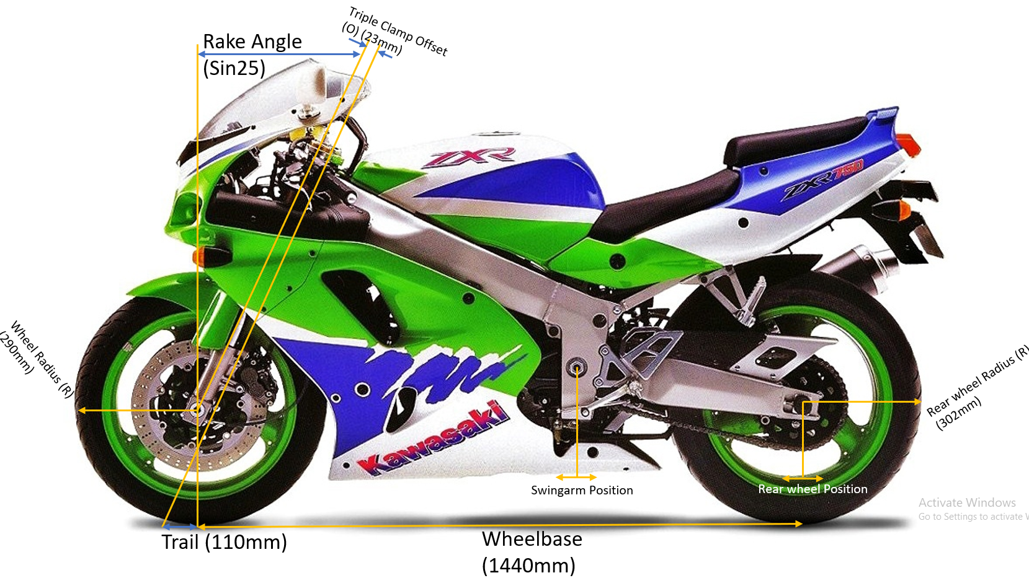
Figure 1 ZXR750 Rake, Trail, and Wheelbase Diagram
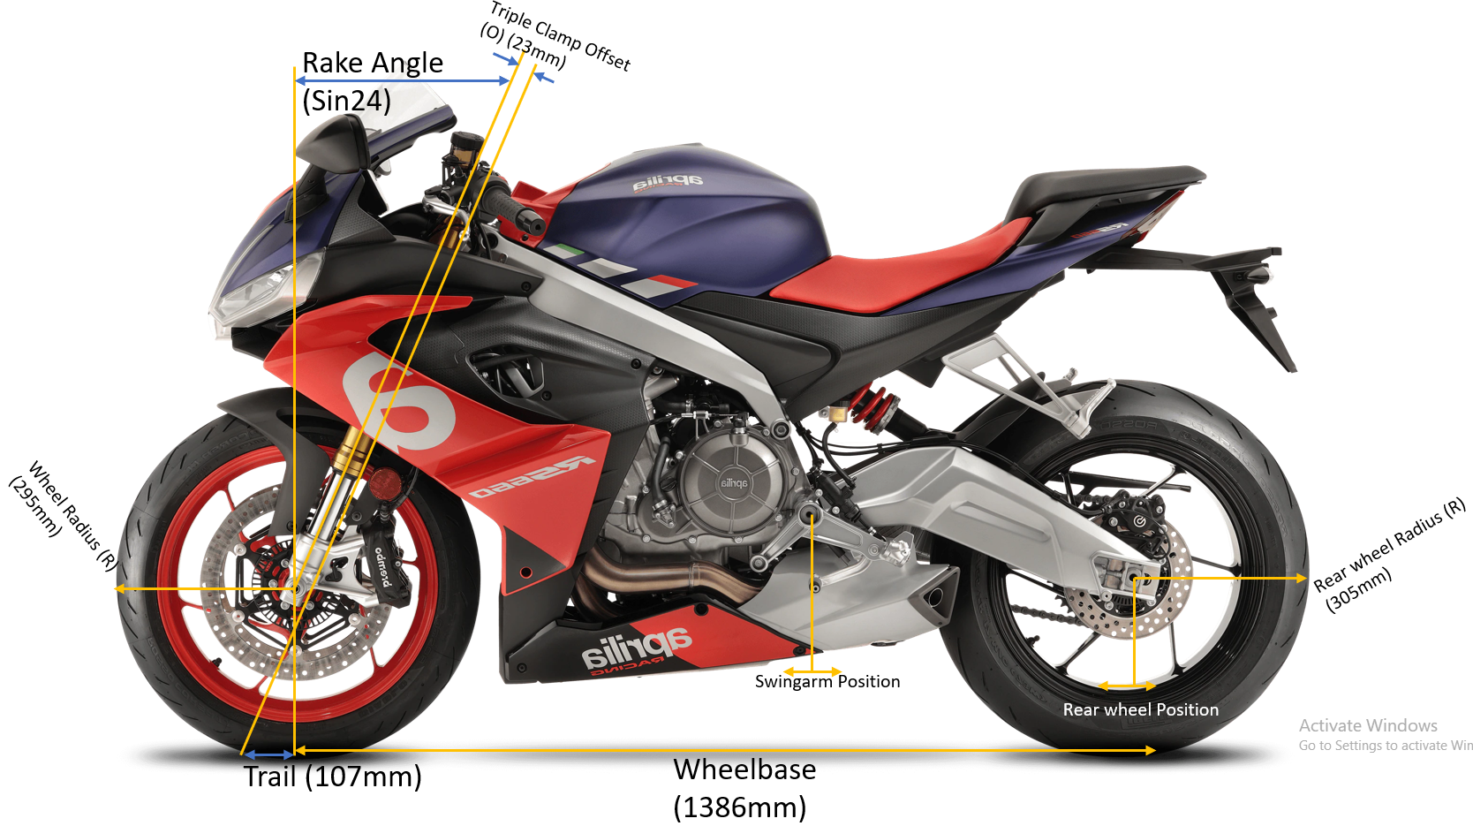
Figure 2 RS660 Rake, Trail, and Wheelbase Diagram

Centre of Gravity plays a big part in how a Motorcycle handles, the higher the CoG (Centre of Gravity) gives more load transfer, but too high of a CoG will allow the front to come off the ground when accelerating and the rear to come up off the ground when braking. A lower CoG will increase stability when braking, but if too low will cause slip and traction loss under accelerating and braking. A common way to gain rear traction is the shorten the swingarm inturn moving the CoG towar the rear tyre allowing more load, although this will create understeer as the front wheel now has a decrease in load.
The Practical way of measuring the CoG of a motorcycle is to place the bike with scales under both wheels in a level position (Xcog) then in a position where the one wheel is raised on a block (Ycog).
Formula for Xcog:
Xcog = (Wr*l)/Wt
Where:
Wr = Load on rear wheel
Wt = Total weight of motorcycle
L = Wheelbase
ZXR750
Weight | (Kg) | Geometry | (mm)
Front | 102.10 | Wheelbase | 1440
Back | 89.80 | Front wheel radius | 290
Front (rider) | 133.50 | Back wheel radius | 302
Back (rider) | 138.80 | Average radius | 296
Lifted | 78.65 | Lift height | 629
Lifted (rider) | 111.20 | Theta | 25.9002

Xcog ZXR750 = (89.80*1440)/(102.12+89.80) = 673.851mm
Xcog ZXR750 with rider = (138.80*1440)/(133.50+138.80) = 734.01396mm

RS660
Weight |  | (Kg) |  | Geometry | (mm)
Front |  | 84.35 |  | Wheelbase | 1386
Back |  | 74.50 |  | Front wheel radius | 295
Front (rider) |  | 114.6 |  | Back wheel radius | 305
Back (rider) |  | 125.6 |  | Average radius | 300
Lifted |  | 62 |  | Lift height | 629
Lifted (rider) |  | 93 |  | Theta | 26.9893

Xcog RS660 = (74.50*1386)/(84.35+74.50) = 650.0283mm
Xcog RS660 with rider = (125.60*1386)/(114.60+125.60) = 724.73605mm
Formula for Ycog:
Ycog = L*(Wr-Wr lifted)/(Wt*tanQ)+Rav
Where:
Wr = Load on rear wheel
Wr lifted = Load on rear wheel when lifted
Wt = Total weigth of motorycle
L = Wheelbase
Q = Angle of lifted bike = (sin-1(height of block/L))
Rav = Average wheel radius
ZXR750
Weight | (Kg) | Geometry | (mm)
Front | 102.10 | Wheelbase | 1440
Back | 89.80 | Front wheel radius | 290
Front (rider) | 133.50 | Back wheel radius | 302
Back (rider) | 138.80 | Average radius | 296
Lifted | 78.65 | Lift height | 629
Lifted (rider) | 111.20 | Theta | 25.9002

Ycog ZXR750 = 1440*(89.80-78.65)/(102.10+89.80)*(Tan 25.9002)+296 = 468.3068mm
Ycog ZXR750 with rider = 1440*(138.80-111.20)/(133.50+138.80)*(Tan 25.9002)+296 = 596.58269
RS660
Weight | (Kg) | Geometry | (mm)
Front | 84.35 | Wheelbase | 1386
Back | 74.50 | Front wheel radius | 295
Front (rider) | 114.60 | Back wheel radius | 305
Back (rider) | 125.60 | Average radius | 300
Lifted | 62 | Lift height | 629
Lifted (rider) | 93 | Theta | 26.9893

Ycog RS660 = 1386*(74.50-62)/(84.35+74.50)*(Tan 26.9893)+300 = 514.1514mm
Ycog RS660 with rider = 1386*(125.60-93)/(114.60+125.60)*(Tan 26.9893)+296 = 669.35386

Squat and Anti Squat happens when a load is transferred to the rear wheel under acceleration resulting either the rear compressing or extending.
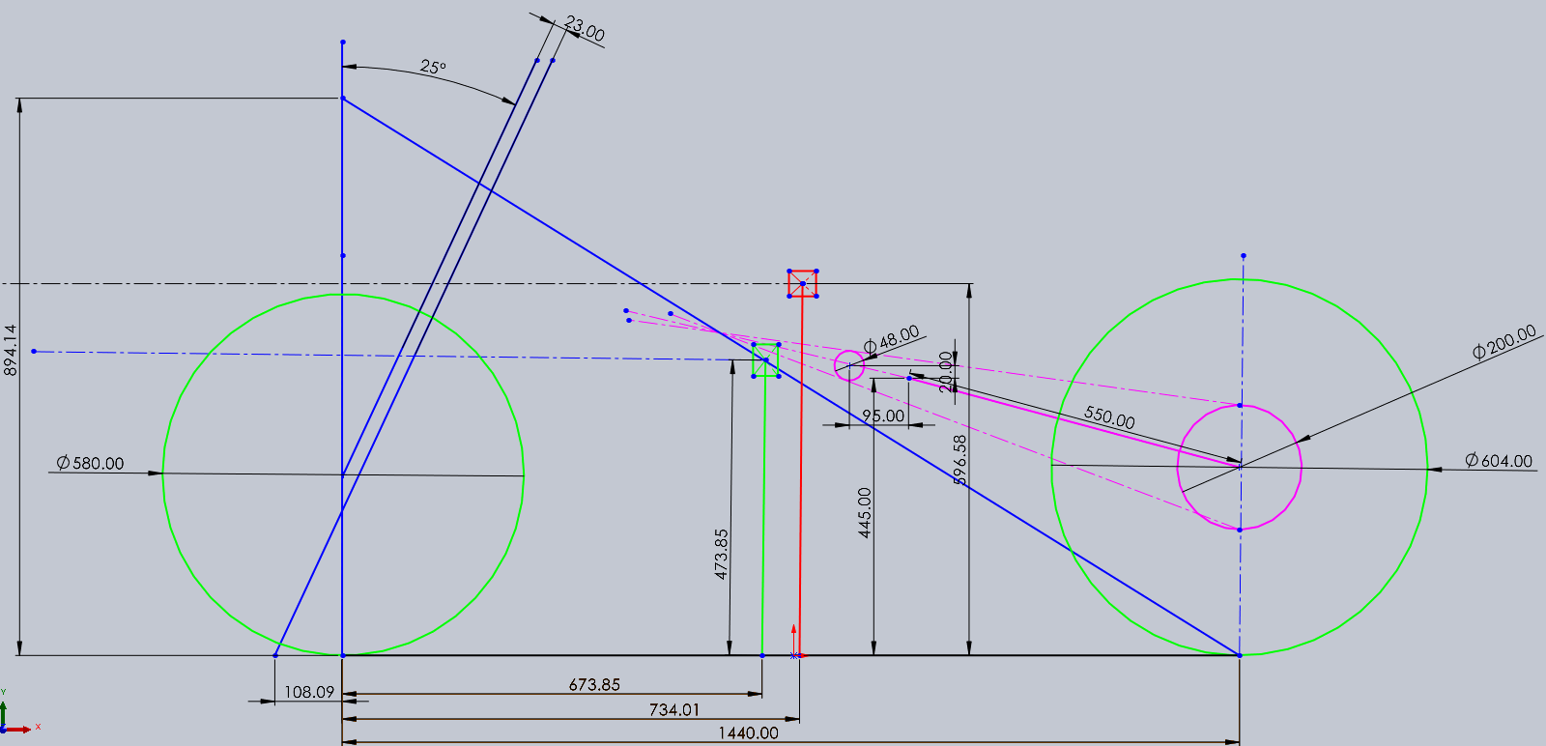
Figure 3 Centre of Gravity (green no rider) (red with rider), Squat (pink), Rake and Trail for ZXR750
As seen in the image above the instantaneous Force is where the chain and the swingarm lines intersect, with the 100% Anti Squat being at 894.14.
To find the Anit Squat value take the 100% value – Ycog.
Anti Squat Value for ZXR 750 = 894.14 - 596.58 = 297.56 Anti Squat%
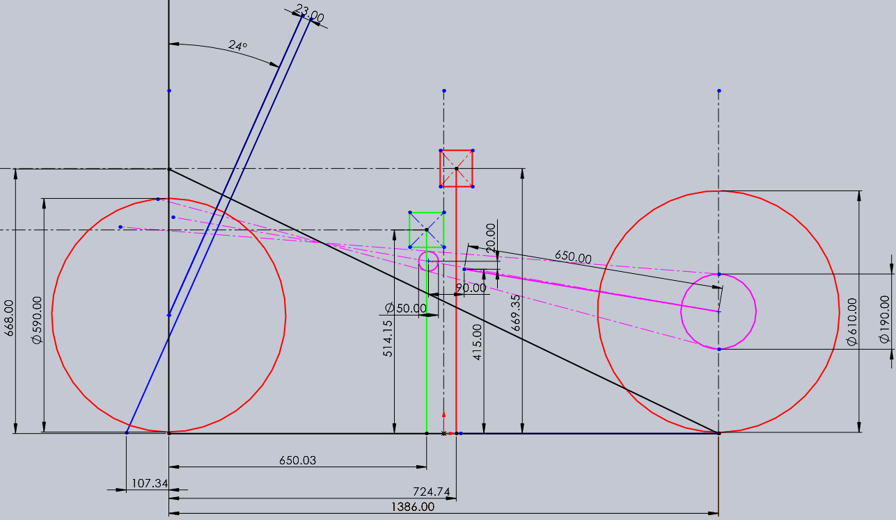
Figure 4 Centre of Gravity (green no rider) (red with rider), Squat(pink), Rake and Trail for RS660
Anti Squat Value for RS660 = 668 – 669.35 = -1.35 Anit Squat (Instantaneous force behind the wheel).

Gearbox ZXR750:
Table 1 ZXR 750 Gearbox
Front Sprocket | Rear Sprocket | Wheel Diameter (M) | Primary |  | Rpm
16 | 46 | 0.5308 | in | 52 | 12000
 |  |  | out | 85
Gearbox | ratio |  |  | km/h | mph
1st | 14 | 40 |  | 89.4186 | 55.88663
2nd | 18 | 36 |  | 127.741 | 79.83804
3rd | 21 | 34 |  | 157.798 | 98.62346
4th | 23 | 34 |  | 172.826 | 108.0162
5th | 27 | 33 |  | 209.031 | 130.6441
6th | 29 | 32 |  | 231.53 | 144.7064

To find the speed (km/h) of the motorcycle for each gear the equation used was:
RPM*60*(gear ratio) *(primary in/out) *(wheel diameter) *(PI/1000) *(front sprocket/rear sprocket)
Therefore, Top speed = 12000*60*(29/32) *(0.5308) *(PI/1000) *(16/46) = 231.53 km/h
To convert km/h to mph use: km/h/1.6
Therefore: 231.53/1.6 = 144.7064 mph

Forces on Motorcycle:
There are 3 forces that act on a motorcycle while in motion, these forces are Aero Drag Force (Fd), Rolling Resistance (Fw) and Road Plane Resistance (Fp).

To find the Aero drag (Fd) on the Motorcycle the equation used is: Fd = ½*Rho*CdA*V^2
Table 2 ZXR 750 Forces table
Rho | 1.167 | kg/m^3
CdA | 0.305 | m^2
V | 231 | km/h
M | 191.9 | kg
g | 9.81 | m/s^2
Theta | 6.842773 | Degrees
Velocity | 64.16667 | m/s

Where:
Rho = Density of air (1.167 kg/m^3)
CdA = Drag coefficient and frontal area (M^2)
V = Velocity (km/h) to (m/s) = V*1000/3600

Drag for ZXR 750 (Fd) = ½*1.167*0.305*64.16667 = 732.7565N

The second force to solve is Rolling Resistance (Fw) to solve this use: Fw = (0.02*m*g)
Where:
m = Total Mass
g = Gravity (9.81 m/s^2)

Rolling Risistance for ZXR 750 (Fw) = (0.02*191.9*9.81) = 37.65078N

The third force to calculate is Road Plane Resistance (Fp) to solve the equation used was: Fp = m*g*SinQ
Where:
m = Total Mass
g = Gravity (9.81m/s^2)
Sin Q = Angle of road plane (Tan^-1 12/100) = Sin 6.8

Road Plane Resistance for ZXR 750 (Fp)= 191.9*9.81*Sin6.8 = 224.2955N

Force needed for Top Speed = (½*Rho*CdA*V^2) + (0.02*m*g)
Force = 732.7565+37.65078 = 770.4072N
Power needed for Top Speed = Power=F*V
F= (½*Rho*CdA*V^2) + (0.02*m*g)
F = 732.7565+37.65078
F = 770.4072N
Power= 770.4072*64.16667
P = 49434.46 Watts = 49kw
Power of ZXR 750 = 82kw
Therefore, the motorcycle has enough power to overcome the forces acting on it to reach its top speed.

Figure 5 Graph for Speed and Forces ZXR 750

ZXR 750 Handling characteristics:
With the ZXR 750 Rake angle being 25 degrees and the trail being 110mm this will result with more stability at high speeds with front contact point being further in front of the stirring axis the downside to an increased rake and trail will be less responsive handling when leaning over in a turn, as well as a longer wheelbase of 1440mm also increasing the stability and traction when accelerating.
The centre of gravity for the ZXR 750 is Xcog 688.47mm and Ycog 468.31mm being further towards the rear and lower down increases the traction on the rear wheel when accelerating and less likely to wheelie as well as slow speed control.

This motorcycle has a rake angle of 24 degrees and a trail of 107mm, with a decrease in rake angle and trail length this will increase the manoeuvrability but will decrease stability at hight speeds and straight lines, the wheelbase is shorter being 1386mm in turn increasing the agility and acceleration but decreasing the front contact patch when accelerating.
Centre of gravity for the RS660 is Xcog650.03 and Ycog is 514.15mm being more toward the front wheel and higher up increases the handling with quick and precise changes in direction.

Discussion
Geometry KTM 450:
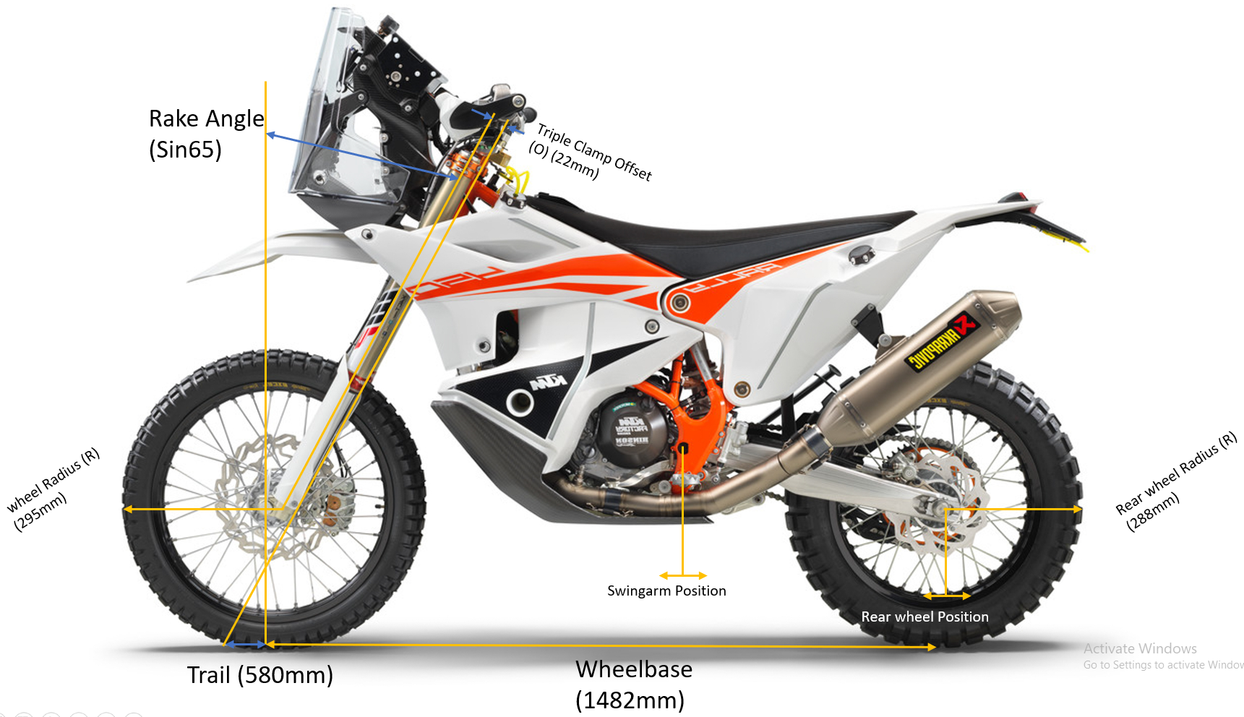
Figure 6 KTM 450 Rake, Trail, and Wheelbase
Equation for Trail: Trail= (R*Sin65-22)/Cos65= 580mm
As seen from the image above the rake angle is 65 degrees and the trail is 580mm resulting in straight line and high-speed stability, with off road suspension making the ground clearance higher as well adding more suspension travel to hard absorb impacts.
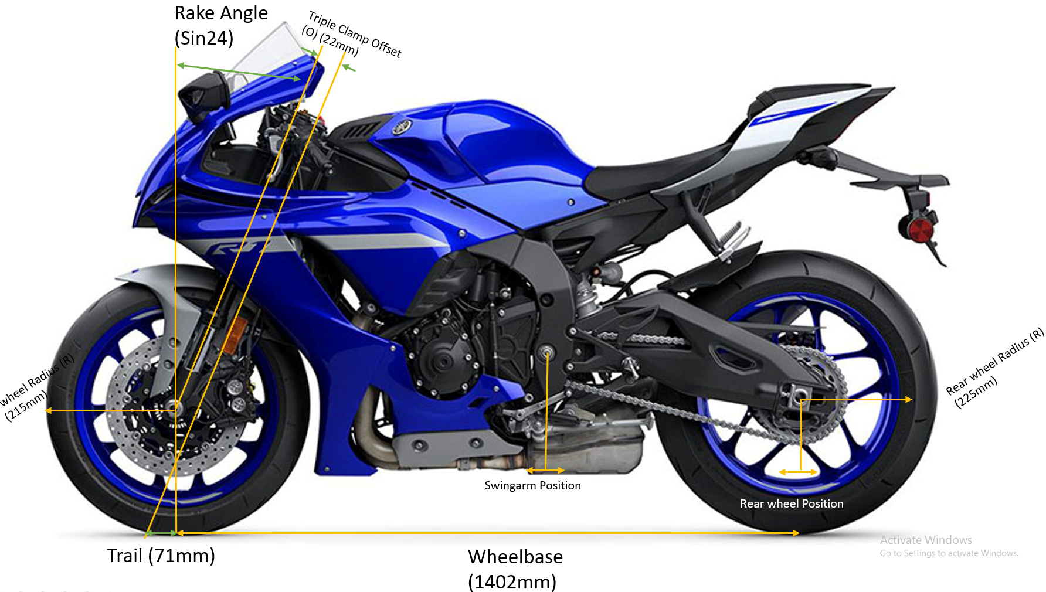
Figure 7 Yamaha R1 Rake, Trail, and Wheelbase
Equation for Trail: Trail= (R*Sin24-22)/Cos24 = 71mm
With the Yamaha R1 the rake angle is 24 degrees and the trail 71 mm, and a shorter wheelbase means this motorcycle will be very quick and precise when changing direction and leaning over but will start to lose stability on straight line speed.

Conclusion
ZXR 750 Alterations:
The Kawasaki ZXR 750 was released in the 90s at the time it was the peak of sports bike technology and engineering but compared to more modern motorcycle of the 2020s and onward there are parts of the ZXR 750 that could be changed to improve the bike’s handling characteristics, firstly would be to decrease the angle of the rake in turn minimising the trail length changing the motorcycle’s handling from straight line performance to more agile and accurate machine, secondly would be the decreasing the overall weight of the motorcycle as the original weight was 191kg this much heavier than most of the modern sports bikes seen today, a weight decrease would also increase acceleration and handling.

References
KTM Technical Data sheet (2023) https://www.bing.com/ck/a?!&&p=cb41ee81cacd9e29JmltdHM9MTcwMjU5ODQwMCZpZ3VpZD0zNTY4ZTRlYS05MWU5LTYzZWItMTAzMC1mNmY0OTBkOTYyZjkmaW5zaWQ9NTIwMA&ptn=3&ver=2&hsh=3&fclid=3568e4ea-91e9-63eb-1030-f6f490d962f9&psq=ktm+450+rake+angle&u=a1aHR0cHM6Ly93d3cua3RtLmNvbS9sYW5ndWFnZS1tYXN0ZXJzL2VuL2V4Yy1tZWRpYS1pbmZvcm1hdGlvbi9NWTIyJTIwS1RNJTIwRVhDJTIwVGVjaCUyMFNwZWNzLnBkZg&ntb=1
[Accessed 12 Dec. 2023]

bikez.com. (2023). 2021 Yamaha YZF-R1. [online] Available at: https://bikez.com/motorcycles/yamaha_yzf-r1_2021.php
[Accessed 15 Dec. 2023]
approved (2023). Kawasaki ZXR750 Close Ratio Gearbox. [online] Nova Racing. Available at: https://novaracing.co.uk/kawasaki-zxr750-close-ratio-gearbox
[Accessed 10 Dec. 2023].
‌

