Assess Environmental Impact and Design Out Impacts

Naim Awal
1802441

Content

- Introduction 3
  - The Importance of Policy Guidance 3
- Site Description 4
2.1. Geological Description 4
2.2. Development Proposal Description 5
- Environmental Impact Assessment Methodology 6
3.1. Screening 6
3.2. Scoping 6
3.3. Impact Analysis 6
- Bristol International Airport 7
4.1. Air Pollution 7
4.2. Noise Pollution 7
4.3. Water Quality 8
4.4. Biodiversity Quality 8
4.5. Landscape and Visual Quality 8
4.6. Geology and Land Quality 9
4.7. Transport 9
4.8. Vortex and Vibration 9
4.9. Community 9
4.10. Cultural and Archaeological heritage 10
4.11. Other Factors 10
- Discussion 11
5.1. Limitations 11
5.2. Recommendations 11
- References 12

Figures

Figure 1: 4
The bedrock (above) and soil strength (below) with key features at BIA (Digimap, 2021).
Figure 2: 5
A diagram showing the proposed development at BIA (ENTEC, 2005).

- Introduction
Bristol Airport is located in Somerset, 51º23’01.07” N to 2º42’48.77” W (Google Earth Pro, 2020), and it is the tenth-largest airport in the UK. In 2003, the UK Government published a strategic framework called ‘The Future of Air Transport’, the report discusses the development of airport expansions without drastic compromises to local communities and to the environment (DfT, 2003; ENTEC, 2005). In 2005, ENTEC conducted an Environmental Impact Assessment (EIA) for Bristol International Airport (BIA) to evaluate if the airport meets the criteria specified in the framework (section 3.) (GOV.UK, 2020). It is mandatory that any organisation that proposed an infrastructural development to undergo an EIA as legislated under Town and Country Planning (Environmental Impact Assessment) Regulations 2017; this regulation can allow such proposal to be approved under Part III of the Town and Country Planning Act 1990. Under the strategic framework, the UK Government supports the proposed development for airport expansion at BIA (ENTEC, 2005).

As enlisted in section 2.2., the purpose of the expansion is to comply with the future demand for air travel. BIA has projected that the demand for airport usage would increase by approximately 8 million passengers per annum (mppa) as by 2015, a potentially exponential growth by 80% compared with 2004. The UK Government recognised the future demand of air travel, thus accepting BIA’s development proposal, as further demands were speculated that BIA’s demand of airport usage will increase between 10-12mppa by 2030 (ENTEC, 2005; Wood., 2018). This paper evaluates the EIA for BIA conducted in 2005 by ENTEC discussing multiple potential concerns (section 4.), although there have been several EIAs for BIA that has been more recently published by other organisations.

  - The Importance of Policy Guidance
For the benefits of the people and the environment, ENTEC (2005) had established a list of guidance for each significant factor (section 4). Policies are legislated on a local and on a national scale of government with varying management plans that are listed below (ENTEC, 2005; Bath and North East Somerset Council, 2007);
- North Somerset Local Plan (NSLPP),
- North Somerset Replacement Local Plan (NSRLP),
- Second Draft Deposit (SDD),
- Joint Replacement Structure Plan (JRSP).

As the EIA may entail, the policies are heavily implemented in for BIA to abide by to alleviate the impact on the people and the environment. Policies are implemented because the resulting impact may be pollution to the air, water and land; noise and traffic congestion; endangering the welfare of the local flora and fauna; endangering the heritage of culture and archaeology. The extent of the development may be restricted due to the Green belt. The UK Government implemented the Green Belt to reduce urban growth, encouraging vegetation growth for ecological and recreational purposes (GOV.UK, 2019; section 4.10.).

- Site Description
  - Geological Description
Figure 1: The bedrock (above) and soil strength (below) with key features at BIA (Digimap, 2021).
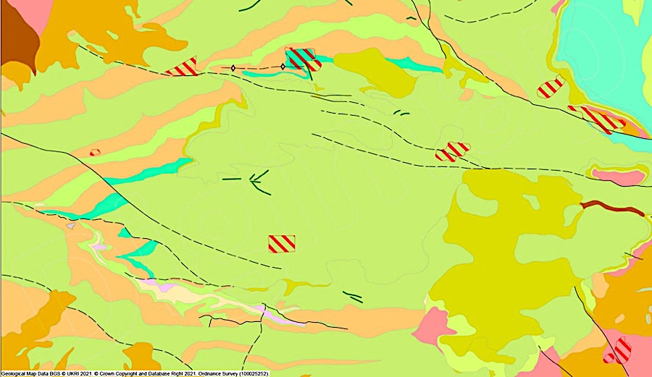



Key features as bedrock Key features as soil strength
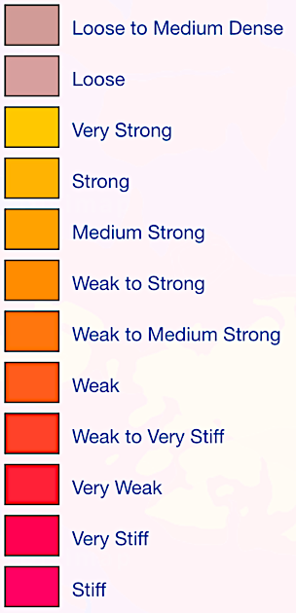
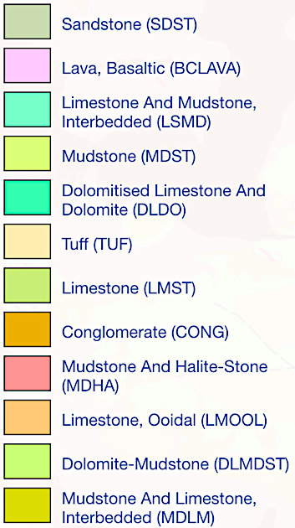

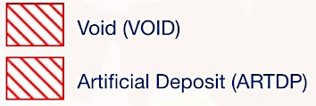

Figure 1 demonstrates the bedrock and soil strength at BIA. According to Digimap (2021), the image above shows the rock type is primarily mudstone and limestone interbedded (MDLM) with multiple other rock types around the vicinity of the airport. There are also artificial deposits and void areas, it is unclear if these factors are harmful to the environment as ENTEC did not mention this in the EIA. The soil strength at BIA is known to be strong with small pockets of medium to strong. It is imperative to understand the key features of the rock type and soil strength in regards to assessing environmental impact. The higher the soil and rock fragility, the harder it is for the proposed development to be accepted. One potential concern in regards to the expansion of BIA, which is not mentioned in the EIA is that the soil strength is graded as weak and weak to medium-strong; this implicates that the soil may not be compatible for the infrastructural development (Digimap, 2021).
  - Development Proposal Description
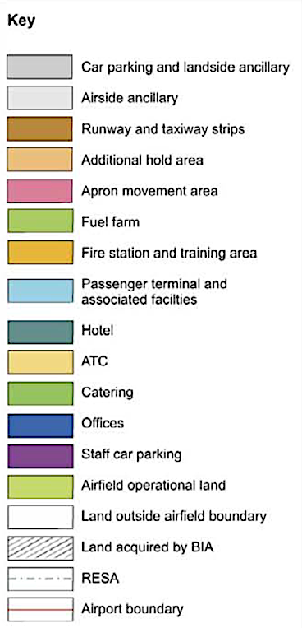
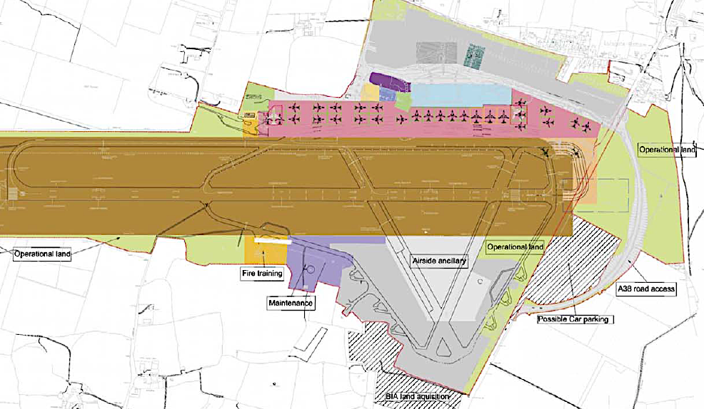
Figure 2: A diagram showing the proposed development at BIA (ENTEC, 2005). Key

Figure 2 portray the proposed expansion to the BIA (ENTEC, 2005). The expansion details are noted with location and colour coordinated with figure 2 is as follows;
- Passenger terminal: increasing the capacity by 60-80% to accommodate 9mppa. Northwards of BIA, light blue;
- Runway and taxiway: the runway is currently sufficient, an additional taxiway may be an option. Centre of BIA, brown;
- New mezzanine floor and aircraft access: to improve access to aircraft and the terminal building;
- Apron: the expansion can allow 30 aircraft to accommodate 9mmpa. Northwards of BIA, pink;
- Hotel: a three-star hotel to accommodate up to 200 beds with leisure and conference facilities. Northwards of BIA, dark green;
- New fuel farm: to accommodate the growth of BIA. North-westwards, light green;
- Fire station: the relocation allows easier access to the runway. Southwards, orange;
- New road infrastructure: a redevelopment means traffic will flow swiftly and safely around BIA;
- Terminal building: the relocation allows the apron to be expanded. Eastwards, light orange;
- Multi-storey car park: to increase car park availability by 1000 spaces to meet air travel demand. Southwards, dark grey;
- Long-stay car park: to increase car park availability to meet demands. Northwards and southwards, dark grey;
- General aviation: new facilities have been constructed regarding general aviation, the EIA states that no further expansion required.

Proposed demolition of the old terminal building to expand the aircraft apron and fire station will allow easier access to the runway and apron. BIA intend to compensate for the demolition by relocating the terminal building and fire station as part of the proposed development (ENTEC, 2005). The economic cost for these infrastructural changes is unknown, the EIA has evaluated these potential changes to see if these developments have a substantial social and environmental impact. The evaluation is found in section 4.

- Environmental Impact Assessment Methodology
This section reviews the systematic functions of the EIA to comply with the UK Government’s ‘The Future of Air Transport’ and the Town and Country Planning (Environmental Impact Assessment) Regulations 2017 (section 1.). A Site Environmental Management Plan (SEMP) helped ENTEC (2005) to construct an EIA that covered impacts found in section 4 onwards.

  - Screening
Once the proposed development is identified, the first stage is screening. The purpose of screening is to understand if the proposed development requires an Environmental Impact Assessment (EIA). The decision to conduct an EIA depends on whether if the extent of the proposed development will have a significant impact on the local community and the environment; upon the screening outcome, a small development may require a limited EIA or none at all, whereas a large development may require a full EIA. If an EIA is needed, the next two stages are vital for the approval of the proposed development, which is scoping (section 3.2.) and impact analysis (section 3.3.).

  - Scoping
The purpose of scoping is to give relevant stakeholders a viewpoint and the authority to monitor certain aspects of the proposed development (European Commission, 2001). The outcome of screening (section 3.1.) will determine the decision on scoping;
- Involved scoping: there is a wide range of stakeholders, including EIA consultants, the client (such as BIA), relevant agencies (such as DEFRA and Wessex Water) and the members of the public who may be interested or will be affected by the development.
- Public scoping: a given proposed development may only require public consultation, by members of the public who will be affected by the development.
- Closed scoping: the consultation will involve the client, the developer and relevant agencies, a given proposed development will not include the public.

  - Impact Analysis
The purpose of impact analysis is to assess the factors that will impact the proposed development (Convention on Biological Development, 2010). Such factors include;
- Significance: to determine if the impact of infrastructural development is ‘important’ or ‘unimportant’.
- Type: the proposed development may have repercussions as health, economic, social, physical or biological impacts. As part of the EIA, stakeholders (section 3.2.) must identify the potential impact to mitigate the concerns the infrastructural development may have on the local community and the environment.
- Nature: this factor suggests the ways that the development can impact the local community and on the environment;
  - Direct: the impact within the vicinity of the airport,
  - Indirect: the impact outside the vicinity of the airport,
  - Jointly cumulative: the impact within and outside the vicinity of the airport.
- Severity: the magnitude scale of the impact could be high, low or moderate.
- Extent: the larger the development, the greater the extent of the impact. The development could have a local, regional, national or an international impact.
- Timing: the larger the development, the longer the construction will take to accomplish. Timing can be classified as short-term or long-term intervals for construction.
- Duration: depending on a given development plan, the initial or changed ideas in the proposal may lead to a temporary or a permanent outcome.
- Reversibility: to understand if a given development proposal is reversible or irreversible.
- Certainty: the likelihood of the initial or changed ideas in a proposal will be approved, the decision can be classified as ‘likely’ or ‘unlikely’.

- Bristol International Airport
The EIA implicates that there is an involved scoping towards the proposed development. The Government Office for the South West (GOSW) and the Department for Transport (DfT) established the Greater Bristol Strategic Transport Study (GBSTS) and conducted by multiple agencies, including Atkins. The GBSTS aims to understand the current strategy for transport and the strategy for Greater Bristol by 2031. In 2004, the agencies had consultations with the members of the public and with local authorities to associate current issues with traffic congestion amidst the discussion of the development proposal and the increased demand for air travel. The local authorities include Bristol, North Somerset, North East Somerset, Gloucestershire and Bath (Atkins, 2004; ENTEC, 2005).

  - Air Pollution
As of 2005, four policies primarily discuss air quality. The primary purpose of these policies is to mitigate potential harmful contaminants into the air. Such policies include Policy 61 – JRSP 2002 and Policy ENV/1 – NSLP 2000. Although air pollution had not yet been quantifiably measured, ENTEC suggests it is appropriate to expect the legislations are effective for BIA to comply.

To understand the importance of legislating air pollution regulation, DEFRA established these policies under the Air Quality Strategy for England, Scotland, Wales and Northern Ireland (AQS) in 2000 (amended in 2003). The AQS provides a revised framework of Air Quality Regulations 2000 that have been made mandatory, furthermore, it is the responsibility of the local authorities to monitor air quality with their area. Thus, it is the responsibility of North Somerset Council to monitor air quality from BIA. Although the DEFRA legislated these policies for the UK, the recommendations to make these policies mandatory were by World Health Organisation (WHO), European Union (EU) and the Government’s Expert Panel on Air Quality Standards (EPAQS).

These legislated policies aim to alleviate the compromise of air quality from such contaminants as benzene (C₆H₆), 1.3-butadiene (C₄H₆), carbon monoxide (CO), nitrogen dioxide (NO₂) and particulate matter (PM₁₀). Although the contaminants are monitored any period between hourly and daily to annually, the date set to achieve the targets range from 2003 and 2010. Since ENTEC produced the EIA in 2005, it is currently unknown if BIA has met these targets. It is also unclear the repercussions of failure to meet these targets as implemented under the legislation.

  - Noise Pollution
The four policies regarding the concern for noise pollution are the same for air pollution (section 4.1.). Much like measuring the impact of air pollution, ENTEC (2005) did not receive any quantitative data from BIA or another third-party agency. However, it is also expected to suggest that these policies are effective under the legislation.

ENTEC (2005) also discussed the significant importance of regulating noise pollution as a vital concern in the residential and communal areas near BIA. Eight of the current receptors experience noise pollution as a nuisance to a certain degree. However, it was recognised by ENTEC (2005) that the construction noise for the proposed development will not be a nuisance to nearby residential properties nor students and staff at nearby schools. Estimated by the Department for Transport (DfT) and Sound Exposure Level (SEL), residents are to experience 57dB of airborne aircraft noise in the day and 82dB in the night.

  - Water Quality
There are five policies to protect water quality and mitigate water pollution, including Policy GDP/4 – NSRLP SDD 2004. Water pollution can be considered as a significant environmental concern as Policy ENV/6 – NSLP 2000 prohibit any proposed developments that will directly pollute a water source. ENTEC (2005) acknowledge the importance of mitigating water pollution claiming it is a criminal offence to cause or approve of inputting harmful contaminants into groundwater or surface water, under Water Resources Act 1991 and Groundwater Regulations 1998. Water is alphabetically measured with descriptions to categorise the level of pollution in a water body; ‘A’ is very good and ‘F’ is very bad.

  - Biodiversity Quality
Much like air and water (section 4.1., section 4.3.), the EIA recognised how vital biodiversity quality is as an environmental factor. All 14 policies iterate the importance of biodiversity quality. Policy ECH/12 – NSRLP SDD 2004 and Policy ECH/14 – NSRLP 2004 discuss the how a constructional development can harm flora and fauna, particularly in conservation areas like Nature Reserves and in Sites of Special Scientific Interests (SSSIs) (ENTEC, 2005). ENTEC (2005) identified multiple receptors that are crucial to pinpoint the quality of biodiversity; ecology has significant economic and social value as well as environmental value, allowing people to enjoy themselves and potentially boosting the tourism sector; whilst species with recognised value are given legal protection implemented by DEFRA.

BIA is a large developed infrastructure (before the expansions) as the runway/taxiway strips, car park areas and the apron contribute to the largest infrastructure at the airport (figure 2). There is a total of 25 legally and non-legally designated sites with ecological significance within 2km of the airport; in regards to legally designated sites, this includes North Somerset and Mendip Bats Special Area of Conservation (SAC) and five SSSIs. There are eleven protected species within the 2km radius of BIA, protected under Wildlife and Countryside Act 1981, The Conservation (Natural Habitats, &c.) Regulation 1994 and/or Protection of Badgers Act 1992 (ENTEC, 2005).

  - Landscape and Visual Quality
Similar to biodiversity quality (section 4.4.), there are 18 policies to help reduce compromise to the landscape and visual quality. The majority of the policies, including Policy ENV/2 – NSLP 2000, discusses given constructional factors, like artificial lights, will be used for public safety with provision there is no environmental harm or changes. Furthermore, the UK Government implemented Policy 16 – JRSP 2002 designating land as undeveloped to minimise the extensive growth of urban development (ENTEC, 2005).

ENTEC (2005) considered the aspects from the proposed development that will have an impact on the landscape and visual quality; landscape limitations include loss of vegetation, a possible change in ground levels in certain areas; visual limitations include views of infrastructure construction associated with the airport. It was stated that the SEMP for BIA taken the conservation of mature vegetation in high regards.
  - Geology and Land Quality
There are four policies concerning the quality of land and geology. Policy ENV/1 – NSLP 2000 and Policy GDP/2 – NSRLP SSD 2004 discuss how a proposed constructional plan should mitigate environmental setbacks for ecological and human benefits, any developments that neglect these factors suggest that BIA will be held liable (ENTEC, 2005).

The land is flat and the bedrock is mudstone and limestone interbedded (MDLM), this means that the rock is relatively strong to support the airport (figure 1; figure 2). The land surrounding BIA is thought to be varied in gradience with such characteristics as valleys, ridges and slopes. Due to the previous history of mining, there are several quarry exposures, which can influence soil erosion and potentially change the local ecosystem (ENTEC, 2005; Ozcan et al., 2012).

  - Transport
Transport policies are heavily implemented with 13 policies in place complied by BIA. The construction materials would be transported via road A38. BIA will create a construction transport management plan to minimise movement of construction vehicles; by monitoring the route to and from the airport; as well as the time of day the construction activities will begin and end. The possible reason is to improve health and safety of passengers when travelling to and from the airport as well as alleviate traffic congestion, thus complying to Policy T/10 – NSRLP SDD 2004 (ENTEC, 2005).

As stated in section 4, the GBSTS uses multiple stakeholders in an involved scoping, including the members of the public, to authorise an improved transport strategy for Greater Bristol by 2031. The expansion of BIA foreseeing the projected demand for air travel to grow by 10-12mppa by 2030 (section 1). The reason for establishing the GBSTS could be to find an approach to mitigate traffic congestion as part of the development details is to expand the long-stay car park and multi-storey car park (section 20). Policy T/11 – NSLP 2000 states that BIA will be held accountable if the development leads to severe traffic congestion (ENTEC, 2005).

  - Vortex and Vibration
There are only two policies concerning vortices and vibrations, which are Policy 61 – JRSP 2000 and Policy T/13 – NSRLP SDD 2004. These policies encourage the overall improvement for the environmental and social wellbeing by mitigating noise nuisances from aircrafts. One of the reasons that the expansion proposal came into fruition for BIA was that the airport was able to maintain the Public Safety Zone and it would not be compromised amidst the construction. The impact of vortices and vibrations is crucial because the receptors who are likely to be affected are residents as well as students and staff of a local school who live and work near the airport (ENTEC, 2005).

  - Cultural and Archaeological Heritage
There are four policies to help maintain the historical heritage of culture and archaeology in the UK. Policy 19 – JRSP 2002 and Policy ARCH/2 – NSLP2000 state that the importance of respecting the historical remains. There are 19 features of historical interests within proximity of the airport, sources include seven site visits, nation monuments record (NMR) and defence of Britain’s project database (DoB) (ENTEC, 2005). BIA is located in a region of Somerset where there are ruins and artefacts from Mesolithic, Neolithic and Bronze ages. Archaeological evaluations have taken place near where the new passenger terminal will be constructed and the discoveries include ditches and postholes that were estimated dated back to the prehistoric era. However, no artefacts were found (ENTEC, 2005). At the south of BIA, there was an industry for lead extraction dating back to AD 1600s in the Mendips, this area is a known today as North Somerset and Mendip Bats SAC and it is protected under legislation (section 4.4.). BIA is currently occupying in an area once occupied by Lulsgate Airfield, which was in commission during WWII and ceased operations in 1946. However, BIA currently uses reinforced air-raid shelters from the old airfield as storage rooms (ENTEC, 2005).

  - Community
There are 17 policies implemented to ensure the wellbeing of the community at the airport. Such policies as Policy GRB/5 – NSLP 2000 and Policy RD/5 – NSRLP SDD 2004 prohibit constructional development within the green belt except for forestry, agricultural or leisure reasons. Such economic factor as trade, tourism and investment was not yet quantified when the EIA was conducted and would have been measured in the Environmental Statement (ES). Public health would have been surveyed in the Strategic Environmental Assessment (SEA) and noted in ES (ENTEC, 2005).

Although ENTEC (2005) extensively discuss the potential environmental impact throughout the EIA, the agency recognises the socio-economic impact associated between the community and BIA. The service provided by the airport is vital as the receptors involve local businesses that may have foreign clients and airport employees. A survey was conducted and it discovered that 42% from an estimated 2500 lived in North Somerset at the time, suggesting that BIA are heavily reliant on the local workforce. Although a green belt and a Public Safety Zone are implemented at BIA, it is noted that there is no Public Right of Way (PRoW) enforced in the proximity of the airport (ENTEC, 2005; Bristol Airport, 2006).

  - Other Factors
Amidst the extent of the proposed development being approved, the intent by BIA will be to dispose of waste to a licenced disposal facility if the waste cannot be recycled or reused by the airport. ENTEC (2005) iterated that BIA will comply with Duty of Care Regulations 1991 and Waste Management Regulations 1994. It was mentioned in the EIA that the development of the EIA may not be the only factor to impact the environment, however, the ES for BIA’s proposed development will consider for the cumulative effects that may impact the members of the public or the environment and will need to be agreed by North Somerset Council (ENTEC, 2005).

- Discussion
This EIA made it clear the importance of local and national governmental legislations as the policy guidance contain 98 policies concerning BIA, some of which described throughout section 4. As figure 2 indicate the scale of the expansion, it was imperative that the scoping involved the members of the public. BIA rely on the local workforce to contribute to the service at the airport, thus many of the impacts can accumulatively affect their employees (section 4., section 4.10.). ENTEC (2005) has made a thorough analysis of the social and environmental impact BIA have made and could make in the future, as evaluated in throughout section 4. However, there are limitations regarding the content of the EIA (section 5.1.).

  - Limitations
Although this paper evaluated the EIA by ENTEC that was produced in 2005, there are EIAs conducted more recently that, albeit produced by other agencies as the most recent EIA was conducted in 2018 by Wood. Although ENTEC (2005) were succinct with the time for BIA to meet environmental targets, particularly with air pollution (section 4.1.), BIA’s environmental targets may have changed since this EIA was produced due to the nature of policy changes. BIA’s environmental targets may have changed to comply with legally binding treaties; such treaties as the Paris Climate Agreement established by the United Nations in 2015 (UNCC, 2021). The EIA does not mention the financial impact of BIA, the overall cost for the development is unclear thus may be difficult to comprehend the size or importance of the expansion. However, ENTEC (2005) signified that BIA’s proposed development required a full assessment as the length of the EIA was conducted to the highest extent.

  - Recommendations
A vital recommendation to ENTEC is to create another EIA of BIA to ensure all targets and statistics are updated. BIA’s current set of targets could be recommended by international governing bodies, such as the United Nations, as the UK intend to comply with the Paris Climate Accord. Furthermore, enlisting economic impact can help people with environmental concerns to understand the financial cost of the expansion development (section 5.1.).

- References
- Atkins (2004). Greater Bristol Strategic Transport Study Final Report. (Accessed: 22nd January 2021).
- Bath and North East Somerset Council (2007). Bath and North East Somerset Local Plan. Including minerals and waste policies. (Accessed: 20th January 2021).
- Bristol Airport (2006). Bristol International Airport Master Plan 2006 to 2030. (Accessed: 15th January 2021).
- DfT (2003). The Future of Air Transport. (Accessed: 20th January 2021).
- Convention on Biological Diversity (2010). What is Impact Analysis? Available at: https://www.cbd.int/impact/whatis.shtml (Accessed: 17th January 2021).
Digimap (2021). ‘Bristol Airport’. [OS map]. Scale 1:50,000 Rock Type [geological data]. Updated 2021 EDINA Digimap Ordnance Survey. (Accessed:19th January 2021).
- Digimap (2021). ‘Bristol Airport’. [OS map]. Soil Strength [geological data]. Updated 2021 EDINA Digimap Ordnance Survey. (Accessed:19th January 2021).
- ENTEC (2005). Environmental Impact Assessment on the Expansion of Bristol International Airport. Scoping Report. (Accessed: 20th December 2020).
- European Commission (2001). Guidance on EIA. Scoping. (Accessed: 19th January 2021).
- Google Earth Pro (2020). ‘Bristol Airport’. (Accessed: 8th January 2021).
- GOV.UK (2020). Environmental Impact Assessment. Available at: https://www.gov.uk/guidance/environmental-impact-assessment (Accessed: 20th January 2021).
- GOV.UK (2019). Green Belt. Available at: https://www.gov.uk/guidance/green-belt (Accessed: 16th January 2021).
- Ozcan, O. et al. (2012). Environmental Impact Analysis of quarrying activities established on and near a river bed by using remotely sensed data. Fresenius Environmental Bulletin. (Accessed: 20th January 2021).
- UNCC (2021). The Paris Agreement. Available at: https://unfccc.int/process-and-meetings/the-paris-agreement/the-paris-agreement (Accessed: 21st January 2021).
- Wood. (2018). Development of Bristol Airport to accommodate 12 million passengers per annum. (Accessed: 20th January 2020).

