Tensile test

Engineering Science (ACHA4002 & ACMA4028)

Alexander Joseph Jay (2416946)

University of Wales Trinity Saint David
School of engineering

Motorsport engineering BSc

02/12/24

Contents
1. Introduction 4
2. Experimental procedure 5
2.1. Pre-test preparations 5
2.2. Testing phase 6
2.3. Post test phase 6
2.3. Post test analysis 7
3. Results 8
3.1. Steel 8
3.2. Duralumin 9
3.3. Aluminum 10
3.4. PVC 11
4. Analysis 12
4.1. Steel 12
4.2. Duralumin 14
4.3. Aluminum 16
4.4. PVC 18
5. Conclusion 20
5.1. Steel 20
5.1.1. Youngs modulus 20
5.1.2. Yield stress 20
5.1.3. Tensile strength 20
5.1.4. Elongation 20
5.2. Duralumin 21
5.2.1. Youngs modulus 21
5.2.2. Yield stress 21
5.2.3. Tensile strength 21
5.2.4. Elongation 21
5.3. Aluminum 22
5.3.1. Youngs modulus 22
5.3.2. Yield stress 22
5.3.3. Tensile strength 22
5.3.4. Elongation 22
5.4. PVC 23
5.4.1. Youngs modulus 23
5.4.2. Yield stress 23
5.4.3. Tensile strength 23
5.4.4. Elongation 23
6. Evaluation 24
6.1 Knob dial speed 24
6.2 Reading of Digital Thickness Indicator (DTI) 24
6.3 Experiment environment 24
7. Further work 25
7.1. Environment 25
7.2 Digital dial indicator 25
7.3 Load nut movement 25
8. References 26

Introduction

This report aims to display and analyse the results of a tensile test lab completed at UWTSD. It will go over the results gathered during the test and analyse the data to find useful information which can tell us more about each of the samples. It will then go over the method used to carry out the experiment along with an evaluation on what techniques were used to increase the accuracy of results, on top of what potential adjustments could be made in future experiments to improve results.

Experimental procedure

2.1. Pre-test preparations

Rigorously read the lab guidance notes. Then select the specimen you wish to test and use a vernier to measure both the thickness and width of the specimen. Attach the specimen to the tensile tester and set the dial to zero

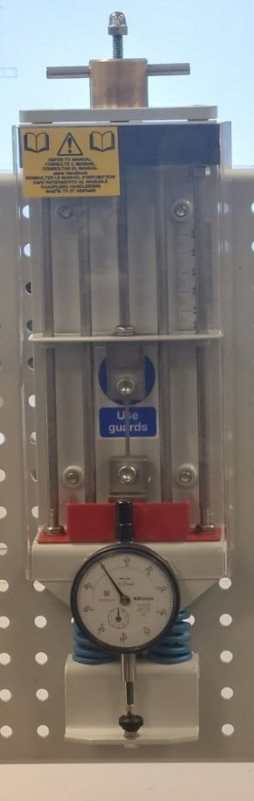
Springs
Bottom chuck
Top chuck
Vertical scale
Sample
DTI (Digital Thickness Indicator)
Dial knob

2.2. Testing phase

Turn the load nut in a clockwise direction at a constant steady speed, in 0.2mm increments until you reach 5mm then switch the increments to 1mm until you reach 10mm extension, finally switch to 10mm increments until the specimen breaks.
Record the dial indicator after every step
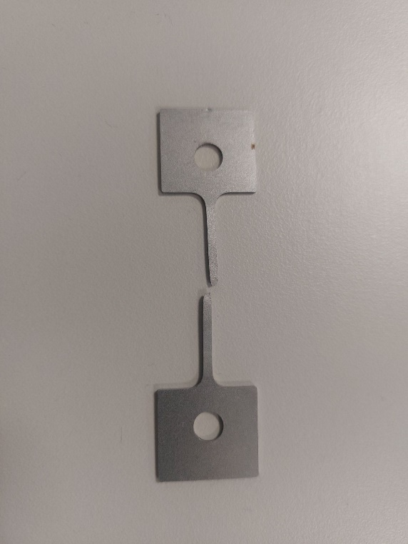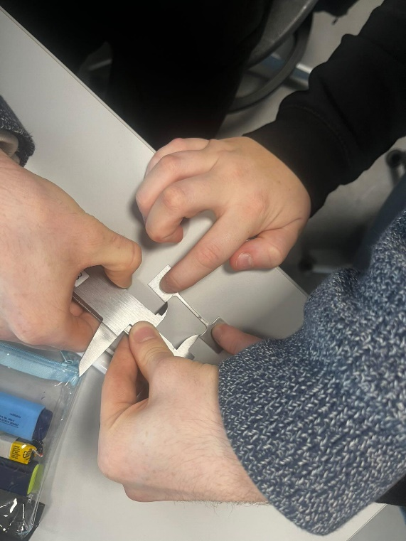

2.3. Post test phase

After the specimen breaks remove it from the tensile machine. To check how much the specimen has extended, push the broken ends together and measure its new length. Next convert the dial readings into force values by multiplying them by 100. Subtract the dial indicator results from the load nut movement to find the extension at each stage of the experiment. Divide the extension at each stage by the original length to work out strain. Divide the force at each stage by the original cross-sectional area of the specimen to work out the stress

2.3. Post test analysis

Plot the stress/strain graphs of each specimen onto individual scatter graphs. Examine each graph to find the yield point at which the material stopped behaving elastically band then plot a new graph of the elastic region of each specimen. Finaly find the gradient of each specimen's elastic region to find the youngs modulus of the materials.

Results

3.1. Steel

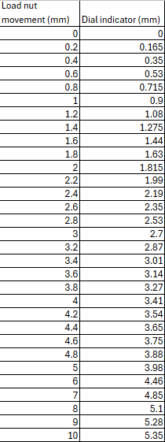
Original cross-sectional area: 0.9mm x 1.98mm = 1.782x10^-6 m^2
Original length = 30.9mm
End length = 38.2mm

3.2. Duralumin

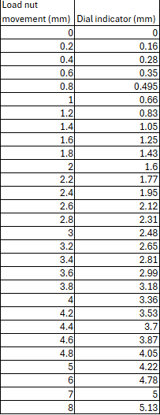
Original cross-sectional area: 1mm x 1.9mm = 1.9x10^-6 m^2
Original length = 31mm
End length = 33.4mm

3.3. Aluminum

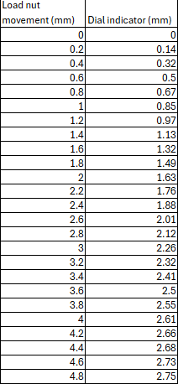
Original cross-sectional area: 1mm x 1.94mm = 1.94x10^-6 m^2
Original length = 30.98mm
End length = 33.14mm

3.4. PVC

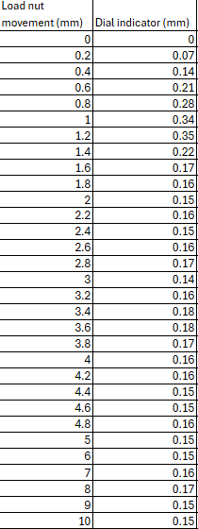
Original cross-sectional area: 1mm x 1.9mm = 1.9x10^-6 m^2
Original length = 31.1mm
End length = 41.68mm

Analysis

4.1. Steel
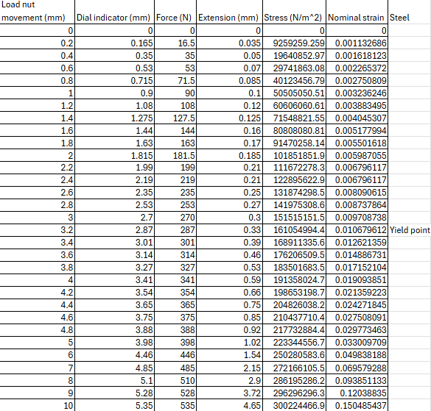

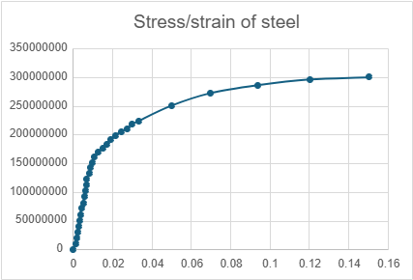

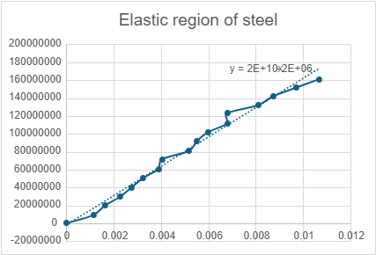

4.2. Duralumin
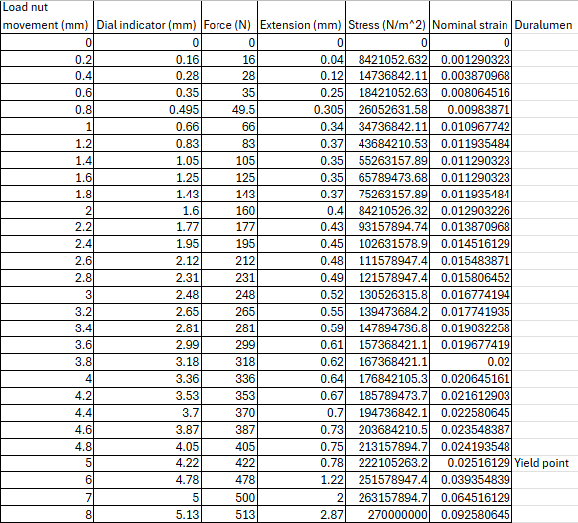

4.3. Aluminum
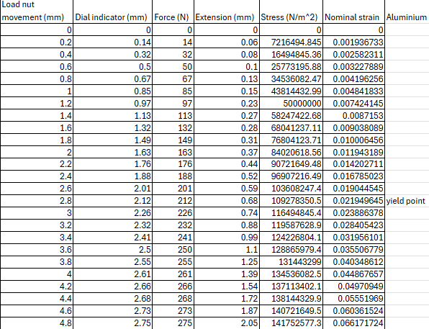

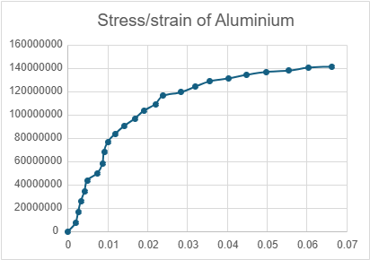

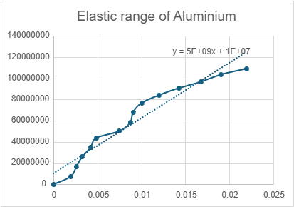

4.4. PVC
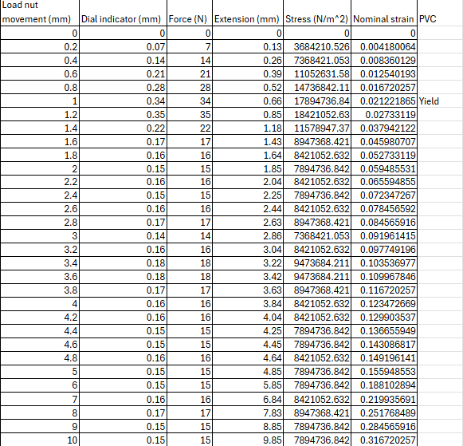
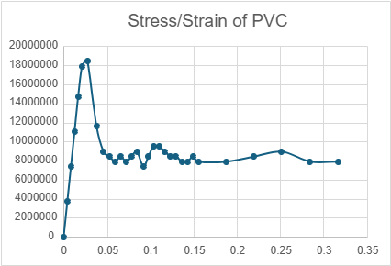

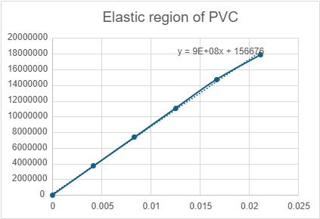

Conclusion

5.1. Steel

5.1.1. Youngs modulus

For the tensile strength test of steel, the determined youngs modulus was 2x10^10 Pa. Comparing this to the most accepted value of 200 GPa (SUGNA, 2023) you can tell there is a significant difference in the theoretical answer and the measured one.

5.1.2. Yield stress

The measured yield stress for steel was 170 MPa which compared to the usual range of steel yield stress of between 200 MPa and exceeding 300 MPa (Unionfab, 2024) is slightly less than what should be expected for this sample, however this could be because of lower quality steel or another external factor.

5.1.3. Tensile strength

The measured tensile strength of the steel sample was 300 MPa, comparing this number to the typical tensile strength of steel which is between 400 MPa and 700 MPa (Econ Steel, 2024) you can see this is below the expected tensile strength of a typical steel sample.

5.1.4. Elongation

The measured elongation of steel in the test was 23.6%, compared to the usual measured extension of steel which is 10%-20% (Xometry, 2023). This is slightly atypical, however not far from the measured elongation.

5.2. Duralumin

5.2.1. Youngs modulus

For the tensile strength test of duralumin, the determined youngs modulus was 10 GPa. Comparing this to the most accepted value of 76 GPa (Nuclear power, 2024) you can tell there is a large difference in the theoretical answer and the measured one.

5.2.2. Yield stress

The measured yield stress for duralumin was 220 MPa which if you compared to the usual duralumin yield stress of around 450 MPa (Chem Europe, 2024) is less than what typically would be expected for this sample.

5.2.3. Tensile strength

The measured tensile strength of the duralumin sample was 2.7x10^8 Pa, comparing this number to the typical tensile strength of duralumin which is between 420 MPa and 500 MPa (AZO materials, 2013) you can see this is around half the expected tensile strength of a typical duralumin sample.

5.2.4. Elongation

The measured elongation of duralumin in the test was 7.7%, compared to the usual measured extension of aluminum which is 22% (AZO materials, 2013). This is very different, and shows the sample tested had a low strain before breaking.

5.3. Aluminum

5.3.1. Youngs modulus

For the tensile strength test of aluminum, the determined youngs modulus was 5 GPa. Comparing this to a typical value of 73 GPa (Britannica, 2024), you can tell there is a large difference, this maybe due to a different aluminum composition or the temperature while testing.

5.3.2. Yield stress

The measured yield stress for aluminum was 110 MPa which if you compared to the usual aluminum yield stress of around 390 MPa (Matweb, 2024) you will see it is only around a third of what's expected.

5.3.3. Tensile strength

The measured tensile strength of the aluminum sample was 140 MPa, comparing this number to the typical tensile strength of aluminum which is around 310 MPa (Gabrian international, 2024) you can see this is massively underneath the expected tensile strength.

5.3.4. Elongation

The measured elongation of aluminum in the test was 7%, compared to the usual measured extension of aluminum which is 8% (Italpres, 2024). This is very similar to the measured result.

5.4. PVC

5.4.1. Youngs modulus

For the tensile strength test of PVC, the determined youngs modulus was 9x10^8 Pa. Comparing this to a typical value of 3.7 GPa (Oxford reference, 2024) there is quite a difference in the theoretical answer and the measured one however this was likely due to environmental factors.

5.4.2. Yield stress

The measured yield stress for PVC was 18 MPa which if you compared to the usual PVC yield stress of around 3.45 MPa to 73.1 MPa (matweb, 2024) you will see it is exactly in the band of expected results.

5.4.3. Tensile strength

The measured tensile strength of the PVC sample was 14 MPa, comparing this number to the typical tensile strength of PVC which is around 16 MPa (Oxford reference, 2024) you can see this is very close.

5.4.4. Elongation

The measured elongation of aluminum in the test was 34%, compared to the usual measured extension of aluminum which is between 30% and 40% (Material science and engineering, 2007). This is exactly in the range of expected results.

Evaluation

Both before and during the experiment, we took several practical precautions. We did this in the hope of improving both the consistency and accuracy of our results as well as the future repeatability of the experiment by other students.

6.1 Knob dial speed

One of the most critical steps we took was keeping the rate at which the dial knob was rotated at a slow consistent speed. To do this, we kept the same person turning the knob for all specimens, this ensured that the force applied to the sample didn't suddenly increase which could cause a premature fracture in the material.

6.2 Reading of Digital Thickness Indicator (DTI)

Another step we took was we made sure that one person always had a clear view of the DTI, and they were the one calling out the results in order for other people to write them down. We did this to ensure the timing the measurements were taken were consistent along with eliminating viewing errors like parallax error.

6.3 Experiment environment

Additionally, we kept the lab environment the same throughout the test, this was done to minimize potential errors which may arise from variables such as temperature, air pressure and humidity. Factors from the environment can greatly affect material properties especially materials such as PVC (ASTM, 2022). By keeping these the same thought we aimed to minimize discrepancies in our results.

Further work

If this experiment were to be repeated with unlimited time and more resources, its accuracy and repeatability could be improved in a few critical areas.

7.1. Environment

The first improvement which could be made is better control of the storage and test environment. Although the environment stayed consistent throughout all 4 samples and during each test the temperature, air pressure and humidity were all not controlled. This is especially important as on the day, the lab was quite cold which increases how brittle materials are (ASTM E28-18, 2022), which will have affected the results. If repeated the storage and experimental environment should be kept at industry testing standards.

7.2 Digital dial indicator

Another option to increase the accuracy and consistency of results is to use a digital dial indicator. This will eliminate human causes of errors such as reaction time and parallax error. In turn this will make it more repeatable as everyone has different reaction times and a computer will be constant.

7.3 Load nut movement

Finally having a machine control the load nut movement would ensure a smooth and uniform force is applied on the sample at each stage. This will eliminate large jumps in the force on sample which could change their measured properties.

References

Sugna, 2023. SUGNA premium steel
Available at: https://sugnatmt.com/youngs-modulus-of-steel/#:~:text=Known%20for%20its%20impressive%20strength,per%20square%20inch%20(psi).

Unionfab, 2024. Yield Strength of Steel: A Comprehensive Guide
Available at: https://www.unionfab.com/blog/2024/03/yield-strength-of-steel

Econ Steel, 2024. Econ steel Tensile strength vs yield strength
Available at: https://www.econsteel.com/blog/tensile-strength-vs-yield-strength#:~:text=Yield%20Strength%20of%20Steel&text=Typically%20measured%20in%20megapascals%20(MPa,yield%20strengths%20exceeding%20600%20MPa.

Xometry, 2023.
Available at: https://www.xometry.com/resources/materials/elongation-at-break/#:~:text=Different%20steel%20types%20will%20have,between%2010%25%20and%2020%25.

Nuclear power, 2024
Available at: https://www.nuclear-power.com/nuclear-engineering/metals-what-are-metals/alloys-composition-properties-of-metal-alloys/aluminium-alloys/series-2000-duralumin/

Chem Europe, accessed December 8th, 2024
Available at: https://www.chemeurope.com/en/encyclopedia/Duralumin.html#:~:text=%25)%204.4%25%20copper%2C%201.5%25,on%20the%20composition%20and%20temper.

AZO materials, 2013. Duralumin - Chemical Composition, Mechanical Properties and Common Applications.
Available at: https://www.azom.com/article.aspx?ArticleID=8073

Britannica, 2024. Youngs Modulus
Available at: https://www.britannica.com/science/Youngs-modulus

MatWeb, 2024
Available at: https://asm.matweb.com/search/specificmaterial.asp?bassnum=ma6061t6

Gabrian international, 2024
Available at: https://www.gabrian.com/how-strong-is-aluminum/

Italpres, 2024
Available at: https://www.italpres.com/aluminium-die-casting-news/mechanical-properties-aluminum#:~:text=The%20elongation%20of%20aluminum,elongation%20rate%20of%20about%208%25.

Oxford reference, 2024
Available at: https://www.oxfordreference.com/display/10.1093/acref/9780198832102.001.0001/acref-9780198832102-e-4711#:~:text=Rigid%20or%20unplasticized%20PVC%20(uPVC,ultimate%20tensile%20strength%2016%20MPa.

Matweb, 2024
Available at: https://www.matweb.com/search/datasheet_print.aspx?matguid=69642362cb864d25b8f6eb9d02092ecf

Callister, W.D. (2001) Fundamentals of Materials Science and Engineering: An interactive etext. New York: Wiley.

ASTM, 2022. Standard Test Method for Tensile Properties of Plastics
Available at: https://www.astm.org/d0638-14.html

ASTM E28-18, 2022
Available at: https://cdn.standards.iteh.ai/samples/114106/7b5bcb8c08a04de9970514ddd5b8e46b/ASTM-E28-18-2022-.pdf

