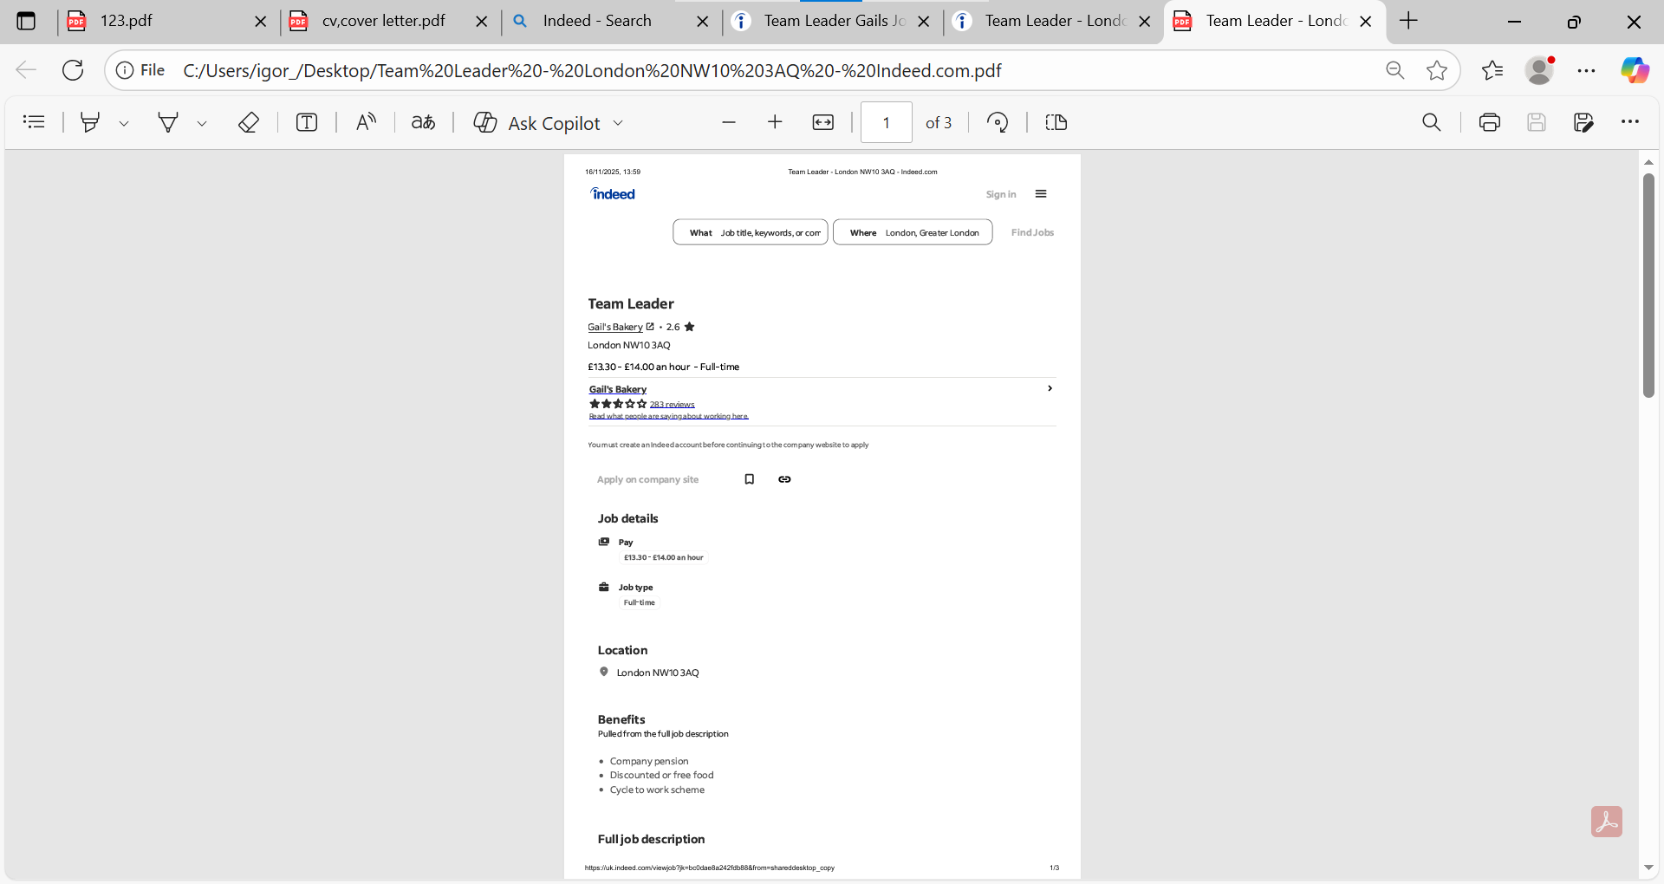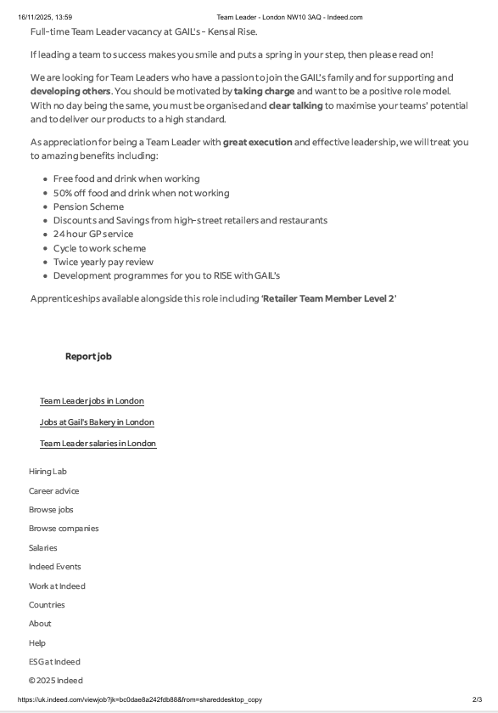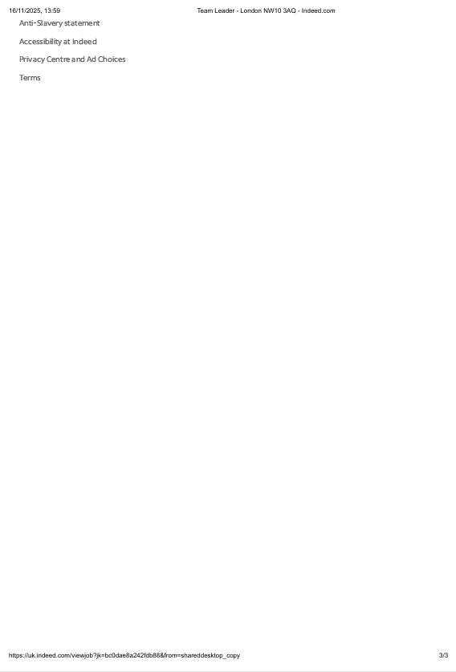

Anna Example
+44 7000 000000 example@email.com

London
+44 7862 972935 | prysiagnuk@gmail.com
09 November 2025
Dear Hiring Manager,
I am writing to express my interest in the Team Leader position at your coffee shop. With over 1.5 years of experience at Pret a Manger as a Team Member and Hot Chef, I have developed strong leadership, communication, and teamwork skills that help create a positive and efficient working environment.
In my current role, I have gained hands-on experience in food preparation, customer service, and team support, often taking initiative to train new staff and assist with daily operations. I am confident that my reliability, positive attitude, and understanding of fast-paced service environments make me a strong candidate for this position.
I am passionate about delivering excellent customer experiences and supporting a motivated, well-organised team. I would welcome the opportunity to contribute my skills and enthusiasm to your business.
Thank you for considering my application. I look forward to the opportunity to discuss how I can contribute to your team.
Kind regards,
Anna Example

Anna Example
+4470000000000
example@gmail.com

Professional profile

Motivated and reliable hospitality professional with over 1.5 year of experience at Pret a Manager as a Team Member and Hot Chef.
Skilled in leading by example, ensuring high standarts of customer service., food safety, and teamwork. Currently studying Business Management at the University of Wales Trinity Saint David (UWTSD)., developing strong leadership and communication skills to support team growth and deliver excellent customer experience.

Core skills

- Team leadership
- Customer service excellence
- Food Preparation & safety
- Time managment & Organisation
- Training and Supporting New staff
- Cash handling & store Operetions
- Problem solving & Decision making

Career Summary

Pret a Manger – Team Member / Hot Chef (Feb 2023 – Present)
- Prepared high-quality food items according to brand standards and food safety regulations.
- Delivered friendly and efficient customer service in a fast-paced environment.
- Supported and trained new team members to maintain smooth daily operations.
- Assisted shift leaders with opening, closing, and stock management.

Education

BA (Hons) Business Management
University of Wales Trinity Saint David (UWTSD), London
2025 – Present

Languages

- English – Upper-Intermediate
- Ukrainian – Native

