HALIMA RAHMAN (1914850)

DR AZORA HURD
CHANGEMAKERS- CREATIVITY AND VALUE CREATION
BMHP- 5014
TASK 1&2
26/01/2021

Table of Contents
1
Task 1: 3
Introduction: 3
Mind Map: 5
Task 2: 6
Selection of this Topic 6
How it adds value to the process: 6
Advantages of this tool: 6
References: 8

Task 1:

Introduction:
This part will describe the details about the importance of e-portfolio in learning in the educational environment. The focus will be on the current pandemic condition concerning the learning education. There will be a mind map covering the aspects and importance of e-portfolios in the learning environment of the students in their academic career in this time of Covid-19.
The idea of E-portfolio has gained immense popularity and expansion in recent years. It is also extensively being used when the Covid-19 has halted the schools and colleges around the world. Mainly because of the advanced technologies, and state of the art practices, this has been helpful for the students to learn, engage and deliver their ideas in a more creative way than ever before as compared to the traditional methods of learning. In the field of education, this technological advancement not only helps students but the teachers as well (Nguyen and Ikeda, 2015). The idea of selecting this topic is also important as according to the research, the education is not purely academic, but it becomes holistic for which e-portfolios play an important role to think, analyze, reflect, and deliver the projects accordingly (Kehoe and Goudzwaard, 2015)
The E-portfolios also have great importance in this time of corona as everyone is entitled to their homes. It is not possible to perform activities that need physical interaction. This notion has come in the great times where students can learn and access the skills with the help of portfolios, and they can do so many activities in this new normal time when everything is jeopardized.

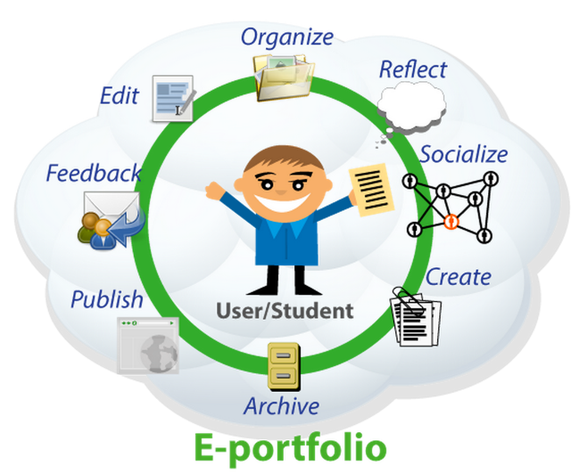
Advantages of E-portfolio in the learning process (Kharbach, 2021)
The differences between using the e-portfolios and its alternative methods are.
- It is extremely easy to alter the digital formatting.
- It makes it easier to make the connection between documents and links using hyperlinks.
- The format is portable to carry around.
- It has helped immensely in the Covid-19 to resume the learning activities as compared to the traditional learning process.
The mind map for the selected topic that will be covered under this assignment is shown below.

Mind Map:

Tools used for online monitoring in COVID-19
Distance Learning Initiation
Importance of this topic in this time

Knowledge sharing
Adding Value in the learning
The new normal routine of the learning process
E-portfolios in Educational Learning in the time of Covid-19

Critical thinking
Creation of flyer and poster
Communication
Reflection
Enhanced self-learning process
Self-understanding
Portability of everything
Learning Outcomes
Monitoring the whole progress online

Mind map of activities to be covered in this module

Task 2:

Selection of this Topic
The purpose of choosing this topic is that E-Portfolio is a model of fact-finding with a focus on visualizing and sharing curriculum, writing visual effects, linking learning across multiple levels and making instructions frequently updated. Furthermore, its importance has greatly been increased in the Corona time as it helps to deliver the knowledge and resume the learning activities without considering the space, time or location issues. It has helped to return to the new normal state for almost all the students and learners around the world and somehow made its ways to their electronic devices. Moreover, it provides many other benefits such as promoting academic achievement, practising e-learning through design observations; encouraging students to participate in real-world activities to develop a sense of learning; students participating in supervised and self-directed learning as an important learning process; providing follow-up information on continuing education support, and promote student independence through the collaborative building of literacy. All these examples show how creative and innovative it is to utilize the benefits of e-portfolio which is why it has been chosen.

How it adds value to the process:
E-portfolios are becoming more prevalent amongst teachers as a knowledge device. It provides the benefit of working and learning along with monitoring the engagement of the learners at the comfort of the location. Many types of research have even shown that e-registration can be used to promote the growth of services for self-learning. These skills include self-assessment of performance, setting learning goals, and selecting future careers. But it is not clear in what circumstances e-commerce makes the best improvement of this technology(Yang et al., 2016). The educational data is used effectively when teachers are trained to monitor the development of self-directed learning when personal information is integrated into the curriculum, when teachers inform students at all times, when scaffolding is in place, force increased support, and at least when personal information is designed to support goal setting, performance appraisal, strategic planning and self-assessment.

Advantages of this tool:
Current research data confirms that new developments such as choice, ownership, voice, and real-world learning are the basis for e-learning portfolios. To determine whether this content is relevant to students continuing to use e-Portfolios, different surveys are used that include measures of choice, ownership, voice, and knowledge true(Beckers et al., 2016; Roberts et al., 2016)). For e-Portfolio users, the benefits of this study show that real-time campaigns, measuring earnings, getting feedback, and managing e-Portfolio during learning time has a significant impact on continued use or e-Portfolio after a student's degree in technology.
From the student's point of view, many institutions were offering blended learning programs in the past, but Covid-19 has made it's through this by forcing them to fully adopt the process of online learning and the development of e-portfolio education makes student management become independent in the curriculum and make decisions before the teacher’s manual. E-data recording can lead to management and self-directed learning. It is often used as a combination of instruction and measurement learning process (Thibodeaux et al., 2017). Evidence provided by the student should be a process of reflection and reflection that can establish a relationship between what is taught and what is learned. This allows students to include
what and how he learns, let him make his equal voice of learning and work. This is a constant thought and what does it mean that e-records are being used as a tool for analysis and measurement in the current continuous measurement (Abdullah et al., 2016). In academia, it is a common use of e-commerce with online integration or collaboration learning tools. Therefore, In this case, use and manage a personal e-portfolio with the constant support of a teacher or professor to teach/disseminate feedback to students, enabling them to direct their efforts to achieve professional development skills.

References:
Abdullah, F., Ward, R. and Ahmed, E., 2016. Investigating the influence of the most commonly used external variables of TAM on students’ Perceived Ease of Use (PEOU) and Perceived Usefulness (PU) of e-portfolios. Computers in human behaviour, 63, pp.75-90.
Beckers, J., Dolmans, D. and Van Merriënboer, J., 2016. e-Portfolios enhancing students’ self-directed learning: A systematic review of influencing factors. Australasian Journal of Educational Technology, 32(2).
Kehoe, A. and Goudzwaard, M., 2015. ePortfolios, badges, and the whole digital self: How evidence-based learning pedagogies and technologies can support integrative learning and identity and development. Theory Into Practice, 54(4), pp.343-351.
Kharbach, M,2017.https://www.educatorstechnology.com/2014/07/great-eportfolio-resources-for-teachers.html
Nguyen, L.T. and Ikeda, M., 2015. The effects of ePortfolio-based learning model on student self-regulated learning. Active Learning in Higher Education, 16(3), pp.197-209.
Roberts, P., Maor, D. and Herrington, J., 2016. ePortfolio-based learning environments: Recommendations for effective scaffolding of reflective thinking in higher education.
Thibodeaux, T., Cummings, C. and Harapnuik, D., 2017. Factors That Contribute to ePortfolio Persistence. International Journal of ePortfolio, 7(1), pp.1-12.
Yang, M., Tai, M. and Lim, C.P., 2016. The role of e‐portfolios in supporting productive learning. British Journal of Educational Technology, 47(6), pp.1276-1286.

