
Skills for the Workplace
Module Assignment Submission
Student Name: | Christopher downey
Student Number: | 1910814
Module No: | BMSK4003
Module Title: | Digital Skills and Research Methods

Statement of Confirmation of Authenticity
By the act of making this submission, the student declares that this is the work of the student named above. The work has not, in whole or in part, been knowingly presented elsewhere for assessment, or where assessment has been built on a previous assessment, this has been identified. Where materials have been used from other sources it has been properly acknowledged. If this statement is untrue, the student acknowledges that an assessment offence has been committed.
Attention is drawn to the plagiarism and unfair practice policies of both the University and of ILM.
Permission for ILM to use this script
ILM uses learners’ submissions – on an anonymous basis – for assessment standardisation. By submitting, both the centre and the learner agree that ILM may use this script on condition that identifying information is removed. However, if you are unwilling to allow ILM use this script, please refuse by ticking the box: □

Table of Contents
What has been the impact of 21st Century Technologies on the modern workplace? 3
Part 1 3
An Overview of the 21st Century Workplace 3
An in-depth look at technologies used in own workplace 3
Part 2 4
An exploration of the use of social media in the workplace generally 4
An in-depth look at the use of social media in own workplace 4
The use of social media to enhance networking and career prospects 4
LinkedIn Profile 4
Conclusion 5
References 6

What has been the impact of 21st Century Technologies on the modern workplace?
During this report I will take an in-depth look at technological advancements and changes in the modern workplace since the start of the 21st Century. I will be exploring the advantages and disadvantages of what I have found. I will also look at one of the training companies I work for, I will be looking at the technology used and also there online and social media footprint. I will talk about my LinkedIn profile, show a photograph of what you will initially see when visiting my page. I will then move on to discuss what needs to be changed or added to my profile to improve it. I will conclude this report in a deeper look at social media on a whole including my own professional media account.

Part 1

An Overview of the 21st Century Workplace

From the start of the early 21st-century technology has advanced and developed at an extraordinary rate. It has developed even faster when it comes to electronic devices which we use more and more in the everyday workplace with the advancements in portable personal laptops, handheld touch screen tablets and smartphones. These devices allow the employees to take their work with them wherever they need to be. They also provide the opportunity to share work and to help any companies have a communication system, whether it be email or skype.
These devices are now able to use and are compatible with software and applications like Microsoft word or Excel, for example, now pieces of work, reports, spreadsheet or even invoicing and email can all be done from touch screen tablets and Smartphone’s. In the past this could have only be done on a static fixed hard-lined computer which is in the work place or at home as they were the only systems that could run these types of software and applications completing to complete these types of work and tasks.
These devices and advancements in technology have also changed the way we communicate with colleagues and clients. Before these advancements communicating options were limited. Businesses, Employees and clients could call each other and speak over the phone, face to face or letters sent to one another. Now there are numerous ways of communication at their disposal, from email, messenger applications like Whats App, Signal – Private and Telegram Messenger. This can help employees and employers communicate in and outside of office hours if needs be. It also provides a more reliable source of communication as you will no longer have to wait until they purposely check their emails.
Also, with all of these devices they now have the capability of video calling allowing the user to have face to face video conference calls and meeting to colleagues, clients or other businesses anywhere in the world. This can also add more to a person’s workload. Simply because they may be to needed to check multiple communication streams and applications constantly to keep update with any changes or work.
Some Companies have started using online training application and online services so their employees can download or login to them on their own personal devices and complete some mandatory training in working hours or their own time for example, Business Training TV (BTV). This is an easier and cheaper way for employees to complete this training and if completed they receive a certificate with the grade, they completed it at. Below I have inserted a screenshot of the app showing a detailed description of it from the Apple App Store.
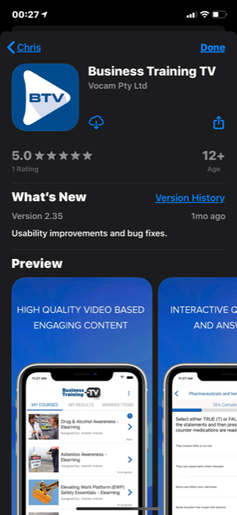
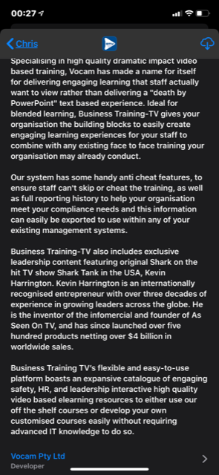
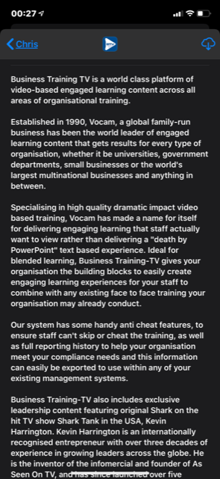

The use of these training applications has eliminated companies needing to employ qualified trainers and the cost of training materials and equipment. Employers can also set deadlines in which the employees have to meet with completing these courses, they can also track their employees progress to see who has logged in recently or see who has not made an attempt of it.
Another development in technology that workplaces have started to use has been in the way that we store data and files. Before it was either hard copies, stored onto the hard drive of the computer or site system where it was created. Now these can be saved to private and secure online data storage clouds where all aspects of our work assignments, spreadsheets or whatever the file maybe can be uploaded and stored to these online storage clouds allowing access to any one in the workplace that has been granted access to the information on these data storage clouds.
With access the employee can view change or upload their own files to these storage clouds from anywhere where they have an Internet connection this can also be done on their own personal device and with the improvements with mobile data (internet) being faster and cheaper from mobile phone provider networks this can be completed and download while you’re on the move quite literally from anywhere in the world.
The advantages of this to the are exceptionally beneficial to both the employer and the employee. The benefits that the employer gain is that with personal devices and laptop work or presentations can be easily taken anywhere set up used remotely from the work place also data files can be saved, sent, stored and accessed anywhere with just a login or a click of a button from cloud storage. Having the ability to do this eliminates hard copies which takes up space or mountains of paperwork to search through these can now all be accessed quickly and easily. Also having the advantages of staff working from home or on the go outside of office hours deadlines can be more manageable for them.
Furthermore, there also can be disadvantages to companies and employers with these technological advancements that have been stated are that files can become corrupt or carry virus from employees’ personal computers and devices that may not have up to date anti-virus software. Original master copies or template files might be altered or deleted on the cloud storage applications other disadvantages can be with the employees working out of the office from home or from remote locations need to be considered are is any of the companies sensitive information or clients personal data isn’t at risk of poor security work ethics by the employee. Another aspect to view is that is work performance going to be as productive as if they were working office based? Are they going to use that time to complete the tasks or are they going to do more personal things with their time instead of work?
For some employees the availability of working from home, because of these technological advancements, can really help someone that would not be able to work in an office environment whether it be due to child care issues, illness or mental health. Being able to have everything that you would find on an office computer available on your own personal devices from the comforts of home can allow them to take conference or video calls or meet deadlines at their own pace without being at the work place. No more working late nights, this means they could see and spend time with their family. This could increase productivity as employees feel independent, in charge of their work and not feel pressured.
The disadvantages could be that the employee may shut themselves away due to constantly working all the time, either on their laptops or their devices. They may not be giving themselves time to relax or spend time with family or friends on days that they would normally have off in an office-based environment. For example, weekends. They may have fallen behind in the week and this means they need to do more on weekends in order to mee set deadlines.
The manufacturing industry workplaces have also seen a massive development since the start of the 21st Century with the advancements in machinery and robotics vehicles. They now can be completely assembled by programable robotic machinery. Things that can be objects can be forged made by 3D printers, steel and other materials can be cut to precise measurements with laser cutting machinery. This automated machinery will take away the need for companies to need a larger workforce as some of these robotic machineries are fully automated not needing a human operator at all, meaning that normal jobs could be at risk as companies adopt more automation systems and machinery the amount of jobs available will be less than in the past and could cause existing staff to lose their jobs. In the long run this will play out to be cheaper for companies to do this.
Below I have inserted a bar graph which I found on the “National Statistics” website. This graph is showing the variety of careers that will be at risk of a loss of job from automation in the upcoming years. As you will be able to see, there will be a considerable rise in loss of non-academic jobs, meaning jobs that will be available will need you to have a good educational background or professional qualification for. Jobs that are simply day to day jobs, not a career are at a higher risk as they can easily be replaced.
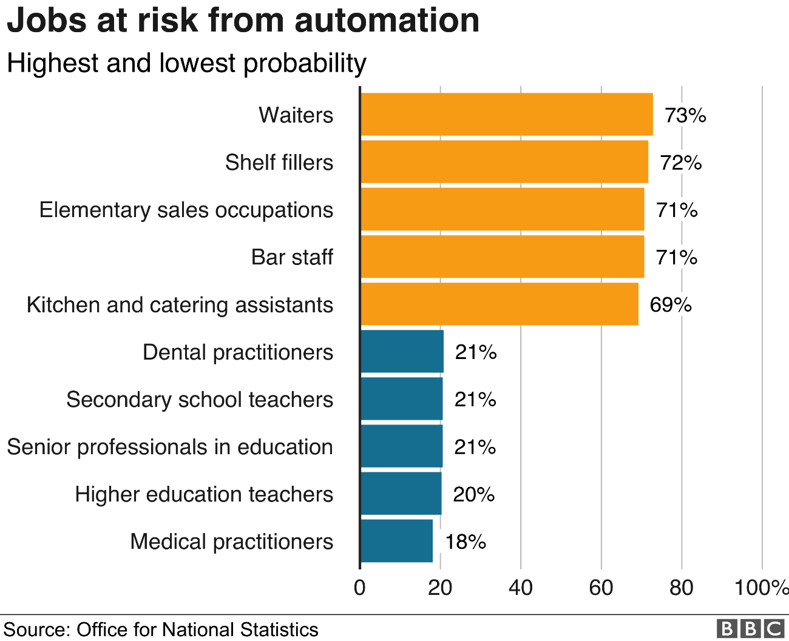
Although technology in the workplace is rising there are still disadvantages as well as advantages to it. For example, it can improve communication. This means employees can use various communication tools to help them interact and exchange information at work or as spoken of above, from home. An example of this would be using video conferencing tools, for example, skype, this can be used to share and exchange work related things. Another way it can improve communication is through the customer service department if there were one.
Technology in the workplace can change and adapt the way human resource managers complete their job. It can improve the process of screening, recruiting and hiring new employees. It can then be used to track performance and productivity of each employee, once employees are known to be monitored their work ethic increases dramatically.
Now moving onto the disadvantages of the rise in technology. There are high maintenance costs when it comes to technology, all the way from purchasing it right down to any technical problems that need fixing. Many small companies may struggle with these rising costs and definitely are not able to hire a full-time technician. There is also a risk of employees becoming lazy and will lower their creativity and skills towards their work. Finally, data protection, although this can be seen as an advantage as it hold a lot of information and has security it still holds the risk of breach of data. Any employee who holds any important decision-making role need to have access to private business information, this for obvious reasons can have its issues. It may be hard for employers to monitor the usage and privacy of the information. Also, some employees may hold a flash drive at work which they can easily transfer information over to use for their own personal gains.
A lot of companies and workplaces use social media applications as well as company Webpages pages to advertise, publish their work, ongoing work or contracts to a wider global audience. Some companies also use the social media sites for their recruitment process or to advertise these positions. So as you can see the advances in technology, software and applications in the 21st-Century has and is rapidly changing the way companies and ourselves work and the way things that once could only be done from an fixed office computer can now be completed on our mobile smart phone or other devices while sat on the train before we even get to work.

An in-depth look at technologies used in own workplace

Looking in-depth at technology and social media that is used in my own workplace and the company I work for and the way it has changed or advanced in the 21st century, the biggest changes are that with the use of online storage clouds, social media and communication applications that the company now uses also the technology devices we use and that of some of the venues and clients we hold our training course have changed as well.

Firstly, looking at the equipment we use in delivering training courses we have always used laptops, computers and projectors which hasn’t changed that much but the one major change is the sizing of them. In the past they were big bulky and heavy equipment, now with the advances in technology all our equipment can fit in one bag the laptops are just bigger than the size of a DVD case and some of the projectors you can hold in one hand. Also, the use of tablets for students to do there tests online and get instant result where in the past it was paper exams witch then where sent off and the student wouldn’t get the results till twelve working days.

Some of the venues and clients have advanced in their technology on sites, some having massive seventy-inch smart touch screen televisions which means we no longer need to use our tablets or laptops with our presentations or power points we only need to have a thumb drive storage device with them saved to plug in to these smart screen televisions.

The company utilises an application called Dropbox which is an online storage cloud that all their trainers have access to on there. On this app they upload and update all the training power points and resource material we need for any training that we are presenting. They have also adopted the use of a communication application call Whats-App, this is used as one of the main ways of communicating, using it to send our rosters, venue locations and just general conversation.

Part 2

An exploration of the use of social media in the workplace generally
A lot of companies and workplaces use social media application like Facebook or Instagram for example, for the use of advertising as it allows them to reach out to a wider audience of potential customers so using of social media can enable companies to achieve more of a global exposure with the possibility being seen by millions that they may not normally reach through conventional ways of advertising.
The benefits for businesses advertising in this way is that is cost effective and on some of these social media platforms basic advertising is free so for the smaller business or companies just starting out this can be a great financial benefit. It can really help get the name of your company out there and friends can share it which will help get a wider audience worldwide.
Social media can also be used by companies for market research because these platforms are an efficient way of connecting with people. They can conduct polls or surveys and can ask people to write reviews about the services or products. This is a good way of finding out what is good and what may possibly need adapting or changing. They can also utilise these platforms for seeing what their competitors and other business in the area are doing, that can be beneficial in planning and their own strategies, such as what services or products are doing well and help with ideas for moving forward.
There are some good advantages to companies using social media platforms, some I have already mentioned, for example, being able to be seen by a wider audience of potential customers, advertising can be inexpensive or even free on some of these sites. Finally, the benefits that can be gained by market research that can be conducted on them.
There can also be some disadvantages if their profiles aren’t constantly update and used regularly people aren’t going to know about the services and products they can provide, so maintaining and keeping these pages active can be a very time-consuming process even more if they are on multiple social media platforms. Although they can be time consuming you will find the results be outstanding as technology is taking over and social media is something that everyone uses on their day to day, you may find someone come across your page without even looking.

An in-depth look at the use of social media in own workplace

The company has a large social media footprint utilising sites like Facebook and Instagram which are updated daily by them posting photographs of courses that have been completed, advertising future courses and job opportunities within the industry. They do utilise these formats of social media very well with the advantage of having a vast number of members and companies following them and sharing their post. by these members doing this it is promoting their company and services they provide to a larger audience on theses social media platforms that they wouldn’t normally reach.

The disadvantages the company has is that the audience that they reach on these sites is still limited on these social media site. This is because they put so much time into these, they have allowed other online presents laps their company website hasn’t been updated for a while and is in a bit of disrepair and needs modernising and reformatting so it is help full to the user. I believe updating their website regularly and modernising it would help boost their customers because if the company is googled for training in South Wales, they are one of the first companies visible on that search results. Over the past few courses I have run for them I completed a survey on 50 trainees I had for the company on how they found out about the company and the services we provide.
Below I have inserted a pie chart which I created myself using information that I collected on my recent course, as you can see Goggle search is shown to be the highest.

The results out of 50 trainees the way they found out about the company are.
Google search: 27 people
Facebook: 15 people
Instagram: 3 people
Other: 5 people
Only 18 trainees found out about the company from social media the majority found the company through Google search engine and the remainder found out from word of mouth. Social Media platforms can be a good tool for companies to utilise for free advertising and to spread their brand name and services they provide to a wider audience than they might have reached normally through conventual ways of advertising.

The use of social media to enhance networking and career prospects
The use of some social media platforms is being widely used now by people trying to enhance the ways of networking with other working professionals and companies in the same areas of expertise and lines of work. This is done to stay up to date with any advances or changes within their areas of expertise and line of work, also they do it to enhance their career prospects to better their careers with other companies headhunting and posting current and potential future vacancies in their company. Other than normal social media platforms like Facebook and Instagram there are also social media platforms specifically designed for this purpose as professional networks, for example, LinkedIn and Data.com Connect. These offer a centralised service for everything career-related as a free online space. This app provides you with the ability to upload your curriculum vitae and experience, qualifications, interests and gives you the ability showcase samples of your work on there for everyone to see.
These sites will find companies and our professional in the same area of expertise to connect you with, as I have mentioned above this will help you stay up to date with any changes or new developments in your area of work. It can also enhance your chances of career opportunities and progression. As you can imagine this is a great opportunity to find new jobs and to really express who you are through your work before they have met you. This may increase your chances with new companies in hiring you.
Although with all social media sites it requires you to maintain them and to keep your page up-to-date otherwise it will look inactive and the people and companies may not consider you when they have opening or a future opportunity within their company. Meaning, when searched, people like to see what other people think of it. They want to see reviews, up to date information and maybe even some photographs. Photographs catch people instantly. If your social media looks run down and not “attractive” to the eye, it will not catch the attention of possible clients.

LinkedIn Profile
Upon reviewing my own linked in profile, on there I have a professional looking photograph but I found some things I need to address and change. For example, I may need to edit the “about” section. I feel I need to go into more depth about what I have done recently, new jobs, different course I have run and the qualities I have to offer. I also need to talk about the educational side of things, the qualifications I have and the course I am currently doing to get more qualifications. I think it may be a good idea to possibly go into detail about my education history as-well. Another possible improvement I feel I could make would be getting more recommendation comments from my contacts, different people I have taught on different courses and people from past work experiences. I feel this will give my readers a more in-depth idea of who I am, what I have to offer and the experiences I have completed. If I have more recommendations from people who have worked closely with me or who I have taught on a course it will show potential clients that I am reliable and experienced. If possible, I would like the idea of uploading pictures that have been taken of me working. I feel this will show possible clients what to expect, how I work, my presentations for example.
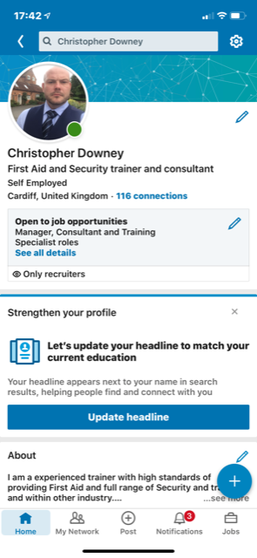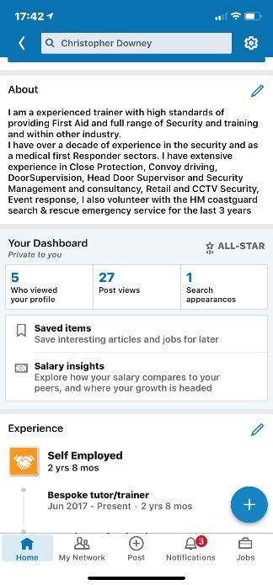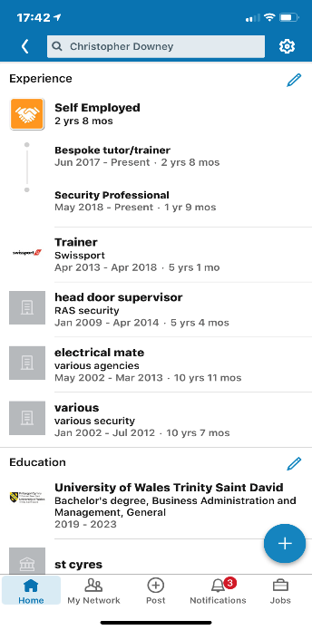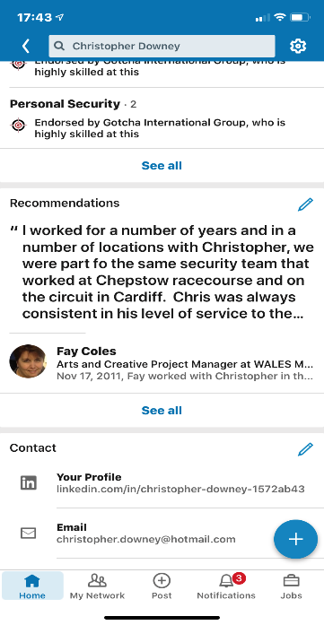

Conclusion
Overall upon completing this report I have come to the conclusion that technology in the work place is very much on the rise. I can see how it affects our daily working lives. All the way from being able to complete items of work anywhere in the world from our phones or tablets. This does come with issues as when employees take work home, they may be missing our on-home life. Spending time with family and friends. It is clear to see that advancements in technology will continue to grow over the next few years and more and more jobs will be at more risk. As spoken about above, a lot of the non-academic jobs are at a higher risk rather than jobs which require experience and qualifications. Saying this, I do believe in a matter of years this could change, and them jobs too could be at risk from advancements in technology. I also believe working within manufacturing industries are at a high risk of less jobs due to more and more growth in technology, it is possible that having hundred of employees is more expensive than just purchasing a type of technology and hiring 1 full time technician to deal with any possible issues.

References

https://www.ons.gov.uk/employmentandlabourmarket/peopleinwork/employmentandemployeetypes/articles/whichoccupationsareathighestriskofbeingautomated/2019-03-25

