Clarks company
The UK Footwear Market
Critical analysis and evaluation
MKF Assessment 2
Miroslava Andreeva Georgieva - 2112588@student.uwtsd.ac.uk
1/12/2022

The report will provide a critical analysis and evaluation of the footwear market due to the impact of COVID-19.

Table of content
- Executive Summary………………..3
- Introduction……………………………4
- Analysis…………………………………..5
- Internal analysis
- External analysis
- Porter’s 5 forces analysis
- SWAT
- Conclusion………………………………..7
- References……………………………………….8

Executive Summary
The world has faced a pandemic for two years now-humanity and businesses have been looking for a solution.
The pandemic wave has enormous influence on any aspect of the business- from travel restrictions and obligated to communicate behind the windows through temporary closures and a shift to online shopping. The firm has changed its direction and shifted digital-online. For some industries, the decision has been crucial, but for others was a meaningful change. The digital investment has opened lots of opportunities and moved the representative office at people’s homesnomic downturn due to coronavirus restrictions that have concentrated among certain types of businesses. One of many is footwear retail.
The report aims to analyse the impact of COVID-19 on the footwear industry, the Clarks Company. During some sectors shrunk up to 90% in April and May 2020-21, others reported significant growth. In 2019, 37% of the buyers still preferred visiting stores for inspiration and socialising rather than online. That had changed by 2020 when the pandemic swished the in-store shopping into the online. After the initial hit, all retail companies began to work hard on three distinct aspects:
-trying to be more efficient
-reducing prices
-finding a way to collaborate with other retailers
The business has changed its direction and shifted digital-online. For some industries, the decision has been crucial, but for others was notable change. The digital investment has opened lots of opportunities and moved the usual office at people’s homes. They referred to digital showrooms or B2B platforms to deal with their shoppers. Many people are now focused on the B2C platforms and working with Zalando and Amazon to keep their sales. The question is: Is this enough to save the industry and particular brand?
Meanwhile, using several key marketing models to emphasise the various aspects of the footwear industry. Moreover, it will update and present a new vision of the business. The tools of the Marketing mix have strategically aimed at penetrating the target marketing groups. A critical role for doing business is building the relationship between customers or buyers and the goods. Trade shows are important and link the shopper with the brand.
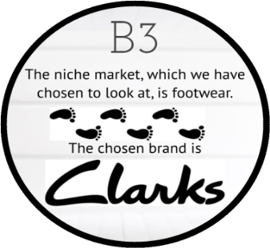
Introduction
C&J Clark, famously known as Clarks, is one of the leading footwear trading companies in the United Kingdom. The company was founded by Cyrus and James Clark in 1825 and remained in the village of Street, Summerset. The company has 1,400 branded stores and franchises worldwide and sells throughout third party distributors. (https://en.wikipedia.org/wiki/C._%26_J._Clark)
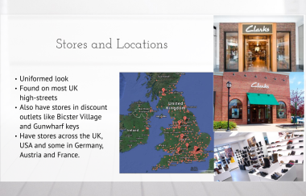
In 200-years, Clarks has been the UK’s largest privately-owned business and a world leader of shoe-care products for children and a 35-34y group of people. They are not at the highest price. Also, the company’s heart is to represent high-quality value for money. The company was 35th largest private institution in the United Kingdom with 81% shares owned by the Clarks family, and the remained 19% is with related institutions. In 2020 the outbreak of COVID-19 had a major influence on the footwear sector. Because of the government regulations, most retail shops were mandatory closed. Since the first lockdown, the in-store experience has changed online, and many leading retailers have announced store closures. Unfortunately, the problems of Clarks' firm began long before the crisis. The pandemic situation just moved a step ahead into the company's financial instability.
Turnover fell by over £600 million from £137 billion in 2019/20 to £755 million in 2020/21.Underlying operating profits also fell from £46.2 million in 2019/2020 to a loss of £70.9 million in 2020/2021. The annual report said: "The impact of COVID-19 in the year was immediate given that reduced demand coincided with the commencement of our SS season and the new inventory resulted in a significant working capital impact which continues in 2021." (Sophie Smith, 21October, 2021, https://www.theindustry.fashion/clarks-annual-report-reveals-company-losses-due-to-covid-19/)
The Company focused on critical business spending, saved up to 70% of capital expenditures, and extended payments with suppliers. Clarks also benefited from the Government's suspensions for 12 months, utilised the furlough scheme and saved £21 million. The firm's priority was to secure the business's long-term future if it safe guided all the employees, suppliers, and customers. In November 2020, the company was rescued by the Hong Kong-based private company Lion Rock Capital.
Analysis
In the United Kingdom, the footwear market is affected by imports, like the garment industry. Overseas production has become the norm for all companies on the island.
An ‘internal factor’ of the company is the micro-environment that affects companies’ ability to serve their customers. These factors are the companies departments such as finance, marketing, research and development, accounting and purchasing operations. Others include the suppliers, competitors and public markets On the other hand, the company's macro environment is the 'outside factors' including- economy, demographics, technology, natural forces, and politics.
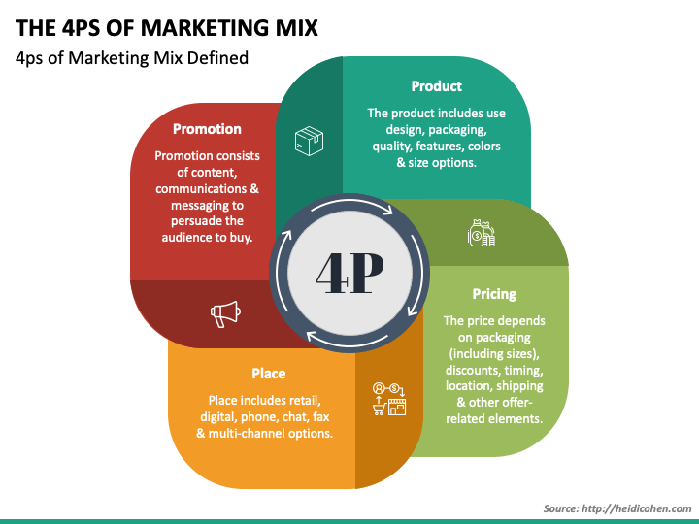
According to the marketing principles, a compelling blend of the marketing mix will provide elements that will enhance the company's marketing objectives by engaging consumers and delivering value to them. (Principles of Marketing, 17th edition, Kotler&Armstrosng,pp 52-54)
The 4P subtractions of the marketing mix over the Clarks’ company will uncover the strategy and tools that work better.
- Product- Clarks ‘is recognized as making comfortable shoes, not fashionable. A wide range of infant/yang children, sports, the casual and smart collections have been offered to the customer audience. During the pandemic, most of the people struggled with online orders just because in-store, they could measure their feet. Also, not always could find the right color or size options. People easily adapted and continue buying online.
- Pricing- the Company has some technics for pricing it products. By using premium prices, Clarks’ has a significant growth. Usually, Clarks gains sales by psychological pricing when offering up to 60% off. That is good bargaining for customers and a strategy to convince them to come back again.
- Place- By 2019, Clarks has 521 stores in the United Kingdom. It was linking a great website and email subscription option to receive offers. But this is the glamorous side of the company. Behind the scene, there was a financial imbalance five years before the pandemic wave that put the company in crisis.
- Promotion- Clarks could consider lowering the price to increase the market share by competing effectively against the large supermarkets such as Asda, Sainsbury’s or M&S. As any brand, the company is trying to persuade and make an impulse into the buyer. Usually the big sales announcements are the key and a huge bargain deal for its customers.
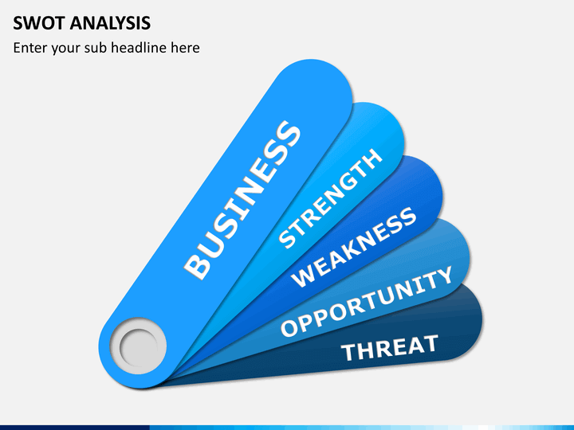
Clarks Shoemaker's strengths are to create a niche position and to expand the market. Also, as a manufacturer, the company is focused on comfort shoes and regarding the world trends adding innovative models- stamped Clarks. Using high quality of products the shoemaker easily launching new goods directed to middle class customers at affordable price. Moreover, the manufactures has a strong connection with its suppliers and the supply chain partners.
The company weakness is facing the lack of capability and skills to build a sustainable competitive advantage-struggling to restructure machine learning processes and focusing on light development. Due to reduce the front staff all the retail shops are struggling with customer’s dissatisfaction. The shoemaker should change direction and focus more on areas with customer purchases and post-purchase improvement. Another weakness of the company is the lack of investment after falling red after years of refinance debt. Now the boot is on another foot with the Chinese leadership. LinRock will have to flip the trouble brand, where sales fallen rapidly since 2014th. One of the reasons for the situation is that he shoemaker has been kicked aside thanks to discounts and upcoming rivals.
Opportunities could show-up from changing the consumer preferences through technological innovations. To grow its market share, Clarks could collaborate with other shoemaker-it is Wunderkind. This may be a reference to the strength as a niche to the market.
The brand’s partnership is driven towards extending innovative ecommerce operations. This is the way how to build the relationship with the brand in long term and to increase the customer’s value.
Clarks Threats are the macro environmental factors. Reducing cost and increasing efficiency is a treat of the new entrance. Clarks is aimed at lowering the prices to reach more customers. The competitors can do the same- locally and internationally. Also, the company must deal with new government regulations about higher environmental taxes. As a result, the shoemaker will face higher logistic and packaging costs.

Clarks provides an excellent quality of shoes at an affordable price. The power of the buyers is one of the five forces that drive the price down and limit the potential of earning sustainable profit.
Competitive rivalry faces the shoemaker from the worldwide. The intense competition will result slow earning profit.
The new entrant with significant ambitious must spend lots of money to compete in the market.
Changing the customers tastes of stile make a huge influence on the market.
Threat of new entrants - if there is strong threat of new entrants then current players will be willing to earn fewer profits to reduce the threats.
The goal of the company is to seek a premium price because of the differentiation and uniqueness of the offering. Industry analysis using Porter Five Forces can help Clarks to avoid spaces that are already overpopulated by the competitors.

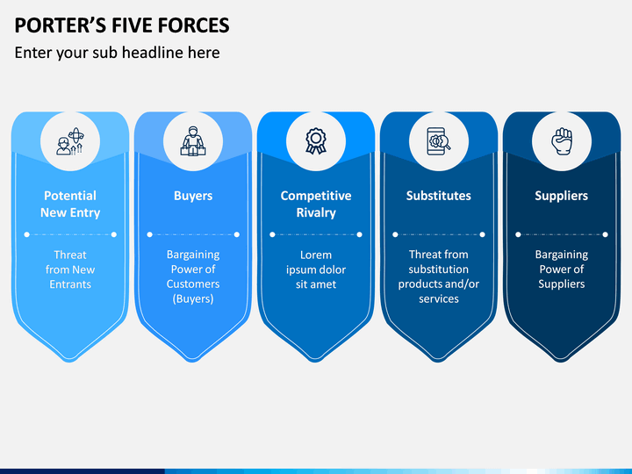
Conclusion
Overall, the shoe market is therefore, severely affected by the pandemic is still better suited in-store retailing. One of the biggest threats to the market has been the online shopping expansion, threatening retailers with large store portfolios, as well as the decline in consumer confidence. The market is heavily reliant on branded footwear, and if people start to trade down and move away from these, the category could suffer.( https://store.mintel.com/report/uk-footwear-retailing-market-report)

References:
BBC News (https://www.bbc.co.uk/news/uk-england-somerset-40479472)
British footwear organisation ( https://britishfootwearassociation.co.uk/about-us/)
Clarks (https://www.clarks.co.uk/)
Educheer (https://educheer.com/business-plans/market-analysis-c-j-clarks-ltd/)
Gloucesteshire (www.gloucestershirelive.co.uk/whats-on/family-kids/clarks-announces-plans-release-gender-484357)
Ibsworld (https://www.ibisworld.com/united-kingdom/market-research-reports/online-footwear-retailers-industry)/
The industry (https://www.theindustry.fashion/clarks-annual-report-reveals-company-losses-due-to-covid-19/)
Principles of marketing ((Principles of Marketing, 17th edition, Kotler&Armstrosng, pp 52-54)
https://premierconstructionnews.com/2021/07/29/clarks-steps-up-digital-revenues-with-1-2-1-marketing-from-wunderkind/
Retail-week (https://www.retail-week.com)
Retail-in side (https://www.retail-insight-network.com/)
Wikipedia (https://en.wikipedia.org/wiki/C._%26_J._Clark)

References

