Assignment title: Parkinson's Disease: Long-Term Condition Management and Person-Centred Care
Student name(s): [Insert name(s)]
Student number(s): [Insert student number(s)]
Module code and title: [Insert module code and title]
Lecturer's name: [Insert lecturer's name]
Submission date: [Insert date]

- CONTENTS
Introduction 1
2. Definition, prevalence, aetiology and risk factors 2
2.1 Definition and disease process 2
2.2 Global and UK prevalence 2
2.3 Aetiology and risk factors 3
3. Physical, psychological and social impacts 4
3.1 Physical impact 4
3.2 Psychological impact 4
3.3 Social impact and family caregiving 5
3.4 Critical evaluation 5
4. Evidence-based treatments available through the NHS 6
4.1 Medication 6
4.2 Rehabilitation and multidisciplinary support 6
4.3 Advanced treatment 7
5. Models and frameworks for long-term condition management 8
5.1 UK model: House of Care 8
5.2 International model: Chronic Care Model 8
5.3 Comparison 8
6. Political, health and social care agendas 9
6.1 NICE guidance and evidence-based practice 9
6.2 NHS priorities and integrated care 9
6.3 Social care, personalisation and inequalities 10
6.4 Critical analysis and opportunities for change 10
7. Person-centred care and self-management recommendations 11
8. Palliative care and end-of-life planning 12
9. Conclusion 13
Additional statistical data and graph 13
10. Reference list 14

- Introduction
Parkinson's disease is a progressive disease of the nervous system that affects movement and also affects mental health, sleep, communication, independence and relationships. As symptoms change over time, people may need help from general practitioners, neurologists, Parkinson''s nurses, physiotherapists, social workers and family carers. Management therefore requires more than medication; it must address the person as a whole, their priorities, their living conditions and their social relationships.
This booklet evaluates the status of Parkinson’s Disease as a long-term condition. It examines the worldwide and UK prevalence, the causes and risk factors, the physical and psychosocial consequences, evidence-based NHS treatments, models of long-lasting care, policies of the relevant health and social services and recommendations for improved person-centred care. The central message is that good outcomes depend on early diagnosis, treatment and referral, on multidisciplinary services, on active involvement of the patient and their family and on equitable access to care and support.
- Definition, prevalence, aetiology and risk factors
2.1 Definition and disease process
Parkinson's disease is a neurodegenerative disease associated with the loss of dopamine-producing nerve cells in the brain, especially in the substantia nigra, which is involved in the control of movements. Reduced dopamine levels lead to a decrease in movement speed, rigidity and resting tremors, postural instability and balance difficulties can also develop, symptoms differ between individuals and between the stages of the disease (Kalia and Lang, 2015; Bloem, Okun and Klein, 2020).
Non-motor symptoms of Parkinson’s disease may include constipation, loss of smell, sleep disorders, pain, anxiety, depression, neuropsychiatric changes, autonomic disturbances, and dizziness upon standing (Chaudhuri, Healy, and Schapira, 2006; Schapiri, Chaudhri and Jenner, 2017).
There is currently no cure that can stop or reverse the underlying progression of the disease. However, medication, rehabilitation, psychological support and certain surgical or device-related treatments can reduce symptoms and improve functioning. Diagnosis is mainly clinical, based on the assessment of symptoms and signs by a specialist. Other diseases can have similar symptoms and a differential diagnosis is sometimes necessary.
2.2 Global and UK prevalence
The World Health Organization (WHO, 2023a) reports that the global prevalence of the disease has doubled in the last 25 years and in the year 2019 estimates of over eight million people worldwide were living with the disease. The WHO also reported a significant increase in disability-adjusted life years and deaths from disease since the year 2000, which reflect a growing public health concern. Although the estimates can vary because of different diagnostic capabilities, population age structures, and the availability of reliable data, this shows a new and growing burden of the world.

Figure 1. Global and UK prevalence estimates. Sources: WHO (2023) and Parkinson’s UK (2025).
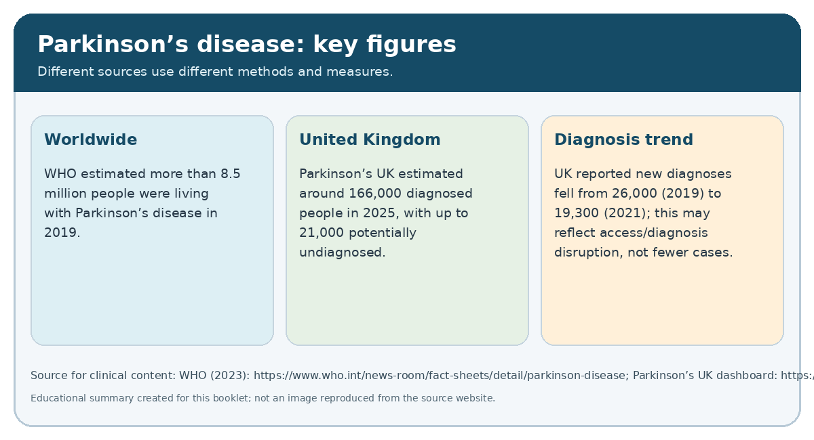
In the United Kingdom, for example, in 2025, Parkinson UK reported that there were approximately 166,000 recorded cases and that 21,000 people were believed to be living with the disease without a record. However, it also reported a decline in the number of recorded cases between 2019 and 2021, which had not returned to previous levels (Poinier, 2025a). These figures are important for service planning, but they should be interpreted with caution: recorded cases are not necessarily the same as the true number of people affected, because delayed presentation, delayed diagnosis, unequal access to specialists can influence the figures.
Figure 2. UK prevalence and diagnosis trends. Source: Parkinson’s UK prevalence and incidence dashboard.
An ageing population adds to the burden, as the prevalence of this condition increases with age, although it may also affect younger people. This burden is not distributed equally: those who are in poverty, isolated in the countryside, confronted with a language barrier or with confined access to specialist care may have additional difficulties in accessing a diagnosis and treatment. As a consequence, prevalence data should be used not only to inform workforce planning but also to ensure equitable access to services.
2.3 Etiology and risk factors
PD usually develops as a result of a complex interaction between genetic, biological and environmental factors. Almost all cases are idiopathic, i.e. without identified cause, whereas age is the strongest established risk factor, but PD should not be considered an inevitable part of aging. Certain inherited gene variants increase the risk, and family history is relevant especially in the early form of the disease (Kalia and Lang, 2015; Bloem, Okun and Klein, 2021)
Environmental exposures, for example certain pesticides and occupational chemicals, are also investigated as possible risk factors. However, the fact that associations are made does not necessarily indicate that a particular exposure caused an individual's disease; differences in study design, exposure measurement and genetic susceptibility complicate the interpretation. It is therefore inappropriate to imply that individuals are personally responsible for developing the disease.
The causes of parkinsonism remain insufficiently understood. More research is needed to clarify how the factors of hereditary predisposition, the environment, ageing and cell functions combine. Until then, services should prioritise early recognition, symptom management and support rather than promising preventive strategies that have not been demonstrated to prevent the disease.
- Physical, psychological and social impacts
3.1 Physical impact
In addition, motor symptoms may have an effect on walking, turning, balance, handwriting, dressing, eating and other activities of daily life. Bradykinesia and rigidity may make tasks more tiring and time-consuming, while tremors may interfere with fine motor movements; freezing of gait, decreased balance and stability can increase the risk of falls and injuries; difficulties with swallowing can lead to choking, aspiration and malnutrition; changes in speech can lead difficulties in communication.
Non-motor symptoms also contribute considerably to disability. Constipation, urine problems, pain, sleep problems, low blood pressure and tremors can affect the individual's independence, even when the movement symptoms are relatively well controlled. Also, mental deterioration can affect planning, attention and decisions, and as the disease progresses, some people develop a dementia called Parkinsonism (Aarsland et al., 2017).
These effects indicate why evaluation based only on the visible tremor is inadequate. A person with mild trembling may experience great fatigue, anxiety and sleep disturbances, whereas another with more pronounced movement symptoms may be socially active with the appropriate support. Regular evaluations should therefore be based on the overall functioning of the person, not just on the motor symptoms.
3.2 Psychological impact
Living with a progressive condition may create uncertainty about future mobility, work, relationships and independence. Anxiety and depression can be symptoms of the condition itself or understandable responses to its consequences. Changes in facial expression, speech or movement may also cause others to misunderstand the individual’s emotional state or abilities.
These changes can affect confidence and decision-making. Hallucinations and problems with impulse control may be related to the disease itself or to treatment. NICE recommends that people with Parkinson's and their relatives should be informed of any medication-related risks, such as impulse control disorders, sleepiness and psychotic symptoms. These effects must be assessed sensitively as they can cause distress and can have an effect on family relationships and security.
Figure 3. Motor, physical and psychological symptoms. Content based on NHS (n.d.).
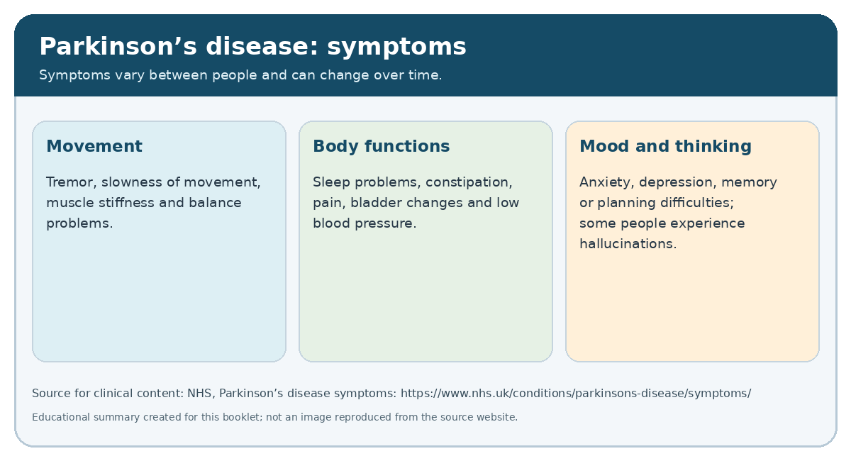
But psychological distress should not be assumed in every person with Parkinson's disease; they may develop effective coping strategies, preserve significant roles and report a good quality of life. Caregivers must question their individual needs rather than label them according to the diagnosis. Psychological therapies, peer support, accessible information and appropriate treatment of depression or anxiety can help maintain their well-being.
3.3 Social impact and family caregiving
Parkinson's can limit the ability to work, to travel, and to be active in the community. Difficulty with movement, fatigue, communication, and toilet needs can lead people to avoid certain situations. The work itself may become difficult where speed, concentration and physical co-ordination are required. Reduced income and extra expenses for transport, care, and caregiving can create financial pressure.
Family and friends often provide practical and emotional support, assisting with medication, attendance at medical appointments, personal care and domestic tasks. Such support may strengthen relationships, but it can also cause fatigue, stress, reduced work opportunities and loss of personal time. A systematic review by Perepezko et al. has identified associations between burden and poorer health status of the carer and the patient with Parkinson’s disease. Given the heterogeneity of the reviewed studies, such associations do not prove that burden is the cause of reduced health status, but they emphasize the need for assessment of both parties in the caring relationship.
Carers should not be treated as an infinite resource. The Care Act 2014 in England provides a framework for assessing eligible adult social care needs and carers' needs. Local authority support, respite services, carer's assessment and benefits advice can help, although the scope and eligibility vary. People living alone or without a reliable support network may be particularly vulnerable to missed appointments, difficulties with medication and social isolation.
3.4 Critical evaluation
A major problem is the interaction between physical, psychological and social effects. A fall may make you lose confidence, and you may avoid walking and company. Reduced activity may lead to inactivity and even further loss of confidence; in the same way, the exhaustion of the carer may affect the sustainability of home care. This explains the support for a biopsychosocial approach rather than a narrow emphasis on drugs. If a person has to independently navigate several referrals, the theoretical promise of integrated care may not be fulfilled. Therefore, it is important that the service also measures what is important for the person, such as self-management, participation, mood, carer well-being and quality of life, as well as clinical symptoms.
- Evidence-based treatments available through the NHS
4.1 Medication
Levodopa, usually in combination with carbidopa or benserazide, is the most effective treatment for motor symptoms. NICE recommends the use of levodöpa when the motor symptoms in the early stages affect the patient's quality of life. In the less severely affected, levodopa, dopamine agonists or MAO inhibitors can be used, depending on clinical and personal circumstances.
Figure 4. Treatment options and rehabilitation. Content based on NICE (2017).
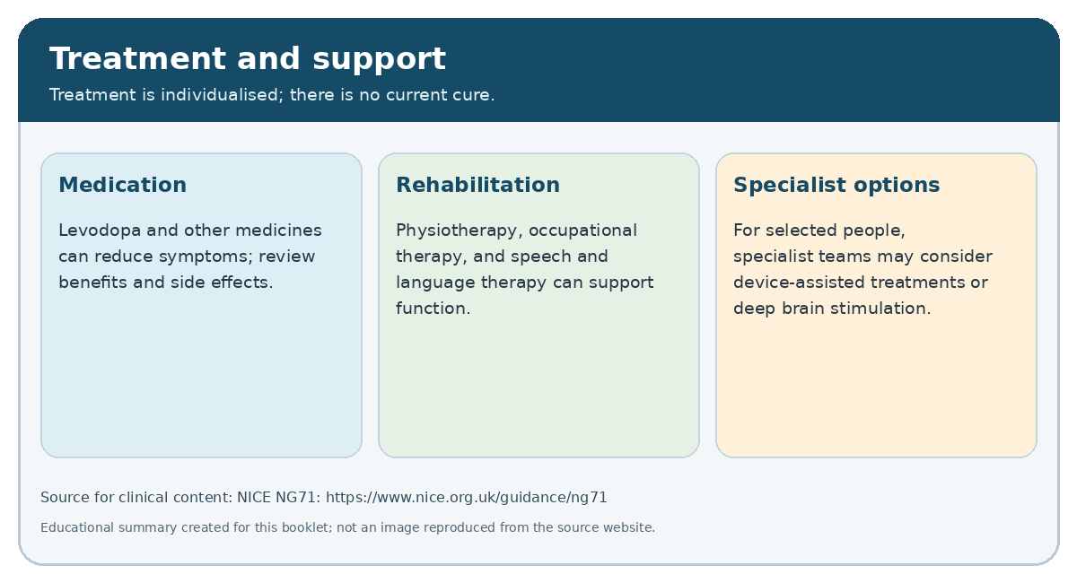
Levodopa improves movement and everyday life, but long-term use is associated with wearing-off periods and involuntary movements known as dyskinesia. Dopamine agonists can cause side effects such as sleepiness, hallucinations, and loss of inhibition. Consequently, it is important to review the therapy and benefits and risks of treatment individually, and for the patient to consider the side effects that may compromise safety and quality of life.
Especially important is the timing of the medicine. NICE advises that the medicines for parkinsonism should be given at the right times during a hospital or nursing home stay, and that changes in therapy should be discussed with a specialist. Late or omitted doses can impair mobility and functioning, so medication reconciliation, clear documentation and staff training are necessary safety measures (NICE, 2017).
4.2 Rehabilitation and multidisciplinary support
Physiotherapy can deal with gait, balance, posture, mobility and fall risk. Occupational therapists can evaluate everyday activities and suggest practical adaptations, equipment or alternative ways of performing tasks. Speech therapist can support communication, voice projection and swallowing safety. Dieticians may advise on nutrition, weight loss, timing of food and medication. NICE recommends physiotherapy for those experiencing difficulties in balance or motor functioning, occupational therapy for people with difficulties in the performance of their daily activities, and speech therapy for those with difficulties communicating or swallowing.
Figure 5. Multidisciplinary, person-centred care. Content based on NICE (2017) and NHS England (2019).
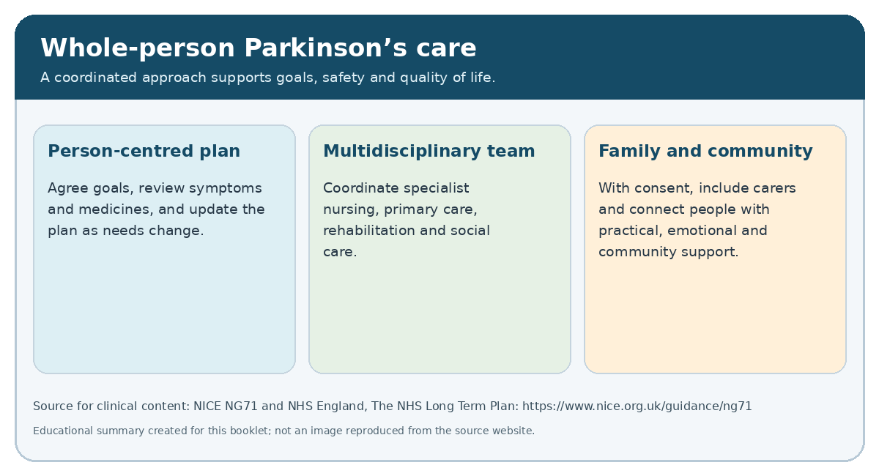
Exercise can improve physical fitness, balance and functional outcomes, but the effect varies with the intervention, the stage of the disease and the outcome measured. Systematic reviews support the potential benefits of exercise and physiotherapy, but evidence from individual trials may be limited by small samples and differences between programmes (Goodwin et al., 2008; Tomlinson etal., 2012). Exercise should be adapted to individual abilities, fall risk, preferences and access to resources rather than prescribed as one-fits-all.
A nurse specialized in Parkinson's disease can provide continuous contact, education, clinical supervision and coordination. Psychological support, community services, mutual support groups and carer support may help to address the needs that medication cannot resolve. The strength of multidisciplinary care is that it addresses several dimensions of the disease; its weakness is that services may be fragmented or lacking in some areas.
4.3 Advanced treatment
For some people with advanced and poorly controlled symptoms, a specialist may consider other therapies such as continuous apomorphine infusion, other device-assisted medication or deep brain stimulation. Deep brain stimulation is not suitable for everyone, it requires a careful assessment of the symptoms, the ability to understand, the health status and the personal goals of the person concerned. Deep Brain stimulation is recommended by NICE only for selected people whose symptoms are poorly controlled with best medical treatment (NICE, 2017).
These treatments can improve certain symptoms, but do not cure the disease or necessarily alleviate all the problems with the other non-motor symptoms. This means that the decision to have the treatment should be based on realistic expectations and shared discussion of the benefits, risks, practical demands and follow-up needs.

- Models and frameworks for long-term condition management
5.1 UK model: House of Care
The House of Care is a British approach to personalised care planning for people with long-term conditions. It stresses an informed and engaged patient, a health professional who works in partnership, an organisational process that supports care planning, and local commissioning processes that allow services to operate efficiently (NHS England, n.d.).
For people with Parkinson's disease, care planning should explore their priorities, such as remaining in employment, maintaining their mobility, living independently, reducing their falls. The person and the carer can agree on their goals, review their medicines, support needs and plan for likely changes. Family carer, with the person's agreement, may be involved.
The model’s strength is that it favours mutual consultation, rather than professional predetermination of goals. Personalised conversations need organisational support. A care planning appointment cannot compensate for a lack of physiotherapists, long waiting lists or inadequate social care. Without these, the House of Care risks becoming an aspiration rather than a reliable service.
5.2 International model: Chronic Care Model
The Chronic Care Model (CCM) is a model developed by Wagner and colleagues that seeks to improve outcomes for chronic diseases through the creation of effective interactions between patients who are well informed and activated and prepared, pro-active health care professionals. The model includes self-care support, care systems, decision support, clinical information systems, organization, and community resources. (Wagner, Austin and Von Korff, 1996; Bodenheimer, Wagner, and Grumbach, 2002).
In Parkinsonian care, self-care support could include education on medication, falls prevention, exercise, sleep and symptom monitoring. In the case of a symptom, the decision-making process is based on scientific evidence, but individual needs are taken into account. Information systems can help the team to share medication plans and document changes in symptoms. Community resources can connect people with exercise groups and peer support.
CCM’s strength is that it is not focused solely on individual behavior, but on the design of services. It recognizes that people need a responsive system to manage a progressive disease. Self-management can, however, be misunderstood as transferring responsibility for the patient’s care from health professionals to patients. People experiencing intellectual or mental impairment, poverty, lack of health literacy, or lack of family support may find self-management difficult without additional support.
5.3 Comparison
Both models advocate partnership, planned reviews and coordinated care. The House of Care offers a practical framework for a more individualized care plan, while the Chronic Care Model provides a broader system-level approach to redesigning chronic care. They are complementary rather than competing models. Both share the limitation that models do not automatically produce better outcomes. Effective implementation depends on staffing, leadership, sharing of information, accessible services and evaluation. For people with Parkinson’s, a combined model might combine an individual care plan with an early, pro-active, multidisciplinary review, community support and outcome monitoring. The evaluation should include whether the person’s goals are being met, whether the carer’s needs are being addressed and whether access to care differs between social groups.
- Political, health and social care agendas
6.1 NICE guidance and evidence-based practice
NICE guideline NG71 provides national guidelines for the diagnosis and management of Parkinson’s disease in adults. It covers medication, non-motor symptoms, rehabilitation, specialist nursing, and advanced treatment and palliative care (NICE, 2017).
National guidance helps to reduce unjustified variation and provides a common basis for clinical decisions. It also enables informed discussions of treatment benefits and risks. Publication of guidance does not guarantee consistent implementation. Variation in the availability of nurses specialized in Parkinson's disease, rehabilitation appointments and multidisciplinary teams, and the evidence base also varies with the interventions and outcomes. Some recommendations are supported by more solid evidence from trials, while individual needs can change over time. Therefore, professionals should use the guidance together with clinical judgment and shared decision-making rather than as a rigid guide.
6.2 NHS priorities and integrated care
The NHS Long Term Plan emphasizes prevention, community-based care, individualized support, and greater integration between services. (NHS England, 2019). These priorities are relevant to people with parkinsonism, who often need the support of hospital specialists, primary care, community rehabilitation, and social services for many years.
INTEGRATED CARE could reduce duplication, improve communication and provide opportunities to address problems before they lead to crisis admissions. In practice, integration may be limited by the respective organizational responsibilities, work pressure, incompatible information systems and unequal local supply. The person may still have to explain their story repeatedly or keep track of multiple appointments. INTEGRAL CARE should therefore be assessed by the user experience and measurable results and not by the existence of partnership meetings.
6.3 Social care, personalisation and inequalities
In England the Care Act of 2014 defines the statutory framework for adult social care, including assessment of eligibility and support for unpaid carers. This matters because people with Parkinson's can have difficulties with their personal care, with household chores, mobility and their ability to participate in community life. But eligibility thresholds, local resources and waiting lists all affect whether support is available when needed.
Personalised care agendas mean that services are responsive to what each person cares about, rather than simply focusing on diagnosis. For example, one person may value remaining at work, while another may wish to stay living independently or to carry out a valued caring role. But personalisation is not achieved by merely asking people about their preferences. They also need genuine choices and access to services that can meet their goals.
6.4 Critical analysis and opportunities for change
One of the great tensions in policy is between the individual aspirations and the resource constraints. It is possible for policies to support freedom of choice and independence, but the aims can be undermined if rehabilitation is delayed or carers cannot get enough rest. Another tension concerns self-management: support for independence is positive, but it must not become a reason for diminishing the responsibility of the profession.
Local planners should use prevalence, waiting time, referral and patient experience data to identify gaps. They should consider whether people in rural communities, ethnic minorities, younger-onset patients and people living alone face additional barriers. The 2025 prevalence data from Parkinson’s UK reinforce the need to improve recognition and service planning, but also recognize that diagnosis counts alone are not sufficient to reveal the full extent of unmet need.
A meaningful policy response requires a combination of adequate staffing, accessible information, carer support, and clear and observable results.
- Person-centred care and self-management recommendations
Person-centred care recognizes that people with Parkinson’s are individuals with differing values, abilities, relationships and ambitions. Here are some improvements to recommend.
- Provide a coordinated, regularly reviewed care plan. The plan should identify the person's goals, medication schedule, motor and non-motor symptoms, falls risks, communication needs, relevant professionals and contact arrangements. It should be updated when symptoms or circumstances change.
- Improve access to specialist multidisciplinary care. Local pathways should enable timely referral to Parkinson's nurse specialists, physiotherapists, occupational therapists, speech and language therapists, dietitians and psychological services. Services should monitor waiting times and explain alternatives when specialist support is delayed.
- Support informed self-management. People should receive clear information about medication, exercise, sleep, nutrition, symptom monitoring and when to seek clinical advice. Information should be accessible in different formats and languages. Self-management plans should be realistic and adapted where fatigue, cognition or other conditions make tasks difficult.
- Involve family carers appropriately. With the person's consent, carers should be included in relevant discussions and offered information about symptoms, medication safety and available support. Carers' own wellbeing and support needs should be assessed. Respite and social care should be considered before exhaustion becomes a crisis.
- Strengthen medication safety. Primary care, hospital and care-home teams should record the exact medication schedule and ensure doses are given at the prescribed times. Staff education and clear handover procedures are especially important during hospital admission or transfer between services (NICE, 2017).
- Address inequalities in access. Commissioners should review who receives specialist referrals, rehabilitation and social care. Outreach, accessible transport, remote appointments where suitable and interpreters may help reduce barriers. Remote services should complement, not replace, face-to-face assessment when physical examination or hands-on rehabilitation is required.
- Evaluate outcomes that matter to people. Services should measure not only clinical symptoms and hospital admissions but also quality of life, confidence, participation, achievement of personal goals, carer wellbeing and access to support. Feedback should lead to documented service improvements.
These recommendations require collaboration between the National Health Service, local government, voluntary organizations, people with Parkinson’s and their carers. The aim is not to ensure that everyone follows the same pathway, but to ensure the right choices and support for these choices are available to all.
- Palliative care and end-of-life planning
Palliative care is relevant to Parkinson's because the disease is progressive and can lead to complex symptoms, disability and increasing care needs. Pallaviative care should not be seen as only the care in the last days of life. NICE's guidelines for the treatment of Parkinson' s disease include palliation, urging attention to the changing needs and advanced planning as the disease progresses (NICE, 2017).
Palliative care may help with pain, distress, swallowing difficulties, psychological problems, and family support. It can be provided along with active treatment for Parkinson's. Early conversations can include the person's priorities, preferred place of care, wishes about future treatment, and who should be involved in making decisions. This should be a sensitive, continuous conversation, rather than imposed at a single appointment.
If it is voluntary, well explained and appropriately recorded, the advance directive can be a support for autonomy. The person's understanding and decision-making needs should be checked by the professional, if possible with the person' s family, who can be included with his or her consent. In cases where the person lacks the capacity to decide, decisions must be taken within the relevant legal framework and with regard to the person 's rights and interests. The Mental Capacity Act is the relevant legislation in England and Wales.
Major challenges are the fact that dementia, communication difficulties or emergency admission can make it difficult to have discussions at a later stage. Services should therefore also offer the opportunity to discuss future care before urgent decisions have to be made. On the other hand, professionals should not assume that everyone wants to talk about death soon after the diagnosis. Person-centred practice means respecting the readiness, culture, values and personal preferences of the individual.
- Conclusion
CANINE DISEASE is a complex, long-term neurodegenerative disorder whose effects extend beyond movement to psychological well-being, relationships, participation and family life. Its prevalence is increasing in the world, but the UK data show continuing problems with recognition and service planning. Medication can improve the motor symptoms, but effective management also requires rehabilitation, nursing care, psychological support, social care and attention to the non-motor symptoms.
The House of Care and the Chronic Care Model provide complementary frameworks for individualized and coordinated support, but their success depends on implementation, workforce capacity and equitable access. National guidelines set important standards, but differences in local services limit the benefits people experience. A stronger response is needed, combining shared care planning, timely multidisciplinary care, carer support, medication safety, accessible self-management education, and early palliative care conversations where appropriate. In the end, good care is defined by its ability to help people with Parkinson's disease to achieve their goals, to maintain their dignity and to participate in decision-making throughout the course of their disease.
Additional statistical data and graph
UK diagnosis trends and service-planning implications
Parkinson’s UK (2025a) estimates that around 166,000 people in the United Kingdom have a diagnosis of Parkinson's, and that up to 21,000 may be living with the disease without being diagnosed. These are estimates rather than a complete national register. The analysis also reported that new cases fell from 26,000 in 2019 to 19,300 in 2021, a drop of 26% which, as of 2025, had not returned to pre-pandemic levels (p. 129).
Figure 1 shows the reported changes in annual new diagnoses. The decline should not be interpreted as a real decline in disease frequency; the NN reports possible problems with access to neurology services, shortages of specialists, and long waiting lists. The figures are useful in discussing recognition, access to diagnosis and service planning, but do not determine the exact number of people whose diagnosis has been delayed.
Figure 1: Annual new diagnoses of Parkinson's in the UK in 2019 and 2021. Source: Parkinson’s UK (2025a)
GLOBAL IMPACT The World Health Organization reported that more than 8.5 million people were living with Parkinson’s disease in 2019. That same year, it also estimated that 5.8 million years of disability and 329,000 deaths were attributable to the disease (WHO, 2023).
The World Health Organization reports that global prevalence doubled in the last 25 years. These global estimates and UK figures for recorded diagnoses are based on different populations and methods and cannot be directly compared as if they were the same data set.

- 10. Reference list
- 1. Aarsland, D., Creese, B., Politis, M., Chaudhuri, K.R., Ffytche, D.H., Weintraub, D. and Ballard, C. (2017) 'Cognitive decline in Parkinson disease', Nature Reviews Neurology, 13, pp. 217-231. doi: 10.1038/nrneurol.2017.27.
- 2. Armstrong, M.J. and Okun, M.S. (2020) 'Diagnosis and treatment of Parkinson disease: a review', JAMA, 323(6), pp. 548-560. doi: 10.1001/jama.2019.22360.
- 3. Bloem, B.R., Okun, M.S. and Klein, C. (2021) 'Parkinson's disease', The Lancet, 397(10291), pp. 2284-2303. doi: 10.1016/S0140-6736(21)00218-X.
- 4. Bloem, B.R., Henderson, E.J., Dorsey, E.R., et al. (2020) 'Integrated and patient-centred management of Parkinson's disease: a network model for reshaping chronic neurological care', The Lancet Neurology, 19(7), pp. 623-634. doi: 10.1016/S1474-4422(20)30064-8.
- 5. Bodenheimer, T., Wagner, E.H. and Grumbach, K. (2002) 'Improving primary care for patients with chronic illness', JAMA, 288(14), pp. 1775-1779. doi: 10.1001/jama.288.14.1775.
- 6. Chaudhuri, K.R., Healy, D.G. and Schapira, A.H.V. (2006) 'Non-motor symptoms of Parkinson's disease: diagnosis and management', The Lancet Neurology, 5(3), pp. 235-245. doi: 10.1016/S1474-4422(06)70373-8.
- 7. Dorsey, E.R., Elbaz, A., Nichols, E., et al. (2018) 'Global, regional, and national burden of Parkinson's disease, 1990-2016: a systematic analysis for the Global Burden of Disease Study 2016', The Lancet Neurology, 17(11), pp. 939-953. doi: 10.1016/S1474-4422(18)30295-3.
- 8. Goodwin, V.A., Richards, S.H., Taylor, R.S., Taylor, A.H. and Campbell, J.L. (2008) 'The effectiveness of exercise interventions for people with Parkinson's disease: a systematic review and meta-analysis', Movement Disorders, 23(5), pp. 631-640. doi: 10.1002/mds.21922.
- 9. Kalia, L.V. and Lang, A.E. (2015) 'Parkinson's disease', The Lancet, 386(9996), pp. 896-912. doi: 10.1016/S0140-6736(14)61393-3.
- 10. National Institute for Health and Care Excellence (NICE) (2017) Parkinson's disease in adults: diagnosis and management (NG71). Available at: https://www.nice.org.uk/guidance/ng71 (Accessed: 18 October 2026).
- 11. National Institute for Health and Care Excellence (NICE) (2018) Decision-making and mental capacity (NG108). Available at: https://www.nice.org.uk/guidance/ng108 (Accessed: 18 October 2026).
- 12. National Institute for Health and Care Excellence (NICE) (2019) End of life care for adults: service delivery (NG142). Available at: https://www.nice.org.uk/guidance/ng142 (Accessed: 18 October 2026).
- 13. NHS England (2019) The NHS Long Term Plan. Available at: https://www.longtermplan.nhs.uk/ (Accessed: 18 October 2026).
- 14. Parkinson's UK (2025a) Prevalence and incidence of Parkinson's in the UK dashboard. Available at: https://www.parkinsons.org.uk/professionals/resources/prevalence-and-incidence-parkinsons-uk-dashboard (Accessed: 18 October 2026).
- 15. Parkinson's UK (n.d.) Parkinson's symptoms. Available at: https://www.parkinsons.org.uk/information-and-support/parkinsons-symptoms (Accessed: 18 October 2026).
- 16. Parkinson's UK (n.d.) Treatments and therapies. Available at: https://www.parkinsons.org.uk/information-and-support/treatments-and-therapies (Accessed: 18 October 2026).
- 17. Perepezko, K., et al. (2023) 'Caregiver burden and quality of life in Parkinson's disease: a systematic review', International Journal of Geriatric Psychiatry, 38(1), e5870. doi: 10.1002/gps.5870. Check the full author list and article title against the journal record before submitting.
- 18. Postuma, R.B., Berg, D., Stern, M., et al. (2015) 'MDS clinical diagnostic criteria for Parkinson's disease', Movement Disorders, 30(12), pp. 1591-1601. doi: 10.1002/mds.26424.
- 19. Pringsheim, T., Jette, N., Frolkis, A. and Steeves, T.D.L. (2014) 'The prevalence of Parkinson's disease: a systematic review and meta-analysis', Movement Disorders, 29(13), pp. 1583-1590. doi: 10.1002/mds.25945.
- 20. Schapira, A.H.V., Chaudhuri, K.R. and Jenner, P. (2017) 'Non-motor features of Parkinson disease', Nature Reviews Neuroscience, 18, pp. 435-450. doi: 10.1038/nrn.2017.62.
- 21. Seppi, K., Ray Chaudhuri, K., Coelho, M., et al. (2019) 'Update on treatments for nonmotor symptoms of Parkinson's disease-an evidence-based medicine review', Movement Disorders, 34(2), pp. 180-198. doi: 10.1002/mds.27602.
- 22. Tomlinson, C.L., Patel, S., Meek, C., et al. (2012) 'Physiotherapy intervention in Parkinson's disease: systematic review and meta-analysis', BMJ, 345, e5004. doi: 10.1136/bmj.e5004.
- 23. Wagner, E.H., Austin, B.T. and Von Korff, M. (1996) 'Organizing care for patients with chronic illness', The Milbank Quarterly, 74(4), pp. 511-544. doi: 10.2307/3350391.
- 24. Wagner, E.H., Austin, B.T., Davis, C., Hindmarsh, M., Schaefer, J. and Bonomi, A. (2001) 'Improving chronic illness care: translating evidence into action', Health Affairs, 20(6), pp. 64-78. doi: 10.1377/hlthaff.20.6.64.
- 25. World Health Organization (WHO) (2017) Integrated care for older people: guidelines on community-level interventions to manage declines in intrinsic capacity. Geneva: WHO. Available at: https://www.who.int/ (Accessed: 18 October 2026).
- 26. World Health Organization (WHO) (2023) Parkinson disease. Available at: https://www.who.int/news-room/fact-sheets/detail/parkinson-disease (Accessed: 18 October 2026).
- 27. Care Act 2014, c. 23. London: The Stationery Office. Available at: https://www.legislation.gov.uk/ukpga/2014/23/contents (Accessed: 18 October 2026).
- 28. Mental Capacity Act 2005, c. 9. London: The Stationery Office. Available at: https://www.legislation.gov.uk/ukpga/2005/9/contents (Accessed: 18 October 2026).
- 29. van der Marck, M.A., Bloem, B.R., Borm, G.F., et al. (2009) 'Effectiveness of multidisciplinary care for Parkinson's disease: a randomized, controlled trial', Movement Disorders, 24(5), pp. 605-611. doi: 10.1002/mds.21994.
- 30. National Health Service (NHS) (n.d.) Parkinson's disease. Available at: https://www.nhs.uk/conditions/parkinsons-disease/ (Accessed: 18 October 2026).

