BMSW5103
Understanding and Engaging in the Customer Experience
Uanjuma Thompson (1713127)
Lecturer
Submission Date – 01/04/2021

Contents
Introduction 1.0
Objectives 1.1
Methods 1.2
Ethics and Sustainability of Thai Airways International 2.0
- Ethical policy 2.1
- Sustainability policy 2.2
- Corporate Value Chain Explained 2.3
- Quality Model Assessment 2.4
- Discussion 2.5
- Conclusions 2.6
Ethics and Sustainability of American Airlines 3.0
- Ethical policy 3.1
- Sustainability policy 3.2
- Consumer pledge 3.3
- Quality Model Assessment 3.4
- Discussion 3.5
- Conclusions 3.6
Ethics and Sustainability of British Airways 4.0
- Ethical policy 4.1
- Sustainability policy 4.2
- Quality Model Assessment 4.3
- Discussion 4.4
- Conclusions 4.5
Conclusions 5.0
References 6.0
Appendixes 7.0

Introduction 1.0
This report has been requested by the ‘The Research and Analysis Wing’ of the Aviation Research Centre. This report will focus on the customer experience within three Airline companies:
- Thai Airways International (PLC)
- American Airlines
- British Airways
This report aims to show what ethical and sustainability policies are in place and how effective they are.
- Ethics – Morals and principles are the core values of ethics when the morals and principles are used as a guide for proper action, this can be used both in a personal situation and in business. The way a business conducts itself throughout all stages of customer contact and the way it treats its internal and external stakeholders can provide great insight into a company's ethical values and practices this notion is explained within the CIM “What is ethical marketing” research report (2016).
- Sustainability – The ability to maintain and the avoidance of depleting natural resources to enable balance ecologically. This can be related to business practices regarding, coordination of social, environmental and financial factors to guarantee ethical practices resulting in sustainable success as suggested by the World Bank (2013).

This report will discuss some of the ways in which the ethical and sustainability targets are attained by these three airline companies. It will achieve this by the use of three quality control models:

- Thai Airline “Service Ring” (figure 1.2) from the Sustainability and Development Report (2019).
- “PDCA” Deming wheel (1950).
- “Gap Model of Service Quality” produced by Berry et al (1985).
These quality control model visually explain the process in which these airline companies monitor and develop the quality control aspects of the company as a whole for better customer experiences over the long and short term. This effect is verified within the three airline companies annual report, these reports show the progression of the company detailing the targets, reforms and any important positive and negative developments within the organisation in terms of profits, losses and successes of previous years strategies.

These annual reports help manage the ethical responses to the customer and the general public who are all potential customers as shown within the AMA statement of ethics (2020), the British airlines statement of sustainability and ethics alongside the Thai airline similar reports.
.
Objectives 1.1
The Objective of this report is to identify what ethical policies are in place within the three chosen airline companies (Thai Airline, American Airline and British Airways). This report will on to discuss the similarities between the three companies in terms of how they ensure the sustainability of the Airline companies within the industry. This report will demonstrate the link between ethics and sustainability within the company policy and how they affect the quality of customer service and the CRM system in place. Further discussion will be used to explain the importance of a strong ethical and sustainability policy and structure alongside organisational culture within these selected aviation companies. The beneficial effect of the ethical/sustainability policies as explained by Buttle, F (2004) Within his research report will also analysed in regards to the three chosen airline companies. companies. This report also aims to explain in greater detail three different Quality Control Models and the relevance to their business practices.
Methods 1.2
- An examination of a report from Thai Airlines was conducted to gauge the airline's ethical response to the COVID-19 pandemic alongside a case study of British Airlines and American Airlines Ethical and Sustainability policies online.
- An examination of The online survey entitled “COVID-19 Screening Questionnaire” (2020).
- Analytical review of the selected Airlines Ethical and sustainability policies against the relevant Theoretical concepts, from the organisations perspective (Berry et al, 2002), from the consumer's point of view (Schmitt 2011), and the co-creation methodology produced by Chandler and Lusch (2015), these are all based on multidimensional structures within an organisation.

Ethics and Sustainability of Thai Airways International 2.0

Thai Airways International Ethics and Sustainability
With the outbreak of the COVID-19 pandemic, the Ethical and sustainability policies of the companies within the airline industry have come under immense scrutiny from the respective countries governments and the public on a whole.
Airline companies have had to reinvent the ethical/sustainability policies around the new government guidelines suggested to keep the public safe and the companies themselves safe from health risks and economical risks. In the UK the treasury department has ramped up their furlough schemes and other similar Financial stimulus packages to alleviate the stress of losing customers and revenue during this COVID-19 pandemic.
The study from the ministry of Bangkok shows well the ethical practices put in place to safeguard the customer and employee alike, with rigorous screening distance measuring and overall adherence to the social distancing rules have proven to be very challenging to maintain throughout the whole flight process (Pongpirul et al, 2020).
Thai Airways Uses a multi-dimensional policy when it comes to Ethics and sustainability. The governance for ethics comes down from government in the form of the “Constitution of the Kingdom of Thailand B.E.2550” where it sets out the ethical codes and standards for all state enterprises. “THAI” assimilates these guidelines set out by government into a “Good Corporate and ethics code”.

Ethical policy 2.1
In The “THAI” Ethical standards and practices are well thought out and strategical, as laid out in their “Good Corporate Governance and Ethics Code” (2010). Within the organisation, it explains in great detail the importance of ethical conduct within the company, the laws, regulations from government an all the company's rules and directives in the strictest possible form.
On the first page of the “THAI” ethics code, there is an announcement where it is made clear that ethics and the application of its principles are paramount to creating customer confidence in the company. It is also stated that the ethics code, which was designed in full compliance with the “Constitution of Kingdom of Thailand B.E.2550 ”(2010).
The “THAI” organisations ethical code is based on the perspective of the company regarding its policy of conduct towards its customer and workforce (Berry et al, 2002; Stuart and Tax 2004), and the perspective of the Kingdom of Thailand's constitution itself as explained by Chandler and Lusch, (2015). The organisation has taken firm responsibility for its customers experience using ethical values to guide the overall conduct of the company from the top down. This sort of structure can also be seen as a multidimensional structure as Thailand's constitution plays a major guide within the ethical code and culture of the company.

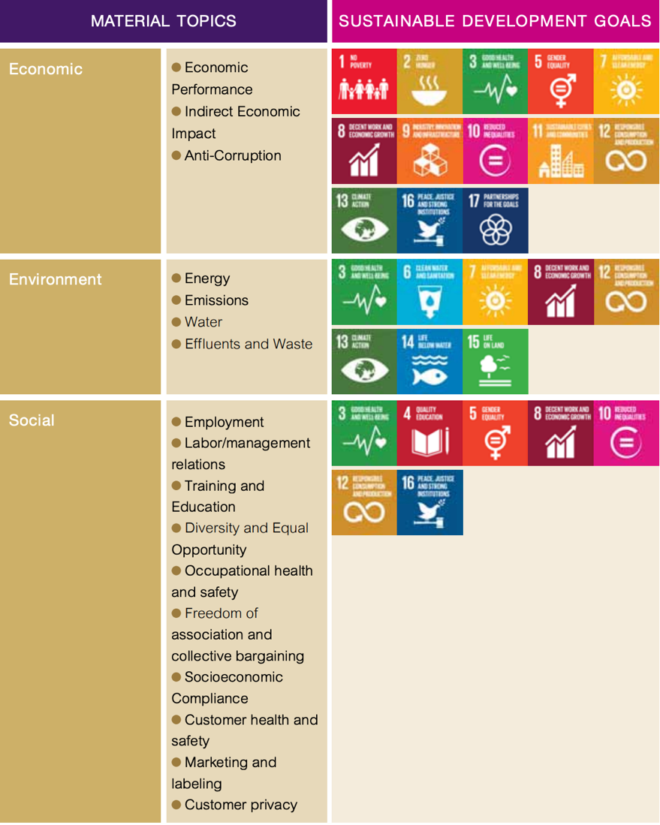
Figure 1.0
THAI show in many ways their dedication to ethics and it is an ethical culture passed down from the Kingdoms very own constitution and manages to combine the values of the company with the values of their country and so doing, create a very strong bond with their customers, who are either their countrymen and women or foreign customers who can enjoy the values and ethics of the company enjoying the brand in its most optimum form as explained in a report from K. N. Lemonand Vehoef (2016).

.

Sustainability policy 2.2
The “THAI” “Sustainability and Development Report” found on the Thai Airways investors page (2020) via the internet proves the company's dedication to the concept of sustainability within the airline industry. This report comprises of Sustainability reports spanning back several years which shows dedication if anything to the cause of sustainability within the organisation.

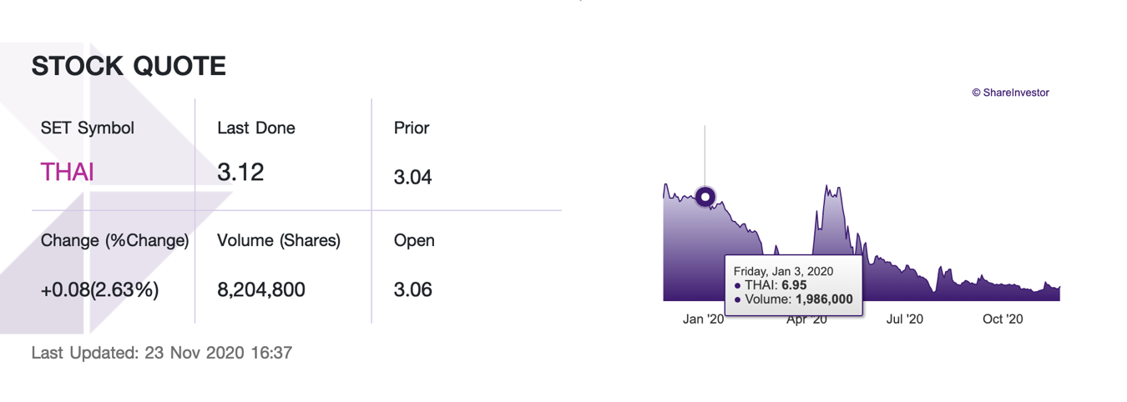
Figure 1.1
In the Stock growth chart above (Figure 1.1) it shows the trajectory of the stock value of Thai Airways International. This chart is part of the "THAI” annual report found on the internet wherein it details the airlines comprehensive approach to many aspects of sustainability, from financial to the Environmental. Within the Sustainability Development Report (2019) it is explained in great detail the company's achievements and future aspirations for the sustainability of the company and, the culture in terms of the corporate value chain, good governance and corporate social responsibility.
These successes can be achieved by following of the Gap Model of Quality control or similar, as we can see within the annual reports, the information on customer satisfaction is gathered from the data collected at the designated touch points, as shown in figure 1.2, the information constructed from this data is shown to be absorbed into the company’s organisational culture as shown in “figure 1.0”.

Corporate Value Chain Explained 2.3
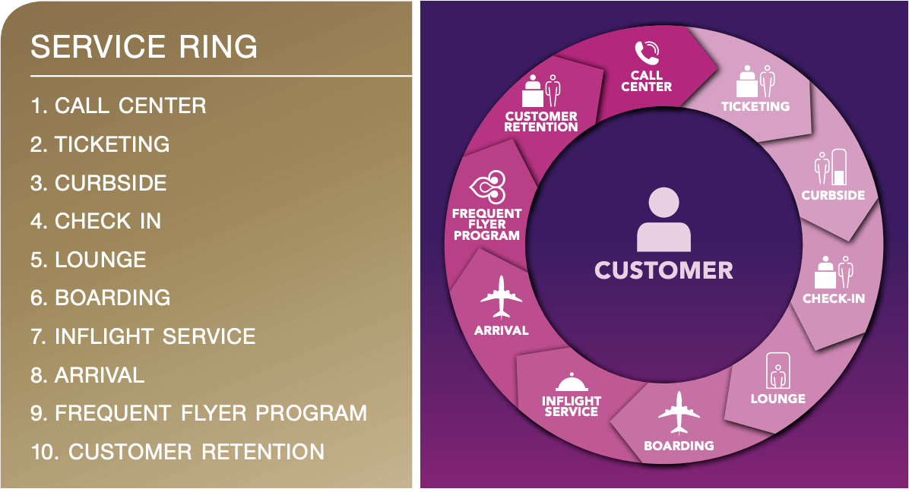
Figure 1.2
In the diagram above shows a visual representation of the THAI’s customer touch points and their quality control structure. It is evident from this “service ring” that the customers experience is crafted from date collected from these established touch points within the quality control structure of the company. “The Service Ring” shows a very strait forward structure which takes into consideration the quality and feedback from the:
- Inflight service
- Frequent flyer program, and
- Customer retention
Return custom will be based on how the customer receives and then later values the services provided as explained by Berry et al, (2002)
“According to a report by “OECD policy responses to the coronavirus (Covid-19)”, Recent times have proven very difficult for all in the airline industry due to the Covid – 19 restrictions and added regulatory factors like.
- The cost of health-related countermeasures
- The effects of international travel bans
- The culmination of the “negative demand” (COVID-19 AND THE AVIATION INDUSTRY© OECD 2020)
For the future sustainability of Thai Airways, their response to the pandemic will be of great importance judging by the relative drop in share price, customer share and international flight restrictions. These issues have been faced by all airline worldwide. The Thai Airlines response to the pandemic is outlines in a research article entitled “Commercial airline protocol during COVID-19 Pandemic: an experience of Thai Airways International” where the perspective of the passengers and aircrews was surveyed using an online survey of passengers alongside interviews with Airline staff. Two flights where selected, which comprised a total participant of three hundred and seventy-seven passengers and thirty-five crew. The survey found that the protocol was received adequately by the participants with some improvements suggested by them (Pongpirul K, et al, 2020).

Quality Model Assessment 2.4
“It is not enough to do your best; you must know what to do, and then do your best”. William Edward Deming

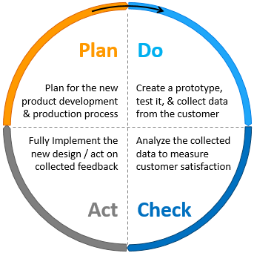
Figure 1.3

The concept of PDSA was created by Walter Shewart (1920), once-prominent scientists at Bell Laboratories. PDSA stands for Plan, Do, Study then Act. Shewart was a mentor to the Scientist later renowned for the concept, W. Edwards Deming who promoted the concept as the PDCA Deming wheel throughout the 1950s.
There is some controversy as to when this concept was created, and by whom. Some are of the school of thought that Deming created the concept in the 1950s, and some are of another who place the founding of the concept with Shewart in the 1920s. For this report the Deming Wheel will be used, this PDCA concept is widely used and has proven to be a very good determiner of quality product and services. The concept comprises of four axioms:
- PLAN:
PLAN for a new product, service development and their subsequent production and delivery process.
- DO:
Following the planning process of said product/service, a prototype or script must be crafted, then tested with all the data collected from the relevant touch points, be them customer or corporations' departments.
- CHECK:
Using the Data collected it is now time to scrutinise the data to gauge the products/services end-user quality this can be done by many means but a very staple way to work a new test product or services overall quality it to have a very robust CRM. The CRM created by Peelen (2013) theorises the results which could be attained by any company if the principles within the theory are implemented correctly, will cultivate a perpetual relationship with their target market, existing customers, management team and the general workforce. By having a CRM that monitors all relevant touchpoints both internally and externally it could be conceived that boost in loyalty will be achieved.
- ACT:
Now is the time in the process to Act upon the Information derived from the data. Now it's time to do your best with the added confidence of knowing what you are doing.
Thai Airways International has shown this type of quality control in practice with their response to the Covid outbreak. Their response was well documented, and covered many touchpoints regarding:
- Preventative Measures
- Financial feasibility
- Infection control protocol
- Implementation feasibility
Within only a short amount of time, a plan was formulated, Tested, analysed and then implemented, almost in perfect alignment with the Deming Cycle (1950).

Discussion 2.5
The PDSA model shows a relevant model for use in the airline industry and its flow of information is evident in the annual reports of the Thai airlines, American Airlines and British Airlines organisational structures. As shown in the annual reports over the years, planning is a process which these airlines do in a very meticulously way, taking into account the customers, the frontline staff, the management team and all internal stakeholders:
- Expectations (derived from the previous years data analytics within the yearly reports).
- The customers expectation (derived from customer feedback to the airline through the customer services department).
Conclusions 2.6
Thai Airways International has shown within its companies conduct within the public domain that it has a very structured ethical and sustainability policy, and procedure, documented within their annual reports going back several years. Their values could be perceived as a very controlled structure based mostly from the firm's perspective. But with closer investigation into their practices via research papers and customer forum's you can see a very multidimensional approach from the Airline, demonstrated by their response protocol to the pandemic. A more customer-orientated approach could be implemented to add a more multidimensional plan of action. Also, the addition of a more robust internet and social media connectivity to their service ring would give broader insight into the customers experiences and their varied needs real time, both post and pre-flight. This could enhance the customer experience as a whole and have the knock-on effect of customer retention over the Long-term as explained by Meyer and Schwager (2007).

Ethics and Sustainability of American Airlines 3.0

American Airways
Ethical Policy 3.1
Most ethical policies are more so generic in their structure, using the core values innate to most human beings as a guide for the overall theme of the policies and the resident trading territories governing bodies constitution as a further template for the ethical culture evident within the company's policy. American Airlines is a prime example of this theory.
AA believe in the need for strong commitment, solid team and customer relationships and unwavering loyalty to their shareholders and business partners. They base this value system on a system that is universal to all comprising of:
- Integrity
- Honesty
- Ethical decisions
- Responsibility
- Human rights
AA explain in detail the actual standard that they hold their staff to regarding their conduct these codes of conduct are a requirement of employment and is formed the data collected from many touchpoints within their organisation. One of the ways they collect important data on Team member, Vendors and contractors are through the ethics helpline. Human rights are taken very seriously within this airline alongside corporate responsibility showcasing those ethics are a big part of this company's culture.
“We know that leadership and effective management of environmental, social and governance (ESG) issues are critical to the long-term success of American and the vitality of our planet. We strive to provide clear, transparent information about how we manage and address the range of ESG issues we encounter in our business”.
AA believe that Leadership and successful management of what they call ESG is a critical factor in the progression and long-term success of America with a huge positive effect to be felt subsequently by the planet. It could be argued by the competitors that the information provided is not transparent and precise information regarding how they tackle and manage these issues which arises from the ESG factors, upon review of said report it can be found that AA survey public opinion alongside staff input to tackle:
- Environmental
- Social
- Governance
The ESG factors show the macroenvironmental issues which AA strive to manage.
Sustainability Policy 3.2
AA recognise that the airline industries and their actual service have a great negative impact on the environment with an emphasis on climate change and how they can reduce carbon emissions within the airline industry.
Within the Sustainability report found on AA’s web site, it breaks down the airlines respond to these Environmental, Social and Governance factors. They explain their corporate responsibility to offset the carbon emission they create with environmental based green initiatives. This report is backed with accurate environmental data and AA’s actual responses in an open document by Lemon, K. N. and Vehoef, P. C. (2016).
Consumer pledge 3.3
AA explained in the “customer commitment” section of their sustainability reports the importance of creating a consistent experience for thew consumer across the network, and they invest billions into new product/service development.
The CRM that manages these developments and cross-lateral sharing of relevant information have a multi-layered, multi-dimensional structure utilising both internal systems with web-based customer-friendly interfaces as Buttle, F (2004) detailed in his paper regarding web based interfaces. This system has evolved over many years of information gathering, analysing and then acting upon the data transomed into information and recognisable ways forward. This information has been proven to show the experience of the organisation, and the experience of the customer. The commitments are outlined as follows:
- Conditions of conveyance
- Plan for customer service
- Covid update and guidelines
- Privacy policy
- Special assistance
- Contingency plans regarding Tarmacking (US Airports)
- Web ergonomics
AA detail their value for the workforce within their report also, explaining that by investing into the development of their workforce they create a competitive environment for their workers to thrive and flourish within, by means of their “industry-leading benefits". These values are further detailed within the Employee benefits and career paths at American, documented within their sustainability policy, as reported by Chandler and Lusch (2015).

AA stipulate the fact that diversity is a big part their corporate culture, this is shown with their:
- Workforce demography
- Inclusion, Equality and Diversity values
- Supplier diversity programs
AA believe that everyone has a value and a place in their company and the world as a whole no matter what:
- Generation
- Race
- Gender
- Sexual orientation
- Gender identity
- Disabilities
- Religion
Community spirit is a big part of AA’s corporate culture and activity through their corporate responsibility programs which help:
- Children
- Communities
- Military Service Members
The help is conveyed through community engagement programs, volunteerism and investment for social enterprises that help all of the above subsection of society.
Quality Models explained 3.4
AA has a very efficient system of turning Data into information as seen within their Ethical and Sustainability reports. A theme of getting data from many touch points is in operation and evident. To further explain the Quality model requirements of AA a “Gap Model of Service Quality” will be used:
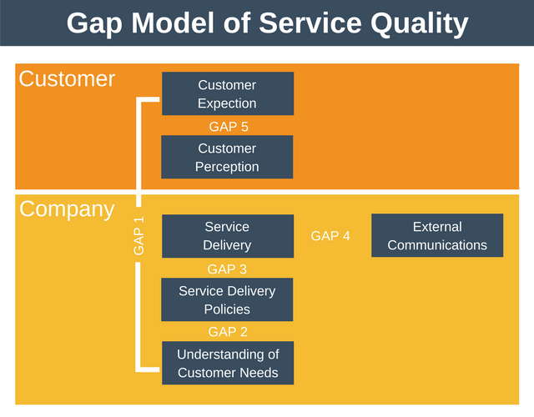
Figure 1.4
The diagram above is a good example of how AA gauge the Quality of the service through many touch points pre, during and post flight.
Gap 1:
Gap one is the knowledge gap, this gap occurs when management have no information on what the customer expects. This is caused due to:
- Unsubstantial communication with customer, employees, management team.
- Negligent market research
- Neglect of relational focus
- Neglect of customer complaints
AA counter this Gap 1 by keeping up to date with:
- Conditions of conveyance
- Plan for customer service
- Covid update and guidelines
- Privacy policy
- Special assistance
- Contingency plans regarding Tarmacking (US Airports)
- Web ergonomics
AA detail their value for the workforce within their report also, explaining that by investing into the development of their workforce they create a competitive environment for their workers to thrive and flourish within using their “industry-leading benefits". These values are further detailed within the Employee benefits and careers at American documents within their sustainability policy reported by Chandler, J. D. and Lusch, R. F. (2015).
AA stipulate the fact that diversity is a big part of their corporate culture, this is shown with their:
- Workforce demography
- Inclusion, Equality and Diversity values
- Supplier diversity programs
AA believe that everyone has a value and a place in their company and the world as a whole no matter what:
- Generation
- Race
- Gender
- Sexual orientation
- Gender identity
- Disabilities
- Religion
Community spirit is a big part of AA’s corporate culture and activity through their corporate responsibility programmes which help:
- Children
- Communities
- Military Service Members
The help is conveyed through community engagement programs, volunteerism and investment for social enterprises that help all of the above subsections of society.
Discussion 3.5
In comparison to Thai Airlines and British airline you can start to see a universal frame work in which the quality control models are used by collecting data from the relevant customer and workforce touch point, these factors are highlighted within the annual reports and then the companies attempt to carry adjustments for any discrepancies or better practices derived from the information realised from the annual reports, alongside the regular upper management meetings and communication from both internal and external sources.
Conclusions 3.6
American Airlines has shown an adept nature to ethics and sustainability, though it could be argued that their true policy is profit based predominantly, and only ethical at its minimum degree for the regulatory factors in place in the USA as detailed by Davenport (2010) in his research report into American Airlines.

Ethics and Sustainability of British Airways 4.0

British Airways
Ethical Policy 4.1
British airways are very passionate about managing its business responsibilities and their responsibilities to the customer. It achieves this by supporting people at all levels of life. This is shown by their promise to celebrate and support local communities equally, using diversity and inclusion as a guide. They continue the fight against human trafficking and wildlife trafficking to mention just two of the documented ways this organisation flexes its ethical muscles as shown within the British airways annual report (2019).
Sustainability Policy 4.2
This organisation also does everything it can do to lower the impact aviation has on the environment. This is achieved by investing in sustainable fuels, fuel-efficient aviation and help to push change with the industry.
According to a report by Charles R. Weiser (1991), the company needed a radical approach to change, a change of direction. This was due to the fact that there was a noted rise in customer dissatisfaction. This was due to but not exclusively to the drop of customer calls to the tune of 60%, with a rise in compensation and grievances rising too.
Their first step to tackle these issues was to take a proactive approach and focus the whole airline in the task of eliminating all deficiencies and failures. The airway called on the organisational expertise of W, Edward Deming, Deming quickly went to task with his view that “Profit comes from repeat custom, and repeat custom comes from a satisfied customer. From the customer research undertaken it was derived that only 13% of customers were fully satisfied with the service provided by the organisation. With Deming help, the airline realised that the non-complainer defect to other airlines, and only 50% of those who don’t complain defect to another airline. It was also noted that customers who communicate can be retained whether the communication is positive or negative in regard to their experience with the airline's services as explained in a report by Homburg, et al (2015).
Here below is the quality model that Deming established to resolve the quality-of-service issue.
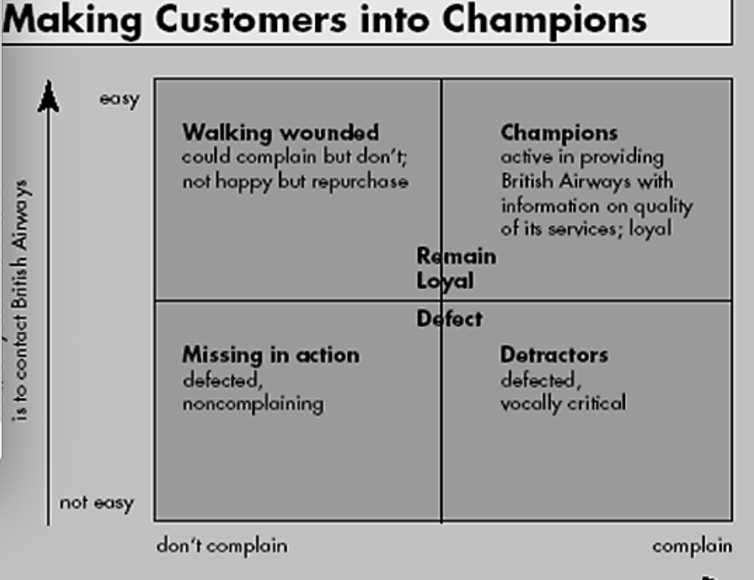
Figure 1.5

They came to an understanding that retainment of the customer is task 1 and to do this customer feedback is paramount. This is achieved by the use of a very customer and profit retention-based CRM. The quality model used to achieve these principles is illustrated in the figure above.
Quality models Explained 4.3
By following the information derived from the data collected using the new robust CRM and following the steps in the newly formed quality model British airways could see the factors in which improvement was needed:
- Investment into People or Corporate responsibility
- Restructuring of the customer service process (Bolstering the CRM)
- Throwing away the old failed processes
- Retraining and personal development

Here below is an extract from Charles R. Weisers mission statement to British airways (1991). Within this extract of the mission statement is shows the relevance of customer touchpoint to reveal the hidden customer sentiment, or what lurks beneath as illustrated in “figure 1.5” below.

customer relations. (See the exhibit “The Customer Contact Iceberg.”)
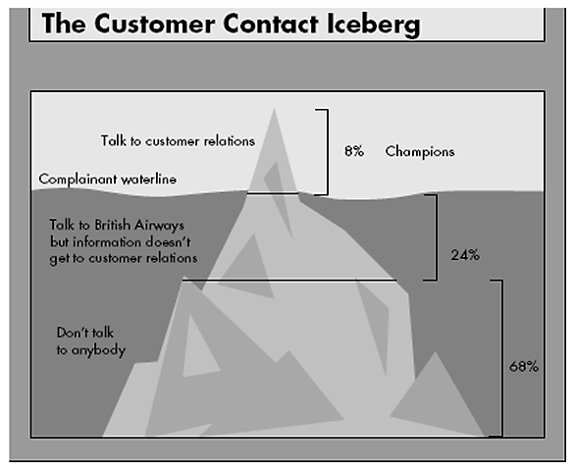
Figure 1.6

Discussion 4.4
In figure 1.6 above we can see that british airlines has identified a problem with their touch point data collection, this has been visualised in the form of an iceberb. The part of the iceberg above water shows the customers which they regard as “champions” (8%), these customers communicate with the company letting the company know of any problems they have faces and suggestion as to how to remedy these problems. Next is the first section below the water line which shows the customers who relay there complaints but the complaints don’t get to the relevant team (24%), this section is a touch point which needs work as the information flow from the external source is not getting to the relevant internal department which as explained in the report by Charles R. Weisers in his mission statement to British airways (1991). The third and final submerged section of this iceberg analogy is the “Don’t talk to nobody” section (68%), this is the largest and most worrying section as it is the majority of the customer base and they are reluctant to communicate. A remedy for the customers who do not communicate back with the airline about their experiences good or bad could be an incentive system where by the customer gets some sort of reward for completing any of the airlines questionaries.

Conclusions 4.5
British Airways is a longstanding aviation company leader, with its wealth of experience and longevity in the business, it seems that the organisation is positioned to weather the storm of the pandemic. It can be seen that all aspects of ethics and sustainability have been considered by British airways. The best way to continue the success of the company and resolve longstanding customer complaint problems, the use of modern social media platforms could further inform the company of which directions it must go for survival of the company and reputation of the brand overall (Davenport, 2010).
Conclusions 5.0
The biggest hurdle for the Airline industry as a whole is the Covid-19 Pandemic and the ethical responses to the issue. The response in this matter will prove paramount in concern to the sustainability of the individual companies and the stability of the industry worldwide. With more touch points to be considered in a whole different aspect to just profits and customer satisfaction, now a new health and safety touch point aspect is added to the mix with varied Governmental policy of an ever-changing nature (IEA, 2020).
Then the quality of the company’s overall service can be seen in the annual reports. The airline can see the level of quality within the organisation and its customers through the:
- Understanding of the customer’s needs through feedback forms online, questionnaires directly sent to customers on completion of services. Repeat custom is often a great indicator of customer satisfaction and quality of service.
- Policy created to govern the service delivery. These policies must take into account, Health and safety, Equality, Data protection and legal requirements set out by the law of the land. Aviation is an ever-evolving industry which has many regulations to follow set out by government which regulate the safety requirements as standard for all passenger and workforce alike, this is the common rule globally. This fact is made apparent within the three airlines annual reporting.
- Service delivery reports are derived from internal reporting and accountability reporting from workforce to upper management. The response reporting from the management team explaines the execution of the objectives sent down from the board of directors disclosing which targets where met and where there is room for improvement within the workforce and the management of the workforce. It is a standard for large airline companies of this size to have quarterly board meetings in which the service quality, among many other company functions are reviewed and discussed, suggestions are put forward for adaptation into their future objectives.
- External communication is key to any quality model, as collecting relevant data at the relevant data points is time sensitive meaning the information needs to be relayed back to the correct department to help facilitate the implementation of changes in a clear and precise manner. This is paramount when it comes the experience of the customer, the reliability of any supplies to the airline and the environmental factors faced by all airline, a great example of this is weather reporting. Airlines must have the most technologically advanced weather reporting systems as the health and safety of the workforce and customers relies upon the proper reporting of the weather condition for flights.
References 6.0

IEA (2020), “Changes in transport behaviour during the Covid-19 crisis”, International Energy Agency, Paris, https://www.iea.org/articles/changes-in-transport-behaviour-during-the-covid-19-crisis

World Bank (2013). World Development Indicators, 2013, Washington, DC: World Bank.
Buttle, F. (2004). Customer relationship Management: concepts and
Tools, Elsever Butterworth Heinemann, Oxford.
AMA (2020). Codes of Conduct | AMA Statement of Ethics, available @:
https://www.ama.org/codes-of-conduct/, (01/02/2020)
CIM (2016). What is ethical marketing available @:
https://exchange.cim.co.uk/blog/what-is-ethical-marketing/, (accessed on
01/02/2020)
Implementing an Evolving Marketing Concept,” Journal of the Academy of Marketing Science, (published
electronically August 19), [DOI: 10.1007/s11747-015-0460-7].
, K. N. Lemonand Vehoef, P. C. (2016), “Understanding Customer Experience Throughout the Customer Journey,”
Journal of Marketing, 80(6),69-96.
Pongpirul K, Kaewpoungngam K, Chotirosniramit K, Theprugsa S (2020) Commercial airline protocol during COVID-19 pandemic: An experience of Thai Airways International. PLoS ONE 15(8): e0237299. https://doi.org/10.1371/journal.pone.0237299
https://hbr.org/1995/11/competing-on-customer-service-an-interview-with-british-airways-sir-colin-marshall\

by Thomas H. Davenport June 11, 2010 https://hbr.org/2010/06/why-cant-americans-business-tr
(https://www.thaiairways.com/static/common/pdf/about_thai/thai_corporate/1_2CG_and_Ethics_Code%20_eng.pdf).
COVID-19 Screening Questionnaire [Internet]. Bangkok: Ministry of Transport; 2020. Available from: http://www.thaiembassy.org/london/contents/filemanager/document/T8_form.pdf
(https://journals.plos.org/plosone/article/authors?id=10.1371/journal.pone.0237299)
Berry, L. Carbone, P. and Haeckel, S. H. (2002), “Managing the Total Customer Experience,” MIT Sloan Management
Review, 43 (3), 85–89.
Chandler, J. D. and Lusch, R. F. (2015), “Service Systems: A Broadened Framework and Research Agenda on Value
Propositions, Engagement, and Service Experience,” Journal of Service Research, 18 (1), 6–22
Homburg, C. Jozic, D. and Kuehnl, C. (2015), ´ “Customer Experience Management: Toward
Implementing an Evolving Marketing Concept,” Journal of the Academy of Marketing Science, (published
electronically August 19), [DOI: 10.1007/s11747-015-0460-7].
Lemon, K. N. and Vehoef, P. C. (2016), “Understanding Customer Experience Throughout the Customer Journey,”
Journal of Marketing, 80(6),69-96.
Marketing Science Institute (2014), “Research Priorities 2014–2016.” Cambridge, MA: Marketing Science Institute,
[available at http:// www.msi.org/uploads/files/MSI_RP14-16.pdf].
Meyer, C. and Schwager, A. (2007), “Understanding Customer Experience,” Harvard Business Review, February 1,
17–26
Stuart, Ian F. and Stephen S. Tax (2004), “Toward an Integrative Approach to Designing Service Experiences:
Lessons Learned from the Theatre,” Journal of Operations Management, 22 (6), 609–27.
Wilson, R. & Gilligan, C. (1997). Strategic Marketing Management 2nd ed Butterworth-Heinemann Oxford UK
Peelen, E., & Beltman, R. (2013). Customer Relationship Management. United Kingdom: Pearson Education Limited.
Dent, J. (n.d). Customer Journey Mapping: A Walk In Customers’ Shoes. Retrieved from: http://www.ascendforairlines.com/
Sabre Airline Solutions. (n.d). The Evolution Of The Airline Business Model. Retrieved from: http://www.sabreairlinesolutions.com/
Dent, J. (2012). Customers: The Heart Of An Airline. Retrieved from: http://www.ascendforairlines.com/
http://investor.thaiairways.com/en/home
Appendixes 7.0
- Appendix 7.1
Figure 1.0
Figure 1.1
Figure 1.2
Figure 1.3
Figure 1.4
Figure 1.5
Figure 1.6

References
A. Parasuraman, Valarie Zeithaml, and Leonard L. Berry in 1985.

