
Skills for the Workplace
Module Assignment Submission
Student Name: | Venisha Fraser
Student Number: | 1604703
Module No: | (BMSK5006_LON)
Module Title: | Knowledge and information management skills for the workplace

Statement of Confirmation of Authenticity
By the act of making this submission, the student declares that this is the work of the student named above. The work has not, in whole or in part, been knowingly presented elsewhere for assessment, or where assessment has been built on a previous assessment, this has been identified. Where materials have been used from other sources it has been properly acknowledged. If this statement is untrue, the student acknowledges that an assessment offence has been committed.
Attention is drawn to the plagiarism and unfair practice policies of both the University and of ILM.

Content
Introduction……………………………………………………………………………………………………………………03
Learning Outcome Part One……………………………………………………………………………………….04
The relationship between data, information, knowledge and wisdom…..………04
- Data……………………………………………………………………………………………………………………………………04
Information…………………………………………………………………………………………………………………..04-05
Knowledge………………………………………………………………………………………………………………………….05
Wisdom…………………………………………………………………………………………………………………………06-07
Organisational Knowledge Management……………………………………………………………………….07-08
The Lloyds banking Annual Financial and Non-financial Performance report………………………09
Learning Outcome Part Two……………………………………………………………………………………….10
Knowledge Assets……………………………………………………………………………………………………………….10
Swot’s Analysis for Knowledge Management………………………………………………………………………11
Integrated framework for applying information knowledge management…………………….11-12
Consider the importance of Intellectual Property rights………………………………………………………12
Learning outcome 3……………………………………………………………………………………………………… 13
The benefits of knowledge in the organisation……………………………………………………………………13
Knowledge management requirements…………………………………………………………………………13-14
Evaluation of knowledge shearing framework in the organisation………………………………….14-15
Recommend improvements to the current framework……………………………………………………….15
Conclusion………………………………………………………………………………………………………………….15-16
Reference………………………………………………………………………………………………………………17-18-19

Introduction

This report aims to give an attempted insight in how to develop the understanding and challenges when managing information and knowledge processes assets within an organisation. it also identifies the different sources for the information and knowledge management systems. This report also demonstrates the abilities and argues the importance of creating, storing and shearing information knowledge assets within the organisation. knowledge management asset has a variety of system in place that will contribute to the current and future processes to enhance the organisational structure and developments plans. As these developments will affect the culture of the everyday transactional demands. This report is based on how the Lloyds banking group manages knowledge information assets. The Lloyds banking is one of the UK’s best bank for Britain. According to, (investors, 2018) Lloyds banking group is known for delivering first class performances which encourages and maximises profits and revenues. Information knowledge management is a benefit that contributes to keep risk at a low. Lloyds banking group has also developed a strong plan that will start from (2018) to (2020). The plan is to improve and transformation of the organisation in addition to be successful especially in the digital word based on the current and futures information knowledge assets. However, this report will cover the relationship between data, information and knowledge, data, information, knowledge, wisdom, organisational knowledge management, the Lloyds banking annual report, Lloyds banking annual financial and non-financial performance report, knowledge assets, swot’s analysis for knowledge management. Integrated framework for applying information knowledge management, consider the importance of Intellectual property rights, the benefits of knowledge in the organisation, knowledge management requirements, evaluation of knowledge shearing framework in the organisation and recommended improvements to the current framework.

Part One
The relationship between data, information, knowledge and wisdom
Data
Any given context becomes data, people perceive data as raw data, based on signals, know-nothing, unproven and proven facts. When raw data is gathered, it then becomes meaningful, useful, organised and structured information. For example, at the Lloyds banking group, each time when shearing another opening for work via web-based networking media, download an application or filling in a vocation application we're sharing individual information – data that recognizes us as people. Sharing information can assist the business to enhance client benefit or customize offers however, it can likewise be appealing to fraudsters. So, it's constantly essential to think about what you're sharing and who with. According to, (Emma Higgins, 2014) Data sharing can help with decreasing duplication of exertion between open part organisations and can diminish costs and empower more co-ordinated arrangement of open dispensations. Sharing between open segment organisations can work successfully if suitable consideration is taken while making data sharing assertions between accomplice organisations. It is essential to precisely decide the necessities for data sharing, to build up information sharing understandings, to have secure game plans for data sharing, and to guarantee consistence with data protection enactment.

Information management
Information becomes knowledge, as knowledge is given insights of contextual, synthesized and learning. According to, (O'Neal, 2017) Information management is an authoritative program that deals with the general population, procedures and innovation that give command over the structure, handling, conveyance and utilization of data required for the board and business insight purposes. Information management as known today, incorporates both electronic and physical data. The authoritative structure must be equipped for dealing with this data for an amazing duration cycle, paying little heed to source or arrangement, information, paper records, electronic archives, sound, video, and so forth for conveyance through numerous channels that may incorporate cell phones and on the web. Information Management is a subset of Information Management. It contains all controls identified with overseeing information as an important, hierarchical asset. In particular, it's the way toward making, getting, changing, sharing, ensuring, arching and protecting information. information reveals the relationships and knowledge reveals the patterns, which are known as the past. However, information management focuses on data and information. Assisting and to Manage unstructured and organized statistical data points, advantage enormously from innovation, since the information being passed on is now arranged and in an effectively transferrable frame. Information management additionally centre around arranging, examining, and recovering - again because of the classified idea of the data. It Is about comprehend what, i.e. it offers a reality that you would then be able to use to help make valuable information, however in itself that reality does not pass on a strategy. For example, at the Lloyds banking group there is a variety of information created, stored and sheared. Weather it is organisational structure information, product information, service information, employee’s information and customer information. All information is important and confidential, which is treated with delicacy and care. Information is what contributes to, communication, daily huddles, one to one meeting’s, conversations, decision making, simplification, growth, development, implementations, performances, individuals’ accountability’s, effective management, organisational advance, choreography and core competency. Information is what drive the business to be transparent, sustainable, successful and deliverable. According to, (Picincu, 2018) Any business, enormous or little, must have a framework set up to gather, process, store and offer information. Previously, these assignments required a ton of time and printed material. Today, organizations utilize present day innovation to streamline and mechanize these tasks. Data frameworks are currently assuming a vital job in information preparing and basic leadership. At the point when utilized accurately, they can emphatically affect an organisation general performance and income

Knowledge
The future is based on knowledge as it contributes to the organisation’s direction, to enhance and pursue best practices. According to, (Tools, 2018) knowledge focuses Spotlight is on knowledge, comprehension, and astuteness, and manages both systematized and uncodified knowledge. Uncodified knowledge is a significant sort of knowledge and is found in the psyches of specialists and is implied, setting based, and experience based. innovation is greatly helpful, yet knowledge management attention is on individuals and procedures. Since what's to come depends on it is incredible for exchanging explicit, classified knowledge, however it's job in the exchange of more profound, disguised knowledge is more unpredictable. Since this sort of learning is passed from individual to individual, through cooperation, coordinated effort, tutoring, preparing, specialized, devices. To unite individuals, culture, process, understanding and ideally in an unstructured domain. Information is put away sheared and made. For example, at the Lloyds banking group, the relationships between data, information and knowledge will influence the individual’s future growth. All accredited colleagues have gained knowledge through, training, observing, past - experience and understanding their individual roles. In addition to, accomplish the organisational goals, a knowledgeable colleague is an asset to the company and will help individuals excel and be promoted on to a higher platform within the organisation. According to, (Troppello, 2015) colleagues that might not have an abundance of money related resources, but rather you have an assortment of expert resources that you can convey to an organization. All workers have something unique to offer the business. Inside self-standers, morals, discipline, understanding, relational aptitudes, communicational abilities, individual idealistic disposition a conduct and a lot of increasing individual quality's, as having a positive thinker frame of mind which is a precious resource can be conveyed to the table.

Wisdom
Wisdom is the greatest by nature and to also, gained through the amount of knowledge received, wisdom is made up with understating, integrated and actionable which is developed from, raw data, information, knowledge and the past experiences. However, raw data, information, knowledge, and wisdom will contribute to the future direction, principles, transactions, executing, changes and decision making. Data create Information, information influences knowledge and knowledge mature into wisdom. According to, (Groothuis, 2002) Jesus Christ was a magnificent thinker, who utilized consistent contentions to disprove His pundits and build up reality of His perspectives. At the point when Jesus adulated the confidence of children, He was empowering humility as a temperance, not irrational religious trust or a visually impaired act of pure trust in obscurity. Jesus deftly utilized an assortment of thinking systems in His discussions on different points. These incorporate getting away from the horns of a difficulty, a fortiori contentions, requests to proof, and reductio promotion absurdum contentions. Jesus' utilization of influential contentions exhibits that He was both a philosophy and a theological rationalist who soundly guarded His perspective in talks with the absolute best thinkers of His day. This scholarly methodology does not reduce His awesome specialist but rather upgrades it. Jesus' high estimation of levelheadedness and His own use of contentions demonstrates that Christianity isn't an enemy of scholarly confidence. Adherents of Jesus today, consequently, ought to imitate His scholarly enthusiasm, utilizing similar sorts or contentions He Himself utilized. Jesus' factious procedures have applications to four contemporary discussions: the connection among God and profound quality, the dependability of the old and new testament, the revival of Jesus, and moral relativism. For example, the Lloyds banking group generates information through surveys, feedback, questionnaire, observations, characteristics and influences for individuals to make their own informed or collective decisions. the relationship between data, information and knowledge within the Lloyds banking group, is a significant element that contributes to satisfying and safeguard customers’ needs. In addition to also maximise the customer, business and the brand values. when a customer is new to the Lloyds banking group it’s imperative to ask for primary data to then input into the system which is then transformed into customer information and is also known as a customer profile. As customer information helps colleagues to have an idea of the customers characteristics and requirements before calling to confirm the customers appointment date and time, before the customer arrive for their interview. The specialist that will be interviewing the customer will gain knowledge through the information which is created at the first point of contact then stored and sheared on the customers profile. Below is a visual of (DIKW) Pyramid.

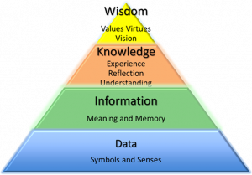

(Prithard, 2012)

Organisational Knowledge Management
Understanding the diverse structures that learning can exist in, and along these lines, having the capacity to recognize different sorts of information, is a fundamental advance for Knowledge management, and information. For instance, at the Lloyds banking group, it ought to be genuinely apparent that the information caught in a report would or should be overseen. In addition to, specifically put away, recovered, shared, changed, and stored. In a very surprising manner than assembled throughout the years by a specialist expert. According to, (Bhatt, 2002) In the current post-industrial society, knowledge has turned into a key asset. In any case, nevertheless, associations confront endless difficulties in supporting and overseeing information. In contrast to assembling exercises, information exercises are hard to screen and control, on the grounds that just a piece of learning is disguised by the organisation, the other part is disguised by the people. This duality between individual information and hierarchical learning requests distinctive arrangements of administration methodologies within knowledge management. For example, at the Lloyds banking knowledge management is apart of the organisations processes and procedures. First to utilize master engineering abilities and learning to structure and strengthen the conveyance of a progression of Knowledge Management arrangements amid the advancement and usage over numerous Group IT capacities and in accordance with the general Group IT Knowledge management methodology. Also, to go about as an ace Librarian of an explicit or different domain’s and divisions who might run and deal with all knowledge management related exercises in accordance with the general strategies and guidelines characterized by the knowledge management Lead planner. Such exercises to incorporate enrolment of information area specialists, recognizable proof, accumulation and catch, profiling and arrangement, stockpiling, upkeep and security, and the meaning of Group IT impacts, examination and announcing. In charge of reaping information, for bridling thoughts produced from knowledge management exercises, and for fundamentally evaluating the estimation of learning in the organisation. According to, (Evans, 2000) there is uncertainty at knowledge is currently a key resource with data and information, specking to the essential wellspring of financial esteem. The level of the gross national product that originates from knowledge-based organisation is currently around fifty percent. Working in a buiness world where data and information have turned into the essential wellspring of upper hand has brought about a move in accentuation from items to form. Associations are looking up to the truth that genuine upper hand lies in their workers not in other settled resource, as before. It isn’t astonishing then ability the board has turned into key buiness need. Without successful methodology for building and holding reportative ‘know how’s’ associations don’t have an economical knowledge the executive’s approach. Below is a visual diagram of a strategic, tactical and operational pyramid.

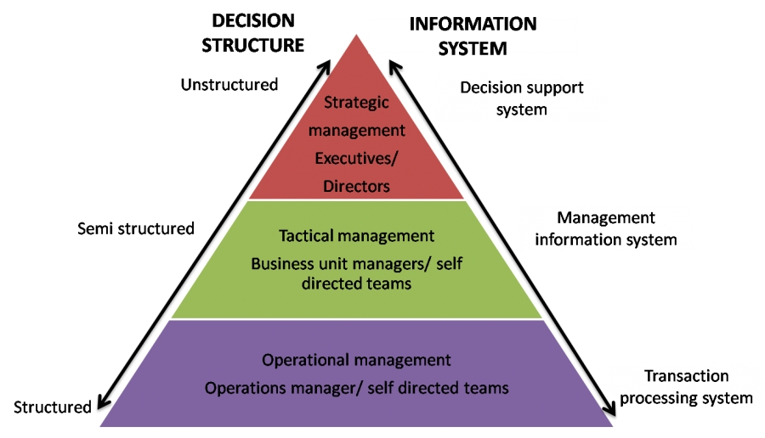
(Divyendra, 2017)

Lloyds banking Annual Financial and Non-financial Performance report
All organisations have their own tailored comprehensive annual report’s, which informs all stakeholders of up-dated information of all elements of the business, such as, the financial performances and activities. For example, at the Lloyds banking group an annual report has been broken-down into three elements which aims to maximise, transform and digitise. Lloyds banking group strategic priorities is to develop a leading customer experience across all channels within the organisation and to develop new technology to assist all stakeholders with all information needs efficiently. Also, to deepen customers relationships by maximising colleague’s developments and systematic capabilities. According to, (Miller, 2018) an annual report signifies the company’s accomplishment to all stakeholders and the over-all community. An annual report shears all current and future information to existing and new colleagues and, customers. an annual report is also information gathered from raw data and is a tangible and intangible asset which can be referred to as report to the public, or a call to action or transformation. For example, at the Lloyds banking group also highlights the groups success, failures, risk decision making problem solving, learning points questionnaires, surveys, observation, colleagues and customer habits, organisational culture and structure, customer feedback, values, ethics, behaviour, profits, shares, investing in the community and new implementation, code of conduct, future transformation plans, helping Britain to prosper plan and a few more other activities and developments. Lloyds banking group is a very large company so when looking at their annual report information it is fragmented into fifteen areas. Below is an brief example of a financial and non-financial key annual performance report.

Financial and non-financial key annual performance report.

Key performance indicators
Financial | 2014 | 2015 | 2016 | 2017
Underlying proﬁt before tax | 7,756 | 8,112 | 7,867 | 8,493
Statutory proﬁt before tax | 1,762 | 1,644 | 4,238 | 5,275
Ordinary dividend | 0.75 | 2.25 | 2.55 | 3.05
Statutory return on tangible equity | 4.4 | 2.6 | 6.6 | 8.9
Earnings per share | 1.7 | 0.8 | 2.9 | 4.4
Common equity tier 1 ratio | 12.8 | 13 | 13 | 13.09
Cost income ratio | 49.8 | 49.3 | 48.7 | 46.8
Asset quality ratio | 23 | 14 | 15 | 18
Total shareholder return | 0.04 | 0.02 | 10 | 14
Non-Financial | 2014 | 2017 | 2016 | 2017
Customer satisfaction | 58.06 | 58.9 | 62 | 62.7
Digital active customer base | 10.4 | 11.5 | 12.5 | 13.4
Best bank for customers | 72 | 78 | 77 | 80
Customer complaints | 0 | 0 | 4.3 | 4.1
Employee engagement index | 60 | 71 | 71 | 76
Helping Britain Prosper Plan targets achieved | 20/25 | 27/28 | 20/24 | 21/22
(Goup, 2017)

Learning outcome two
Knowledge Assets
In an organisation knowledge regarding Products, processes, market, and technology, are all known as knowledge assets. Knowledge assets is an advantage that enables the business processes to add value by generating profits and to maximise the brand values. for example, at the Lloyds banking group, knowledge assets are a benefit to the company and knowledge management creates knowledge, stores knowledge, uses knowledge and shear knowledge, Knowledge management assists the company to stand out from other current competitors. The types of knowledge assets Lloyds banking group uses on a day to day bases are, the intranet, mullite channels, and customer profiles, According to (MacMillan, 2015) presently in the global corporate world, organisations are rated based on the advantages and the business reports to all stakeholders, based on the physical benefits individuals own, their cash in hand, revenues and profits and also, in the pass, current and future. Below is a visual diagram of what knowledge assets looks like.

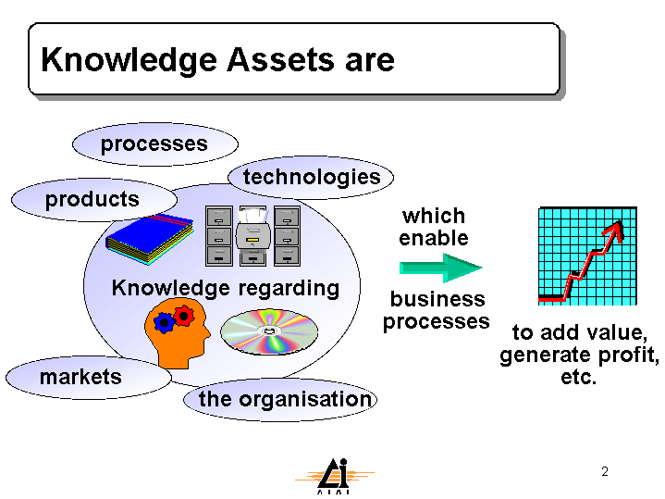
(Macintosh, 1998)

SWOT’s Analysis for Knowledge Management
Below is an attempted insight to a swots analysis based on knowledge assets for the Lloyds banking group, to analyse knowledge assets, that will potentially identify the strengths, weaknesses, opportunities and threats.

Internal Strengths | Internal Weaknesses
Professional techniques  Provide the UK’S best banking products  Well known in the UK  Can not be copied | Not all colleagues understand all elements of knowledge management.  More training is needed.
External Opportunity | External Threats
Implement these ides to other globally  Develop other banks outside of the UK  More publicity  More future jobs  Excellent training methods | Losing competent staff to other competitors  Competitors will try to duplicate similar ideas.

Integrated framework for applying information knowledge management
Integrated framework is a mixture of the organisations culture, motivation, leadership learning innovation, training individual personality’s, processes knowledge management applications, strategy’s creations, shearing, storing, implementation and a variety of element’s that are broken down into three parts, which is known as people, technology and the organisation. When creating, storing, implementing and integrating knowledge, their must be tailored knowledge management processes in place for each method. For example, the Lloyds banking group has their own tailored software that’s creates, stores, shears, implement and integrate knowledge. The main tool that is used to achieve all elements of knowledge management is the internal, intranet, emails, other software applications and multichannel software application, as this protects confidential information and gives colleagues access to create a customer’s profile, stores and shear customers or organisational information. In addition to, integrate the employees, the organisational processes and the technology infrastructure. According to, (Goswam, 2013)A powerful KM System in a business must deliver the issues identified with information creation, learning catching, learning stockpiling, learning amalgamation, information sharing, information extraction, and learning exchange and information documentation. For powerful tending to of these issues, KM System must have all encompassing methodology by accentuating every one of the three variables of businesses which are People, Process and Technology.



People Technology Organisation

Consider the importance of Intellectual Property rights.
Intellectual property rights is a protection that helps the company to be original globally and prevents others from imitating the same idea. According to, (center, 2009) intellectual property contributes colossally to our national and state economies. Many enterprises over our economy depend on the sufficient authorization of their licenses, trademarks, and copyrights, while buyers use intellectual property to guarantee they are buying safe, ensured items. it is trusted that intellectual property rights worth ensuring, both locally and abroad. It’s important to treat intellectual property rights with care as each intellectual property rights are valuable assets to, the organisation and within the most important parts of knowledge management processes. For example, at the Lloyds banking group, intellectual property rights incorporate a variety of elements such as, the design rights, the brands name owned by the Lloyds banking group and the trademarks. High security methods are in place to protect the intellectual property rights and to help maximise the brands values and modify intellectual property rights to suites the organisation. Lloyds banking group have strict procedures in place in the way they create, store, use and shear with others. According to, (since, 2017) intellectual property rights is accepted globally for important reasons to provide encouragement to people’s new creations, recognition, financial growth and successes within the technology zone, as protection is important. Intellectual property rights provide’s an advantage for the business growth within technology. For example, at the Lloyds banking group, colleagues are trained and understand how to create, store, use and shear information and respect other’s intellectual property’s

Learning outcome 3
The benefits of knowledge in the organisation
All organisation benefit from having factual information as it drives the business to success and to achieve the organisations core goal. For example, at the Lloyds banking group the information and knowledge gained from questionnaires, surveys, experiences, customers feedback and stakeholder’s requirements. Will make an impact to the business tractional ways and will maximise product knowledge, customer services, colleague’s knowledge, the business development and brand values. According to, (Ibraheem, 2007) competitive benefits is a mean by which business produce value’s better than other present competitors. Current knowledge assets would need to a benefit the company and tailored to the organisation’s plans and developments. Also, inimitable in a practical way and non-substitutable if the business could not exchange something else for resource. For example, at the Lloyds banking group knowledge management culture will change to the current Morden era at present, as the future is moving towards systematic processes that can hold more information then ever, implement new ideas and to share important information cheaper then before which will help the company to save money and maximise their profits. For instance, the way how Lloyds banking group will save money, is to invest more into self-services machines, educating customers to go paper free, assist in demonstrating online uses and many more other advantages that knowledge assets will contribution and benefit the organisation. According to, (Gurteen, 1999) It is frequently said that it is fundamental to make an "Information Sharing Culture" as a major aspect of a Knowledge Management activity. A secluded information the executives program cared for by an advantaged few is an oddity in itself and won't make due for long. Just compelling joint effort and correspondence which ranges over the entire organization structure will give information the board the lift it truly needs. Every representative has an effective reach alongside their own individual learning, and this is the place information sharing society can start.

Knowledge management requirements
Knowledge management requirements for the business is acknowledge as the most significant strategic asset for all organisations. For example, at the Lloyds banking group knowledge asset is a fundamental tool to have as it drives the organisation to achieve its core objectives and will contribute to the future success. Knowledge asset also identifies and takes, shares, reuse and assist with unlearned knowledge. According to, (ISACA, 2015) Information is perceived as the most essential vital resource to each association. It is critical to distinguish, catch or get, share, reuse and unlearn knowledge. These exercises are overseen through information the executives, it is a fairly difficult assignment to assess the dimension of information and knowledge the board in an business. knowledge is viewed as an essential asset to keep up the aggressiveness of a business. In an economy where the main belief is a vulnerability, the one beyond any doubt wellspring of enduring upper hand is knowledge, it is critical to realize how to recognize information and how to share it. For example, at the Lloyds banking group a knowledge management tool is a system that the organisation uses to shear information internally and externally, as it provides information around customers profile system, the organisational strategies, policy and procedures, discover learning system and other knowledge management assets. According to, (Braz, 2005) having the correct deliberation isn't sufficient for ensuring the advancement of satisfactory answers for any business. For that, a reliable framework designing procedure is required. imperative necessities for a satisfactory procedure are, Offering the correct arrangement of ideas and builds for the focused-on framework designing stage. Giving a visual dialect other than literary portrayals, along these lines encouraging the correspondence among stakeholders and investigators, and among examiners and the organisations framework creators. being moderately available and not requiring excessively overhead in the feeling of additional work from the piece of the investigator in comprehension and utilizing the given dialect and strategy.

Evaluation of knowledge shearing framework in the organisation
Knowledge shearing framework contribute to the organisational structures as change is a demand within this present time. As people’s needs changes the system must keep up to date with all changes. For example, at the Lloyds banking group when implementing new Ideas colleagues have to change their mindset towards the new transitional way and have to up-skilled and be competent in their deliverables to meet the organisational standers. Changes drives the business, colleagues and stakeholders to ensure a better condition and return in all elements of knowledge shearing. According to (Renaud, 2017) the Usage of Knowledge Management brings huge changes at different dimensions of an business. knowledge sharing is one of the viewpoints that assumes a noteworthy job in the accomplishment of knowledge management. Research will break down the relevance of knowledge management as another adjustment in an organisation, while considering the angles impacting information sharing. For example, at the Lloyds banking group knowledge shearing achieves the business objectives, in delivering quality services results. Knowledge shearing framework consists with the organisational structure, the coordination, for the information and security processes, moderating effective national culture and business-based information security management. According to, (Fazlollahtabar, 2015) It is considered that a change in the framework, to process knowledge shearing in an business dependent on two proportions of premium and links. The purpose is to propose a knowledge shearing actuates in an endeavour dependent on. Deciding imperative endeavour assets after information sharing configuring a 0/1 switch on the undertaking assets, reinforcing knowledge sharing and Determining bottlenecks for learning sharing. Below is a visuals diagram of an information security shearing system within an organisation across the wold.

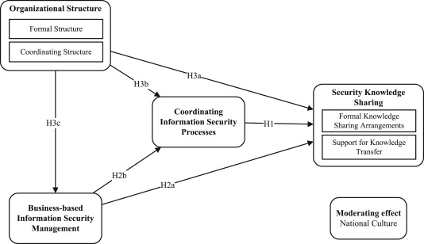

(WaldoRocha Flore, 2004)

Recommend improvements to the current framework.
Recommendation is guidance to improve the knowledge and information management system, as it is requirement to design new questionnaires based on the customer demands and needs. Customer’s needs are always changing and therefore the organisation must keep up with all changes. In this report It has been identified that knowledge management shearing does not cover all elements of knowledge management and their should be more investigations arounds accurate individual information when examining and shearing confidential data.

Conclusion
This report has demonstrated the importance of knowledge management within an organisation. what was analysed in this report was the way how information, knowledge shearing assets would impact and maximise profits, revenues and the brands values. there is examples, given of primary data regarding the transactional way of the Lloyds banking and a description of understanding of creating, storing and sharing information and knowledge assets within the Lloyds banking group. The points that was covered are based on, the relationship between data, information and knowledge, data, information, knowledge, wisdom, organisational knowledge management, the Lloyds banking annual report, Lloyds banking annual financial and non-financial performance report, knowledge assets, swot’s analysis for knowledge management. integrated framework for applying information knowledge management. consider the importance of intellectual property rights, the benefits of knowledge in the organisation, knowledge management requirements, evaluation of knowledge shearing framework in the organisation and recommend improvements to the current framework.

References
Bhatt, G. D., 2002. Management strategies for individual knowledge and organizational knowledge. Emeraldinsight , 6(1), pp. pp.31 - pp.39.
Braz, J., 2005. Analyzing requirements of knowledge management systems with the support of agent organizations. Journal of the Brazilian Computer Society, 11(1), pp. ISSN 0104-6500.
center, G. i. p., 2009. Why Are Intellectual Property Rights Important?. [Online]
Available at: https://www.theglobalipcenter.com/why-are-intellectual-property-rights-important/
[Accessed Sunday January 2019].
Divyendra, P., 2017. Plans Strategic, Tactical, operation, Redefining Knowledge. [Online]
Available at: https://hemantmore.org.in/management/general/plans/4961/
[Accessed Tuesday December 2018].
Emma Higgins, M. T. P. L. F. A., 2014. Developing a data sharing framework: a case study. Emerald Insight, 8(1), pp. pp151- pp164.
Evans, C., 2000. Developing and Retaining Organisational Knowledge. [Online]
Available at: https://www.roffeypark.com/wp-content/uploads2/Developing-and-retaining-organisational-knowledge.pdf
[Accessed Monday January 2019].
Fazlollahtabar, H. &. S. B. &. P. G. A., 2015. A Framework for Knowledge Sharing of Enterprise Resources. International Journal of Information and Computer Science. [Online]
Available at: https://www.researchgate.net/publication/277979485_A_Framework_for_Knowledge_Sharing_of_Enterprise_Resources
[Accessed Monday January 2019].
Goswam, M. G. a. A. K., 2013. Integrated Framework for Implementing Knowledge Management in Contemporary Organizations. Global Journal of Management and Business Studie, 3(6), pp. pp. 611-618.
Goup, L. B., 2017. Lloyds Banking Group Annual Review 2017. [Online]
Available at: https://www.lloydsbankinggroup.com/globalassets/documents/investors/2017/2017_lbg_annual_review.pdf
[Accessed Sunday January 2018].
Groothuis, D., 2002. Jesus: Philosopher and Apologist. Christian Research Journal, volume, Wednesday Novemeber, 25(2), p. DJ700.
Gurteen, D., 1999. Creating a Knowledge Sharing Culture. [Online]
Available at: www.gurteen.com/gurteen/gurteen.nsf/id/ksculture
[Accessed Sunday January 2019].
Ibraheem, G., 2007. The role of knowledge Assets in gaining competitive advantage. [Online]
Available at: https://www.iasj.net/iasj?func=fulltext&aId=50985
[Accessed Sunday January 2019].
investors, p., 2018. Lloyds banking group Q3 2018 Interim Management Statement. [Online]
Available at: https://www.proactiveinvestors.co.uk/LON:LLOY/Lloyds-Banking-Group/rns/LSE20181025070004_13841580
[Accessed Monday January 2018].
ISACA, 2015. How to Evaluate Knowledge and Knowledge Management in the Organization Using COBIT 5. [Online]
Available at: https://www.isaca.org/Journal/archives/2015/Volume-3/Pages/how-to-evaluate-knowledge-and-knowledge-management.aspx
[Accessed Sunday January 2019].
Macintosh, A., 1998. Adaptive workflow to support knowledge intensive tasks. [Online]
Available at: http://www.aiai.ed.ac.uk/~alm/KAMSLIDES/index.htm
[Accessed Sunday January 2019].
MacMillan, I., 2015. Do you understand your company’s knowledge assets?. [Online]
Available at: https://www.weforum.org/agenda/2015/04/do-you-understand-your-companys-knowledge-assets/
[Accessed Sunday January 2019].
Miller, K. L., 2018. How to Write an Annual Report. [Online]
Available at: https://www.thebalancesmb.com/write-nonprofit-annual-report-2502336
[Accessed Saturday January 2019].
O'Neal, K., 2017. What’s the Difference Between Information Management and Data Management?. [Online]
Available at: https://www.firstsanfranciscopartners.com/blog/difference-between-information-management-data-management/
[Accessed Tuesday December 2018].
Picincu, A., 2018. Role of Information Systems in an Organisation. [Online]
Available at: https://bizfluent.com/about-6525978-role-information-systems-organization.html
[Accessed Monday January 2019].
Prithard, D. M., 2012. From Data to Wisdom. [Online]
Available at: https://academy.isf.edu.hk/en/from-data-to-wisdom/
[Accessed Wednesday November 2018].
Renaud, J., 2017. Evaluation of Knowledge Management in an Organisation. [Online]
Available at: https://www.worldscientific.com/doi/pdf/10.1142/S021964921750006X
[Accessed Monday January 2019].
since, U. E. t. b. s., 2017. Importance of intellectual property rights. [Online]
Available at: https://www.ukessays.com/essays/property/importance-of-intellectual-property-rights.php
[Accessed Sunday January 2019].
Stenmark, D., 2014. The Relationship between Information and Knowledg. [Online]
Available at: https://pdfs.semanticscholar.org/8c8d/c68dd0854bba591847a74f2935d94efe5d5b.pdf
[Accessed Saturday November 2018].
Tools, K. M., 2018. Information Management vs Knowledge Management. [Online]
Available at: https://www.knowledge-management-tools.net/IM_vs_KM.php
[Accessed Wednesday November 2018].
Troppello, J., 2015. 10 Assets You Can Bring to Your Company. [Online]
Available at: https://www.careeraddict.com/10-assets-you-can-bring-to-your-company
[Accessed Monday January 2019].
WaldoRocha Flore, E. A. M. E., 2004. Information security knowledge sharing in organizations: Investigating the effect of behavioral information security governance and national culture. Science Direct , Volume 42, pp. pp90 - pp110.

