Module Assignment Submission
Cover Page

Student Name: | Mayesha Choudhury
Student Number: | 1811545
Module No: | BMSK6001
Module Title: | Emergent Leadership Skills for the Workplace

Date submitted: | 18/07/2021
Time submitted: | 23:45
Statement of Confirmation of Authenticity
By the act of making this submission, the student declares that this is the work of the student named above. Where materials have been used from other sources it has been properly acknowledged. If this statement is untrue, the student acknowledges that an assessment offence has been committed. Proven incidents of plagiarism, collusion or cheating can result in a learner being withdrawn from a
qualification.
Attention is drawn to the Plagiarism, Collusion and Cheating Policy and Unfair Practice policies of the University and ILM.
Permission for ILM to use this script
ILM uses learners’ submissions – on an anonymous basis – for assessment standardisation. By submitting, both the centre and the learner agree that ILM may use this script on condition that identifying information is removed. However, if you are unwilling to allow ILM use this script, please refuse by ticking the box: □

Table of Contents
1.0 Introduction 3
2.0 - Leadership models and theories and its ability to impact on individual’s workplace performance 4
2.1 Leadership Theories 5
3.0 – Direction, Motivation, Delegation and Empowerment in relation to leadership and organisational change. 9
3.1 Assessment of student’s abilities 11
4.0 Conclusion 12
References 13
Appendix A 18
Appendix B 19
Appendix C 21
Appendix D 23

Introduction

The meaning of leadership can differ from person to person in different places throughout the world, and different things in different situations. Examples of different types of leadership is political leadership, religious leadership and community leadership.
In an organisational context, leadership is crucial in order to maximise workplace performance as according to studies carried out by Brandon Hall (2015) 83% of the organisations agree that is important to develop and grow leaders at all levels as it they believe it results in success across all teams and channels. Leadership plays a big role in an organisation’s success; without good leadership all other aspects of organisations remain inactive (Pasmore, Lafferty and Spencer, 2009). Strong leaders can assist a business to optimise production levels and attain corporate objectives. In contrast, ineffective leadership can harm productivity and jeopardise the company’s performance (LaMarco, 2019). Many individuals believe that owning a business immediately makes one a leader because they are in charge of such things like directing the company’s strategy, key decision making and determining the direction of the business etc. However, that is not all there is to becoming a leader. To be an effective leader and to have strong leadership is significantly a more difficult duty/responsibility/role that involves a variety of essential competences, personal attributes and in many cases years of practise and experience (Black, 2015).
This report will explore leadership within an organisation and what it takes to be strong and effective leader in the business sector. The student will refer to their own organisation which is a retail mobile network company where their role is a customer advisor.

2.0 - Leadership models and theories and its ability to impact on individual’s workplace performance

Leadership can be defined as a procedure of influencing people to comprehend and concur on what is required to be accomplished and how to carry it out/ways on completing the necessary activities; as well as the process of supporting individual and collaborative attempts to achieve common goals (Yukl, 2006). Another similar simplified description of leadership is Northouse’s (2014, P.3) definition, which he described as “a process whereby an individual influences a group of individuals to achieve a common goal”. Immediately one can establish mutual grounds between the two definitions of leadership as both portrayals imply that leadership requires the ability to influence others. Influencing is a key component of successful leadership, as it enables the leader to impact, inspire and motivate individuals or a great number of people (Lunenburg, 2012); This can allow the leader to utilise their influence to start new projects, strategize, make judgements and overall bring about change in the company (Peters, 2018). In addition, Yukl and Northouse both establish that leadership is a process within itself, rather than a series of innate characteristic traits, this indicates that leadership is a transactional event that occurs between the leaders and their cohorts. The process involves providing a meaningful direction and giving purpose (Kottterman, 2006). Another common feature with the two descriptions is that leadership entails achieving objectives which are shared between both parties. It is crucial for leaders and their team to share the same goal to obtain organisational growth and success (Hollander, 2012). Not only will it benefit the organisation, but it will also improve the morale of the team and the leaders (Boyatzis, Rochford and Taylor, 2015). This is because team members will feel valued and motivated to work collaborative as a team towards achieving their shared purpose as their actions will align with the rest of the teams; whose efforts can ultimately result in rapid growth and productivity (Colbert, et al, 2008). For example, in the students’ workplace, their bonus is achieved by accomplishing the monthly team targets – it is not individual commission. This promotes collaborative team work as to obtain that bonus, everyone needs to be working together to hit these targets to unlock bonus. It is the managers role to dictate that leadership to ensure that their team has the desire to obtain the objectives set by the leader. In the students’ organisation, the managers goals are to hit the stores targets compliantly and maximise the bonus available which the manger has successfully influenced onto their team. As the group’s goal is to hit their team target to ultimately earn bonus.
The phrases leadership and management are frequently used interchangeably, it is important to understand that they are not synonymous, they should not be mistaken for one another (Kotter, 2013. Although there are similarities between the two, leadership necessitates qualities that go beyond those of a manager. For example, leaders must inspire their followers whereas managers can be inspirational to the individuals working under them, but they do not necessarily need to be. (See Appendix A for the full table on Leadership vs Management). The major distinction between the two is that managers have employees that work for them whilst leaders have followers that follow them (Gavin, 2019). Management is about monitoring and administering the day-to-day operations, ensuring that they are being completed in the correct manner while on the other hand, leadership is to do with inspiring and motivating others to comprehend and believe in the leader’s mission as well as collaborating with the leader to accomplish their goal (Algahtani, 2014). The function of a leader is to direct and inspire a vision for the future whilst a manager’s function includes planning, organising, recruiting, directing and controlling. In order to be a successful corporate owner, the individual must be capable of having strong leading and managerial attributes to enlist their team to join them in their quest for success (Toor and Ofori, 2008); the two-work hand in hand so to become a successful manager, one would need to be an effective leader. Mintzberg (1973) agreed on this as he suggested that leadership can potentially be a part of management.
As already touched upon previously, it is apparent that strong leadership within the organisation can have a positive impact. Effective leadership can directly result in an effective team as good leaders will encourage, motivate and lead their team by example which builds up trust and staff satisfaction (Palmer et al., 2001). The benefits form a knock-on dominoes effect, as if you have formed an effective team, the team will be determined to succeed which will increase the productivity levels as the members of the team will willingly want to put in more effort and work harder because they feel the included, appreciated and supported (Yukl, 2012). Moreover, staff loyalty and retention will rise as the team members will be more satisfied and content in their roles (DePree, 2011) – the boost in morale will assist in retaining employees as organisations cannot be successful without their employees. It is a win-win situation for both sides, the organisation and the employees. Other benefits include motivated employees, implementing vision and values, effective communications and delegation which will be explored in depth in section 4.

2.1 Leadership Theories
Over the years, there has been many different approaches to leadership. These leadership theories and framework can be useful in understanding and knowing the many attempts in which people decide to lead. It can assist in developing one’s own style of leading and help become a further efficient and successful leader (Bolden, 2004). The leadership theories can be categorised into several main groups:
- Behavioural theory
- Participative theory
- Trait theory
- Contingency theory
- Relationship/Transformational theory
- Situational theory
These are just some of the most popular leadership theories put forward, there are many other approaches to leadership. This section of the report will explore and assess the situational theory framework.
The well-known situational leadership theory (Hersey-Blanchard model) was first developed in 1969 by Paul Hersey and Kenneth Blanchard in their book, Management of Organisation Behaviour: Utilising Human resources. As briefly touched upon above, the model implies that there is no single leadership approach that is superior to another. It is a flexible template whereby leaders can adapt their leadership style to fit the many factors in the organisation, taking account of the competences and commitment of their followers (Kenton and Drury, 2020). The bottom-line emphasis on the Hersey-Blanchard model depicts is that different situations require different styles of leadership even with the same individual. The model practises an individualistic approach instead of a group approach as it is dependent on the leaders decision-making skills (Meirovich, and Gu, 2015). In relation to the many tasks and connections that leaders encounter within the workplace, Hershey and Blanchard established four styles of leadership, these are: Directing, Coaching, Supporting and Delegating (Blanchard & Zigarmi, 1993). Moreover, the subordinates have been grouped into four categories based on their aptitudes, dedication and self-confidence which have been listed below – the group the individual/situation falls in, determines the leadership style that is used (Lee-Kelley, 2002). These categories are:
- Low Competence/Low Confidence and commitment
- Low Competence/High Confidence and commitment
- High Competence/Low Confidence and commitment
- High Competence/high confidence and commitment
Hersey and Blanchard went on to underline that there are two factors to dictate what leadership style approach is best to take, the two factors to take into consideration are:
- What the task is
- What skills are possessed by the individual
The diagram below demonstrates the four leadership styles in each quadrant against a supportive behaviour and a directive behaviour variable.

Supportive
Behaviour
Four Leadership Styles
Directive Behaviour

Supporting (S3)  High supportive behaviour and low directive behaviour | Selling (S2)  High directive behaviour and high supporting behaviour
Delegating (S4)  Low supportive behaviour and low directive behaviour. | Directing (S1)  High directive behaviour, Low supporting behaviour.

(Aliekperova, 2016)
Directing is the first quadrant on the diagram, this style requires high directive, instructive and autocratic behaviour from the leader whilst the supportive element is low. Directing style of leadership is used when the situation possesses an individual who is not very confident or dedicated to the task along with not having the capabilities required to fulfil the required activities. Therefore, the leader must guide and instruct them on what to do a how to do it. Rotating anti-clockwise, when the subordinate is low in competence but is willing and confident to do the tasks, the leadership style that is normally approached is coaching. This is where a leader would present a high directive, persuasive and encouraging behaviour towards their followers; at this stage, leaders can explain and sell the task. The next style is supportive, this is also known as a participative style. Leaders are more supportive, involved and involved with the individuals in this approach whilst being low in their authoritative and directive manner. This is usually because in these situations, the followers have the experience to complete the activities however they may not have the confidence or willingness to do so; therefore, the leaders must motivate them to want to do the job. The selling and supporting quadrants are where leaders put in the most effort as they need to be constantly engaged with the people, providing regular feedback etc. Finally, the last of the quadrants and leadership styles is delegation which is where the followers have high maturity, they have the skills, experience and eagerness to complete the tasks. This allows the leaders to put trust into the individuals to take responsibility for certain task decisions, providing them with empowerment. In this approach, leaders do not need to be involved as much so there is low supporting and low directive behaviour. It is key to note that at this stage, leaders should not take their eye off the team as it is possible for something new to occur, and the individuals may not have the experience for that particular task in that given situation; it can potentially set one up for failure as the individual can feel like they have been trusted and given the responsibility to figure it out and fulfil the tasks and can be afraid to ask for the help which can lead to demotivating the individual (Papworth, Milne and Boak, 2009).
The situational leadership model allows leaders to assess how the strengths, weaknesses and attentiveness of their subordinates can impact their performance in the workplace, along with results of projects (Thompson and Vecchio, 2009). This can direct the leaders to apply the relevant style and degree of control to accomplish the required outcomes. The advantage of this is that leaders can adapt and change their leadership approach at their own time and choice as it is a flexible model. Moreover, Kaushik (2020) mentions that a great advantage of the Hersey Blanchard model is straightforward and easy to implement as leaders can swiftly assess a situation to determine what approach is best fitted. On the other hand, academics like Cirstea & Constantinescu (2012) argues that the model has some limitations that is out of the leader’s power such as position and authority restrictions by potential chain-of-command or hierarchy in a firm. This evidence suggests that the leader can sometimes have no choice but to follow a certain leadership style to their subordinates rather than adapting to their subordinate’s maturity. Another weakness that has been addressed is that this model can sometimes place excessive liability on the leader whose judgements can possibly be incorrect (Gaille, 2018). In addition, Bedford and Gehlert (2013) stated that another flaw is that the framework can allow leaders to easily overlook an organisation’s long-term goal due to them prioritizing and being invested in the relationships with their followers and the tasks instead.
Although there is a lot of discussion and opposing views around the Hersey-Blanchard model, overall, there is a logical reasoning behind the concept. This can be supported by a study from Kenneth Blanchard (2021) that shows that 54% of leaders use only a single leadership style despite the circumstances and 50% of leaders are not using the appropriate leadership style that corresponds to their followers’ requirements. These results indicate that more than half of the leaders are not being effective in their role and to their subordinates as if a leader is taking a one-style-fits-all attitude, it can lead to issues such as demotivated individuals because some team members may find themselves being micro-managed whereas others may end up not getting the support or guidance they require. Kaifi, et al. (2014) supports this argument as he mentions that the situational leadership model tackles such issues by educating leaders on how they can modify their leadership style according to the competency and dedication of the subordinates on a specific objective or task.
The situational leadership model can be compared to many other theories and models. For example, another popular theory of leadership is the action centred leadership model by John Adair. This model highlights three concepts that leaders must manage in order to be efficient, these are the task, the team and the individual (Cherry, 2020). In accordance with Adair’s (2015) description, strong and effective leaders should be actioned-centred towards the three concepts mentioned above (Zigarmi and Roberts, 2017):
- Task: Directive to the job that is required to be completed
- Team: Coordinating and fostering the entire work team
- Individual: Supporting and evaluating the individuals who are completing the tasks (Bolden, et al 2003)
This model contrasts with the Hersey-Blanchard, as the situational leadership model is oriented towards circumstances whereas the Adair’s theory of leadership is function oriented. The action centred leadership model is attentive on the subset of duties that leaders must accomplish when performing an activity, irrespective of the nature of followers (Pilgrim, 2014). On the other hand, the situational leadership model seeks to improve team members performance by altering the leadership approach depending to the individual’s nature or maturity (Tortorella and Fogilatto, 2017). Leaders and managers can adopt the action-centred leadership, however, to apply the situational leadership model, one must have the necessary power and status in a corporate hierarchy.

3.0 – Direction, Motivation, Delegation and Empowerment in relation to leadership and organisational change.

In order to bring about change in an organisation, there are several factors that can contribute or not contribute to this. The employees must have certain attitudes and behaviours to help work towards creating such changes which are implemented and influenced by strong leaders (Morgan and Zeffane, 2003). For example, the employees need to have some sort of encouragement and purpose for them to want to help achieve organisational goals shared by the leader. This requires a collaborative and engaging team effort, because if a team only has a few employees who are set to help fulfil goals it is very unlikely to reach these or be as productive due to not having the full commitment and energy from everybody else (Mohammed, Mathieu and Bart’Bartlett, 2002). Therefore, it can be established that it is important to have all members of the team on board, motivated and directed to accomplishing the tasks. Senger (1990) supports this argument as he believes that to be able to have a hardworking, dynamic and productive team, one must work on improving and developing the individuals first in order to improve the team.

Direction is an important element in leadership as leaders need to know where they are going and why they are going there. Setting direction involves setting clear and specific expectations to your team so that every team member is aware of what is required of them to fulfil the goals and the reasoning behind it (Drath, et al., 2008). This further assists in generating accountability within the team, as individuals can be held liable for their actions and activities which according to Brearley (2020) is crucial for performance and motivation. It can be beneficial in situating boundaries for performance criteria or the ultimate target because if subordinates happen to be performing poor or moving in an opposite direction, leaders have the tools to present relevant feedback and emphasise consequences to facilitate the individuals to progress (Lorinkova, Pearsall and Sims Jr, 2013). In order to set direction clearly so it can be the most effective, leaders should aim to provide autonomy to their followers along with a set timeframe to ensure that the followers are able to manage and prioritise their workload. Setting direction generally follows the SMART objectives guidelines as directions need to be specific, measurable, attainable, relevant and time bounded.

The goal-setting theory put forward by Locke and Latham (1990) implies that the more difficult and specific a goal is, the harder individuals tend to work to attain and accomplish those goals. This conforms with the element of setting direction, as it is involving clear and well-defined expectations and objectives being set out. Locke and Latham presented five goal-setting doctrines that they believe can increase the likelihood of success, these are:
- Clarity
- Feedback
- Commitment
- Challenge
- Task complexity
The principles align with what direction in leadership is about. The clarity and specificness of the task or goal, along with providing feedback can motivate the team to commit and excel in the given activities.

One of the most crucial and central components of leadership in all organisations and contexts is the aspect of motivation. Many academics have concluded that motivation directly impacts an individual’s performance and behaviour (Kim and Lee, 2008; Fejes and Nicoll, 2008). People need to be motivated to take action, to want to do their job, to succeed. King and Teo supported this as they (2012) defined motivation as the ‘want-to’ factor of people’s conduct and acts.
Motivation can be described as an internal psychological process that is connected the emotional state of an individual (Mayer, 2011). Therefore, this suggests that it can be a great benefit for leaders to have a high level of emotional intelligence so that they are able to observe their subordinates and understand their emotional well-being to take the necessary actions to motivate them for the benefits of both parties. For example, the leaders can get them on board to help fulfil organisational goals and tasks along with increase moral and satisfaction for the employees when they fall low. In addition, one should be aware that motivation can be categorised into two groups: extrinsic and intrinsic. Extrinsic motivation is where individuals are encouraged to attain objectives via the system of rewards and sanctions; whereas intrinsic motivation is where individuals are driven to succeed solely because they are personally interested and attracted in reach such goals (Mata, et al., 2009).
Intrinsic motivation has been proven to be more powerful and effective than extrinsic motivation according to Singh (2016) studies. The evidence suggests that intrinsic is more effective because it comes from within, there are no external factors like rewards and sanctions that can impact the individual’s motivation; it is an internal and personal curiosity that seeks the eagerness and motivation. Research conducted by Pinder (2011) implies that intrinsic motivation is better in the long run as it requires a higher level of effort and promotes cohesive interaction. There are many other factors that can determine one’s motivation levels, some examples are meaningful work, feeling valued, stability and challenge work. Herzberg’s two factor theory (2017) implies that there are two distinct groups to motivation which are:
  - Motivating factors – these are essential elements that assist in allowing employees reach high levels of satisfaction in the organisation. Some examples of these are recognition, empowerment, achievement, personal growth, the work etc. (Young, 2017)
  - Hygiene factors – they don’t necessarily motivate an individual, but it can demotivate one. Hygiene factors are required to prevent employees from being dissatisfied in the workplace although these factors alone will not help an individual attain a high level of satisfaction. Examples of these are pay, job security, status, safety, supervision, psychical environment and relationship with co-workers (Alshmemri, Shahwan-Akl and Maude, 2017)

The model advocates that the standard hygiene aspects are a necessity in order to avoid dissatisfaction in an organisation, however, a collection of motivating factors such as personal growth and empowerment are obligatory to generate actual satisfaction and happiness in the workplace (Alfayad and Arif, 2017). Other academics such as Kanfer (1992) states that direction, intensity and persistence are three elements that are the main drivers for motivation. Direction has been mentioned already above, however intensity relates to how hard an individual attempts, whereas persistence is how long the individual attempts for.

Another important concept in leadership is delegation, many people tend to undermine the effectiveness of delegation. It can aid as a valuable tool for developing and empowering individuals in the team. A common mistake in organisations when attempting to delegate is that leaders and managers tend to hand out the tasks that they don’t want to do, which normally tends to be the less attractive and boring tasks. This can result in low morale in the team along with damaging employees’ development and confidence levels. So, it is crucial for leaders to be able to delegate properly as it can help boost the performance and productivity of both the teams and the organisations (Wright, 2016). Delegation is to do with sharing responsibility and giving others the opportunity to contribute towards the objectives (Skinner, 2020). It allows employees to feel empowered and trusted which can make the individuals feel valued, appreciated and engaged in in the workplace that results back into that element of motivation as it starts to become meaningful work. This then can be seen as a win-win outcome as leaders are able to share responsibilities and tasks out to their team which helps them get things done faster. In addition, the leaders will have a more developed team as the individuals carrying out the delegated tasks will be learning new skills, tasks and accountability; this also comes as an advantage to the individuals as they are developing their competencies and experiences which can open more opportunities to learn new process or even progress in their role (Jokisaari and Vuori, 2016).

Empowerment has been briefly touched upon above and as it is already apparent, it has links with the delegation and motivation. Empowerment has been described as allocating authority and power with the goal of increasing individuals’ engagement and interest in their roles (Zhang and Bartol, 2010). To have empowered employees in the team can give an organisation a competitive advantage over others for a number of reasons. For example, allowing team members to take charge of their jobs can have long-term benefits for both the organisation and the individuals as the employees will feel supported, confidence and free to act on their own initiative – it gives them self-belief and determination to excel in the given task. This has been supported by a study from Folkman (2017), which indicated that employees who are empowered are 67% more eager and happy to put in extra effort in their role. This results in better and stronger work performance, job fulfilment and loyalty towards the organisation.

3.1 Assessment of student’s abilities

The student has completed a number of leadership-based questionnaires that can be found in Appendix B, C & D. The results of the situational leadership survey (Appendix D) dictated that the student’s leadership style follows a mix of the participating and selling style in referral to Hersey and Blanchard’s theoretical model. The student scored the highest equally amongst the two, this suggests that the student is more oriented towards the relationship between their subordinates as both participating and selling style prioritises the relationship. The student can agree with the assumption as reflecting on past situations, the student deems their self to be very self-aware of themselves and of others. They put the feelings and emotions of others as a top priority as they advocate for a positive and collaborative environment where everyone can get along. This can be an advantage as self-awareness and emotional intelligence is crucial leadership as one needs to be able to understand their subordinates. This can also be seen as a weakness too as being too self-aware can sometimes cause the individual to not express themselves fully or not be assertive as they will be very conscious of it being taken the wrong way. Although, the participating style demonstrates that the student is low task focused, in contrast the selling style represents that this approach is high task focused. The student considers them to be leaning more towards the selling side as they find themselves to be high task focused from past experiences. The results from the other two questionnaires completed in Appendix B and C also conform to the same traits.

4.0 Conclusion

In conclusion, the report has made clear that effective leadership can have an impact on not only the organisation but the individuals too. It has demonstrated that there are many traits and characteristics in being a strong leader in an organisation. In addition, the report has made apparent that learning is a crucial factor in leadership as it is an ongoing process. Warren Bennis quoted “The basis of leadership is the capacity of the leader to change the mindset of another person.” The research has demonstrated this throughout the report, that leadership is to do with inspiring others to share the same visions and goals as you which can be done through direction, motivation, delegation and empowerment. Overall, for an organisation to maximise to their full potential and succeed, an effective leader is needed.

References

Adair, J, (2015). Action-Centred Leadership. [Online]. Available at: http://www.valuing-your-talent-framework.com/sites/default/files/resources/THK-032%20John%20Adair.pdf [Accessed 5th July 2021]

Alfayad, Z. and Arif, L.S.M., (2017). ‘Employee voice and job satisfaction: An application of Herzberg two-factor theory’. International Review of Management and Marketing, 7(1), pp.150-156. Available at: https://www.researchgate.net/profile/Zaid-Alfayad-Aburumman/publication/ [Accessed 18th July 2021]

Algahtani, A. (2014). ‘Are Leadership and Management different? A review’. Journal of management policies and practices. 2(3), pp.71-82. DOI: http://dx.doi.org/10.15640/jmpp.v2n3a4 [Accessed 3rd July 2021]

Aliekperova, N. (2016). ‘Management and marketing in pharmacy Part I’. Management in Pharmacy. Available at: https://www.researchgate.net/figure/The-Situational-Model-by-Paul-Hersey-and-Ken-Blanchard_fig5_298791759 [Accessed 4th July 2021]

Alshmemri, M., Shahwan-Akl, L. and Maude, P., (2017). ‘Herzberg’s two-factor theory’. Life Science Journal, 14(5), pp.12-16. DOI: https://doi.org/10.7537/marslsj140517.03. [Accessed 18th July 2021]

Bedford, C. and Gehlert, K.M., (2013). ‘Situational supervision: Applying situational leadership to clinical supervision’. The Clinical Supervisor, 32(1), pp.56-69. DOI: https://doi.org/10.1080/07325223.2013.778727 [Accessed 4th July 2021]

Black, S.A., (2015). ‘Qualities of effective leadership in higher education’. Open Journal of Leadership, 4(02), p.54 DOI: https://doi.org/10.4236/ojl.2015.42006 [Accessed 25th June 2021]

Blanchard, K. H. and Zigarmi, D. (1993). ‘Situational Leadership after 25 years: A retrospective’. Journal of Leadership and Management. 1(1). Pp. 21-36. DOI: https://doi.org/10.1177%2F107179199300100104 [Accessed 4th July 2021]

Blanchard, K. (2021). Situational Leadership. Available at: https://www.kenblanchard.com/Solutions/SLII [Accessed:4th July 2021]

Bolden, R. et al., (2003). a review of leadership theory and competency frameworks. [Online]. Available at: http://centres.exeter.ac.uk/cls/documents/mgmt_standards.pdf&gt [Accessed 4th July 2021]

Bolden, R. (2004). What is leadership? Centre for Leadership Studies, University of Exeter. Available at: https://ore.exeter.ac.uk/repository/handle/10036/17493 [Accessed 3rd July 2021]

Boyatzis, R.E., Rochford, K. and Taylor, S.N., (2015). ‘The role of the positive emotional attractor in vision and shared vision: toward effective leadership, relationships, and engagement’. Frontiers in psychology, 6, p.670. DOI: https://doi.org/10.3389/fpsyg.2015.00670 [Accessed 3rd July 2021]

Brearley, B. (2020). The Power of Setting a Direction for Your Team. [Online] Available at: https://www.thoughtfulleader.com/setting-direction/ [Accessed 17th July 2021]

Cherry, K. (2020). The situational theory of Leadership. [Online]. Available at: https://www.verywellmind.com/what-is-the-situational-theory-of-leadership-2795321 [Accessed 4th July 2021]
Cîrstea, C. and Constantinescu, D., (2012). ‘Debating about situational leadership’. Management and Marketing, 10(1), pp.53-58. Available at: https://core.ac.uk/download/pdf/26142143.pdf [Accessed 4th July 2021]

Colbert, A.E., et al. (2008). ‘CEO transformational leadership: The role of goal importance congruence in top management teams’. Academy of management journal, 51(1), pp.81-96. DOI: https://doi.org/10.5465/amj.2008.30717744 [Accessed 3rd July 2021]

DePree, M. (2011). Leadership is an Art. Currency.

Drath, W.H., McCauley, C.D., Palus, C.J., Van Velsor, E., O'Connor, P.M. and McGuire, J.B., (2008). ‘Direction, alignment, commitment: Toward a more integrative ontology of leadership’. The leadership quarterly, 19(6), pp.635-653. DOI: https://doi.org/10.1016/j.leaqua.2008.09.003 [Accessed 17th July 2021]
Fejes, A. and Nicoll, K. (2008). Foucault and lifelong learning: Governing the subject. New York, NY: Routledge.
Folkman, J. (2017). The 6 Key Secrets To Increasing Empowerment In Your Team. [Online]. Available at: https://www.forbes.com/sites/joefolkman/2017/03/02/the-6-key-secrets-to-increasing-empowerment-in-your-team/?sh=69eb6c4277a6 [Accessed 18th July 2021]
Gavin, M. (2019). Leadership VS. Management: What’s the Difference? Harvard Business School. [Blog) Available at: https://online.hbs.edu/Blog/post/leadership-vs-management [Accessed 3rd July 2021]
Gaille, B., (2018). 13 situational leadership advantages and disadvantages [Blog] Available at: https://brandongaille.com/13-situational-leadership-advantages-and-disadvantages/ [Accessed 4th July 2021]

Groves, K.S., LaRocca, M.A. (2011). ‘An Empirical Study of Leader Ethical Values, Transformational and Transactional Leadership, and Follower Attitudes Toward Corporate Social Responsibility’. J Bus Ethics 103, 511–528. DOI: https://doi.org/10.1007/s10551-011-0877-y [Accessed 3rd July 2021]

Hall, B. (2015). State of Leadership Development 2015: Time to Act is Now. [Online] Available: https://www.brandonhall.com/mm5/merchant.mvc?Screen=PROD&Product_Code=IP15+-+State+of+Leadership+Development+2015 [Accessed 25th June 2021]

Hersey, P. and Blanchard, K.H., (1969). ‘Management of organizational behaviour: Utilizing human resources’. Academy of Management journal.12(4). DOI: https://doi.org/10.5465/amj.1969.19201155 [Accessed 4th July 2021]

Herzberg, F., (2017). Motivation to work. Routledge.

Hollander, E., (2012). Inclusive leadership: The essential leader-follower relationship. Routledge.

Jokisaari, M. and Vuori, J., (2018). ‘Leaders’ resources and newcomer socialization: the importance of delegation’. Journal of Managerial Psychology. 33(2). Pp. 161-175. DOI: https://doi.org/10.1108/JMP-09-2016-0274 [Accessed 18th July 2021]

Kaifi, B.A., et al., (2014). ‘The importance of situational leadership in the workforce: A study based on gender, place of birth, and generational affiliation’. Journal of Contemporary Management, 3(2), pp.29-40. Available at: https://www.researchgate.net/profile/Nile-Khanfar/publication/28 [Accessed 4th July 2021]

Kanfer, R., (1992). ‘Work motivation: New directions in theory and research’. International review of industrial and organizational psychology, 7, pp.1-53. Available at: https://www.researchgate.net/profile/Ruth-Kanfer/publication/232575544_Work_motivation_New_directions_in_theory_and_research/links/0a85e535725bda0933000000/Work-motivation-New-directions-in-theory-and-research.pdf [Accessed 18th July 2021]

Kaushik, P. (2020). The 9 Pros and Cons of a Situational Leadership Style. [Blog]. Available at: https://www.startingbusiness.com/blog/situational-pros-cons [Accessed 4th July 2021]

Kenton, W. & Drury, A. (2020). Hersey-Blanchard Model. Investopedia. [Online] Available at: https://www.investopedia.com/terms/h/hersey-and-blanchard-model.asp [Accessed 4th July 2021]

Kim, J. H., & Lee, C. H. (2008). ‘Multi-objective evolutionary generation process for specific personalities of artificial creature’. Computational Intelligence Magazine, IEEE, 3(1), 43-53. DOI: https://doi.org/10.1109/MCI.2008.913368 [Accessed 16th July 2021]
King, K. M., & Teo, K. K. (2012). Cardiac rehabilitation referral and attendance: not one and the same. Rehabilitation Nursing, 23(5), 246-251. DOI: https://doi.org/10.1002/j.2048-7940.1998.tb01794.x [Accessed 16th July 2021]
Kotter, J.P., (2008). Force for change: How leadership differs from management. Simon and Schuster.
Kotterman, J., (2006). ‘Leadership versus management: what’s the difference’. The Journal for Quality and Participation. 29(2). Pp. 13-17. Available at: https://files.transtutors.com/cdn/uploadassignments/5517167_3_leadership-versus-management-.pdf [Accessed 3rd July 2021]
LaMarco, N. (2019) The Importance of Leadership in Business. Small Business. [online] available at: https://smallbusiness.chron.com/importance-leadership-business-3117.html [Accessed 25th June 2021]

Lee-Kelley, L. (2002). ‘Situational leadership: Managing the virtual project team’, Journal of Management Development. 21(6). pp. 461-476. DOI: https://doi.org/10.1108/02621710210430623 [Accessed 4th July 2021]

Locke, E.A. and Latham, G.P., (1990). ‘A theory of goal setting & task performance. Prentice-Hall, Inc.

Lorinkova, N.M., Pearsall, M.J. and Sims Jr, H.P., (2013). ‘Examining the differential longitudinal performance of directive versus empowering leadership in teams’. Academy of Management Journal, 56(2), pp.573-596. DOI: https://doi.org/10.5465/amj.2011.0132 [Accessed 17th July 2021]

Lunenburg, F.C., (2012). ‘Power and leadership: An influence process’. International journal of management, business, and administration, 15(1), pp.1-9. Available at: http://www.nationalforum.com/Electronic Journal Volumes/Lunenburg, [Accessed 3rd July 2021)

Mata, J., et al., (2009). ‘Motivational “Spill-over” during weight control: increased self-determination and exercise intrinsic motivation predict eating self-regulation’. Sport, Exercise, and Performance Psychology, 1(S), 49–59. DOI: https://doi.org/10.1037/2157-3905.1.S.49 [Accessed 17th July 2021]

Mayer, R.E. (2011). ‘Towards a science of motivated learning in technology-supported environments’. Educational Technology Research and Development. 59(2). Pp. 301-308 DOI: https://doi.org/10.1007/s11423-011-9188-3 [Accessed 17th July 2021]

Meirovich, G. and Gu, J., (2015). ‘Empirical and theoretical validity of Hersey–Blanchard’s contingency model’. Journal of Applied Management and Entrepreneurship, 20(3), pp.56-73. DOI: https://doi.org/10.9774/GLEAF.1158.2015.au.00006 [Accessed: 4th July 2021]

Mintzberg, H., (1973). ‘Strategy-making in three modes’. California management review, 16(2), pp.44-53. DOI: https://doi.org/10.2307%2F41164491 [Accessed 3rd July 2021]

Mohammed, S., Mathieu, J.E. and ‘Bart’Bartlett, A.L., (2002). ‘Technical‐administrative task performance, leadership task performance, and contextual performance: considering the influence of team‐and task‐related composition variables’. Journal of Organizational Behavior: The International Journal of Industrial, Occupational and Organizational Psychology and Behavior, 23(7), pp.795-814. DOI: https://doi.org/10.1002/job.169 [Accessed 17th July 2021]

Morgan, D. and Zeffane, R., (2003). ‘Employee involvement, organizational change and trust in management’. International journal of human resource management, 14(1), pp.55-75

Northouse, P.G., 2014. Introduction to leadership: Concepts and practice (p. 3). SAGE Publications, Incorporated.

Palmer, B., et al., (2001). ‘Emotional intelligence and effective leadership’. Leadership & Organization Development Journal, 22(1), pp. 5-10. DOI: https://doi.org/10.1108/01437730110380174 [Accessed 4th July 2021]

Papworth, M.A., Milne, D. and Boak, G. (2009). ‘An exploratory content analysis of situational leadership’. Journal of Management Development, 28 (7), pp. 593-606. DOI: https://doi.org/10.1108/02621710910972706 [Accessed 4th July 2021]

Pasmore, W., Lafferty, K. and Spencer, S., (2009). ‘Developing a leadership strategy: A critical ingredient for organizational success’. Greensboro: Center for Creative Leadership. https://www.ccl.org/wp-content/uploads/2016/09/developing-leadership-strategy-center-for-creative-leadership.pdf [Accessed 25th June 2021]

Peters, R. (2018). Why influence is critical to leadership today. Available at: https://medium.com/@standardoftrust/why-influence-is-critical-to-leadership-today-8ac602dc9173 [Accessed 3rd July 2021]

Pilgrim, T. (2014). Action-Centred Leadership. [Blog]. Available at: https://eduflow.wordpress.com/2014/10/31/action-centred-leadership/ [Accessed 5th July 2021]

Pinder, C.C., (2014). Work motivation in organizational behavior. psychology press.

Senge, P.M., 1990. The art and practice of the learning organization.

Singh, R., (2016). ‘The impact of intrinsic and extrinsic motivators on employee engagement in information organizations’. Journal of Education for Library and Information Science, 57(2), pp.197-206. DOI: https://doi.org/10.3138/jelis.57.2.197 [Accessed 16th July 2021]

Skinner, T. (2020). Delegation in Leadership: How to effectively delegate as a leader. [Blog] Available at: https://www.rhythmsystems.com/blog/leadership-skill-how-to-delegate-effectively [Accessed 18th July 2021]

Tortorella, G. and Fogliatto, F., (2017). ‘Implementation of lean manufacturing and situational leadership styles: An empirical study’. Leadership & Organization Development Journal. 38(7). pp. 946-968. DOI: https://doi.org/10.1108/LODJ-07-2016-0165 [Accessed 5th July 2021]

Thompson, G. and Vecchio, R.P., (2009). ‘Situational leadership theory: A test of three versions’. The leadership quarterly, 20(5), pp.837-848. DOI: https://doi.org/10.1016/j.leaqua.2009.06.014 [Accessed 4th July 2021]

Toor, S.U.R. and Ofori, G., (2008). ‘Leadership versus management: How they are different, and why’. Leadership and Management in Engineering, 8(2), pp.61-71. Available at: https://ascelibrary.org/doi/abs/10.1061/(ASCE)1532-6748(2008)8:2(61) [Accessed 3rd July 2021]

Young, J. (2017). Heroes of Employee Engagement: No.3 Frederick Herzberg’s Two Factor Theory. [Blog] Available at: https://peakon.com/blog/employee-success/frederick-herzberg-two-factor-theory/ [Accessed 18th July 2021]

Yukl, G. (2006). Leadership in Organizations. 6th edn. Upper Saddle River, NJ: Pearson Education

Yukl, G., (2012). ‘Effective leadership behavior: What we know and what questions need more attention’. Academy of Management perspectives, 26(4), pp.66-85. DOI: https://doi.org/10.5465/amp.2012.0088 [Accessed 4th July 2021]

Ward, S. (2020). What is leadership? [Online]. Available at: https://www.thebalancesmb.com/leadership-definition-2948275 [Accessed 2nd July]

Wright, J. (2019). The importance of Delegation for Leadership. [Blog] Available at: https://www.eaglesflight.com/blog/the-importance-of-delegation-for-leadership [Accessed 18th July 2021]

Zhang, X. and Bartol, K.M., (2010). ‘Linking empowering leadership and employee creativity: The influence of psychological empowerment, intrinsic motivation, and creative process engagement’. Academy of management journal, 53(1), pp.107-128. DOI: https://doi.org/10.5465/amj.2010.48037118 [Accessed 18th July 2021]

Zigarmi, D. and Roberts, T.P., (2017). ‘A test of three basic assumptions of Situational Leadership® II Model and their implications for HRD practitioners’. European Journal of Training and Development. 41(3), pp. 241-260. DOI: https://doi.org/10.1108/EJTD-05-2016-0035 [Accessed 4th July 2021]

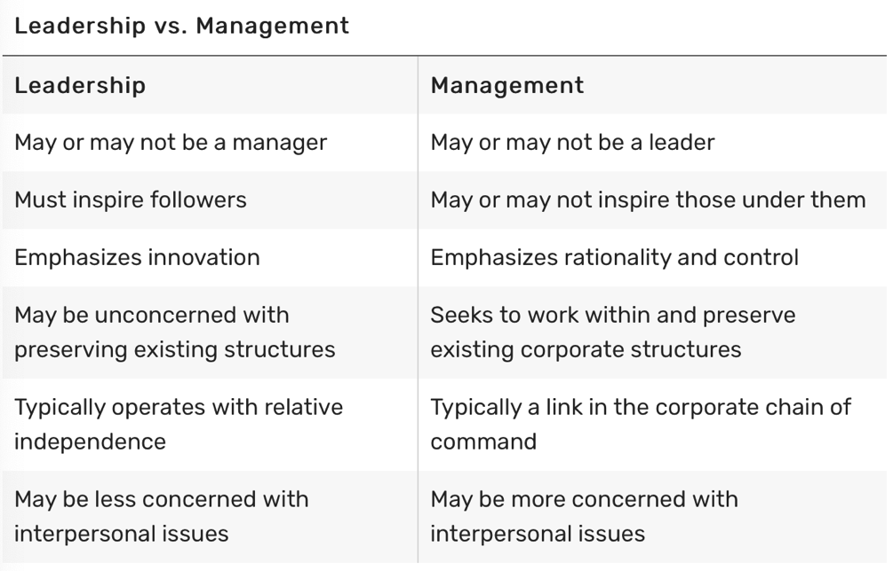
Appendix A

(Ward, 2020)

Appendix B

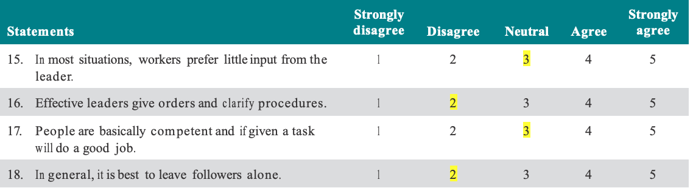
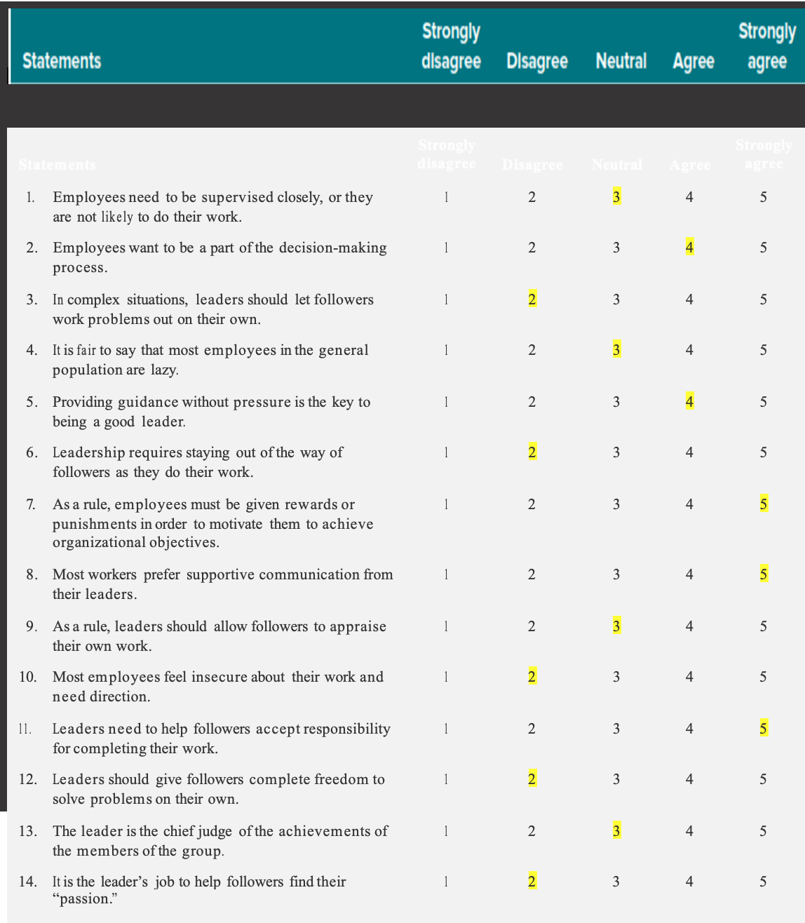
Leadership style questionnaire

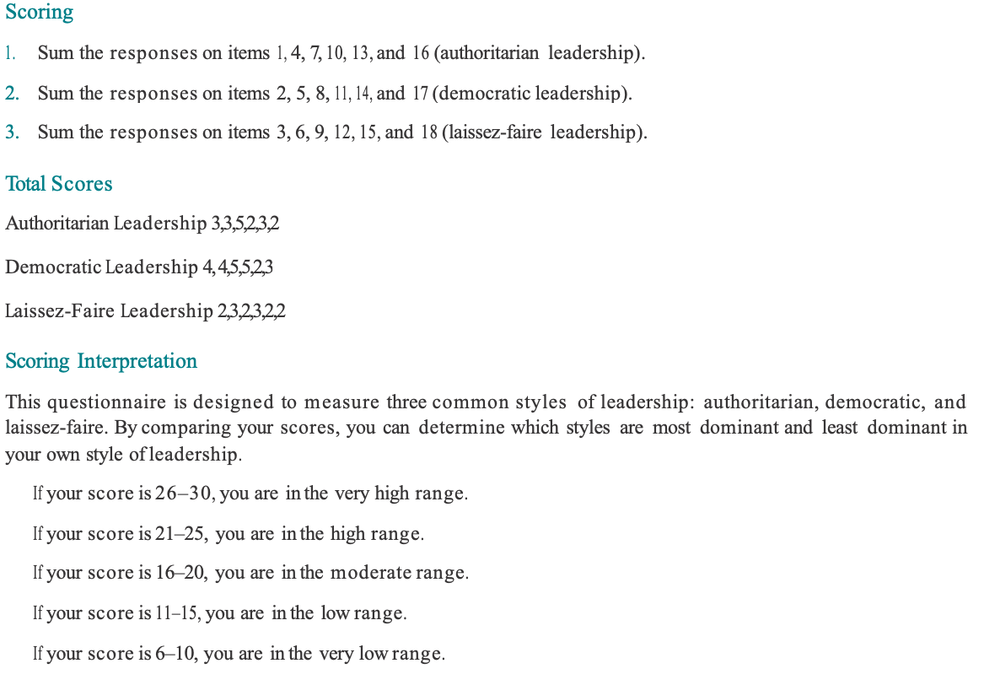

Appendix C

Leadership skills questionnaire
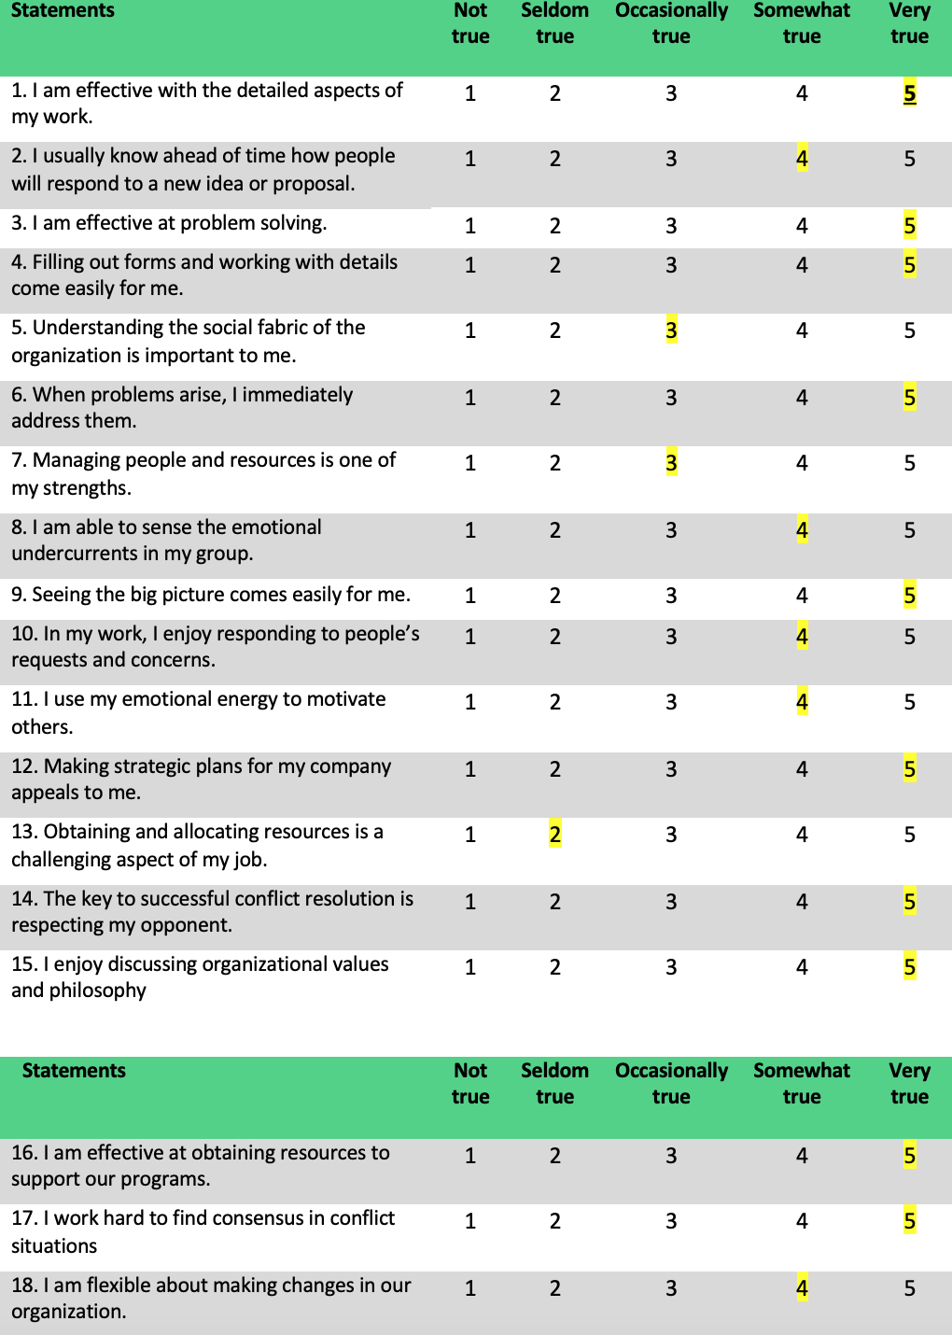
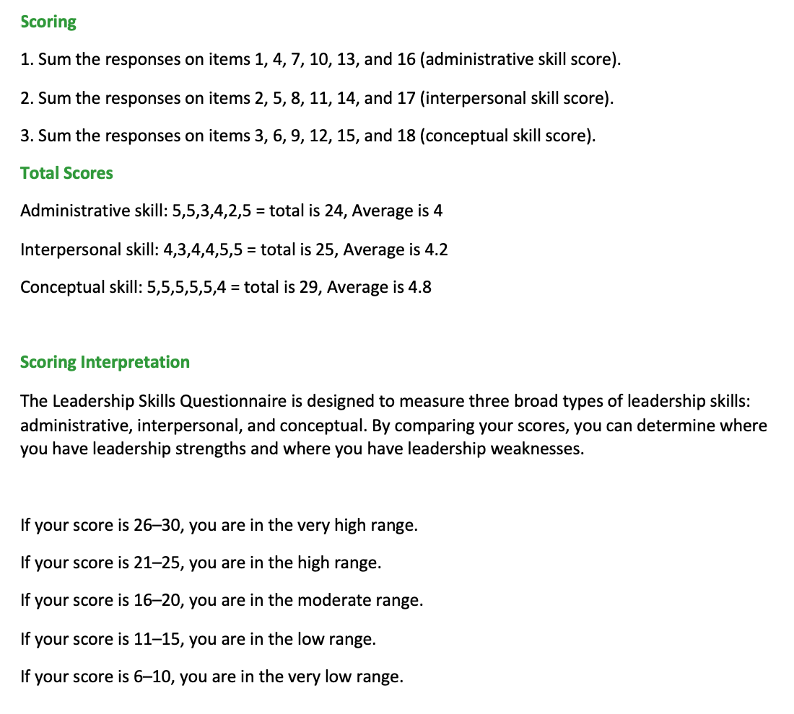

Appendix D

Situational Leadership questionnaire


