Task1

ISO 27000 series
The ISO 27000 series is a common security framework jointly issued by the International Organization for Standardization (ISO) and International Electrotechnical Commission (IEC). Its purpose is to control and manage the risk of information assets through a prescribed information security management system (ISMS), to help organizations ensure the security of information assets. It was first modified and integrated the existing British standard BS 7799, and it was continuously updated and added later, and it was renamed ISO27000 series then.
The series has published and planned to release more than forty documents and standards. Each standard is designed to focus on a specific area. Among them, ISO / IEC 27000, 27001 , 27002 are the most important and basic standards. Other standards are modified, supplemented and improved based on these three standards. For example, ISO 27018 focuses more on the protection of personal privacy data it bases on ISO 27002, it extends the definition of privacy protection for new personal data.

ISO / IEC 27001.2013
ISO/IEC 27001:2013 [ISO/IEC 27001:2013]
Information technology — Security techniques — Information security management systems — Requirements
ISO / IEC 27001: 2013 is the latest version of the 27001 document and the most well-known standard in the series，it provides requirements for an information security management system (ISMS).
ISO/IEC 27001:2013 specifies the requirements for establishing, implementing, maintaining and continually improving an information security management system within the context of the organization. It also includes requirements for the assessment and treatment of information security risks tailored to the needs of the organization. The requirements set out in ISO/IEC 27001:2013 are generic and are intended to be applicable to all organizations, regardless of type, size or nature. Chart 1 shows ISO/IEC 27001:2013 contents
0 Introduction
1 Scope
3 Terms and definitions
4. Context of the organization
5. Leadership
6 Planning
7 Support
8.Opreration
9 Performance evaluation
10 Improvement
Chart 1-1

ISO / IEC 27002.2013
ISO/IEC 27002:2013 [ISO/IEC 27002:2013]
Information technology — Security techniques — Code of practice for information security controls
The newest version of ISO 27002 is ISO/IEC 27002:2013. 27002 is an auxiliary file supporting the implementation of 27001.
ISO/IEC 27002:2013 gives guidelines for organizational information security standards and information security management practices including the selection, implementation and management of controls taking into consideration the organization's information security risk environment(s).
It is designed to be used by organizations that intend to:
1.select controls within the process of implementing an Information Security Management System based on ISO/IEC 27001;
2.implement commonly accepted information security controls;
3.develop their own information security management guidelines.
Chart 1-2 shows the content of ISO/IEC 27002:2013
0 Introduction
1 Scope
2 Normative references
3 Terms and definitions
4 Structure of this standard
5 Information security policies
6 Organization of information security
7 Human resource security
8 Asset management
9 Access control
10 Cryptography
11 Physical and environment security
13 Communication security
14 System acquisition, development, and maintenance
15 Supplier relationships
16 Information security incident management
17 Information security aspects of business continuity management
18 Compliance
Chart 1-2
Some other well-known ISO series standards are listed in the chart 1-3 below
Standard | Title or Topic
27003 | Information Security Management Systems Implementation Guidance
27004 | Information Security Measurements
27005 | ISMS Risk Management
27006 | Requirements for Bodies Providing and Certification of an ISMS
27007 | Guidelines for ISMS Auditing
27008 | Guidelines for Information Security Auditing
Chart 1-3
It can be seen that the ISO series of standards covers a very wide range. Some of the documents focus on specific aspects of information security, such as network security and application security, and some involve special industries such as healthcare. Therefore, no matter what the organization is, Find the appropriate documentation to resolve the issue.
In addition, we can see from ISO / IEC 27002: 2013 and ISO / IEC 27001: 2013 that this series of standards only provides a framework, not very detailed, and the documents in this series deliberately broaden the content and do not involve confidentiality Privacy, network security issues, and IT technology, so its another advantage is that it is suitable for companies and organizations of all sizes and technical levels, so this series is very popular worldwide.
Some of the standards in the ISO 27000 series are free and open source, but there are still some that require paid use and are sold directly by ISO. However, ISO encourages organizations to develop ISMSs suitable for them, and only considers the ISO 27000 series as a framework and guide. Finally, the ISO standard has been continuously updated and supplemented to adapt to the rapid development of information technology, which is one of the reasons why it is so popular.

NIST SP800 series
The NIST SP800 series of standards are a series of models and guidelines on information security issued by the United States NIST (National Institute of Standards and Technology). The earliest purpose was to help non-military federal agencies to adapt to federal information processing standards. After a lot of practice and cumulative collection, this series of government information security work has developed many standards, including a large number of documents and standards. Chart 1-4 shows some common standards
Standard | Title of Topic
NIST SP800-12 | An Introduction to Information Security
NIST SP800-14 | Generally Accepted Principles and Practices for Securing Information Technology Systems
NIST SP800-18 | Guide for Developing Security Plans for Federal Information Systems
NIST SP800-34 | Contingency Planning Guide for Federal Information Systems
NIST SP800-37 | Guide for Applying the Risk Management Framework to Federal Information Systems: A Security Life Cycle Approach
NIST SP800-39 | Managing Information Security Risk: Organization, Mission, and Information System View
NIST SP800-53 | Security and Privacy Controls in Federal Information Systems and Organizations
NIST SP800-53A | Assessing Security and Privacy Controls in Federal Information Systems and Organizations: Building Effective Assessment Plans
Chart 1-4
In fact, this series of standards is much more than that, it can be said that one of the characteristics of this series is that it covers a wide range.
This series of protocols has the following two significant advantages
1.They are publicly available at no charge
2.They have been available for some time, thus, they have been broadly reviewed by government and industry professionals.
Because of these two advantages, the U.S. government and many U.S. companies choose this series instead of the ISO series standards. In addition, this series of protocols has considerable flexibility and comprehensiveness, so this series has become very popular.
Of these standards, NIST SP800-53 and NIST SP800-53A are the most widely known and used

NIST SP800-53
NIST SP800-53 provides all the security and privacy directories of the U.S. Federal Information System, except of course for national security related content, it is part of the Special Publication 800-series. Specifically, NIST SP800-53 includes detailed information on the NIST family of security controls, all steps in the risk management framework and "a more holistic approach to information security and risk management by providing organizations with the breadth and depth of security controls necessary to fundamentally strengthen their information systems and the environments in which those systems operate- contributing to systems that are more resilient in the face of cyber attacks and other threats.”
It is worth noting that the NIST SP800-53 framework is very flexible and can be customized, sometimes as part of an organization's risk management strategy.
This document has a fifth revision in draft. In the fifth revision, twenty different privacy and security controlled directories allow U.S. federal agencies and organizations to better manage their risks.

NIST SP800-53 A
NIST SP800-53 A is a companion guide to NIST SP800-53, which provides a set of procedures for evaluating security controls and privacy controls used in federal information systems and organizations. A big advantage of this program is that it can be easily modified and customized, so it can be applied to various organizations. It also provides information on establishing an effective security evaluation plan and privacy evaluation plan, and guidance for analyzing the evaluation results.

NIST Cybersecurity Framework
The NIST Cybersecurity Framework (NIST CSF) is a new CSF released by NIST in the United States in 2014.It provides a computer security guidance policy framework and is designed specifically for individual businesses and other organizations. The main purpose is to help them assess risks and guidance based on existing standards that how US private companies can improve their ability to detect, defend, and respond to cyber attacks and risks. The NIST Cybersecurity Framework has proven to be flexible enough to be used by organizations outside the United States. In fact, NISTCSF did not introduce new standards and concepts at the beginning, but just used and extracted the network security frameworks already widely used by the industry such as NIST and ISO.
The framework is divided into three parts, "Core", "Profile" and "Tiers". The "Framework Core" contains an array of activities, outcomes and references about aspects and approaches to cybersecurity. The "Framework Implementation Tiers" are used by an organization to clarify for itself and its partners how it views cybersecurity risk and the degree of sophistication of its management approach. A "Framework Profile" is a list of outcomes that an organization has chosen from the categories and subcategories, based on its needs and risk assessments.
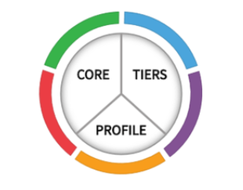
The framework has a simple self-assessment system with the following evaluation criteria
Leadership
Strategy
Customers
Measurement, Analysis and Knowledge Management
Workforce
Operations
It should be noted that the NIST Cybersecurity Framework is not a comprehensive and standard framework. It is more similar to ISO 27001, a general guide.it provides a brief and accessible high-order guide to information security, broken down into five categories: identify, protect, detect, respond, and recover.
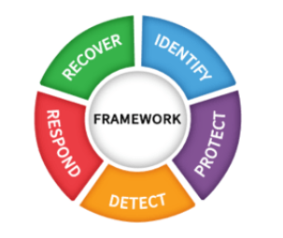
This makes it not comprehensive and detailed, but it also reduces the time and investment costs of using it, so it can be popular among SMEs. And one of its disadvantages is that its simplicity does not make it meet common compliance requirements.
In addition, the NIST Cybersecurity Framework is a voluntary framework that contains standards, guidelines, and best practices for managing Cybersecurity-related risks, and is a fee.
NIST Cybersecurity Framework is also constantly improving and modifying

Comparison of ISO 27000 series, NIST800 series and NISTCSF
Compared to ISO 27000 series, NIST SP800 series is more comprehensive, and can get many past success stories. The required documents can also be obtained for free, but NIST SP800 series also brings disadvantages because of the comprehensive content, such as time and investment costs are higher than ISO, and require very experienced professionals to guide the operation. And NIST mainly serves the US federal agencies and organizations, and ISO is an internationally recognized standard
Compared with NIST SP800 series, the main advantage of ISO 27000 series is that ISO standards are suitable for all types of organizations, including public institutions, private institutions, profit institutions and non-profit organizations. Another advantage of ISO 27000 series is that the technology is low and is based on risk management approach.
NIST cybersecurity framework has less coverage of major cybersecurity frameworks than ISO 27000 series, but it will also be more friendly to smaller organizations. In contrast, ISO 27000 series is a widely used international network security framework, covering a lot of content.
Finally, compared to NIST SP800 series , NIST CSF is more basic and simple, and the cost of use is low. Therefore, it is very suitable for small and medium-sized enterprises that cannot afford a lot of time and investment costs. Efficient.

The connection of the three frameworks and how to choose from ISO 27002, NIST SP800-53 and NISTCSF
In fact, there is a close relationship between ISO 27002 and NIST SP800-53 and NISTCSF. NISTCSF borrowed part of ISO 27002 and NIST SP800-53 and added its own new content, but overall it is less than the other two frameworks. Therefore, NISTCSF is more suitable for small organizations, and ISO27002 and NIST800-53 are more suitable. Large organizations with wider demand. NIST SP800-53 can be seen as a more detailed ISO 27002, because the former contains almost everything of the latter, and the relationship between the three can be represented by the following figure 1-1
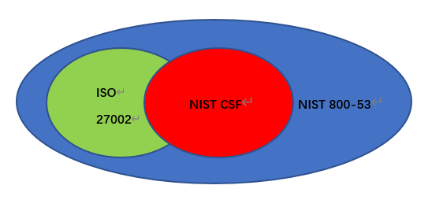
figure 1-1

Task 2

Security Management Practice

Risk Management
First of all, we need to assess the value of the company's assets. Only after we assess the value of the assets can we define the severity of the risk, because the size of the risk is directly proportional to the impact on the property.
Assets to be evaluated include physical assets and information assets
Physical assets include company infrastructure, computer room, server, computer, communication equipment, factory, transportation, etc
Information assets include code, web page, user data, company data, etc.
Here, the NIST framework in Task1 is used to assess the value of all assets

Risk assessment
Only through a comprehensive risk assessment can we know the risks faced by the company and the risk degree of each risk, and then we can specify a targeted safety implementation plan for each risk and select appropriate safety technology and products. Here use NIST generic risk model in Task1, Figure 2-1 shows the process.
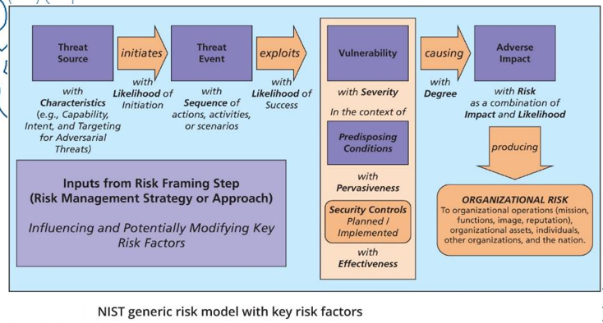
Figure 2-1 NIST generic risk model

Develop risk assessment table, possibility table and finally risk table
Rank | Description | Definition | Suggestion
0 | No risk | No security issues | No need to process
1 | Insignificant | Very small security issues, no direct impact on the business | Record, assess, and deal with risks when necessary
2 | Minor | Minor security issues will only have a very small impact on the business | Record, assess and deal with risks within 130 days
3 | Moderate | Medium risk security issues that may affect the business | Record, assess and deal with risks within 90 days
4 | Major | Serious security vulnerability, if exploited, may have a serious impact on the enterprise | Record, assess and deal with risks within 30 days
5 | Severe | Very serious security vulnerability, if exploited, will cause serious damage to the business | Record, assess, deal with risk immediately
Table 2-1 risk assessment table

Rank | Description | Percent Likelihood
0 | Not applicable | 0% likely in the 12 months
1 | rare | 5% likely in the 12 months
2 | unlikely | 25% likely in the 12 months
3 | moderate | 50% likely in the 12 months
4 | likely | 75% likely in the 12 months
5 | Almost certain | 100% likely in the 12 months
Table 2-2 possibility table
Severe | Low | Medium | High | High | Critical
Major | Low | Medium | Medium | High | High
Moderate | Low | Low | Medium | Medium | High
Minor | Low | Low | Low | Medium | Medium
Insignificant | Low | Low | Low | Low | Low
 | Rare | Unlikely | Moderate | Likely | Almost Certain
Table 2-3 risk assessment table
Evaluate the possible risks according to the risk table, and the aspects to be evaluated include
Physical security risk
- Safety risks caused by personnel entering and leaving the machine room at will
- Anti-theft measures in the computer room do lead to the risk of equipment theft and damage
- Risks of equipment room facilities caused by temperature and humidity exceeding the allowable range
- Risks caused by equipment stop operation due to failure of power supply facilities in machine room
- Risks caused by natural disasters, such as earthquake, fire, lightning, etc
- Electromagnetic interference risk
Calculate environmental security risks, the aspects to be evaluated here include
- Identity authentication
- Access control system audit
- Intrusion Prevention
- Software fault tolerance
- Data integrity
- Backup and recovery
- Etc.
Regional border security risk
- Border access control
- Boundary integrity detection
- Border intrusion prevention
- Border security audit
- Etc.
Communication network security risk
- network structure
- Network security audit
- Network equipment protection
- Communication integrity and confidentiality
- Etc.

Risk Treatment
After a complete assessment of all aspects of risks, it is necessary to formulate governance strategies for risks. The process of risk governance is shown in the following figure 2-2. Here, iso 27005 information security risk management process in ISO 27000 series is selected
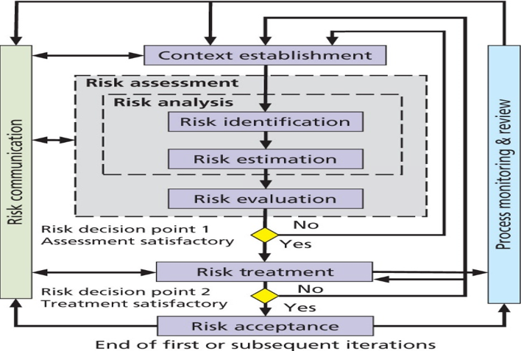
Figure 2-2 ISO 27005 risk treatment process

Contingencies planning
It is also necessary to formulate emergency response. In many cases, some crises are sudden, such as natural disasters, human operation errors, etc. if there is no pre-determined measures to deal with the emergency, it is easy to cause a large number of losses or even bankruptcy of the company after the emergency.
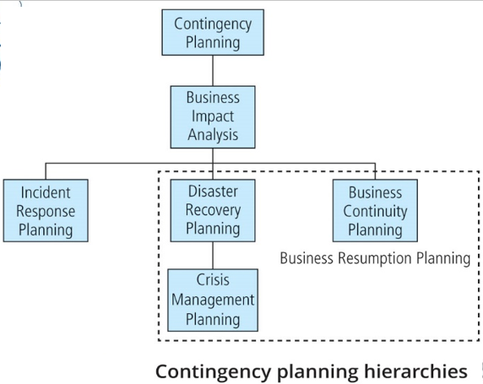
Figure 2-3 contingency planning hierarchies
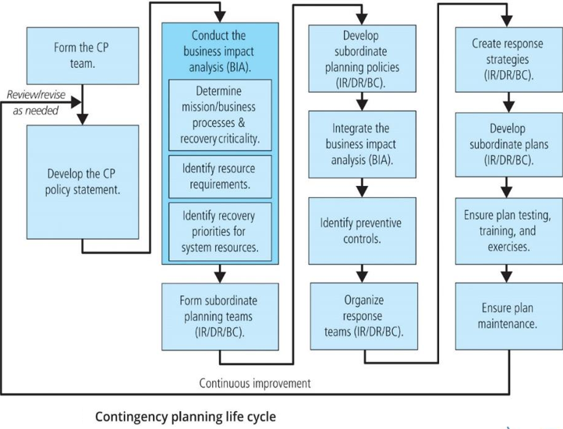
Figure 2-4 contingency planning life cycle

Incident response
Developing incident response is an effective way to deal with emergencies, which can effectively detect and respond to staff errors, service interruptions, natural disasters and other situations
According to NIST sp800 series framework in Task1, the flow of incident response is as follows
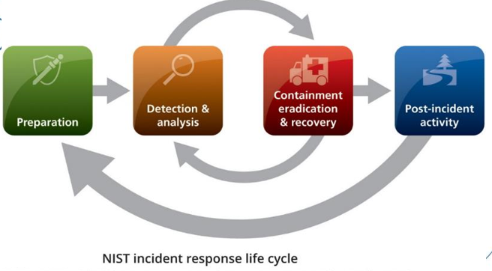
Figure 2-5 NIST incident response life cycle
The responsibility for creating an organization’s IR plan usually falls to the CISO, or an IT manager with security responsibilities
According to NIST SP 800-61, Rev. 2, the IR plan includes:
- Mission
- Strategies and goals
- Senior management approval
- Organizational approach to incident response
- How the incident response team will communicate
- Metrics for measuring incident response capability and effectiveness
- Roadmap for maturing incident response capability
- How the program fits into the overall organization

Disaster Recovery
Disasters can be divided into
- Natural disasters
- Man-made disasters
According to the development speed of the disaster, it can be divided into
- Rapid onset disasters
- Slow onset disasters
To deal with different disasters, different Dr plans should be formulated. The basic Dr plan elements are
- Name of agency
- Date of completion or update of the plan and the date of the most recent test
- Agency staff to be called in the event of a disaster
- Emergency services to be called (if needed) in event of a disaster
- Locations of in-house emergency equipment and supplies
- Sources of off-site equipment and supplies
- Salvage priority list
- Agency disaster recovery procedures
- Follow-up assessment

Business Continuity Planning (BCP)
Sometimes the disaster is too serious for the company to continue to operate in common office places, so business continuity planning (BCP) is also required

Protection mechanisms
Protection mechanisms need to be applied in two areas.
First, access controls. Set access levels for all employees and users. A certain access level can only access certain information and assets.
The user level is the lowest, and can only access the open information published on the network, and cannot contact the company's physical assets.
General employees can only access limited company information assets. For example, programmers can access some surface code but not the bottom code. They may access the company's core database, and they cannot access the company's computer room.
Senior employees can access more information, such as company databases and servers
Managers have the highest level of access to all information assets and physical assets, so they should be strictly audited to prevent them from stealing and damaging assets.
The other is network security. The firewall should be used between the internal network and the external network of the company to prevent the internal network of the company from being attacked and influenced by the external network. Considering that most of the companies use Windows platform, ISA Server firewall can be used, which is the best firewall in the application layer. Due to the large scale of the company, the following scheme is adopted
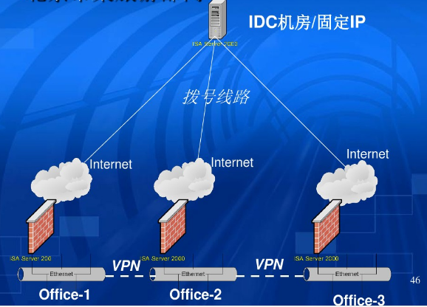
Figure 2-6 Firewalls implement
In terms of network security, we also need to take a protective mechanism to prevent network viruses, which will pose a huge security threat to the company. Therefore, it is necessary to fully deploy the anti-virus system in the enterprise

Service level agreement
Finally, make a service level agreement
It is impossible to set SLA too high in the company's scale, but if the SLA is set too low, it will affect the company's image and customer's trust in the company and satisfaction with the company's services. Therefore, SLA is set at 99.99%, and the following compensation is made for the situation that the SLA fails to meet 99.99%
SLA | Compensation measures
99.9% | Reduce the price of all products by 5%
99% | Reduce the price of all products by 10%
Below 99% | Reduce the price of all products by 20%
Table 2-4 SLA

