Community Engagement

Local Authority Community Engagement Process - Assessment 1
Third Age Project
Student Name: Valeria Peeva
Student Number: 2029005

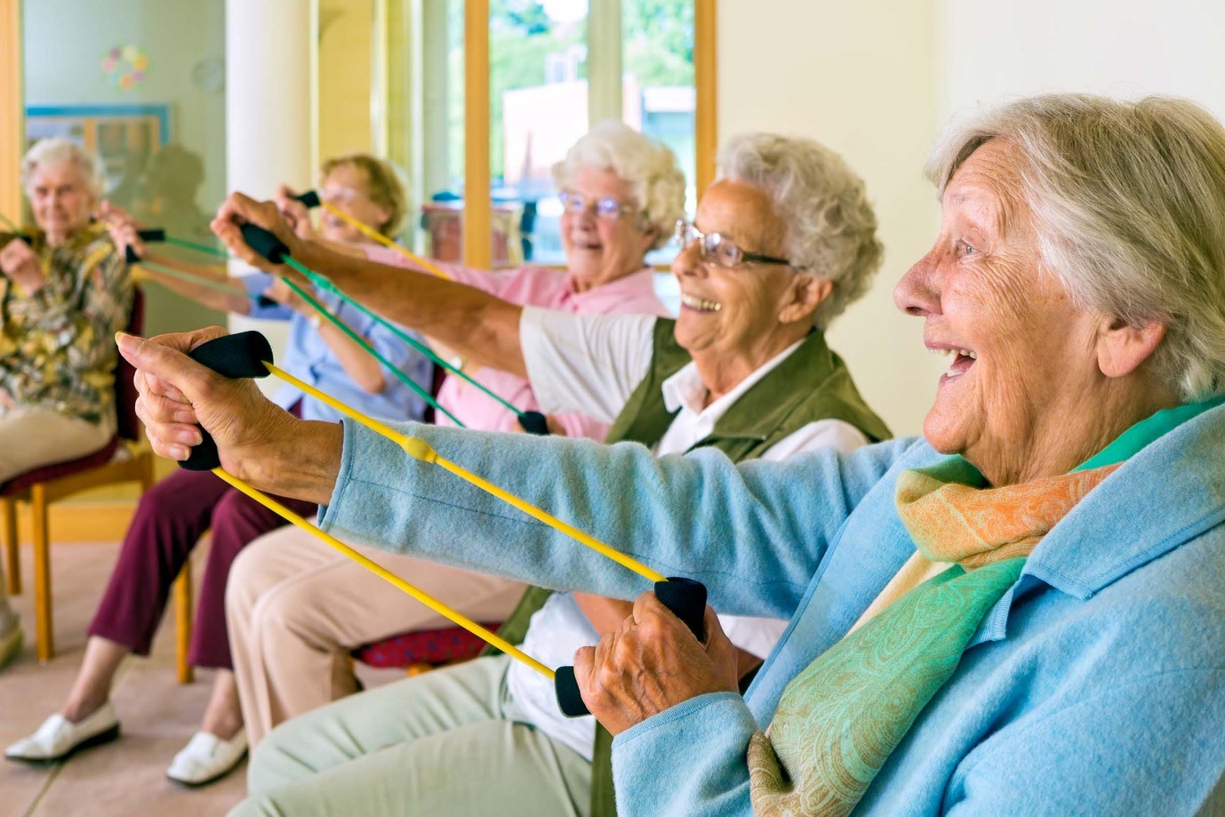
This Photo by Unknown Author is licensed under CC BY

Programme: BA Business Management
Module: Community Engagement
Module code: LCBB4002
Module Coordinator/ Lecturer: Faizu Edu/ Toyin Adisa

Table of Contents
Introduction 3
The Project 3
Community engagement principles 4
National Standards for community engagement 4
Benefits of stakeholders’ participation 4
Social Media Platforms 5
Community involvements ………………………………………………...……………………….. 5
Collaboration………………………………………………………………………………….…… 5
Socio cultural integration…………………………………………………………………….….… 5
Multiculturalism…………………………………………………………………………………… 5
Internal factors…………………………………………………………………………………….. 6
External factors……………………………………………………………………………………. 6
Conclusion…………………………………………..…………………………………………..……. 7
References …………………………………………………………………………………………… 8


This Photo by Unknown Author is licensed under CC BY

Introduction
Community engagement helps in creating changes which can results in better society. It is a determined method which creates a valuable connection among neighbourhoods, public businesses to assist them to distinguish and action on society demands and aspirations. It implies considerate conversation amongst all participating, targeted at increasing knowledge among them and bringing collaborative activity to attain encouraging transformation. The Third Age Project was begun to challenge sheer community, wellbeing and financial disparities that occur along with regional mature individuals that implies they need a much sharper life cycle and are at more danger of creating extended period situations and experiencing inadequate psychological strength. To maintain and inspire underprivileged resident eldest families in defeating the obstacles that occur (hardship, incapacity, communication, and ethnicity) that avoid them from retrieving conventional and different amenities and facilities. To decrease isolation and public loneliness that happen along with countless mature individuals particularly those who survive on their own by linking them to fellow citizen, extended family, and acquaintances. To offer underprivileged adult persons a more right to be heard and speech and provide them with the abilities and expertise to practice broader selection and further power across their lifetimes so that they can take over role additional completely in daily life cycle. To enhance the common physical condition and happiness of needy elder ones within the local region through the supply of natural movement and healthful dwelling plans.
The project
TAP’s aim is to change on its own common position that the Third Age is a responsibility on the world and encourage the understanding older individuals are important and beneficial resources to be positioned at the extremely heart of a society. In undertaking so we convert mature people’s beings, encourage innovative ambition, co-generate low-cost public services, and create society, changing the deteriorating value of life cycle and well-being of the elderly. They deliver an extensive variety of communal, social, informative, vigorous existing and elementary existence ability progressions, as well as assisting and funding facilities, with the goals of refining value of life, overall wellbeing, and cosiness, and to prepare older people with the sureness and information to work out better choice and inspiration over results that touch their lives. These services are commenced to help the generous objectives for the people advantage. They are based in their own centre located on a big, elevated upswing accommodation property that is one of the greatest culturally varied in London especially concerning the selection of home languages and the statistics of faiths followed. Such variety could be found as representing numerous obstacles to community unity and individuals having to understand and believing each other or as we see it as an exceptional society benefit. There are expanding public, commercial and wellbeing disparities that occur with typical lifetimes other than ten years shorter than in more wealthy regions. Furthermore, they are extra expected to suffer inadequate physical condition and improve long term strength disorder during their final years. The region includes a few of the neediest retirees in the area who mostly live only, over the land in flatted public leased lodging, on low wages and endure reduced healthiness. Elder people are at elevated danger of suffering social loneliness and isolation as of achieving such probability causes. There are few secure and reliable neighbourhood areas and prospects for recruits and individuals staying only to join others and develop innocent relations. As we get older, we grow to be further exposed to community separation at evolutions in our natural life such as grief and retreat with a demand to build new-found alliances and individual assistance systems. The facility has developed a much appreciated and extremely fashionable spot delivering a welcoming cheer to everyone.

Community engagement principles
Several groups and academics put together classified fundamental rules of community engagement. The Co-Intelligence Institute has established the next seven main beliefs that reveal the general principles and attitudes of those employed in the subject of public commitment – disagreement, dispute resolve, and cooperation. In preparation, these beliefs, and others, are affected in various aspects. The extremely prevailing result is that neighbourhoods are certainly not ideal, but they are effective. They and their populace are crucial to enhancing all from teaching and commercial progress to wellbeing treatment and race affairs. Across sufficient and comprehensive development, guarantee that the project, business, and arranging of the procedure provide together an obviously well-defined objective and the demands of the members. Rightfully integrate various individuals, opinions, concepts, and data to put the foundation for excellence results and elected authority. Help and inspire applicants, administration and public associations, and others to act collectively to progress the ordinary great. Assist all participating take heed to each other, discover innovative concepts unrestricted by determined effects, discover and request knowledge in practices that produce different possibilities, and calculate open commitment movements for efficacy. Be transparent and accessible regarding the procedure, and deliver a shared history of the planners, supporters, results, and variety of ideas and concepts stated. Guarantee every involved attempt has true ability to make a change, and that applicants are informed of that possibility. Encourage a society of involvement with courses and organizations that encourage continuing value public commitment.
National Standards for community engagement
The National Standards for public action are great-exercise tenets intended to encourage and advise the practice of public commitment and develop whatever occurs consequently.
- Inclusion - recognize and engage the individuals and businesses that are impacted by the aim of the commitment.
- Support - We will find and defeat any obstacles to involvement.
- Planning - There is a certain reason for the situation, which is cantered on a mutual appreciation of the public demands and aspirations.
- Working together - organized to accomplish the objectives of the commitment.
- Methods - techniques of action that are suitable for intent.
- Communication - connect obviously and frequently with the individuals, businesses and neighbourhoods impacted by the commitment.
- Impact - evaluate the effect of the action and apply what we have discovered to enhance our potential civic position.
Benefits of stakeholders’ participation
Involvement by design investors requires communicating a shared knowledge and participation in the decision-making method of the plan. Contribution by investors indicates to equality and to mutual possession of the strategy. To boost membership the scheme must begin with a discussion procedure that leads to conversations and closes with common conclusions. Input by development sponsors has numerous profits and compensations, between them like safeguards that the scheme tactics reproduce the actual requirements and urgencies. Creates an atmosphere of responsibilities by letting the opinions of the participants be understood and their concerns be established. Bring about the development answerable to the participants and allows the speeches of the participants to be learned and by making that the degree of confidence in the interaction’s boosts. Stimulates clarity in the activities of the design and guarantees that the mission is taken responsible for its activities. Improves tenure by investors who think the venture is bringing in balance their ideas and inspires them to fund the venture, which in the end runs to sustainability. Is a strategic approach to victory funding to the venture, to achieve dedication to the plan, and finally to boost the prospects for sustainability when the development has been finished. Original growth involves a public focused methodology as a substitute of a production tailored one. Mission leaders want to get around the traditional method of top-down results to integrate a bottom-up style that allows a more viable explanation. Though involvement might involve more point and reserves and may be more challenging to execute; the outcomes is a growth in dedication to the task. Participants who are asked and make up portion of the result experience additional wanting to help the development.
Social Media Platforms
With the help of social media, they update people on regular basis so that they can also contribute towards various charity programs. Creative post and innovative content attract substantial number of people who can take initiative to resolve the various problems which are elder people are facing in society. Many people get engage through some content on social media which has posted by many creativities artist who shows there when you will contribution in getting best results. As social media platforms grow to incentive genuine social relations, social media commitment has developed a crucial part of any promotion approach. Without commitment, social media is simply a media. Individuals do not employ social links for a one-way understanding. They are looking for relationships — with individuals and with labels. What began as a means for individuals to hang out with their friends virtual has transformed into a location where products can participate in significant discussions and turn those chats into followers and consumers. And social media engagement has a key effect on small companies, impacting all from product appreciation to client devotion.
Community involvements
Social media participation is one of an initiative to engage more people towards them. Not only the aged once but the younger youth also getting inspired from their programs. All public effort offers the chance to interact with regional company vendors, non-profit corporations, public advisers, and neighbourhoods. You might be amazed by groups or area projects that you were not informed of earlier. Plus, you can discover brand new partnership prospects and methods you be capable of effort simultaneously in an equally advantageous manner that were not evident in the past. Although interacting is a fantastic approach to create your web of connections, you should not find this as a fast approach to expand your volume of enterprise. It is important to go into these interacting prospects with legitimate objectives to understand and develop.


Collaboration
The aim of alliances is to create persons, groups, associations, and public representatives themselves collectively in an environment of help to methodically resolve current and developing difficulties that could not simply be explained by one party only. Every degree could be necessary to accomplish the required objective. Intellectual around association as a variety assistance to evade or resolution a shared test to associations: if associates have dissimilar meanings of teamwork, they will consume contradictory prospects foremost to suspicion and prevention; for instance, if one partner thinks about interacting and the other one about collaborating, their outlooks about their work together will be very incompatible and delay objective accomplishment.
Socio-cultural integration
Socio-cultural assimilation is involved with the issue of whether cultural sector alliances develop role of the accepting culture or whether these classes stay different from the present nation.
Multiculturalism
Multiculturalism has many advantages. The most important one is that it promotes open-mindedness between various parties of society, and it dismisses harmful labels. This is particularly valuable as the UN stated that one-third of the globe's key disputes have a cultural aspect to them.
Internal factors
Internal pressures consist of aspirations, likes, dislikes, individual beliefs, and opinions of community standards. They are fractured into four types: social factors, community factors, environment and geography, and assets. Each element debated in the paper is simply a cause that might be current in a neighbourhood that know how to promote in the direction of public growth.
External Factors
External impacts involve society representatives, family, ethnicity and customs, acquaintances, expertise, and the media. Society issues relate to the urgent basic and common environments of entities and families/groups that both improve or reduce a person's probability of suffering cruelty, mistreatment, or violence in the past, throughout or later transferring.

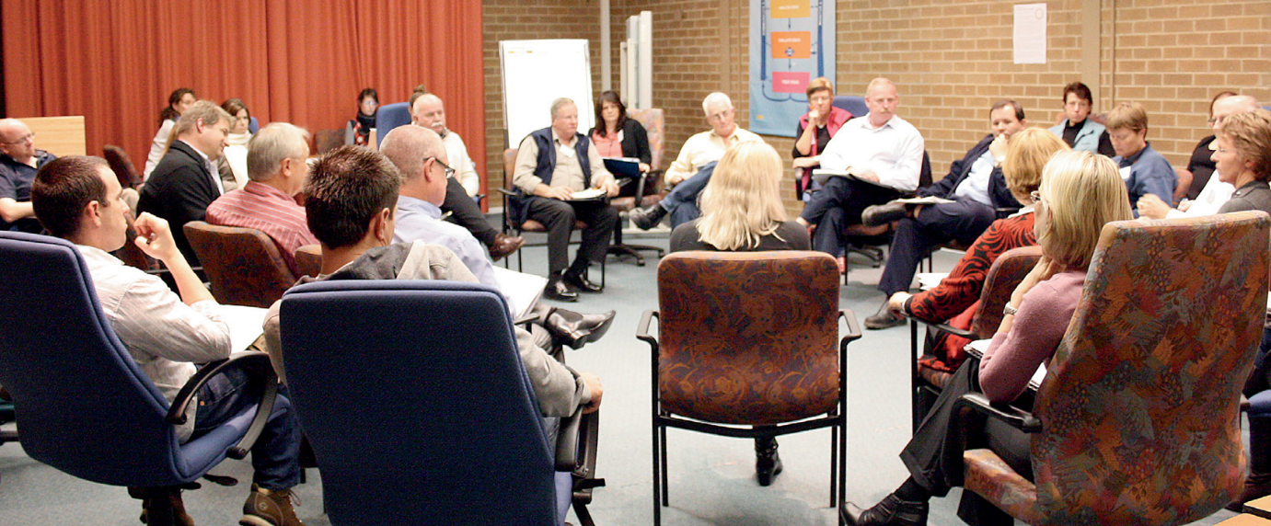
This Photo by Unknown Author is licensed under CC BY-NC
Conclusion
Community engagement is a path of improving an effective connection among community organisations (such as regional bodies) and civic factions. Excellent communal action will suggest that equally parties can appreciate and action on the demands or concerns of society practices, assisting to attain constructive transformation. It helps in getting interact with people and communicate about on life and perceptions which will boost confidence of aged people. The purpose of the charity is to offer community wellbeing, learning and relaxation facilities especially for adults over 50 years of age residing in the West Euston Area of the London Borough of Camden. The representatives keep out the bodies of the charity over the establishment of a broad variety of assistance packages and events to enhance the circumstances of living of elder persons.

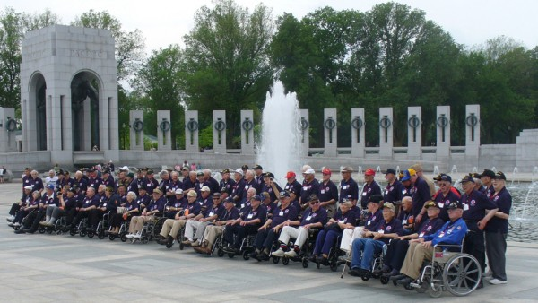
This Photo by Unknown Author is licensed under CC BY

References
ABOUT US, Available at: https://thirdageproject.org.uk/about/ (Accessed on 17/04/2022)
Community Collaboration, Available at: https://actforyouth.net/youth_development/communities/collaboration.cfm (Accessed on 18/04/2022)
Community Engagement, Available at: https://www.scdc.org.uk/hub/community-engagement (Accessed on 17/04/2022)
Community Engagement and Collaboration with Key Stakeholders, Available at: https://csgjusticecenter.org/publications/expanding-first-response/the-toolkit/stakeholder-collaboration/ (Accessed on 18/04/2022)
Community group environment for people participation and empowerment: the socio-cultural perspective, Available at: http://www.scielo.org.za/scielo.php?script=sci_arttext&pid=S0301-603X2013000100004 (Accessed on 20/04/2022)
Core Principles of Community Engagement, Available at: https://aese.psu.edu/research/centers/cecd/engagement-toolbox/engagement/core-principles-of-community-engagement (Accessed on 17/04/2022)
Day G. (2006) Community and everyday life
Exploring Strategic Factors of Community Development, Available at: https://www.universalclass.com/articles/business/exploring-strategic-factors-of-community-development.htm (Accessed on 20/04/2022)
Gilchrist A. (2009) The well-connected community: a networking approach to community development
Hardill, I. (2011) Enterprising care? [electronic resource]: Unpaid voluntary action in the 21st century
National Standards for Community Engagement, Available at: https://www.scdc.org.uk/what/national-standards/ (Accessed on 19/04/2022)
Rochester C. (2010) Volunteering and society in the 21st century
Transformation of Sociocultural Integration Policy and Inherent Political Theories in the United Kingdom: A Way Forward, Available at: https://journals.sagepub.com/doi/10.1177/21582440211007461 (Accessed on 19/04/2022)
Useful Concepts for the Practice of Community Engagement, Available at: https://www.atsdr.cdc.gov/communityengagement/pce_useful.html (Accessed on 20/04/2022)
7 Benefits of Stakeholder Participation, Available at: https://www.pm4dev.com/pm4dev-blog/entry/benefits-of-stakeholder-participation.html (Accessed on 18/04/2022)

