BEng, HND & HNC Automotive, Motorcycle & Motorsport Engineering
Engineering Technical Report
Module: Workshop & Practice
Module Code: ACHA4011
Student Name: William Davies
Student Number: 2400569
Lecturer: Dr Kerry Tudor
Submission Date: 01/12/2024

Contents
BEng, HND & HNC Automotive, Motorcycle & Motorsport Engineering 1
Introduction 3
Chapter 2 – Health & Safety 4
Chapter 3 – Engineers Roles in Society 5
Chapter 4 – Problem Solving 6
Chapter 5 – Team Structure 9
Chapter 6 – Personal Development Plan 10
Conclusion 12
References 13

Introduction
In this technical report the following topics will be covered will be health and safety along side a risk assessment in chapter 2. In chapter 3 I will be covering an engineers role within society. Chapter 4 will be about problem solving as an engineer. Chapter 5 is a personal review on a team structure. Chapter 6 is the personal development plan and finally a conclusion in Chapter 7.

Chapter 2 – Health & Safety
Activity – Operation of Lathe
Provision & Use of Work Equipment Regulations (PUWER) 1998
This legislation ensures that it is suitable for its intended use alongside with its safety, being maintained in a safe condition and it is inspected which will ensure that it is correctly installed and does not deteriorate in its condition.
This legislation also states that it is to be used by only personal who have received the correct information and training on the use of the machinery. The machinery should also be included with protective devices such as a guard, an emergency device and a source of isolation (any sources of power to the machine).
Control of Substances Hazardous to Health – (COSHH) 1989
This legislation is applied to the use of a lathe due to their being lubrication and/or cooling systems as well as the use of hydraulics to operate the machinery. Therefore, there could be some danger with this machine as there could be potential of exposure to oils, coolant, and metal swarf.
The PPE that must be worn –
- Eye protection – this ensures that any metal swarf flying off the material does not cause an accident and keeps the eyes safe from injury
- Steel toe cap boots/composite – this ensures that if any tools, equipment or materials are dropped that it will prevent injury to the foot
- Safety jacket – wearing this prevents any metal swarf getting ejected from the machine does hit the operator, this prevents injury
- Additional Safety Protection: in the use of machinery guards or any other safety equipment that the machine has should be used

 |  |  |  | Consequences
 |  | Minor |  | Moderate | Severe
Very Likely |  | Fingers and/or hand being jammed in the moving components |  | Body parts being cut and/or scratched via cutting tools or sharp object | Loose clothing being entangled in the machine
Likely |  | Getting hit by debris |  | Debris getting into the eye | No room by the machine when in use (when people passing by may hit or nudge into the machine)
Possible |  | Manual handling heavy objects |  | Harm caused by debris | Burnt hand caused by freshly cut part
Unlikely |  | Lubricants irritating the skin |  | Vice not being secure down enough | Electric shock
 | Severe Risk
 | Moderate Risk
 | Low Risk

Chapter 3 – Engineers Roles in Society
The code of conduct for engineers was implemented by two organisations, the Engineering Council and the Royal Academy of Engineering. This was a code of conduct introduced to state the ethical principles of an engineers practice and behaviour. This code of conduct was generated in 2017.
Engineers must follow this code of conduct, and in Motorsport the engineers need to follow the respect for life, law and the environment. Engineers strive to minimise the environmental impact of their design and their process. When it comes down to motorsport and its events, its sustainability footprint gets thrown around a lot and get mentioned especially due to the carbon emissions, its waste management and fuel consumption. The engineers play a crucial role in developing a more sustainable technology process such as the hybrid engines and sustainable alternatives. The engineers design and process the engines so they can meet the regulations set by the higher up board which have a low emission standard, and this must be met. This is to reduce the amount of carbon emissions being emitted into the atmosphere. Any waste material etc must be recycled properly and any hazardous liquids must be disposed of effectively and efficiently. As engineers abide with this code of conduct, they reduce the environmental impact of the sport and they align their work with the global sustainability goals.

Chapter 4 – Problem Solving

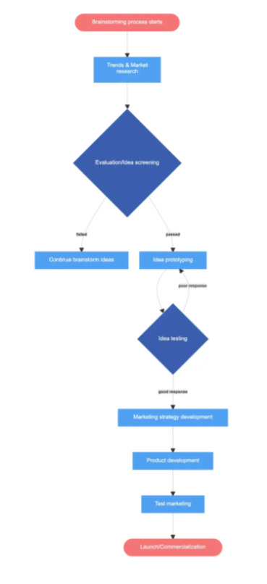
Issue Found in Development
The development of a new product is where the majority of issues occur and are to be solved. It is very uncommon for there to be a first draft of a design and for it to be perfect and the use of prototypes, the design can go through extensive testing which shows its strengths but also highlights its weaknesses and its flaws. This allows the issues to be seen and to be resolved. Presented is a flow chart showing the corrective actions that should be taken when problems occur within the development period.

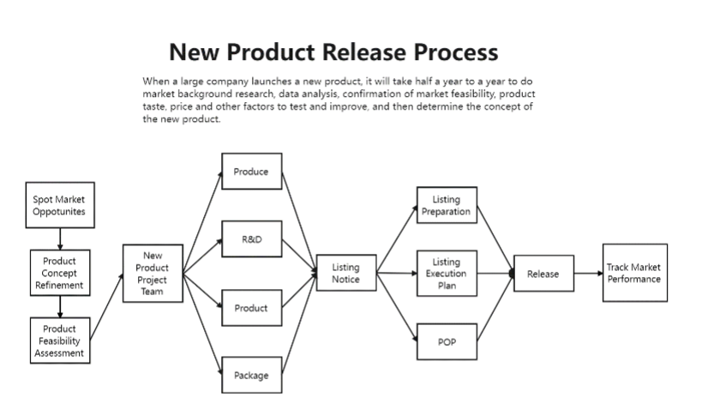
Issue Found Once on Market
When products are published to buy on the market, there may be flaws to the design or to the operation which may occur and were not seen when developing. Customers generally find problems or potential issues with the product through use or in other ways of using the product. These type of issues can be resolved through customer feedback and different iterations of the product in hand. These types of solutions occur in the trade of motorsport as some parts may have been developed and past testing but due to excessive wear or use faults occur. The flow diagram presented demonstrates the possible solutions that can be used when a product is in the market

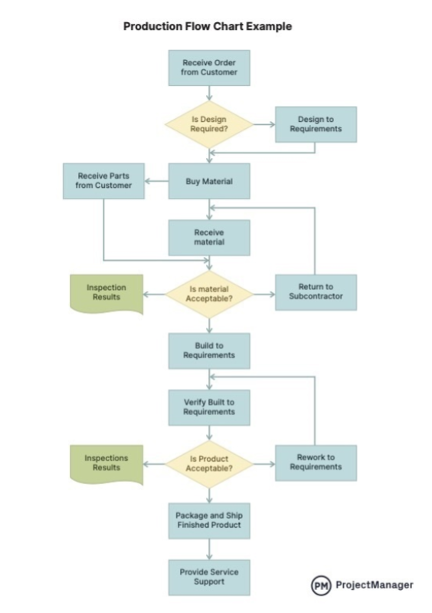
Issues Found in Production
Issues do occur when producing a product e.g. when the product is going to be made, is there a more cost-effective way to produce the product and are the materials being used available majority of the time. When producing product issues occur in supply chains of the materials resulting in the product cannot be produced or other factors could cause an issue such as the machines or the people creating the product who are inoperative or unable to complete the job resulting in the occurrence of issues. Here is a flow diagram representing the solutions to problems in production.

Chapter 5 – Team Structure
There are many main cores of a good working functional team, and it can be broken down into communication, collaboration, compatibility, likeliness, diversity etc. For an example, I was part of a team of four and we all had our own knowledge, strengths and weaknesses. The task was comparing the transmissions on a C1 track car and a Porsche 911. These two cars had the same intention of use to race round a track however are completely different. I was appointed as team leader as others, and I included felt I had to leadership capabilities and what it took to lead a team. So I decided that we all collaborated with each other and wrote down the transmission facts and compared showing how each car varied to one another. The group that I was with was people who I knew and had similar interests and got along well which is a pro to the group working so well, there was a good dynamic. A positive thing about the group was that we were able to communicate well and jot down our knowledge to put ideas forward. Negative of the group was that we all had the same interest therefore lacking the diversity, which led to it being difficult coming up with different ideas to one another.

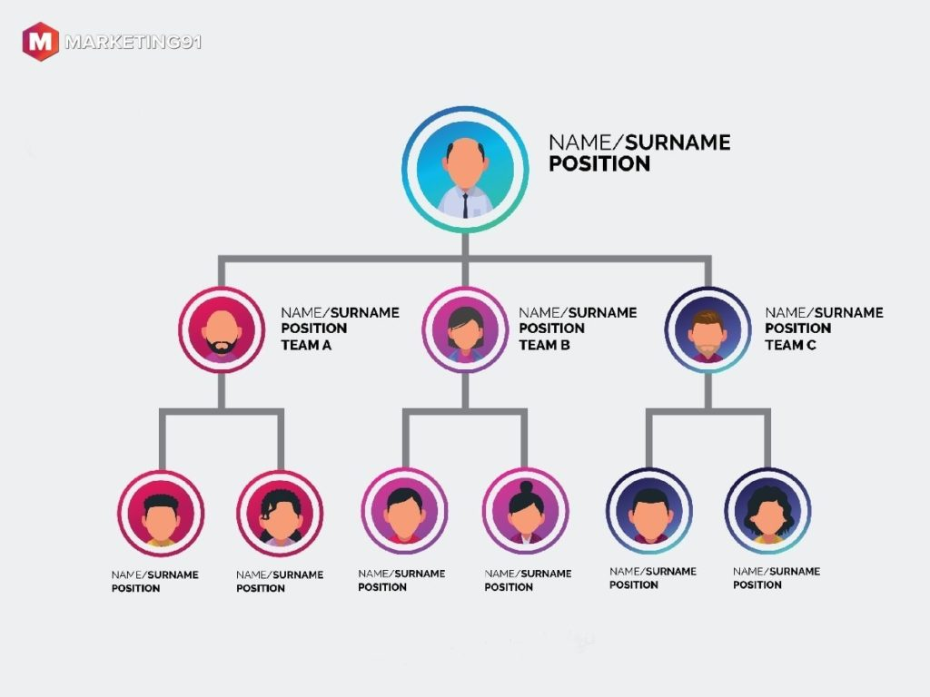
Here is an example of a hierarchal structure. With this structure relating to my team, we could have split into two separate groups increasing productivity as one or two people may have had more of an input than others with the workload also being split up. It could have allowed us to have a more diverse opinions and ideas and then coming together at the end to discuss our points.
As there are many positives to this structure, there are many negatives which could be associated.

Chapter 6 – Personal Development Plan
Personal Development Plan
Name – Will Davies
Degree – Motorsport Engineering HND
Previous Qualifications – BTEC Level 3 Diploma Advanced Manufacturing in Engineering
Previous Experience – non-professional experience in motorsport industry
Long Term Goals (5 to 10 years)
Become an F1 mechanic
Have a stable income, own a house
Short Term Goals (0 to 5 years)
To graduate with a Motorsport HND diploma
Become a more competent mechanic.
Apply for a motorsport job
Goal | Objective | Resources Required | Measurement | Target Date
Graduate with a Motorsport HND Diploma | To obtain the facilities to apply for a role in the Motorsport industry | -Course Materials  -Textbooks  - Library  - Software packages and writing tools | - Grades Achieved  - Completing all modules to a high standard  - Attendance | July 2026
Become a more competent mechanic | Work hard in my studies | -Knowledge of lecturers and peers  -Use of textbooks and resources  -Hands on experience  -mechanical knowledge and understanding | Graduate with 2.1 or above. | JNov/Dec 2026
Apply for a Motorsport job | To fulfil my dream and to have a stable income of a high end | -Experience  -High end knowledge | -Offer for jobs  - The fulfilment of reaching Formula 1 | July 2026
Obtaining a stable income and house | -to do well in my field of work, allowing me to earn a sustainable income | -Advanced knowledge of Motorsport vehicles and racing  - university degree in motorsport engineering  -high end well detailed CV with required skills and experience | -ownership of a house  - consistency of constant sustainable income | 2029

Conclusion
To conclude this report, I believe I have raised some ideas and have provided information on topics with the use of research and information from sources found online. Alongside with personal knowledge and information, with an insight on my personal goals in life and the achievements for the future. Furthermore, I have discussed about types of subjects which will come under an overarching area of engineering within the modern world with the inclusion of health and safety, roles of engineers in society, and the varies types of team structures which can be used for problem solving in an engineering scenario and environment.

References
Health and Safety Executive (HSE), Provision and Use of Work Equipment Regulations 1998 (PUWER)
Available at: Provision and Use of Work Equipment Regulations 1998 (PUWER) - HSE Accessed at 25.11.24
Engineering Council (2017). Statement of Ethical Principles
Available at Engineering Council
Accessed at 29.11.24
Precision Systems Inc: A Guide to Problem Resolution in Product Development - Precision Systems, Inc.
Accessed at 1/12/24
www.gleek.io (n.d). Diagram maker for developers
Available at https://www.gleek.io/blog/product-development-flowchart.
Accessed at 01/12/24
Tean Asana (2021). 10 Effective Ways To Organise Your Team
Available at https://asana.com/resources/team-structure.
Accessed on 01/12/24
Koeneke, B (2022). How to make a Production Flow Chart for Manufacturing Processes
Available at https://www.projectmanager.com/blog/production-flow-chart.
Accessed on 01/12/2024
Mavink. Hierarchal Organisational Structure Chart
Available at Hierarchical Organizational Structure Chart
Accessed on 01/12/2024

