Qualification:
CIPD Diploma in Applied Human Resources
Module Name:
Understanding Employment Law

Word Count: Activity 1 (822 words)
Activity 2 (823 words)
Activity 3 (824 words)
Activity 4 (814 words)
Activity 5 (813 words)
Activity 6 (825 words)
Total Word Count: 4,921 words
Student Name: Kate Houston
Student Number: 1403228
CIPD Membership Number: 49777067
By signing below, I confirm that the work/evidence presented is my own, unaided work. I understand the regulations pertaining to candidate malpractice and the action that may be taken as a result.

Signed: Kate Houston
Date: 11th March 2019

Question 1
Employment law regulates the relationship between employers and employees through the rules and agreed ways of working. It details the employers and employees’ rights, duties and obligations set by legislation, regulations of conduct and how the law is processed. It protects both parties and ensures fairness for individuals and the whole organisation, protecting against discrimination and promoting equality at work (Daniels, 2019; CIPD, ND). Employers can be more powerful than employees therefore, without legislation employers could exploit or compromise on health and safety, low wages and deny basic rights such as maternity pay. Employment law influences HR decisions, policies and procedures together with practices (Taylor and Wilkinson, 2016).

Employment law is governed by civil law concerned with resolving an issue between two parties with most disputes resolved at an Employment Tribunal where compensation or damages can be awarded as monetary reward and are based on; contract, tort, and property law (Daniels, 2019).
Employment matters can signify criminal law such as the Data Protection Act 2018 relating to improper use of personal and confidential data; and the Health and Safety at Work Act 1974 concerned with breaches of health and safety legislation (Daniels, 2019; Gov, ND). Criminal proceedings are heard in the Magistrates Courts, serious offences to Crown Court and Appeals on facts go to the Crown Court whereas issues of law to the High Court. Appeals lead to the Court of Appeal and to the Supreme Court.
Employment Tribunals cover 80 distinct legislations relating to employment law, the most common is unfair dismissal (Taylor and Wilkinson, 2016; Daniels, 2019), wrongful dismissal, discrimination, equal pay and deductions from wages (CIPD, 2019); many more can be heard in the County Courts (Shackleton, 2005, as cited in Taylor and Woodhams, 2016, p. 25) or in the High Courts’ such as an alleged breach of contract, defamation, negligence or a work-related injury or mental breakdown as a personal injury claim. The High Court will only hear cases with damages sought of more than £15k or £50k in the case of personal injury (CIPD, 2017).
Claimants are required to inform the Advisory Conciliation and Arbitration Service (ACAS) of their intention to pursue a claim before lodging at an Employment Tribunal, there are exceptions such as a claim against an insolvent employer or the Security Service. ACAS will offer the claimant and the respondent the opportunity to resolve the dispute informally engaging in the Employment Tribunal process known as early conciliation encouraging both parties to reach an out-of-court settlement reducing costs of running a Tribunal. If no conciliation is reached, within a prescribed period of one month the claimant can proceed to Tribunal; this can be extended to two months to negotiate settlement (CIPD, 2017; Gov, ND).
Employment Tribunal’s consists of an Employment Judge and two lay members; a trade union official and a HR manager each with equal vote. In cases of unfair dismissal an Employment Judge can sit alone (Daniels, 2019).
Claimants’ have 3 months to lodge a claim of the alleged incident (ET1) unless for unfair dismissal for unofficial industrial action, redundancy payment and equal pay where it is extended to six months. Accessibility is easy registering an ET1 which is sent to the employer; they have 28 days to respond from the date on which the ET1 was sent (Munro, 2015) outlining the respondent’s defence. A preliminary hearing takes place to clarify points, an Employment Judge can strike out a claim or impose a maximum deposit of £1,000 if the case is unlikely to succeed which is refundable if successful. Settlement agreements (COT3) can be reached prior to a hearing regardless of previous ACAS conciliation or through judicial mediation where an Employment Judge and both parties believe mediation will reach a settlement. If the Employment Tribunal proceeds all evidence is presented and witnesses heard the Tribunal will provide a verdict. Reinstatement and re-engagement are primary remedies for a successful claim of unfair dismissal unless the claimant does not wish to return to work and compensation can be awarded. In discrimination cases, in addition to compensation recommendations can be applied, failure to adhere can see additional compensation sanctioned (Croner-i, 2019).
Fees were introduced in 2013 however this was found to be unlawful when challenged therefore, fees were removed with immediate effect (Pyper et al. 2017).
Appealing at the Employment Appeal Tribunal has to be on a point of law, further appeals are directed up to the Court of Appeal and up to Supreme Court. In the event of non-employment law a civil claim can be brought to County Court and appealed in the Court of Appeal and up to Supreme Court. Employment Tribunal’s hear wrongful dismissal claims however, it is capped to £25k compensation therefore the claimant may refer to the County Court or High Court (Daniels, 2019). The £25k compensatory cap may be increased or removed plus extending the limitation periods to six months in the proposed Employment Tribunal Reform (Crossland, 2018).
Question 2
Equality Act 2010 consolidated previous anti-discrimination legislation streamlining laws into one Act for easiness strengthening protection in some cases; it sets out different ways in which it is unlawful to treat someone (Gov, 2015).
It protects anyone with or associated with one of the nine protected characteristics in the workplace: age; gender reassignment; marital status and civil partnership; pregnancy and maternity; disability; race; religion or belief; sex or sexual orientation (Daniels, 2019; Gov, 2015).
Failing to offer an applicant a position can lead applicants, current employees and past employees to challenge an organisation in court or at an Employment Tribunal. Self-employed, trainees, armed forces and police are also covered therefore it is crucial that recruitment is not discriminatory (Daniels, 2019). If discrimination is claimed compensation can be awarded (Taylor and Wilkinson, 2016; Macdonald, ND). Individuals’ discriminated against can take action in the civil courts by direct, indirect, associative, perceptive, victimisation and harassment discrimination.
Direct discrimination (s13 EqA 2010) refers to treating an individual with a protected characteristic less favourably than others thus unlawful (Citizens Advice, ND) such as if the employer fails to shortlist or appoint a well-qualified person based on a protected characteristic (Taylor and Wilkinson, 2019). To justify a claim, it is necessary, to compare your treatment with a comparator (ACAS, ND). Occupational requirements can exist such as advertising for women in a women’s refuge.
Indirect discrimination (s19 EqA 2010) refers to a provision, criterion or practice imposed by an employer applied equally to everyone which disadvantages certain groups which cannot be justified as a proportionate means to achieve a legitimate aim (Citizens Advice, ND; The Law Society, 2012; Daniels, 2019) such as during recruitment employers cannot specify UK qualifications only as this indirectly applies to race discrimination (Taylor and Wilkinson, 2019; Macdonald, ND).
Associative discrimination refers to being treated unfavourably based on another person’s protected characteristic (Daniels, 2019) such as a disability (Simpson, 2014; XpertHR, 2013).
Perceptive discrimination is another form of direct discrimination referring to being treated unfavourably due to being perceived to have a protected characteristic but in reality have not (ACAS, 2015) such as perceived to be gay (XpertHR, ND).
An example of a successful associative discrimination was Price (P) v Action-Tec Services Ltd t/a Associated Telecom Solutions, ET 1304312/2011 upheld as direct discrimination; (P) had degenerative disc disease and is disabled and her husband has leukaemia. (P) was dismissed following a few absences (Simpson, 2014; XpertHR, 2013; The HR Director, ND).
The Equality Act 2010 protects employees, self-employed people providing their services to an organisation, job applicants and ex-employees (Daniels, 2019) during recruitment and selection.
Employers must take care not to apply criteria and conditions to job requirements through the recruitment process as this could result in unjustified indirect discrimination against job applicants (Macdonald, ND). Central to the recruitment process is diversity and equality of opportunity (MS Solicitors, ND).
Job advertisements cannot discriminate an applicant on the grounds of a protected characteristic. To eliminate judgement whilst shortlisting the person’s ability should be considered (MS Solicitors, ND).
It is unlawful to ask a job applicant about their; health or disability before making an offer of employment, although there are exceptions to this rule such as to monitor the diversity of applicants (Government Equalities Office, 2012; Macdonald, ND); or if they are or have been a trade union member (Croner-I, 2018).
Applicants’ with disabilities have the right to ask for reasonable adjustments from requesting application forms in different formats to ensuring the workplace has the right facilities and equipment (Gov, ND).
Duties should be constructed objectively and be gender neutral in job descriptions and person specifications as not to imply discrimination or imply a person from a particular sex, ethnic group or age. To avoid direct discrimination on the grounds of age refer to qualifications rather than a specific number of years’ experience.
Positive action is lawful if an employer ‘reasonably thinks’ the protected group is underrepresented thus to advertise a job from an underrepresented ethnic minority in a specific area where they are likely to live is acceptable. Where two or more candidates apply for a job and are equal in every way the law allows the employer to appoint the underrepresented candidate (Daniels 2019; Robinson, 2016).
Contracts of employment define the relationship between both parties and are legally binding agreements, verbal or written, consisting of express terms; discussed and agreed which cannot diminish statutory rights such as National Minimum Wage. Implied terms; those not expressed but conversed in another way such as work rules and practices like a non-smoking policy, collective agreements, statues and from law including duty to provide work, pay and support against bullying (Daniels, 2019; Gov, ND).
Employers’ have up to two months to issue a written statement of employment if an employee working for them has over one month service (s1 ERA 1996). This will become a day one right after April 2020 (CIPD, 2019) the statement includes:-
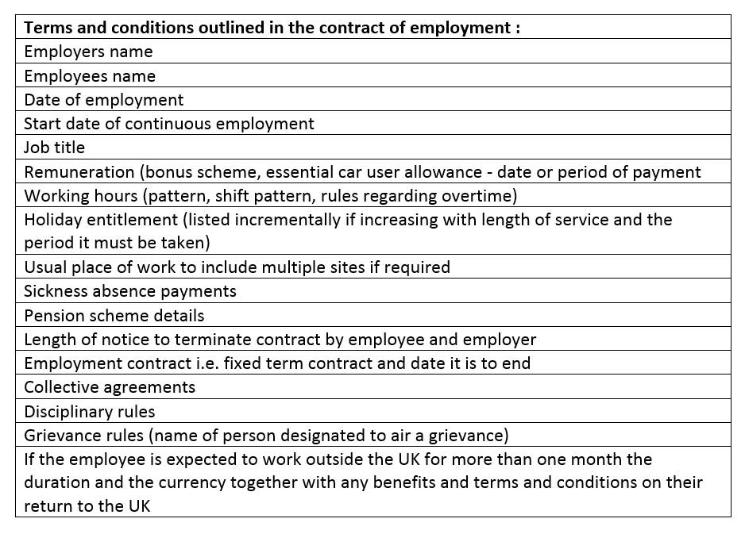
(Daniels, 2019)
Question 3
Contracts of employment are legally binding for both parties; an employer cannot unilaterally vary the contract without consulting (Daniels, 2019; ACAS, ND). It may be necessary to reorganise due to economic circumstances, possible changes could be place of work as employers have to make changes for strong business reasons (Taylor and Wilkinson, 2016).

Technical changes to working arrangements such as new work practices can be amended, contractual terms such as hours of work or pay cannot. Breaches of contract claims succeed in court if a genuine detriment has been suffered (Taylor and Wilkinson, 2016).

Any changes of particulars can be agreed individually or through collective agreements allowing one month notice in writing of the change taking effect, it is best to renegotiate terms through consultation reaching a compromise (ACAS, ND).

If this does not happen employees’ can: resign and make a claim of constructive dismissal if they have two years’ service posing a financial risk for the employer (Taylor and Wilkinson, 2016); or to continue working whilst seeking damages for any loss in the civil courts for breach of contract (Daniels, 2019).
Consultation period differs:-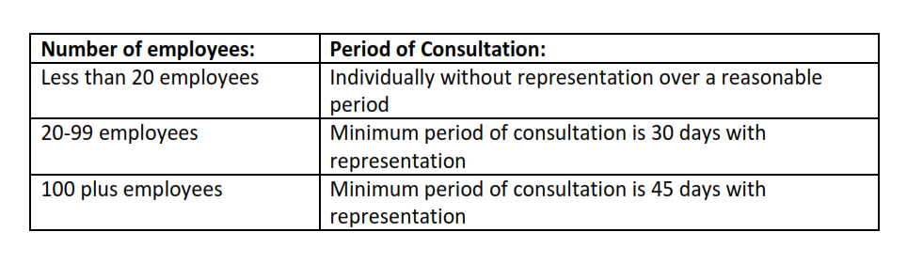
(Daniels, 2019)
Without agreement, where employees’ continue to work without protest continuing as normal for a significant period their employer can assume these changes are accepted. Where employees refuse to work and do not accept changes it is difficult to proceed, it is necessary to terminate the contract of employment (for potentially fair reason) ‘some other substantial reason’ offering new contacts and terms.
Redundancy (s139 ERA 1996) is a fair reason for dismissal, an employee can be made redundant if: their workplace closes for financial reasons or via re-organisation and the post is no longer available (Citizen’s Advice, ND). Employees with two years’ service are entitled to statutory redundancy pay and notice period payments. Statutory redundancy notice periods apply if: employed between one month and two years providing one weeks’ notice; after which one week’s notice for each year employed between two years and up to 12 years a maximum of 12 weeks’ notice (Gov, ND).
Employment Tribunals assess whether the redundancy process is followed correctly:-
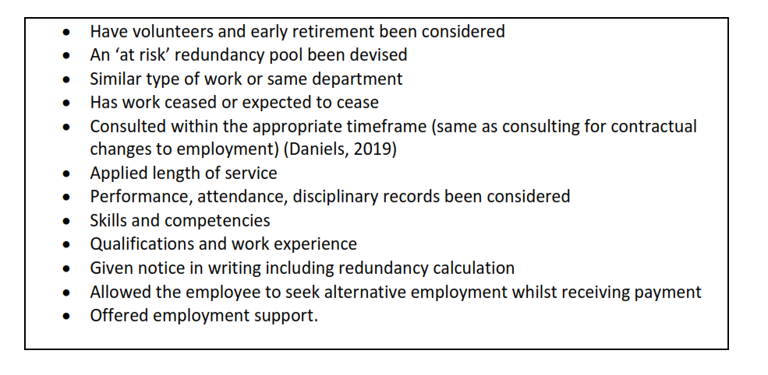
Employees should have: opportunity to challenge the decision of redundancy; be accompanied during the consultation process although there is no statutory right for appeal or accompaniment (Taylor and Wilkinson, 2016; CIPD 2018; XpertHR, ND).
Employers can offer suitable alternative employment via renewal or re-engagement (s141 ERA 1996) as a minimum four week trial. Refusal may result in losing statutory redundancy pay if the employer deems it a suitable alternative.
Transfer of Undertakings (Protection of Employment) Regulations (TUPE) ensures the legal rights of employees are protected such as contractual rights, continuity of employment, liability for all statutory rights, claims and liabilities arising from a contract of employment when the identity of their employer is transferred to another business or a major function is outsourced to another provider.
TUPE Regulations 2006 has two types: a business transfer ‘economic entity that retains its identity’, part of the business moves to another employer; or a service provision change, a service in-house is awarded to a contractor, the contract ends and is given to a new contractor or contract ends and is transferred in-house by the former customer. Additionally, activities remain the same after the transfer. Key considerations: continuity of service; contracts of employment; trade union recognition and collective agreements detailing rights and obligations are protected and transferred to the transferee (Daniels, 2019; Gov, ND; Taylor and Wilkinson, 2016).
Dismissals are not automatically unfair when for an ‘economic, technical or organisational’ (ETO) reason. However, if the reason for dismissal is the transfer alone this is treated as unfair as with Taylor v Connex South Eastern Ltd (2000) case where the employer wanted to change the terms and conditions of employment two years after the transfer occurred. Employees refusing to transfer are treated the same as if they resigned and are normally unable to claim unfair dismissal or redundancy pay however, could claim constructive dismissal. No notice is required the employer must be informed before the date of the transfer. Alternatively, where working conditions are worse due to the transfer employees can resign and claim unfair dismissal (ACAS, 2014; Daniels, 2019; Gov, ND).
Collective agreements are negotiated between trade union representative and employer in a transfer, these arrangements are transferred to the transferee which can be renegotiated one year after transfer such as pay (Daniels, 2019).
Consultation is with selected employees and representatives’ either trade union or elected employees; there is no set timeframe for consultation. If the consultation is deemed inadequate the transferee and transferor hold joint liability with compensation awarded; a maximum of 13 weeks gross pay for each affected employee, no statutory cap is provided. Transferor must provide:-(Daniels, 2019; CIPD 2018)
Employee liability information must be provided to the transferee 28 days prior to transfer, failure could lead to a minimum £500 fine per employee at a Tribunal, details include:-
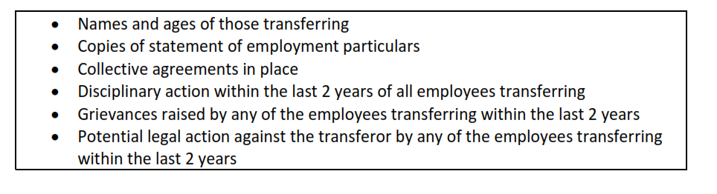(Daniels, 2019; CIPD, 2018)

Question 4
Working Time Regulations define anyone a worker if: they have a contract of employment; expressed or implied terms; or self-employed independent contractors. Excluded: self-employed persons’ operating their own business. Work is defined: working for an employer carrying out duties; on training; and any other time treated as working for an organisation. Various workers are excluded such as the police (CIPD, 2018).

Working Time Regulations derive from the European Union, entitlements are:-
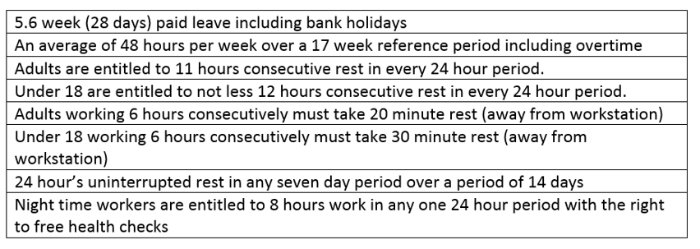
(Taylor and Wilkinson, 2019; Daniels, 2019)
Employees have the right to a written pay statement before payment of salary illustrating gross, net pay, nature and purpose of deductions (CIPD, 2018). From April 2019, number of hours worked if pay depends on hours, the different types of work and hours spent on each task must be included (Daniels, 2019).
National Minimum Wage Act 1998 entitles workers to minimum hourly rate:

(Gov, ND)
Statutory Sick Pay is awarded for: a maximum of 28 weeks in 12 months; four or more consecutive calendar days off; and an average earnings at least equal to lower earnings limit. If suspended on medical grounds entitlement is 26 weeks of their normal rate of pay unless the employee has worked one month or less, there is no entitlement (Daniels, 2019).
Working Time Regulations state workers must take four weeks annual leave entitlement in a holiday year with no provision to carry leave forward and cannot be replaced by payment in lieu except on termination (XpertHR, ND). The case of Lock v British Gas Trading Ltd (2014) IRLR 648 ECJ ruled; commission and overtime be accounted for when calculating holiday pay (Daniels, 2019).
Legally UK employers can insert an ‘opt-out’ clause to remove the average 48 hours working week under the Working Time Regulations (Taylor and Wilkinson, 2016).
The Employment Appeal Tribunal have deliberated over time spent on-call, cases include MacCartney v Oversley House Management (2006) IRLR 514 the claimant was not getting the appropriate rest whilst on-call as she lived and remained in the workplace (Daniels, 2019).
Pregnant women are protected against discrimination and dismissal on the grounds of pregnancy and pregnancy-related treatment thus are entitled to antenatal care and care at work. To qualify for Ordinary Maternity Leave (OML) the employee must earn at least an average £116 per week and have 26 weeks continuous service. Employers’ are informed no later than the 15th week of expected week of confinement (EWC) providing the date intended to start OML no earlier than the 11th week before EWC (Daniels, 2019). Employees can take 52 weeks Statutory Maternity Leave, the first 26 weeks is OML and the last 26 weeks is Additional Maternity Leave. First six weeks is at 90% of your average weekly earnings before tax, the next 33 weeks is £145.18 per week or 90% of your average weekly earnings whichever is lower and 13 weeks unpaid. Employees must take two weeks compulsory leave unless a factory worker which the requirement is four weeks. Maternity leave starts the day after childbirth or automatically if off work due to pregnancy-related illness four weeks before EWC (Daniels, 2019; The Money Advice Service, ND).
Notice of eight weeks’ to the employer is required when returning to work under the same terms and conditions and work unless the position is redundant, in which case, a suitable alternative with similar terms and conditions is offered. All benefits continue to accrue such as holiday entitlement and company car (Taylor and Wilkinson, 2016).
Ten ‘keeping in touch’ (KIT) days can be offered with payment without ending maternity leave for maintaining working relationships, training and discussing returning to work (Taylor and Wilkinson, 2016; Daniels, 2019).
To receive Statutory Paternity Leave employees’ must: have responsibility for the upbringing of the child and includes same-sex relationships; 26 weeks continuous service at the 15th week of EWC; provide employer 28 weeks’ notice; take leave within 56 days of the birth of the child; take up to two weeks leave; at the lower rate of SMP. Contract of employment continues and employees’ have the right to return to their job after the leave ends (Daniels, 2019).
Statutory Adoption Leave applies to employees’ adopting in order to build a relationship with the child, it mirrors OML and the same contractual rights and right to return to work apply.
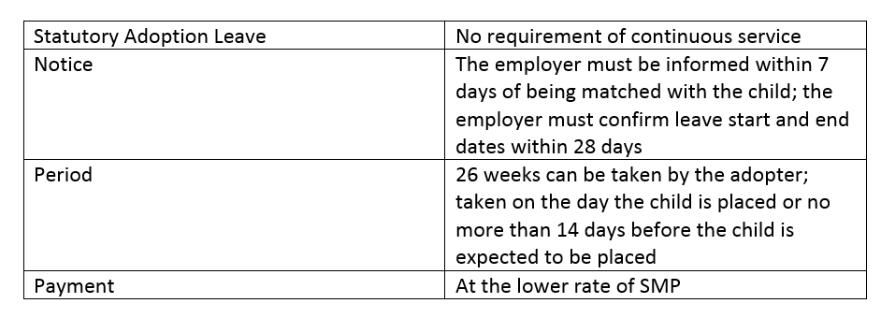 (Daniels, 2019; Gov ND)
Applications for flexible working: must be in writing; employees cannot have made an application in the last 12 months; have 26 weeks continuous service; can be accompanied at meetings and any appeal discussions; if successful is both contractual and permanent. Employers can reject based on business reasons such as; burden of additional costs; detrimental effect on the business and its ability to meet customer needs; unable to reorganise work among existing employees; detrimental impact on quality; detrimental impact on performance; planned structural changes and insufficiency of work in the period the employee proposes to work (Taylor and Wilkinson, 2016).
Question 5
There are various statutes governing health and safety at work, employers are obligated to protect employees which are referenced in the implied terms of employment contracts to: provide a safe place of work; safe systems of work; adequate plant and equipment; and recruit competent and safety conscious staff (CIPD, 2018).
Main UK legislation refers to Health and Safety at Work Act 1974 (HASAWA) it places obligations on the employer and employee which is policed by an inspectorate from the Health and Safety Executive (HSE) giving powers to close down unsafe workplaces and forms part of criminal law. HSE and the Courts wish to see evidence of ‘risk assessments’ when employers are defending (Taylor and Wilkinson, 2016).
Employees have responsibility by their actions to ensure they take reasonable care of themselves, others and cooperate with their employers HASAWA (s7). Employers are legally bound to train staff providing reference material on employee’s responsibilities; if not face prosecution in the Magistrates Court incurring fines up to £50k and unlimited fines in the Crown Court, although action is usually against the employer (Daniels, 2019).
There are other health and safety regulations covering specific areas such as: Personal Protective Equipment Regulations 1992 employees must be suitably trained in the correct use of equipment; Health and Safety (Display Screen Equipment) Regulations 1992 focussing on regular breaks and workstation layouts; Reporting of Injuries, Diseases and Dangerous Occurrences Regulations 1995 reports on injuries requiring hospital treatment of more than seven days, from certain diseases to the death of a person; Control of Substances Hazardous to Health (COSHH) Regulations sets out requirements for storage, use and risk assessments of materials which if handled incorrectly can be hazardous; and Working Time Directive 1998 such as minimum holidays, rest periods and working hours.
A claim of tort (wrong-doing) of negligence lays with the employer’s duty of care. Damages awarded in the County Court are less than £50k and in the County or High Court are greater than £50k. The employee must determine the employer owed duty of care to employee; employer has breached their duty through negligence; and the employee has suffered damage as a result of negligence (Daniels, 2019).
Claims of constructive dismissal refer to an employee resigning as a result of the employer’s duty of care. Criminal penalties under HASAWA are fines or imprisonment, the severity of which depends on the actual breach.
In 2008, Corporate Manslaughter and Corporate Homicide Act 2007 was introduced; companies and public bodies face prosecution if a death results from health and safety failing thus the organisation is guilty of an offence where senior management has managed the activity (Daniels, 2019).
Petty (2016) state equality and diversity relates to everyone having the same: access; opportunities; fair treatment; to work in an environment that is free from discrimination; harassment; victimisation and bullying by active promotion of a matching equal opportunity policy.
The Race Relations Act 1965 was established over 40 years ago, subsequent personal characteristics besides race have been protected against discrimination as result of domestic initiatives or European Directives (Gov, ND). The Equality Act 2010, replaces separate pieces of legislation such as: the Race Relations Act 1976; and the Sex Discrimination Act 1975. Introduced to eliminate unlawful discrimination against any protected characteristic promoting and advancing equal opportunities putting the onus on the business to prohibit prejudicial behaviour by providing the same opportunities. The nine protected characteristics are: age; disability; gender reassignment; marriage and civil partnership; pregnancy and maternity; race; religion or belief; sex; and sexual orientation. Discrimination of these protected characteristics can be by: direct, indirect; associative; perceptive; harassment; and victimisation. Discrimination can be on the grounds of a single characteristic such as being female or a number of single but unrelated characteristics such as female and race, in which case each characteristic is treated separately (ACAS, 2017).
Capital Law (ND) state employers are obligated to owe the employee duties implied by law such as: pay; if they arrive at work and can work; provide work; adhere to Health and Safety Regulations taking reasonable care of employees; to respect the privacy of employees; to indemnify the employee against all liabilities and losses during employment; provide correct information regarding their rights under their contract which they would not ordinarily be aware; give reasonable opportunity to consider any complaints; there is no duty to provide references however, if providing a reference must ensure it true, accurate and fair and not to make any negligent statements; to deal with grievances effectively; both parties owe each other “mutual trust and confidence”; provide support against bullying at work; free from harassment and victimisation (Daniels, 2019).
Daniels (2019), reflect organisations are required to follow the ACAS Code of Practice: Disciplinary and Grievance Procedure, if the employer has not followed the procedure it needs to show good reasons when defending a claim. Employment Tribunals can reduce compensatory awards by up to 25%.
Question 6
Employees can be dismissed with or without notice if: they have not met the standard of performance expected of them; their conduct is unacceptable; fixed-term contract has ended or when an employee terminates the contract without notice due to the conduct of the employer (Daniels, 2019).
The dismissal process if handled incorrectly can lead to potential claims of unfair or wrongful dismissal. Wrongful dismissal focuses on contractual breaches such as failing to give an employee the correct statutory notice. Unlike unfair dismissal there is no set period of continuous service in order to pursue a claim; it is a ‘day one right’ (Knowles, 2017).
Employees have the right not to be dismissed unfairly by their employer (s93 (1) ERA 1996). Potential fair reasons include; capability or qualifications, conduct, redundancy, statutory ban or some other substantial reason (SOSR) (Daniels, 2019).
Capability (s98 ERA 1996) refers to inability to perform due to insufficient skills, aptitude, physical or mental health. Employees must understand their role and expectations thus employers must ensure this at recruitment and subsequent periods after. Qualifications relate to degrees, diplomas, technical or professional qualifications. Training must be given if expectations are not met before instigating a disciplinary. When referring to ill-health employers must consider the Equality Act 2010, the nature of illness, the potential length of absence, the employer’s situation: size; resources and its impact (Daniels, 2019; ACAS, 2019).
Dismissal due to long-term ill-health are fair if the employer has considered: would a reasonable employer wait longer; are they able to wait longer; is it reasonable to expect this; consultation undertaken and views considered; have opinions been balanced against medical opinion; and have reasonable attempts to understand the condition and long-term prognosis (Daniels, 2019).
Dismissals which cannot go to an Employment Tribunal include non-employees, less than two years’ service unless dismissal is automatically unfair, employed under an illegal contract or in the police service (Daniels, 2019).
Conduct is typically: gross misconduct includes theft or gross negligence, the employee can be dismissed immediately following fair process and investigation giving the employee time to respond; misconduct includes persistent lateness or unauthorised absence thus less serious dealt by disciplinary procedure issuing first and second warnings (Gov, ND).
Regardless of fair reason to dismiss fairly the employer needs to act reasonably during dismissal following the ACAS Code of Practice for Disciplinary and Grievance Procedures, unless for redundancy or termination of a fixed-term contract. If the Code is not followed an Employment Tribunal could award compensation up to 25% for unreasonable failure to comply (ACAS, ND).
Where misconduct is alleged employers are to satisfy the ‘Burchell test’ identified by the Employment Appeal Tribunal as a result of British Home Store Ltd v Burchell (1978): employers’ have genuine belief of employee’s guilt; had reasonable grounds for that belief; and has investigated as was reasonable at the time it had the belief.
Disciplinary situations include misconduct or poor performance if an organisation has a separate capability procedure this is followed which should reflect ACAS Code of Practice. Disciplinary and Grievance process:-
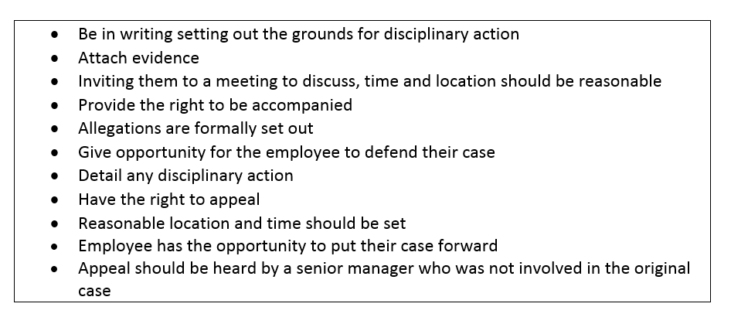
(Daniels, 2019; ACAS 2019)
Serious allegations of misconduct may lead to suspension pending investigation when an employee is likely to destroy evidence or influence witnesses. Full pay and benefits are paid unless there is a clear contractual right not to and should not exceed maximum period specified in the contract with no assumption of guilt made (ACAS, 2019).
Not all disciplinary action warrants dismissal, if warnings are given the employer must follow the ACAS Code of Practice and apply a formal written warning to remain on the employee record for six months, 12 months for a final written warning and finally dismissal. Not covered within the Code are verbal warnings; the organisation’s procedure would apply.
According to (s10 Employment Relations Act 1999) employees have a statutory right to be accompanied by a colleague or trade union representative if: a formal warning is being issued; taking disciplinary action such as suspension without pay; or the confirmation of a warning or some other disciplinary action such as an appeal hearing. The right is not extended to informal discussions such as fact-finding meetings as the ACAS guidance states the meeting to investigate are not disciplinary meetings (Daniels, 2019; ACAS, ND).
Constructive dismissal such as bullying or involving change (Thiruchelvam, 2013) relates to employee’s terminating their contract due to the employer’s treatment with no actual dismissal. Employees’ who bring a claim of constructive dismissal to an Employment Tribunal must demonstrate their decision to terminate employment was in response to a breach and not because of another job. Employment Tribunal’s consider: the length of time to resign; and reasons for the grievance. (ACAS, ND).
Remedies for unfair dismissal at Employment Tribunals are reinstatement, re-engagement or compensation. (ACAS, ND).
Compensation for unfair dismissal is capped at £83,683 or one year’s salary whichever is lowest in addition the limit on one week’s pay for the basic award is £508 collectively the maximum is £98,922 (Mullineux, 2018).

Bibliography
ACAS (no date) Rights at work.
Available at: http://www.acas.org.uk/media/pdf/e/9/Acas__Discipline_Grievances___dismissals_rights_at_work_RW01(APRIL2009).pdf
(Accessed: 21st February 2019).
ACAS (2014) Varying a contract of employment.
Available at: http://m.acas.org.uk/media/pdf/k/s/Varying-a-contract-of-employment-Acas-leaflet.pdf
(Accessed: 21st February 2019).

ACAS (2015) Comparators in direct discrimination cases.
Available at: https://www.citizensadvice.org.uk/law-and-courts/discrimination/what-are-the-different-types-of-discrimination/comparators-in-direct-discrimination-cases/
(Accessed: 21st February 2019).

ACAS (2015) Understanding discrimination by association and perception.
Available at: http://www.acas.org.uk/index.aspx?articleid=5362
(Accessed: 21st February 2019).

ACAS (2017) Guidance Equality and Discrimination: Understand the basics.
Available at: http://m.acas.org.uk/media/pdf/1/0/Equality_discrim_understand_basics_Nov.pdf
(Accessed: 6th March 2019).
ACAS (2019) Discipline and Grievances at work the ACAS guide.
Available at: http://www.acas.org.uk/media/pdf/p/3/DG_Guide_Feb_2019.pdf
(Accessed: 21st February 2019).
BlakeMorgan (2015) What constitutes a reasonable investigation?
Available at: https://www.blakemorgan.co.uk/training-knowledge/features-and-articles/what-constitutes-reasonable-investigation/
(Accessed: 21st February 2019).

Capital Law (no date) What obligations/duties does the employer owe to the employee?
Available at: https://www.compactlaw.co.uk/free-legal-information/employment-law/employer-obligations-to-employee.html
(Accessed: 27th February 2019).

CIPD (no date) Employment law.
Available at: https://www.cipd.co.uk/knowledge/fundamentals/emp-law
(Accessed: 16th February 2019).

CIPD (2017) Employment law: the court system.
Available at: https://www.cipd.co.uk/knowledge/fundamentals/emp-law/about/court-system
(Accessed: 16th February 2019).

CIPD (2018) Health and safety at work.
Available at: https://www.cipd.co.uk/knowledge/fundamentals/emp-law/health-safety/factsheet
(Accessed: 27th February 2019).

CIPD (2018) Transfer of undertakings (TUPE): an introduction.
Available at: https://www.cipd.co.uk/knowledge/fundamentals/emp-law/tupe/factsheet
(Accessed: 5th March 2019).

CIPD (2018) Working Time Regulations Q&As.
Available at: https://www.cipd.co.uk/knowledge/fundamentals/emp-law/working-time/questions
(Accessed: 28th February 2019).

CIPD (2019) Employment status Q&As.
Available at: https://www.cipd.co.uk/knowledge/fundamentals/emp-law/employees/status-questions
(Accessed: 18th February 2019).
CIPD (2019) Recent and forthcoming legislation.
Available at: https://www.cipd.co.uk/knowledge/fundamentals/emp-law/about/legislation-updates
(Accessed: 23rd February 2019).

CIPD (2019) The role of employment tribunals.
Available at: https://www.cipd.co.uk/knowledge/fundamentals/emp-law/tribunals/factsheet
(Accessed: 16th February 2019).

Citizens Advice (no date) Direct discrimination.
Available at: https://www.citizensadvice.org.uk/law-and-courts/discrimination/what-are-the-different-types-of-discrimination/direct-discrimination/
(Accessed: 21st February 2019).

Citizens Advice (no date) Employment tribunals – legal tests for unfair dismissal claims – redundancy.
Available at: https://www.citizensadvice.org.uk/work/problems-at-work/employment-tribunals-from-29-july-2013/making-an-employment-tribunal-claim-is-it-worth-it/employment-tribunals-unfair-dismissal-claims/legal-tests/employment-tribunals-legal-tests-for-unfair-dismissal-claims-redundancy/
(Accessed: 21st February 2019).

Croner-i (2018) Recruitment – Legal Issues: In-depth.
Available at: https://app.croneri.co.uk/topics/recruitment-legal-issues/indepth
(Accessed: 22nd February 2019).

Croner-i (2019) Employment Tribunal Proceedings and Remedies: In-depth.
Available at: https://app.croneri.co.uk/topics/employment-tribunal-proceedings-and-remedies/indepth?product=132
(Accessed: 5th March 2019).

Crossland (2018) Reforming employment tribunal hearings.
Available at: https://www.crosslandsolicitors.com/site/cases/Employment-Law-Hearing-Structures-consultation
(Accessed: 5th March 2019).

Daniels, K. (2019) Introduction To Employment Law.
(5th edn). London: Kogan Page Limited.

Employment Case Update (2011) Thomas Sanderson Blinds Ltd v English UKEAT/0316/10/JOJ.
Available at: https://www.employmentcasesupdate.co.uk/site.aspx?i=ed8101
(Accessed: 22nd February 2019).
Employment Case Update (2018) Royal Mencap Society v Tomlinson-Blake (2018) EWA Civ 1641.
Available at: https://www.employmentcasesupdate.co.uk/site.aspx?i=ed37252
(Accessed: 22nd February 2019).

Equality and Human Rights Commission (no date) Equal pay for equal work: what the law says.
Available at: https://www.equalityhumanrights.com/en/advice-and-guidance/equal-pay-equal-work-what-law-says
(Accessed: 28th February 2019).

Gov (no date) Adoption pay and leave.
Available at: https://www.gov.uk/adoption-pay-leave/how-to-claim
(Accessed: 28th February 2019).
Gov (no date) Business transfers, takeovers and TUPE.
Available at: https://www.gov.uk/transfers-takeover
(Accessed: 5th March 2019).

Gov (no date) Business transfers, takeovers and TUPE.
Available at: https://www.gov.uk/transfers-takeovers/transfers-of-employment-contracts
(Accessed: 5th March 2019).
Gov (no date) Dismissals for conduct or performance reasons.
Available at: https://www.gov.uk/dismiss-staff/dismissals-on-capability-or-conduct-grounds
(Accessed: 21st February 2019).

Gov (no date) Dismissing staff.
Available at: https://www.gov.uk/dismiss-staff/fair-dismissals
(Accessed: 21st February 2019).

Gov (no date) Employment Contracts.
Available at: https://www.gov.uk/employment-contracts-and-conditions/contract-terms
(Accessed: 23rd February 2019).

Gov (no date) Equality Act 2010 Background and summary.
Available at: http://www.legislation.gov.uk/ukpga/2010/15/notes/division/2/1
(Accessed: 27th February 2019).

Gov (no date) How to dismiss someone.
Available at: https://www.gov.uk/dismiss-staff/how-to-dismiss-someone
(Accessed: 21st February 2019).

Gov (no date) Making a claim to an Employment Tribunal.
Available at: https://assets.publishing.service.gov.uk/government/uploads/system/uploads/attachment_data/file/780638/t420-eng.pdf
(Accessed: 5th March 2019).
Gov (no date) National Minimum Wage and National Living Wage rates.
Available at: https://www.gov.uk/national-minimum-wage-rates
(Accessed: 27th February 2019).

Gov (no date) Reasonable adjustments for workers with disabilities or health conditions.
Available at: https://www.gov.uk/reasonable-adjustments-for-disabled-workers
(Accessed: 21st February 2019).

Gov (no date) Redundancy: your rights.
Available at: https://www.gov.uk/redundant-your-rights/notice-periods
(Accessed: 5th March 2019).

Gov (2015) Equality Act 2010@guidance.
Available at: https://www.gov.uk/guidance/equality-act-2010-guidance
(Accessed: 21st February 2019).

Government Equalities (2012) Equality Act 2010 Recruitment-asking questions about disability and health.
Available at: https://assets.publishing.service.gov.uk/government/uploads/system/uploads/attachment_data/file/138117/small-business-guidance.pdf
(Accessed: 21st February 2019).

Knowles, C. (2017) What’s the difference between unfair and wrongful dismissal.
Available at: https://www.peoplemanagement.co.uk/experts/legal/unfair-dismissal-wrongful-dismissal-differences
(Accessed: 5th March 2019).
Macdonald, L. (no date) Discrimination in recruitment and selection.
Available at: https://www.xperthr.co.uk/employment-law-manual/discrimination-in-recruitment-and-selection/157530/
(Accessed: 22nd February 2019).
MS Solicitors (no date) Factsheet: Diversity and Quality & The Recruitment Process.
Available at: https://www.ms-solicitors.co.uk/employer/employer-responsibilities/factsheet-diversity-and-equality-and-the-recruitment-process/#3
(Accessed: 25th February 2019).

Mullineux, N. (2018) Unfair Dismissal Compensation: What’s the Risk?
Available at: https://croner.co.uk/end-of-contract/unfair-dismissal-compensation/
(Accessed: 21st February 2019).

Munro, M. (2015) Responding to an employment tribunal claim: five tips for employers.
Available at: https://www.personneltoday.com/hr/responding-to-an-employment-tribunal-claim-five-tips-for-employers/
(Accessed: 16th February 2019).

Petty, L. (2016) How Equality & Diversity Improves Your Workplace: Examining the Benefits.
Available at: https://www.highspeedtraining.co.uk/hub/equality-diversity-benefits-workplace/
(Accessed: 27th February 2019).

Pyper, D., McGuinness, F. and Brown, J. (2017) Employment tribunal fees.
Available at https://researchbriefings.parliament.uk/ResearchBriefing/Summary/SN07081
(Accessed: 5th March 2019).

Robinson, M. (2016) Positive action – your opportunity to advance equality.
Available at: https://www.equalityhumanrights.com/en/legal-work-scotland/legal-work-scotland/scottish-legal-articles/positive-action-%E2%80%93-your-opportunity
(Accessed: 22nd February 2019).

RossMartin (2019) Uber drivers are employed workers.
Available at: https://www.rossmartin.co.uk/sme-tax-news/3061-uber-drivers-are-employed-workers
(Accessed: 3rd March 2019).

Simpson, S. (2014). Five disability discrimination cases brought by careers against their employers.
Available at: https://www.personneltoday.com/hr/five-disability-discrimination-cases-brought-by-carers-against-their-employers/
(Accessed: 21st February 2019).

Taylor, M., Marsh, G., Nicol, D. and Broadbent, P. (2017) Good Work. The Taylor Review of Modern Working Practices.
Available at: https://assets.publishing.service.gov.uk/government/uploads/system/uploads/attachment_data/file/627671/good-work-taylor-review-modern-working-practices-rg.pdf
(Accessed: 16th February 2019).

Taylor, S. and Wilkinson, K. (2016) ‘Employment Law’, in Taylor, S. and Woodhams, C. (ed.) Human Resource Management: People and Organisations (2nd edn). London: CIPD

The Law Society (2012) Equality Act 2010.
Available at: https://www.lawsociety.org.uk/support-services/advice/practice-notes/equality-act-2010/
(Accessed: 21st February 2019).

The Money Advice Service (no date) Maternity leave and pay.
Available at: https://www.moneyadviceservice.org.uk/en/articles/maternity-pay-and-leave
(Accessed: 5th March 2019).

Thiruchelvam, J. (2013) The qualification for a constructive dismissal claim.
Available at: https://www.personneltoday.com/hr/the-qualification-for-a-constructive-dismissal-claim/
(Accessed: 21st February 2019).

Lloyd, V. (2013) Disability Discrimination by Association.
Available at: https://www.thehrdirector.com/legal-updates/legal-updates-2013/disability-discrimination-by-association/
(Accessed: 21st February 2019).
XpertHR (no date) Do employees have the right to be accompanied at meetings under a redundancy procedure?
Available at: https://www.xperthr.co.uk/faq/do-employees-have-the-right-to-be-accompanied-at-meetings-under-a-redundancy-procedure/99445/
(Accessed: 5th March 2019).

XpertHR (no date) English v Thomas Sanderson Blinds (2008) EWCA Civ 1421 CA.
Available at: https://www.xperthr.co.uk/editors-choice/english-v-thomas-sanderson-blinds-2008-ewca-civ-1421-ca/90717/
(Accessed: 21st February 2019).

XpertHR (no date) Holiday and holiday pay.
Available at: https://www.xperthr.co.uk/employment-law-manual/holiday-and-holiday-pay/20366/
(Accessed: 27th February 2019).

XpertHR (no date) Must an employer give an employee the right to appeal against a decision to make him or her redundant?
Available at: https://www.xperthr.co.uk/faq/must-an-employer-give-an-employee-the-right-to-appeal-against-a-decision-to-make-him-or-her-redundant/99447/
(Accessed: 5th March 2019).

XpertHR (2013) Associative disability discrimination: dismissal after time off for husband’s leukaemia.
Available at: https://www.xperthr.co.uk/law-reports/associative-disability-discrimination-dismissal-after-time-off-for-husbands-leukaemia/116720/?cmpid=ILC%7CPROF%7CHRPIO-2013-110-XHR_free_content_links%7Cptod_article&sfid=701w0000000uNMa
(Accessed: 18th February 2019).

