Shabti/Ushabti

Cyfartha Castle, Merthyr Tydfil CCM1693.004.3
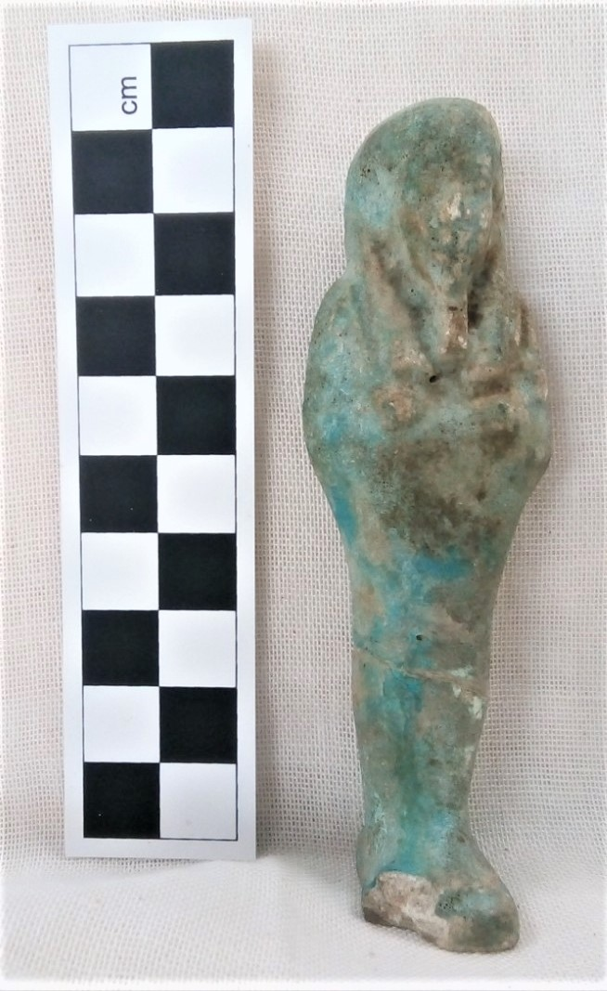
Object type: Ushabti
Material: Faience
Period: Post 26th dynasty
Provenance: (Unknown) Egypt
Dimensions: 9.5cm height
1.8cm Width of head
2.9cm Width of body
1.6cm Width of Legs
1.7cm Width of feet

Object analysis by Patrick Sweeney

Description
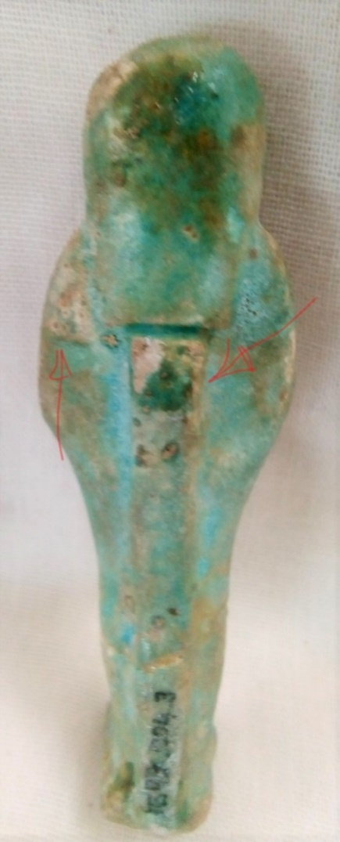
The Ushabti is 9.5cm tall, and 2.9cm at its widest point. It is small and can comfortably fit within an enclosed hand. Its legs are stretched out, arms held to the side, bent at the elbows across the chest, with the left hand holding a mattock and the right a hoe, these tools leaning upon each shoulder, see figures 3 and 4. It wears upon its head a lappet wig(Birrell, 1991, p. 152); this is divided into three parts, with the majority falling to the back of the head, and a strand falling to each side of the face over the shoulders (Birrell, 1991, p.152). The beard upon its face forms a small tube sprouting from the chin, approximately 4-5cm in length. It could be described as either Pharaonic or Osirian in style(Milde, Henk, 2012, p.6). The back has what is called a dorsal pillar upon it, a small flat raised area running along the spine from just below the end of the wig/shoulder blades to the base of the feet. This is approximately 10cm wide and 3cm deep. Milde attributes this to the “Saite Renaissance”(Milde Henk, 2012, p.6), where inscriptions could be placed, this Ushabti is blank. The features are heavily eroded, dark patches upon the top of the head, face, shoulders, waist, and down the legs. There is a piece broken away from the front left section of the feet and base, approximately 8cm by 6cm, wider at the front and tapering to the left. The Ushabti is dull all over, the only shiny patch on the back and top of the head. There are still just a few small patches of blue left upon the figurine, reminding you that this is made from faience.
Figure 1: Ushabti, P. Sweeney, Roderic Bowen Library,2019.

Faience is composed of crushed quartz or sand with the addition of limited amounts of lime and natron or plant ash(Nicholson and Shaw, 2009, p. 186). This non-clay ceramic is coated in a glaze composed of soda, lime and silica, and with the final addition of copper giving it, its blue-green colour (Nicholson and Shaw, 2009, p.186). The addition of lime and soda to the mixture stops the finished product from crumbling apart once dried(Nicholson and Shaw, 2009, p.186). According to Noble, there were three main types of faience in production (Noble, 1969, p.435), and that faience was the first glazed ceramic invented by man, and has been in uninterrupted use for more than six thousand years(Noble, 1969, p.435).
Figure2:Ushabti,P.Sweeney,Roderic Bowen Library, 2019.

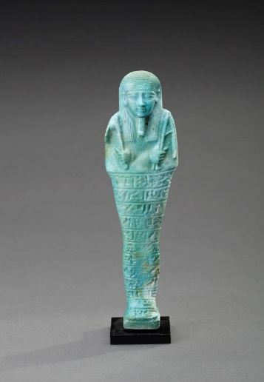
The Ushabti figurine was made in a mould from faience, which could explain the eroded nature of the face, head and arms. Stewart speaks of “negligent execution”, and “perfunctory in workmanship”(Stewart, 2000, p. 167) when describing Ushabti that went from individually handcrafted to mass-produced servants for the afterlife(Stewart, 2000, p.167) see figure 3.
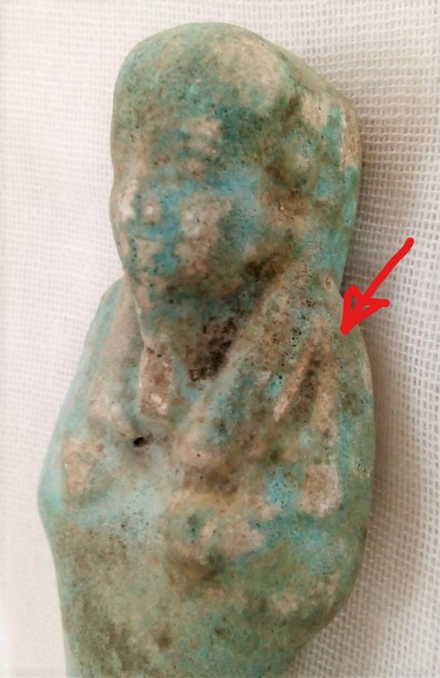
Faience is made by mixing the ingredients into a paste, shaping it in a mould before being dried and glazed.
Figure3 Ushabti of Semetaui 5331. n.d
Ushabti means “one who Answers”(Duffy, 2017, p. 28).
The Shabti was a replica statue of a human (Duffy, 2017,p. 28) having grown out of the earlier tomb funerary statues(Taylor, 2001, p.112); and served the dual purpose of being a receptacle for the Ka (Milde, 2012,p.2) and a substitute prepared to perform the work expected from the deceased in the afterlife. Just as in life when the Pharaoh called upon his agriculturally conscripted labour force, so the God’s expected no less from the deceased, but to also answer the call to work (Milde, 2012, p.3). The earliest versions of the Shabti figurines were crudely formed mud or more often wax figurines, which played a strong role in the magical practices of Ancient Egypt (Taylor, 2001), usually naked and wrapped in linen, placed within a small wooden decorated box.
Figure4:Ushabti, P.Sweeney, Roderic Bowen Library, 2019.
The 12th and 13th dynasties saw the first mummiform figurines that could be described as Shabtis(Milde, 2012, p.3). This name was used from the Late Middle Kingdom and Late Second Intermediate Period, until the 21st dynasty. The name Shawabti appeared in the 17th dynasty, mostly this named was used in the 19th dynasty and particularly on figurines found on the west Bank of Thebes at Deir el-Medina(Taylor, 2001, p.115). Ushebti according to Spanel, is first used on a figurine for Pinudjem II in the 21st dynasty, and its etymology is “to answer”(Spanel, 1986, p.251).
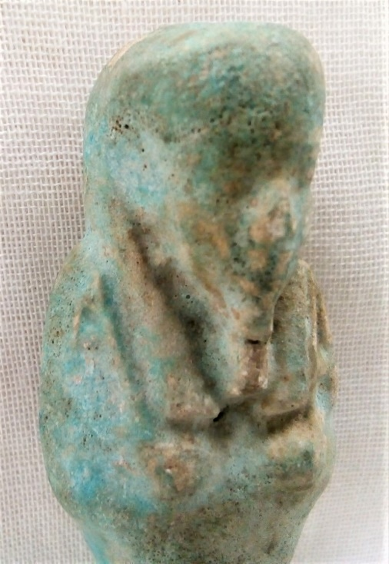
The Shabti is animated by magic from the coffin spell 472, later incorporated into the Book of going forth, or better known as the Book of the Dead(Taylor and British Museum, 2010, p.43). This spell would be written from the waist to the feet, the spell had several variations but would generally command the figurine to rise in place of the deceased, when their name was called to work. Called to perform the hard manual labour, these Ushabti at first were the substitutes, then the servants in the afterlife, answering “here I am”(Taylor and British Museum, 2010, p. 43) before performing their magically induced manual labours. From substitute to servant and possibly ‘slave’ with “answerer”(Taylor and British Museum, 2010, p. 245), altering depending on which version of spell 6 from the Book of the Dead you used.
Figure 5: Ushabti, P.Sweeney, Roderic Bowen Library, 2019.
This figurine has no inscription on the waist and legs, nor upon the dorsal pillar. With its arms crossed and holding a just visible mattock and hoe, wearing an Osirian beard that is just visible, a small triangular basket over the left shoulder and a lappet wig upon its head, these components of an Ushabti’s appearance, plus the barely discernible ‘Greek’ smile lead me to the conclusion that it dates from after the 26th Dynasty.

Reference

Birrell, M., 1991. What is an Ushabti? Ancient History Resources for Teachers; North Ryde 21, 152–156.
Duffy, J.S., 2017. I, Ushabti: “I shall do it, here I am.” Ancient Egypt Magazine 18, 28–32.
Milde, H., 2012. Shabtis 1.
Milde Henk, 2012. UCLA Encyclopedia of Egyptology- Shabtis.
Nicholson, P.T., Shaw, I. (Eds.), 2009. Ancient egyptian materials and technology, 1. Aufl.; 5. Neudr. ed. Cambridge Univ. Pr, Cambridge.
Noble, J.V., 1969. The Technique of Egyptian Faience. American Journal of Archaeology 73, 435. https://doi.org/10.2307/503999
Spanel, D., 1986. Notes on the Terminology for Funerary Figurines 249–253.
Stewart, H.M., 2000. Note on an Enigmatic Shabti Form. The Journal of Egyptian Archaeology 86, 166–167. https://doi.org/10.2307/3822319
Sweeney, P. (2019) Ushabti [Photographs], Roderic Bowen Library, Lampeter, April 2019.
Taylor, J.H., 2001. Death and the afterlife in ancient Egypt. University of Chicago Press, Chicago.
Taylor, J.H., British Museum (Eds.), 2010. Ancient Egyptian Book of the Dead: journey through the afterlife; [published to accompany the exhibition at the British Museum from 4 November 2010 to 6 March 2011]. The British Museum Press, London.
Blue Faience Ushabti of Semetaui. Available at: https://miekezilverberg.com/object/antiquities/egypt/blue-faience-ushabti-of-semataui/ (Accessed:9 April 2019).

