
APPENDIX GA36a

LEVEL 4 ASSESSMENT SPECIFICATION

Student name: | Tom Davies | Student ID number:
Programme: | HNC Electrical and Electronic Engineering, HNC Instrumentation Engineering.
Module: | Industrial Measuring Systems
Module code: | PCEE4003 | Contribution to Overall Module Assessment (%): | 100%
Lecturer: | Anthony Howles | Internal Verifier: | Jason Pointer
Assignment Title: | Measurement systems | Word count (or equivalent): | 2000
Submission deadline: | 25/05/2022 | Return date of provisional marks & written feedback: | 08/06/2022
Submission method: | All written assessments, where practical and possible, must be submitted via Turnitin unless otherwise instructed by the Lecturer. (Please DO NOT put this assessment specification into Turnitin or it will match many similarities with other students’ submissions.)  Alternative submission method (if applicable):  Late submission of the assessment will result in a late penalty mark. Penalties for late submission: Up to one week late, maximum mark of 40%. Over one week late, 0%. Only the Extenuating Circumstances Panel may approve a change to submission dates.
Academic honesty / referencing: | Academic honesty is required. In the main body of your submission you must give credit to authors on whose research and ideas your work is based. Append to your submission a reference list that indicates the books, articles, etc. that you have used, cited or quoted in order to complete this assessment.

Module Learning Outcomes
(from module syllabus)
LO1, LO2.

TASK DESCRIPTION

Assignment Brief

For this assignment, you are required to complete six tasks that investigate sensor operation and characterisation, signal processing, signal transmission, open and closed loop control.

Task 1. Pressure sensor

To measure and indicate a process pressure value, analogue or digital systems could be used. For this task evaluate the two technologies with respect to an analogue bourdon tube pressure gauge and a digital pressure gauge employing a resistive strain gauge sensor (see figure 1). Compare and contrast these two instruments with respect to their principles of operation and their static and dynamic characteristics. Include any advantages and disadvantages for each of the measuring technologies in your answer.

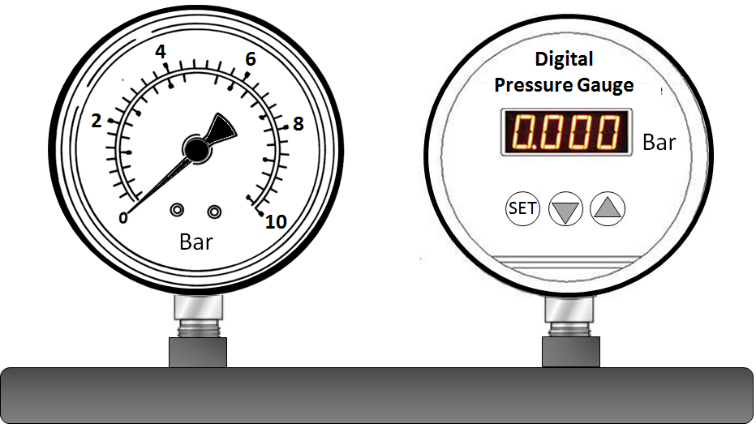

Figure 1. Analogue and Digital Pressure Gauges

Analogue Bourdon Tube Gauge
A bourdon tube is used a lot when measuring pressure and temperature as it uses the same working principle in both instances. The bourdon tube is made up of a ‘C’ shaped tube. As the pressure increases the tube wants to straighten out. On the end of the tube is are gears attached to a pivot point. As the pressure increases and the tube tries to straighten out it moves the indicator around the range. As the pressure decreases the tube will curl back into its original ‘C’ shape and move the indicator back down the range.
An analogue gauge has many static and dynamic characteristics however not all are great for purpose and its operation. For its static characteristics an analogue gauge does have good linearity as it is fitted in line with the system meaning that there are no barriers between the process and the gauge to cause false readings. However, it can be susceptible to a build-up of waste around the fitting. The analogue gauge does also have a high level of sensitivity. However, this depends on the range as the smaller the range then the more sensitive it will be to change. The mechanical parts can wear and stretch over time with its operation causing it to be less sensitive. The gauges resolution is not great as it depends on how small the range is and is reliant on people to read it. This leaves room for human error as the reading is all based on the perception of the person looking at it. Also known as hysteresis, the gauges threshold is not great as anything below its zero will not be detected leaving dead space.
The analogue gauge does have dynamic characteristics such as its speed of response as this is good due to its operation and how it is positioned in line with the process. However, overtime its speed of response can lessen as its mechanical parts wear and stretch. Unless the gauge is faulty then there will be no overshoot as it has great linearity with the process and is not designed to overshoot as its purpose is to give a live reading. The fidelity of the analogue gauge is great as it should be able to reproduce the same response and accuracy during its operation unless other factors interfere such as worn parts or the tap-in point becomes blocked.

Digital Pressure Gauge
A digital Pressure gauge is used a lot more these days are they are a modern version of an analogue gauge which can be calibrated and depending on the type, can be made to measure many different units. The digital gauge works by having a cell which is split in two. On one side of the cell is the process and the other is a known volume. As the process increases in pressure it puts pressure onto the cell divider which will then change the pressure in the other half of the cell causing a change in pressure reading. This gauge can be calibrated to read different processes such as processes under a vacuum. A digital gauge is good as it will give an exact numerical answer for a pressure unit when looked at which will remove any human error when reading it. However, there are some drawbacks such as it requires power and if water gets inside the head, then this can ruin the electronics and cause false readings.
The digital gauge has some qualities especially with its static characteristics such as it has good linearity with the process however depending on the type used it may only change the displayed value at the end of the timer meaning that it will have a delay on it before the value changes. The digital gauge will have a high sensitivity as it is able to sense smaller amounts of changes due to its display being to three decimal places. Another point with the gauge being to three decimal places is that it will have a high resolution due to its display being 1_{x10}⁻³. The threshold for the digital gauge is great and most likely one of its strongest points as its zero can be set wherever is needed for the process meaning that if the process ranges between a vacuumed state and atmospheric then it can be calibrated and set to cover the range.
The digital gauge does have some dynamic characteristics however some are poor such as its speed of response. This is due to the gauge most likely having a timer set between updates to the pressure being displayed. This means for example that it could always be 20 seconds behind what the pressure is reading. There would be no overshoot in the digital gauge as its operation is to just display a reading rather than to control the process. The gauge would have a high degree of fidelity as it has an accuracy of ±5% or ± 1 digit. However, its fidelity would depend on its operating state as its battery could be low or empty leading to it being faulty.

Task 2. Position sensors

- Identify a sensor that could be used to measure the angular velocity of an electric motor from 0 to 1000 RPM.
A good way to measure the angular velocity of an electric motor is by using a tachometer. Tachometers work by having a reference point on the shaft of the motor and a pickup point. As that point passes the pickup it switches a counter. As the shaft increases in speed the counter will increase in number with each full rotation. There are many types of tachometers for example light emitting, proximity and magnetic. A good type for this example would be a magnetic tachometer as it is simple in design and is very accurate. A magnet is placed on the shaft as the reference point and the pickup point would be a reed switch. As the magnet passes the reed switch it pulls the magnetic material of the reed switch causing it to close the loop which adds 1 onto the counter. As the magnet comes away from the reed switch the loop is then opened again until the magnet does another full rotation.
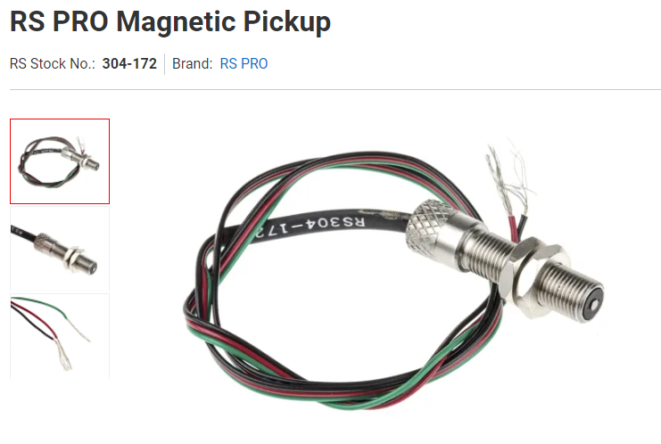
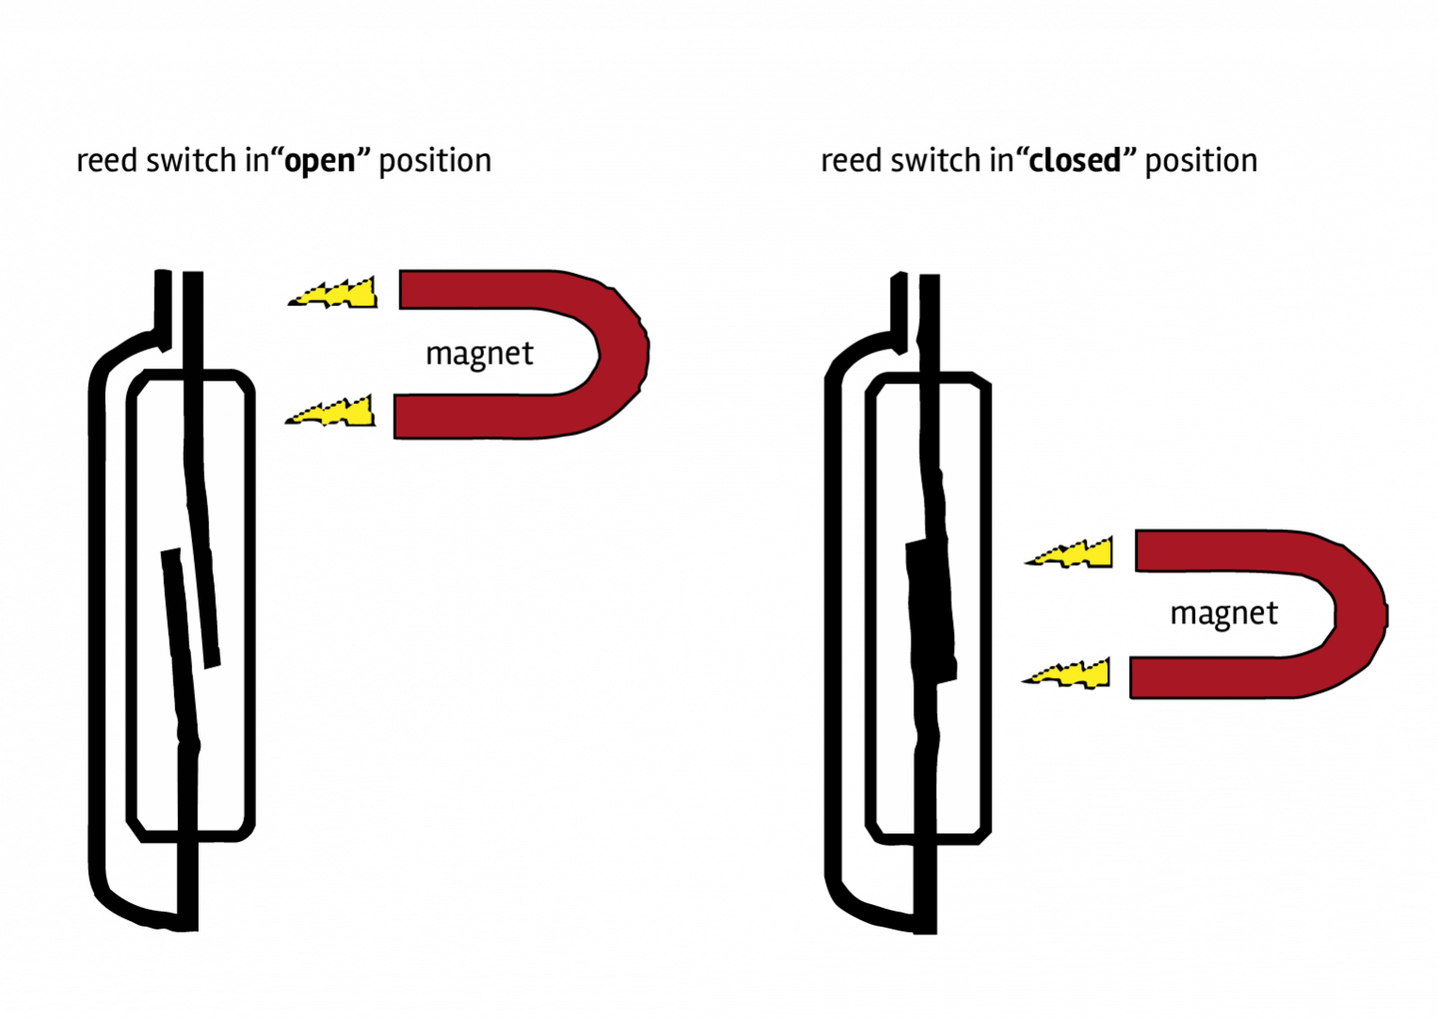

Deeter Electronics. (2019).

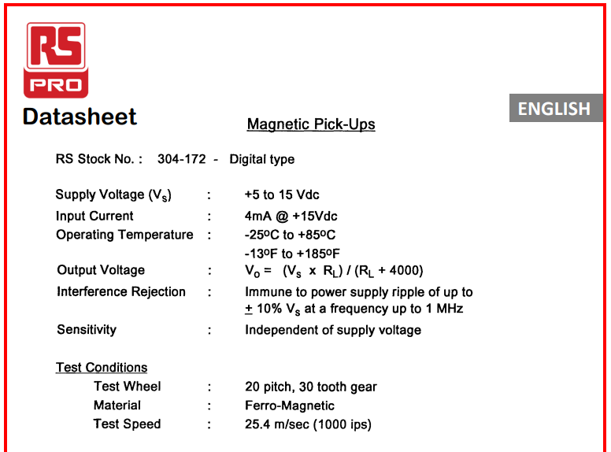
RS components. (2020).

- Identify a sensor that could be used to measure the rotation of a 3-way ball valve through 180° operation. In addition, there is a requirement to indicate the operation of the valve from 0 to 100 % of its travel in both the forward and reverse action.
There are many ways to measure the rotation of a 3-way valve such as proximity sensors, linear encoders or rotary encoder. For this example, a rotary optical encoder would be best as it can show the position of the valve between each point and it operates naturally with the valves shaft. The rotary encoder works by have a code disk with holes in it, with a LED one side and a photo sensor on the other. As the code disk rotates with the shaft of the valve different amounts of light will get to the sensor. More than one layer of code disk can be used to make the instrument more accurate. Each hole or amount of light let through the code disk will have a set percentage or numerical value for where the valve is.
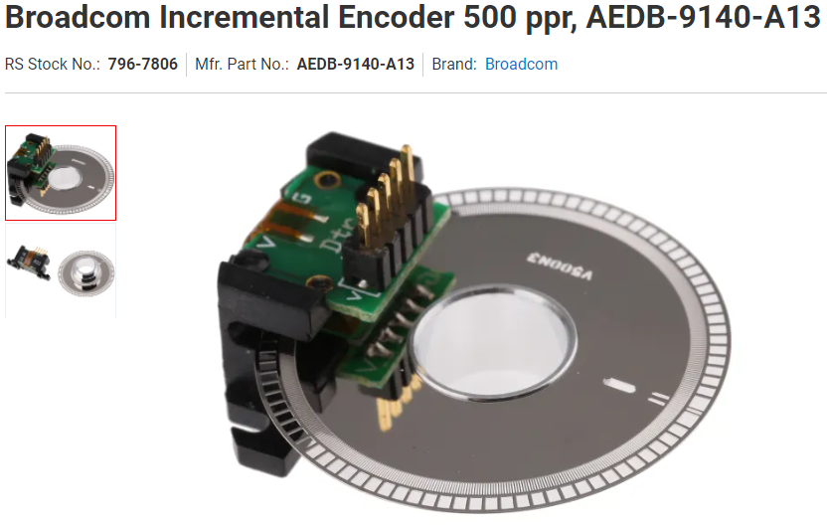
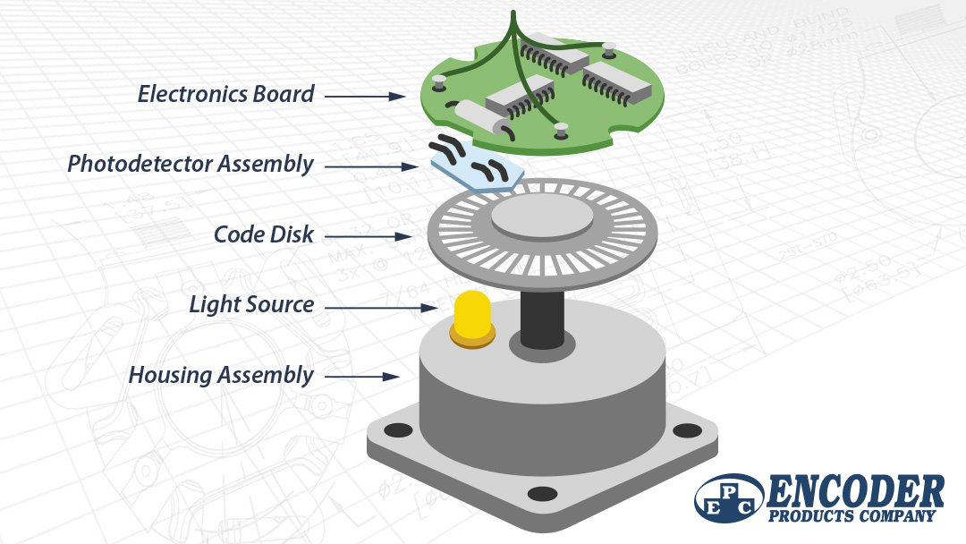
EPC . (2015). RS components. (2020).
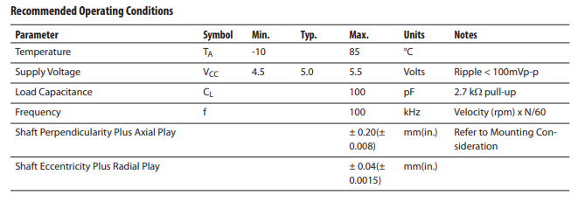

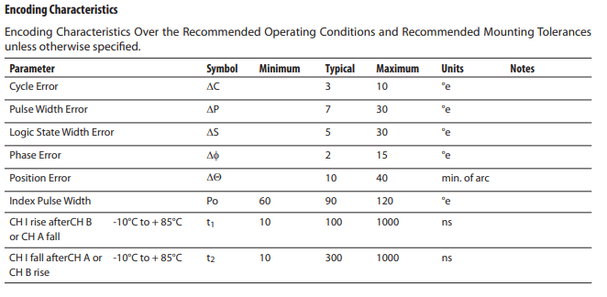

For both answers include an explanation of the sensor’s construction and its principle of operation. Include a data sheet for a commercially available sensor of the type you are proposing for each of the applications.

Task 3. Temperature Sensor characteristics

A PT100 platinum type RTD is being used to measure the temperature of a process from 0 °C to 100 °C. The RTD being used has a temperature coefficient of resistance of 3.85 x10⁻³ ⁰C. For this task, use these values to answer the following questions.

- Calculate the resistance of the sensor at 5°C intervals from 0 °C to 100 °C. You may use a table to collate your results but include all calculations in your answer.

Calculation for Resistance
Ω=100*(1+0.00385*°C)
Temperature(°C) | Resistance Calculation | Resistance(Ω)
0 | 100*(1+0.00385*0) | 100
5 | 100*(1+0.00385*5) | 101.925
10 | 100*(1+0.00385*10) | 103.85
15 | 100*(1+0.00385*15) | 105.775
20 | 100*(1+0.00385*20) | 107.7
25 | 100*(1+0.00385*25) | 109.625
30 | 100*(1+0.00385*30) | 111.55
35 | 100*(1+0.00385*35) | 113.475
40 | 100*(1+0.00385*40) | 115.4
45 | 100*(1+0.00385*45) | 117.325
50 | 100*(1+0.00385*50) | 119.25
55 | 100*(1+0.00385*55) | 121.175
60 | 100*(1+0.00385*60) | 123.1
65 | 100*(1+0.00385*65) | 125.025
70 | 100*(1+0.00385*70) | 126.95
75 | 100*(1+0.00385*75) | 128.875
80 | 100*(1+0.00385*80) | 130.8
85 | 100*(1+0.00385*85) | 132.725
90 | 100*(1+0.00385*90) | 134.65
95 | 100*(1+0.00385*95) | 136.575
100 | 100*(1+0.00385*100) | 138.5

- The platinum RTD is to be used in a voltage divider circuit (Fig 3.1 – Voltage Divider). If the supply voltage (V_{s}) is 10v, R = 100 Ω and R_{t} is the platinum RTD calculate the circuit output for the same range of temperatures in question 1a. You may add a separate column to your table to show these results but include all calculations in your report.
Calculation for Voltage
V=10*Ω/(100+Ω)
Temperature(°C) | Resistance(Ω) | Output Voltage(V)
0 | 100 | 5.000
5 | 101.925 | 5.048
10 | 103.85 | 5.094
15 | 105.775 | 5.140
20 | 107.7 | 5.185
25 | 109.625 | 5.230
30 | 111.55 | 5.273
35 | 113.475 | 5.316
40 | 115.4 | 5.357
45 | 117.325 | 5.399
50 | 119.25 | 5.439
55 | 121.175 | 5.479
60 | 123.1 | 5.518
65 | 125.025 | 5.556
70 | 126.95 | 5.594
75 | 128.875 | 5.631
80 | 130.8 | 5.667
85 | 132.725 | 5.703
90 | 134.65 | 5.738
95 | 136.575 | 5.773
100 | 138.5 | 5.807

- Assuming the input and output responses of the sensor are linear, determine the sensitivity of the circuit.

Sensitivity = Δ Output/Δ Input
Δ Output = 45ºC to 90ºC
Δ Input = 5.399V to 5.738V
Sensitivity = (5.738V-5.399V)/(90ºC-45ºC)
Sensitivity = 7.533_{x10}⁻³V/ºC
Sensitivity = 7.533mV/ºC

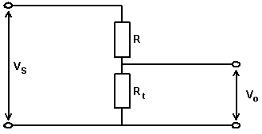
- The temperature sensor has a first order response with a time constant of 5ms. Plot the output response to a step change in input from 0 °C to 50 °C in 1ms steps until a steady state condition is achieved.

T=T₀(1-e^{-t/Ƭ})
T=output temperature
T₀=final (steady state) temperature
T=time(ms)
Ꞇ=time constant=5ms

Time(ms) | Temperature(°C)
0 | 0.000
1 | 9.063
2 | 16.484
3 | 22.559
4 | 27.534
5 | 31.606
6 | 34.940
7 | 37.670
8 | 39.905
9 | 41.735
10 | 43.233
11 | 44.460
12 | 45.464
13 | 46.286
14 | 46.959
15 | 47.511
16 | 47.962
17 | 48.331
18 | 48.634
19 | 48.881
20 | 49.084
21 | 49.250
22 | 49.386
23 | 49.497
24 | 49.589
25 | 49.663
26 | 49.724
27 | 49.774
28 | 49.815
29 | 49.849
30 | 49.876
31 | 49.899
32 | 49.917
33 | 49.932
34 | 49.944
35 | 49.954
36 | 49.963
37 | 49.969
38 | 49.975
39 | 49.980
40 | 49.983

(Fig 3.1 – Voltage Divider)

Calculation for First Order Response
°C=50*(1-exp(time/5)

Task 4. Indicators

- Explain the difference between an LCD and a LED seven segment display. Include in your answer advantages and disadvantages for each.
LCD
LCD stands for Liquid Crystal Display and is used a lot throughout industries and even replaced the use of LED’s in uses such as smartphones, TV’s, etc. LCD uses florescent backlights with a 4-bit data bus and a 3-core control. LCD’s have many advantages to its use, one of the main being it is lightweight and slim, hence why it is used a lot with TV’s and smartphones. LCD’s has other advantages such as it requires low amounts of energy, produces low amounts of heat, and has a low refresh flicker rate. There are some disadvantages to using LCDs such as older models or faulty models can suffer from uneven backlighting where some areas are brighter than others. There are also limited viewing angles meaning that the image can only be clearly seen when looking at it directly.

LED
LED stands for Light Emitting Diode and is used a lot for lighting operations and equipment state signalling. A 7-segment display LED is driven directly meaning that each segment is told to be on or off. LEDs use their own emitting light as its backlight allowing it to have superior picture quality, but the backlight configurations can vary segment to segment. There are many benefits to using LEDs such as they have a lifetime in operation unless they become faulty which also means they are efficient, they require low amounts of power to work, there’s not much maintenance required, produces low amounts of heat and it is very small in size making it great for many operations. LEDs do have some disadvantages such as its colour mixing is not great with RGB’s and its white colour is not very clear. There is no standardisation with LED’s meaning that their quality can differ a lot. LEDs can be very expensive when bought new, however, they get their money back by having a lifetime working life. If the LEDs are poor quality, then the semiconductors that are used can form a crystalline layer causing them to become faulty and produce high temperatures.

- Explain the operation of an analogue to digital conversion (ADC) process that could be used to turn a 4 to 20 mA signal into a digital indication. Include sensitivity, resolution quantization and quantization error in your explanation.
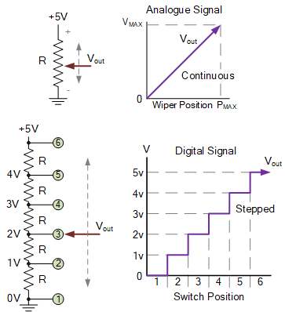
ADC’s take logic circuit signals and coverts them so that readings and data can be taken from it such as pressure, level, sound, light, and flow. Analogue signals such as 4-20mA will constantly change value depending on what they’re taking signals from. Transducers are where the analogue signal is sent and converted into a digital signal. Digitals circuits operate differently to analogue as they work in binary hence why ADCs are used. An ADC looks at the analogue voltage and represents that voltage with a digital code. The number of bits used to represent the analogue signal will depend on the resolution. Resolution is the number of values it is allowed to produce over an analogue range.
Admin@ElectronicsTutorials. (2021).
The size of the resolution will determine the quaternization error and will also determine the maximum signal noise ratio to avoid oversampling. Quantization error occurs in an ideal analogue to digital conversion. Quantization error occurs due to rounding values when converting between analogue to digital. The quantization error is solely signal dependant and is nonlinear. Sensitivity of an ADC is described as the smallest increment of change that can be sensed by the sensor. “Consider a measurement device that has a ±1.0-volt input range and ±4 counts of noise, if the A/D converter resolution is 2¹² the peak-to-peak sensitivity will be ±4 counts × (2 ÷ 4096) or ±1.9 mV p-p. This will dictate how the sensor responds. For example, take a sensor that is rated for 1000 units with an output voltage of 0-1 volts (V). This means that at 1 volt the equivalent measurement is 1000 units, or 1 mV equals one unit. However, the sensitivity is 1.9 mV p-p so it will take two units before the input detects a change.” Measurement Computing Admin. (2019).

Task 5. Signal transmission

- Explain the advantages and disadvantages of current and voltage signal transmission.
Current Signal Transmission
Current signal transmission also known as a current loop is in relation to a 4-20mA signal. A current loop uses 4mA as its 0% and 20mA as its 100%. There are many advantages and disadvantages to using current transmission, such as, there is lower risk of attenuation with the signal when using varying current compared to when using voltage. Another advantage to using current transmission is that it can have a live zero. As stated, prior it uses 4mA as its 0%. This lets those working on the equipment to know the equipment is working as if they got 0mA then they would know the equipment is faulty. If the signal transmission used 0mA as its working zero, then you couldn’t tell easily that the equipment was working correctly or not. When using current transmission there is also very low impedance. However, when using a current transmission there is always a risk of ignition which is why there are many regulations that surround the use of current transmission and its use in many industries. another disadvantage when using current signal transmission is that most of the time it will have to be converted into a current transmission from voltage.

Voltage Signal Transmission
Voltage signal transmission has many forms of use. One of its most popular working ranges is 1-5V. voltage transmission is very popular due to how easy it is to measure and how easily it can be transmitted to easy stage. Another advantage to using voltage transmission is that the signal can be amplified easily allowing it cover greater distances to each stage. However, voltage transmissions do suffer from noise causing faulty signals and readings, which is why voltage transmission is not usually used over long distances. There is also a lot of resistance caused by using voltage transmission which will result in attenuation. Like current signal transmission, voltage transmission also has a high risk of ignition.

- The output signal from a measurement system typically has to be processed in some way to make it suitable for the next stage of the process. Explain the operation and identify reasons why the five processes listed would be applied to a measurement signal:

- Conversion
Signal conversion is used in ADC systems where an analogue signal is coverts into data that can be read, processed, or stored. Signal conversion is required to ensure that the data is more accurate and removes a lot of possible errors that can be made.
- Amplification
Signal amplification is used to increase the strength of the output signal. This is used when the signal needs to be sent over large distances to processing units or controllers. Due to signals being oscillations, amplifiers help increase the oscillations so that signals get to where they are inputting.
- Elimination
Signal elimination is in relation to the noise that comes from unwanted signals being picked up in the cable from nearby electrical equipment, magnetic fields, random movement, and equipment properties. Electrical noise can be eliminated by twisting the cores of the cable which will induce an emf in the cable going in opposite directions. Another way noise can be eliminated is by using a coaxial cable for screening. However, the screening cable should only be earthed on one end.
- Manipulation
Signal manipulation is how the signal can be taken and changed into a form that is desired by the user. This could be converting an analogue signal into a digital signal or digital to analogue. This would be needed in many applications as some equipment may only be able to produce an analogue signal which would require it to be manipulated if required.
- Protection
Signal protection would be similar to using coaxial cable to prevent noise from interfering with the signals in the cable. Another form of protection is ensuring there is an earth on one end of the cable. Another way to protect the signal is by using physical barriers. These barriers are essentially a switch. The barriers ensure that in the event of a surge it drags the signal down to earth and stops any further damage to controllers or other equipment. the signal continues to ground until a normal signal is found and then the system returns. An example of one of these would be a Zener diode.

Task 6. Basic control systems

- Briefly explain open loop control systems. Include an application, one advantage and one disadvantage in your answer.
Open loop control systems are designed in a way that the input to the system is independent from the output but the output replies on the input to work. In the system there is no feedback loop from the output to the input. An example of this in use would be turning on a light at home. The input would be pressing the light switch. The signal is then sent to the bulb illuminating it. As it is an open loop system, the light remains on until it the light switch is pressed to turn off the light. There are many advantages to using a open loop control system such as, it is simple in design making it easy to maintain and the signal is usually stable. There are some disadvantages to its use such as it’s state remains until physically changed by an operator. These systems are also inaccurate as they have no feedback.
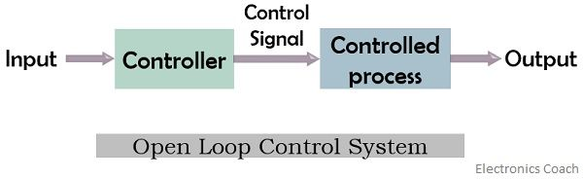

ElectronicsCoach.(2015).

- Draw a block diagram of a closed loop control system and describe the function of each element.
Element
Set-Point
Variable/Output

Process
Correction
Controller

Measurement Sensor

Set-point - is the desired value set by the operator
Element – is where the value from the sensor is compared to the set-point
Controller – a switch or relay
Correction – will correct the process to the set-point if the value from the sensor is undesired
Process – the process of changing the variable such as increasing the temperature
Variable/Output – increasing the temperature of a heater to the set-point
Measurement – sensor that monitors the variable such as a thermocouple or RTD

Referneces
Task 1
Task 2
- Deeter Electronics. (2019). Reed Switch - How Its Works. Available: https://www.deeterelectronics.com/reed-switch-how-it-works/. Last accessed 11/05/2022.
- RS components. (2020). RS PRO Magnetic Pickup. Available: https://uk.rs-online.com/web/p/motion-control-sensors/0304172. Last accessed 11/05/2022.
- EPC . (2015). What Is an Optical Encoder?. Available: https://www.encoder.com/article-what-is-an-optical-encoder. Last accessed 11/05/2022.
- RS components. (2020). Broadcom Incremental Encoder 500 ppr, AEDB-9140-A13. Available: https://uk.rs-online.com/web/p/motion-control-sensors/7967806?cm_mmc=UK-PLA-DS3A-_-google-_-CSS_UK_EN_Automation_%26_Control_Gear_Whoop-_-Motion+Control+Sensors_Whoop-_-7967806&matchtype=&aud-83247487. Last accessed 11/05/2022.
Task 3
Task 4
- Admin@ElectronicsTutorials. (2021). Analogue to Digital Converter.Available: https://www.electronics-tutorials.ws/combination/analogue-to-digital-converter.html. Last accessed 16/05/2022.
- Measurement Computing Admin. (2019). Accuracy, Precision, Resolution, and Sensitivity. Available: https://www.mccdaq.com/TechTips/TechTip-1.aspx. Last accessed 17/05/2022.
Task 5
Task 6
- ElectronicsCoach.(2015). Open-loopControlSystem. Available: https://electronicscoach.com/open-loop-control-system.html#:~:text=Definition%3A%20An%20open%2Dloop%20system,known%20as%20non%2Dfeedback%20system.. Last accessed 18/05/2022.

GUIDANCE FOR Students IN THE COMPLETION OF TASKS

NOTE: The guidance offered below is linked to the five generic assessment criteria overleaf.

- Engagement with Literature Skills
Your work must be informed and supported by scholarly material that is relevant to and focused on the task(s) set. You should provide evidence that you have accessed an appropriate range of sources, which may be academic, governmental and industrial; these sources may include academic journal articles, textbooks, current news articles, organisational documents, and websites. You should consider the credibility of your sources; academic journals are normally highly credible sources while websites require careful consideration/selection and should be used sparingly. Any sources you use should be current and up-to-date, mostly published within the last five years or so, though seminal/important works in the field may be older. You must provide evidence of your research/own reading throughout your work, using a suitable referencing system, including in-text citations in the main body of your work and a reference list at the end of your work.

Guidance specific to this assessment: You must provide evidence of individual research with respect to theory and operation and provide relevant referencing.

- Knowledge and Understanding Skills
At level 4, you should be able to demonstrate knowledge of the underlying concepts and principles associated with your area(s) of study. Knowledge relates to the facts, information and skills you have acquired through your learning. You demonstrate your understanding by interpreting the meaning of the facts and information (knowledge). This means that you need to select and include in your work the concepts, techniques, models, theories, etc. appropriate to the task(s) set. You should be able to explain the theories, concepts, etc. to show your understanding. Your mark/grade will also depend upon the extent to which you demonstrate your knowledge and understanding.

Guidance specific to this assessment: Your report should show you gained knowledge of measuring systems, operational characteristics and the application of instrumentation and control theory.

- Cognitive and Intellectual Skills
You should be able to present, evaluate and interpret qualitative and quantitative data, in order to develop lines of argument and make sound judgements in accordance with basic theories and concepts of your subject(s) of study. You should be able to evaluate the appropriateness of different approaches to solving problems related to your area(s) of study and/or work. Your work must contain evidence of logical, analytical thinking. For example, to examine and break information down into parts, make inferences, compile, compare and contrast information. This means not just describing what! But also justifying: Why? How? When? Who? Where? At what cost? You should provide justification for your arguments and judgements using evidence that you have reflected upon the ideas of others within the subject area and that you are able to make sound judgements and arguments using data and concepts. Where relevant, alternative solutions and recommendations may be proposed.

Guidance specific to this assessment: The report should show analysis of the experimental work and calculated values.

- Practical Skills
At level 4, you should be able to apply the basic underlying concepts and principles to evaluate and interpret these within the context of your area of study. You should be able to demonstrate how the subject-related concepts and ideas relate to real world situations and/or a particular context. How do they work in practice? You will deploy models, methods, techniques, and/or theories, in that context, to assess current situations, perhaps to formulate plans or solutions to solve problems, or to create artefacts. This is likely to involve, for instance, the use of real-world artefacts, examples and cases, the application of a model within an organisation and/or benchmarking one theory or organisation against others based on stated criteria.

Guidance specific to this assessment: Correct theoretical and calculated outcomes have been achieved.

- Transferable Skills for Life and Professional Practice
Your work must provide evidence of the qualities and transferable skills necessary for employment requiring the exercise of some personal responsibility. This includes demonstrating: that you can communicate the results of your study/work accurately and reliably, and with structured and coherent arguments; that you can initiate and complete tasks and procedures, whether individually and/or collaboratively; fluency of expression; clarity and effectiveness in presentation and organisation. Work should be coherent and well-structured in presentation and organisation.

Guidance specific to this assessment: Your work should be well organised and presented in a professional manner.

Student FEEDBACK FORM

This section details the extent to which the assessment criteria are demonstrated by you, which in turn determines your mark. The marks available for each category of skill are shown. Lecturers will use the space provided to comment on the achievement of the task(s), including those areas in which you have performed well and areas that would benefit from development/improvement.

Generic Assessment Criteria | Marks available | Marks  awarded
1. Engagement with Literature Skills
.
Selection of relevant and credible sources. Generally sound referencing, with no/very few inaccuracies. | 20 | 12
2. Knowledge and Understanding Skills

Excellent knowledge and understanding of the basic underlying concepts and principles of the subject. | 20 | 15
3. Cognitive and Intellectual Skills

Excellent evaluation of the underlying concepts and principles. | 20 | 14
4. Practical Application Skills

Very good consideration of the context of the application. | 30 | 18
5. Transferable Skills for Life and Professional Practice

Work is coherent, very fluent and is presented professionally. | 10 | 8

Assessment Mark (Assessment marks are subject to ratification at the Exam Board. These comments and marks are to give feedback on module work and are for guidance only until they are confirmed. ) | Late Submission Penalties (tick if appropriate) |  | 67%
 | Up to 1 week late (40% Max) |  | 67%
 | Over 1 week late (0%) |  | 67%

GENERIC ASSESSMENT CRITERIA

Level 4
In accordance with the Framework for Higher Education Qualifications, at the end of Level 4 students will be expected to have demonstrated knowledge of the basic underlying concepts and principles of a subject, and an ability to evaluate and interpret these within the context of that area of study. They should be able to present, evaluate and interpret qualitative and quantitative data in order to develop lines of argument and make sound judgements in accordance with basic theories and concepts of their subject(s) of study. They will have learned how to evaluate different approaches to solving problems, and will be able to communicate the results of their study/work accurately and reliably, and with structured and coherent arguments. They will be able to undertake further training and develop new skills within a structured and managed environment and will have the qualities and transferable skills necessary for employment requiring the exercise of some personal responsibility.

Level 4 | FAIL | MARGINAL FAIL | SATISFACTORY  (3rd / Pass) | GOOD  (2.2 / Pass) | VERY GOOD  (2.1 / Merit) | EXCELLENT  (1st / Distinction) | EXCEPTIONAL  (1st / Distinction)
Category | 0-29% | 30-39% | 40-49% | 50-59% | 60-69% | 70-84% | 85-100%
Engagement with literature (including reading, referencing,  academic conventions and  academic honesty) | Little or no evidence of reading and/or reliance on inappropriate sources.  Views and findings mostly unsupported and non-authoritative.  Referencing conventions used incoherently or largely absent. | Poor engagement with essential reading. No evidence of wider reading. Reliance on inappropriate sources, and/or indiscriminate use of sources. Heavily reliant on information gained through class contact. Inconsistent and weak use of referencing. | Engagement with a limited range of mostly relevant and credible sources but with some reliance on information gained through class contact. Some omissions and minor errors.  Referencing conventions evident though not always applied accurately or consistently. | Engagement with an appropriate range of literature, including sources retrieved independently. Some over-reliance on texts rather than other sources. Referencing may show minor inaccuracies or inconsistencies. | Engagement with a wide range of literature, including sources retrieved independently.  Selection of relevant and credible sources. Generally sound referencing, with no/very few inaccuracies or inconsistencies. | Engagement with an extensive range of relevant and credible literature. Consistently accurate application of referencing. | Exceptional engagement with an extensive range of relevant and credible literature. High-level referencing skills consistently applied.
Knowledge and understanding (Knowledge of the basic underlying concepts and principles of a subject.) | Major gaps in knowledge and understanding of the basic underlying concepts and principles of the subject matter. Inclusion of irrelevant material. Substantial inaccuracies. | Gaps in knowledge of the basic underlying concepts and principles, with flawed or superficial understanding. Some significant inaccuracies and/or irrelevant material. | Limited knowledge and understanding of the basic underlying concepts and principles within the subject area. Some elements may be missing. | Knowledge of the basic underlying concepts and principles is accurate with a good understanding of the field of study but lacks depth and/or breadth. | Competent knowledge of the basic underlying concepts and principles. Exhibits very good understanding. | Excellent knowledge and understanding of the basic underlying concepts and principles of the subject. | Exceptional, detailed knowledge and understanding of the basic underlying concepts and principles
Cognitive and intellectual skills  (Evaluate underlying concepts and principles of a subject and interpret qualitative and quantitative data in order to develop lines of argument and make sound judgements.) | Wholly or almost wholly descriptive work. Little or no evaluation of the underlying concepts and principles.  Failure to develop arguments, leading to illogical or invalid judgements. Minimal or no use of  evidence to back up views. | Largely descriptive work, with superficial evaluation of the underlying concepts and principles. Weak interpretation of data, flawed development of arguments and judgements. Information accepted uncritically, uses generalised statements made with scant evidence and unsubstantiated opinions. Ideas sometimes illogical and contradictory. | Limited attempt at evaluation of the underlying concepts and principles, tending towards description.  Can interpret qualitative and quantitative data but with some errors. Some evidence to support emerging arguments and judgements but these may be underdeveloped or with a little inconsistency / mis-interpretation. | Good evaluation of the underlying concepts and principles. Can interpret qualitative and quantitative data, with minor errors.  An emerging ability to use evidence to support the argument.  Mostly valid arguments and logical judgements. | Sound evaluation of the underlying concepts and principles. Can interpret qualitative and quantitative data accurately. Ability to devise arguments using evidence to make mostly appropriate and valid judgements. | Excellent evaluation of the underlying concepts and principles. Can interpret qualitative and quantitative data accurately and with some insight. Excellent ability to devise arguments using evidence and make appropriate and valid judgements. | Exceptional evaluation of the underlying concepts and principles-based evidence. Outstanding interpretation of qualitative and quantitative data.  Exceptional ability to devise arguments using evidence and make wholly appropriate and valid judgements.
Practical skills  (Different approaches to solving problems in particular contexts.) | Limited or no use of taught, basic methods, materials, tools and/or techniques.  Little or no appreciation of the context of the application.  Very weak evidence of different approaches to problem-solving in particular contexts. | Rudimentary application of taught, basic methods, materials, tools and/or techniques but without consideration and competence. Flawed appreciation of the context of the application.  Weak evidence of different approaches to problem-solving in particular contexts. | An adequate awareness and mostly appropriate application of basic methods, materials, tools and/or techniques.  Basic appreciation of the context of the application.  Can identify problems in particular contexts and propose basic alternative approaches or solutions though there may be errors. | A good and appropriate application of basic methods, materials, tools and/or techniques.  Clear appreciation of the context of the application.  Good evidence of different approaches to problem-solving in particular contexts and proposes mostly appropriate solutions. | A very good application of a range of basic methods, materials, tools and/or techniques.  Very good consideration of the context of the application. Very good evidence of different approaches to problem-solving in particular contexts and proposes appropriate solutions. | An advanced application of a range of taught, basic methods, materials, tools and/or techniques.  The context of the application is well considered, and insightful.  Excellent evidence of different approaches to problem-solving in particular contexts and proposes appropriate solutions. | Exceptional levels of application and deployment skills in particular practical contexts. Outstanding identification of problems in particular contexts and formulation of wholly appropriate, thoughtful solutions / different approaches.
Transferable skills for life and professional practice  (Communicate the results of their study/work accurately and reliably, and with structured and coherent arguments; the qualities needed for employment requiring the exercise of some personal responsibility within a structured and managed environment.) | Work is poorly structured, disorganised, inaccurate and/or confusingly expressed. Very weak use of language and/or very inappropriate style. Failure to work effectively individual or as part of a group. Little or no evidence of the skills for employment requiring the exercise of some personal responsibility. | Work is poorly presented in a disjointed manner. It is loosely, and at times incoherently, structured, with information and ideas often poorly expressed. Weak use of language and/or inappropriate style. Flawed approach to individual or group work, meeting only partial obligations to others. Limited evidence of the skills for employment requiring the exercise of some personal responsibility. | Mostly ordered presentation and structure in which relevant ideas / concepts are reasonably expressed. Work may lack coherence and/or accuracy in places. Can work as part of a group, meeting most obligations to others but perhaps with limited involvement in group activities.  Demonstrates the basic skills for employment requiring the exercise of some personal responsibility, with some areas of minor weakness. | Mostly coherent, organised and accurate work, in a suitable structure and is for the most part clearly expressed. Can work effectively independently and/or as part of a team, with clear contribution to group activities.  Demonstrates the skills for employment requiring the exercise of some personal responsibility, with some areas of strength and some of minor weakness. | Work is accurate, coherent, fluent, well-structured and organised.  Can work effectively independently and/or as part of a team, with very good contribution to group activities. Demonstrates very good skills for employment requiring the exercise of some personal responsibility, with just occasional minor weakness. | Work is coherent, very fluent and is presented professionally. Can work effectively independently and/or as part of a team, with an excellent contribution to group activities. Demonstrates excellent skills for employment requiring the exercise of some personal responsibility with an appetite for further development. | Work is accurate, exceptionally coherent, very fluent and presented well. Can work effectively independently and/or as part of a team, with an exceptional contribution to group activities. Demonstrates exceptional skills for employment requiring the exercise of some personal responsibility with an appetite for further development.

THIS DOCUMENT IS ALSO AVAILABLE IN WELSH

