Module Title: Marketing Fundamentals
Module Code: LCBB4004

Student Name: Marius Boldeanu
Student ID: 2224837
Table of Contents
1. Introduction 3
2. Environmental Scanning 3
2.1. Purpose and Function of Environmental Scanning 3
2.2. SWOT Analysis 3
2.3. PESTEL Analysis 4
3. Competitive Analysis 5
3.1. Purpose and Function of Competitive Analysis 5
3.3. Porter's Five Forces 5
4. Marketing Concept 6
4.1. Purpose and Function of the Marketing Concept 6
4.2. Application of Marketing Concepts 6
4.3. STP Analysis 6
5. Strategic Planning 7
5.1. Purpose and Function of Strategic Planning 7
5.2. Ansoff Matrix 7
6. Strategy Implementation 8
6.1. Purpose and Function of Strategy Implementation 8
6.2. 4Ps of the Marketing Mix 8
7. Control and Monitoring 9
7.1. Purpose and Function of Control and Monitoring 9
7.2. Implementation of Control Systems 9
7.3. Use of Performance Metrics and Key Performance Indicators (KPIs) 9
8. Conclusion 9
9. Reference List 10

1. Introduction
The case study centres on farmers from Quebec, stressing their necessity to scan the business environment to grasp their existing status and design successful marketing tactics. Given the particular problems and possibilities encountered by farmers in Quebec, this report attempts to give a complete overview of the marketing process steps that the farmers might pursue. This report seeks to guide farmers in navigating their business environment and implementing successful marketing strategies.

2. Environmental Scanning

2.1. Purpose and Function of Environmental Scanning
Environmental scanning is a critical step in the marketing process that helps farmers from Quebec to get insights into the external elements affecting their business environment. Farmers may discover and comprehend the strengths, weaknesses, opportunities and threats of the organisation and the political, economic, social, technical, environmental and legal variables impacting their operations by undertaking a complete study.

2.2. SWOT Analysis
Strengths | Weaknesses
- High-quality agricultural goods, commodities and farming products like dairy, pork, and blueberries (Canada Action, 2023)  - Access to various agricultural resources  - Strong agricultural knowledge and skills  - Established supply chain networks | - Limited technology uptake in certain sectors  - Seasonal character of agricultural output  - Reliance on particular crops or livestock  - Vulnerability to weather conditions and climate change
Opportunities | Threats
- Growing demand for organic and locally sourced goods  - Increasing consumer awareness of sustainable farming practices  - Expansion into overseas markets  - Collaboration possibilities with food processing businesses | - The intense rivalry between regional and international farmers  - Fluctuating commodity prices  - Changing government legislation and policies (Schreiber et al., 2022)  - Potential environmental concerns impacting crop yield
Table 2: SWOT Analysis
(Source: Created by Author)
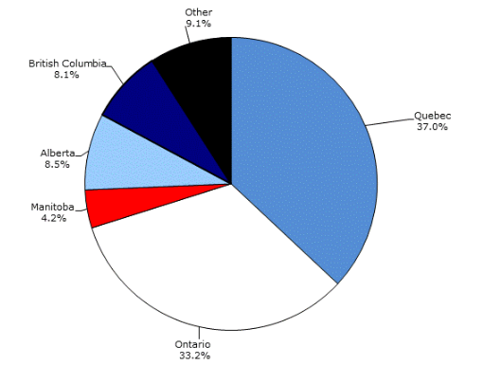
Figure 1: Quebec is Leading in High Quality Farming Products
(Source: statcan.gc.ca, 2023)

2.3. PESTEL Analysis
Factors | Descriptions
Political | - Political stability and significance of the agriculture sector in the economy (Skogstad, 2019).  - Level of corruption and government regulation in the business.  - Trade laws, tariffs and preferred trade partners.  - Taxation policies and incentives.  - Industrial safety rules and product labelling requirements.
Economic | - Type of economic system and stability.  - Exchange rates and currency stability.  - Infrastructure quality and its influence on operations.  - Skill level of the workforce.  - Economic growth rate, unemployment rate and inflation rate.
Social | - Demographics and skill level of the people.  - Cultural elements and attitudes.  - Entrepreneurial spirit and social backing for agriculture.  - Education level and norms.  - Leisure interests and customer preferences.
Technological | - Recent technical breakthroughs by rivals.  - Impact of technology on product offers and cost structures.  - Influence on the value chain structure.  - Rate of technological dissemination.
Environmental | - Weather conditions and climate change.  - Laws and regulations governing environmental contamination.  - Recycling and trash management need.  - Consumer views toward green or ecological goods (Zeng and Durif, 2019).  - Support for renewable energy.
Legal | - Anti-trust legislation and regulations.  - Intellectual property protection.  - Consumer protection and e-commerce legislation.  - Employment and health and safety requirements.  - Data protection and privacy legislation.
Table 1: PESTEL Analysis
(Source: Created by Author)

3. Competitive Analysis

3.1. Purpose and Function of Competitive Analysis
The competitive analysis acts as a critical element in the marketing process, helping organisations to understand their competitive environment and make educated strategic choices. Its objective is to examine the competition in the industry, potential of new entrants, power of suppliers, power of customers, threat of substitute products of the industry. Farmers may find areas of advantage, possible threats and options for expansion by examining the competitive environment.

3.3. Porter's Five Forces
Forces | Analysis | Impact
Competition in the Industry | - The intensity of rivalry in Quebec (Geloso, 2023)  - Market share and placement of rivals  - Differentiation methods adopted by rivals | High
Potential of New Entrants | - Barriers to entrance, such as financial requirements and government restrictions  - Existence of established agricultural methods and networks  - Potential dangers from new entrants and disruptive developments | Moderate
Power of Suppliers | - Dependence on suppliers for agricultural inputs and resources  - Bargaining power of suppliers based on market concentration  - Availability and pricing of major inputs (seeds, fertilisers, equipment) (Parcerisas and Dupras, 2018) | Low
Power of Customers | - Bargaining power of purchasers, such as retailers and distributors  - Price sensitivity and preferences of consumers  - Availability of alternative providers and goods | Moderate
Threat of Substitute Products | - Availability and acceptability of replacement items in the market  - Competitive pricing and differentiation of alternative goods  - Shifts in customer preferences towards different agricultural goods | Moderate
Table 3: Porter’s Five Forces
(Source: Created by Author)

4. Marketing Concept

4.1. Purpose and Function of the Marketing Concept
The objective of the marketing idea is to aid firms in meeting consumer wants and accomplishing organisational goals via successful marketing techniques. It highlights the significance of client focus, integration of marketing efforts and long-term profitability. By embracing the marketing idea, farmers from Quebec may move their emphasis from production-cantered tactics to customer-cantered strategies.

4.2. Application of Marketing Concepts
Farmers from Quebec might apply numerous marketing techniques to understand client demands and preferences. These principles entail performing market research, acquiring data and evaluating customer behaviour. Farmers may acquire significant insights into client preferences, expectations and purchase behaviour by utilising these principles. This insight helps them to customise their goods, services and marketing activities to match client demands successfully.

4.3. STP Analysis
Market Segmentation | Farmers may segment the market by finding discrete groups of clients with comparable demands, features and habits (Kumar et al., 2018). This helps businesses to customise their marketing efforts to target categories, guaranteeing greater alignment with client expectations.
Targeting | Once categories are found, farmers may assess their desirability and pick the most feasible target market groups. This comprises examining the size, growth potential, competitiveness and compatibility with the farmers' skills.
Positioning | Positioning refers to the distinctive spot a farmer's product or brand holds in the minds of the target buyers. Farmers can express their value offer effectively and generate a competitive edge by designing a compelling and unique positioning strategy.
Table 4: STP Analysis
(Source: Created by Author)

5. Strategic Planning

5.1. Purpose and Function of Strategic Planning
Strategic planning acts as a critical step for farmers from Quebec to develop a clear path for their firm and match their efforts with long-term objectives. The objective of strategic planning is to establish a roadmap that specifies the activities and choices necessary to attain targeted results. It entails studying the internal and external environment, recognising strengths and weaknesses and capitalising on opportunities while reducing dangers. Strategic planning offers a framework for making educated choices and allocating resources efficiently to enhance corporate development and profitability.

5.2. Ansoff Matrix
Market Development | Diversification
- Purpose: Identify and penetrate new markets using current goods.  - Function: Conduct market research to uncover untapped market niches, design focused marketing strategies and build distribution channels in new geographic regions. | - Purpose: Expand into new markets with new goods or services.  - Function: Conduct a detailed market study to find growth prospects, analyse market viability and allocate resources to explore new business sectors (Breul, Hulke and Kalvelage, 2021).
Market Penetration | Product Development
- Purpose: Expand market share within current markets using existing goods.  - Function: Utilise efficient marketing methods, such as promotions and advertising, to attract more consumers and improve sales. | - Purpose: Introduce new or enhanced items to current markets.  - Function: Conduct research and development efforts to generate unique goods, fulfil growing customer wants and distinguish from rivals.
Table 5: Ansoff Matrix
(Source: Created by Author)

6. Strategy Implementation

6.1. Purpose and Function of Strategy Implementation
Strategy implementation turns strategic plans into practical activities, assuring their effective execution. It tries to distribute resources efficiently, coordinate operations and assess progress towards organisational objectives. For farmers from Quebec, strategy implementation requires transforming their selected strategies into actual activities, aligning teams and maximising resource allocation to accomplish desired goals.

6.2. 4Ps of the Marketing Mix
Factors | Analysis
Product | Farmers may design and market distinctive agricultural goods, stressing attributes like organic, local sourcing and freshness via packaging and labelling methods (Allaby, MacDonald and Turner, 2021).
Price | Determining competitive but profitable pricing by considering market research and delivering value-added or premium choices.
Place | They can export the firming, fishing and intermediate food products. Establishing strong distribution channels, cooperating with local businesses, farmer's markets and online platforms, assuring efficient logistics and fast delivery (Vlachopoulou et al., 2021).
Promotion | Implementing digital marketing, social media and influencer collaborations to increase awareness, engage customers and boost brand exposure.
Table 6: 4'Ps Marketing Mix
(Created by Author)
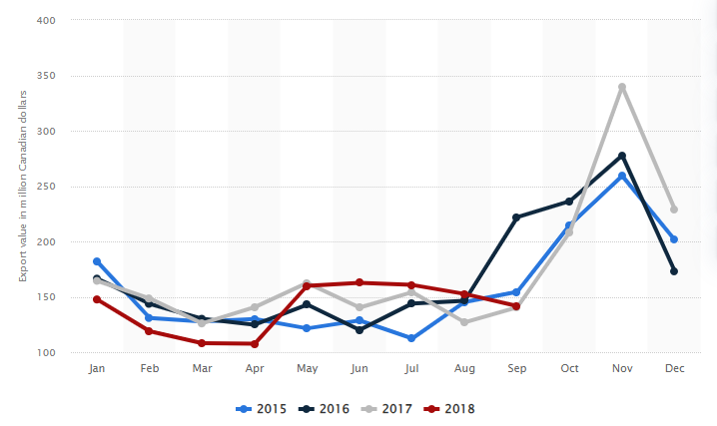
Figure 2: Monthly Export Value of Agriculture, Fisheries and Intermediate Food Products
(Source: Statista, 2023)

7. Control and Monitoring

7.1. Purpose and Function of Control and Monitoring
Control and monitoring serve the objective of recording and analysing the performance of adopted solutions for farmers from Quebec. They guarantee that the plans fit with intended goals and allow required modifications for greater performance.

7.2. Implementation of Control Systems
Control systems are established to measure progress and assess the success of marketing tactics. Regular data collection, analysis and reporting allow farmers to evaluate key performance indicators (KPIs) such as sales revenue, market share, customer satisfaction and brand recognition.

7.3. Use of Performance Metrics and Key Performance Indicators (KPIs)
Performance measurements and KPIs give quantitative standards for monitoring progress and making required changes. Farmers employ certain KPIs, including market share gain, return on marketing investment (ROMI), client retention rates and average order value (Tuten, 2022). These indicators help decision-making and optimise marketing activities.

8. Conclusion
Farmers from Quebec embrace a systematic marketing strategy to assess their company environment and develop successful tactics. The steps of this process include environmental scanning, competitive analysis, marketing concept, strategic planning, strategy execution and control and monitoring. Adopting a systematic strategy is crucial in the agriculture business, helping farmers to overcome problems, capitalise on opportunities and attain a competitive advantage. By adopting this marketing method, Quebec farmers may strengthen their business environmental position by making educated choices, optimising resources and attaining sustainable development.

9. Reference List
Allaby, M., MacDonald, G.K. and Turner, S., 2021. Growing pains: Small-scale farmer responses to an urban rooftop farming and online marketplace enterprise in Montréal, Canada. Agriculture and Human Values, 38, pp.677-692.
Breul, M., Hulke, C. and Kalvelage, L., 2021. Path formation and reformation: studying the variegated consequences of path creation for regional development. Economic Geography, 97(3), pp.213-234.
Canada Action, 2023. Farming in Quebec: 20 Facts. [online] Canada Action. Available at: https://www.canadaaction.ca/quebec-farming-facts#:~:text=Did%20you%20know%20that%20over [Accessed 22 Jun. 2023].
Geloso, V., 2023. Unenlightened peasants? Farming techniques among French-Canadians, circa 1851. Cliometrica, 17(2), pp.341-363.
Kumar, V., Leone, R.P., Aaker, D.A. and Day, G.S., 2018. Marketing research. John Wiley & Sons.
Parcerisas, L. and Dupras, J., 2018. From mixed farming to intensive agriculture: Energy profiles of agriculture in Quebec, Canada, 1871–2011. Regional environmental change, 18(4), pp.1047-1057.
Schreiber, K., Soubry, B., Dove-McFalls, C. and MacDonald, G.K., 2022. Diverse adaptation strategies helped local food producers cope with initial challenges of the Covid-19 pandemic: Lessons from Québec, Canada. Journal of Rural Studies, 90, pp.124-133.
Skogstad, G., 2019. The Political Economy of Agriculture in Canada. In The Political Economy of Agricultural Trade and Policy (pp. 35-56). CRC Press.
Tuten, T.L., 2022. Principles of marketing for a digital age. Principles of Marketing for a Digital Age, pp.1-100.
Vlachopoulou, M., Ziakis, C., Vergidis, K. and Madas, M., 2021. Analyzing agrifood-tech e-business models. Sustainability, 13(10), p.5516.
Zeng, T. and Durif, F., 2019. The influence of consumers’ perceived risks towards eco-design packaging upon the purchasing decision process: An exploratory study. Sustainability, 11(21), p.6131.

