

Internet Technology and Security

Website and Report

Elliot Barnett
1801749

BSc Computer Networks and Security

22/04/2019

Table of contents
- Abstract
- Requirements
- Implementation
  - Screenshots of website
  - Validation
- Evaluation
- References
- Image references

- Abstract
This report is about the website “Surfhub” and contains information and images to show how well the website is built. Below there are evaluations on how well the website functions, looks and feels. There are also validations on the HTML5 and CSS.

- Requirements

The website's purpose is to provide images, videos, and information on surfing. Also, it covers other related subjects such as beaches and the sea. The target audience for this audience is quite broad and it will have to suit all ages from young people to old people. It would be most relevant to people who like surfing, visiting the coast and love the sun.

- Implementation

  - Screenshots of all the pages within the website:

Homepage
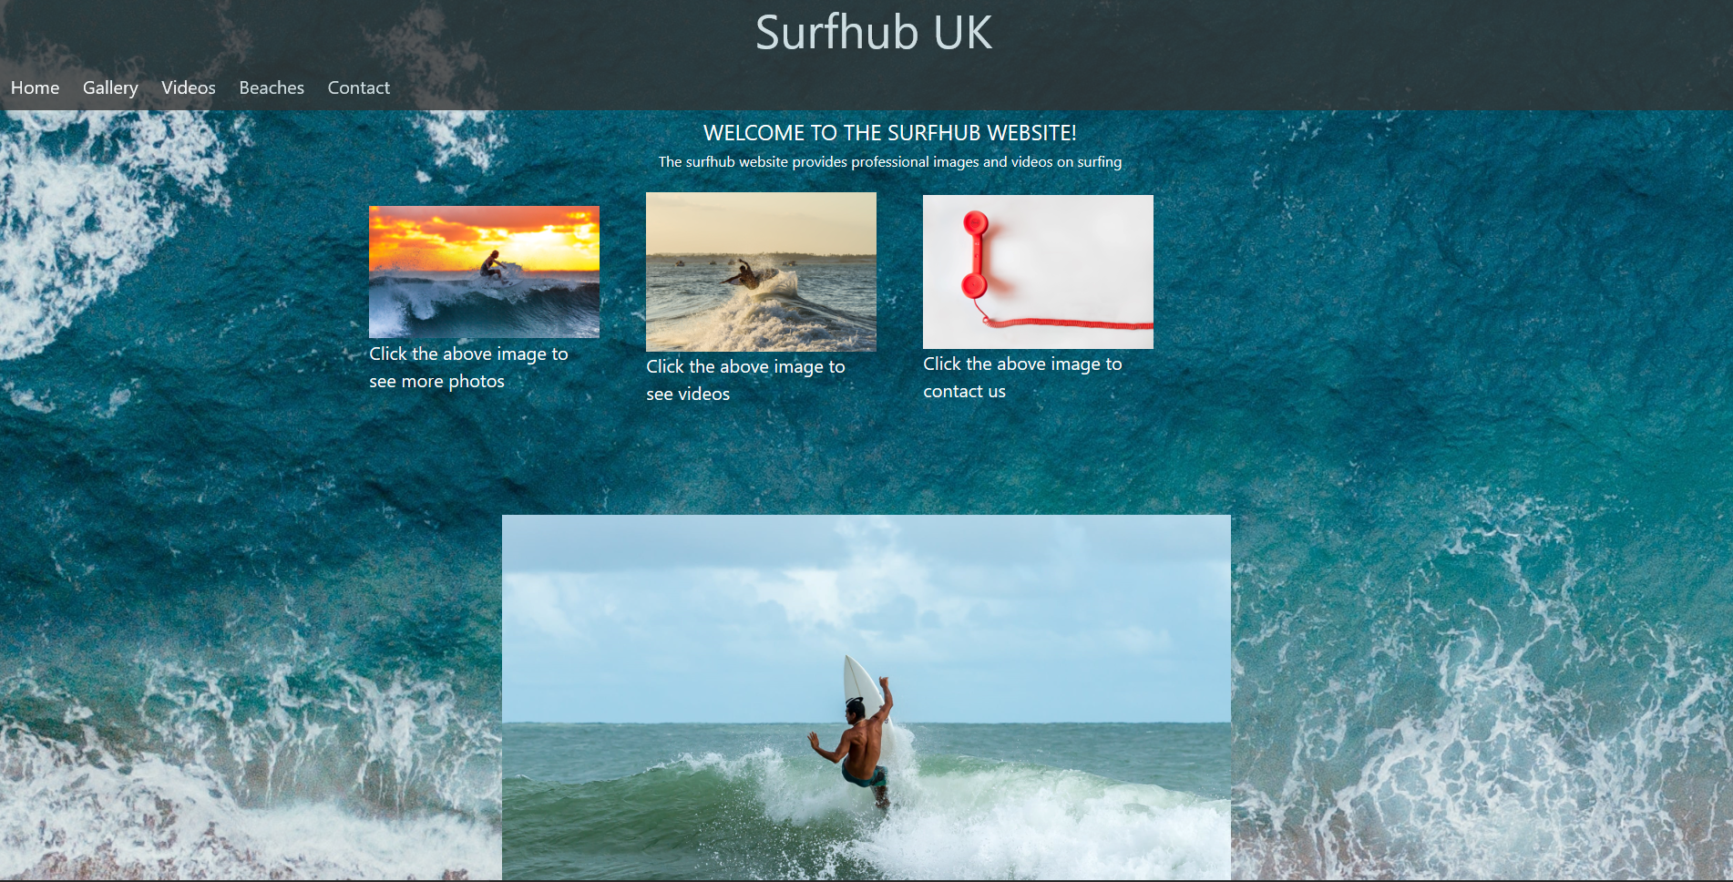

Gallery
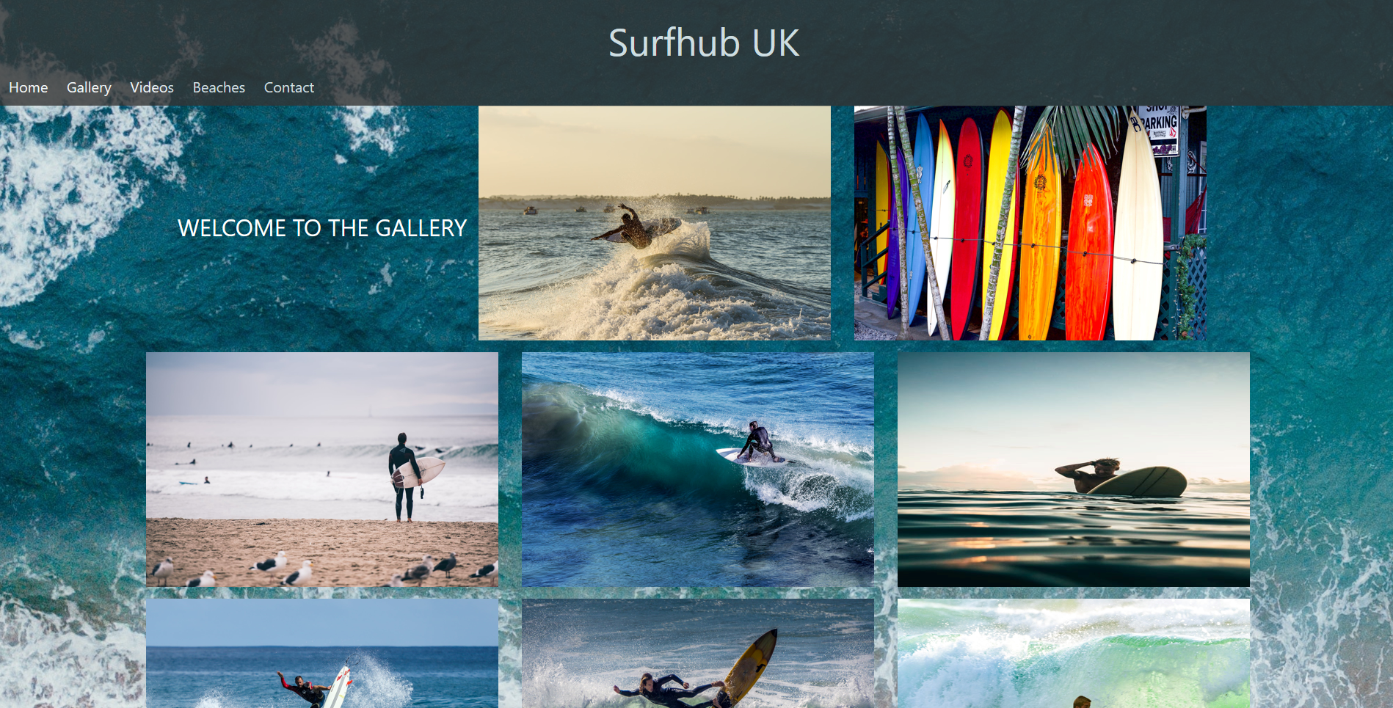

Videos
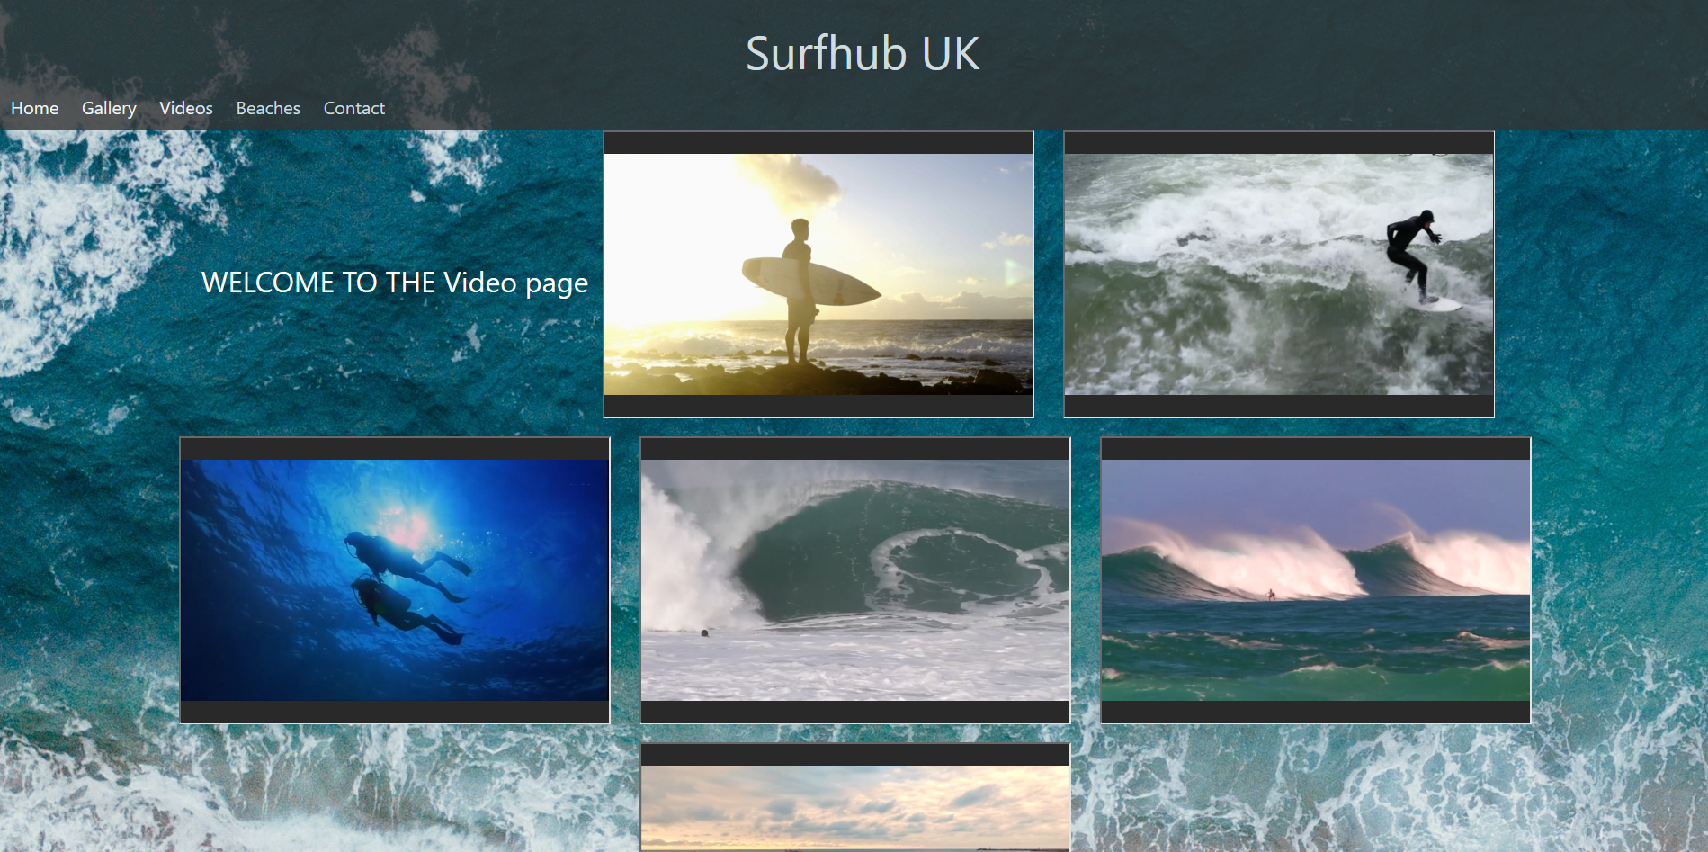

Beaches
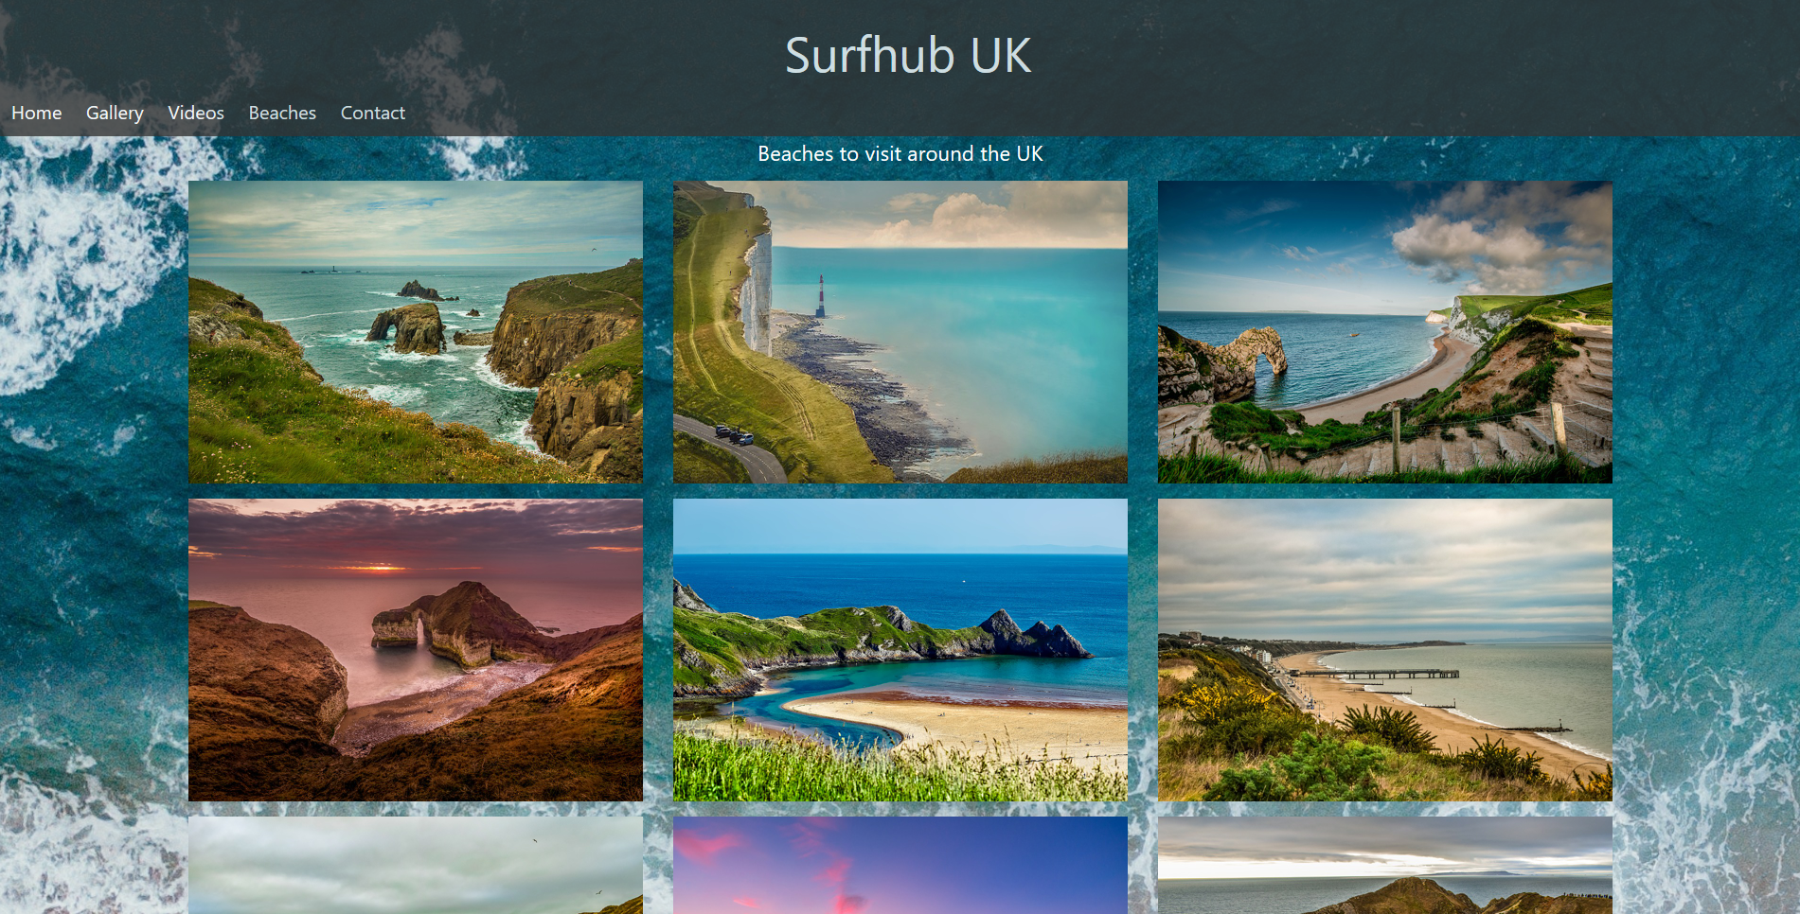

Contact
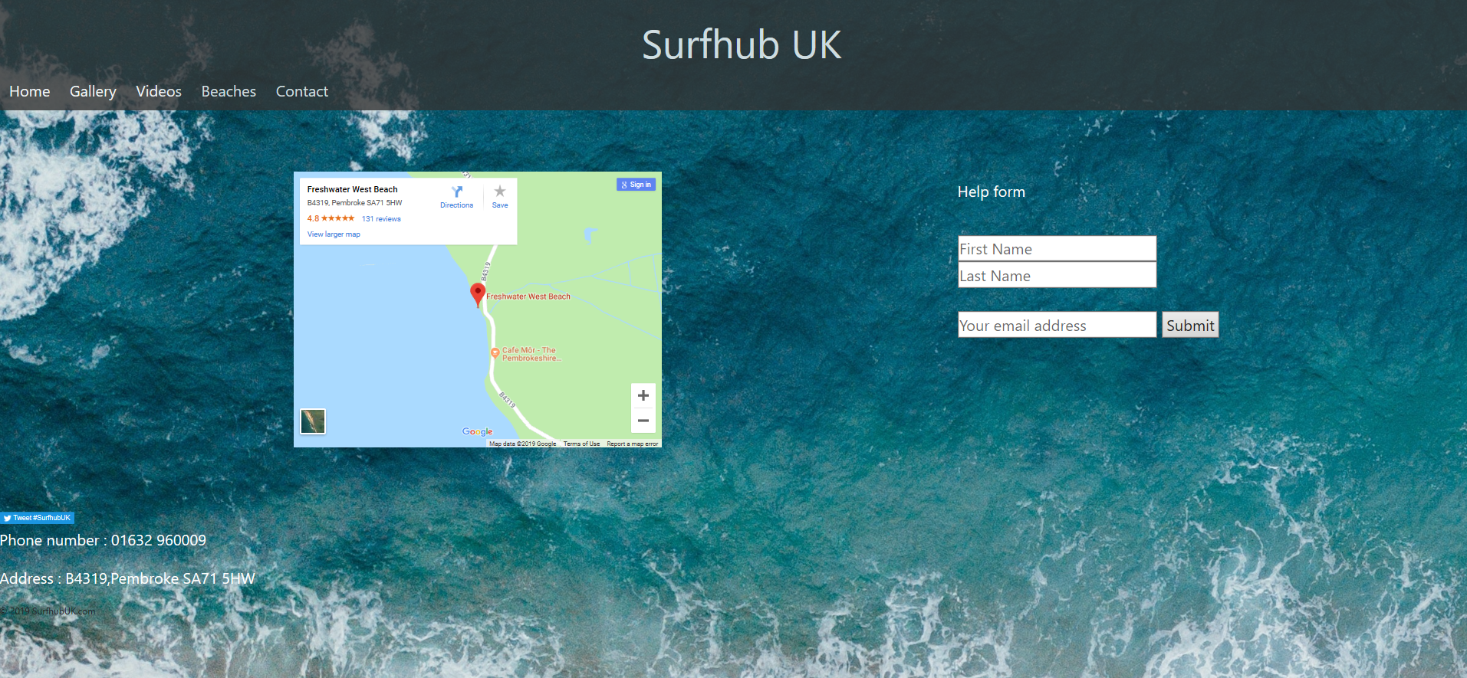

  - Validation

Index page
Within the index page, there are six errors. These errors include:

- “The character encoding was not declared. Proceeding using windows-1252”. The author thinks that the error is from what encoding the HTML file was saved with.

- “Attribute value not allowed on element meta at this point”. The author fixed the error by deleting the value attribute and entered keywords into the meta name.

- Similar to the above error the meta tag had no content in it. This was resolved by entering keywords into the meta field.

- The last three errors are because of the missing ‘alt’ attribute in the “<img class="slide" src="./images/surf6.jpeg" style="width:100%" />”. The solution to this is adding the alt attribute after the ‘src’ attribute. “<img class="slide" src="./images/surf6.jpeg" alt="Surfer1" style="width:100%" />”.

Gallery page
Within the Gallery page, there are 20 errors. These errors include:

- “Attribute value not allowed on element meta at this point”. As fixed on the index page. The writer added content to the meta tag and deleted the value attribute.

- “No space between attributes”. The writer as fixed this error by adding a space between the two attributes.

- "An ‘img' element must have an ‘alt' attribute. Except under certain conditions". The last lot of errors have the same error of not having an ‘alt' attribute in it. The writer has fixed this by adding ‘alt' attributes in every " <img src="../images/air.jpeg" alt="Surfer1" width="600" height="400" />”.

Video page
Within the video page, there is one error. This error is:

- “Element meta is missing one or more of the following attributes: content, property”. The writer has fixed this error by entering keywords and content in the new attributes.

Beaches page
Within the video page, there are 12 errors. These errors include:

- “Attribute value not allowed on element meta at this point.” The writer has fixed this error by taking away the value attribute.

- “Element meta is missing one or more of the following attributes: content, property”. The writer has fixed this by adding the content and name attribute. Also, the writer has added keywords and phrases into the attribute fields.

- The last 10 errors are the same. “An ‘img’ element must have an ‘alt’ attribute, except under certain conditions”. The writer has fixed this error by adding the alt attribute into the ‘img’ element.

Contact page
Within the contact page, there are three errors. These errors include:

- "Element meta is missing one or more of the following attributes: content, property". This error is fixed by adding a new attribute such as content, then enter the keywords and phrases in the field.
- “The frameborder attribute on the iframe element is obsolete”. The fix for this error is rather than using inline HTML commands, the writer has changed to CSS commands [1].
- “The value of the for attribute of the label element must be the ID of a non-hidden form control”. This error was fixed by changing the value of the for attribute to an ID for email.

Validation of the CSS
The CSS contained no errors and what validated for CSS level 3 and SVG.
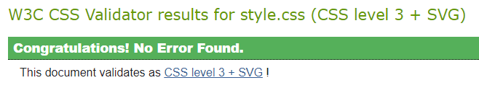

- Evaluation
  - Accessibility
A successful website must be accessible under all circumstances. If the website is not accessible, then it will not perform and attract many users [2]. There are four main factors to accessibility on a website these are:

Perceivable
When testing if the website is perceivable on all browsers, the writer found that the website works on chrome, internet explorer and Firefox. He used visual studio to open all three internet browsers at the same time and found that they functioned and look the same on all. The responsive CSS and HTML worked on all three as well allowing the website to be accessed in a structured way from any devices that has an internet connection. None of the internet browsers tried hiding any of the content due to the responsive code in the website, therefore the website is perceivable.

Operable
When testing the functionality of the website. The writer used visual studio to have all browsers tested to see if all the buttons and functions work on the website. The writer found that all buttons on the websites worked on all three internet browsers, also all the videos were working and allow the user to play and pause them at any time, on any of the three browsers. All interaction with the website is visible and functional to the users’ eye and all navigation is visible and functional allowing the user to navigate around the site.

Understandable
When testing the understandability of the website, the writer used colour contrast templates to help use colours that will not hide or make the operations in the website invisible, due to lack of good contrast between colours. The colours of the text on the website could be better due to the background's opacity being too high, but the text is still visible and helps point out the buttons and navigation functions on the website.

Robust
The writer used the developer tools on google chrome to see if the website worked on different resolutions. The resolution is to show how the website would look on smartphones with lower resolutions. The website works on all resolutions and the responsive code helps wrap all the content in the website, so it is visible to the user on a smaller resolution. The website is also written in the latest version of HTML "HTML5" and the latest version of CSS. Also, with the website be responsive it will allow the user to use it on any of the new smartphones or tablets.

  - Evaluation of the website
Below are different sections where the writer is reflecting on the different aspects of the website:

Design
The design of the website is in the writer’s opinion quite basic. The use of an image as a background could be a bad and good thing. The structure of the website is clean and no excess buttons or pop-ups that will pull users off. The images on the front screen could be a bit more centered but the images used as buttons for navigation makes the functionality of the website for better.

Usability
The navigation bar is clean and shows basic and simple buttons that clearly show where the button will navigate too. The use of responsive code helps the content wrap condense into a column and a lower resolution, which helps view the website on a smartphone or tablet.

Content
The content overall is good with the images and videos but lacks the information about them. More text could be added to the gallery showing where the images are from and taking by who. The content is spaced equally allowing the user to not get overwhelmed by the number of photos. The use of the flexbox on the gallery allows the images to be equally apart.

Future Improvements
There are a lot of future improvements that could make this website more efficient and good looking. This include:
- Adding text to speech will allow blind users to have an idea on what is on the website and allows them to picture in their mind what the surfers and beaches might look like.
- Adding colour blind modes such as protanopia, deuteranopia, and tritanopia. Allowing colour blind users to see the images and videos more easily.
- Allowing users to upload non-copyright images and videos to the website for everyone to use would be a good future improvement. It will allow the website to reach a broader audience such as photographers.
  - More information is needed on the website and a help bar that will help the user around the website.

  - Evaluation of the SEO
Search engine optimisation will play a big factor on whether the website will have a lot of traffic or not. More than 93% of all traffic comes from a search engine [3]. On the website, the writer uses meta tags that contain keywords that help search engines see what is on the website. The title tags that are used are good keywords to help search engines find traffic. All images have alt attributes which help show the user what is supposed to be there. Using the validator helped the writer see what meta tags and alt tags etc were missing. A future improvement to the SEO of the website could be using googles keyword planner which will help organise and find the best keywords and phrases to give the website a better SEO [4].

- References

[1] | user2950291, “Stack Overflow,” 14 10 2014. [Online]. Available: https://stackoverflow.com/questions/26274082/the-frameborder-attribute-on-the-iframe-element-is-obsolete-use-css-instead. [Accessed 24 04 2019].
[2] | W3, “W3,” 2016. [Online]. Available: https://www.w3.org/TR/UNDERSTANDING-WCAG20/intro.html. [Accessed 25 04 2019].
[3] | M. Whiteman, “Multi channel merchant,” 13 August 2018. [Online]. Available: https://multichannelmerchant.com/blog/5-basic-seo-principles-to-increase-your-website-traffic/. [Accessed 26 04 2019].
[4] | M. Whiteman, “Multi Channel Merchant,” 13 August 2018. [Online]. Available: https://multichannelmerchant.com/blog/5-basic-seo-principles-to-increase-your-website-traffic/. [Accessed 2019 04 26].

- Image References
Below are all the images used in the website. They were all from non-copyrighted websites.
image1 -https://www.pexels.com/photo/action-adult-beach-birds-305268/
image2 -https://www.pexels.com/photo/assorted-colors-of-surfboard-757133/
image3 -https://www.pexels.com/photo/person-surfboarding-1545696/
image4 -https://www.pexels.com/photo/person-surfing-1572062/
image5 -https://www.pexels.com/photo/beach-foam-landscape-nature-533923/
image6 -https://www.pexels.com/photo/marketing-office-working-business-33999/
image7 -https://www.pexels.com/photo/man-surfing-2045292/
image8 -https://www.pexels.com/photo/man-holding-white-surfboard-1122413/
image9 -https://www.pexels.com/photo/sea-wave-surfer-ocean-67386/
video 10 -https://www.pexels.com/video/man-holding-a-surfboard-1093664/
image11 -https://www.pexels.com/photo/photograph-of-a-person-surfing-1494720/
image12 -https://www.pexels.com/photo/surfer-about-to-ride-a-wave-barrel-1654485/
image13 -https://www.pexels.com/photo/man-riding-surfboard-on-body-of-water-1667005/
image14 -https://www.pexels.com/photo/action-athlete-beach-fun-305261/
image15 -https://www.pexels.com/photo/person-riding-on-surfboard-2081007/
video16 -https://www.pexels.com/video/man-surfing-856132/
video17 -https://www.pexels.com/video/paddle-surfing-and-scuba-diving-video-854387/
video18 -https://www.pexels.com/video/man-holding-a-surfboard-1093664/
video19 -https://www.pexels.com/video/person-surfing-the-waves-857185/
video20 -https://www.pexels.com/video/people-surfing-854351/
video21 -https://www.pexels.com/video/video-of-surfers-856422/
image22 -https://cdn.pixabay.com/photo/2016/09/30/01/23/cornwall-1704183_960_720.jpg
image23 -https://cdn.pixabay.com/photo/2017/06/21/22/51/beach-2428964_960_720.jpg
image24 -https://cdn.pixabay.com/photo/2017/12/12/12/50/sea-3014623_960_720.jpg
image25 -https://cdn.pixabay.com/photo/2019/02/08/19/51/bournemouth-3983868_960_720.jpg
image26 -https://cdn.pixabay.com/photo/2016/11/04/19/00/england-1798699_960_720.jpg
image27 -https://cdn.pixabay.com/photo/2019/02/10/19/00/lulworth-cove-3987982_960_720.jpg
image28 -https://cdn.pixabay.com/photo/2017/06/25/09/20/seascape-2440097_960_720.jpg
image29 -https://cdn.pixabay.com/photo/2019/01/04/14/10/man-o-war-cove-3913233_960_720.jpg
image30 -https://cdn.pixabay.com/photo/2019/02/27/20/24/lulworth-cove-4024961_960_720.jpg

