
Skills for the Workplace
Module Assignment Submission
Student Name: | JOSE M. LOPETE CHONCO
Student Number: | 1808701
Module No: | BMSK4003
Module Title: | Digital Skills and Research Methods
Lecturer:

Table of Contents

1. INTRODUCTION 2
2. Effectiveness of the use of modern technologies within the workplace 3
2.1 Evaluating technology at workplace - Cloud Storage 3
2.2 Evaluating technology at workplace – Smart phones 3
2.3 Evaluating technology at workplace – Self Checkout 4
3. Social Media at workplace 5
3.1 Social media as a tool of marketing 5
3.2 Analysis of social media as tool for workplace communication 7
3.3 Analysis of social media as tool for information gathering 7
Reference: 9

1. INTRODUCTION
According to Belanger and Van Slyke, (2012), technology is all things created by humans that can make our life easier, more convenient and more functional. Technology assists organisations to achieve productivity and organisational efficiency. This report examines and analyses different technology used in everyday life in workplace. The report consists of two sections. The first section analyses effectiveness of the use of modern technologies within the workplace such as cloud storage, smartphones, and self-checkout. The next section analyses social media as a tool for marketing, information gathering and communication within the workplace.

2. Effectiveness of the use of modern technologies within the workplace

2.1 Evaluating technology at workplace - Cloud Storage
According to Belanger and Van Slyke, (2012), “Cloud storage is a service model in which data is maintained, managed, backed up remotely and made available to users over a network (typically the Internet)”. Some of the most popular cloud storages are: Dropbox, Google Drive, Mega, OneDrive, and iCloud.
At workplace cloud storage assists to cut costs on expensive hardware, energy and also keep IT spending low (Faronics, 2018). A survey conducted on 56 organisations by MindSHIFT (cloud storage service provider) suggests that moving to cloud based storage assist them to save around £50,000. furthermore moving to cloud storage solution provides several workplace benefit for examples, instant access to the file, can be accessed from anywhere, improved system redundancy as a result of that, improve efficiency and productivity at the workplace (Faronics, 2018). OpsRamp, a cloud solution provider, conducted a survey on IT executives from several organisations and reported the top most motivations for switching cloud storage are: aspiration for better flexibility and scalability, and improve workplace productivity (OpsRamp, 2018).
However, the disadvantages of cloud storage are:
- Require Internet connection to access any file.
- Provide slow service and impact operation if the Internet connection is not fast enough.
- Take longer time to upload or download for bigger file size.

2.2 Evaluating technology at workplace – Smart phones
According to Statista, in the UK 46.4 million people use smartphone and Labour Force Survey identified that 32 million people are in employment and uses smartphones (Dalton, 2017). A combined research of Samsung and Frost and Sullivan reported that workplace satisfaction, efficiency and productivity can be linked to smartphones and productivity increase up to 34% for using smartphones.
Smartphones brings a various benefits at workplace. Using smartphone at work employees can save their paperwork, can take important notes. Smartphones enable instant access of real time information at all the time. Smartphones assists employees to stay contact with office, suppliers, and customers. Communication becomes easier. Employee can check email, send email, can share files easily from smartphones. So workplace efficiency imp become easier. Smartphone contain lot of applications such as reminder, to do list, task manager, diaries, calendars, and so on. These applications can help workforce to improve their efficiency. (Dalton, 2017)
However, various substantial business difficulties may arise as a result of using mobile phones at workplace. Continuous communication in the smartphone might disturb the workflow of emolyees and decline productivity. All time availability might interrupt employee’s personal life. (Johnson, 2013)

2.3 Evaluating technology at workplace – Self Checkout
Organisation are continuously looking for new way to make business process more efficient by using technology and self checkout technology is assisting business to integrate their business and make more efficient.
The most significant advantage of self checkout it that it assist to speedup customer’s purchase and pay. Customer can avoid long queue. It makes the customer happy and reduce the stress employee. Many self check out terminals can be placed comparative less space. This helps retail stores to take of customer transactions in less space and stores get additional space to display products. Generally, the UK retailers employ one employee for six checkout terminals. Thus, the business saves on employee overhead. (Boothe, 2014)
However, self checkout service has several difficulties. Such as customer might find difficulties in scanning products, bar code don’t scan properly, age restricted products and so on. These may frustrate customers and they might not be uses the service in future. Although most of the self checkout terminals are equipped with anti theft technology, still it easier for people to steal as they will not be monitored closely. Many customers like interaction with employees and want to serve by human not by machine. (Boothe, 2014)

3. Social Media at workplace
Social media consists of two words, social and media. The word social means the interaction between people or group with same interest. Media means the medium or channel, which allows interaction and exchange of information between individuals or groups. (Stelzner, 2014)
According to Richard (2009), “Social media network are applications that allow users to build personal web sites accessible to other users for exchange of personal content and communication and can be characterized as: online applications, platforms and media which aim to facilitate interactions, collaborations and the sharing of content”. In recent time, almost everyone and every organisation have their presence in social media such as Facebook, Twitter, LinkedIn, Instagram, Pinterest and so on.
This section focuses in examining how businesses are using Facebook as a tool for marketing, information gathering and communication within the workplace. Developed on 2004 in Unite State by a twenty-four-year-old Mark Zuckerberg, Facebook is a technology channel that you express your idea, business massages and any marketing issue. (Boothe, 2014)

3.1 Social media as a tool of marketing
As Facebook is dominating the online communication so organisations are targeting Facebook or other social media as a marketing tool Kietzmann (2013). Accordign to Stelzner (2014) the most important benefits that the organisations gain form marketing on Facebook are increased exposure and increased traffic. Bacon (2011) suggested four important factors that organisation needs to consider for successful appearance on Facebook and these are:
Contents: Contents are important aspect on Facebook. Organisations need to publish fresh and relevant information regularly to keep the customers’ interested.
Engagement: Business need to engage with their Facebook audience with positive perceptions, which will in turn assist to gain in sales, goodwill, loyalty, benefaction, brand association, loyalty and will act as brand ambassador to promote the business.
Skills: Important skills regarding to the designs, graphics, colours, monitoring, analysing all are important aspect in order to reach Facebook audience.
Consistency: Organisation need to be consistent to back the knowledge gained from Facebook and need to commit to analyse the data regularly.

Advantage of social media as a tool of marketing
Colliander, J. and Dahlén, M. (2011) pointed out organisations use social media to improve fan loyalty (72%), acquire market intellect (71%), and improve sale (50%). Some of these advantages are described below:
i. Improved sales: According to Drury (2008), around 50% of the organisation that have been surveyed acknowledged that social media assists them to improve sale.
ii. Improve exposure: Dean (2014) pointed out most of the organisation that have been surveyed admitted that social media has provided their business with improved exposure.
iii. Develop business partnerships: According to Dean (2014), half of the organisations that have been surveyed acknowledged that social media assist their business to make new partnerships. Dean stated that organisations could be more profitable by selling to other businesses than those selling to consumers (Dean, 2014).
• Reduced marketing expenses: According to Assaad and Gómez (2011), “At least 57% of businesses with 10 or fewer employees agreed social media reduced marketing expenses, while only 40% of businesses with 1000 or more employees agreed”
• Improved search rankings: Organisations that uses social media assist their business to improved search engine rankings.
• Developed loyal fans: According to Assaad and Gómez (2011), “B2C marketers were much more likely to develop a loyal fan base through social media than B2B marketers. Of those who have been using social media for at least 1 year, 69% found it useful for building a loyal fan base. Time invested makes a difference. Of those spending at least 6 hours a week, 78% found benefit compared to 56% of those spending 5 hours or fewer per week.” (Assaad and Gómez, 2011)

Disadvantage of social media as a tool of marketing
According to Richard (2009), “negative effects of social media marketing could affect the brand of the organization and affect the overall performance of the organization”. As people are free to express their comments on social media without thinking about the consequence therefore marketing using social media can be some unpredictable and uncontrollable. According to Richard (2009), “by choosing whom to follow on these sites, products can reach a very narrow target audience. Social media hasn’t only had an impact on organisations but on marketing itself, the era of catchy punch lines and striking images is no longer the be all and end all; it is about a continual dialogue, building trust and interacting with the right audience in the right way, as fast as possible, marketers are now in the front of the line facing consumers and controlling the brand”.

3.2 Analysis of social media as tool for workplace communication
Organisation can create Facebook page or group for their employee and use it for regular communication with their employees. As all the employees within the company will be able to send out notice on any meeting, update, change update, distribute jobs, send job performance and so on. Facebook as a social media can be used as a tool to communicate with employees who work from distance or various locations at different time zone. Therefore, Facebook assists to improve workplace efficiency and employee engagement. Moreover, the decision making process become faster and it becomes easier to employees who are working towards a common goal to collaborate (Miller-Merrell, 2013).
However, employees who continuously engaged in Facebook might not work in their full potential, which will diminish workplace productivity. Continuous work related update on Facebook page or group might interrupt employee’s personal life. Sharing or writing offensive or unexpected comments can reduce employee morale and satisfaction. A Harvard Business Review study also suggests “workers who use social media at work are more likely to cultivate the connections they would need to move on to their next job, even though they are at your site, working on the clock”. (Adams-Mott, 2018)

3.3 Analysis of social media as tool for information gathering
Organisations collect raw data from their Facebook posts’ shares, likes, comments, mentation and impression. Based on the customers’ comments on production or services published on Facebook, organisation can take strategic decision to develop or marketing product. Feedback gained on Facebook can be used to improve customer service. After gathering the data from Facebook, organisation can use these data to develop for its brand development. According Bennett (2017), Facebook allows business to access feedbacks from customers and after analysing the data businesses can reach to the emerging trends on branding their products and determine the quality of product that people look for. According to Bennett (2017) “with such information gathered from Facebook, a company can then optimize the said product to meet the customers’ expectations which will, in turn, attract more customers to purchase the product. The social media channels also allow easy communication with customers hence making it easy to respond to complains that may arise in the course of service delivery. Also with a feedback system, a company can realize the different aspects of the competitive market in which they operate. Customers’ comments also enable one to understand how different competitors are doing which in turn offers an opportunity for improvement in a bid to meet the customers’ demands.” Based on the customers’ comments on production or services published on Facebook, organisation can take strategic decision to develop or marketing product. Feedback gained on Facebook can be used to improve customer service.

3.- OPEN AN ACCOUNT IN
Facebook https://www.facebook.com/joseph.lo.754
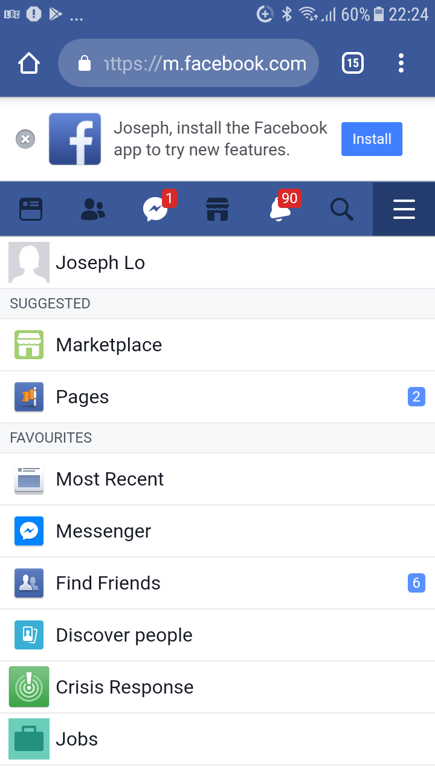

Twitter: https://twitter.com/JL96627480

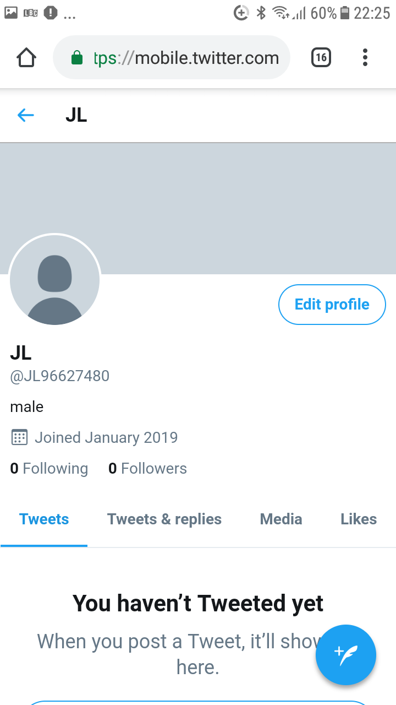

Linkedin: https://www.linkedin.com/in/jose-m-lopete-l-7638b2bb/
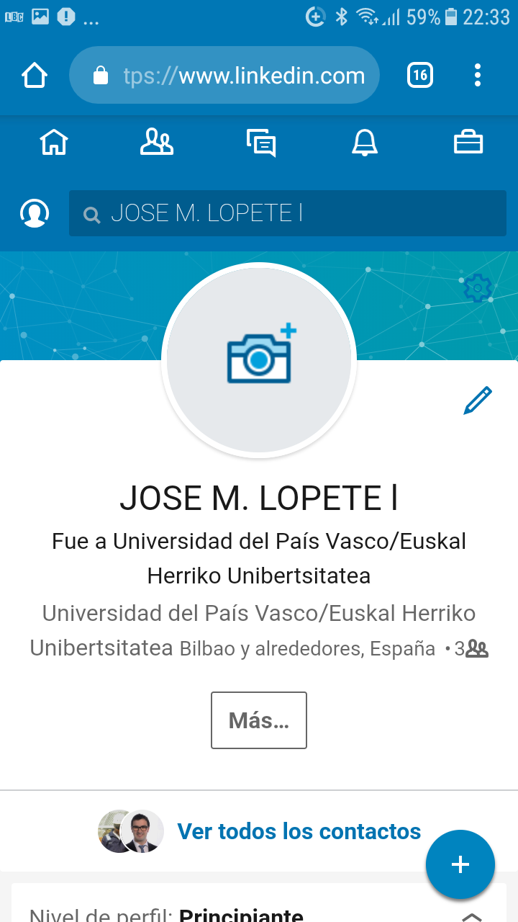

Reference:
Adams-Mott, A. (2018). The Disadvantages of Social Networking in the Workplace. [online] Smallbusiness.chron.com. Available at: https://smallbusiness.chron.com/disadvantages-social-networking-workplace-21064.html [Accessed 11 Jan. 2019].
Assaad, W. and Gómez, J.M. (2011). Social Network in marketing (Social Media Marketing)-Opportunities and Risks. International Journal of Managing Public Sector Information and Communication Technologies 2: 13-22.
Bacon, J. (2011). Impact of Social Media on Marketing Industry - Fourth Source. [online] Fourth Source. Available at: https://www.fourthsource.com/social-media/impact-of-social-media-on-marketing-industry-3515 [Accessed 11 Jan. 2019].
Belanger, F. and Van Slyke, C. (2012). Information systems for business. Hoboken, NJ: John Wiley & Sons.
Bennett, S. (2017). The 10 Biggest Challenges Facing Social Media Marketers. Social Times.
Boothe, G. (2014). The Pros and Cons of Using Self-Checkouts | Business.org. [online] Business.org. Available at: https://www.business.org/software/point-of-sale/the-pros-and-cons-of-using-self-checkouts/ [Accessed 11 Jan. 2019].
Colliander, J. and Dahlén, M. (2011). Following the Fashionable Friend: The Power of Social Media Weighing Publicity Effectiveness of Blogs versus Online Magazines. Journal of Adverting Research 51: 313-320.
Dalton, A. (2017). Smartphones in the Workplace. [online] Insightsforprofessionals.com. Available at: https://www.insightsforprofessionals.com/blog/smartphones-in-the-workplace?sid=leadership [Accessed 11 Jan. 2019].
Dean, A. (2014). Internet technologies.
Drury, G. (2008). Opinion piece: Social media: Should marketers engage and how can it be done effectively? Journal of Direct Data and Digital Marketing Practice 9: 274-277.
Faronics (2019). [online] Faronics.com. Available at: https://www.faronics.com/assets/Cloud-Storage-Cost-Benefit-Analysis.pdf [Accessed 11 Jan. 2018].
Johnson, L. (2013). [online] Available at: https://www.business2community.com/tech-gadgets/advantages-of-using-smartphones-in-your-business-0375741 [Accessed 11 Jan. 2019].
Kietzmann, J.C. (2013). Bittersweet! Understanding and Managing Electronic Word of Mouth. Journal of Public Affairs 13: 146-159.
Miller-Merrell, J. (2013). [online] Workology. Available at: https://workology.com/social-media-enterprise-communciation/ [Accessed 11 Jan. 2019].
OpsRamp, I. (2018). Service-Centric AIOps: Efficient Analysis. Effective Response. Effortless Remediation. [online] Info.opsramp.com. Available at: https://info.opsramp.com/service-centric-aiops-white-paper [Accessed 11 Jan. 2019].
Richard (2009) Measuring Organizational Performance. Journal of Management p50-62.
Stelzner, M.A. (2014). How Marketers Are Using Social Media to Grow Their Businesses. Social Media Marketing Industry Report.

