Shafia Bibi | 1711966 | Cohort 1 | Group 2
LECTURER | ABDULLAH AL MAMUN
DEVELOPING RELATIONSHIPS AND WORKPLACE ACHIEVEMENTS
MODULE CODE: BMSK5002_birm

Contents
INTRODUCTION 2
MOTIVATION 3
REWARDS AND BENEFITS 8
TRAINING AND DEVELOPMENT 11
PERSONAL DEVELOPMENTAL PLAN 14
CONCLUSION 16
REFERENCES 17

INTRODUCTION

By looking at the title of this report, it can be suggested that there is a connection between relationships and the impact it has on an organisation. Some may say, the upmost importance of a positive relationship is to build a better workforce or future. Relationships can be positive or negative. Whatever the outcome, this could possibly highlight any achievements or idleness.
Relationships can be encouraged through a number of different ways. In a work setting, employers must ensure to build relationships with employees and their customers. Employees help the growth of a business, attracting customers from a wide target area. Customers will use the service and if made happy, this may help boost workplace achievements. Employee engagement and customer satisfaction thus is vital for workplace triumph. This detailed report discusses and evaluates the impact and benefits of three developmental vehicles, used to develop the needs of individuals.
Motivation, Feedback and Reward, and Training are all vehicles that may be used to support an individual to develop in a workplace setting. The views of each vehicles can be debatable depending on different perspectives. Current research and theories can be used to evaluate the benefits and effectiveness of each vehicles. A Personal Development Plan (PDP) is a tool that can be used to help enhance ones chances of better engagement at work. The organisation in which will be discussed is NEXT RETAIL LTD.


Source: https://www.bbc.co.uk/news/business-43512375

MOTIVATION

MOTIVATION SUMMARY

Motivation is often the result of an action, not the cause of it. (Clear, 2018). Motivation is having a drive to accomplish ones goals or objectives. This can bring personal satisfaction. There are two types of motivation: extrinsic motivation and intrinsic motivation. Extrinsic motivation can be stimulated by external factors such as employment, social factors or environment. Intrinsic motivation can be enthused through ones soul and desires, such as hobbies. Motivation in the workplace is essential for company growth. Individuals require motivation to work more efficiently. It also helps to stay focussed on what is important and on what is required of them. Motivation can be a key to success.
People can be motivated in a number of different ways. It is important to understand an individual before finding a way that may be suitable for them. For example, a person experiencing financial difficulty may thrive on the idea of overtime or reward systems. Giving one the opportunity for overtime opens more doors for them. This may help reduce their financial stress. Reward systems such as employee of the month can also prompt people to work harder and more efficiently. The thought of more recognition in the workplace may push them to work faster. Flexibility is also another motivational technique. Some people may prefer to work a variety of different hours a week, rather than a set period of time or days. This can radiate positivity, as people will have more personal time. The downside of that however may be for the employer, they are unable to find cover for the rest of the hours that is required. Employers should have a variety of motivational methods so that they are not experiencing loss in some areas.

MOTIVATION AT NEXT

“Our priority is to provide an environment where our employees are motivated to achieve their full potential.” (NEXT PLC, 2019).

NEXT is a retail store that offers unique high quality clothing and homeware. They have over 5 million active online shoppers, across more than 70 countries. They have 510 stores and offer home delivery services. NEXT also offers finance options for purchases and franchise stores in 35 different countries. Their main source of products is from Hong Kong. (NEXT PLC, 2019).

“Our approach to cooperate responsibility is to address key business related social, ethical and environmental impacts in a way that aims to bring value to all our stakeholders.” James (2019, P.2). In their cooperative responsibility report, James (2019, P.22), the director of NEXT clearly states amongst several of their aims, they seek to develop positive relationships with their suppliers and to take care of their employees. They have a team of people who specialise in meeting their needs. Motivation can sometimes be a little difficult to arouse. It takes hard work, stimulation and a desire to be motivated. NEXT uses a variety of methods to motivate their employee. This includes: Rewards and Benefits, Training and Development, Sharesave, Payroll Giving, and Workplace Nursery.



Source: https://www.pickeverard.co.uk/case-study/next-steps-day-nursery/

Sharesave gives employees the opportunity to save money over 3-5 years and buy a NEXT share at a discounted price. This discount is for 20%, and the total employees that have participated in 2015 in this scheme was around 11,100. Payroll Giving is an opportunity for employees to give the tax taken from their wages towards a charity of their choice, rather than it go to the Treasury. It is estimated that in one year, the total amount that the employees have contributed towards charity is £29,000. Workplace nursery is an opportunity for NEXT employees to use their nursery whilst at work. NEXT STEPS NURSERY was opened in 2013, and has had an OFSTED report as “outstanding” on its first inspection. This method of motivation has helped the employees by reducing the overall travel distances the employees have had to take for using other nurseries. It also helps the employees feel valued, as it demonstrates NEXT have taken employees personal life into consideration. The employees will feel more welcome to work at NEXT, opening the window for more hours of work too. (NEXT, 2015).

MOTIVATION THEORIES

“What the workmen want from employers beyond anything else is higher wages: what employers want from workmen most of all is low labour costs in manufacture.”
Frederick Taylor, cited in Expert Program Management (2018).

Frederick Taylor’s (1856-1915) motivation theory was to look at everything scientifically. His idea of scientific management was that all workers should be given small tasks, where they are able to observe it scientifically and them complete the task. He believed managers should be responsible for assigning the small tasks to the appropriate people, and wages should be dependent on the quantity of products. Taylor believed that workers are lazy. They are motivated by money. (Expert Program Management, 2018).

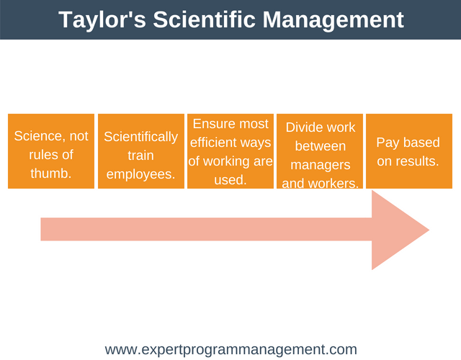

Source: https://expertprogrammanagement.com/2018/05/taylors-scientific-management/
Frederick Taylor’s motivation theory is that money is the mother of influencers. It can be said that yes, money is an influencer, however there could be other factors that motivate employees too, such as training and development. Money alone will not be a motivation method for all. NEXT’s NEXT STEPS NURSERY is also another good example of motivation. Also, Taylor mentioned that wages should be given depending on the amount of products that are produced. This method alone does not apply in today’s world. Not every organisation applies this method. People are encouraged to work hard but they are mostly paid by the hour, not the amount created. However, in some businesses, people may get a commission such as the sales department but they are following other rules too, something that Taylor did not emphasis on. At the end of the day, people need money.
Whatever the reason for their chosen career, they will earn some money and that money will be used for their desires. Who doesn’t want money? Saying that, there are some individuals that would work for organisations without receiving an income, for charity. They feel they want to make a difference to the world, help those in need. Or perhaps shape a good reputation for themselves, to build a better future. If this report was based on self-employed individuals, then it could be argued that Taylors motivation method applies here. Pay is based on results. The more they work, the more they earn. However, it could be said that money alone does not motivate people. It could be ones hobbies, interests and needs. This could be backed by Maslow’s Hierarchy of Needs (1943), another motivation theory.


Source: https://www.simplypsychology.org/maslow.html
Maslow suggested that people need to meet their lower level needs before meeting their higher needs. Motivation increases as their needs are being met. This can be demonstrated with NEXT STEPS NURSERY. An individual needs childcare for their youngsters (basic need). Once that need has been met, they can then consider employment and relationships (psychological need).
NEXT’s chief executive, Lord Wolfson stated, “2017 was the most challenging year we have faced for 25 years. It has also prompted us to take a fresh look at almost everything we do including the structure of its shop portfolio and the in-store experience.” BBC News (2018).
In BBC’s report, it can be seen that the needs have changed for NEXT. The loss of profits has made their motivation for business purposes increase. The drop in profits has encouraged NEXT to rethink business structure and strategy. Their motivation is money but their need has changed, therefore the motivational method for an increase in profits will also change.

ADVANTAGES AND DISADVANTAGES

The advantage of having motivational methods in an organisation, is so that all individuals can participate in the well-being and progression of an organisation. This includes better productivity from everyone, lower labour costs and higher levels of external engagement. Individuals will seek better methods for task accomplishment, which are more quality-oriented. Most of all, one motivated worker can motivate an unmotivated or a demotivated worker.
The disadvantages of having motivational methods is that not all individuals will desire the same method. Managers may overstress the importance of control and the control could get out of hand. There could be more conflict between employees, wanting to achieve a higher status or a better reputation in the eyes of the employer. This could have massive effect on the business overall, damaging the success of the business. Also, those who are encouraged using extrinsic motivation, may not last very long in that particular job, as their desire for the external reward has ended.

REWARDS AND BENEFITS

REWARDS AND BENEFITS SUMMARY

Rewards and benefits are a way of attracting and motivating talented people. Rewards help one to be recognised by their employer, encouraging them to feel satisfied by their actions and promote more positive behaviour. When an employee is rewarded and praised for their hard work, they feel proud and valued. This improves their overall performance within the workplace, with a better sense of job satisfaction. There are two types of reward and benefits: Extrinsic and Intrinsic. Extrinsic rewards include financial based rewards / benefits, and intrinsic rewards are non-financial rewards, which emphasises on employee job satisfaction. Some examples of extrinsic rewards and benefits include: job security, pay rise, bonuses, pension scheme, employee discounts, childcare voucher, company car and paid leave. Intrinsic rewards may include: job satisfaction, appraisals, appreciation, recognition, and personal development.

REWARDS AND BENEFITS AT NEXT

“Having a good reward system helps keep employees happy, loyal to the company, and eager to move up the ladder.” Abourizk (2019).

As mentioned previously, some of the benefits that help motivate employees, that are provided by NEXT are: Training and Development, Sharesave, Payroll Giving and Workplace Nursery. They also offer extrinsic rewards for working with them and to help them feel satisfied about their career choice. “We believe in rewarding all employees with fair and competitive salaries, along with the opportunity to gain additional pay in the form of a bonus depending on the Company (or in some cases store, or individual) performance.” NEXT (2015, p.22). The problem with this statement is that the salary may be “fair and competitive, however the employee may desire more. This fair and competitive salary may not be sufficient enough for NEXT to retain their staff. The staff may look for employment elsewhere. Also, they mention that they give the opportunity to gain additional pay, but the opportunity may prove to be of a huge struggle. Especially when there is more competitors in the workplace.
In his motivation theory, Frederick Taylor believed people are motivated purely by money. If that is the case, then Taylor’s theory is relatable to rewards and benefits to some extent. Taylor’s theory may support the fact that extrinsic rewards such as a bonuses are a major influencer on attracting employees.

ADVANTAGES AND DISADVANTAGES

The advantages of having extrinsic and intrinsic rewards and benefits is that it will motivate people to develop in the workplace. It will help them settle and focus on their job role. Having a variety of rewards and benefits also shows employers have taken a keen interest on their employees.
A research was conducted to assess what influenced organisations to promote employee benefits. As Figure 1 demonstrates, the vast majority of the respondents selected they promote benefits to attract, recruit and retain the employees to support their current business needs, followed by organisations wanting to promote benefits to support their future business needs, as well as promoting work-life balance and employee health.

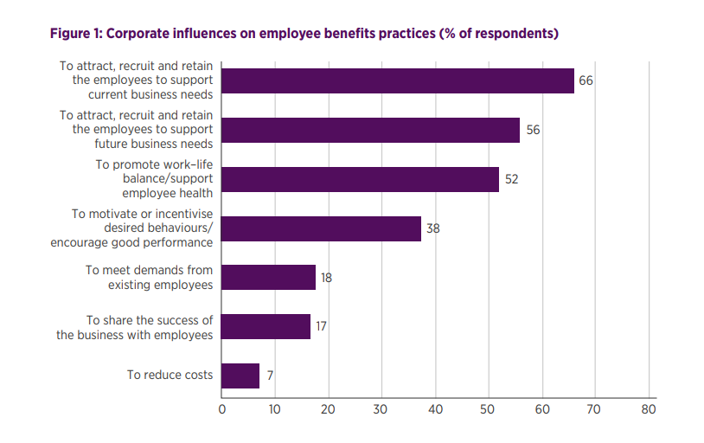

Marriott and Perkins (2018, p.14).

It can be seen from this chart that not only do rewards and benefits help employee development within the workplace, but it can go both ways. It can also aid the organisations growth.
As well as the advantages of having rewards and benefits, there are some disadvantages that may come with it. People may not really focused on their work, they may wait on receiving rewards and benefits. They may be so inclined on rewards that they develop a belief that they are owed rewards and benefits. Also, some rewards may not work for others. For example, if there was a reward for employee of the month, it may not convince everyone to work hard to achieve the same. It just may not be enough. According to Marriott and Perkins (2018, p.19), history can play a part. Employers may offer a benefit that once profited the organisation, even if those benefits didn’t make sense today.

TRAINING AND DEVELOPMENT

TRAINING AND DEVELOPMENT SUMMARY

Training and Development is another vehicle that can be used, to support an individual's development in the workplace. It emphasises on the importance of performance and managing individuals or groups. Training is the process of learning new skills and experiences. It helps broaden ones knowledge, changes behaviour and improves attitude, which in return helps an organisation progress. Training and development helps one to identify their strengths and weaknesses. It enables them to build their confidence in areas they lack. Training can also be provided, simply to refresh ones knowledge. A company that follows a systematic model of training, acquire more in business. A systematic method is the process of an action. The process of training and development includes: identifying needs, objectives, methods, delivering and evaluating.

SYSTEMATIC TRAINING MODEL
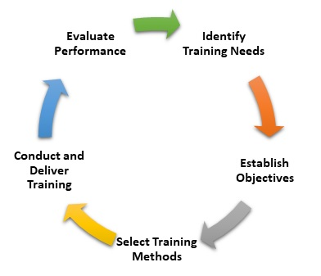

Source: https://www.mbaskool.com/business-concepts/human-resources-hr-terms/8685-training-and-development.html

Following this process will ensure the company that they are providing suitable training to individuals in the correct method. (MBA Skool-Study.Learn.Share., 2019). It leaves little room to miss out on fundamental points. If one method of training and development did not work, after evaluation the company could then start again, identifying particular needs which may meet the method of training they require.

TRAINING AND DEVELOPMENT AT NEXT

There are different methods for training and development. In some organisations they have face-face training, whether it be in a meeting or on the go. Most organisations use in-house methods. In other organisations they have online training.
NEXT’s challenges and targets involve providing training opportunities to develop employees to achieve their full potential. (NEXT PLC, 2019). They do this by offering a wide range of training and development opportunities. NEXT’s motive by offering these opportunities is to ensure employees are supported and equipped to carry out their role to the best of their ability. Also, NEXT wants to manage the needs and challenges of the business. Each area of the business has its own training methods, appropriate to individual need and job sector. NEXT ensures their employees knowledge and skills are up to date, with their individual needs and business related needs met. They also provide mandatory training such as Health and Safety, First Aid and Manual Handling, to ensure the safety of their employees. NEXT (2015, p.34). NEXT’s training and development also includes: Management Development Programme, Trainee Team Manager Programme, Life Long Learning, Engineering Academy and E-Learning. The variety of training allows individuals to select which training best meets their needs. The training also allows employees to develop their career, going from their current role to a higher role, for example the Trainee Team Manager Programme. This programme allows individuals who want to go into management experience the role by shadowing the team manager and attending relevant courses.

ADVANTAGES AND DISADVANTAGES

There are many advantages of having training and development opportunities. Some of this may include: employee job satisfaction, employee motivation, increased productivity, more capacity to adopt new technologies and methods, further innovation, reduced labour costs, company reputation, and health and safety. Turan (2015, p.1104) states, Frederick Taylor highlighted the importance of recruiting the right personnel and training of them, and regarding it as a part of the management’s mission. The benefit was to lower labour costs and the fact that it is not easy for an employer to give up on an employee who is recruited and subject to training unless it is really necessary. After conducting some research, Majeed and Shakeel (2017, pp.500-501) suggests there is a positive relationship between the training and the organisation effectiveness. Results show that the productivity of the organisation is increased because of the training and development.

One of the downfalls of having training and development in place, is that some employees may lack interest in development. It will be hard to motivate them and can prove to be costly. If the training and development opportunities were not made use of or not understood, then it will simply be a waste of time, money and effort. Some individuals may be committed to their job but may not be towards training. Perhaps they do not have a drive for further development. Some organisations use online training. This can go either way. People nowadays are more obsessed with the internet, so this method of learning should not be a problem for them. However, there is little opportunity for help when undertaking these online training methods.

PERSONAL DEVELOPMENTAL PLAN

A Personal Development Plan (PDP) is a plan to improve an individual’s personal or business goals. A PDP in the workplace can identify aims for an individual, recognising strengths and weaknesses and the need for improvement. (Rolfe, 2019). It is important to remember any obstacles that may arise, and ways to tackle this. A timescale of the goals is essential on a PDP, to give room for implementation and evaluation after the period ends. The timescale also helps one to motivate themselves, by adapting to different situations and challenges.
A retail assistant considers becoming a manager at NEXT, but does not have the relevant skills to become one. Without experiencing some managerial tasks, they will not be certain if that job is suitable for them. Below is an example of a PDP.

Vehicle | Objective | Action | Support | measures | target
Training and Development | Complete Trainee Team Management Programme. | Fulfil programme requirements.  Shadow team manager.  Attend operational courses. | Line manager.  Team manager.  Course tutor. | Completion of the course.  Knowledge and understanding.  Use of skills, theory and models. | Monthly review.  6 months shadowing.  12 months to complete course.
 | Complete Management Development Programme. | Fulfil programme requirements.  Complete trainer led modules, self-study units and post course activities. | Line manager.  Senior training and development advisors.  Dedicated development rooms.  Online e-learning. | Completion of the programme.  Application of skills and knowledge. | 18 months to complete programme.

This PDP will enable the individual to stay on the right tracks. It may give them the push they need to achieve their aspirations of becoming a manager. If they want to stop at Team Management, then that is up to them but the opportunity for completing the management programme is there. It outlines what is required of them and the length of time. The PDP shows there is support available from a variety of sources. If one feels they lack online skills, that can be seen as a weakness, and the individual can seek further help to strengthen that particular skill. Every information will not be stated on a PDP, but the PDP will help the individual to challenge themselves by seeking out their strengths, weaknesses, likes and dislikes.

CONCLUSION

It can be concluded that every organisation differs, especially in business terms. Every business’ success rate will be different, and that will depend on a variety of factors. The methods for developing their employees within the workplace is a huge factor to consider. Managers play a big part in an employees development. It is up to them how they want to support their employees. They should find out more about their staff and cater different vehicles to meet their individual needs. It is important to make sure the vehicle is still relevant to today, as some methods for development may be irrelevant. Communication and interaction are also vital, for developing an individual in the workplace. To give reference to theories, different views will help identify which theory works well for an organisation. Theorists can give different methods and become quite confusing, however they have undertaken much research to get where they are, therefore they play an important part in the running of a business. There’s even theory on behaviour. That just goes to show behaviour is an umbrella for several factors.

REFERENCES

Abourizk, R. (2019). [online] Study.com. Available at: https://study.com/academy/lesson/reward-management-theory-importance.html [Accessed 2 Aug. 2019].

BBC News. (2018). Next hit by toughest trading for 25 years. [online] Available at: https://www.bbc.co.uk/news/business-43512375 [Accessed 2 Aug. 2019].

Clear, J. (2018). Motivation: The Scientific Guide on How to Get and Stay Motivated. [online] Available at: https://jamesclear.com/motivation [Accessed 23 Jul. 2019].

Expert Program Management. (2018). Taylor’s Motivation Theory – Scientific Management. [online] Available at: https://expertprogrammanagement.com/2018/05/taylors-scientific-management/ [Accessed 2 Aug. 2019].

Garfinkle, J. (2019). Building Positive Relationships at Work. [online] Garfinkleexecutivecoaching.com. Available at: https://garfinkleexecutivecoaching.com/articles/build-positive-work-relationships/building-positive-relationships-at-work [Accessed 22 Jul. 2019].

James, A. (2019). COOPERATE RESPONSIBILITY REPORT. [online] Available at: https://www.nextplc.co.uk/~/media/Files/N/Next-PLC-V2/documents/cr-reports/cr-2019.pdf [Accessed 23 Jul. 2019].

Majeed, A. and Shakeel, S. (2017). International Journal of Scientific & Engineering Research. 8th ed. [ebook] Pakistan: Ijser, p.500. Available at: https://www.ijser.org/researchpaper/IMPORTANCE-OF-TRAINING-AND-DEVELOPMENT-IN-THE-WORKPLACE.pdf [Accessed 3 Aug. 2019].

Marriott, L. and Perkins, P. (2018). REWARD MANAGEMENT. [ebook] London: Global Policy Institute, pp.14-19. Available at: https://www.cipd.co.uk/Images/reward-management-report-2018_tcm18-51630.pdf [Accessed 3 Aug. 2019].

Martini, M. and Cavenago, D. (2016). The role of perceived workplace development opportunities in enhancing individual employability. International Journal of Training and Development, 21(1), pp.18-34.

Maryska, M. and Wagner, J. (2013). REFERENCE MODEL OF BUSINESS INFORMATICS ECONOMICS MANAGEMENT. Journal of Business Economics and Management, 16(3), pp.621-637.

MBA Skool-Study.Learn.Share. (2019). Training and Development Definition | Human Resources (HR) Dictionary | MBA Skool-Study.Learn.Share.. [online] Available at: https://www.mbaskool.com/business-concepts/human-resources-hr-terms/8685-training-and-development.html [Accessed 3 Aug. 2019].

Mcleod, S. (2018). Maslow's Hierarchy of Needs. [online] Simply Psychology. Available at: https://www.simplypsychology.org/maslow.html [Accessed 2 Aug. 2019].

NEXT (2015). CORPORATE RESPONSIBILITY REPORT TO JANUARY 2015. OUR PEOPLE.. [ebook] pp.34-37. Available at: https://www.nextplc.co.uk/~/media/Files/N/Next-PLC-V2/documents/corporate-responsibility/cr-2015-our-people.pdf [Accessed 2 Aug. 2019].

NEXT PLC (2019). BUSINESS MODEL. [online] Nextplc.co.uk. Available at: https://www.nextplc.co.uk/~/media/Files/N/Next-PLC-V2/documents/2019/business-model.pdf [Accessed 24 Jul. 2019].

NEXT PLC (2019). Our people. [online] Nextplc.co.uk. Available at: https://www.nextplc.co.uk/corporate-responsibility/our-people [Accessed 30 Jul. 2019].

Pick Everard. (2019). Next Steps Day Nursery - Pick Everard. [online] Available at: https://www.pickeverard.co.uk/case-study/next-steps-day-nursery/ [Accessed 2 Aug. 2019].

Rolfe, A. (2019). Personal development planning: What you need to know. [online] reed.co.uk. Available at: https://www.reed.co.uk/career-advice/personal-development-planning-what-you-need-to-know/ [Accessed 3 Aug. 2019].

Turan, H. (2015). Journal of Economics, Business and Management. 3rd ed. [ebook] Turkey: Hitit University, p.1104. Available at: http://www.joebm.com/papers/342-M031.pdf [Accessed 3 Aug. 2019].

