03/09/2021
BINTA DIOP (2009719)
LECTURER ‘S NAME: HUSAM ALHARAHSHEH
MODULE CODE: BMSW4005
PROFESSIONAL CAREER DEVELOPEMENT
“INDIVIDUAL REPORT”
Table of content
Introduction: 2
Reflection on the role play: 2
Personal development planning 4
Johari Window 4
Personal swot analysis 4
Personal development plan 5
Review of my understanding and expectations of the world of employment 6
Career ambitions and aspirations 6
Personal Development plan to enable me to achieve my ambitions 7
Conclusion: 7
References 8
Appendix: 9
Application for Employment 9
Role Play answers 17

Introduction:
If I am where I am now, it is all thanks to my parents. They come from a poor town near Dakar in Senegal, they taught me to always appreciate what I have and if I have a dream to pursue it without ever giving up. And that is the reason why I am here in England today, to undertake my studies and to be able to obtain a degree in Business and Management in a couple of years.
During my past school years, I have had wings and downs.
During the summer I have always made cultural exchanges in other countries such as France, Switzerland, and England to improve the English and French language.
But life is not all fun and games, in fact during my last year of high school, due to family problems, I was rejected and therefore forced to repeat the last year twice.
Having passed the last year and graduated, I took a year off from my studies so that I could work and the following year be able to economically move to the UK.
As soon as I arrived in the UK, in 2020, I started the procedure necessary to enroll at the university and took the related tests. I ran into a bit of trouble with being in a new city and having to rely only on my strength. Since my savings would only be enough for a few months, I immediately started looking for a job and after 1 month and a half I found a job in an Indian restaurant. Within 5/6 months I have grown in position from sorting dirty dishes to waitress to training manager for new employees. At the beginning it was very hard because of the English language that I had not yet fully assimilated and because of the practice of a job that I had never done before.

Reflection on the role play:
For the first part of our evaluation, we had to work with a partner of ours to role-play where we had to interview each other. The purpose of the task was to challenge ourselves and act as if we were applying for a job.
In the first part I started by asking questions to my partner, who was applying to be manager at the Savoy bar. A few days earlier, my partner sent me the announcement of the job he wanted to apply to, so that I can prepare some related questions. I didn't find this part very difficult because I was able to rely on a file that the professor had sent us weeks before. So, in preparing the questions I was sure I was going the right way. I started the interview by politely greeting and thanking the candidate for attending the interview. Even though I had already read his application form, I wanted to ask him to tell me a little about him so as to break the ice, because everyone feels a little nervous at the interviews. I therefore learned the importance of putting the person I am interviewing at ease. One of the things I wanted to do but didn't do, was interact a little more with the person I was interviewing. And by interacting, I mean giving a little feedback after every answer to my question and not moving on to the next question right away. So, this is definitely one of the things I need to keep in mind and a part that I need to improve for a future interview that I need to do.

In the second part I was interviewed by my partner and to be honest it was a bit challenging. This is because in all the interviews I have done in the past, I have always found myself in difficulty in answering questions and very often making a silent scene. During this interview I understood the reason for this difficulty. One of the main reasons is that I did not do enough pre-preparation before the interview. Normally, I would apply for the job and show up for the interview without preparation or practice, and by doing this the interview could only end in one way: not getting the job I was applying for. In addition, one of the difficulties that I knew I would have was that of not being able to control anxiety; I have a good public speaking skills but every time I have an interview, I suffer from it. For this interview, however, I prepared myself and in addition to consulting the question file, I also did an online search for other probable questions that could be encountered during an interview. Preparing myself in a good way, however, helped me. I think the interview went well, but I still think there is room for improvement.
I also think that during my answers, I should have given one or two examples referring to my old job in order to give more complete answers.

Personal development planning:

Johari Window
 | KNOWN TO SELF | NOT KNOWN TO SELF
KNOWN TO OTHERS | Public Arena (Public self)  - Organized  - Dependable  - Mature  - Independent  - Sensible  - Sincere  - Hard-working  - Cultured | Blind Spot (Unknown Self)  - Confident  - Kind  - Helpful  - Funny  - Trustworthy  - Generous  - Likable  - Polite
NOT KNOWN TO OTHERS | Façade (Hidden Self)  - introvert  - shy  - patient  - adaptable  - religious  - sentimental  - cautious  - Modest | Unknown Area (Unconscious self)  - Wise  - Ingenious  - Proud  - Powerful  - Unique  - Tactful  - Direct

Personal swot analysis

STRENGHTS | WEAKNESSES
- Time management  - Creative  - Reliability  - Public speaking | - Written communication  - Commercial awareness  - Lack of qualifications
OPPORTUNITIES | THREATS
- New experience  - Autonomy  - Networking  - Internship | - No HR manager experience  - Language  - Economy and unemployment

Personal development plan

NAME | Binta Diop | Target Job/career  HR manager

TIME PERIOD | From: 01/10/2021 | To:01/05/2025

What Skills do I need to achieve my goal?
SKILLS | How Will I get them | What resources or support will I need? | What can prevent me from achieving my goals: (unemployment, illness | How long should it take
- Good communication skills  - Leadership skills  - Organisational skills  - Three-year degree in business and management  - Confidence with numbers | - Completing university in business and management  - doing internships during the studies | - my university teachers | - work in a company that does not allow me to grow professionally | - 3 years
Ability to build relationship with team | Internship | My superior at work | Not finding a job | 5 months
Being socially aware | Reading the newspaper and doing research online | Newspaper and google | No internet connection or newspaper | Couple of months
Have experience in general HR role | Working in a company as an assistant HR manager | Advice from my senior colleagues who are following the same path as me | Not being able to find an internship during my years of study | 2 years

Review of my understanding and expectations of the world of employment:
Thinking about my future job, I expect to find myself in a positive environment, that allows me to mature both professionally and personally. I hope to have appropriate training from my superiors, to have support and to be helped. I hope to work in a safe and healthy environment, to be made aware of all company policies and procedures and my responsibilities at work.
In my work environment I hope to have a good relationship with my superiors, and to receive feedback from them regarding my work. I expect to have all the resources I need to be able to perform my tasks at best, and also to receive credit and acknowledgment for work achievements. Since the world of work is all about give-and-take, I for my part will strive to complete all my tasks on time, be open to constructive feedback, ask for help if I need it, respect the people I work with and be self-motivated and reliable. But the world of work can be a difficult, in fact I don't know if all these expectations of mine will come true if I don't find a job first.
In October, I will begin the three-year degree. I expect the university to give me and teach me all the knowledge I need and will use in the future for my work. I also expect my teachers to help me connect my education with real life. Is an important aspect since I will then find myself in the working world after three years of study.

Career ambitions and aspirations:
In 5 years, my goal is to have successfully completed my bachelor's degree in business management and finance and to have already started my fourth year of apprenticeship in some company. I would like to work in a company, that allows me to continue learning and embracing new opportunities every day and improve my skills. In 5 years, I hope to be able to have different work experiences around the world. I know that after the third year of university, there is the possibility of doing a placement in a city outside London, so I’m looking forward for it. I hope to work full-time, between 35 and 40 hours per week with weekends off; and this is because I don't want my job to become my whole life. I have some hobbies that I have practiced since childhood, such as roller skating or swimming. By working through the week and keeping the weekends off, I will be able to continue practicing my hobbies. I really hope to be able to work in a leader position, in fact my goal is to work as HR manager of a public company, become a leader for my team and lead the company towards success. The working environment has always attracted me, I like being in contact with people, so I hope to be able to work in a full-time office, as to be in contact with people, interact with them, have an exchange of ideas. Working in the office will help me to have a routine, to schematize and manage my time in an intelligent way without risking procrastinating, what would happen if I worked from home.

Personal Development plan to enable me to achieve my ambitions:
Being that my goal is to become an HR manager, there are some skills that I have yet to acquire, so that I will be able to do my job in a few years. The first thing to do is to have a degree in business and management; in order to have it next year I will start my bachelor's degree. An HR manager must have a list of skills, including excelling in communication skills but also the ability to listen, be a strong leader, the ability to remain calm in stressful situations, be a support and motivate their team etc. In order to achieve all this ability and skills, I intend to do several part time internships in different working sectors, so as to obtain all these skills. Another reason why I will have these work experiences, is to work in different sectors before finishing my bachelor's degree. The work experience will also help me understand if I really want to work as an HR manager, I will have the chance to see how the work really operates from closer. At the end of the three years and after graduating, I will do the fourth year of placement offered by the university in a country outside the UK. During that year abroad, I will have the opportunity to use all the skills and knowledge I acquired during the years of study. Even after having done all these years of internship and placement, I will still have to work as an assistant to the HR manager for a couple of years and have general experience in the field. And this is because it is one of the necessary requirements to become an HR manager.

Conclusion:
In conclusion, I think this report has helped me a lot to reflect on my future and more importantly to remember where I come from and why I am doing all this. I have had the opportunity to do deeper research into the work I want to do in the future, know what I need to do and what resources will I use to achieve that goal, and set a time frame within which to achieve it.

References
Ridout, S. H. a. N., 2018. Frontiers. [Online]
Available at: https://www.frontiersin.org/
[Accessed 26 August 2021].

Schooley, S., 2020. Business news daily. [Online]
Available at: https://www.businessnewsdaily.com
[Accessed 23 August 2021].

Appendix:

Application for Employment
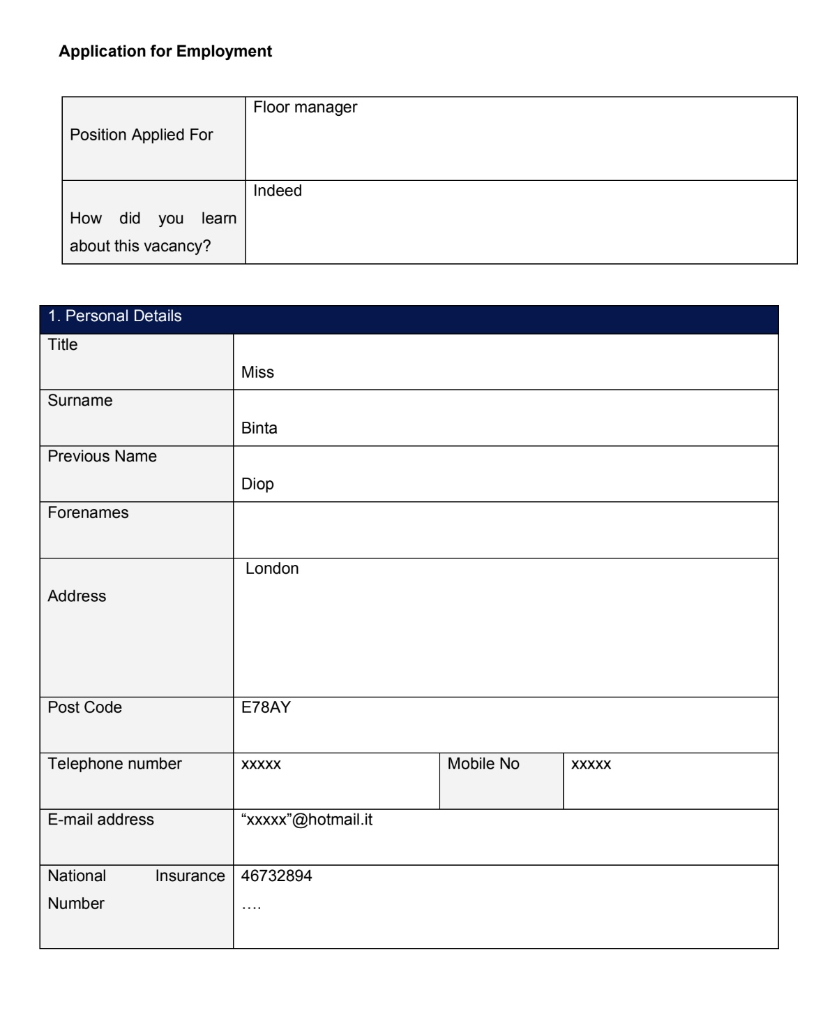
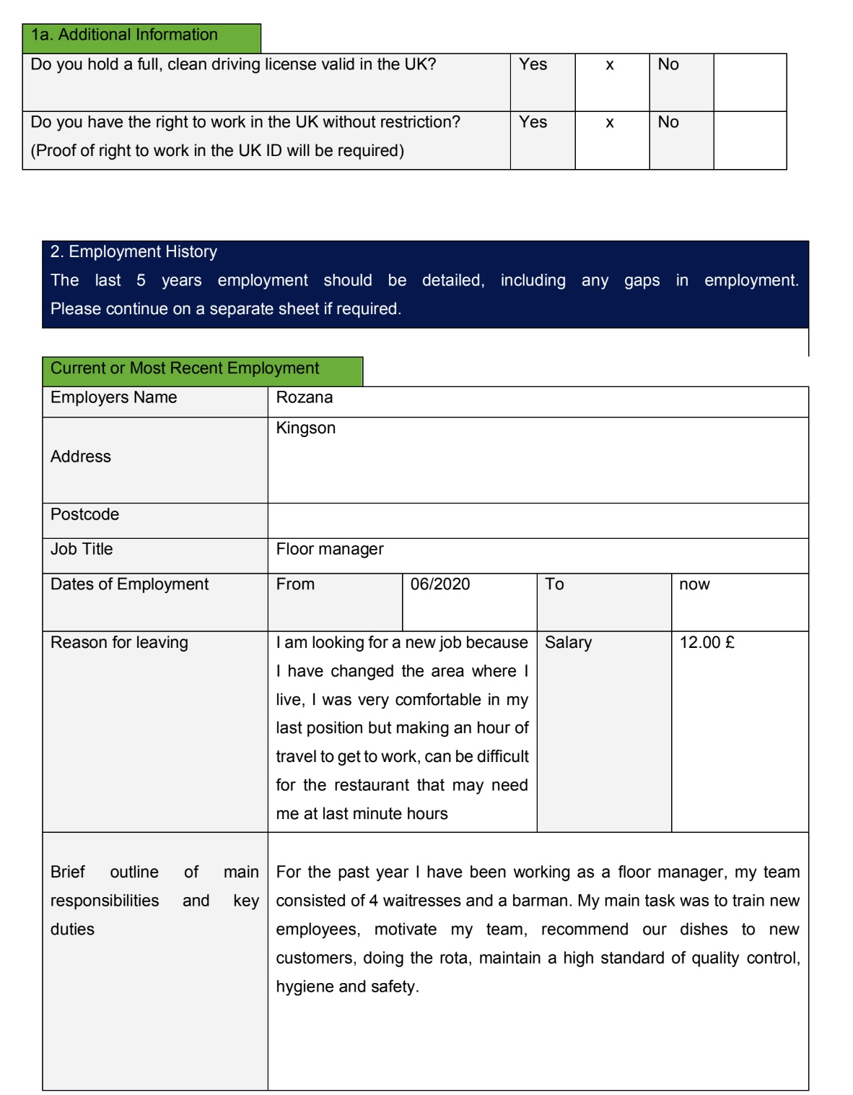
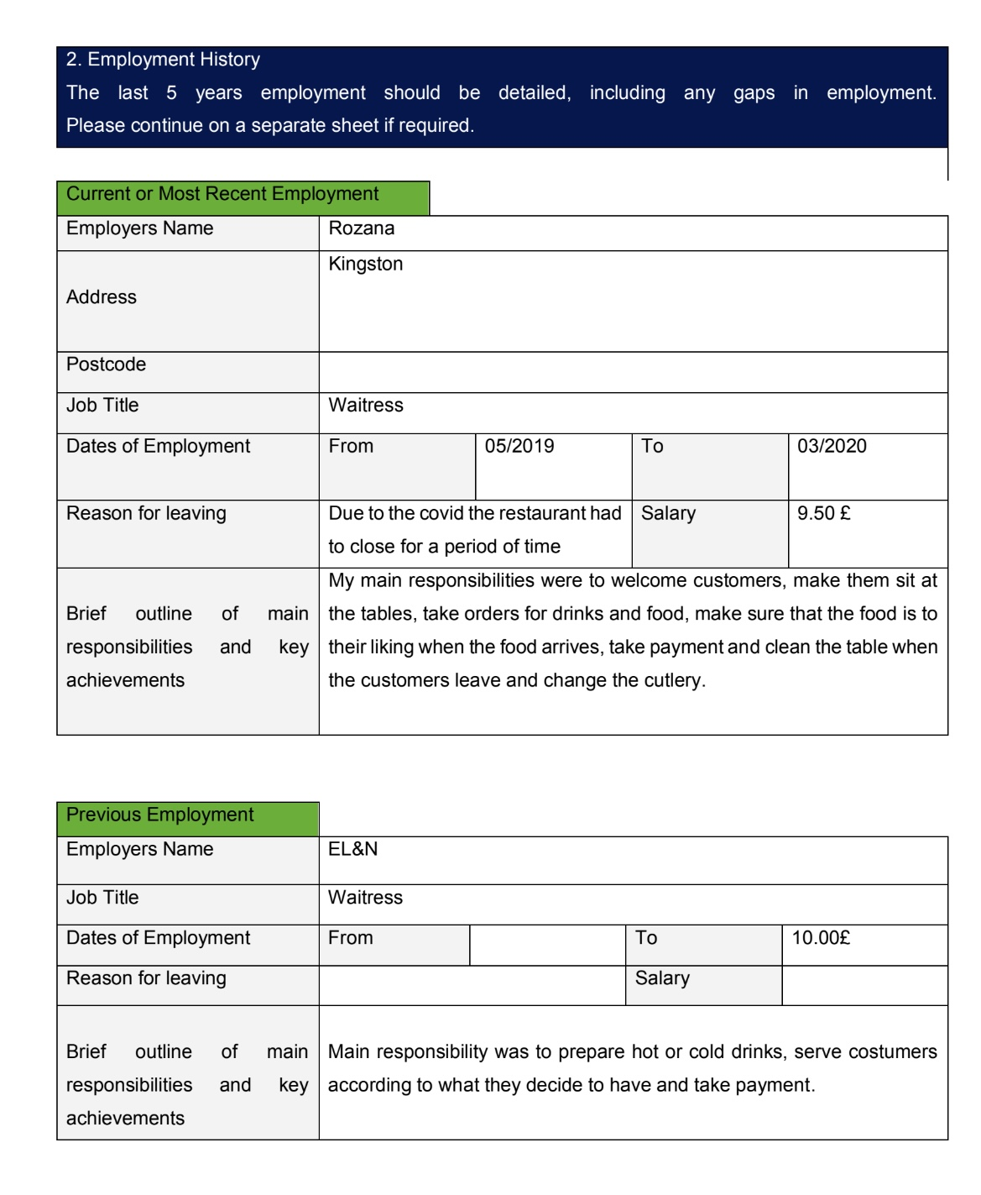
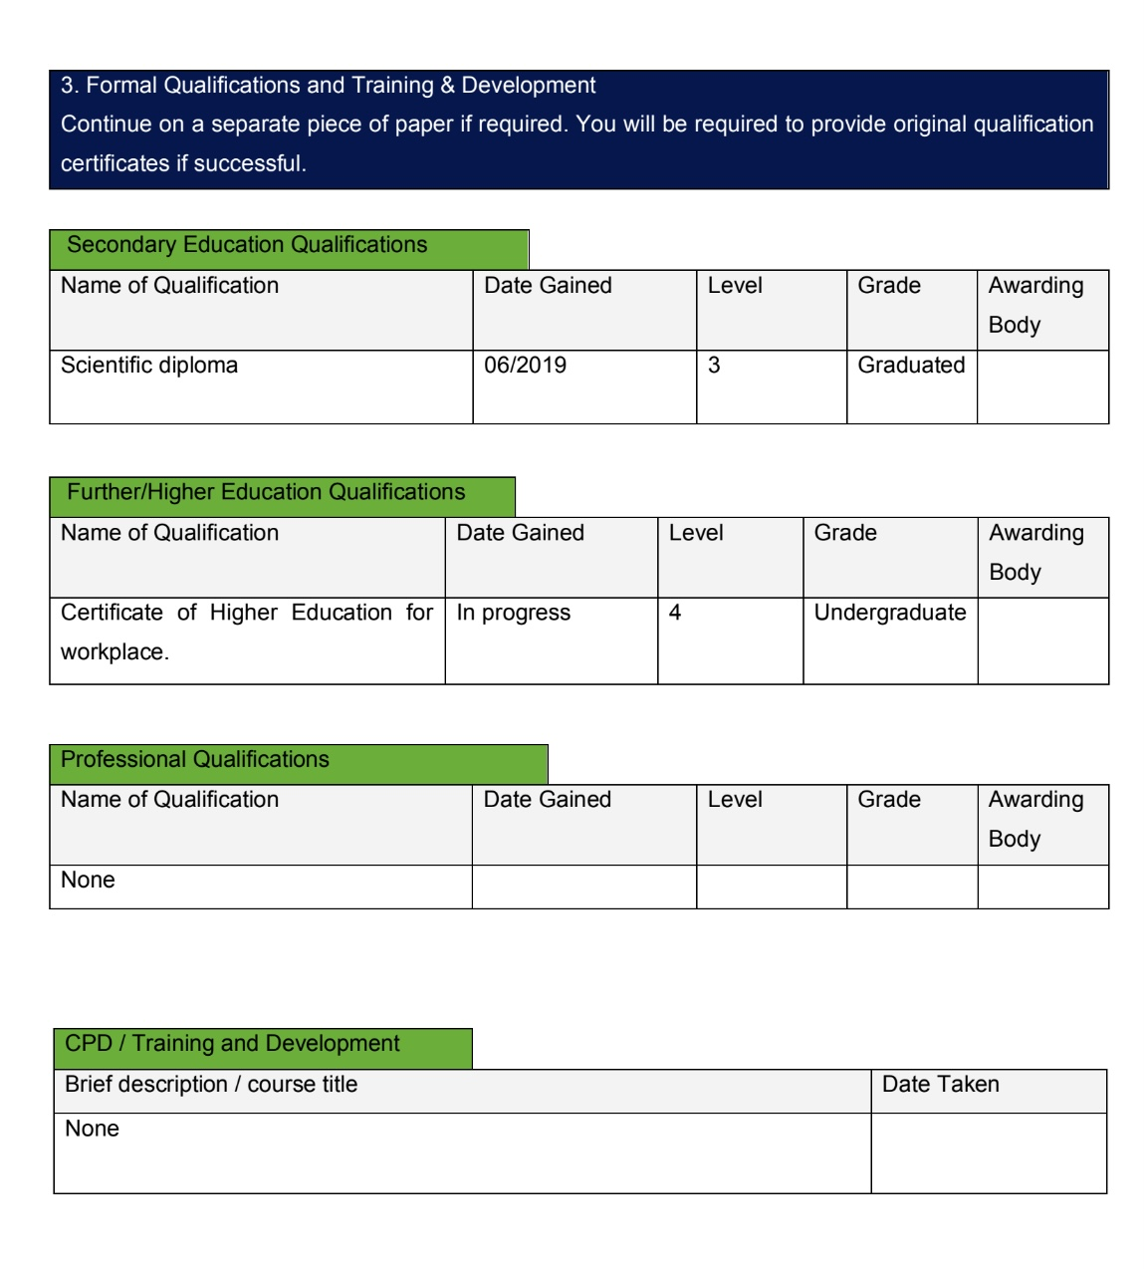
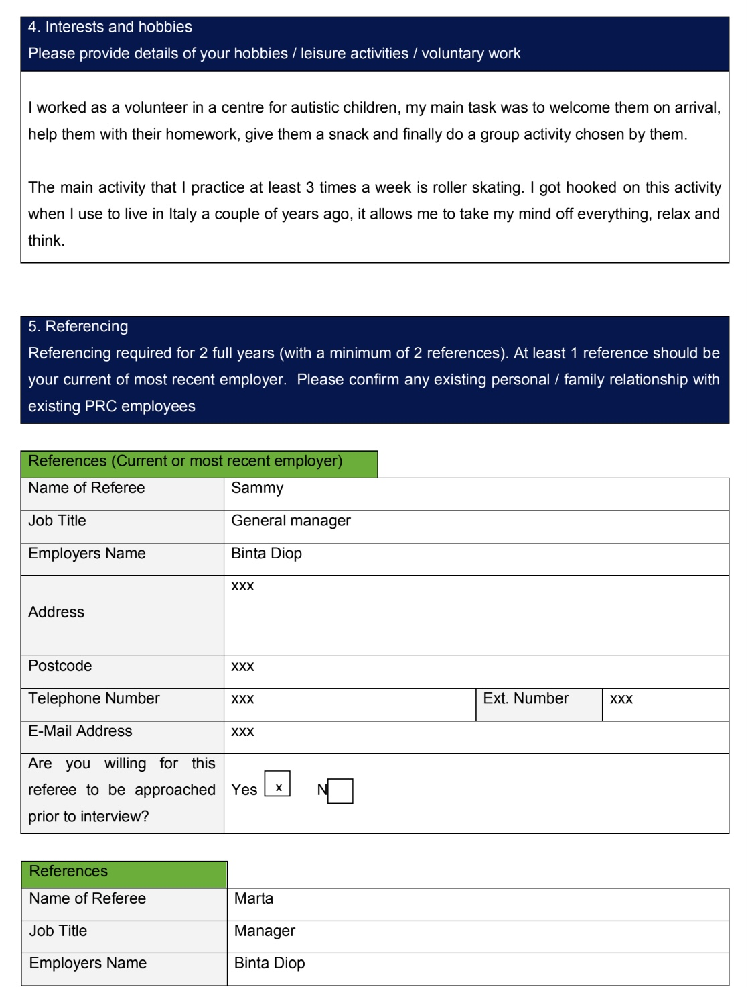
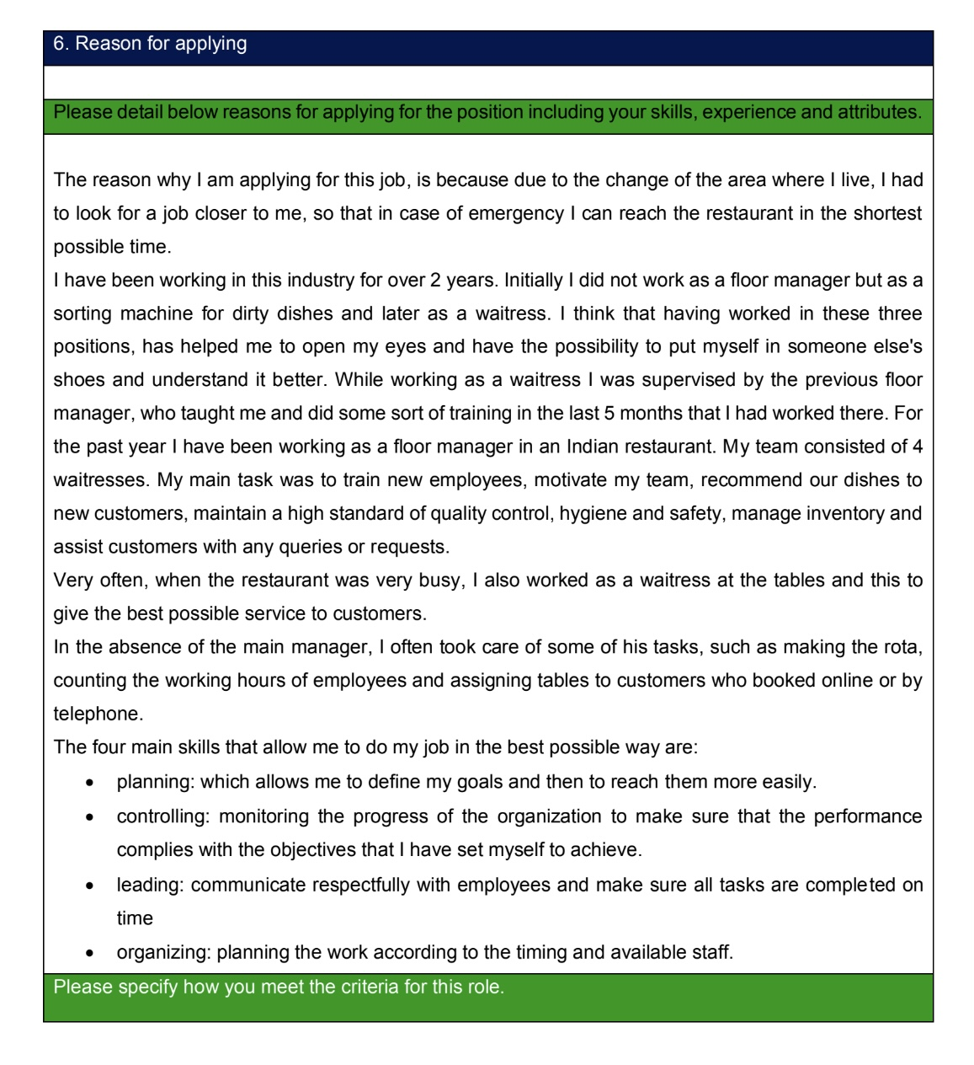
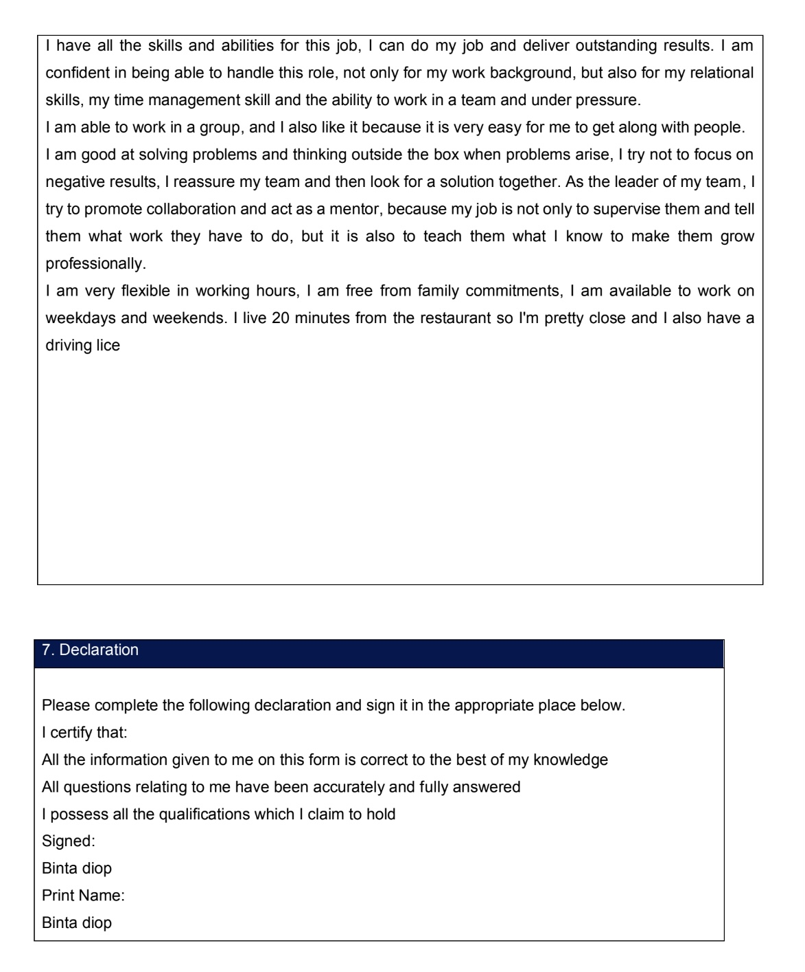

Role Play answers

Binta Diop applied for Floor Manager position

1.Where did you hear about the opportunity from, in what platform you have applied for the position?
Why are you looking for a job?

I found the job posting online on the indeed site, it is the site I usually use to look for and find work. I am looking for a new job because I have changed the area where I live, I was very comfortable in my last position but making an hour of travel to get to work can be difficult for the restaurant.

2.What is your background in the industry? Do you have any previous experience in this field of restaurant service?
If you do have experience, what is your previous/current position, and what type of venue you working for or managing?

I have been working in this industry for over 2 years. Initially, I did not work as a floor manager but as a sorting machine for dirty dishes and later as a waitress. I think that having worked in these three positions has helped me to open my eyes and have the possibility to put myself in someone else's shoes and understand it better. For the past year I have been working as a floor manager in an Indian restaurant in Kingston. My team consisted of 4 waitresses. My main task was to train new employees, motivate my team, recommend our dishes to new customers, maintain a high standard of quality control, hygiene and safety.

3.Why do you think that you would be the right person for the position? What can you bring to the table? Are you able to work in a team, manage a team, while being under pressure?

I honestly have all the skills and abilities you are looking for, I can do my job and deliver outstanding results. I am confident in being able to handle this role.
I am able to work in a group, solving problems and thinking outside the box when problems arise, I try not to focus on negative results, I reassure my team and then look for a solution together. As the leader of my team, I try to promote collaboration, act as a mentor.

4. How flexible are you in terms of work schedule? Are you able to work early in the morning, or late night if needed? Are you living nearby?

I am very flexible in working hours, I am free of family commitments, I am available to work on weekdays and weekends and I am able to work early in the morning and late in the evening if needed. I live 20 minutes from here so I'm pretty close and I also have a driving license.

5.Where do you see yourself in 5 years? Are you planning to grow within the company?

One of my future goals is to complete my studies in business, management and finance and be able not only to manage the floor but the whole company. And yes, I’m looking forward to growing with the company and in the future to also take care of the financial part of the restaurant to find the most effective way to increase profits.

