Research and case scenario in Data Security and Compliance
Aleksandr Badger
University of Wales, Trinity Saint David
Swansea, Wales
2308404@student.uwtsd.ac.uk

Table of Contents
I. RESEARCH IN DATA SECURITY AND COMPLIANCE 3
Abstract 3
II. ZERO TRUST ARCHITECTURE 3
A. Aims of this paper 3
B. What is Zero Trust? 3
C. Core Principles 3
D. How to implement Zero Trust Architecture 4
E. ZTA and Compliance 5
III. COMPARISON WITH TRADITIONAL SECURITY MODELS 5
IV. EVALUATION OF ZERO TRUST PRINCIPLES 6
V. CONCLUSION 7
Case Scenario 9
Introduction 9
Organisational structure 9
Policies and Procedures 9
Compliance 11
Government and Strategy 11
Risk Management 11
Contingency Planning 12
Protection Mechanisms 12
References 13

- RESEARCH IN DATA SECURITY AND COMPLIANCE

Abstract
This paper is a comparative evaluation of the Zero Trust Architecture (ZTA), which is a modern approach to data security that challenges traditional perimeter-based security models by assuming that all users, devices, and networks are untrusted by default. This paper examines the core concepts, principles, and implementation strategies of Zero Trust, including least-privilege access, continuous authentication, identity and access management, micro-segmentation, and continuous monitoring. It explores how these mechanisms are designed to address modern threats such as social engineering and lateral movement within networks. The study also compares ZTA to traditional security models, highlighting ZTA’s strengths in mitigating both internal and external threats, while acknowledging the increased complexity, operational complexity and cost associated with its implementation and maintenance. The paper focuses on the challenges faced by continuous monitoring, user experience, and organisational readiness. The paper concludes that although Zero Trust Architecture offers significantly stronger protection for sensitive and high-risk environments, its suitability depends on organisational scale, resources, and risk profile, making it more appropriate for larger or highly regulated organisations than smaller, low-risk organisations.

- ZERO TRUST ARCHITECTURE
- Aims of this paper
This paper aims to critically evaluate and conceptually analyse the Zero Trust Architecture by analysing its core principles, the implementation of the architecture, it’s strengths and weaknesses and to compare it to traditional perimeter-based security models. This paper is based on the listed academic literature and follows the industry standards of data security such as NIST.
- What is Zero Trust?
Zero Trust (ZT) is a group of concepts that are aimed at securing data via a least-privilege access system with constant revision and reauthorisation [1].
Zero trust architecture (ZTA) is the implementation of ZT principles across an organisation. ZTA is a type of system design that assumes threats are both internal and external and thus requires every access to be confirmed by a trusted member and it will be continuously authenticated once granted to ensure that only the correct user can access the resource, this creates the idea of a “never trust and always verify” approach, [2]. The design principle behind this is that this helps to prevent data breaches, both accidental and malicious, as it assumes there is always a potential threat to the system at any given time, alongside continuous revisions of access, abstracting trust to individual resources instead of groups and repeated testing of authorisation, this creates a strong data protection policy and helps to minimise the risk of a breach [2].
- Core Principles
The core idea of ZT is that modern threats are more focused on attacks such as social engineering, exploitation and other methods, for example this could be a user giving access to someone they believe to be a IT support worker, where in reality it is actually a hacker attempting to gain access to their system, these sort of attacks bypass regular defence methods like a firewall and anti-virus, which people often view as the main way to attack a system [3].
Furthermore, the other core principles of ZTA are identifying all relevant resources possible and potential risks to data. This may include users, internal and external devices, services used such as software and even vendors and finally the data itself [4].
Another principle is that access to resources should always be granted on a per-session and individual basis, which requires the requestee to be evaluated as a trustworthy individual before any access is granted. Furthermore, only the bare-minimum privileges should be given to the requestee that are possible, preventing accidental data leaks and separating resources from one another [2].
- How to implement Zero Trust Architecture
The first step in implementation is to identify all resources, which will include users, applications, services, networking components and more, this is regardless of whether they are an on-prem, cloud or remotely hosted. Doing this allows the organisation to understand how data and devices are accessed and connect to each other, which will help later on when they begin to micro-segment each sector to being enforcing least-privilege policies [3].
After all resources have been identified, the organisation can begin to implement an identity and access management system (IAM), this is a system where an identity is given to all subjects, both human and non-human, which allows them to be uniquely identifiable, so that that any resource usage and requests can be tracked back to a singular subject, this helps greatly when a data breach has occurred to identify the cause [2].
Once this is in place we can use a service known as multi-factor authentication (MFA), which is a tool that requires, as the name states, multiple authentication tokens from a user to access a resource, this is typically in the form of username and password alongside a one-time time sensitive code, usually provided by an authentication app such as Microsoft Authenticator, or a code sent to a phone number or email (the former becoming the more common modern method) [4].
Another requirement of ZTA is the use of Policy Decision Points (PDPs) and Policy Enforcement Points (PEPs). The PDP evaluates access requests by viewing a multitude of information, such as the requester, the reasoning behind the request, organisational policies and more, which then based on the relevant information, the PEP will accept or deny the request. Furthermore, PEPs should be placed as close as possible to resources to help reduce implied trust zones and reduce potential lateral movement (giving unnecessary access to resources than necessary) [4. 2. 4]. The graph below helps demonstrate these key components:
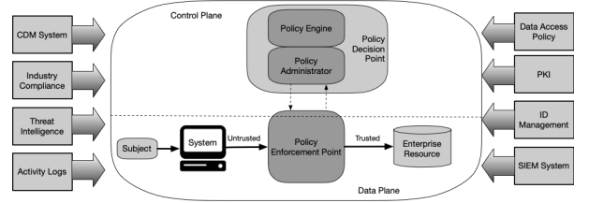
Figure 1:Core Zero Trust Logical Components [2]
The next step is to implement enforcement of a per-session least privilege access, which as described only allow access for the duration of a specified time period and only to the necessary resources, this is often used with MFA, as most MFA services allow for a max duration limit to be set allowing for authentication to be revoked when the time period has expired [2]. This has to be set up to reach a middle-ground between security and user experience, as most users will find frustration with having to request access every day, however this is for the organisation to decide and could result in more privilege access than is required breaking ZT principles [4].
Organisations must also employ continuous monitoring and diagnostic systems to collect data from devices, users and other potential security threats to help detect any anomalous behaviour and potential bad actors. These factors may include unusual access to resources from unexpected users, out of date software and unknown devices and by monitoring these factors, the organisation can either fix the issue, restrict access or completely deny it on a case-by-case basis [3. 1. 3].
Touched upon briefly earlier, micro-segmentation is an essential part of ZTA, this idea breaks the network down into smaller, separated segments, which helps to create more security, as if an attacker breaches one part of the system, it cannot move laterally and gain access to another segment, as they would have to request access, helping to limit the potential damage an attacker could create [2. 2. 5].
A successful ZTA implementation requires a phased approach and the organisation to be willing to take the time, and more importantly money, to implement ZTA. Taking a phased approach where ZT is slowly rolled out is often more practical for organisations, this is due to the tremendous down-time the transition would require, which most organisations cannot do, instead they take a top-down approach, where the most important resources are protected first and slowly rolling this out to less important resources [6. 3. 6].
Finally, ZTA is a system that requires continuous monitoring, updating and most importantly training to be an effective method of data security and while you can implement all these zero trust systems, it is imperative that training and teaching of users on how to use these systems and the importance of them that will ultimately control the effectiveness of it once implemented [7].
- ZTA and Compliance
ZTA aligns with modern compliance practices such as accountability, traceability and continuous monitoring by integrating them into its core principles. IAM assigns each subject a unique identifier, so that every action can be tracked and traced [3], furthermore PDPs and PEPs allows for well-documented records of all requests and actions [2]. Continuous monitoring of subjects allows for the recording of any anomalous behaviours and will automatically generate alerts if implemented correctly, combined with the PDPs and PEPs this will create a full auditable trail of logs for an organisation. Furthermore, least-privilege access and micro-segmentation reduce the risk of unauthorised resource accesses, which align with data protection laws by taking a proactive approach [8. 7. 8].
- COMPARISON WITH TRADITIONAL SECURITY MODELS
Traditional security models employ a perimeter-based approach to data security, which rely on prevention via firewalls, anti-viruses and VPNs to protect the network. Instead of access being granted on a request and taking a ZT stance, they instead opt to grant resource access based on network location and group membership, assuming that any users and devices inside the network can be trusted. The benefit of this approach is that it is straight forward to implement and the cost is cheap due to less time to implement, however this comes with the cost of increased network vulnerability, as once the perimeter has been breached attackers can move laterally in the network due to increased permissions [7].
In contrast, ZTA assumes that no user, device, or network is trusted and anticipates that an attack will eventually happen, therefore access is granted per-session, with the least-privilege possible and it must be continuously verified against policies and external factors. Furthermore, micro-segmentation and PEPs restrict lateral movement, making it much harder for attackers to compromise multiple resources [6]. By keeping a continuously updated potential threat framework, ZT achieves a proactive risk model that will anticipate a potential security threat before it even happens.
Whereas traditional models will provide resources in groups and tend to have most files viewable to subjects and without segmentation, which allows for easy lateral movement within a network, instead ZTA will instead use least-privilege access and micro-segmentation to reduce the impact from a compromise, as these prevent further access by isolating network segments from each other and by only allowing subjects the minimum access needed to work, this protects the organisation from insider and outsider threats [4. 4. 6].
Traditional models, however, are more appropriate applied to small scale organisations that will be unlikely to deal with multiple and constant threats to their resources, for example, Microsoft is a company that would employ ZTA due to their large economical and technological presence in society, which encourage bad actors and constant attacks on their business to blackmail and leak data, whereas a local one store business has a significantly lower likelihood to deal with threats and regular internal and external attacks, therefore a perimeter based solution, which is cost effective, easy to maintain and reactive focused would be a more suitable solution [9. 3. 9. 3. 7. 9].
While ZTA does offer stronger protection against internal and external threats, the complexity of the system creates a much higher cost of maintenance due to the continuous monitoring and training, taking a preventative and proactive stance, which means that only larger or successful organisations can afford to implement such a system [9], while the defensive and reactive stance of traditional models means that they are incredibly more cost-effective, especially for smaller organisations, where threats are less common and they have a low-risk environment [9. 2. 9].
- EVALUATION OF ZERO TRUST PRINCIPLES
The least-privilege access ensures that subjects can only access the minimum resources necessary to complete their tasks, this significantly reduces the risk of accidental or malicious data leaks, however this can prove frustrating to users as they would repeatedly have to re-authorise and to access necessary document, which impedes their work and slows them down [6].
Continuous monitoring of subjects can help to detect any unexpected behaviour which could result in prevention of a data breach; however this system must be monitored by a person, which requires man-hours to operate. Furthermore, if the monitoring system developed is inadequate, this can result in false positives and can create a high number of alerts, taking up resources from other sectors in an organisation [9. 6. 9]. This also creates an issue where companies employ a bring your own device policy, as many feel that installing monitoring systems on a non-organisation owned device is a breach of privacy [9]. This approach is, however, incredibly effective for detecting insider threats and even zero-day attacks, which traditional based models often miss due to reliance on detecting previously known attacks.
Identity and Access Management (IAM) provides a unique identifier for all subjects, both human and non-human, so that every action can be traced back and logged to an individual, this can help find gaps in security, as alerts can be set in place for when an authorised subject accesses a resource, or even to trace back a malicious or accidental attack to one place [3]. However, if this system is misconfigured it can create large gaps in security, as faults and users cannot be traced and no one would be aware of this [3. 2. 3].
Policy Decision Points (PDPs) and Policy Enforcement Points (PEPs) enable decisions to be made based on real-time context, such as user identity, device posture, and observed behaviour [2]. When anomalous behaviour is detected, systems can automatically revoke access, terminate sessions, quarantine devices, or deny further requests without requiring immediate any human present, which can significantly reduce response time if there is an active incident and limits what attackers can do in a short time period [4]. However, automated services rely on accurate policy configuration, as errors or rules often disrupt legitimate business operations, very commonly seen when sending an email, and having it blocked due to detected spam/phishing. Despite this, an automated response is an extremely important and effective tool used to counter potential and active attacks in a network, as it does not rely on human response times, whether that is applying the counter-measure or finding it in the first place and modern attacks are fast and precise, striking an segment and attempting to spread and download any data possible [7].
Micro-segmentation separates the network into smaller, disconnected segments in an effort to reduce lateral movement in case of a breach/attack, this makes for a great way to contain any breaches, as well as tracing the root of them, however the downside to this is increased network complexity and considerable planning time to create an optimal solution [2. 2. 7].
- CONCLUSION
While ZTA is a very complex solution, both in implementation and as it requires continuous effort and revision to ensure it stays a viable solution, these decisions and principles are justified by the massive decrease in risk to organisational resources and by using a phased approach during implementation, this allows for a smoother and more cost effective transition to Zero Trust Architecture, however it would be wrong to say it is without flaw, or even the most appropriate solution depending on scale and operations of the organisation, making it a non-universally optimal solution.

Case Scenario

Introduction
This report proposes a Zero Trust Architecture (ZTA) aligned security programme for the new EU branch, this will discuss the organisational structure, policies, compliance, risk management, contingency planning and protection systems that will be put in place.

Organisational structure
This approach will require clear and concise roles for the following teams: Cloud, DevOps and security operations, split into five different roles that align with their responsibilities.
Role | Responsibilities | Reasoning
Chief Information Security Officer (CISO) | Strategic security oversight,  Regulatory compliance,  Business alignment. | Ensures alignment of security with DORA/NIS2
Cloud Security Architect | Design and monitor cloud security controls, CSPM, IAM, micro-segmentation | Critical for hybrid/cloud infrastructure and automated threat detection
DevSecOps Lead | Integrate security into CI/CD pipelines, ensure AI/ML models are validated and secured | Reduces supply chain vulnerabilities and enforces “security as code”
Security Operations Centre (SOC) Analysts | Monitor SIEM/EDR alerts, incident response, automated threat mitigation | Enables real-time threat detection and response
Compliance & Risk Officer | Monitor adherence to DORA operational resilience, NIS2 reporting, and internal policies | Ensures regulatory compliance and traceability

Further justification for this decision is that cloud and AI require dedicated specialists to ensure security, a DevSecOps Lead can integrate security into software lifecycle and having a dedicated Compliance & Risk Officer allows for improved traceability and adherence to regulations.
This table aligns with best practices suggested by researchers such as Patel from the IJARSCT [10] and Nadipalli et al [11].

Policies and Procedures
The first policy that is implemented is an AI Usage policy, to ensure that all AI related tools are used ethically and with traceability, especially considering that ResilientIntellect Ltd develop their own AI-powered threat analysis software. All AI models must be validated prior to deployment to prevent risks such as poisoned datasets, biased outputs, or the introduction of vulnerabilities into production environments. All resources related to AI should follow a least-privilege access model, this ensures that subjects can only perform actions necessary for their role [6]. In addition, continuous monitoring and logging of all AI-related activity provide a full audit trail, which supports rapid detection of anomalies and satisfies regulatory traceability requirements. There should also be regular reviews and security approval processes for AI model updates, ensuring that changes are secure and documented and there will be mandatory training on how to safely use it. This policy aligns directly with Zero Trust principles, where every access request and system action is verified continuously, and anomalous activity can trigger automated quarantine or deletion [6. 6. 12].
The next policy to implement will be a secure Software-as-a-Service (SaaS) configuration policy, which will provide a framework on how to protect cloud-hosted software, which is necessary due to the company’s hybrid workforce. The first step is to implement multi-factor authentication (MFA) for any SaaS accounts and access will be based depending on the role of the user, this will help enforce per-session and least-privilege principles [3. 1. 3]. AI Configuration should be reviewed every few months, also using automated Cloud Security Posture Management (CSPM) tools to detect misconfigurations or policy violations. Furthermore, audit logs for all SaaS activity are kept and regularly reviewed to comply with EU regulations, including DORA operational resilience requirements and NIS2 reporting obligations. By applying the ZT policy to SaaS we can ensure that security is maintained continuously, reducing the potential impact of an attack [13].
There can also be a bring your own device policy (BYOD), as this will allow for a smoother transition for hybrid employee, thus we must employ a system to deal with personal devices on corporate systems. All BYODs must meet certain security standards such as, up-to-date operating systems, so that any known vulnerabilities have been patched out, suitable anti-virus software and encryption. Access to business resources in on a conditional basis of continuous device reassessment which ensures that only compliant devices can access resources. If a device has been compromised, the device can be remotely quarantined or even completely remotely wiped to prevent further data breaches. Training procedures for users must also be created, where they are trained in reporting procedures, the importance of device security and how to look out for threats. This policy with these steps in place will comply with zero trust principles and continuous verification will help to prevent lateral movement in case of a successful attack[11. 11. 14].
Policy | ZTA Principle | Compliance
AI Usage | Continuous monitoring, least trust | DORA risk management for software
Secure SaaS | Least privilege, per-session auth | NIS2 security of network systems
BYOD | Device posture verification | DORA operational resilience, NIS2 reporting

Together, these policies provide a secure framework for AI systems, cloud services, and hybrid devices. By integrating Zero Trust systems such as Policy Decision Points (PDPs) and Policy Enforcement Points (PEPs), the company ensures that policies are applied consistently and in real time. Automated verification and continuous monitoring reduce the risk of human error and social engineering attacks, which are common causes of data breaches. Furthermore, these policies produce audit logs and reports, which allows ResilientIntellect Ltd to comply with DORA requirements and NIS2 reporting obligations [10. 10. 12. 10. 12. 13. 10. 12. 13. 14].

Compliance
Compliance is necessary for ResilientIntellect Ltd’s to follow DORA (Digital Operational Resilience Act) and NIS2 (Network and Information Security Directive) requirements. Zero Trust mechanisms support compliance by ensuring traceability, and continuous monitoring [4]. Identity and Access Management (IAM) provides unique identifiers for each user, creating a fully auditable trail of actions, while PDPs and PEPs document access requests and enforcement decisions, supporting reporting obligations for audits [2. 2. 4] Continuous monitoring enables detection of anomalies and real-time alerts, aligning with DORA’s requirements for timely incident reporting and NIS2’s obligation to notify competent authorities of cybersecurity incidents within 24 hours [15]. By integrating compliance requirements directly into Zero Trust, ResilientIntellect Ltd can improve accountability and data protection.

Governance and Strategy
A Zero-Trust security programme for ResilientIntellect Ltd must have a strong strategy model that directly links cybersecurity activities to business objectives. The NIST Cybersecurity Framework (CSF) 2.0 [2] provides a suitable foundation for this structure, as it emphasises risk management and continuous improvement. In a Zero Trust context, governance ensures that security policies, unique identification, and monitoring mechanisms are with organisational goals in mind such as regulatory compliance, service availability, and protection of intellectual property (IP). By adopting NIST CSF 2.0, ResilientIntellect can standardise decision-making processes, define accountability across all levels, and ensure that Zero Trust principles are applied across cloud infrastructure, AI development, and other services [2].
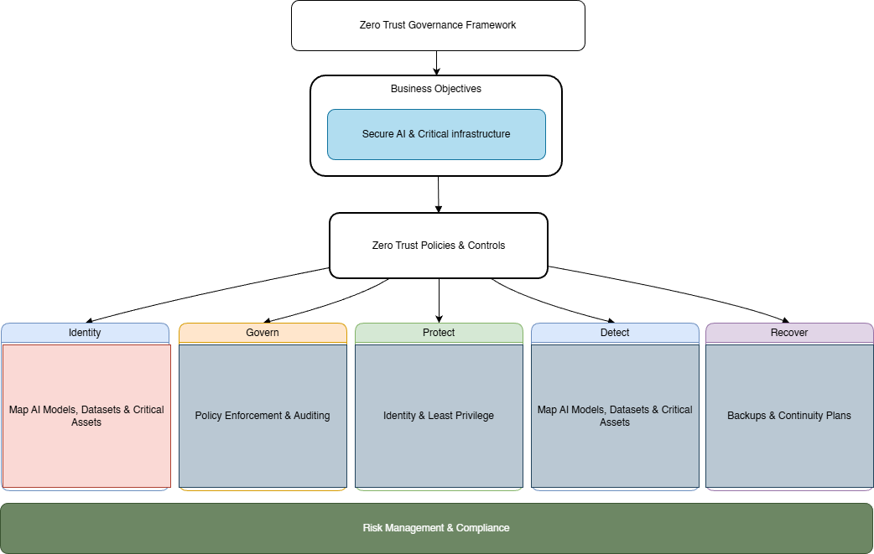
Figure 2:Zero Trust Governance Framework

Zero Trust supports ResilientIntellect’s business goal of providing proactive threat intelligence and compliance consultancy by integrating security directly into its business model. The NIST CSF’s “Govern” and “Identify” functions enable leadership to prioritise business critical resources such as AI models and training datasets, ensuring that security investments are risk-driven rather than reactive. Continuous monitoring is central to both Zero Trust Architecture and the NIST CSF and allows the organisation to adapt its security practices in response to evolving threats and regulatory requirements such as DORA and NIS2. This approach ensures that cybersecurity is treated as a core business system that is important for a fast-growing innovation-driven organisation in a highly regulated environment [2. 2. 7].

Risk Management
Risk management within the organisation must prioritise supply chain threats and cloud misconfigurations, as these threats pose a significant risk to a hybrid and AI focused company. ZTA helps to mitigate these risks by assuming no trust and enforcing verification and least privilege access, alongside continuous monitoring of all resources [1]. During AI development threats such as poisoned data sets, malicious model update and third-party vulnerabilities can be reduced through secure access policies, continuous authorisation and validation and identification controls [7]. Integrating ZT principles into DevSecOps ensures that only authorised users and verified third parties can interact with their respective resources, which reduces the likelihood of coming into contact with third party and insider threats [6].
Cloud misconfigurations are often the result of excessive permissions and assumed trust in a shared cloud space, such as SharePoint/OneDrive. ZT helps to mitigate these risks by removing trust based on group permissions and network location and instead enforces authorisation based on identity, device and other contextual information (such as sign-in location, time of day, etc.) [9]. Continuous monitoring and policy enforcement enables ResilientIntellect to detect and fix any misconfigurations in real-time, which supports the ongoing risk assessment principle [3].
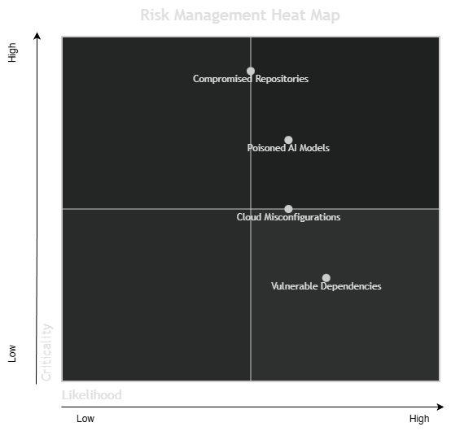
Figure 3: Risk Assessment Heat Map

Contingency Planning
A contingency and disaster recovery plan is imperative for any organisation, even small-scale ones, and due to the high value of the data stemming from the nature of AI powered threat analysis software, which if leaked would massively impede the software as bad actors would be able to analyse and build counter measures to the program. Zero Trust will help greatly limit the impact of a potential attack, whether it is socially engineered, or a virus such as ransomware, as the micro-segmentation, least privilege access and encryption of devices thanks to the BYOD policy in-place, will greatly prevent the attack(er) from progressing once access is gained [2]. Furthermore, continuous monitoring of identities and system activities will allow for detection of any anomalous activities, which can result in the device being immediately quarantined or even disabled and wiped entirely to prevent further data breach without the need for human intervention, potentially preventing the attacker from gaining any leverage or resources at all [7]. These systems will greatly reduce the window of opportunity the attack has during an active incident.
Disaster recovery planning must include backups of all system critical resources, which are preferably stored in a secondary and even tertiary way, different from the original source, for example if the data is stored on a cloud system, then a secondary place could be an internal server that has no authorised access unless there is need such as a rollback after an attack [2. 2. 9]. Zero Trust principles would ensure that backup infrastructure is not implicitly trusted and will require continuous authentication and repeated authorisation. Backup methods and devices should also be subject to regular testing to ensure they function as expected under operational conditions and allow for fast restoration while having a long-lasting life span [6. 6. 7]. This will allow for ResilientIntellect Ltd to continue operationally even while under attack and if there was an attack severe enough to stop operations, then service can be restored and the company can become functional again quickly.
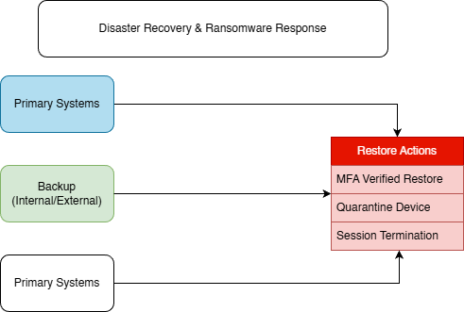
Figure 4: Disaster Recovery & Ransomware Response

Protection Mechanisms
Modern defensive mechanisms should be implemented that support ZTA, such as continuous authorisation, visibility and automated responses, i.e. defensive measures. Systems such as MFA are crucial to defend against attacks, as they provide another layer of protection against attacks that significantly reduce the risk of a credential-based attack (i.e. log in details), which remains one of the most common forms of attacks for organisations [9]. Furthermore, Endpoint detection and response (EDR) solutions provided automated response capabilities that remove manual human intervention, improving response speeds during any imminent threats and align with ZT policies [16. 2. 16].
Monitoring platforms such as Security Information and Event Management (SIEM) and Cloud Security Posture Management (CSPM) are tools that provide more visibility for threat detection, auditability and compliance reporting [16. 16. 17]. SIEM systems collect various data such as identity services and cloud infrastructure that helps investigation and reporting, while CSPM tools identify cloud misconfigurations that could go against ZT principles [17. 16. 17]. These tools help create a more proactive framework that aligns with ZT principles.
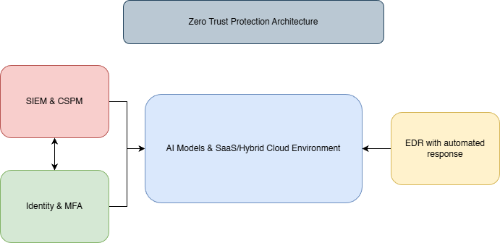
Figure 5: Zero Trust Protection Architecture

References
References
[1] M. F. Ahammed, "Zero-Trust Architectures for Securing U.S. Critical Infrastructure," vol. 4, no. 3, pp.9, November 30 2025, doi: 10.32996/fcsai.2025.4.2.7. Accessed: Nov 7, 2025. Available at: https://al-kindipublishers.org/index.php/fcsai/article/view/11571.
[2] Rose Scott, Borchet Oliver, Mitchell Stu and Conelly Sean, "Zero Trust Architecture," August 2020, Accessed: Jan 3, 2026. Available at: https://doi.org/10.6028/NIST.SP.800-207.
[3] Motamed Anooosheh, "The Zero Trust Security Model and Its Application in
Organizations," vol. 3, no. 3, pp.21–32, September 01 2024, Accessed: November 3 2025. Available at: https://file:///C:/Users/AGLB/Downloads/JRMDE-3-3-21-32-code78.pdf.
[4] NCSC. "Zero trust architecture design principles." National Cyber Security Centre. Accessed: 30/12 2025. [Online]. Available: https://www.ncsc.gov.uk/collection/zero-trust-architecture/introduction-to-zero-trust
[5] Cybersecurity and Infrastructure Security Agency, "Microsegmentation in Zero Trust
Part One: Introduction and Planning," July 29 2025, Accessed: November 29, 2025. Available at: https://www.cisa.gov/sites/default/files/2025-07/ZT-Microsegmentation-Guidance-Part-One_508c.pdf.
[6] A. Rosén, G. S. Gaba and A. Gurtov, "A Strategic Roadmap for Phased Zero Trust Architecture Implementation in Organizations", pp. 1–6. [Online].doi: 10.1109/CNS66487.2025.11194934.Available: https://ieeexplore.ieee.org/abstract/document/11194934
[7] M. L. Gambo and A. Almulhem,Zero Trust Architecture: A Systematic Literature Review, 2025. doi: 10.36227/techrxiv.173933211.18231232/v1
[8] European Parliament. "Regulation (EU) 2016/679 of the European Parliament and of the Council." UK Government Legislation. Accessed: Jan 4 2026. [Online]. Available: https://www.legislation.gov.uk/eur/2016/679/contents
[9] Z. Adahman, A. W. Malik and Z. Anwar, "An analysis of zero-trust architecture and its cost-effectiveness for organizational security," Comput.Secur. vol. 122, pp.102911, 2022, doi: 10.1016/j.cose.2022.102911. Available at: https://www.sciencedirect.com/science/article/pii/S0167404822003042.
[10] D. Patel, "Zero Trust and DevSecOps in Cloud-Native Environments with Security Frameworks and Best Practices," vol. 3, pp.454–464, 2023, doi: 10.48175/IJARSCT-11900D.
[11] R. Nadipalli, "Zero Trust Security Implementation Using DevSecOps in Cloud-Native Applications," vol. 2, no. 1, pp.47–56, August 22 2021, doi: 10.47941/ijce.3195. Accessed: Jan 4, 2026. Available at: https://carijournals.org/journals/IJCE/article/view/3195.
[12] S. Mushtaq, M. Mohsin and M. M. Mushtaq, "A Systematic Literature Review on the Implementation and Challenges of Zero Trust Architecture Across Domains," Sensors (Basel). vol. 25, no. 19, pp.6118. doi: 10.3390/s25196118, Oct 3 2025, doi: 10.3390/s25196118.
[13] R. Wang, C. Li, K. Zhang and B. Tu, "Zero-trust based dynamic access control for cloud computing," Cybersecurity. vol. 8, no. 1, pp.12, February 16 2025, doi: 10.1186/s42400-024-00320-x. Accessed: December 12, 2026. Available at: https://doi.org/10.1186/s42400-024-00320-x.
[14] J. Anderson, et al., "BYOZ: Protecting BYOD through zero trust network security", 2022 IEEE International Conference on Networking, Architecture and Storage (NAS), pp. 1–8.
[15] "Digital operational resilience for the financial sector and amending Regulations (EC) No 1060/2009, (EU) No 648/2012, (EU) No 600/2014, (EU) No 909/2014 and (EU) 2016/1011," December 14 2022, Accessed: Jan 4, 2026. Available at: https://eur-lex.europa.eu/eli/reg/2022/2554/oj/eng.
[16] A. Hassan, S. Khan, M. A. Khan and R. Kumar, "ZenGuard: A machine learning based zero trust framework for context aware threat mitigation using SIEM, SOAR and UEBA," vol. 15, no. 1, pp.20998, 2025, doi: 10.1038/s41598-025-20998-4. Available at: https://doi.org/10.1038/s41598-025-20998-4.
[17] F. N. U. Jimmy, "Cloud security posture management: tools and techniques," vol. 2, no. 3, November 20 2023, doi: 10.60087/jklst.vol2.n3.p622. Accessed: Jan 5, 2026. Available at: https://jklst.org/index.php/home/article/view/272.

