OpenGL Based 3D Game

Student Name: Mathew Taylor

P Number: 149885

Module Title: Game Programming and Graphics

Assignment Title: OpenGL Based 3D Game

Module Lecturer’s Name: Gordon Dickers

Contents
Introduction 3
Scripts 3
Init() 3
Drawbox() 4
Display() 6
Reshape() 8
Keyboard() 8
Camera() 11
Mouse() 11
Main() 12
LoadBitmapFile() 13
WriteBitmapFile() 14
Control() 15
Sphere() 15
isBoundSpherIntersect() 16
Libraries 16
Global Variables 16
Declaring Functions and Lighting Values 17
Testing 17
Screenshots 18
Controls 18
Object Display 19
Card Flipping 20
Pair Found 21
Movement of Camera 22
References 24

Introduction
This report will cover the development of an OpenGL Based 3D Game. The game developed is a pair’s game using cards created in OpenGL. This will be covering the testing of the software and the important algorithms and data structures used in it.

Scripts

Init()
This function creates the Lighting in the world and loads in the images to be used for the textures[1].
void init()
// Initialize
//************************************************************************
// desc: initializes OpenGL
{
//MOUSE CONTROL==================================================================
WorldT[0] = 1; WorldT[4] = 0; WorldT[8] = 0; WorldT[12] = 0;
WorldT[1] = 0; WorldT[5] = 1; WorldT[9] = 0; WorldT[13] = 0;
WorldT[2] = 0; WorldT[6] = 0; WorldT[10] = 1; WorldT[14] = 0;
WorldT[3] = 0; WorldT[7] = 0; WorldT[11] = 0; WorldT[15] = 1;
//MOUSE CONTROL==================================================================

glClearColor(0.0f, 1.0f, 0.7f, 0.0f); // clears colour buffer to to white
glEnable(GL_DEPTH_TEST); // hidden surface removal
glEnable(GL_CULL_FACE); // do not calculate inside of poly's
glFrontFace(GL_CCW); // counter clock-wise polygons are out

//***** lighting
glEnable(GL_SMOOTH);
glEnable(GL_LIGHTING); // enable lighting

// Setup the materials for LIGHT0
glMaterialfv(GL_FRONT, GL_AMBIENT, matAmbient);
glMaterialfv(GL_FRONT, GL_DIFFUSE, matDiff);

// Now setup LIGHT0
glLightfv(GL_LIGHT0, GL_AMBIENT, ambientLight); // setup the ambient element
glLightfv(GL_LIGHT0, GL_DIFFUSE, diffuseLight); // the diffuse element
glLightfv(GL_LIGHT0, GL_POSITION, lightPosition); // place the light in the world

// Enable the light
glEnable(GL_LIGHT0);

glEnable(GL_TEXTURE_2D); // enable 2D texturing

//Open txt file containing images to be used
FILE *ptr = fopen("ImageToBeLoaded.txt", "r");
int textnumCount = 0;
char buffer[32];

glGenTextures(TOTALNUMOFCARDS + 1, texnum); // generate 10 texture objects

do
{
fscanf(ptr, "%s", buffer);

//*Texture********************************************************8
// load our bitmap file
bitmapData = LoadBitmapFile(buffer, &bitmapInfoHeader);

glBindTexture(GL_TEXTURE_2D, texnum[textnumCount]); // enable our first texture object

glTexParameteri(GL_TEXTURE_2D, GL_TEXTURE_MAG_FILTER, GL_NEAREST);
glTexParameteri(GL_TEXTURE_2D, GL_TEXTURE_MIN_FILTER, GL_NEAREST);

// generate the texture image
glTexImage2D(GL_TEXTURE_2D, 0, GL_RGB, bitmapInfoHeader.biWidth,
bitmapInfoHeader.biHeight, 0, GL_RGB, GL_UNSIGNED_BYTE, bitmapData);

//*Texture********************************************************8
textnumCount++;
} while (!feof(ptr)); //Run loop until the end of the file has been reached

fclose(ptr);
ptr = NULL;
}

Drawbox()
Load the textures corresponding the cards and place them on the actual objects[1].
void drawBox(float w, float h, float l, int imageCount, int cardSelectionCount, int sphereCount)
//drawBox
//***************************************************************************
//This function first translates a further x,y,z units then draws a box of
//width w, height h, length l
{
//glPushMatrix();
//glTranslatef(collision[sphereCount].BVposition.x, collision[sphereCount].BVposition.y, collision[sphereCount].BVposition.z);
//glutWireSphere(BoundSphereRadius, 18, 18);

//glPopMatrix();

glPushMatrix(); //save modelview
w = w / 2.0; h = h / 2.0; l = l / 2.0; //adjust values so centre is in middle of box
if (cardSelectionCount == cardSelection) //Check if card being drawn is the card currently selected
{
glBindTexture(GL_TEXTURE_2D, texnum[5]); // enable our second texture object
glBegin(GL_QUADS); // top face
glTexCoord2f(0.0f, 0.0f); glVertex3f(w, l, h);
glTexCoord2f(1.0f, 0.0f); glVertex3f(w, l, -h);
glTexCoord2f(1.0f, 1.0f); glVertex3f(-w, l, -h);
glTexCoord2f(0.0f, 1.0f); glVertex3f(-w, l, h);

// front face
glTexCoord2f(0.0f, 0.0f); glVertex3f(w, l, h);
glTexCoord2f(1.0f, 0.0f); glVertex3f(-w, l, h);
glTexCoord2f(1.0f, 1.0f); glVertex3f(-w, -l, h);
glTexCoord2f(0.0f, 1.0f); glVertex3f(w, -l, h);

// right face
glTexCoord2f(0.0f, 0.0f); glVertex3f(w, l, h);
glTexCoord2f(1.0f, 0.0f); glVertex3f(w, -l, h);
glTexCoord2f(1.0f, 1.0f); glVertex3f(w, -l, -h);
glTexCoord2f(0.0f, 1.0f); glVertex3f(w, l, -h);
glEnd();

//glBindTexture(GL_TEXTURE_2D, texnum[0]); // enable our first texture object
glBindTexture(GL_TEXTURE_2D, texnum[imageCount + 5]);
glBegin(GL_QUADS); // top face
glTexCoord2f(0.0f, 0.0f); glVertex3f(-w, l, h);
glTexCoord2f(1.0f, 0.0f); glVertex3f(-w, l, -h);
glTexCoord2f(1.0f, 1.0f); glVertex3f(-w, -l, -h);
glTexCoord2f(0.0f, 1.0f); glVertex3f(-w, -l, h);

glTexCoord2f(0.0f, 0.0f); glVertex3f(-w, -l, h);
glTexCoord2f(1.0f, 0.0f); glVertex3f(-w, -l, -h);
glTexCoord2f(1.0f, 1.0f); glVertex3f(w, -l, -h);
glTexCoord2f(0.0f, 1.0f); glVertex3f(w, -l, h);

glTexCoord2f(0.0f, 0.0f); glVertex3f(w, -l, -h);
glTexCoord2f(1.0f, 0.0f); glVertex3f(-w, -l, -h);
glTexCoord2f(1.0f, 1.0f); glVertex3f(-w, l, -h);
glTexCoord2f(0.0f, 1.0f); glVertex3f(w, l, -h);
glEnd();
}
else
{
glBindTexture(GL_TEXTURE_2D, texnum[0]); // enable our second texture object
glBegin(GL_QUADS); // top face
glTexCoord2f(0.0f, 0.0f); glVertex3f(w, l, h);
glTexCoord2f(1.0f, 0.0f); glVertex3f(w, l, -h);
glTexCoord2f(1.0f, 1.0f); glVertex3f(-w, l, -h);
glTexCoord2f(0.0f, 1.0f); glVertex3f(-w, l, h);

// front face
glTexCoord2f(0.0f, 0.0f); glVertex3f(w, l, h);
glTexCoord2f(1.0f, 0.0f); glVertex3f(-w, l, h);
glTexCoord2f(1.0f, 1.0f); glVertex3f(-w, -l, h);
glTexCoord2f(0.0f, 1.0f); glVertex3f(w, -l, h);

// right face
glTexCoord2f(0.0f, 0.0f); glVertex3f(w, l, h);
glTexCoord2f(1.0f, 0.0f); glVertex3f(w, -l, h);
glTexCoord2f(1.0f, 1.0f); glVertex3f(w, -l, -h);
glTexCoord2f(0.0f, 1.0f); glVertex3f(w, l, -h);
glEnd();

//glBindTexture(GL_TEXTURE_2D, texnum[0]); // enable our first texture object
glBindTexture(GL_TEXTURE_2D, texnum[imageCount]);
glBegin(GL_QUADS); // top face
glTexCoord2f(0.0f, 0.0f); glVertex3f(-w, l, h);
glTexCoord2f(1.0f, 0.0f); glVertex3f(-w, l, -h);
glTexCoord2f(1.0f, 1.0f); glVertex3f(-w, -l, -h);
glTexCoord2f(0.0f, 1.0f); glVertex3f(-w, -l, h);

glTexCoord2f(0.0f, 0.0f); glVertex3f(-w, -l, h);
glTexCoord2f(1.0f, 0.0f); glVertex3f(-w, -l, -h);
glTexCoord2f(1.0f, 1.0f); glVertex3f(w, -l, -h);
glTexCoord2f(0.0f, 1.0f); glVertex3f(w, -l, h);

glTexCoord2f(0.0f, 0.0f); glVertex3f(w, -l, -h);
glTexCoord2f(1.0f, 0.0f); glVertex3f(-w, -l, -h);
glTexCoord2f(1.0f, 1.0f); glVertex3f(-w, l, -h);
glTexCoord2f(0.0f, 1.0f); glVertex3f(w, l, -h);
glEnd();
}

glPopMatrix(); //restore previous modelview matrix so leaving things as you found them
}

Display()
Handles the drawing of the scene, such as drawing the cards and rotating them as needed.
// display
//************************************************************************
// desc: handles drawing of scene
void display()
{
glPushMatrix();
glClear(GL_COLOR_BUFFER_BIT | GL_DEPTH_BUFFER_BIT); // clear screen and depth buffer
// reset modelview matrix
int cardSelectionCount = 1, imageCount = 1, sphereCount = 0;

////MOUSE CONTROL==================================================================
//glGetDoublev(GL_MODELVIEW_MATRIX, WorldT);//get for use with gluUnproject
//glBegin(GL_TRIANGLES); //fire ray
//glNormal3f(0.0, -1.0, 0.0);
//glVertex3d(objectNear[0], objectNear[1], objectNear[2]);
//glVertex3d(objectFar[0], objectFar[1], objectFar[2]);
//glVertex3d(objectNear[0] + 0.1, objectNear[1], objectNear[2]);

//glEnd();
////MOUSE CONTROL==================================================================

if (matchCounter == 4) //Check if all matches have been found
{
printf("WINNER!!!");
exit(0);
}
for (int count = 0; count < 3; count++)
{
for (int count2 = -1; count2 < 2; count2++)
{
// enable our first texture object
glPushMatrix(); //save current position/orientation, etc.
glTranslatef((count2 * 1.5), (count * 2), 0); //move by x,y and z units

//MOUSE CONTROL==================================================================
collision[sphereCount].position.x = (count2 * 0 - 0.5);
collision[sphereCount].position.y = (count * 0 + 0.25);
collision[sphereCount].position.z = 0.5;

sphere(&collision[sphereCount]);
//MOUSE CONTROL==================================================================

if (cardFlips[cardSelectionCount - 1] == 1 || cardFlips[cardSelectionCount - 1] == 3) //Check if the card should be flipped
{
glRotatef(180, 0, 1, 0); //Flip card around so the user can see the other side
}

if (cardFlips[cardSelectionCount - 1] == 2) //Check if the card needs to be flipped back around
{
glRotatef(180, 0, 1, 0); //Flip card back around so the user can only see the back of the card
cardFlips[cardSelectionCount - 1] = 0;
}
glMaterialfv(GL_FRONT, GL_AMBIENT, matAmbient1);//set backdrop material properties
glMaterialfv(GL_FRONT, GL_DIFFUSE, matDiff1);
drawBox(1, 0.01, 1.5, imageCount, cardSelectionCount, sphereCount); //draw back drop
cardImages[cardSelectionCount - 1] = imageCount;
glPopMatrix(); //restore previous "current" position/orientation etc.
cardSelectionCount++;
if (imageCount > 3)
imageCount = 0;
imageCount++;
sphereCount++;
}
}
// glTranslatef(0,0,0); //move by x,y and z units
//drawBox(5.0, 10.0, 0.20); //draw floor
glPopMatrix();
glFlush(); //force drawing

glutSwapBuffers(); // bring backbuffer to foreground
//any errors then display error codes
GLenum errCode;
const GLubyte *errString;
if ((errCode = glGetError()) != GL_NO_ERROR)
{
errString = gluErrorString(errCode);
fprintf(stderr, "OpenGL error : %s\n", errString);
}

}

Reshape()
This code resizes the window and objects as needed[2][3].
void reshape(int w, int h)
//reshape
//************************************************************************
//OpenGL reshape callback is called when the window is resized
{
glViewport(0, 0, (GLsizei)w, (GLsizei)h); //respecify size of view port to match new w and h
glMatrixMode(GL_PROJECTION); //go into projection mode
glLoadIdentity(); //reset projection matrix
gluPerspective(60.0, (GLfloat)w / (GLfloat)h, 1.0, 200.0); //redefine projection matrix to match changes in w and h
glMatrixMode(GL_MODELVIEW); //switch back to modelview mode
glLoadIdentity(); //reset modelview matrix
gluLookAt(0.0, 2.0, 5.0, 0.0, 2.0, -1.0, 0.0, 1.0, 0.0);// note these match the initial values

//MOUSE CONTROL==================================================================
winview[0] = w; winview[1] = h;
//MOUSE CONTROL==================================================================
}

Keyboard()
Handles the keyboard controls, like movement of the camera and movement of the selected card.
void keyboard(unsigned char key, int x, int y)
//This function alters the camera angle and x,y,z position and lets you change the selected card
// and both a vx and a vz formula will be needed in each 'i' and 'k' case.
{
static float vx = 0, vy = 2, vz = 5, angle = 0;

switch (key) {
case 'a' | 'A': //Make selected card the one to the left of the currently selected card and if the currently selected card is one of the very left card set the selected card to the very right in the same row
switch (cardSelection)
{
case 1:
cardSelection = 3;
break;
case 4:
cardSelection = 6;
break;
case 7:
cardSelection = 9;
break;
default:
cardSelection -= 1;
break;
}
break;
case 'd' | 'D': //Make selected card the one to the right of the currently selected card and if the currently selected card is one of the very right card set the selected card to the very left in the same row
switch (cardSelection)
{
case 3:
cardSelection = 1;
break;
case 6:
cardSelection = 4;
break;
case 9:
cardSelection = 7;
break;
default:
cardSelection += 1;
break;
}
break;
case 'w' | 'W': //Make selected card the one above the currently selected card and if the currently selected card is one of the very top card set the selected card to the bottom card int the same column
switch (cardSelection)
{
case 9:
cardSelection = 3;
break;
case 8:
cardSelection = 2;
break;
case 7:
cardSelection = 1;
break;
default:
cardSelection += 3;
break;
}
break;
case 's' | 'S': //Make selected card the one below the currently selected card and if the currently selected card is one of the very bottom card set the selected card to the top card in the same column
switch (cardSelection)
{
case 1:
cardSelection = 7;
break;
case 2:
cardSelection = 8;
break;
case 3:
cardSelection = 9;
break;
default:
cardSelection -= 3;
break;
}
break;
case 'e' | 'E':
if (flipCardCount == 2) //Check if user has already flipped 2 cards
{
for (int count3 = 0; count3 < TOTALNUMOFCARDS; count3++) //Loop through the total number of cards
{
if (cardFlips[count3] == 1) //Check if current card looking at is flipped
{
for (int count4 = 0; count4 < TOTALNUMOFCARDS; count4++) //Loop through the total number of cards
{
if (cardFlips[count4] == 1) //Check if current card looking at is flipped
{
if (cardImages[count3] == cardImages[count4] && count3 != count4) //Check if both flipped cards have the same images on them
{
//Set flipped cards to being match cards
cardFlips[count3] = 3;
cardFlips[count4] = 3;
matchCounter++;
printf("MATCH!!!\n");
}
}
}
}
}
for (int count = 0; count < TOTALNUMOFCARDS; count++)
{
if (cardFlips[count] == 1)
cardFlips[count] = 2;
}
flipCardCount = 0;
}
else
{
if (cardFlips[cardSelection - 1] != 3) //Check if card selected hasn't already been matched up
{
cardFlips[cardSelection - 1] = 1; //Set card to array of cards to be flipped
flipCardCount++;
}
}
break;
case 'q' | 'Q':
exit(0); //Quit game
break;
case 'j' | 'J':
vx -= 0.1; //Move Camera left
break;
case 'l' | 'L':
vx += 0.1; //Move Camera right
break;
case 'i' | 'I':
vz -= 0.1; //Move Camera forward
break;
case 'k' | 'K':
vz += 0.1; //Move Camera backwards
break;
case 'u' | 'U':
angle -= 10; //Rotate Camera to left
break;
case 'o' | 'O':
angle += 10; //Rotate Camera to right
break;
default:
break;
}

glMatrixMode(GL_MODELVIEW);
glLoadIdentity();
camera(vx, vz, angle); //use glulookat() if you want
glutPostRedisplay();
}

Camera()
Handles the actual movement of the camera[2][3].
void camera(float x, float z, float angle)
{
glRotatef(angle, 0, 1, 0); //not the inverse transforms and their sequence
glTranslatef(-x, -2, -z); //what happens if you swap the transform order
//visualize it first then try it.
}

Mouse()
Handles the mouse controls, the mouse controls were attempted to get a God Solution implemented[4], however there were difficulties getting this to work and so it was not finished and the function is not necessary.
//MOUSE CONTROL==================================================================
void mouse(int button, int state, int x, int y)
{
if (state == GLUT_DOWN) {
int view[4];
// double modelview[16];
double proj[16];

glGetIntegerv(GL_VIEWPORT, view);
glGetDoublev(GL_PROJECTION_MATRIX, proj);

int realy = view[3] - (GLint)y - 1;
int check = gluUnProject(x, realy, -1, WorldT, proj, view, objectNear, objectNear + 1, objectNear + 2);

printf("unprojected near co-ords are ");

for (int i = 0; i<4; i++) {
printf("%f ", objectNear[i]);
} printf("\n");

check = gluUnProject(x, realy, 1, WorldT, proj, view, objectFar, objectFar + 1, objectFar + 2);
printf("unprojected far co-ords are ");

for (int i = 0; i<4; i++) {
printf("%f ", objectFar[i]);
} printf("\n");

//prepare for collision test by making a ray
vectors d(objectFar[0], objectFar[1], objectFar[2]);
vectors p(objectNear[0], objectNear[1], objectNear[2]);
Ray ray1; //this is the ray cast

ray1.SetOrigin(p); //initialise ray with origin and direction vector
ray1.SetDirection(d - p);

bool hit = isBoundSphereIntersect(ray1);

if (hit == true)
printf("hit");
else
printf("miss");

glutPostRedisplay();
}
}
//MOUSE CONTROL==================================================================

Main()
Calls all the necessary functions for the pairs game to work.
int main(int argc, char** argv)
{
control();
glutInit(&argc, argv);
glutInitDisplayMode(GLUT_DOUBLE | GLUT_RGB | GLUT_DEPTH);
glutInitWindowSize(500, 500);
glutInitWindowPosition(100, 100);
glutCreateWindow(argv[0]);
init();
glutReshapeFunc(reshape);
glutDisplayFunc(display);
glutKeyboardFunc(keyboard);

//MOUSE CONTROL==================================================================
glutMouseFunc(mouse);
//MOUSE CONTROL==================================================================

//glutIdleFunc(spinDisplay);
glutMainLoop();
return 0;
}

LoadBitmapFile()
Returns a pointer to the bitmap image of the bitmap specified[1].
// LoadBitmapFile
// desc: Returns a pointer to the bitmap image of the bitmap specified
// by filename. Also returns the bitmap header information.
// No support for 8-bit bitmaps.
unsigned char *LoadBitmapFile(char *filename, BITMAPINFOHEADER *bitmapInfoHeader)
{
FILE *filePtr; // the file pointer
BITMAPFILEHEADER bitmapFileHeader; // bitmap file header
unsigned char *bitmapImage; // bitmap image data
int imageIdx = 0; // image index counter
unsigned char tempRGB; // swap variable

// open filename in "read binary" mode
filePtr = fopen(filename, "rb");
if (filePtr == NULL)
return NULL;

// read the bitmap file header
fread(&bitmapFileHeader, sizeof(BITMAPFILEHEADER), 1, filePtr);

// verify that this is a bitmap by checking for the universal bitmap id
if (bitmapFileHeader.bfType != BITMAP_ID)
{
fclose(filePtr);
return NULL;
}

// read the bitmap information header
fread(bitmapInfoHeader, sizeof(BITMAPINFOHEADER), 1, filePtr);

// move file pointer to beginning of bitmap data
fseek(filePtr, bitmapFileHeader.bfOffBits, SEEK_SET);

// allocate enough memory for the bitmap image data
bitmapImage = (unsigned char*)malloc(bitmapInfoHeader->biSizeImage);

// verify memory allocation
if (!bitmapImage)
{
free(bitmapImage);
fclose(filePtr);
return NULL;
}

// read in the bitmap image data
fread(bitmapImage, 1, bitmapInfoHeader->biSizeImage, filePtr);

// make sure bitmap image data was read
if (bitmapImage == NULL)
{
fclose(filePtr);
return NULL;
}

// swap the R and B values to get RGB since the bitmap color format is in BGR
for (imageIdx = 0; imageIdx < bitmapInfoHeader->biSizeImage; imageIdx += 3)
{
tempRGB = bitmapImage[imageIdx];
bitmapImage[imageIdx] = bitmapImage[imageIdx + 2];
bitmapImage[imageIdx + 2] = tempRGB;
}

// close the file and return the bitmap image data
fclose(filePtr);
return bitmapImage;
}

WriteBitmapFile()
Converts the images loaded into 24-bit RGB .BMP files[1]. This function isn’t necessary as the images loaded are already 24-bit RGB .BMP files, this was left in however in case another image ends up being used that does need to be converted.
// WriteBitmapFile()
// desc: takes image data and saves it into a 24-bit RGB .BMP file
// with width X height dimensions
int WriteBitmapFile(char *filename, int width, int height, unsigned char *imageData)
{
FILE *filePtr; // file pointer
BITMAPFILEHEADER bitmapFileHeader; // bitmap file header
BITMAPINFOHEADER bitmapInfoHeader; // bitmap info header
int imageIdx; // used for swapping RGB->BGR
unsigned char tempRGB; // used for swapping

// open file for writing binary mode
filePtr = fopen(filename, "wb");
if (!filePtr)
return 0;

// define the bitmap file header
bitmapFileHeader.bfSize = sizeof(BITMAPFILEHEADER);
bitmapFileHeader.bfType = 0x4D42;
bitmapFileHeader.bfReserved1 = 0;
bitmapFileHeader.bfReserved2 = 0;
bitmapFileHeader.bfOffBits = sizeof(BITMAPFILEHEADER) + sizeof(BITMAPINFOHEADER);

// define the bitmap information header
bitmapInfoHeader.biSize = sizeof(BITMAPINFOHEADER);
bitmapInfoHeader.biPlanes = 1;
bitmapInfoHeader.biBitCount = 24; // 24-bit
bitmapInfoHeader.biCompression = BI_RGB; // no compression
bitmapInfoHeader.biSizeImage = width * abs(height) * 3; // width * height * (RGB bytes)
bitmapInfoHeader.biXPelsPerMeter = 0;
bitmapInfoHeader.biYPelsPerMeter = 0;
bitmapInfoHeader.biClrUsed = 0;
bitmapInfoHeader.biClrImportant = 0;
bitmapInfoHeader.biWidth = width; // bitmap width
bitmapInfoHeader.biHeight = height; // bitmap height

// switch the image data from RGB to BGR
for (imageIdx = 0; imageIdx < bitmapInfoHeader.biSizeImage; imageIdx += 3)
{
tempRGB = imageData[imageIdx];
imageData[imageIdx] = imageData[imageIdx + 2];
imageData[imageIdx + 2] = tempRGB;
}

// write the bitmap file header
fwrite(&bitmapFileHeader, 1, sizeof(BITMAPFILEHEADER), filePtr);

// write the bitmap info header
fwrite(&bitmapInfoHeader, 1, sizeof(BITMAPINFOHEADER), filePtr);

// write the image data
fwrite(imageData, 1, bitmapInfoHeader.biSizeImage, filePtr);

// close our file
fclose(filePtr);

return 1;
}

Control()
Output the control for the pairs game to the console.
void control()
{
//Print the controls for the game
printf("(w, a, s, d) - Cooresponds with the card selection, moving up, left, down and right \n");
printf("(e) - Flips un-flipped card that is selected, once two cards are selected press (e) again on any selected card to reset the selection \n");
printf("(q) - Quits Game \n");
printf("(i, j, k, l) - Changes the position of the camera, foward, left, backwards and right \n");
printf("(u, o) - Rotates the camera left and right \n");
printf("(Left Mouse Click) - Click on which card you want to flip #WARNING - THIS WAS ATTEMPTED BUT DOESN'T WORK#\n");
}

Sphere()
Sets the radius and position of the sphere to be used for the mouse click[4]. As the mouse click was not completed this function currently isn’t necessary.
//MOUSE CONTROL==================================================================
void sphere(vectors position, vectors BVposition)
{
intersect = false;
BoundSphereRadius = 1.0;
BVposition.x = position.x + 0.5;
BVposition.y = position.y - 0.25;
BVposition.z = position.z - 0.5;
}
//MOUSE CONTROL==================================================================

isBoundSpherIntersect()
Detects if the mouse click was a hit based on the position of the sphere[4]. As the mouse click was not completed this function currently isn’t necessary.
//MOUSE CONTROL==================================================================
bool isBoundSphereIntersect(Ray v)
{
int cardCounter = 0;

for (int count = 0; count < 3; count++)
{
for (int count2 = -1; count2 < 2; count2++)
{
//calc collision
printf("line point distance squared is: %f\n", v.LinePointDistanceSqd(collision[cardCounter].BVposition));

float boundSphereRadius = (BoundSphereRadius + (count2 * 1.5)) * (BoundSphereRadius + (count2 * 2));
float vCompare = v.LinePointDistanceSqd(collision[cardCounter].BVposition);

if (vCompare < boundSphereRadius)
{
cardFlips[cardCounter] = 1;
return true;
}
cardCounter++;
}
}
return false;
}
//MOUSE CONTROL==================================================================

Libraries
#include "vectors.h"
//MOUSE CONTROL==================================================================

////// Includes
#include <math.h>
#include <stdio.h>
#include <stdlib.h>
#include "glut.h"
#include <windows.h>

Global Variables
////// Texture Information
BITMAPINFOHEADER bitmapInfoHeader; // bitmap info header (needs windows.h to define type
unsigned char* bitmapData; // the texture data
static GLuint texnum[10]; // array of 2 texture object names

/////////#include <gl/gl.h> // standard OpenGL include
/////////#include <gl/glu.h> // OpenGL utilties - we use glut - it already includes these

////// Global Variables
float globangle = 0;
static int cardSelection = 1;
int cardFlips[9] = { 0,0,0,0,0,0,0,0,0 }; //Determines which cards need to be flipped (0 = No Flip, 1 = Flip, 2 = Flip Back, 3 = Stay Flipped)
int cardImages[9] = { 0,0,0,0,0,0,0,0,0 }; //Hold the number corresponding to the image for each card
int flipCardCount = 0; //Number of cards flipped
int matchCounter = 0; //Number of pairs discovered so far

//MOUSE CONTROL==================================================================
int winview[2]; //contains window view width [0] and height [1]
float aspect = 1.0;
float fov = 60;
double WorldT[16];
double objectNear[4];
double objectFar[4];
static int theta = 0;
bool intersect;
float BoundSphereRadius;
vectors position; //point
vectors BVposition;//point
//MOUSE CONTROL==================================================================

Declaring Functions and Lighting Values
//function prototypes
unsigned char *LoadBitmapFile(char *filename, BITMAPINFOHEADER *bitmapInfoHeader);
int WriteBitmapFile(char *filename, int width, int height, unsigned char *imageData);
void init(void);
void display(void);
void spinDisplay(void);
void drawBox(float w, float h, float l);
void reshape(int w, int h);
void camera(float, float, float);
void control();

//MOUSE CONTROL==================================================================
bool isBoundSphereIntersect(Ray v);
//MOUSE CONTROL==================================================================

////// Lighting variables
float ambientLight[] = { 0.2f, 0.2f, 0.2f, 1.0f }; // ambient light
float diffuseLight[] = { 0.8f, 0.8f, 0.8f, 1.0f }; // diffuse light
float specularLight[] = { 1.0f, 1.0f, 1.0f, 1.0f }; //Specular Light
float lightPosition[] = { 10.0f, 100.0f, 10.0f, 0.0f }; // the light position

////// Material variables
float matAmbient[] = { 0.3f, 0.5f, 0.8f, 1.0f };
float matDiff[] = { 0.25f, 0.25f, 0.25f, 1.0f };
float matAmbient1[] = { 0.83f, 0.5f, 0.8f, 1.0f };
float matDiff1[] = { 0.525f, 0.25f, 0.25f, 1.0f };
float matAmbient2[] = { 0.83f, 0.0f, 0.0f, 1.0f };
float matDiff2[] = { 0.525f, 0.2f, 0.2f, 1.0f };

Testing
Test No. | Test | Expected Result | Result | Pass/Fail
1 | Object Loading | 9 Loaded Rectangles | 9 Loaded Rectangles | Pass
2 | Texture Loading | 9 Cards with loaded Textures | 9 Cards with loaded Textures | Pass
3 | Camera Movement | Move the camera forward, backward, left and right, using (I, k, j, l) respectively. | Move the camera forward, backward, left and right, using I, k, j, l respectively. | Pass
4 | Rotate Camera | Camera Rotates when using (u or o) | Camera Rotates when using (u or o) | Pass
5 | Show selected card | Selected card will be highlighted | Selected card is highlighted | Pass
6 | Change selected card | Using (w, a, s, d) selected card changes. | Using (w, a, s, d) selected card changes. | Pass
7 | Card Flip | When (e) is pressed the selected card is flipped, to the user can see the other side of the card. | When (e) is pressed the selected card is flipped, to the user can see the other side of the card. | Pass
8 | Pair stays flipped | When a pair is found the cards will not flip back and will stay revealed. | When a pair is found the cards will not flip back and will stay revealed. | Pass
9 | Game End | When (q) is pressed out all four matches are found the game will close. | When (q) is pressed out all four matches are found the game closes. | Pass
10 | God Solution | When mouse is clicked on card, the card flips. | This was not finished and doesn’t not work. | Fail

Screenshots

Controls
Inform the user on how to play.
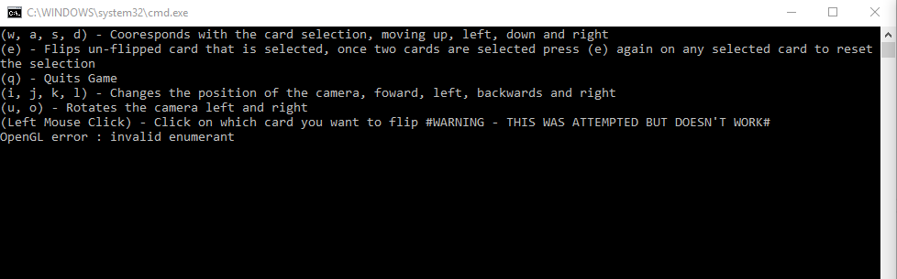

Object Display
Shows the nine cards being rendered and the bottom left card currently being selected as it’s highlighted.
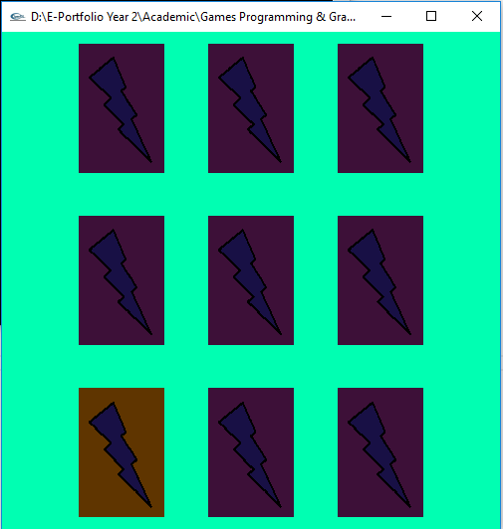

Card Flipping
Two cards flipped, but not matching.
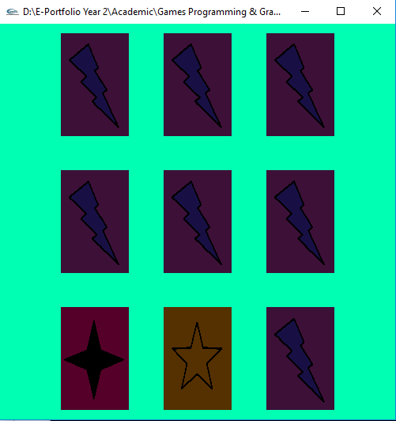

Pair Found
When a pair is found they will stay flipped.
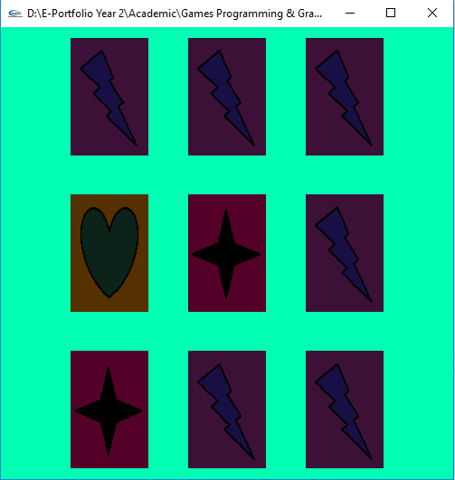

Movement of Camera
Camera moved backwards.
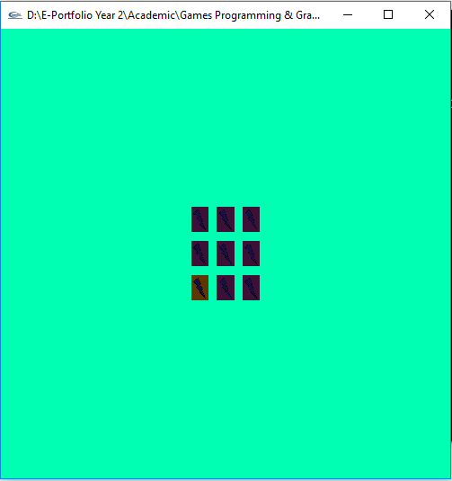

Camera Moved Forward
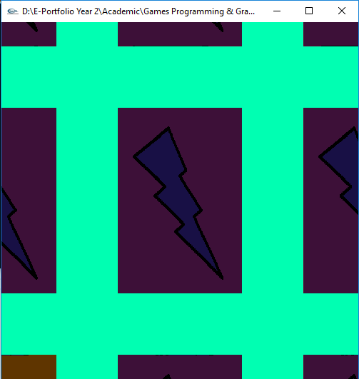

Camera moved behind the cards and rotated so backs of cards are viewable.
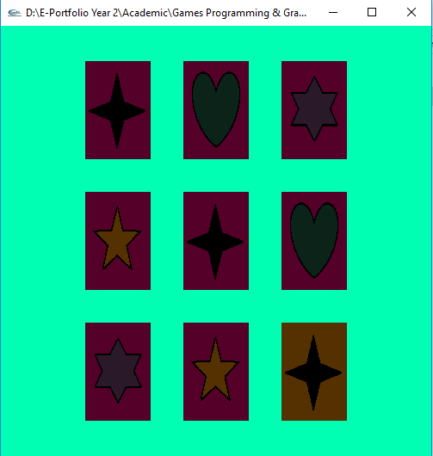

References
[1] Gordon Dickers, “scene dev egs,” moodle UWTSD, 2018. [Online]. Available: https://moodle.uwtsd.ac.uk/mod/resource/view.php?id=18427. [Accessed: 16-Mar-2018].
[2] D. Shreiner, OpenGL, 7th ed. The Khronos OpenGL ARB Working Group, 2009.
[3] OpenGL, “OpenGL FAQ / 8 Viewing and Camera Transforms, and Using gluLookAt(),” OpenGL.org, 1997. [Online]. Available: https://www.opengl.org/archives/resources/faq/technical/viewing.htm. [Accessed: 16-Mar-2018].
[4] Gordon Dickers, “house pick example,” moodle UWTSD, 2018. [Online]. Available: https://moodle.uwtsd.ac.uk/mod/resource/view.php?id=18441. [Accessed: 16-Mar-2018].

