

Programme: CertHE Computing Skills for Workplace
Module: Computer Architecture and Operating Systems

Module code: ACCA4022

Lecturer: Redhwan Al-Amri

Assignment Title: Component 2-Coursework

Student Name: Alina Andreea Firu

Student ID:2323237

Submission Date:17.12.2025
Table of Contents
1. Introduction 2
2. Task 1. Key functions of general Operating Systems 2
3. Task 2. Use of Windows OS CLI commands 4
4. Task 3. Use of Linux OS CLI commands 8
5. Task 4. Use of Windows OS scripts 13
6. Task 5. Use of Linux OS scripts 14
7. Conclusion 15
Reference List 16
Appendices 17
Appendix 1: Windows OS Script 17
Appendix 2: Linux OS Script 18

1. Introduction
The essential IT skills among 21st-century employees for operating complex software systems can be referred to as Computing Skills, which enable multinational corporations to perform complex tasks (Babashahi et al. 2024; Mahmud and Wong, 2022). This report is regarding the major functions involved with the contemporary operating systems, such as Windows 11, that can help corporate officials towards applying suitable CPU memory and digital memory systems.

2. Task 1. Key functions of general Operating Systems
An operating system (OS) is low-level software, which is engaged in software and hardware resources of a computer. It also bridges applications, hardware and offers user programmes in an interface and hides hardware complexity (Akhtar, 2024). For example, this is Windows 11, which has control over CPU scheduling, memory, and device allocation in the background.
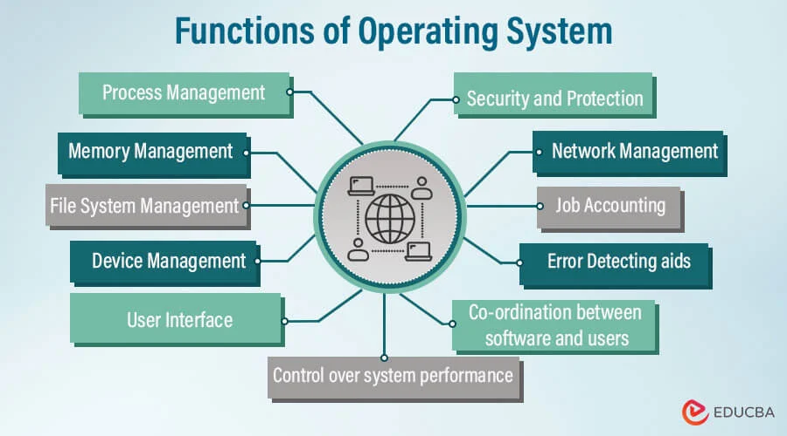
Figure 1: Major Functions of the Operating System
(Source: Pedamkar, 2023)
Process Management: The OS also allocates and controls processes (active programmes). It observes the creation of processes, the implementation of these processes, the suspension of processes, and the termination of such processes. According to the view of Abu-Dalbouh (2022), Windows 11 is able to run multiple applications simultaneously; the algorithms that the kernel itself employs to schedule the applications (e.g., round-robin or priority-based) can be checked to trade off the CPU time. A representation of this management is the Task Manager of the windows 11, which presents the use of CPU as well as operating processes. The other elements regulated by the OS are threads and inter-process communication, which assign each process its share of CPU time. Hence, Windows processes are offered isolation as stability and security features, and therefore, when one process crashes, it is not isolated to the entire system.
Memory Management: This operating system allocates the programmes with the RAM and deals with the virtual memory (paging to disc). On demand, Memory Manager will switch between RAM and the page file in disc, which will extend RAM in Windows 11. Windows 11 is also based on performance smart prioritisation, and compression of the memory. An example is one of the new features of Windows 11, whereby it is optimised to use the virtual memory, whereby the fast SSDs are utilised to page and access the memory, making it quicker (Leis et al., 2023). The memory management also apportions the address space of all processes to avoid cases where it is accessed by the wrong individual.
File system management: Files and directories of storage devices are operated using the OS. Windows 11 is built on the NTFS file system (NTFS file system in system drives) and therefore can support such functionality as access control lists (ACLs) and encryption. In one case, to secure files, NTFS has provided the administrators thereof the right to administer read/write/execute privileges in a user-based manner. Windows 11 comes with a file browser referred to as the File Explorer to enable a graphical user interface bookkeeping to process files (Simpson, 2024). With the help of the file system (in Explorer), it is easy to navigate files through the folders, add/ delete files, but at the same time, one can easily copy or move files.
I/O and Device management: The OS also has input /output devices and drivers attached to it. Windows 11 is also compatible with the hardware (USB drives, printers etc). An example of a file system in Windows 11 is the connection to a USB disc, in which the I/O subsystem is mounted and enables access to files through the File Explorer.
User interface (UI): The OS has brought the interface for operating the computer. The graphical user interface, like the Start menu, Taskbar, and desktop, has an update in Windows 11. This UI allows users to begin programmes, including settings. Onix, as an example, the user interface design of the new centred Start menu and Snap Layouts are enhancements in the user interface of Windows 11.

3. Task 2. Use of Windows OS CLI commands
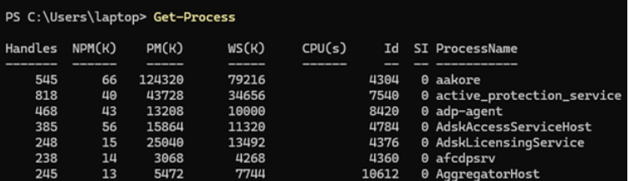
Figure 2: The Get-Process command of Windows OS
(Source: Self-developed)
The current Windows OS 11 system involves the Get-Process command that enables individual users to easily retrieve all of the running processes in computer systems for identifying local processes.
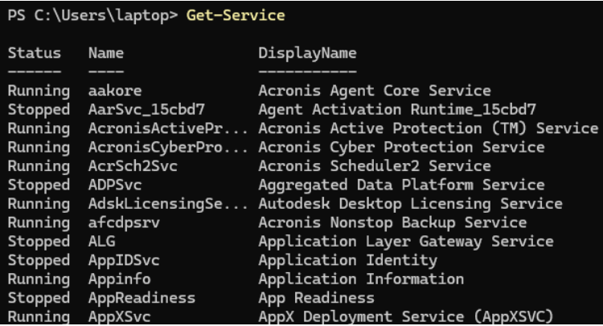
Figure 3: The Get-Service command of Windows OS
(Source: Self-developed)
All of the localised PC processes, such as Windows 11 updates and deleted programmes, can be performed with the Get service software implementation.
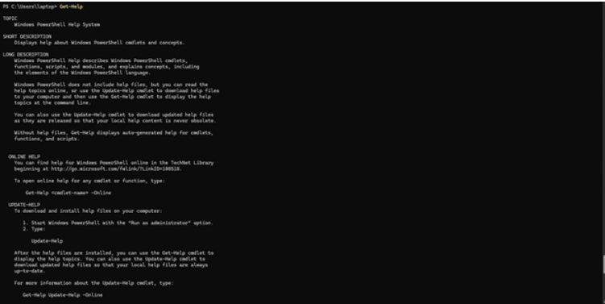
Figure 4: The Get-Help command of Windows OS
(Source: Self-developed)
The corporate official using a Windows 11 OS can employ the Get-Help procedure for performing the PowerShell command to understand system parameters.

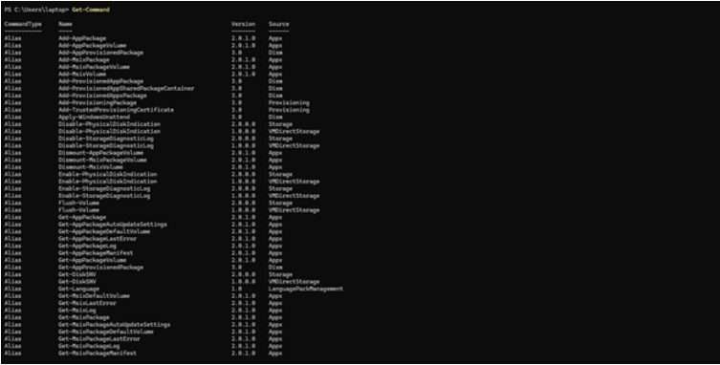
Figure 5: The Get-Command of Windows OS
(Source: Self-developed)
The Get-Command can be recognised as the principal command of Windows 11 that enables corporate officials to retrieve functions and discover cmdlets for business tasks.
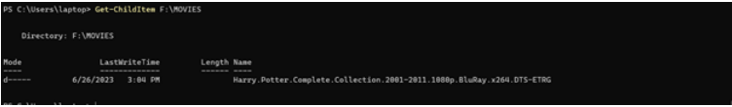
Figure 6: The Get-ChildItem command of Windows OS
(Source: Self-developed)
The effective display of Windows 11 directories, such as company files and customer folders, can be achieved with the assistance of the Get-ChildItem command.

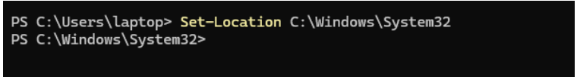
Figure 7: The Set-Location command of Windows OS
(Source: Self-developed)
Both the Windows OS and Linux possess the smart location command within their respective software coding that can help the visually impaired workers to easily locate workplace files (Mind et al. 2021). Windows 11 systems also include the Set-Location feature that can help corporate employees to set individual system identity based on the current digital directory.

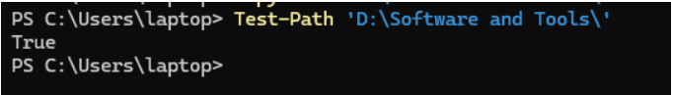
Figure 8: The Test-Path command of Windows OS
(Source: Self-developed)
Within the organisational Windows systems, the Test-Path command system can help corporate officials easily locate files, registry keys and folders relevant to daily business operations.
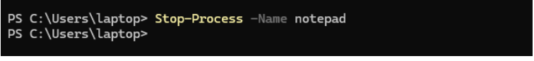
Figure 9: The Stop-Process command of Windows OS
(Source: Self-developed)

The Stop-Process feature of Windows 11 is also effective for terminating unnecessary processes that can increase system internal memory usage.
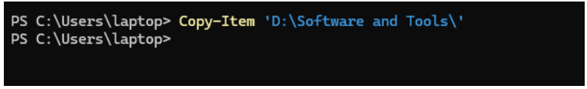
Figure 10: The Copy-Item command of Windows OS
(Source: Self-developed)
The original versions of Windows 11 also involve the Copy-Item command, creating different paths for entire customer directories for multinational corporate entities.

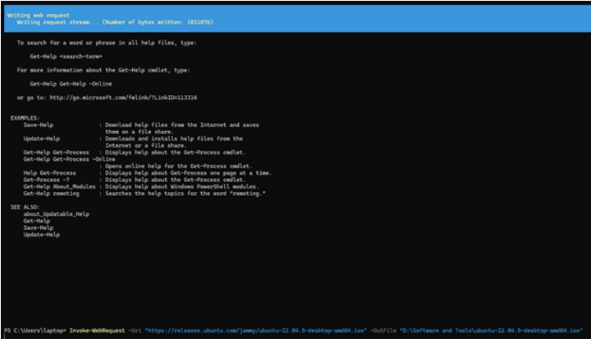
Figure 11: The Invoke-WebRequest command of Windows OS
(Source: Self-developed)
The current HTTP command in the Windows system, such as Invoke-WebRequest, can help corporate officials copy relevant online documents.

4. Task 3. Use of Linux OS CLI commands
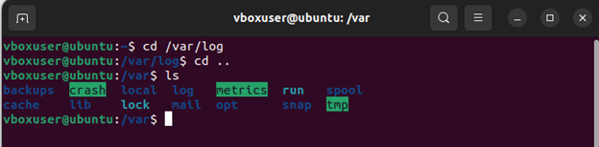
Figure 12: is
(Source: Self-developed)
In order to print the content of a folder, one would be required to execute the (ls) in the folder to give a list of the names of the objects in the folder.
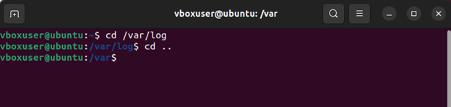
Figure 13: cd
(Source: Self-developed)
It is possible to navigate to a particular folder by typing a path /path/to/dir that would move the person to the folder.
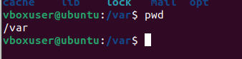
Figure 14: pwd
(Source: Self-developed)
In order to quit, the current pwd command shows the route of your current directory.
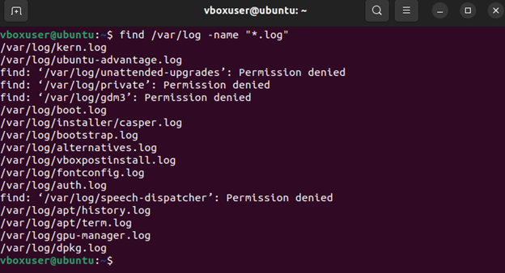
Figure 15: find
(Source: Self-developed)
Find would be useful in locating all of the files (with or without subdirectories) that have a very large number of criteria.
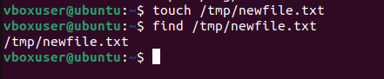
Figure 16: touch
(Source: Self-developed)
This is also to ask to create a file that there is no one in or to alter timestamps.
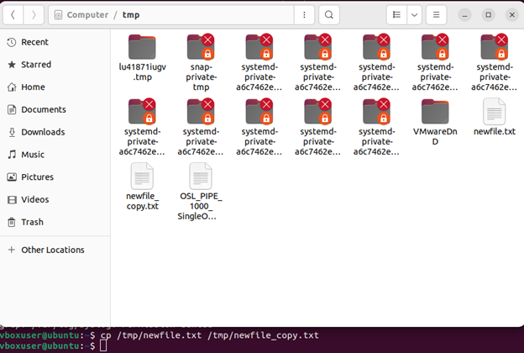
Figure 17: cp
(Source: Self-developed)
The cp command is used in order to duplicate a file in a different location.
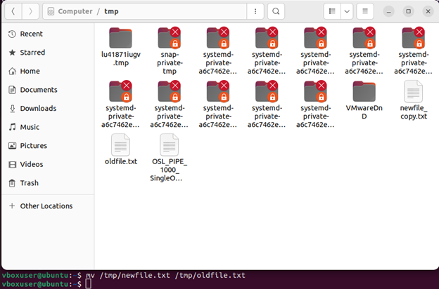
Figure 18: mv
(Source: Self-developed)
Moves an object, or modifies the name of either a file or a directory. One can transfer a file or alter its name with the help of the mv command.
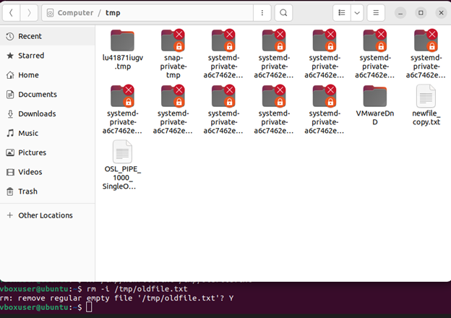
Figure 19: rm
(Source: Self-developed)
The rm command is used permanently to erase files in the system.
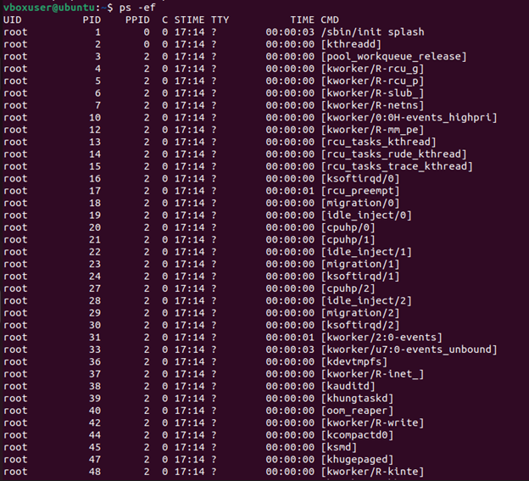
Figure 20: ps
(Source: Self-developed)
The default format of the ps command is processes of the current shell.
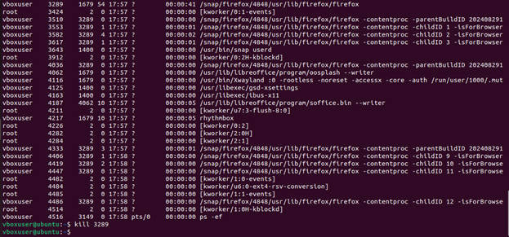
Figure 21: Kill
(Source: Self-developed)
This is the default behaviour when one is giving a command of kill PID, which is to kill the process by giving a SIGTERM command to the process that is being specified by the PID.

5. Task 4. Use of Windows OS scripts
The PowerShell script will be focused on the system temp folder C:\Windows\Temp and delete all the files that are over a specific duration of time (15 days) old. It contains two important variables, which are the target directory (Folderpath) in the form of a string and a age limit of days (Days) in the form of an int. The first step in the script is to ascertain that the directory is present by using Test-Path, which should not cause the script to a runtime error because there is no directory. In essence, this is Code Guard and this code would permitthe utilisation of the script a couple of times (Alenzi and Abbase, 2022). Get-ChildItem will be invoked using the -File parameter and the -Recurse parameter, which will list all the files stored in the directory and all the subdirectories of the directory in the availability of the folder. The pipeline (philtres) items in which (i= -where-object) are all the files filtered on the last write time of the file, and the last write time is compared to (Get-Date). Sort by adding days (-ingredient days) to obtain the files that are before the retention period, and only well-filtered files. The next one applies Remover-item, forcing the ability to remove the matching files and the next one is the error action SilentlyContinue to be able to allocate the files occupied by the system.
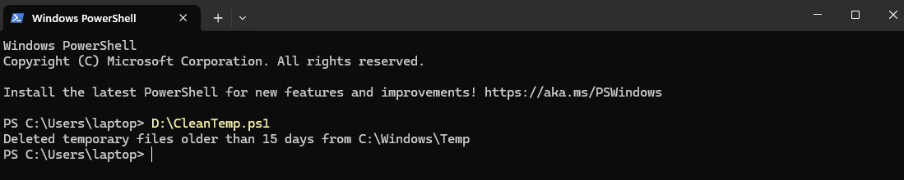
Figure 22: Windows OS Script
(Source: Self-developed)
Execution
In order to save it as CleanWindowsTemp.ps1 and ensure that PowerShell has a setting that can permit it to be utilised to execute local scripts, including the execution of Set-ExecutionPolicy -Scope CurrentUser RemoteSigned in a highly privileged execution session. C: WindowsTemp is a system path that has to be encrypted; thus, PowerShell is an Administrator, and thus, the script would be permitted to delete system temporary files (Margaret and Alice, 2021). To execute the script and schedule it in Task Scheduler, there is a need to just execute the script at least at the peak hours and to consider putting a kind of logging in a log file, which can be used to record the activities and mistakes that will be experienced.
Use Case and Benefits
Clean-up automated (To clean up) to clean up the windows /Temp disc also causes less disc bloat, as well as goes towards ensuring credible free disc, and minimises manual clean-up overhead. The script can be described as an example of PowerShell scripting best practises: the variables are explicitly defined, provider commands are incorporated, a filter is provided, a pipeline is used, and it is defensive, demonstrated through the use of Test-Path.

6. Task 5. Use of Linux OS scripts
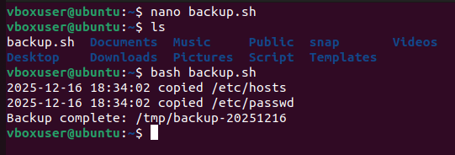
Figure 23: Linux OS Script
(Source: Self-developed)
Explanation
The script variables will be the destinations that will be given as follows: the script, the symbol (), the timestamps might be dynamic, e.g., creation of the directory e.g. /tmp/backup-20251216. It is admissible in the form of an array (FILES= (...) in the list), although in a far less dangerous form: human. The list may be retained in an array (FILES=(...)) or where the list is named safe expansion in an array (FILES=@). conditional readability [-r $f] Cheques Before CP can read and execute errors. It is the log () function that accumulates the output provisioning to a format of timestamp. Quotation marks are made to surround the words between which the sale route and cost (i.e., $DEST, '$f) are typed in, avoiding the splitting of the words and the broadening of the worldwide aspect. A command such as add set -euo pipefail will be added and then clean up the new system with the help of trap handlers and where possible the better-quality performance built-in, which are more portable.
Execution
Wrap: wrap the script into something that is executable, such as the following: chmod +x backup.sh and upload the script:./ backup.sh. It creates the destination folder (mkdir -p $DEST) and loops files, transferring readable files, copying messages are also written down in a series of timestamps with this, Backup complete: /tmp/backup-YYYYMMDD. ls -l can be used to verify the saved files. Trace Visualise debug to debug step 2. run: watch Debug To debug set -x or bash -x In lieu of debug trace. And in the case, where you would like to make it run cron or systemd timer, ensure that the user it is being run under has access to the files it is being read.
Use Case and Benefits
During the implementation of CI, it is the right format with a backup of lightweight configuration, small-scale snapshots of the huge text files or even all-test testing stages in the pre-deployment phase. They can be easily placed into the environment in which the system administrator may desire to obtain a fast copy of the files in the config files, yet in auditory format, prior to making any alterations. It is now extended to it, adding retention policies (x13) (rotate older backups), transfer to remote (scp/rsync) and argument processing (getopts) in order to exploit the custom file lists and destinations. The export runtime in the container of the containerized environment needs to be configured and this must be done with the help of the following script. This given that it may come in handy in the low-context case, once some significant or major backups come into play, it is time to consider the specialised tools (rsync, borg, restic) that can be employed to offer deduplication, and encryption and effective incremental snapshots.

7. Conclusion
Based on the above findings, it can be concluded that the Windows OS and its subsequent CLI commands have been discussed in this report, which can help corporate officials enhance current organisational file management processes. The report further highlights the Windows OS and Linux OS scripts incorporated within modern corporate systems that can help provide a personalised experience to employees.

Reference List
Abu-Dalbouh, H.M., (2022) ‘A new combination approach to cpu scheduling based on priority and round-robin algorithms for assigning a priority to a process and eliminating starvation’, International Journal of Advanced Computer Science and Applications, 13(4), pp.1-22.
Akhtar, Z.B., (2024) ‘Operating systems (OS): An insight investigative research analysis and future directions’, Journal of Technology and Informatics (JoTI), 6(1), pp.58-69.
Alenzi, K.F. and Abbase, O.A.B., (2022) ‘A defensive framework for reflected xss in client-side applications’, Journal of Web Engineering, 21(7), pp.2209-2229.
Babashahi, L., Barbosa, C.E., Lima, Y., Lyra, A., Salazar, H., Argôlo, M., Almeida, M.A.D. and Souza, J.M.D., (2024) ‘AI in the workplace: A systematic review of skill transformation in the industry’. Administrative Sciences, 14(6), p.127.
Leis, V., Alhomssi, A., Ziegler, T., Loeck, Y. and Dietrich, C., (2023) ‘Virtual-memory assisted buffer management’, Proceedings of the ACM on Management of Data, 1(1), pp.1-25.
Mahmud, M.M. and Wong, S.F., (2022) ‘Digital age: The importance of 21st century skills among the undergraduates’. In Frontiers in Education (Vol. 7, p. 950553). Frontiers Media SA.
Margaret, A. and Alice, M., (2021) ‘Automating Windows Server Administration with PowerShell and Desired State Configuration (DSC)’, International Journal of Trend in Scientific Research and Development, 5(3), pp.1349-1354.
Mind, P., Palkar, G., Mahamuni, A. and Sahare, S., (2021) ‘Smart stick for visually impaired’. Int. J. Eng. Res. Technol, 10(06), pp.196-198.
Pedamkar, P., (2023) Functions of Operating System. Available at: https://www.educba.com/functions-of-operating-system/ (Accessed: 10th Dec 2025).
Simpson, A., (2024) Windows 11 for Dummies. John Wiley & Sons.

Appendices

Appendix 1: Windows OS Script
$FolderPath = "C:\Windows\Temp"
$Days = 15

if (Test-Path $FolderPath) {

Get-ChildItem -Path $FolderPath -File -Recurse -ErrorAction SilentlyContinue |
Where-Object { $_.LastWriteTime -lt (Get-Date).AddDays(-$Days) } |
Remove-Item -Force -ErrorAction SilentlyContinue

Write-Output "Deleted temporary files older than $Days days from $FolderPath"
}
else {
Write-Output "Folder $FolderPath does not exist. No files were deleted."
}

Appendix 2: Linux OS Script
#!/bin/bash
DEST="/tmp/backup-$(date +%Y%m%d)"
FILES=("/etc/hosts" "/etc/passwd")

mkdir -p "$DEST"

log() {
printf "%s %s\n" "$(date '+%F %T')" "$*"
}

for f in "${FILES[@]}"; do
if [ -r "$f" ]; then
cp "$f" "$DEST/"
log "copied $f"
else
log "skipped $f (not readable)"
fi
done

echo "Backup complete: $DEST"

