

Assessment 1 – Reading Task Template
PART 1: Upload your photo of your A3 in-class notes here:
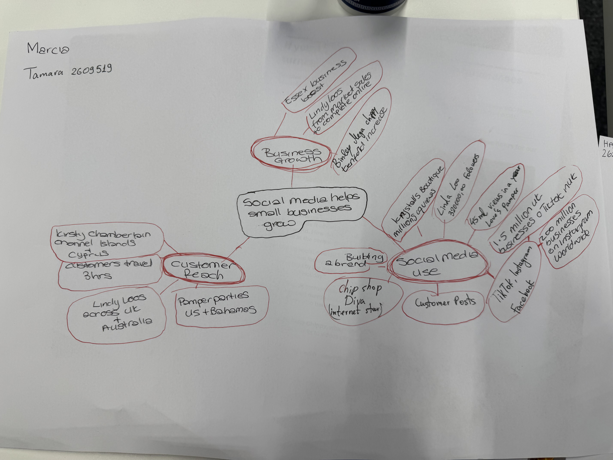

PART 2:
- Answer every question below in 1-3 full sentences.
- Use your own words. Do not use generative AI to answer these questions.
- Include a specific detail from the text when asked.
REMINDER
- The main idea is the overall message of the whole text.
- A key point helps to explain the main idea.
- A specific detail or example from the text shows that the key point is true.

- What is the main idea of the whole text?

The main idea is that social media helps small businesses grow by attracting more customers and increasing sales.

- What is one key point that supports the main idea, and which specific example from the text shows this?

One key point is that social media helps businesses reach customers from far away. For example, some customers travelled three hours to Honywood Sandwich Shop to try its chicken burger.

- What is a different key point that supports the main idea, and which specific example from the text shows this?

Another key point is that viral videos can increase a businesses popularity.
For example, Binley Mega Chippy saw its trade increase tenfold because of the videos on social media.

- Which part of the text do you think is most important, and why?

I think the most important part is how social media helped small companies grow. For instance, Linda Hunter boasts 320,000 Facebook and Instagram followers and now sells clothes online to customers across the U.K and Australia.

Reflection:
- What did you find difficult in this task (including in-class components), and why was it difficult?

Forming a mind map was quite a challenge for me since there was too much information involved. It was difficult to pick out the most important details.

- What helped you with this difficulty, and how did it help you?

The text offered many types of businesses and examples. Creating a mind map helped me sort the information into categories. It helped me understand the main idea also choose relevant examples from the text.

