Data Handling and Business Intelligence
LCBB5000
Student: Kristina Ivanova
Student number: 2020522

Part 1
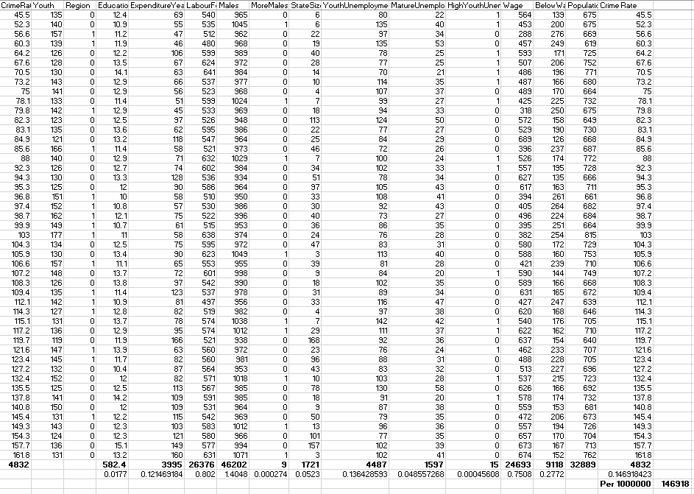

Reasons to Use “IF” in Excel
The IF Statement in Excel performs a test on a certain condition and returns one value if the test is successful and a different value if the condition was unsuccessful. For example, if the total amount of sales is more than $5,000, you should respond "Yes" for Bonus; otherwise, you should return "No" for Bonus (Cleff, 2019). We may use the IF function to evaluate a single function, but we can also combine many IF functions into a single formula. Both of these options are available to us. Nested IF statements are somewhat of a several IF statements that may be used in Excel. The IF function is used often in the role of a financial analyst in order to review and analyse data by assessing a variety of situations. Evaluating text, values, and even mistakes is possible with this function because to its versatility (Simanjuntak, 2020). It is not restricted to only delivering a single response after testing to see whether something is the same as something else. In addition to that, we are able to make use of mathematical operators and carry out more calculations, according to the criteria we choose. We are also able to execute numerous comparisons by nesting several IF functions one within the other.
Reasons to use “LOOKUP” in Excel
Excel's Lookup and Reference functions are where you'll find the LOOKUP function. A rough match lookup is performed by the function in either a one-row or one-column range, and it provides the equivalent value from either yet another or another one-column range. Until you need to find a number in a different row or column that is located in the same location as the one you are looking at in the current row or column, use the LOOKUP function, which is one of the lookup and reference functions. You may search only one row or just one column by using the LOOKUP function. Form vectorielle (Simanjuntak, 2020): You may search for a value in a single row or column by using this form of the LOOKUP command. When you need to provide the range of values that include the ones you wish to match, use the vector form of the expression. In place of the array form, you should use VLOOKUP or HLOOKUP instead, since this is our strongest recommendation. Watch this video to learn how to use the VLOOKUP command. The array form is offered, but its usefulness is severely restricted since it is designed to be compatible with other spreadsheet systems. An array is a collection of data that is organised in rows and columns, similar to a table, and it may be searched like a table (Gao et al., 2018).

Part 2
How many students like vanilla flavour?
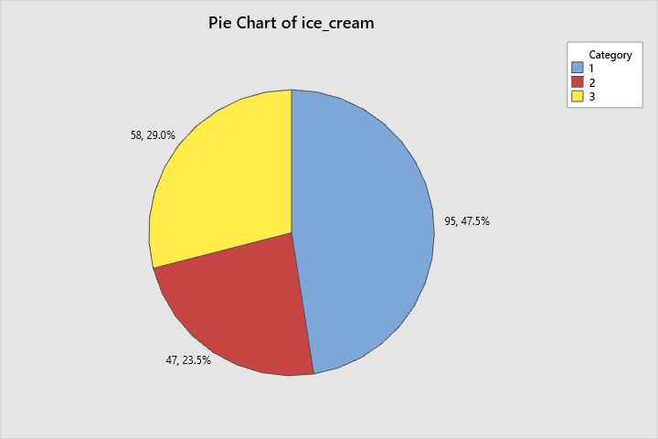
Figure 1: Pie chart for the ice creams
From the chart above, it can be seen that out of a total of 200 students, 95 students opted for the vanilla flavor

How many students are male or female?

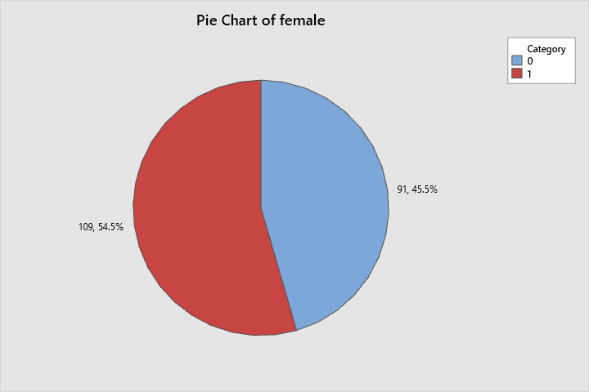
Figure 2: Pie chart indicating the division in male and female
From the chart above, it can be clearly seen that out of 200 students, 91 were male, and 109 were females.
Chocolate Flavour
Mean 99.02618
Media 98

Strawberry Flavour
Mean 100.899
Median 100.5

- Cluster Observation

Amalgamation Steps
Step | Number of  clusters | Similarity  level | Distance  level | Clusters  joined |  | New  cluster | Number  of obs.  in new  cluster
1 | 199 | 100.000 | 0.00000 | 61 | 199 | 61 | 2
2 | 198 | 100.000 | 0.00000 | 106 | 196 | 106 | 2
3 | 197 | 100.000 | 0.00000 | 131 | 195 | 131 | 2
4 | 196 | 100.000 | 0.00000 | 23 | 193 | 23 | 2
5 | 195 | 100.000 | 0.00000 | 19 | 189 | 19 | 2
6 | 194 | 100.000 | 0.00000 | 143 | 182 | 143 | 2
7 | 193 | 100.000 | 0.00000 | 153 | 181 | 153 | 2
8 | 192 | 100.000 | 0.00000 | 156 | 177 | 156 | 2
9 | 191 | 100.000 | 0.00000 | 158 | 172 | 158 | 2
10 | 190 | 100.000 | 0.00000 | 36 | 160 | 36 | 2
11 | 189 | 100.000 | 0.00000 | 139 | 159 | 139 | 2
12 | 188 | 100.000 | 0.00000 | 54 | 156 | 54 | 3
13 | 187 | 100.000 | 0.00000 | 11 | 154 | 11 | 2
14 | 186 | 100.000 | 0.00000 | 133 | 153 | 133 | 3
15 | 185 | 100.000 | 0.00000 | 60 | 148 | 60 | 2
16 | 184 | 100.000 | 0.00000 | 85 | 144 | 85 | 2
17 | 183 | 100.000 | 0.00000 | 71 | 143 | 71 | 3
18 | 182 | 100.000 | 0.00000 | 116 | 139 | 116 | 3
19 | 181 | 100.000 | 0.00000 | 127 | 138 | 127 | 2
20 | 180 | 100.000 | 0.00000 | 28 | 137 | 28 | 2
21 | 179 | 100.000 | 0.00000 | 91 | 134 | 91 | 2
22 | 178 | 100.000 | 0.00000 | 10 | 133 | 10 | 4
23 | 177 | 100.000 | 0.00000 | 122 | 131 | 122 | 3
24 | 176 | 100.000 | 0.00000 | 72 | 126 | 72 | 2
25 | 175 | 100.000 | 0.00000 | 63 | 125 | 63 | 2
26 | 174 | 100.000 | 0.00000 | 112 | 120 | 112 | 2
27 | 173 | 100.000 | 0.00000 | 14 | 117 | 14 | 2
28 | 172 | 100.000 | 0.00000 | 16 | 109 | 16 | 2
29 | 171 | 100.000 | 0.00000 | 17 | 107 | 17 | 2
30 | 170 | 100.000 | 0.00000 | 62 | 101 | 62 | 2
31 | 169 | 100.000 | 0.00000 | 35 | 100 | 35 | 2
32 | 168 | 100.000 | 0.00000 | 83 | 97 | 83 | 2
33 | 167 | 100.000 | 0.00000 | 80 | 88 | 80 | 2
34 | 166 | 100.000 | 0.00000 | 4 | 87 | 4 | 2
35 | 165 | 100.000 | 0.00000 | 78 | 86 | 78 | 2
36 | 164 | 100.000 | 0.00000 | 25 | 79 | 25 | 2
37 | 163 | 100.000 | 0.00000 | 45 | 78 | 45 | 3
38 | 162 | 100.000 | 0.00000 | 42 | 75 | 42 | 2
39 | 161 | 100.000 | 0.00000 | 40 | 71 | 40 | 4
40 | 160 | 100.000 | 0.00000 | 31 | 50 | 31 | 2
41 | 159 | 100.000 | 0.00000 | 20 | 49 | 20 | 2
42 | 158 | 100.000 | 0.00000 | 9 | 42 | 9 | 3
43 | 157 | 100.000 | 0.00000 | 27 | 36 | 27 | 3
44 | 156 | 100.000 | 0.00000 | 24 | 35 | 24 | 3
45 | 155 | 100.000 | 0.00000 | 6 | 12 | 6 | 2
46 | 154 | 100.000 | 0.00000 | 7 | 11 | 7 | 3
47 | 153 | 100.000 | 0.00000 | 5 | 7 | 5 | 4
48 | 152 | 100.000 | 0.00000 | 2 | 6 | 2 | 3
49 | 151 | 98.445 | 0.09315 | 43 | 198 | 43 | 2
50 | 150 | 98.445 | 0.09315 | 104 | 142 | 104 | 2
51 | 149 | 98.314 | 0.10100 | 103 | 150 | 103 | 2
52 | 148 | 98.314 | 0.10100 | 91 | 124 | 91 | 3
53 | 147 | 98.314 | 0.10100 | 114 | 119 | 114 | 2
54 | 146 | 98.314 | 0.10100 | 18 | 51 | 18 | 2
55 | 145 | 98.314 | 0.10100 | 176 | 190 | 176 | 2
56 | 144 | 98.314 | 0.10100 | 5 | 157 | 5 | 5
57 | 143 | 98.314 | 0.10100 | 77 | 146 | 77 | 2
58 | 142 | 98.314 | 0.10100 | 32 | 183 | 32 | 2
59 | 141 | 98.314 | 0.10100 | 99 | 149 | 99 | 2
60 | 140 | 98.314 | 0.10100 | 38 | 136 | 38 | 2
61 | 139 | 96.891 | 0.18629 | 44 | 171 | 44 | 2
62 | 138 | 96.629 | 0.20200 | 22 | 74 | 22 | 2
63 | 137 | 96.629 | 0.20200 | 70 | 188 | 70 | 2
64 | 136 | 96.629 | 0.20200 | 2 | 167 | 2 | 4
65 | 135 | 96.629 | 0.20200 | 106 | 127 | 106 | 4
66 | 134 | 96.629 | 0.20200 | 85 | 116 | 85 | 5
67 | 133 | 96.629 | 0.20200 | 48 | 105 | 48 | 2
68 | 132 | 96.629 | 0.20200 | 41 | 60 | 41 | 3
69 | 131 | 96.629 | 0.20200 | 28 | 58 | 28 | 3
70 | 130 | 96.629 | 0.20200 | 27 | 45 | 27 | 6
71 | 129 | 96.629 | 0.20200 | 19 | 200 | 19 | 3
72 | 128 | 96.629 | 0.20200 | 169 | 178 | 169 | 2
73 | 127 | 96.629 | 0.20200 | 5 | 165 | 5 | 6
74 | 126 | 96.629 | 0.20200 | 67 | 145 | 67 | 2
75 | 125 | 96.629 | 0.20200 | 4 | 81 | 4 | 3
76 | 124 | 96.463 | 0.21191 | 122 | 162 | 122 | 4
77 | 123 | 96.463 | 0.21191 | 69 | 92 | 69 | 2
78 | 122 | 96.288 | 0.22244 | 43 | 187 | 43 | 3
79 | 121 | 96.288 | 0.22244 | 47 | 129 | 47 | 2
80 | 120 | 95.414 | 0.27479 | 94 | 151 | 94 | 2
81 | 119 | 94.943 | 0.30300 | 52 | 192 | 52 | 2
82 | 118 | 94.943 | 0.30300 | 158 | 184 | 158 | 3
83 | 117 | 94.943 | 0.30300 | 90 | 152 | 90 | 2
84 | 116 | 94.943 | 0.30300 | 95 | 141 | 95 | 2
85 | 115 | 94.943 | 0.30300 | 115 | 118 | 115 | 2
86 | 114 | 94.943 | 0.30300 | 13 | 110 | 13 | 2
87 | 113 | 94.943 | 0.30300 | 53 | 91 | 53 | 4
88 | 112 | 94.943 | 0.30300 | 24 | 72 | 24 | 5
89 | 111 | 94.943 | 0.30300 | 10 | 31 | 10 | 6
90 | 110 | 94.943 | 0.30300 | 18 | 23 | 18 | 4
91 | 109 | 94.943 | 0.30300 | 25 | 197 | 25 | 3
92 | 108 | 94.943 | 0.30300 | 99 | 191 | 99 | 3
93 | 107 | 94.943 | 0.30300 | 93 | 102 | 93 | 2
94 | 106 | 94.943 | 0.30300 | 33 | 98 | 33 | 2
95 | 105 | 94.943 | 0.30300 | 37 | 73 | 37 | 2
96 | 104 | 94.943 | 0.30300 | 8 | 64 | 8 | 2
97 | 103 | 94.943 | 0.30300 | 38 | 62 | 38 | 4
98 | 102 | 94.709 | 0.31700 | 1 | 16 | 1 | 3
99 | 101 | 93.257 | 0.40400 | 112 | 175 | 112 | 3
100 | 100 | 92.927 | 0.42382 | 108 | 170 | 108 | 2
101 | 99 | 92.575 | 0.44489 | 46 | 69 | 46 | 3
102 | 98 | 92.227 | 0.46573 | 3 | 179 | 3 | 2
103 | 97 | 92.227 | 0.46573 | 61 | 155 | 61 | 3
104 | 96 | 92.227 | 0.46573 | 40 | 123 | 40 | 5
105 | 95 | 92.227 | 0.46573 | 17 | 104 | 17 | 4
106 | 94 | 92.227 | 0.46573 | 84 | 96 | 84 | 2
107 | 93 | 92.046 | 0.47656 | 132 | 161 | 132 | 2
108 | 92 | 92.046 | 0.47656 | 63 | 103 | 63 | 4
109 | 91 | 91.985 | 0.48024 | 39 | 57 | 39 | 2
110 | 90 | 91.572 | 0.50501 | 22 | 55 | 22 | 3
111 | 89 | 91.572 | 0.50501 | 59 | 169 | 59 | 3
112 | 88 | 91.572 | 0.50501 | 76 | 166 | 76 | 2
113 | 87 | 91.572 | 0.50501 | 9 | 48 | 9 | 5
114 | 86 | 91.572 | 0.50501 | 20 | 28 | 20 | 5
115 | 85 | 91.572 | 0.50501 | 83 | 111 | 83 | 3
116 | 84 | 91.572 | 0.50501 | 26 | 89 | 26 | 2
117 | 83 | 91.527 | 0.50765 | 106 | 140 | 106 | 5
118 | 82 | 91.527 | 0.50765 | 4 | 19 | 4 | 6
119 | 81 | 91.527 | 0.50765 | 70 | 85 | 70 | 7
120 | 80 | 91.527 | 0.50765 | 54 | 67 | 54 | 5
121 | 79 | 91.016 | 0.53827 | 30 | 44 | 30 | 3
122 | 78 | 90.727 | 0.55562 | 93 | 185 | 93 | 3
123 | 77 | 90.727 | 0.55562 | 114 | 164 | 114 | 3
124 | 76 | 90.727 | 0.55562 | 122 | 158 | 122 | 7
125 | 75 | 90.727 | 0.55562 | 24 | 90 | 24 | 7
126 | 74 | 90.727 | 0.55562 | 10 | 53 | 10 | 10
127 | 73 | 90.727 | 0.55562 | 77 | 113 | 77 | 3
128 | 72 | 90.727 | 0.55562 | 68 | 76 | 68 | 3
129 | 71 | 90.727 | 0.55562 | 33 | 38 | 33 | 6
130 | 70 | 90.727 | 0.55562 | 27 | 32 | 27 | 8
131 | 69 | 90.367 | 0.57716 | 56 | 173 | 56 | 2
132 | 68 | 90.082 | 0.59426 | 47 | 52 | 47 | 4
133 | 67 | 89.886 | 0.60601 | 95 | 121 | 95 | 3
134 | 66 | 89.767 | 0.61312 | 108 | 168 | 108 | 3
135 | 65 | 88.535 | 0.68698 | 3 | 163 | 3 | 3
136 | 64 | 88.535 | 0.68698 | 20 | 43 | 20 | 8
137 | 63 | 88.535 | 0.68698 | 8 | 26 | 8 | 4
138 | 62 | 88.535 | 0.68698 | 5 | 18 | 5 | 10
139 | 61 | 88.535 | 0.68698 | 29 | 194 | 29 | 2
140 | 60 | 88.535 | 0.68698 | 176 | 186 | 176 | 3
141 | 59 | 88.535 | 0.68698 | 2 | 83 | 2 | 7
142 | 58 | 88.535 | 0.68698 | 66 | 147 | 66 | 2
143 | 57 | 88.535 | 0.68698 | 40 | 41 | 40 | 8
144 | 56 | 88.098 | 0.71312 | 1 | 132 | 1 | 5
145 | 55 | 87.244 | 0.76430 | 14 | 174 | 14 | 3
146 | 54 | 87.244 | 0.76430 | 13 | 115 | 13 | 4
147 | 53 | 87.244 | 0.76430 | 65 | 80 | 65 | 3
148 | 52 | 86.515 | 0.80801 | 59 | 128 | 59 | 4
149 | 51 | 86.236 | 0.82472 | 94 | 99 | 94 | 5
150 | 50 | 85.870 | 0.84662 | 84 | 180 | 84 | 3
151 | 49 | 84.435 | 0.93262 | 106 | 122 | 106 | 12
152 | 48 | 84.435 | 0.93262 | 15 | 112 | 15 | 4
153 | 47 | 84.435 | 0.93262 | 4 | 24 | 4 | 13
154 | 46 | 84.435 | 0.93262 | 37 | 61 | 37 | 5
155 | 45 | 84.363 | 0.93692 | 30 | 108 | 30 | 6
156 | 44 | 83.652 | 0.97951 | 25 | 40 | 25 | 11
157 | 43 | 82.316 | 1.05955 | 84 | 114 | 84 | 6
158 | 42 | 82.316 | 1.05955 | 27 | 93 | 27 | 11
159 | 41 | 82.316 | 1.05955 | 2 | 9 | 2 | 12
160 | 40 | 81.454 | 1.11125 | 21 | 34 | 21 | 2
161 | 39 | 80.935 | 1.14230 | 20 | 59 | 20 | 12
162 | 38 | 80.483 | 1.16939 | 39 | 130 | 39 | 3
163 | 37 | 79.894 | 1.20468 | 14 | 17 | 14 | 7
164 | 36 | 79.420 | 1.23309 | 46 | 82 | 46 | 4
165 | 35 | 78.500 | 1.28821 | 63 | 94 | 63 | 9
166 | 34 | 78.278 | 1.30151 | 1 | 95 | 1 | 8
167 | 33 | 78.086 | 1.31301 | 37 | 54 | 37 | 10
168 | 32 | 78.086 | 1.31301 | 65 | 77 | 65 | 6
169 | 31 | 77.221 | 1.36485 | 29 | 56 | 29 | 4
170 | 30 | 77.069 | 1.37395 | 8 | 70 | 8 | 11
171 | 29 | 76.749 | 1.39317 | 2 | 5 | 2 | 22
172 | 28 | 76.139 | 1.42967 | 27 | 33 | 27 | 17
173 | 27 | 75.803 | 1.44982 | 10 | 20 | 10 | 22
174 | 26 | 75.154 | 1.48874 | 135 | 176 | 135 | 4
175 | 25 | 74.582 | 1.52296 | 4 | 14 | 4 | 20
176 | 24 | 73.063 | 1.61401 | 13 | 27 | 13 | 21
177 | 23 | 71.932 | 1.68179 | 39 | 68 | 39 | 6
178 | 22 | 71.921 | 1.68242 | 1 | 106 | 1 | 20
179 | 21 | 70.601 | 1.76151 | 30 | 47 | 30 | 10
180 | 20 | 70.208 | 1.78508 | 15 | 63 | 15 | 13
181 | 19 | 69.916 | 1.80259 | 2 | 84 | 2 | 28
182 | 18 | 67.980 | 1.91858 | 15 | 25 | 15 | 24
183 | 17 | 67.980 | 1.91858 | 21 | 46 | 21 | 6
184 | 16 | 64.601 | 2.12102 | 22 | 37 | 22 | 13
185 | 15 | 64.601 | 2.12102 | 8 | 66 | 8 | 13
186 | 14 | 64.346 | 2.13627 | 3 | 30 | 3 | 13
187 | 13 | 60.966 | 2.33879 | 1 | 10 | 1 | 42
188 | 12 | 57.398 | 2.55262 | 1 | 2 | 1 | 70
189 | 11 | 56.236 | 2.62222 | 4 | 135 | 4 | 24
190 | 10 | 55.082 | 2.69135 | 4 | 65 | 4 | 30
191 | 9 | 54.486 | 2.72710 | 29 | 39 | 29 | 10
192 | 8 | 49.574 | 3.02141 | 13 | 22 | 13 | 34
193 | 7 | 46.723 | 3.19223 | 15 | 29 | 15 | 34
194 | 6 | 38.059 | 3.71136 | 3 | 21 | 3 | 19
195 | 5 | 35.698 | 3.85283 | 1 | 4 | 1 | 100
196 | 4 | 35.199 | 3.88269 | 8 | 15 | 8 | 47
197 | 3 | 24.631 | 4.51594 | 1 | 13 | 1 | 134
198 | 2 | 14.124 | 5.14545 | 1 | 3 | 1 | 153
199 | 1 | 0.000 | 5.99174 | 1 | 8 | 1 | 200

Final Partition
 | Number of  observations | Within  cluster  sum of  squares | Average  distance  from  centroid | Maximum  distance  from  centroid
Cluster1 | 200 | 597 | 1.63821 | 3.37967

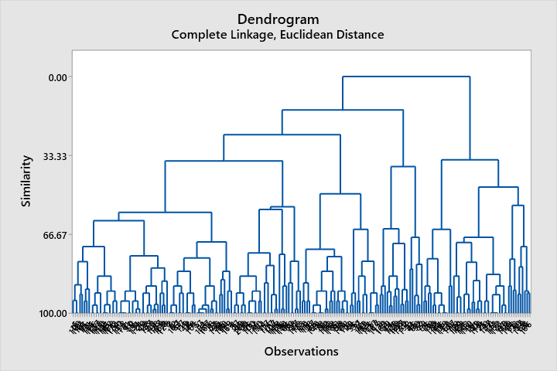

Interpret the results
The table presents the clusters that were linked at each stage, together with their respective distances from one another and the degree to which they resemble one another.
Up to step 15, the amount of similarity will decline by increments of around three or fewer at a time. At stages 16 and 17, when the number of clusters is reduced from 4 to 3, there is a fall in similarity of more than 20 (from 62.0036 to 41.0474)
When clusters are linked together, the distance between them grows, at first by a factor of around 0.6 or less. At stages 16 and 17, the number of clusters is reduced from 4 to 3, which results in an increase in distance of more than 1 (from 1.81904 to 2.82229)
Based on the findings of the distance and similarity analyses, it seems that the final division can be accomplished using just four clusters. If the designer feels that this clustering makes natural sense to them, then selecting it is usually a smart idea. A tree diagram is presented in the form of a dendrogram to represent the information that is in the table.
The designer has to redo the analysis and decide how many clusters will be included in the end partition. Minitab shows additional tables that detail the characteristics of each cluster that is included in the final partition when you define a final partition. These tables are shown after you have specified a final partition.

- Data mining methods
- Clustering
Clustering is a method that is used in the process of graphically representing data, such as in graphs that display purchasing patterns or sales demographics for a certain product. The practise of arranging a number of distinct data points into categories according to the attributes of those categories is referred to as clustering. When this is done, data miners are able to split the data into subsets in a seamless manner, which enables better informed judgments to be made about broad demographics (including customers or users) and the behaviours that are associated with them. The partitioning approach is one that includes separating a data set into a number of distinct clusters so that each cluster may be evaluated according to the criteria that are particular to that cluster. Data points are only ever assigned to a single group or cluster when using this approach. The hierarchical technique organises the data points into a single cluster, which is then subdivided into subclusters according to the similarities between them. These freshly formed clusters may then be examined independently from one another in the next step.
- Association
Finding correlations or relationships between points in a data collection may be accomplished via the application of clustering algorithms. Data miners utilise the technique of association to find variables in datasets that have associations that are either unique or intriguing. Association is often used by businesses to assist with the determination of market analysis and plan. Searching for a single occurrence of a data item or characteristic that appears more than once is required for a single-dimensional relationship. For example, a store may go through its database to find all of the instances in which a given item was bought. The process of searching for associations between several data points in a single data collection is known as multi-dimensional association. It's possible that the same shop would be interested in knowing more about a consumer than just what they bought, such as their age, the manner of payment they used (cash or credit card), and so on.
- Data Cleaning
The method of producing data to really be mined is referred to as "data cleansing." Organizing data, removing any duplicate or erroneous entries, and filling in any blanks or missing information are all part of the data cleaning process. After this procedure has been finished, the information that will be most helpful in the analysis may be gathered. Checking the accuracy of the data: This requires ensuring that each individual data point in the collection has been formatted in the appropriate manner (e.g, telephone numbers, social security numbers). Transforming the kinds of data: This guarantees that the data are consistent all across the collection. Strings variables, on the other hand, can store letters, integers, and symbols in addition to letters, but numeric variables can only store integers. Removing irrelevant data: By doing this, unnecessary or irrelevant data are removed, allowing for the vital data points to get the full attention they deserve (Gao et al., 2018).

Text Mining
Text Mining was among the most important and useful methods for analysing and processing large amounts of data, which accounts for around 80 percent of all data in the world. The vast majority of businesses and institutions in existence today collect and store large quantities of data in database systems and cloud platforms. This information continues to increase dramatically by the minute as fresh data comes flowing in from a variety of sources. Because of this, it becomes difficult for businesses and other organisations to store, analyse, and analyse massive volumes of textual data using the tools that have traditionally been available to them. Acquiring more skills via the use of data science programmes will assist you in overcoming the problems.
- Information Extraction
This text mining method is by far the most well-known one. The process of gleaning useful information from massive swaths of textual material is referred to as information exchange. This method of text mining concentrates on figuring out how to extract entities, properties, and the connections between them from texts that are either semi-structured or unstructured. After information is extracted, it is then saved in a database so that it may be retrieved and accessed at a later time. The methods of accuracy and recall are used in order to assess and analyse the results for their usefulness as well as their relevance.
- Information Retrieval
Information Retrieval, often known as IR, is the process of determining relevant and related patterns based on a certain word or phrase combination. Text mining is a method that involves the application of various algorithms by IR systems in order to follow and analyse user actions and find relevant material in accordance with such behaviours. The search engines operated by Google and Yahoo are now the two most well-known IR systems.
- Categorization
This is one of the text mining strategies that is a kind of "supervised" learning. In this type of learning, regular language texts are allocated to a specified set of themes based upon the material they contain. Consequently, categorization, or more accurately Natural Language Processing (NLP), is a procedure that involves collecting text documents, then processing and analysing those texts in order to discover the appropriate subjects or indexes for each document. In natural language processing (NLP), the co-referencing approach is a technique that is often used to derive meaningful synonyms and abbreviations from textual input. Today, natural language processing has evolved into an automated process that can be used in a variety of scenarios, including the delivery of targeted ads, the filtering of spam, the classification of web pages according to hierarchical definitions, and many other applications.

Software | Advantages | Disadvantages
SPSS | Tools for managing data that are comprehensive. The initial entering of data is the most important and time-consuming aspect of any data analysis. If you input the data in the incorrect manner, you won't be able to do an accurate analysis on it (Ayala Chacaltana, 2020). When it comes to inputting data, you have access to a broad variety of solutions; nevertheless, most of the time, entering the data into IBM SPSS is the best choice. IBM SPSS provides users with a straightforward spreadsheet format for the purpose of data input. This format is user-friendly and quick to learn. Most significantly, IBM SPSS offers a wide variety of data documentation, notably value labels, which will be of use to you as you work to maintain consistency in the input of your data.  Outstanding graphics display choices available. Before beginning your data analysis, you must first have an understanding of the behaviour of your data. The use of graphics is recommended for this. The scatterplots, boxplots, and histograms that are included in IBM SPSS will assist you in recognising trends within your data. It goes without saying that you shouldn't publish conclusions that are based purely on an instinctive interpretation of the images.  A comprehensive selection of different statistical models. At the outset of a research project, it is not always possible to tell which statistical models would be the most appropriate for the topic that you are working on. Sometimes you will have a broad notion, but most of the time the statistical model will alter as you start looking at the data. This may be frustrating. Either that, or you will need to do an additional analysis as a quality check for the analysis that was initially intended. IBM SPSS provides users with access to a wide number of statistical models that are distinguished by their high degree of adaptability. Chief among them are the generic linear model and a selection of logistic regression models. | Because it is so ridiculously costly and needs a licence, you can't simply purchase it and possess it on your own. (Note that R is available for free, and that the licences for SAS and STATA do not need to be renewed on an annual basis (at least, that wasn't the case the last time I used SAS) (Simanjuntak, 2020).  I think that there are some things that it is unable to accomplish, or that it is not as quick or excellent at, such as multi-level analyses or structural equation modelling; however, it has been a while since I attempted to do those things, and I discovered alternative answers to those problems (Stata and MPlus, respectively) (Simanjuntak, 2020).  It will be more difficult to programme it to do everything you want if you become extremely proficient at it (R and SAS are probably the best for this, with STATA a close third)  Does not provide you the ability to show off in front of other data analysts since it is comparable to riding a bicycle in terms of software packages... nonetheless, a tricycle that is in perfect working order.
EXCEL | Excel is used in the workplace for the purpose of producing financial work as well as regular accounting job. You will be able to preserve any vital data you have at the workplace. When the time comes, you may present the structured facts to your supervisor. Additionally, you have the option of creating annual credit and debit sheets.  If you choose to safeguard your Excel file with a password, no other user will be able to access the information stored within. This program's security features are also superior than those of competing products (Ayala Chacaltana, 2020).  This piece of software has a large capacity for data storage. This programme has the capacity to save all of the annual data. Using the charts and other visualisation tools that are included in this programme, you may also arrange the data that you have collected. Your data can accommodate the storage of millions of rows.  This programme is compatible with the operating systems Android, iOS, Windows, and Mac. You may also utilise the online edition of this programme, which enables you to interact with other users as well as use the software yourself.  You also have the option to print and distribute the document through email. It will not be difficult to provide your data to either your workplace or any other institution that requires it. On either their mobile device or their own computer, they have access to the identical file and data. | You are aware that macros may be found in Excel. Because the Excel file may accept macros, it is possible for anybody to introduce a virus into it. If this happens, your computer will also get infected with the virus (No, n.d.).  Learning how to use this programme is far more difficult than learning how to use Microsoft Word or any other software. Formulae are used inside the programme, and it is more challenging for a novice to grasp formulas than other aspects of the software.  The cost of purchasing this programme is rather steep. There are a lot of other options available; for instance, OpenOffice is a free piece of software that may be used for the creation of spreadsheet files.  If you use an incorrect formula, then your results will be inaccurate as a result. Also challenging is the process of locating flaws inside this programme. Because this programme may hold millions of entries, it might be difficult to locate any mistakes that may have been made (Cleff, 2019).

References
Cleff, T., 2019. Applied statistics and multivariate data analysis for business and economics: A modern approach using SPSS, Stata, and Excel. Springer.
Simanjuntak, S.D., 2020. Statistik Penelitian Pendidikan dengan Aplikasi Ms. Excel dan SPSS. Jakad Media Publishing.
No, S., CORE PRACTICAL II: ADVANCE EXCEL AND SPSS. Dr. NGP ARTS AND SCIENCE COLLEGE (Autonomous), 1(K2), p.81.
Gao, Y., Yang, M. and Li, L., 2018. Excel and SPSS analysis of independent sample t-test. Animal Husbandry and Feed Science (Inner Mongolia), 39(10), pp.79-82.
Ayala Chacaltana, P.D., 2020. Cómo realizar un pronóstico con Excel, MiniTab o SPSS.

