

PRODUCT AND FURNITURE DESIGN – BA|BSc
ADDA5017 DESIGN SIMULATION
TEACHING, LEARNING & ASSESSMENT: SEMESTER 2 | 2025-26

COURSEWORK TASKS 1 & 2

CW TASK 1: FINITE ELEMENT ANALYSIS OF THE BOLMEN STOOL
You are to analyse the performance characteristics of the IKEA Bolmen stool (material – Polypropylene) with a loading of 150kg, then optimise the design by adding strengthening ribs to ensure a Safety Factor of 3 is achieved.

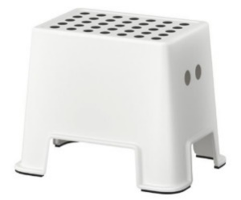

You are to record and comment on at least 3 analysis iterations in evaluating your rib designs to achieve the specified criteria.

CW TASK 2: MANUFACTURABILITY ANALYSIS OF POWERDRILL
You are to inspect the Power Hand Drill for manufacturability within Fusion, and identify and document in an A4 report the following criteria that would be problematic in the manufacture of the component and suggest ways to improve its manufacturability per criteria
:
- Use the Draft function to identify any internal surfaces with a draft of less than 1º;
- Use the Accessibility (Undercut) Analysis to analyse for any Undercut issues when moulding;
- Use the Minimum Radius Analysis to identify any radial surfaces of less than 1.5mm.
- Any other potential manufacturing problems

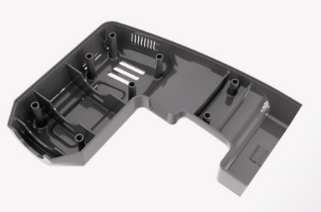

COURSEWORK TASK 1&2 SUBMISSION DEADLINE:
Digital Submission: 12.00pm 18.05.26
Upload all elements to One Drive/Fusion 360 (your specified folder)

Standard Digital File Name: 2025_26_ADDA5017_CW_SURNAME_FIRST INITIAL_1, 2, 3, etc.
Standard Digital File Format: PDF
Standard Video Formats: MP4/MOV/AVI/MPEG
Artwork File Format: PDF (Print friendly)
Artwork File Format: JPEG (Web friendly)
Standard File Format: Fusion F3D

COURSEWORK TASK 1&2 DELIVERABLES & ASSESSMENT:
The specified deliverables and following common assessment & marking criteria will be used in assessing this coursework task elements 1&2 in relation to LO1 & LO2:

Submission Deliverables:
- CWT1: A4 Illustrated FEA Simulation Report
(Documenting the analysis and interpretation of the results in determining the design outcome which achieves the specified criteria)
- CWT2: A4 Illustrated Manufacturability Simulation Report
(Documenting the interpretation of the analysis)

For these tasks, be professional in documenting your observations and comments (bullet points acceptable) in an A4 report (layout format to be well structured, ensure images are readable and font Calibri 11). You may use the generated Fusion report data (recommended that you edit to the most relevant data required).

Note: All 4 coursework task submissions are equally weighted.

Common Assessment & Marking Criteria:
- Cognitive and Intellectual Skills (Marks Available: 70 out of 100)
- Practical Skills (Marks Available: 30 out of 100)

