BMDS7000 The Digital Professional for Health and Care
CW2

Background
The delivery of digital transformation in health and social care has been recognised as a priority by the Welsh Government (2015 and 2021). It identifies that digitally maturity needs to evolve in line with pace of digital evolution in private industry to facilitate Value-Based Health Care (VBHC) (NHS Wales, 2022) for the citizens of Wales.
Achieving VBHC is reliant on capturing, exchange, and use of information to produce health outcomes that matter to patients with the most efficient resource input (NHS Wales, 2022). Intrinsic components of VBHC realisation are prevention, diagnosis, intervention, patient reported outcomes and financial sustainability. Data must be established for each of these components through health informatics if VBHC is to be achieved.
Cardiff and Vale University Health Board’s (CAV UHB) digital strategy has adopted the Learning Health System cycle of Practice to Data, Data to Knowledge and Knowledge to Practice (Foley et al. 2021). If this learning cycle methodology can be facilitated optimally in practice using digital interoperability, the goal of VBHC is a natural evolution. Foley et al. (2021), Yusof et al. (2008) and Scott (2016) illustrate that both subjectivist and objectivist approaches are needed to establish data from practice and data to knowledge in terms of both qualitative and quantitative information.
The Podiatry service (CAV UHB) use the PARIS Electronic Health Record (EHR) by Civica UK and Ireland, to manage patient administration and record patient information. The PARIS system has the capacity to capture both quantitative and qualitative information. It can produce data reports but does not have a text mining capability to use natural language processing to scrutinise free text data. Whilst the system offers a comprehensive record from referral though to discharge, it does not easily integrate with the plethora of other digital systems in Wales. Nevertheless, as open digital architecture gains pace within Wales through interoperability within a National Data Resource (NDR) (Digital Health Wales, 2022), the scope to harness the benefits of aggregated data to produce predictive and preventative health algorithms are within sight.
Software Purpose
With VBHC strategy gaining pace, the capability of analysing quantitative data captured within PARIS and the tantalising opportunity to contribute to national foot wound data via the NDR, the Podiatry wound team developed a Wound Data Set (WDS). The WDS was established through stakeholder engagement with lead clinicians, service managers, a business analyst and PARIS system developers via the Podiatry PARIS coordinator. After a period of user acceptance testing within a test environment and user training (written, video and interactive) the WDS was initiated in September 2021.
The WDS forms an extended part of the PARIS free text case note page. Previously, the free text case note was used to capture all the clinical interaction except for consent, diabetes status and patient risk taxonomy (the latter was not mandated at every contact; therefore, data had become unreliable). The WDS uses data descriptor boxes and drop-down menus to capture pertinent data in grid rows. Data in the grid rows are captured at initial consultation, with additional grid rows added at follow-up consultations. Grid row data can be used for comparison and clinical decision making at each consultation. Grid rows form entries in data frames. Data frames capture specific data set such as foot-health status including vascular status, wound evaluation including infection status, antibiotic prescriptions, and wound offloading interventions. There are free text boxes where test results and additional descriptive information can be recorded in each frame.
The WDS requires the clinician to draw together information from clinically performed tests, data from other software systems such as x-ray, blood, microbiology, and other imaging reports and consultant clinical notes, as well as wound information descriptors such as size, common classifications, and infection status. The data encompasses the three main domains of wound assessment, Vascular status, Infection and Pressure assessment (NHS Wales, 2018). The purpose of the WDS is to amalgamate information in PARIS to allow comprehensive, holistic clinical decision making, to establish diagnoses, interventions, and outcomes with the purpose of understanding VBHC and finally to inform operational demand for staff, skill mix and training.
The adoption of the WDS has not been optimal in the Podiatry team. Anecdotally, some clinicians have reported a lack of time to complete the data fields and system functionality or usability issues. Some clinicians have adopted the new data collection very well and find that the WDS assists in more efficient clinical decision making, although they did report some functional issues. For the WDS to fulfil its purpose, it is imperative that all staff are able to use and realise the value in engaging with the WDS.
Such problems with HIS implementation are well documented (Wachter, 2016, and Eason, 2007). The emergence of a multitude of frameworks (Cresswell et al. 2020, Greenhalgh et al. 2018, Kirk et al. 2016, and Yusof et al. 2007), designed to improve HIS implementation success, indicate the complexity of the interrelated issues which inhibit expected successful adoption. Sociotechnical systems theory is widely explored through numerous frameworks to evaluate the adoption success or non-adoption of HIS. Yusof et al. (2007) evaluate several such frameworks, concluding that they tend to evaluate differing aspects of the sociotechnical issues associated with HIS implementation, but individually did not provide a comprehensive measure of the human, organisational and technological factors associated with HIS implementation. Yusof et al. (2007) also conclude that evaluation methods used in the frameworks must be carefully selected depending on the context evaluation study.
Scott (2016) argues in favour of a mixed methods approach to understand these sociotechnical implications. He dispels the philosophical argument that quantitative and qualitative research methods are incompatible or irreconcilable in favour of the holistic, multidimensional knowledge. This is particularly useful in the sociotechnical environment of health informatics where quantitative and qualitative knowledge impact directly upon each other.
This study used the Fit between Individuals, Task and Technology (FITT) Framework (Ammenwerth et al. 2006) to evaluate the application of the Wound Data Set (WDS) within the PARIS EHR system. The System Usability Score (Brooke, 1996) was also selected to supplement the data in the study with qualitative data alongside WDS usages reports. Ethnographic observations and a think-aloud group study using semi-structured interviews were used to collect subjective data. This mixed methods combination was used by was O’Grady et al. (2019) to study the adoption of a substance use screening and intervention mHealth application. They effectively identified user experience and usability knowledge to assist with successful adoption of the application into clinical practice.
Method
The intention was to use mixed methods evaluation as a holistic approach to understanding the barriers and facilitators to the adoption and use of the WDS by the clinicians, in the unique podiatry sociotechnical environment. The methods included, ethnographic observations and usage System Usability Scale (SUS) survey, a think-aloud group study, and WDS usage report statistics. These methods were applied using the FITT framework.
FITT framework
The FITT framework demands consideration of the relationship or fit between the individual user and the technology, the technology and the task and the individual user and the task. Ammenwerth et al. (2006) demonstrate that by considering the relationship between the dimensions attributes (Figure 1), a clearer understanding of the barriers and facilitators to the successful application of a system can be understood. Mastering this insight can facilitate knowledge of how a system may be adapted and implemented to better fit the specific sociotechnical environment within which the system sits.
Figure 1 shows how the FITT framework was applied to the Podiatry WDS in the PARIS system. The attributes described by Ammenwerth et al. (2006) are noted against each dimension. Ethnographic observations and usage of the WDS on the PARIS system, in a real wound clinic environment, over 3 months were used to establish common elements of the dimensions relating to this system intervention. The observations also formed part of the overall evaluation.

Figure 1.
Podiatry Wound Data Set application of FITT framework
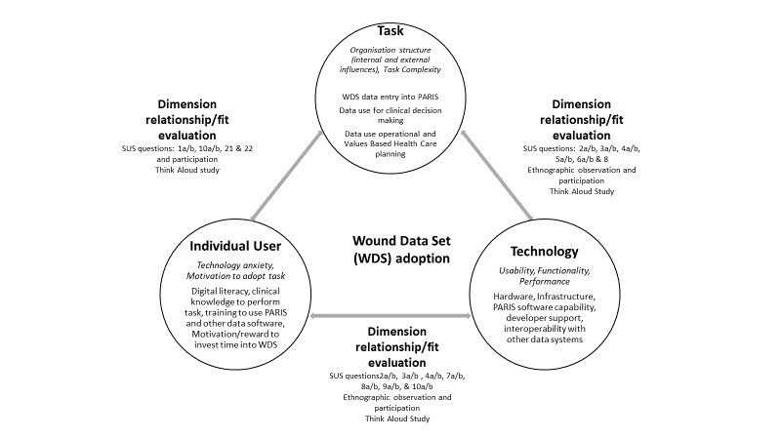

Ethnographic observations
The ethnographic observations were noted in a field note book. The observations were categorised and used to adapt the FITT framework for the Podiatry WDS. Figure 1 illustrates the specific dimension elements drawn from the ethnographic observations.
System Usability Scale (SUS)
Once the dimensions, attributes and elements were established, a pragmatic approach was adopted to understand the relationship or fit between the dimensions using both qualitative and quantitative data. The validated, System Usability Scale (SUS) (Brooke, 1996) was selected as one tool to evaluate the WDS in PARIS. The simple to understand, 10-statement questionnaire has been shown to have good face validity to measure usability of a system exploring elements such as training need, digital literacy and support, system functionality and usability Bangor et al, (2008).
When the statements examined as a whole the SUS survey allows an evaluation of the “Appropriateness to a purpose” (Brooke, 1996, pp1). Following further statistical analysis, Bangor et al. (2008) confirms the caveat of Brooke (1996) that the SUS statements should not be examined individually as confounding factors may skew the absolute truth. The results of their factor analysis indicate that sum of the SUS survey statements addresses a single concept: product usability.
The SUS statements have been allocated to each dimension fit (figure 1) as a gap analysis only, to understand if SUS could add knowledge to each of the FITT dimensions. The statements will not be analysed separately as recommended by Brooke (1996). A gap was noted in the fit between individual user and task. A decision was made to modify the SUS survey to add in questions 21 and 22 to add further knowledge to this fit regarding staff motivation to use the WDS. To establish whether barriers and facilitators were related to the PARIS system as a whole or just to the WDS, the SUS survey questions were asked twice: once in relation to PARIS system as a whole and again in relation to the WDS.

Figure 2.
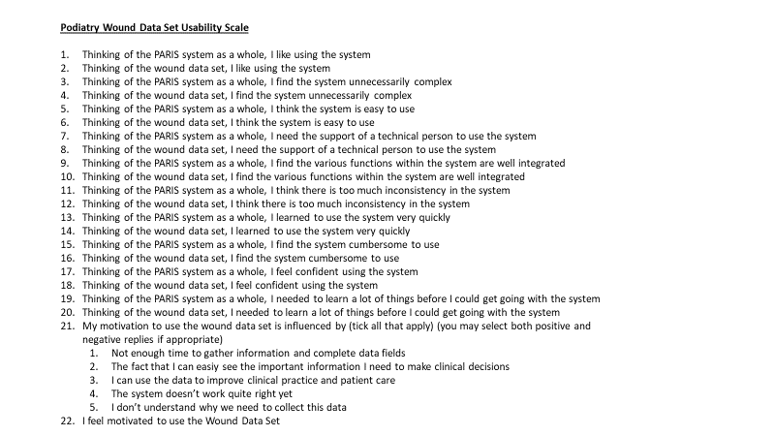

Think-aloud group study
Gov.UK (2021) suggest the use of think-aloud studies to understand user experience of a digital health product. They are beneficial to gain formative usability and experience knowledge whilst developing a product, or a formative/summative evaluation of a product in current use. Gov.UK (2021), recommend including information and activities to help to elicit thoughts and feelings within respondents about their interactions with the product. This study included an introduction to the health learning system model, interactive training on using the WDS and free discussion on its usability, and finally, the semi-structured group interview (Figure 3).

Figure 3.
Semi-structured interview question frame
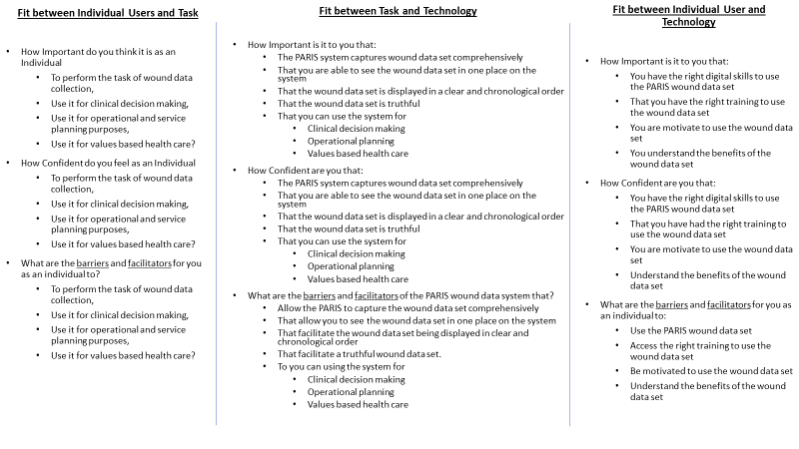
Wound Data Usage Report
The PARIS EHR system can create usage report using a Microsoft excel spread sheets, which enables data filters to be applied. This report can be used to understand how frequently podiatry wound staff use certain elements of the WDS, providing qualitative data on actual usability. It was used to identify how many patients registered with a wound taxonomy classification (A1) had a wound event recorded in the WDS. The wound event, vascular status, and wound offloading sections in the WDS contained the basic information for wound assessment, Vascular, Infection and Pressure (VIP) (NHS Wales 2018). Although none of the sections were made compulsory, staff were asked to complete them as minimum data entry since WDS go live on 6th Sept 2021.
A simple audit using a 10% sample (n=30) was performed on patient records with a recorded wound event (infection status is a mandatory element when recording a wound event) to see how many had a vascular status and a wound offloading intervention recorded in the WDS. The audit period was 6th Sept 2021 to 31 Jan 2022.
Recruitment, inclusion criteria and consent
Staff from the podiatry wound team were asked to take part in the WDS evaluation. All staff had been asked to use the WDS for the previous five months as part of the PARIS EHR documentation. All staff had a minimum of four years’ experience of using the PARIS EHR system.
The evaluation was a service improvement and did not require ethical approval. For best practice potential participants were issued with a participant information sheet, given at least 7 days to consider participation and asked to sign a consent form. Inclusion criteria were, qualified podiatrists who had completed their wound training competencies, had at least 1-year experience of using the PARIS EHR system and were running a wound clinic for the duration of the evaluation.
Data collection Methods
Once consent was gained, the participants were asked to complete the modified SUS survey using Microsoft Forms. The data was captured and processed in the associated excel spread sheet. Four participants agreed to being observed by the evaluator in the clinical environment. An ethnographical approach was used to observe data collection techniques for example; data usage for clinical decision making, usability barriers and facilitator, system adoption and workarounds, system functionality and system performance. Engagement with the clinician as kept to a minimum and field notes were taken with regards to the aforementioned.
Following these clinical observations, a 2-hour think-aloud group study was arranged using a Microsoft Teams meeting. In the first part of the study, the participants were given a presentation designed to motivate interest in the use of information/data to influence clinical practice. The presentation introduced the Learning Health System work by Foley et al. (2021) and described the benefits of linking practice to data, data to knowledge and knowledge to practice. Following the presentation, the PARIS WDS was worked through in a test environment on a shared screen. This was an interactive session, learning how to use the WDS to its maximum and discussing the collection and usefulness of the WDS in general for clinical decision-making purposes. After a 15-minute break, the results of the SUS survey were shared with the group along with the results of the WDS audit and new data elicited from the WDS to date. The final 45 minutes were used to consider the questions in the Semi-structured interview. These questions were used as a guide to elicit a free-thinking only and to ensure information was elicited for the 3 fit dimensions. When information was free flowing the questions were not used. Participants were encouraged to share thoughts, reactions, and emotions they felt whilst using the WDS, without justification or risk of reprisal.
Data analysis methods
The data from the think-aloud group study were analysed solely by the evaluator. This was done by replaying the think-aloud recorded Microsoft Teams session several times to capture the thoughts, comments, and conversations verbatim. These statements were allocated to the appropriate dimension fit: Individual, Task and Technology. From the raw data the WDS Fit themes (Table 2) were identified for further action to improve system usability and adoption of the WDS.
The SUS scores were processed according to the formula described by Brooke (1996). The PARIS scores were compared with WDS score to isolate WDS usability from the overall PARIS usability. Descriptive statistics were used to analyse the results and interpreted using the Adjective Rating Scale (Bangor et al. 2009). The final 2 questions from the modified survey were analysed using descriptive statistics and formed part of the Individual User Technology fit analysis. Wound Data Usage Audit is shown in Table 3, using simple descriptive statistics drawn from a preliminary WDS report from the PARIS system.

Results
All eighteen members of the wound team were invited to complete the survey and take part in the think-aloud group study. Fourteen team members (78%) completed the SUS survey, all data fields were mandatory therefore, no data were missing.
Four Podiatry wound team members (convenience sample) took part in the ethnographical observations. Fourteen team members took part in the SUS survey. Nine staff (50%) took part in the think-aloud group study, 5 were band 6 staff with a primary purpose of using the data for clinical decision making, 3 were band 7 with primary purpose of clinical decision making and secondary purpose of VBHC service improvement, and one participant was band 8a with the added purpose of using the data to inform operational needs.
Ethnographic observations
As previously stated the ethnographic observations were categorised and used to adapt the FITT framework to assist evaluation of the Podiatry WDS. The dimensions in Figure 1 lists the pertinent observational elements used to adapt the framework for the semi-structured interviews and adapted SUS survey. The results mirrored the attributes identified for each dimension noted by Ammenwerth et al. (2006) in their development and evaluation of the FITT framework through its evolutionary stages.
Modified SUS Survey
Table 1 illustrates the SUS results. The average SUS score for the PARIS system as a whole was 71, only 2 points higher than the WDS (69). However, the WDS demonstrated a smaller range (55 – 73) and standard deviation (10) compared to that of the PARIS system as a whole, 53 – 90 and 13, respectively. This trend was echoed in the interquartile ranges with the WDS doing marginally better (61.25 - 78.13) than the PARIS system as a whole (60.63 – 79.38).
Seminal work carried out by Brooke (1996) showed that SUS provided valid and reliable results using 20 of more respondents. SUS reliability and validity has been further heralded by Bangor et al. (2008) and Sauro (2011) with the latter suggesting that results are reliable with less than 20 respondents. The latter papers also express that the industry acceptable standard score for SUS is 68. Bangor et al. (2008 and 2009) successfully added an adjective rating to the SUS scale which allows a more collective understanding of the score meaning. In these studies, they were able to show how overall user-friendliness of a product could be described with adjectives such as Worst Imaginable, Good, or Excellent (Figure 4). Using this scale, the PARIS data as a whole and the WDS fall into the Good category (with scores of 71 and 69 respectively) but are slightly divided between the Acceptability Ranges of High and Low Marginal. If the non-validated Grade Scale is used, based on a university grade analogue, both SUS scores would border on a “C” grade.
Table 1: SUS Results for PARIS and Wound Data set
System | Average | Range | Standard Deviation | Quartile 1 | Quartile 3 | Interquartile Range
PARIS | 71 | 53 - 90 | 13 | 60.63 | 79.38 | 18.75
WDS | 69 | 55 – 73 | 10 | 61.25 | 78.13 | 16.88

Figure 4: System Usability Scale: Score, Adjective Rating, Grade scale and Acceptability comparison.
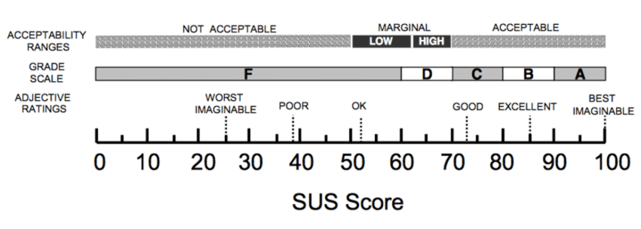
When using SUS to assist with the FITT framework evaluation of the WDS, a gap was noted between the fit of the Individual User and the Task around motivation of the user to use the WDS. As motivation is not specifically addressed in the SUS survey, 2 additional questions were added (Figure 2). Respondents were asked to tick all that apply regardless of whether they were a mix of positive and negative answers (Graph 1). No respondents selected option 5 (I don’t know why we are being asked to collect this data). This may lead to the assumption that all respondents understand the need to collect wound data, but caution should be exercised as respondents may have opted not to answer rather than select the response. Using a Likert scale may have given clarity to this issue. Encouragingly, 71% (n=10) of respondents selected option 2 and 3, seeing information to make clinical decisions and using the data to improve clinical practice and patient care as a motivation to use the WDS. Fifty percent (n=7) expressed motivation was depleted due to not having enough time to gather the data and 43% (n=6) expressed the system not working quite right as a demotivating factor.
Graph 1: Motivation to use the Wound Data Set

Graph 2 shows that overall 71% (n=10) respondents were positively motivated to use the WDS, whilst 14% (n=2) reported demotivation and 21% (n=3) selected the middle option (neither agree or disagree).
Graph 2: Motivation to use the Wound Data Set

Think-aloud Group Study
The themes arising from the think-aloud, semi-structured interview group are listed in Table 2. Overall, 11 themes were identified to be important sociotechnical considerations for the adoption of the WDS in the Podiatry team. It was noted that some of the themes could be associated with more than one fit, an example is motivation. Initially, motivation was thought solely to be associated with the fit between Individual Users and Task. These results have identified that motivation is also a factor in the fit between Individual User and Technology as individuals learn more about the importance of increasing their digital literacy to meet strategic and operational objectives. All but 1 theme require action to increase the adoption of the WDS in the Podiatry team; it was noted that hardware and infrastructure met the requirements to be able to use the WDS.

Table 2: FITT Themes for the Wound Data Set
FITT Themes for Wound Data Set
Fit Between Individual Users and Task | Fit Between Task and Technology | Fit Between Individual User and Technology
There is a realisation of the value of good data collection for clinical decision making. If it is to be done well, the stress and burden at clinic level needs to be adjusted operationally, getting the right balance between treating the patients and collecting data. | Data forms a narrative which can be interrupted by the differing sections of the PARIS system. A review is needed to address duplication of data, removing low yield data and system reliability to prevent loss of data | Training needs to be iterative and real time, with group learning and discussion to learn about data input and more importantly data extraction and usage.
Data is needed to map the complexity of the patients so that operational and strategic considerations can be evaluated and skills training implemented. | A consensus needs to be reached about recording multiple wounds on each foot and consistency in recording offloading data whilst keeping the narrative of the patient story. | Motivation to engage with the technology is growing as people discuss what really works for them. Regular feedback session on data usage and impact needs to be developed building knowledge, confidence, and motivation
Staff are more motivated to engage in the data section that relate to their portfolios. The Value of the data is higher for them. | Displaying the data in a chronological, easy to follow summary may help with the fragmentation and volume of data presented. | Digital literacy skills need to be addressed with the same value as clinical skills. Digital skills training should include computer literacy especially in SaaS (system as a Service) platforms (Microsoft) digitally supported service improvement and basic health informatics knowledge
There is still a gap between clinician knowledge and initiating a Learning Health System to drive values-based health care. |  | Hardware and infrastructure were noted as being much improved in recent years, a welcome relief to decreasing clinician stress.

Five system changes to the WDS in PARIS were identified to enhance usability. Firstly, to reduce duplication of work, data collected in the WDS that is needed for the annual diabetes foot assessment (ADFA) in another PARIS module, will be auto-populated on the ADFA if populated in the WDS first. Secondly, the end date reason for a wound episode will include an option for “Other” with a free text box to state reason. This will assist with coalescing, bridging, or diverging wounds. Thirdly, the number of data entries on the screen will be restricted to 2 or 1 per foot; a “show/hide other entries” toggle will be initiated to view all other entries. This will limit the amount of information overload experienced by clinicians. Fourthly, to prevent further data loss, the system stability will be addressed by the system developers.
Finally, a report button will be commissioned to display relevant information in a single, Portable Document Format (PDF) view. This can be used to provide “at a glance” information to be used for clinical decision-making during clinic, or in a multidisciplinary team (MDT) meeting. A change in process was identified relating to restricting data collection to the most significant wounds on each foot, negating the need to record the minor or satellite wounds, again reducing information overload.
The other themes identified are already aligned to the CAV UHB (2020) digital strategy and the Welsh Governments (2021) plan for a Healthier Wales. These will be presented to the Podiatry senior management team and addressed at regular team meetings and in staff personal development plans.
Wound Data Usage Reports
Using the PARIS reporting facility to evaluate WDS usage an audit was conducted for the period (06/09/21 – 31/01/2022). Following mandating the risk taxonomy in the WDS, the podiatry team were finally able to report accurately how many patients had foot wounds. There were 424 patients recorded as having A1 risk taxonomy which indicates an active foot wound. Of these, 293 patients (69%) had a wound event recorded in the WDS, 131 patients (31%) did not have a wound event recorded in the WDS.

Table 3: PARIS Report of Wound Data Usage
Wound Data Set Audit (06/09/21 – 31/01/2022)
10% sample (n=30) of patients with A1 risk taxonomy and with a Wound Data Event recorded (infection status was mandated in this section) (100% of initial Wound Data Events had a follow-up entry at subsequent appointments
Foot History/Health recorded including Vascular status  % (number) | Wound Offloading Intervention  % (number) | All 3 basic assessments  % (number)
43% (13/30) | 53% (16/30) Initial assessment completed  7% (2/30) Follow-up assessment completed | 43% (13/30)

Discussion
The use of the FITT framework, adopting a mixed method approach to evaluation has yielded key empirical and sociotechnical findings which may improve the adoption and efficacy of the WDS in the PARIS system.
Usability
The SUS results need to be reviewed with caution as there are less than 20 respondents, although the 14 respondents represented 78% of the team. It was useful to compare the PARIS system as a whole with the WDS as this separates out usability specifically relating to the WDS. Both scores reached the industry minimum standard for system usability of 68 with scores of 71 and 69 respectively (Grade C, Adjective Rating: Good). These results are encouraging when compared to results reported by Bloom et al. (2021) on the usability of electronic health records (EHR) in emergency departments in the UK. This study yielded a 19% response rate using SUS to evaluate usability of 25 EHRs and found that the median SUS was 53 (Grade F, Adjective Rating: OK/Good) with an IQR of 35 – 68. Included in their study was the Welsh Clinical Portal Patient Administration System (WCP PAS), also use by the Podiatry wound team. With 21 respondents the median SUS score for WCP PAS was 45 (Grade F, Adjective Rating: OK) (IQR: 30 - 63).
When the SUS scores are considered alongside the wound data usage report, there appears to be disparity between what clinicians are reporting in the SUS survey and what is actually being recorded in the WDS. The high usability score may indicate good adoption of the WDS but 31% (n=131) of A1 taxonomy patients did not have a wound event recorded. Furthermore, the WDS audit reported only 43% (n=13/30) of patients having all three basic assessments recorded in the WDS at the initial consultation. The audit did not record how many follow-up assessments recorded all 3 basic assessments in the WDS which would prove to be useful information for monitoring WDS adoption.
The question arising from the disparity of these two evaluative approaches is; if the WDS system usability is considered to be good then why are the staff not adopting it into practice?
Sociotechnical Considerations
FITT has provided a methodical framework to examine barriers and facilitators to the adoption of the WDS through the fit between each of its domains. Fit between Individual Users and Task revealed an emerging understanding for the
requirement of data to evidence the complexity of the patients being treated and to support individual portfolio work for VBHC. However, operational concerns were raised about the additional stress on clinical time and complexity that data collection causes, resulting in abandonment of the WDS. Tsiknakis and Kouroubali (2009) noted similar organisational issues; system implementations are accompanied by change in process, skills, and environment which can lead to low user satisfaction or non-adoption. Fit between Task and Technology revealed that although usability was regarded as good, there is still some technical improvements that can help users with duplication of data entry, information overload and display of the overall narrative of the patient history. Ammenwerth et al, (2006) also noted data duplication and system performance to be barriers in this domain fit. Furthermore, they identified system adaption to be problematic with some systems implementations. This was not a barrier for the WDS as PARIS offers an important level of adaptability to specific team needs. The fit between Individual User and Technology exposed the value and importance of group training and learning about data input and extraction of data. In particular was the need for knowledge about how to achieve a learning health system and VBHC using the WDS. Also noted was the need to supply digital literacy training for clinical staff.

The FITT framework provided a useful structure to examine the sociotechnical considerations relevant to the adoption of the WDS and was found suitable to provide both summative and formative evaluation of a small system implementation. Themes arising from the ethnographic observations were used to adapt the
framework for the evaluation of the WDS by providing elements to the dimensions.
This helped the clinicians understand better what is meant by the “fit” between
the domains, a concept some staff struggled to understand. Frameworks by Cresswell
et al. (2020) (Technology, People, Organisation and Macroenvironmental [TPOM])
and Greenhalgh et al. (2018) (Non-adoption, Abandonment, Scale-up, Spread and
Sustainability [NASSS]) offer greater guidance within each domain by providing the
user with elements or factors to consider. Whilst this is complex in the
NASSS Framework, the TPOM framework clearly outlines its factor dimensions and
supports them with a description. This may have helped elicit a greater richness and
depth to the think-aloud group session. TPOM provides the semi-
structured interview questions, which may standardise data collection across health
information systems. Both NASSS and TPOM take into consideration how the wider
contextual environment such as the organisational structure or political/professional
bodies affect the system implementation which may be a crucial factor missing
from the FITT framework.

By incorporating both qualitative and quantitative methods into the FITT framework, as demonstrated by O’Grady et al. a point in time evaluation was achieved with key learning themes identified. The process has the potential to be, inexpensively, repeated to measure any change elicited from the intervention work. This is a recommendation of a systematic review by Kirk et al. (2016) of the Consolidated Framework for Implementation research (CFIR). They concluded that CFIR (a software implementation framework) should be utilised at phases of design and implementation as well as post implementation, specifically to link implementation determinants to intended product outcomes.

PARIS Wound Data Set: Value and Limitations
Eleven themes were identified using the framework in the wound team relating to the barriers and facilitators to adopting the WDS (Table 2). Whilst time factors, digital literacy, and knowledge of using aggregated data to influence VBHC were noted in the work as needing support, there was an acceptance that understanding the knowledge from the data collected in the PARIS system would be instrumental in changing clinical practice. Whilst the display of the data needs refining most podiatrists reported that the WDS assisted in clinical decision making and the SUS data suggested usability was good, with minor difference noted between the PARIS system as a whole and the WDS (Table 1).
One major theme that was not picked up by the FITT framework was that automated interoperability between systems would reduce the time spent manually assembling WDS in PARIS and would serve to drive forward VBHC which is reliant of aggregated data (Daniel et al. 2016). This theme may have been identified by using the TPOM framework (Cresswell et al. 2020) or the NASSS framework (Greenhalgh et al. 2018) as these frameworks explore in more detail the organisational structure and macro-environmental/wider system factors. This was a limitation of using the FITT framework.
The WDS has been established as fundamental data to provide clinical and operational decision-making information in foot wound care, with each patient interaction providing the opportunity, through a learning health system, to influence VBHC. The true potential impact on healthcare can only be realised when data can be exported seamlessly into an NDR and used for VBHC. For such data integration, data interoperability needs to be supported with data standardisation and semantics. Whilst PARIS, in its most up-to-date version will embrace SMOWMED CT coding, the infrastructure maturity, governance and strategy needed to negotiate health data interoperability challenges sits outside of the FITT framework but remains a significant hurdle to be overcome.
The Podiatry WDS in the PARIS system, whilst in its infancy, is limited in its impact on VBHC to the CAV UHB podiatry team. However, the PARIS system is supported by adaptive, progressive, and reforming local and national digital strategies and will be ready to contribute to the NDR once interoperability is mastered, making production of predictive and preventative health algorithms a future possibility.
Once fully adopted, the WDS has the potential to provide knowledge on antimicrobial stewardship and supporting independent prescribing solutions (NICE Guidelines, 2015). It will inform best practice for clinical interventions such as evidencing the most effective wound offloading techniques. It will collate important decision-making information to support and engage in consultant led clinics as well as feeding data to the National Diabetes Foot Audit (NHS Digital, 2019) through connector technology. It has the capability for providing evidence to support valuable research funding applications and inform root cause analysis for lower limb amputations, as well as informing operational planning and clinical decision making.
Other limitations of this work are the validity and reliability of the qualitative data collection techniques and theming of the results. These have been conducted within the time restraints of the study presented.
Conclusion
The FITT framework has been adapted to provide a summative and formative evaluation of the WDS adoption in the podiatry team. Using a mixed methods approach, eleven sociotechnical themes addressing barriers and facilitators, specific to the Podiatry wound team, have been identified which will support the most efficient adoption of the WDS into practice. Whist the FITT framework identified important knowledge to support the WDS implementation, it did not identify the importance system interoperability, data semantics and the need for open architecture, which will ensure the widest impact of the WDS.

References

Ammenwerth, E. Iller, C. and Mahler, C. (2006). IT-adoption and the interaction of task, technology, and individuals: a fit framework and a case study. BMC Medical Informatics and Decision Making 6 (3) pp. 1-13. doi: 10.1186/1472-6947-6-3
Bangor, A., (2008). An Empirical Evaluation of the System Usability Scale. International Journal of Human Computer Interaction. 24 (6) pp. 574-594 Doi: 10.1080/10447310802205776
Bangor, A., Kortum, P. and Miller, J. (2009). Determining What Individual SUS Scores Mean: Adding an Adjective Rating Scale. Journal of Usability Studies. 4 (3) pp. 114-123 doi: 10.5555/2835587.2835589
Bloom, B.M., Pott, J., Thomas, S., Gaunt, D. R. and Hughes, T. C. (2021). Usability of electronic health record systems in UK EDs. Emergency Medicine Journal. 38, pp. 410-415. Doi:10.1136/emermed-2020-210401

Brooke, J. (1996). SUS: a “quick and dirty” usability scale. In: Jordan, P. W, Thomas, B. Weerdmeester, B.A, and McClelland, I.L. eds. Usability Evaluation in Industry. London: Taylor and Francis, pp. 189-194. doi: 10.1201/9781498710411
Cardiff and Vale University Health Board. (2020). Delivering Digital Building a learning health and care system A Five Year Strategy. Available at: Delivering Digital Building a learning health and care system A Five Year Strategy (nhs.wales) [Accessed 13/02/2022]

Cresswell, K, Williams, R. and Sheikh, A. (2020). Developing and Applying a Formative Evaluation Framework for Health Information Technology Implementations: Qualitative Investigation. Journal of Internet Research 22 (6) e15068. doi: 10.2196/15068
Daniel, C., Ouagne, D., Sadou, E., Paris, N., Hussain, S., Jaulent, M.C., and Kalra, D. (2016). Cross border semantic interoperability for learning health systems: The EHR4CR semantic resources and services. Available at: Cross border semantic interoperability for learning health systems: The EHR4CR semantic resources and services - Daniel - 2017 - Learning Health Systems - Wiley Online Library (Accessed: 02/02/2022) doi.org/10.1002/lrh2.10014

Digital Health Wales. (2022). National Data Resource. Available at: National Data Resource | Digital Health Wales [Accessed 01/03/2022]

Eason, K. (2007). Local sociotechnical system development in the NHS National Programme for Information Technology. Journal of Information Technology 22 (3), pp. 257–264. doi: 10.1057/palgrave.jit.2000101.
Foley, T. Horwitz. L. and Zahran, R. (2021) Realising the Potential of Learning Health Systems. Available at: LHS2021report.pdf (learninghealthcarEHRoject.org) [Accessed 14/02/2022]
Gov.UK. (2021). Think aloud study: qualitative studies: How to use a think aloud study to evaluate your digital health product. Available at: Think aloud study: qualitative studies - GOV.UK (www.gov.uk) [Accessed 15/02/2022]
Greenhalgh, T. et al. (2018). Analysing the role and complexity in explaining the fortunes of technology programmes: empirical application of the NASSS framework. BMC Medicine 16 (1), pp.66. doi: 10.1186/s12916-018-1050-6
Kirk, M. A, Kelly, C, Yankey, N, Birken, S. A, Abadie, B. and Damschroder. L. (2016). A systematic review of the use of Consolidated Framework for Implementation Research. Implementation Science 11 (1), pp.72. doi: 10.1186/s13012-016-0437-z
NHS Digital. (2019). National Diabetes Foot Care Audit Fourth Annual Report England and Wales 01 April 2015 to 31 March 2018 Available at: PowerPoint Presentation (hqip.org.uk) [Accessed 14/02/2022]
NHS Wales. (2018). All Wales Best Practice DFU Pathways and Standards of Care: A VIP Approach. Available at: DFU-Standard-Of-Care-VIP-Approach_All-Wales.pdf (weds-wales.co.uk) [Accessed 02/02/2022]
NHS Wales. (2022). Welsh Value in Health Centre: Our Strategy. Available at:
https://vbhc.nhs.wales/files/our-strategy-to-2024/ [Accessed: 12/02/2022]

NICE Guidelines, (2015). Antimicrobial stewardship: systems and processes for effective antimicrobial medicine use: NICE guideline [NG15]. Available at:
Overview | Antimicrobial stewardship: systems and processes for effective antimicrobial medicine use | Guidance | NICE [Accessed 28/02/2022]
O’Grady, M.A., Kapoor, S., Gilmer, E., Neighbors, C. J., Conigliaro, J., Kwon, N. and Morgenstern, J., (2019) Point-of-Care Mobile Application to Guide Health Care Professionals in Conducting Substance Use Screening and Intervention: A Mixed-Methods User Experience Study. ACI Open. 3 e1–e12 DOI https://doi.org/ 10.1055/s-0039-1684002.

Sauro, J. (2011). A Practical Guide to the System Usability Scale: Background, Benchmarks and Best Practice. Denver: Measuring Usability LLC.

Scott, P.J. (2016). Mixed Methods: A Paradigm for Holistic Evaluation of Health IT. In: Ammenwerth, E. and Rigby, M. Evidence-Based Health Informatics. E-book: IOS Press pp.102-113 doi:10.3233/978-1-61499-635-4-102
- Tsiknakis, M. and Kouroubali, A. (2009). Organisational factors affecting successful adoption of innovative eHealth services: A Case study employing the FITT framework. International Journal of Medical Informatics. 78 (1) pp. 39- 52 doi: 10.1016/j.ijmedinf.2008.07.001

Wachter, R. (2016). Making IT work: Harnessing the Power of Health Information Technology to Improve Care in England. Available at: https://www.gov.uk/government/publications/using-information-technology-to-improve-the-nhs/making-it-work-harnessing-the-power-of-health-information-technology-to-improve-care-in-england (Accessed: 05/01/2022)
Welsh Government. (2015). Informed Health and Care: A Digital Health and Social Care Strategy for Wales. Available at: A Digital Health and Social Care Informed Heath and Care; A Digital Health and Social Care Strategy for Wales (gov.wales) [Accessed 13/02/2022]

Welsh Government. (2021). A Healthier Wales: our Plan for Health and Social Care. Available at: A Healthier Wales (gov.wales) [Accessed 14/02/2022]

Yusof, M. M., Papazafeiropoulou, A., Paul, R. J. and Stergioulas, L. K. (2008). Investigating evaluation frameworks for health information systems. International Journal of Medical Informatics 77 (6) pp. 377-385. https://doi.org/10.1016/j.ijmedinf.2007.08.004

