Greenwashing in hotel Industry: Accor Group

Student: Monica Roman
Student id: 2128507
Module: BMIH5006 Sustainable Hospitality & Tourism Management
Lecturer: Kathryn Roberts

Contents
Executive Summary 3
Introduction 4
Overview of Accor 5
Greenwashing, Whitewashing 6
Focus on Energy Efficiency and Renewable Energy 8
Responsible Sourcing and Waste Management 8
Community Engagement and Education Initiatives 9
Self-evaluation or third-party evaluation? 9
Conclusion 10
References 11

Executive Summary
This report gives an outline of Accor Group’s commitment to sustainability and its Corporate Social Responsibility strategy and how these are implemented to tune in with the current trends in the hotel industry. Climate and environmental challenges have urged companies to implement measures that address these issues, helping create ethical business that protects the environment and communities they operate in. But because sometimes it is much easier to pretend doing good things rather than genuinely doing them, some companies use deceitful PR and advertising tools to create the false impression, a process called greenwashing. According to Greenpeace (2023) the past few years can be noted in history as “The golden age of greenwashing” as so many companies have been caught in the wrong. This report sheds light on Accor’s sustainability efforts and results, but also shows that while doing good things they also use deceptive tactics, charging customers hidden junk fees. The work proves how important transparency and honesty in business are, and how they can create success, or the lack of them cause major losses for the companies and stain their brand image and reputation.

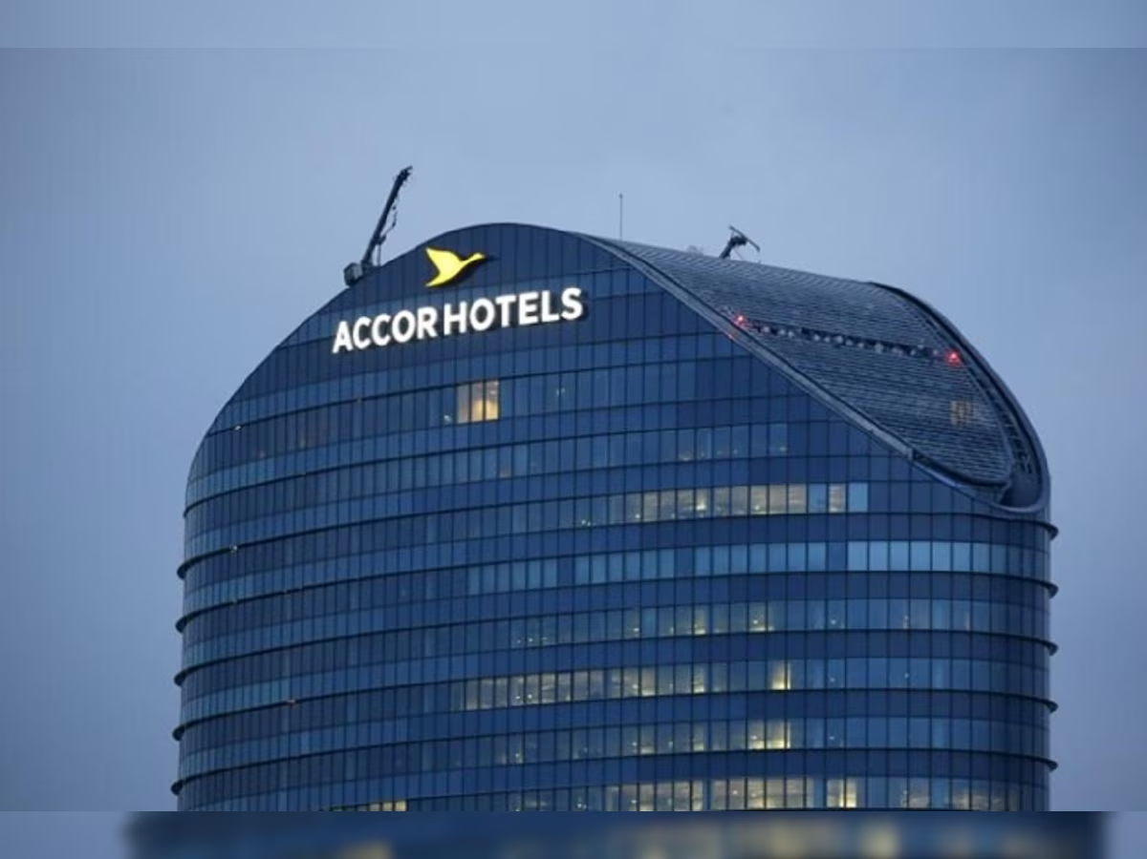
1.(DNA India)

Introduction
The concept of sustainability has become a very important aspect of current globalised and environmentally conscious society, influencing various industries, like hospitality and tourism. Hospitality as industry has a major impact on the global environment through carbon emissions, waste, water and energy usage. As per United Nations World Travel Organization, 1% of the global emissions are attributed to hospitality (UNWTO, 2023) and this is the reason why the industry has recognised the importance of reducing its environmental impact. Investing in sustainable solutions that will meet consumer demands will enhance guest experience and result in benefits for the company and create positive changes in society and the environment. Accor group has been one of the pioneers of sustainability in the hotel industry. The objective of this paper is to carry out a detailed analysis of how Accor Group has introduced sustainability commitments in its Corporate Social Responsibility policy. Sustainability, in terms of Brundtland Commission (1987), means to “fulfil current needs without compromising the capability of future generations to fulfil their own requirements”. Sustainability in tourism means that there is a need to maintain socio-cultural aspects, economic viability, and environmental conservation (Lindgreen and Swaen, 2010). The circular economy aims to reduce waste and optimise resource efficiency by promoting recycling, reuse, and regeneration to extend the lifespan of resources. But since climate crisis and sustainability issues have raised awareness, and people demand ethical solutions, businesses have to align their operations to this trend. Instead, many companies have decided to be green and look good, but only on paper: by greenwashing, they aim to convince us they are doing the right thing, but they are only boosting their image and sales by misleading consumers (Greenpeace, 2022). According to Montgomery, Lyon and Barg (2023) “greenwashing is more virulent than ever” as consumers are bombarded with misleading claims of “zero waste”, “net zero emissions”, “sustainably sourced” and other green credentials. The number of news articles related to greenwashing has increased from 300 a year to over 2000/year in 2021, culminating with Greta Thunberg calling the COP26 conference “a greenwash festival” (BBC Scotland, 2021).

Overview of Accor
Accor Hotels is one of the big players in the hospitality industry offering over 40 brands in all segments of the market. With over 5000 hotels spread across the world, in more than 100 countries, Accor is constantly reinventig itself in order to meet the evolving needs of guests, delivering new and unique experiences to create value and increase brand image and performance of the group.
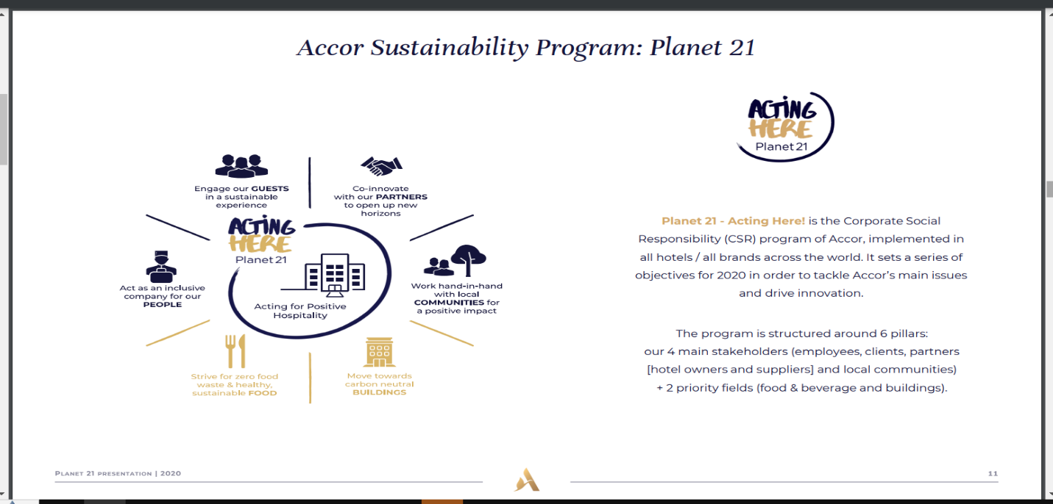
- Accor Hotels (2020)
AccorHotels were among first to commit to a sustainable hospitality development, in early 1990s, when they set up a sustainability department. In 2012 they launched PLANET 21, the group’s commitment that encompasses 21 objectives related to waste, water and energy resources management, responsible procurement, diversity, local sourcing, health and wellbeing. It is an ambitious initiative that involves both stakeholders and employees, but guests as well. As a constantly evolving initiative, Planet 21 allows Accor to learn from present challenges and trends and help them prepare for future ones. Such a framework gives Accor the opportunity to measure sustainability performance and use results to improve it (Accor, 2020). Legrand et al. (2022) argue that this holistic approach includes different actions with the objectives of decreasing the adverse effects it has on the environment, ensuring social accountability, and generating economic growth. Applying principles of the circular economy, Accor shows its intention to transform traditional business models and move towards a more sustainable and green future (Jauhari, 2014).
Accor's relentless commitment to sustainability is ensured through its disciplined process of responsible procurement and waste management practices stated in PLANET 21(Misso et al., 2018). Local and organic produce mark the company's responsible sourcing. This is meant to help grow local economies and minimise emissions from transport (Jones et al., 2014). Furthermore, by designing for resource efficiency and localisation, the principles of circular economy are followed within the design, along with Accor's commitment to sustainability at the value chain. Food waste accounts for over 40% of the operating refuse, with each hotel generating around 20 tonnes of waste per year (Accor, 2023). Accor is working to implement a more sustainable food system to drastically reduce waste, using AI technology. Several other programs need to be implemented across all hotels, such as waste segregation, composting, and recycling (Lockyer, 2013). Accor's waste management initiative is an example of forward-looking ideas enabling increased resource effectiveness and reduced waste production across business units and minimising carbon footprint.

Greenwashing, Whitewashing
“Greenwashing is a PR tactic used to make a company or product appear environmentally friendly, without meaningfully reducing its environmental impact” (Greenpeace, 2022). As Accor has started its sustainability journey over forty years ago, it could be argued that they were genuinely interested in making a difference. Even so, their Plant for the planet project (part of Planet21 ESG strategy) could be viewed as greenwashing. Partnering with Pur Project in this initiative, Accor has commited to plant 10 million trees by the end of 2021. The program encourages guests to reuse their towels and linen during long stays, and in return, Accor will donate half of the savings (water, energy, detergents) to plant trees, aiming to reduce their environmental footprint (Accor, 2019). Initially a reforestation program, Plant for the planet has evolved into agroforestry projects, where trees are planted on agricultural land to improve its productivity and help with conservation. Nowadays, Accor sources produce from farmers that have benefited from this project and items are used in the hotels’ restaurants, while guests are aware that their civic gestures have improved local communities and helped the environment. The latest data offered by Accor in 2020 shows that Plant for the Planet has achieved the plantation of over 7 million trees (Accor, 2020). The initial target of the Plan was planting 10 million trees by 2021, but it could be argued that Accor could not achieve this due to the Covid pandemic.
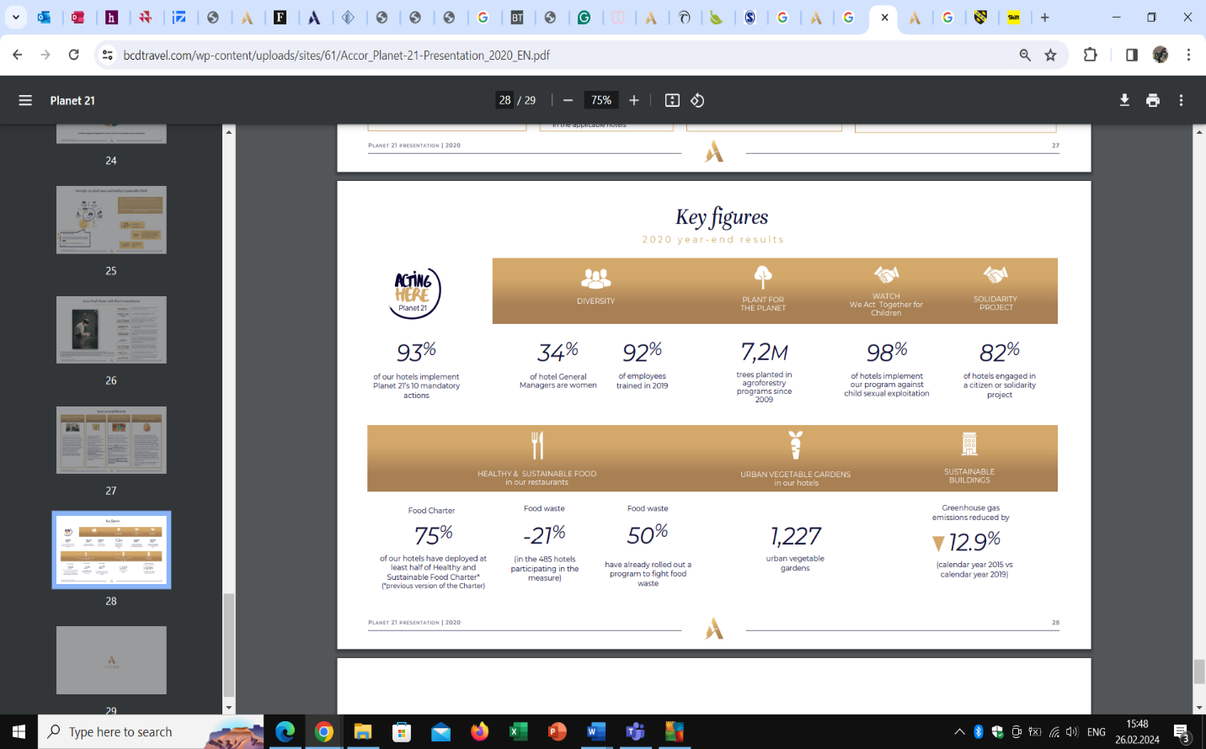
- Key figures (Accor, 2020)
‚Whitewashing’ is when a company is covering up bad incidents with the intention of maintaining its reputation. For Accor, an instance of whitewashing could be the class-action law suit filed in December 2023 by consumer advocacy group Travelers United at Washington D.C. Superior Court (Tycko and Zavareei, 2023). The hotel group is accused of charging its customers junk fees, called „resort” or „destination” fees, which are illegal. Hilton, Mariott, MGM Resorts, Hyatt and Sonesta Hotels have faced similar accusations before Accor. According to Travelers United, junk fees practices as Accor’s exceed two billion dollars annualy in the hotel industry.
.

Focus on Energy Efficiency and Renewable Energy

Energy efficiency and the use of renewable sources are two interconnected dimensions of sustainability of an organisation’s comprehensive CSR plan (Legrand et al., 2022). For Accor, more than 70% of their carbon emissions come from the hotels’ energy consumption. Because of this the group has focused on designing low energy buildings, measure energy usage to see where can be improved and find ways to create green energy (Accor, 2022).
Accor is committed to reducing energy consumption and using renewable energy from their various projects and introduce energy efficiency as a design standard in their hotels. Installing smart thermostats, energy management systems, LED lighting, energy efficient TVs in the room and using automatic shut-off systems for equipment not in use both in the rooms but also back of the house, proves Accor’s (2022) commitment to energy efficiency. Some hotels have roof gardens that ensure a better heat insulation. Accor is constantly looking to creating on-site renewable energy, trading through solar and other sustainable energy projects (Kumar and Sharma, 2014). The use of renewable energy helps lessen its environmental impact and creates a move to a low-carbon economy (Jones et al., 2014). Renewable energy sources are in with the circular economy's tenets because they promote responsible resource management and reduce the burden on finite fossil fuel supplies (Inkson & Minnaert, 2022).

Responsible Sourcing and Waste Management
Through its Healthy and Sustainable Food Charter, Accor encourages a healthy diet and fights food waste. The group is striving to promote sustainable sourcing and it’s proud to engage their supply chain and make them commit to sustainable practices, preserving regional eco-systems and biodiversity (Accor, 2022). Embracing the “farm to fork” model, Accor are working on sourcing food more responsibly, locally wherever possible, thus reducing environmental footprint and ensuring freshest food for guests to enjoy. Over one thousand Accor hotels have their own “urban gardens” where they grow vegetables and spices used in dishes. Accor banned endangered fish species from their menus and is working towards fully sourcing free-range eggs for the hotels.
With a high focus on food waste reduction, at Novotel London, for example, AI technology is used to monitor food waste: Winnow is a computerised AI system which identifies, measures and notes details of food about to be thrown away and chefs can use data to re-think menus. Implemented in 2022, Winnow helped reduce food waste by 45% at Novotel London (Accor, 2023). Guests are also educated to develop eco-conscious eating habits by consuming local and seasonal food. In Europe, meal leftovers and breakfast buffet food are sold on the Too Good to Go app, reducing waste and creating additional revenue for hotels (Accor, 2020).

Community Engagement and Education Initiatives
Accor focuses on community engagement and education as part of its CSR. These initiatives work towards creating a collaborative and long-term attitude among all partners (Onoufriou, 2020). Accor forms partnerships with local community groups and schools where the environmental issues awareness is spread out, and people are encouraged to live sustainably (Misso et al., 2018). The staff volunteerism, environmental education and community engagement projects allow Accor employees to affect communities positively. Accor places emphasis on awareness and educational activities, because they enable the company to build stronger connections with stakeholders and promote a sustainable culture (Jones, Hillier, & Comfort, 2014). Through All Heartist Fund and Accor Heartist Solidarity, Accor hotels engage in citizen or solidarity projects helping individuals, vulnerable people, and communities in need, giving access to training and employment (Accor, 2023).
Accor is committed to social resposibility, environmental stewardship, and long-term economic success with sustainability in all operations. Therefore, Accor becomes a benchmark of sustainable business practices in the hotel sector and serves as a model for responsible corporate behaviour.

Self-evaluation or third-party evaluation?
Businesses have to make transparency and authenticity as priorities in their marketing initiatives to avoid greenwashing (Wu et al., 2020). Consumers need to be provided with substantiated information, and the organisation has to obtain credible certifications and should involve stakeholders to endorse integrity and transparency. Companies self-evaluate on annual bases, at least, in order to observe goals achievement, accomplishments, employee engagement and satisfaction. This process may not be as accurate or true, as companies might only mention achievements, but hide incidents that could damage their reputation. For better transparency, companies should use third party evaluations, as they can offer an unbiased, objective evaluation. Accor issues sustainability reports on annual basis with information including the performance measures of environmental parameters such as energy use, waste management programs and carbon emission reductions. For better transparency regarding their environmental journey, in 2023 Accor have partnered with key sustainable certification programs, Green Key and Green Globe to obtain sustainability accreditations, while for Australia and New Zealand have entered partnership with Ecotourism Australia (Accor, 2023). In Canada and US, Accor collaborates with Green Key Global. The standards of these partners are recognised by the Global Sustainable Tourism Council. They conduct an independent, third-party audit of hotel practices assessing companies through the three pillars of sustainability. Accor is hoping to have all its hotels eco-certified by 2026.

Conclusion
In summary, Accor’s comprehensive CSR strategy clearly shows the company’s commitment to sustainability. This reinforces the fact that hospitality is a major actor when it comes to ensuring social responsibility and environmental awareness globally. Accor has set high goals for its sustainability journey and seems on track with its achievements. Without being accused of it, some of Accor’s actions could be classed as greenwashing and whitewashing. To show transparency and honesty, Accor has partnered with reputable Green partners to help eco-certify their hotels and combat possible accusations. Nevertheless, one needs to understand that though the efforts being made towards greenwashing are a good thing, harbouring some risks is also quite logical in the case of hotel industry (Parguel et al., 2011).

References
Accor (2023) Accor collaborates with key sustainable certification programs. Available at: https://press.accor.com/accor-collaborates-with-key-sustainable-certification-programs/?lang=en (Accessed: 22 February 2024).
Accor (2019) Accor Planet 21 [PDF]. Available at: https://accorhotelscomms.com/newsletter/luxe/2019/issue_02/spotlight-pdfs/Accor-Planet21.pdf (Accessed: 20 February).
Accor (2024) Leave your footprint: SCR Activities. Available at: https://www.accorhotelscomms.com/leaveyourfootprint/csr-activities/ (Accessed: 20 February).
Accor (2022) The business of travel [PDF]. Available at: https://static1.squarespace.com/static/61de9ccd0490754911091999/t/62e3d1616f22de1688dd6090/1659097447195/ACCOR_The_Business_Of_Travel_Report_2022_FV.pdf (Accessed: 19 February).
Accor (2022) Accor CDP Climate [PDF]. Available at: file:///C:/Users/User/Downloads/Accor_CDP_Climate_2022.pdf (Accessed: 25 February 2024).
Batabyal, D. (2018) Managing Sustainable Tourism Resources. IGI Global. Available at: https://books.google.co.uk/books?id=nCpbDwAAQBAJ&printsec=frontcover#v=onepage&q&f=false (Accessed:21 February 2024).
BBC Scotland (2021) News: COP26 ‘A global north greenwash festival’. Available at: https://m.facebook.com/bbcscotlandnews/videos/6469915399745972/ (Accessed: 25 February 2024).

BCD Travel (202) Accor Planet 21 [PDF]. Available at: https://www.bcdtravel.com/wp-content/uploads/sites/61/Accor_Planet-21-Presentation_2020_EN.pdf (Accessed:22 February 2024).
Bloomberg (2021) https://www.bloomberg.com/news/articles/2021-09-01/regulatory-scrutiny-of-esg-greenwashing-is-intensifying?leadSource=uverify%20wall (Accessed:25 February 2024).
Brundtland Commission (1987) Our Common Future. Oxford: Oxford University Press.
Chen, J., Sloan, P. and Legrand, W. (2010) Sustainability in the hospitality industry. Routledge.
DNA India (2018) Business report. Available at: https://www.dnaindia.com/business/report-interglobe-accorhotels-jv-earmarks-another-rs-900-crore-for-ibis-hotels-2573824 (Accessed: 28 February 2024). Image 1.
Dubai World Trade Center (2023) Industry insights: Sustainable luxury at what cost. Available at: https://www.dwtc.com/en/industry-insights/sustainable-luxury-at-what-cost/ (Accessed: 20 February 2024).
Ecologi (2024) How can Businesses avoid greenwashing [blog]. Available at: https://ecologi.com/articles/blog/how-can-businesses-avoid-greenwashing (Accessed: 21 February 2024).

Ellen MacArthur Foundation (2022) Circular Economy. Available at: https://www.ellenmacarthurfoundation.org/circular-economy/concept (Accessed: 15 February 2024).
Cherry, M.A., 2013. The law and economics of corporate social responsibility and greenwashing. UC Davis Bus. LJ, 14, p.281.
Graziano, H., 2021. Responsibility and Sustainability in International Hotel Chains. In Tourism in the Mediterranean Sea: An Italian Perspective (pp. 143-166). Emerald Publishing Limited.
Greenpeace (2022) What is greenwashing. Available at: https://www.greenpeace.org.uk/news/what-is-greenwashing/ (Accessed:23 February 2024).
Holloway, C.J. and Humphreys, C. (2022) The business of tourism. 12th edition. New York: Sage Available at: https://books.google.co.uk/books?id=iT2HEAAAQBAJ&lpg=PT13&ots=2Ql4P3x-El&dq=Holloway%20and%20Humphreys%20The%20environmental%20impacts%20of%20tourism&lr&pg=PT27#v=onepage&q=Holloway%20and%20Humphreys%20The%20environmental%20impacts%20of%20tourism&f=false (Accessed: 21 February 2024).
Inkson, C. and Minnaert, L. (2022) Tourism management: an introduction. Sage.
Jauhari, V. (2014) Managing sustainability in the Hospitality and Tourism Industry: Paradigms and Directions for the Future. CRC Press.
Jayawardena, C., et al. (2013) Trends in the international hotel industry. Worldwide Hospitality and Tourism Themes, 5(2), pp.151-163.
Jones, P., Hillier, D. and Comfort, D. (2014) Sustainability in the global hotel industry. International Journal of Contemporary Hospitality Management, 26(1), pp.5-17.
Kumar, R. and Sharma, S. (2014) Corporate social responsibility-A study on hotel industry. Asian Journal of Multidisciplinary Studies, 2(4), pp.25-32.
Legrand, W., Chen, J.S. and Laeis, G.C. (2022) Sustainability in the hospitality industry: Principles of sustainable operations. Taylor & Francis.
Lindgreen, A. and Swaen, V. (2010) Corporate social responsibility. International journal of management reviews, 12(1), pp.1-7.
Lockyer, T.L. (2013) Global cases on hospitality industry. Routledge.
Misso, R. et al. (2018) Sustainable development and green tourism: New practices for excellence in the digital era. Journal for International Business and Entrepreneurship Development, 11(1), pp.65-74.
Montgomery, A. W., Lyon, T. P. and Barg, J. (2023) No End in Sight? A Greenwash Review and Research Agenda. Organization & Environment, 0(0). Available at: https://doi.org/10.1177/10860266231168905 (Accessed: 24 February 2024).
Onoufriou, N. (2020) Learning from sustainability practice: case examples from Accor, Scandic and Atlantica. Available at: https://www.researchgate.net/publication/343550298_Learning_from_sustainability_practice_case_examples_from_Accor_Scandic_and_Atlantica (Accessed: 24 February 2024).
Parguel, B., Benoît-Moreau, F. and Larceneux, F. (2011) How sustainability ratings might deter ‘greenwashing’: A closer look at ethical corporate communication. Journal of business ethics, 102, pp.15-28. Available at: https://hal.science/hal-00654101/ (Accessed: 24 February 2024).

Tycko and Zavareei LLP (2024) Accor junk fees class action. Available at: https://www.tzlegal.com/news/accor-junk-fees-class-action-filed/#:~:text=The%20lawsuit%20alleges%20that%20Accor,advertised%20price%20of%20the%20rooms (Accessed:20 February 2024).

Wu, Y., Zhang, K. and Xie, J. (2020) Bad greenwashing, good greenwashing: Corporate social responsibility and information transparency. Management Science, 66(7), pp.3095-3112.

