Kristisha Downer-Thomas (2010177)
2010177@student.uwtsd.ac.uk

Module: Changemakers: Building your Personal Brand for Sustainable Employment
Module code: BMHP5015_BIRM
Lecturer: Dr Mark Gallagher-Read
E-Portfolio

Task 1 -: Cover letter for job based on plans for the future.
Kristisha Downer – Thomas
64 Alicante close, Canada,
C58 BNU

09 February 2022

FAO: HR Manager
University of Wales Trinity Saint David (UWTSD)
Birmingham Learning Centre
Spark Hill Centre
636A Stratford Rd
B11 4AR

Dear Dr Gallagher-Read

Re: Entry Level Nurse, registered nurse or Student Nurse.

This cover letter has been written with the intention of applying for a future job within the health and social care, NHS sector whether that be for e.g., entry level nurse, registered nurse, or student nurse position.

Having previously worked in this environment as a health care assistant looking after elderly clients that suffer from diagnosis such as dementia, mental illness, and physical illness with challenging behaviour in a private care home I feel that I would be an ideal employee/candidate for your company as I am eager to further my career pathway in health and social care. As a newly graduated student from the UWTSD University my experience and newly acquired knowledge would make me an essential asset to your company. The qualities I possess are being creative, enthusiastic, with a fierce passion for customer service, being industrious, keen, confident, curious, and flexible, these attributes and using my initiative at any given time enables me to work effectively in a team and alone whilst also prioritising tasks and working well under pressure. My organisational skills and being able to communicate on all levels with people from all types of backgrounds providing a quality personal centred care approach, my aim is to ensure all targets and requirements are met and to quality standard
My abilities of being capable to quickly adapt to new systems, surroundings, ethical backgrounds, and beliefs I believe I am open minded and focused, with my willing attitude, thirst for knowledge this would also be applied to any NHS or health and social care nursing duties.
Considering myself to be dynamic and a social chameleon enables me to adequately cope with diverse situations, I am not afraid of being wrong or being corrected as I always want to learn and be shown the correct way to enhance my skills, with these skills the aim is to effectively apply innovation whether independently or in a team setting, promoting a high standard of care to individual’s lives.
Having worked in the private health and social care industry, for 6 plus years, which can be fast paced and challenging at times. My role involves caring for challenging behaviour adults that suffer from, e.g., dementia, Parkinson’s disease, mental health issues or drug abuse. In this current role It is essential to make sure that all patients are safe and treated with compassion, dignity, respect and as individuals with a personal centred care approach. The current job role also includes providing personal care to those patients whether that be washing/cleaning, feeding patients or just being there as a listening ear or a shoulder to cry on, also having to communicate accurate information to and from staff, nurses, clients and client’s family members so that requirements are met safely and information is correctly documented and communicated to intended individuals, ensuring family members are kept up to date with necessary information enabling them to be able to voice their concerns/issues or different arrangements. Having participated in training provided by my employer I'm able to carry out my role in the safest, effective way possible, Training involved such as manual handling, first aid, fire safety, infection control is priority as it ensures I am adhering to the Health & Social Care Act and legal requirements of the private care home.

Thank you for taking the time out to review my credentials, if successful, I look forward to hearing from you and joining your wonderful team. However, in the unfortunate event that my application is not successful on this occasion I would sincerely appreciate if you would keep my details on your file.

Yours faithfully

Miss Kristisha Downer-Thomas
Task 2 -: Health and social care CV. (My perfect CV, 2022) (My perfect CV, 2022)
Kristisha Downer – Thomas
64 Alicante close, Canada,
C58 BNU
07456726231
Professional summery -:
Health care assistant with 6+ years of experience
Thrives on compassion and care for all ages with diverse backgrounds, beliefs and diverse challenges or behaviour. Worked with adults and younger children in previous jobs in a health and social care setting, also Certificate in Higher Education: Skills for the Workplace (Health and Social Care) level 4 qualification and Bachelor of Science: Health and Social Care level 5 qualification hopefully soon obtaining level 6 to help open doors for a future career goal.
Work history -:
2015 to current Health Care Assistant /Support worker / Birmingham
Westfield Care Home
Roles involved-:
- Personal centred care with personal care duties
- Feeding, clothing, caring for residents whilst dealing with their queries
- Obtaining information
- Passing on information to staff, nurses, clients, and family members.
- Carrying out manual handling Manovours and tasks
- Attend training
- Working with challenging behaviour adults
- Being a listening ear or shoulder to cry on both for patients and families
- Accompanying residents on their last days or hours of life so they are comfortable
- carrying out necessary required training

(2010) Hairdresser / Birmingham
Gladdess Hair and Beauty
Roles involved-:
- Washing hair
- Styling hair
- Meeting and greeting clients
- Making cups of tea
- Suggesting hairstyles
- Receptionist answering phones and taking down appointments

2009 Nursery Assistant / West Bromwich
Little angels
Roles involved-:
- Supervising and planning children’s play
- Responsible for the physical care of babies, young children
- Feeding
- Changing nappies
- Participating in playful, learning activities with children
- Outdoor play
- Communicating with parents

Skills -:
- The capability to work in accordance with health and safety regulations
- The capacity to communicate with people from various backgrounds
- A respectful approach to everyone I encounter
- A personal centred approach
- Professional Effective verbal communication skills
- interpersonal skills ranging with a wide variety of individuals, in person, via writing, and through electronical devices
- Good assessment skills
- Effective observing techniques
- Good time management and organisational skills
- Reliability and flexibility with hours
- A friendly and compassionate attitude
- A sincere passion for helping others
- Empathy and a sense of humour
- Process implementation
- Attention to detail
- Ability to work independently and use my own initiative
- The ability to remain and work calm under pressure.
- Had both COVID-19 Vaccinations

Education -:
2020 – 2022
University of Wales Trinity Saint David (UWTSD) / Birmingham
Bachelor of Science: Health and Social Care level 5 (2022)
Certificate in Higher Education: Skills for the Workplace (Health and Social Care) level 4 (September 2021)

2009 - 2019
Metropolitan College / Birmingham:
Health and Social Care (Adults) for England level 2 (January 2019)
Retail knowledge (OCF) level 2 (April 2014)
Children’s care, learning and development, level 2 (July 2009)

2017- 2019
Acacia training / Birmingham
Preparing to work in Adult Social Care, level 2 (January 2019)
Functional skills English, level 2 (January 2019)
Employment responsibilities and rights in Health and Social Care and children and young people's setting, level 2 (September 2017)

2009 - 2010
City centre / Birmingham
YMTB – Skills for life competence award level 1 (August 2010)
Progression award in Health and Safety in the workplace level 2 (June 2009)
Real care baby program (2009)

2009
Performance through people / Walsall
Level 2 certificate in Children's Care, Learning and Development (July 2009)

2008 - 2009
James Watt Collage / Birmingham
Level 2 Progression Award in Health and Safety in the workplace (June 2009)
NVQ in Hair and Beauty (2009)
Children’s Care Learning and Development Level 2, City & Guilds (21 July 2009)
Progression Award in Health & Safety Level 2, City & Guilds (9 June 2009)
Adult Literacy Level 1, EDEXCEL (July 2008)
Adult Numeracy Level 1, EDEXCEL (July 2008)

2008 to 2009
Perry Beeches School / Birmingham
BTEC Sports Level 2, (July 2009)
Health and safety level 2 (2008-2009)
Task 3 -: “pitch”
Hello, my name is Kristisha Downer–Thomas and today I will be presenting a documentary pitch. The topic chosen is mental health awareness especially for young people. I have first-hand experience with mental health, as an adult I am now starting to deal with those mental health issues, so this subject is very personal to me.
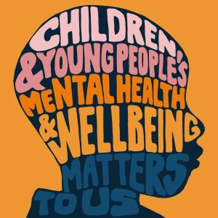VIG (2019)
Felman (2020) stated that Mental health and behavioural health are terms that refer to a person's cognitive behavioural and emotional well-being. It all comes down to how people think, feel, and act, the term mental health can also be used to describe a mental illness.
Mental illness stated by (Mayo Clinic, 2022), often known as mental health disorders, is a broad term that encompasses a variety of conditions that can impact your emotions, thinking, and behaviour. Depression, anxiety disorders, schizophrenia, eating disorders, and addictive behaviours are all examples of mental illness these have the potential to negatively impair our daily lives, relationships, and physical well-being. With this being said a multitude of factors can also contribute to mental health concerns, including individual experiences/encounters, personal and social relationships, and physical conditions.
The Oxford English Dictionary defines wellbeing as the state of being comfortable, healthy, or cheerful. Wellbeing, on the other hand, is a much larger idea than fleeting delight Whilst happiness is included, it also considers how content people are with their lives on a whole, their sense of purpose, and their sense of control (Mental Health Foundation, 2015)
Our emotional, psychological, and social well-being are all part of our mental health state which influences how we deal with stress, interact with others, and make decisions, at all periods of life, including childhood, adolescence, and maturity, mental health is critical, and we need to know if not controlled and monitored properly our mental health could deteriorate making it detrimental. Children and adolescents should be aware that they may experience changes or alterations in their thinking, mood, and behaviour as a result of mental health difficulties over the course of their life. This can be caused by reasons, including genetics or brain chemistry which are examples of biological variables, Traumatic experiences of maltreatment, violence and cruelty which are instances of life occurrences or family history making it more widespread and common. (Mentalhealth.gov, 2022)
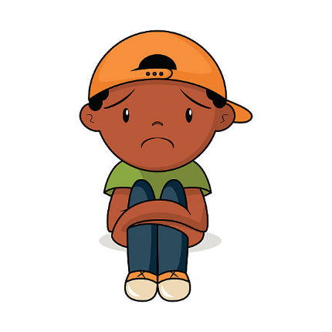(Clip Art Mag, 2022)
Statistics have shown that one in every six children aged five to 16 was identified as having a potential mental health disorder in July 2021, up from one in every nine in 2017. This indicated that there are five children suffering in each classroom. The number of young people aged 18 and under who entered A&E with a recorded diagnosis of a psychiatric disease had tripled between 2010 and 2018-19. According to 83% of young people stated that the coronavirus pandemic had magnified their mental health condition. In 2018 to 2019, 24% of 17-year-olds confirmed to self-harming and in the previous year, 7% admitted to self-harming with suicidal intent at some point in their lives with 16% saying they were in a lot of mental pain. Suicide was the leading cause of death among males and females aged five to 34 years old in 2019 with half of 17 to 19-year olds with a diagnosable mental illness admitting to self-harming or attempting suicide, young women accounted for 52.7% of this total. According to a Young Minds poll three-quarters of parents (76%) also claimed their child's mental health had deteriorated while waiting for help from Child and Adolescent Mental Health Services, (Young Minds, 2022)
However more acknowledgement and help towards mental health is now becoming more available to boost mental wellbeing through Mental Health Assessments and helplines available: 0808 231 3142. At Birmingham Wellbeing Centres, outpatient therapy is available as well as inpatient treatment at hospitals, with expert guidance on mental health and well-being from specialists, accompanying video access which can be viewed in the comfort of your own home for counselling and therapy services, offering greater flexibility to meet the needs of patients.
These are a few measures that are in place as effective mental health care can help manage to have better control over symptoms helping to attain a more positive mental wellbeing. (Priory, 2022)
I hope that this topic can be discussed more widely and openly, as mental health awareness is improving. If you feel that you are experiencing mental health illness/difficulties, you should always seek help and speak to someone you feel comfortable with. (Mentalhealth.gov, 2022) as dealing with the indicators of mental illness early on might help you to deal and take control because identifying when something is wrong is a crucial step in self-care and self-love so you can feel "normal" once more. (Healthy Place, 2022)
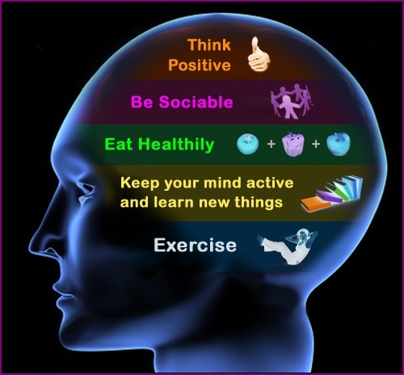(Quora, 2022)
Thank you for listening.

Reference list
Clip Art Mag (2022) Sad Boy Clipart [image] Available at: https://clipartmag.com/sad-boy-clipart (Accessed: 24 March 2022)
Felman, A. (2020) What is mental health? [website] Available at: https://www.medicalnewstoday.com/articles/154543 (Accessed: 28 February 2022)
Healthy Place (2022) Early Warning Signs of Mental Illness [website] Available at: Early Warning Signs of Mental Illness | HealthyPlace (Accessed: 19 March 2022)
Mayo Clinic (2022) Mental illness [website] Available at: https://www.mayoclinic.org/diseases-conditions/mental-illness/symptoms-causes/syc-20374968 (Accessed: 28 February 2022)
Mental Health Foundation (2015) What is wellbeing, how can we measure it and how can we support people to improve it? [website] Available at: What is wellbeing, how can we measure it and how can we support people to improve it? | Mental Health Foundation (Accessed: 18 March 2022)
Mentalhealth.gov (2022) What Is Mental Health? [website] Available at: https://www.mentalhealth.gov/basics/what-is-mental-health (Accessed: 28 February 2022)
My perfect CV (2022) Change your life with our care worker CV example [website] Available at: https://www.myperfectcv.co.uk/cv/examples/social-services/care-worker (Accessed: 9 march)
My perfect CV (2022) CV Examples for 2022 [website] Available at: https://www.myperfectcv.co.uk/cv/examples (Accessed: 9 march)
Priory (2022) Mental Health Treatment and Support in the Midlands [website] Available at: https://www.priorygroup.com/landing-ppc-campaign/midlands-mental-health?gclid=d6b444e053d01840758326c6ebe09641&gclsrc=3p.ds&msclkid=d6b444e053d01840758326c6ebe09641&utm_source=bing&utm_medium=cpc&utm_campaign=G%3A%20Midlands%20-%20New%20-%20Mental%20Health&utm_term=mental%20health%20assessment&utm_content=Mental%20Health (Accessed: 19 March 2022)
Quora (2022) What is the definition of a healthy mind set? [image] Available at: https://www.quora.com/What-is-the-definition-of-a-healthy-mind-set (Accessed: 24 March 2022)
VIG, R.S (2019) Young people’s mental health [image] Available at: https://www.evidentlycochrane.net/suicide-prevention-better-evidence/young-peoples-mental-health/ (Accessed: 23 March 2022)
Young Minds (2022) Mental health statistics [website] Available at: https://www.youngminds.org.uk/about-us/media-centre/mental-health-statistics/ (Accessed: 18 March 2022)

