Catalogue Entry; Storage Jar.

Material: Red Nile Clay.
Period: Early ?
Height: 16.5” Main Body 8”: Foot 8”. Lip .5”
Lip diameter: 4.5”
Age: Possible period between, Predynastic- Old Kingdom.
Provenance: Ancient Egypt?

The storage jar comes from the: Cyfartha Castle collection. Merthyr Tydfil.
At present it is based in Archives at Lampeter Campus UWTSD.

Description
The storage jar was not made on a wheel; it is to uneven; this example was made by hand using coils of clay building the jar up from its base through the body to eventually the lip. The shape in places especially around the body area is too uneven and as such could only be made by hand. The whole jar may have been built in stages as there is some evidence of markings to suggest that the neck, body, and foot were made separately and then joined. Although this building of the storage jar in such away is unlikely I still think that it might have happened. The lip would in any case of been a separate piece joined on at the end. The jar is made of Nile clay, of which there are two varieties; one white and the other red.
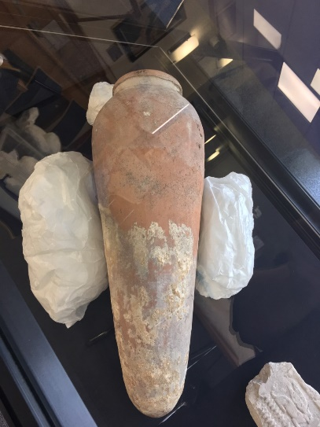
The storage jar shows considerable staining on both the inside and outside. The staining on the lip on both sides; I believe is due to pouring of food stuffs. This could either be Emmer or wheat varieties, or bread/ other food stuffs. The staining on the outside of the body, I believe comes from the storage of the jar; either from being laid with other jars or from standing up in sand. The markings of the Foot of the storage jar although covered well with the residue of whatever has stained it, the staining is not of equal covering over the whole area. This may be because of the soil it stood in or other reasons. On further reflection the most likely reason for the staining at the foot of the jar is from being stood in sand. Other reasons could be another jar breaking; or from seepage from inside of the jar. See picture A), which shows the storage jar in question, as be seen the markings are quite prominent, both top and bottom.
The storage jar being looked at, is considered to be quite early; which would put it in the Pre-Dynastic- Old Kingdom period as a possibility. There are examples both small and large of the same styled storage jars being made in Egypt in the late periods, so it was obviously a design that worked and lasted the test of time. This style of storage jar is known to have been around since the Neolithic Age.
One particular type of jar is the Canopic, these often appear in sets of four, with either human, animal or some other head on the lid. Some jars are even made of glass, these would be for the special perfumes that the Egyptians used; especially in the funerary sense.

History of Storage jars.
Storage jars could come in all sorts of sizes from quite small, which would have been used for libations to several feet tall. The latter would have been used for food stuffs. Like other vessels such as Amphora and Pithos jars they had a usage in both every day life as well as from a funerary sense.
Some of the jars are quite large, a few examples have lips making them more like jugs, others are squat in shape with a funnel. They seem also to come either in very colourful items which I believe are more likely to go to be funerary items then not. Or they are unpainted and rather dull in appearance and more for every-day usage in my mind.
Although my opinion is that the higher ranking persons in their tombs in the social structure would have had painted storage jars to both hold their food, drink and perfumes. The full funerary scene had to be followed, so that the persons Ka, Ba and Kha could complete their cycles. There is evidence that other burials did use un-painted versions and also some of the earlier dynastic higher up’s in the social structure followed this example. The paintings on the separate storage jars would have included scenes like; libations, wildlife, scenes with Gods and Goddesses and images of the Pharaoh passing over to his new life.

Through trade in the Eastern Mediterranean and Aegean, there is evidence of the circulation of small jars and juglets between Cyprus, Syria- Palestine and Egypt, this especially the Tell el-Dab’a variety. (Wilkinson 2010: 473-4). In the same fashion cylinder seals and clay tokens also circulated in the same trading areas. ( Wilkinson, T, 2010: 450-1).
This particular jar I believe may have been in every-day usage as the staining around the lip area suggests re-usage and other markings I feel back this up. The main body of the jar has two indentations which could have happened by virtue of stacking the jars on each other. There are examples of these jars as far away as Mesopotamia; the same shape of storage jar appears in graves and tombs from the Third Dynasty; Royal Cemetery. (2112-2004). Wenke, R.J, (2009).p 117?

Bibliography:

Creasman, P.P, and Wilkinson R.H, 2017; Pharaoh’s Land and Beyond; Oxford University Press, New York and Oxford.
Riggs, C, 2004; The Beautiful Burial in Roman Egypt; Oxford University Press, Oxford.
Wengrow, D, 2006; The Archaeology of Early Egypt; Cambridge University Press, Cambridge.
Wenke, R.J, 2009; The Ancient Egyptian State, The Origins of Egyptian Culture (c 8000-2000 BC); Cambridge University Press, New York and Cambridge.
Wilkinson, T, 2010; The Egyptian World; Routledge Taylor and Francis Group, Abingdon.

