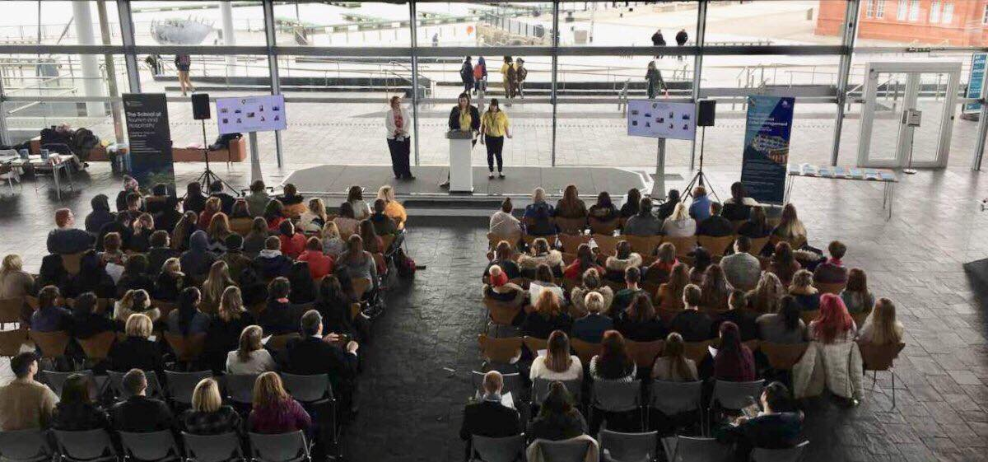
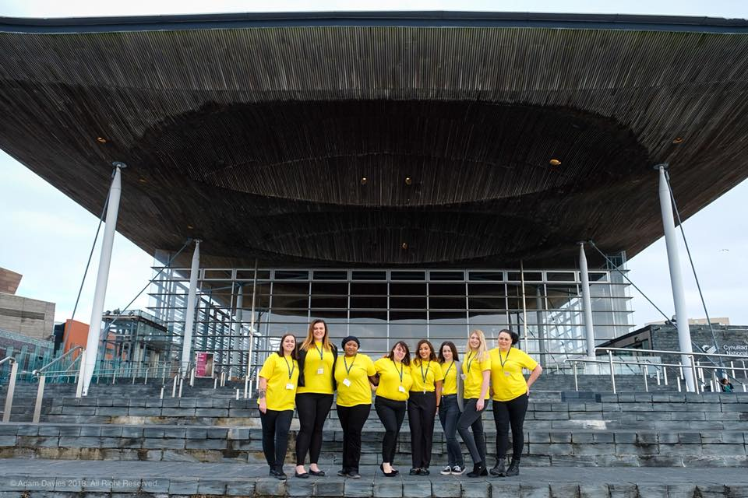

Contemporary global issues in tourism  (M7X02121) | Abstract  Fourth-year Master Students created a Global Student Conference where college students attended at the Senedd on the 19th of March 2018 titled ‘The World is OUR lecture theatre’.  Bethan Watkins  P140639

Portfolio

Table of Contents
1.0. Introduction 5
2.0. Gantt chart 6
3.0. Workshop 7
3.1. Workshop Sheet/Feedback Form 12
First draft of workshop sheet 13
Final Draft of Workshop sheet 14
Feedback Form 16
3.2. Pilot Workshop 18
4.0. Welsh Translator 19
4.1. Welcome Speech & Closing Speech 19
4.2. Conference Feedback forms 21
4.3. Workshop Guidance Sheet 22
5.0. College Communications 23
5.1. Coleg Sir Gar 23
5.1.1. Weather Conditions 24
6.0. Other documentation 27
6.1. Itinerary 27
6.2. The Senedd 29
6.2.1. Email to The Senedd 29
6.2.2. Visits 31
6.3. Venue Set-up 32
6.4. Uniform ideas 33
6.5. Allocation of Steward Job roles 34
6.6. Creating Name Tags 35
6.7. Visuals/Snapchat 37
6.8. UWTSD Minutes 38
7.0. Group Evaluation 40
7.1. Pre-conference Appraisal 40
7.2. Conference Day Appraisal 42
8.0. Individual Evaluation 46
9.0. Conclusion 47
Bibliography 47

Table 1- Bethan Watkins Gantt Chart 6
Table 2 - Delegation of job roles 7
Table 3 - Ideas of conference speakers 8
Table 4 - Presentation of job roles 10
Table 5 - Workshop Guidance Form Completed 15
Table 6 - Feedback form of Workshop 17
Table 7 - Conference speech Welsh and English 20
Table 8 - Conference feedback forms Welsh/English 21
Table 9 - Workshop Guidance Sheet (Welsh) 22
Table 10 – Silje Gronn Minute Taking 39

Figure 1- Amended job roles 11
Figure 2 - Facebook messenger to Mtour Students 12
Figure 3 - Facebook Messenger Video Call with Silje Gronn 14
Figure 4 - First Pilot Run 18
Figure 5 - Second Pilot Run 18
Figure 6 – Phone call to discuss opening and closing speeches of conference 19
Figure 7 - Myself and Hannah on stage 20
Figure 8 - Emails received and sent to Gareth Harvey (Coleg Sir Gar) 23
Figure 9 - Facebook Messenger discussion on weather emergency action plan 24
Figure 10 - Weather emergency action plan emails sent to colleges 25
Figure 11 - First draft of Itinerary 26
Figure 12 - Third draft of itinerary 27
Figure 13 - Restructure of itinerary 27
Figure 14 - Email sent to The Senedd 29
Figure 15 - First visit to The Senedd 30
Figure 16 - Myself visiting The Senedd for the second time 31
Figure 17 - Myelf and Silje with chairs from UWTSD 31
Figure 18 - Using Facebook Messenger to suggest ideas for uniform 32
Figure 19 - Myself walking up the stairs in Mount Pleasant 32
Figure 20 - T-shirts and Lanyard that the SU kindly gave us 32
Figure 21 - Rough Draft of Job Roles for Stewards 33
Figure 22 - Three templates that could possibly be used 33
Figure 23 - Final copy and printed version of nametags 34
Figure 24 - Snapchat Story 35

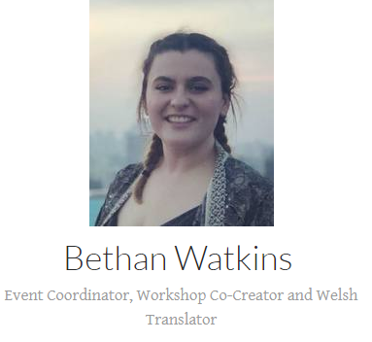
Introduction
This is a portfolio document providing data and evidence that Bethan Jemma Watkins has successfully fulfilled the task duties of the Event Coordinator, Workshop Co-Creator and Welsh Translator for the Global Student Conference 2018. This document will provide images, documents and reason for the methods that were used throughout the duration of 2017-2018. The document provides a group evaluation and an individual evaluation of the conference as a whole and the justifications of certain rating that has been used to evaluate other teams.

Gantt chart
Table 1- Bethan Watkins Gantt Chart

Master Gantt chart

Table 2 - Master Gantt Chart

Workshop
On the 12/10/2017 myself, Silje Gronn and Hannah Thomas-Peters delegated job roles to other students on the Mtour course due to other students not attending the meeting. As a group, the three of us decided to delegate the workshop roles and responsibilities would best suit us.
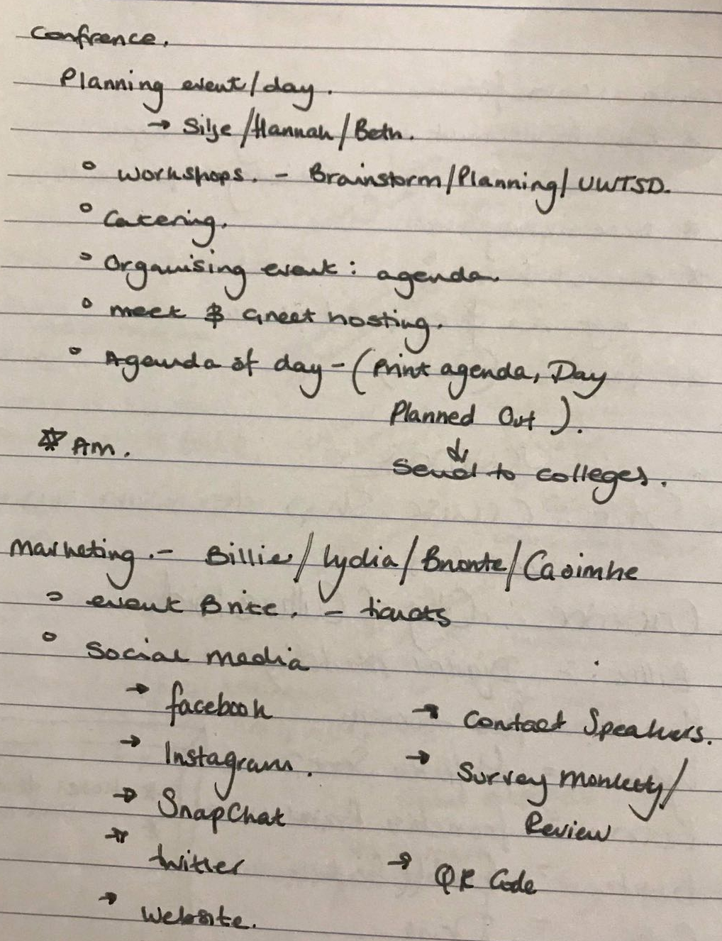

Table 3 - Delegation of job roles

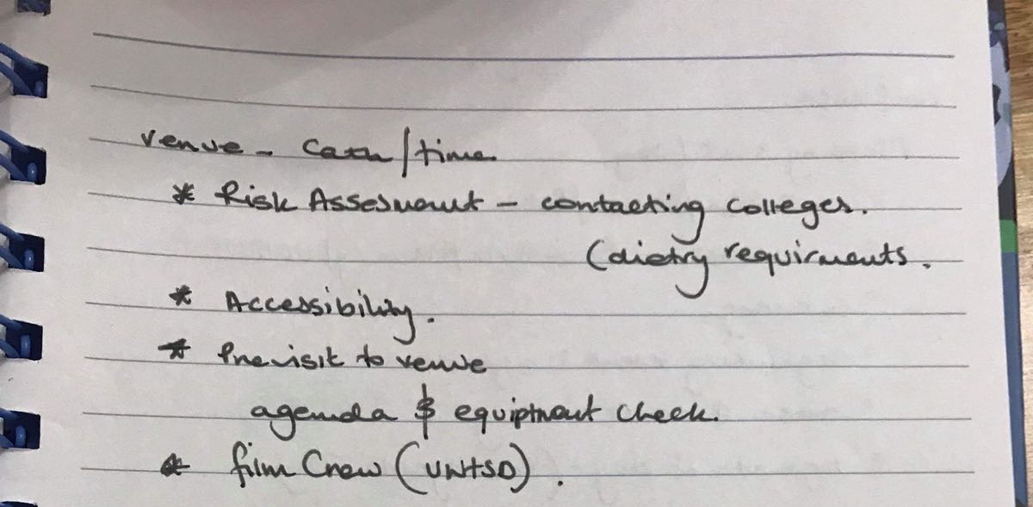
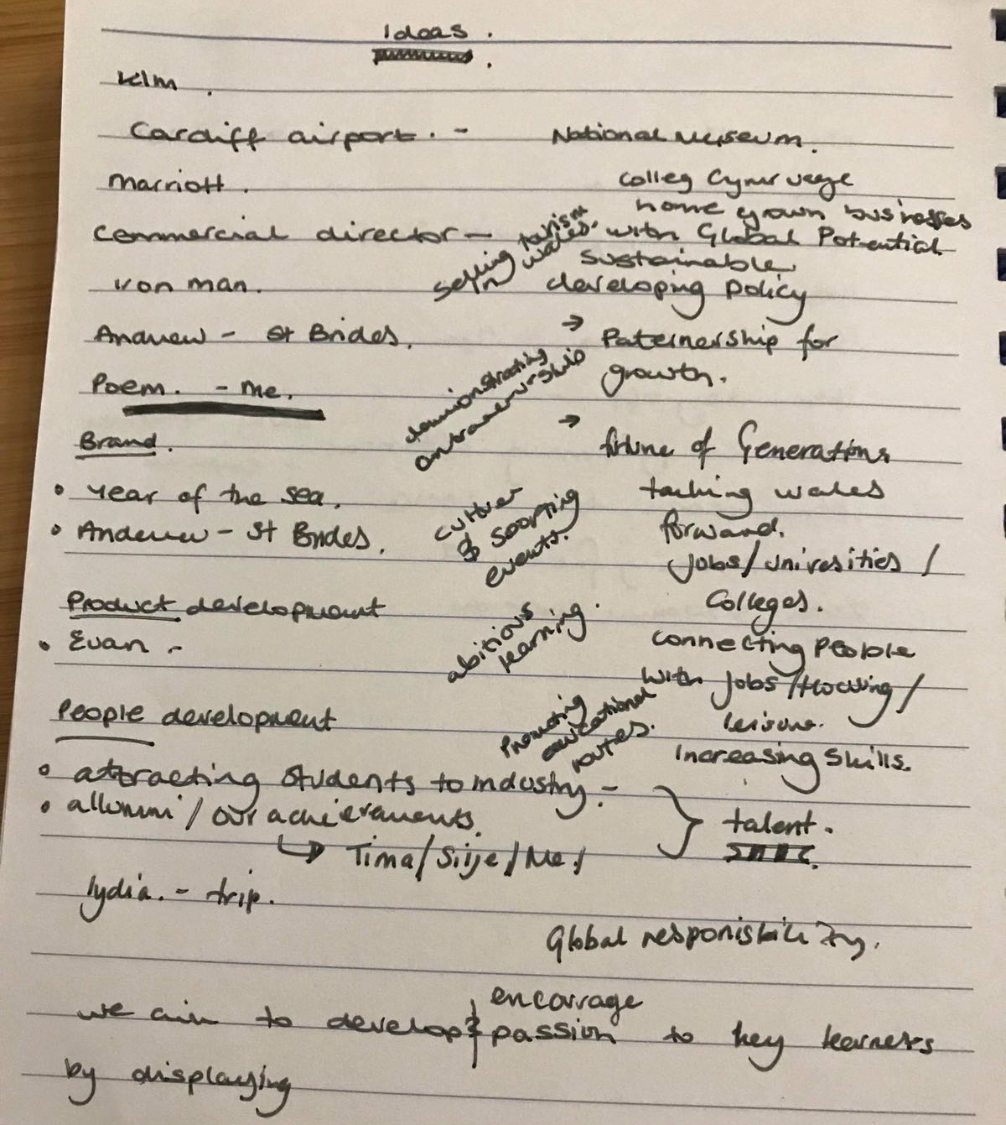

Table 4 - Ideas of conference speakers
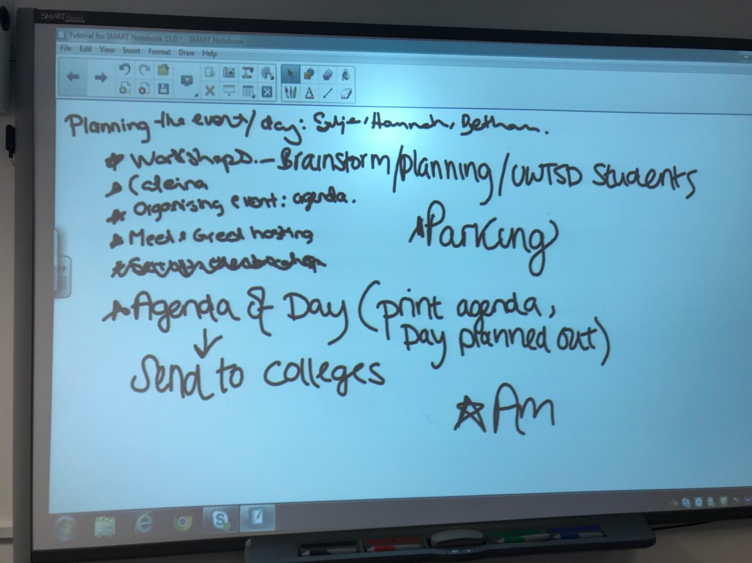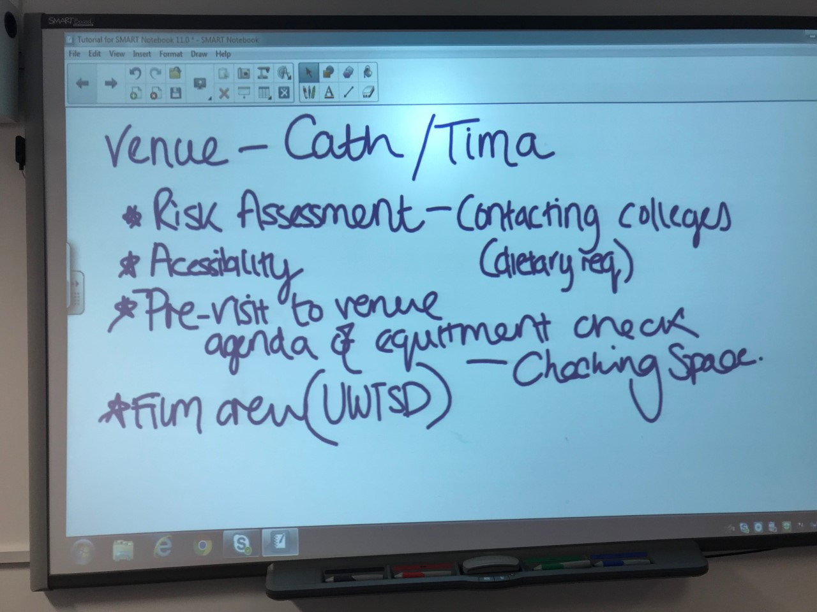
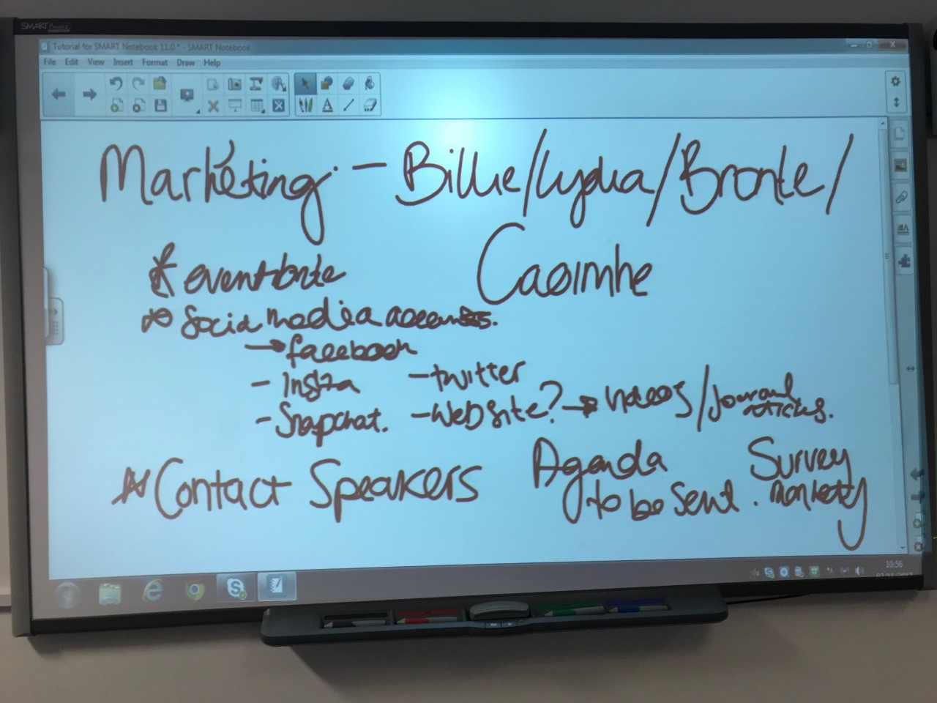
Table 5 - Presentation of job roles

Me, Hannah and Silje original whiteboard storm-thinking of Job roles.

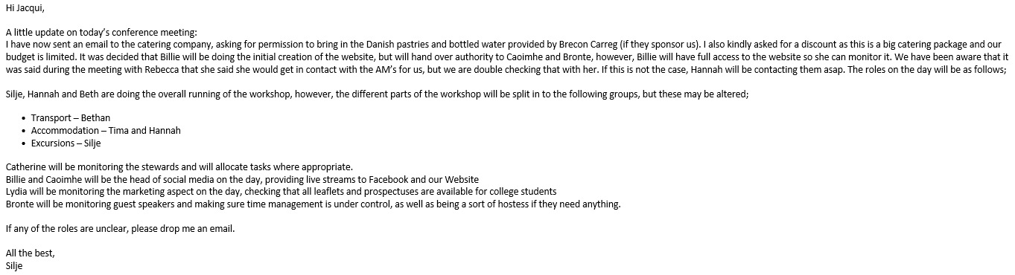

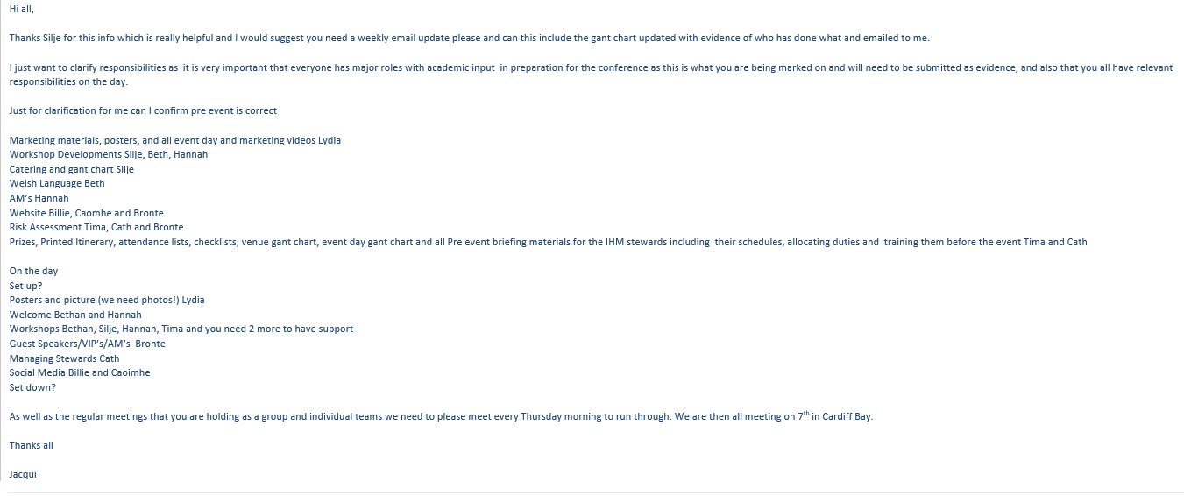
Figure 2- Amended job roles
Silje sent through job roles whereas Jacqui amended and suggested more job roles that will need to be done on the day.

Workshop Sheet/Feedback Form
The original idea for the workshop was for college students to communicate with local organisations where the stalls are located; however, on 15 February I decided that perhaps a different approach to the workshop might be more feasible.
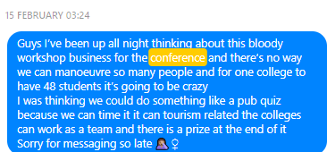
Figure 3 - Facebook messenger to Mtour Students

Following the result of this decision, myself, Hannah and Silje took it upon ourselves to re-structure the workshop as seen in the document below which led to the feedback form being created on the 12/02/2018.

First draft of workshop sheet
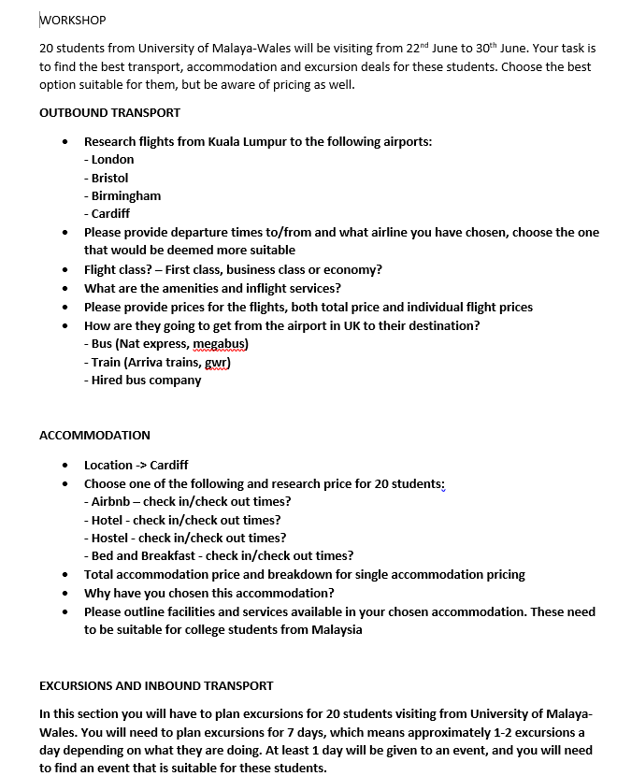

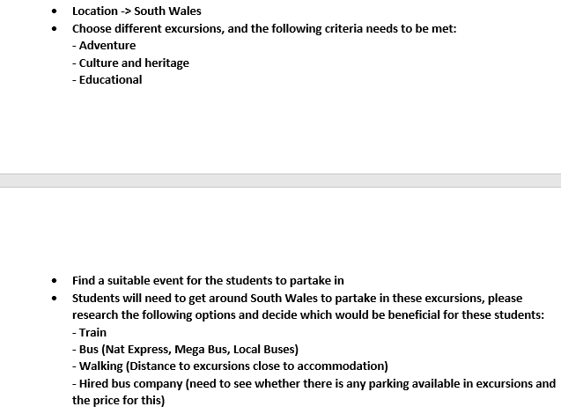

In result to the feedback, we received in the first pilot run the group decided to edit the old workshop sheet to create a second draft.

Final Draft of Workshop sheet
On the 16/03/2018, Silje and I had a meeting for the final draft of the workshop sheet via Facebook Messenger video.
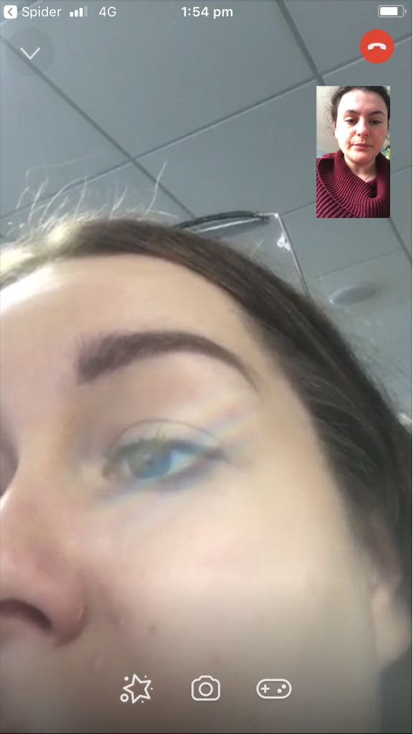
Figure 4 - Facebook Messenger Video Call with Silje Gronn

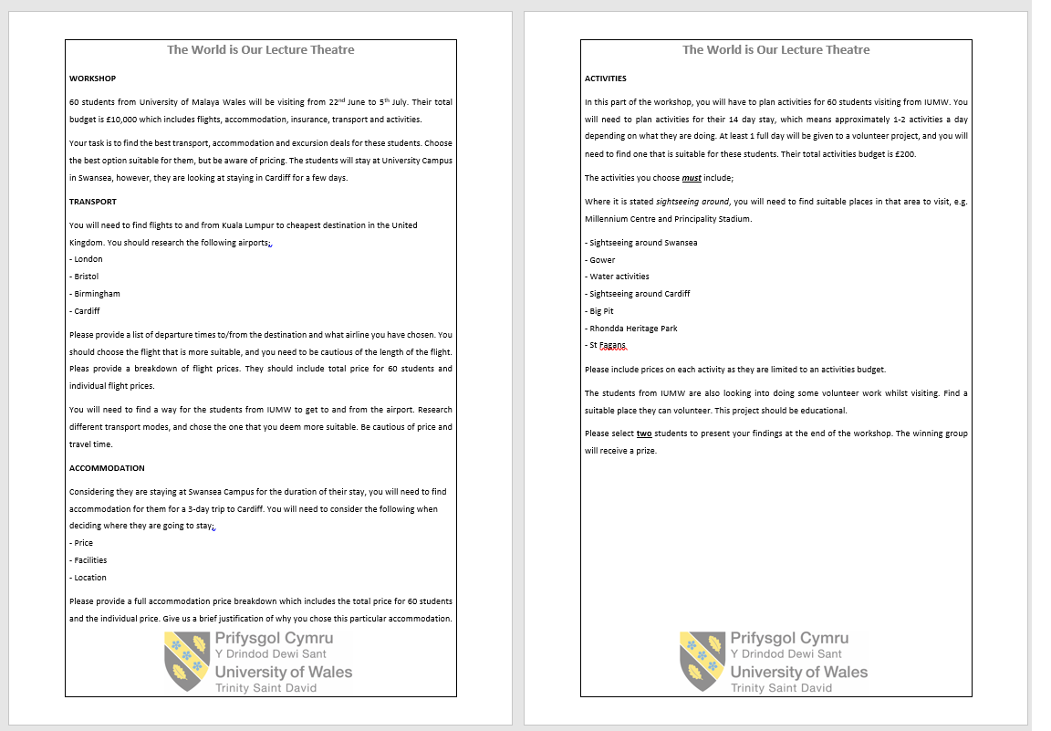
Table 6 - Workshop Guidance Form Completed

Feedback Form
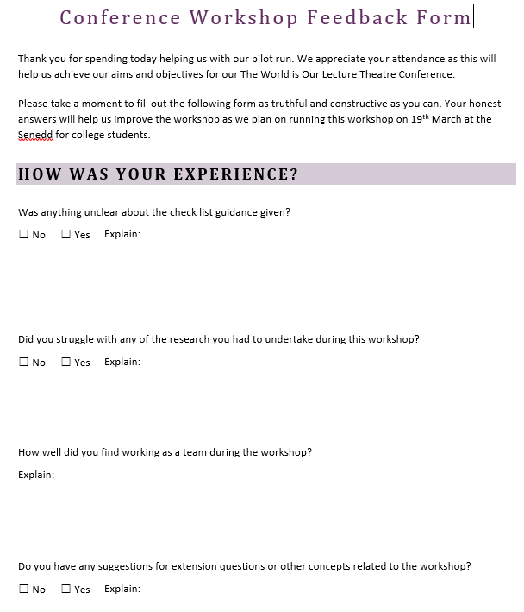

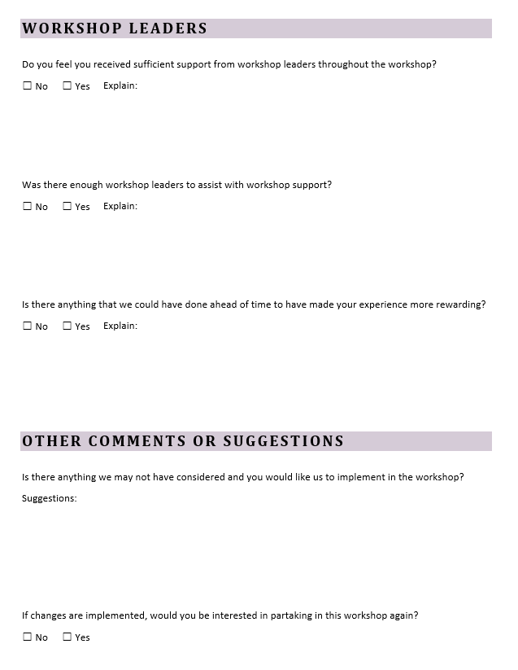
Table 7 - Feedback form of Workshop

Pilot Workshop
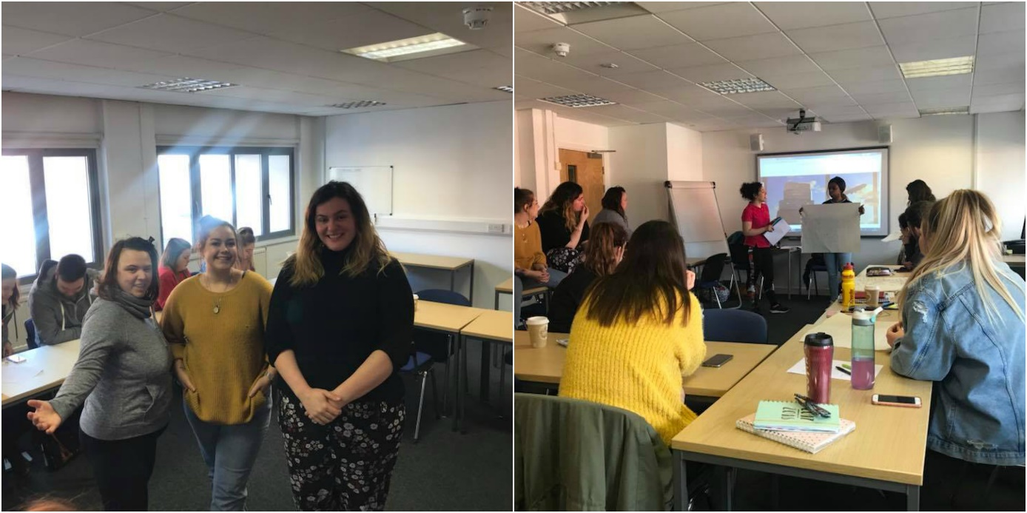
28.02.2018 – Pilot workshop run 1. Hotel Management Students Year 1.
Figure 5 - First Pilot Run

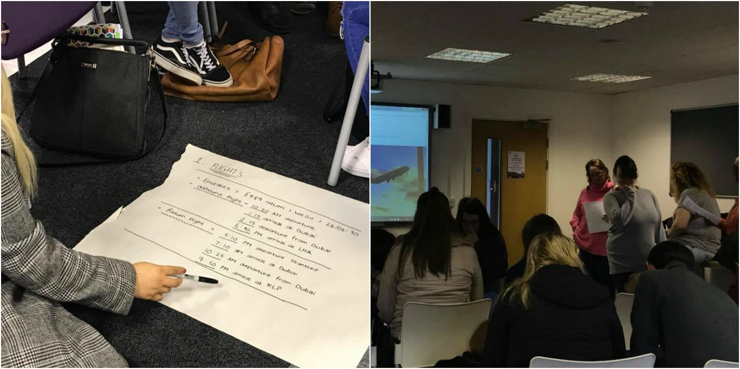
12.03.2018 – Pilot workshop run 2. Travel and Tourism Students Year 1.

Figure 6 - Second Pilot Run

Welsh Translator
I was selected to be the Welsh Translator of this conference, because I am the only student on the course that can speak Welsh.

Welcome Speech & Closing Speech
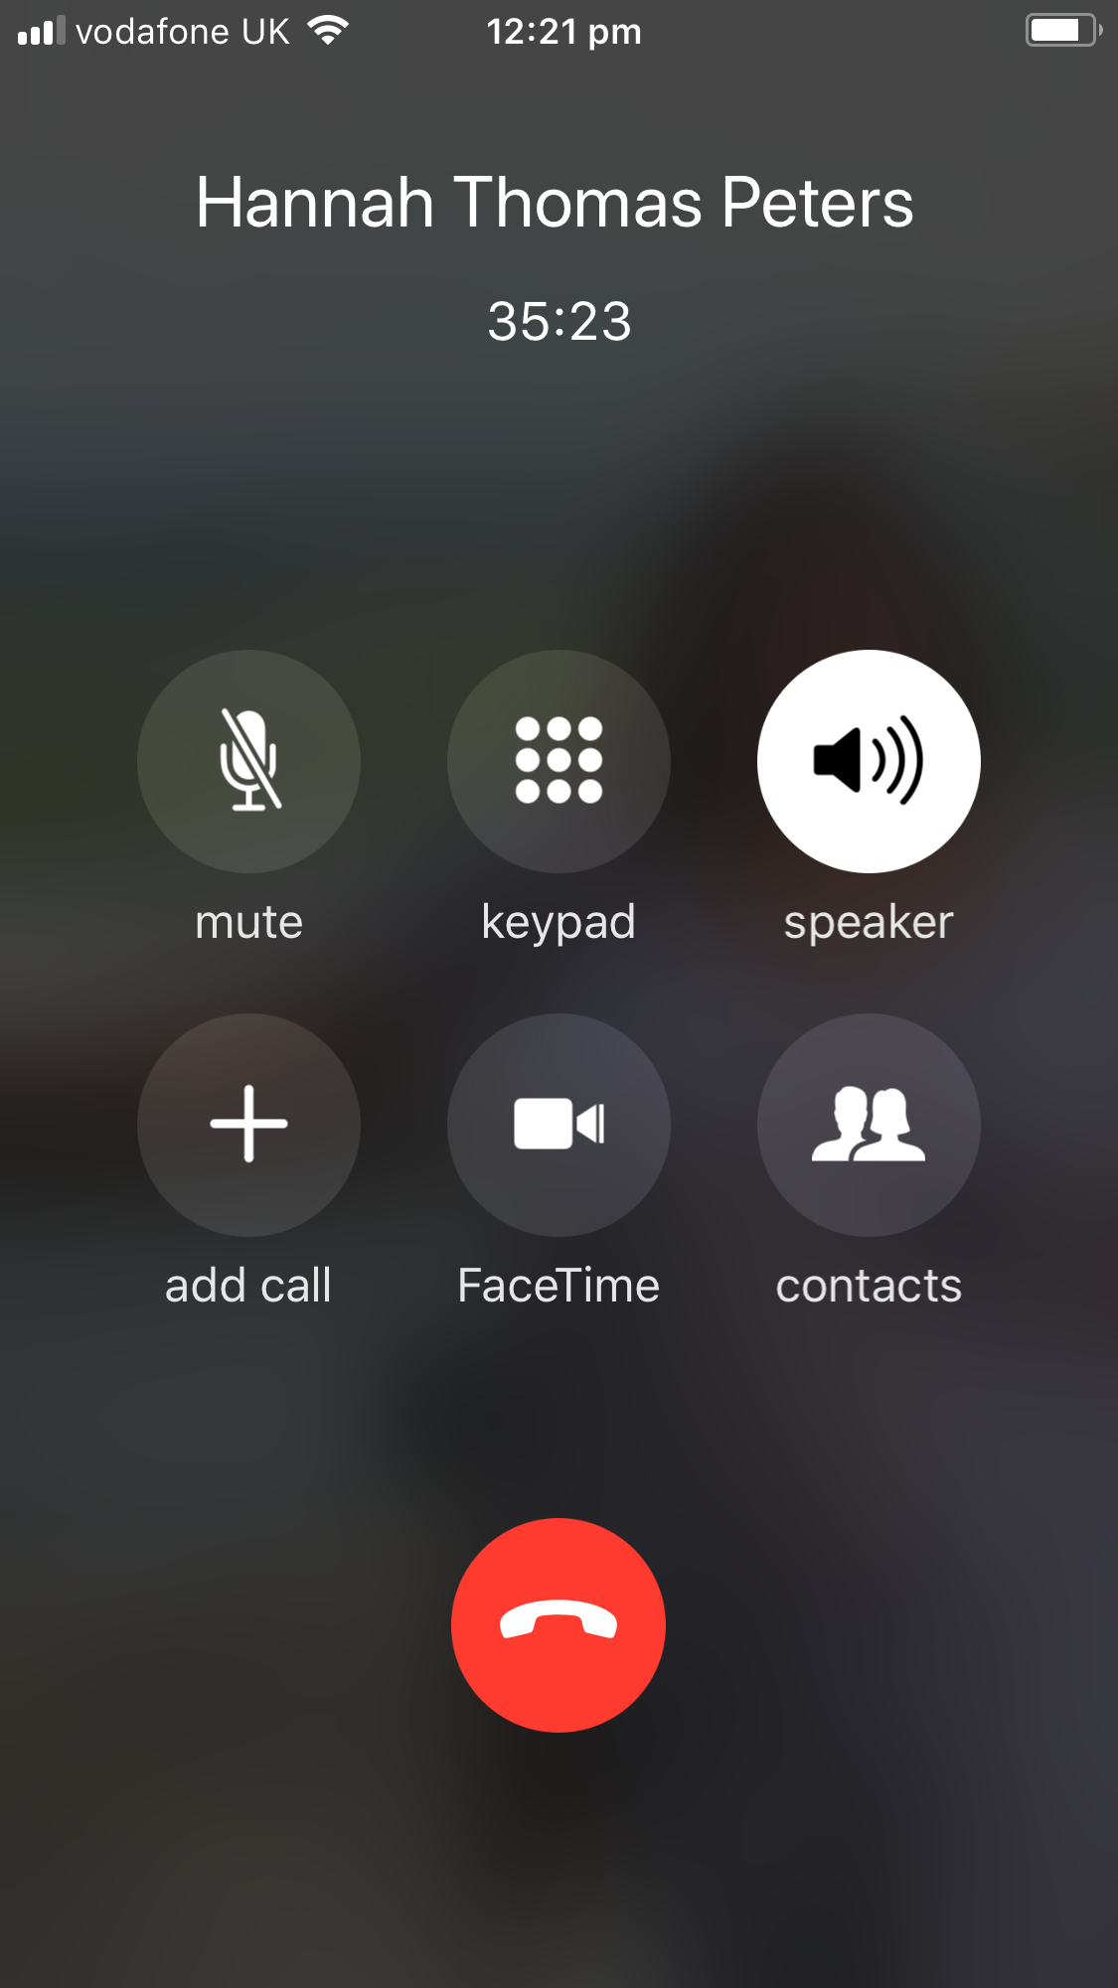
13.03.2018 – Phone meeting with Hannah for introduction and a closing speech for the day.
Figure 7 – Phone call to discuss opening and closing speeches of conference

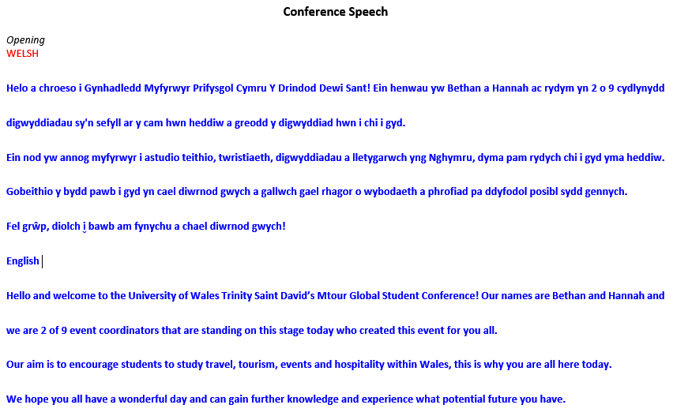
In result of this phone call, the final document for the opening speech completed by myself as Hannah and Jacqui Jones discussed creating the atmosphere of the students being in a flight scenario.
Table 8 - Conference speech Welsh and English
The font is blue as I suffer from Dyslexia. The blue font makes it easier for me to read especially in front of a large audience.
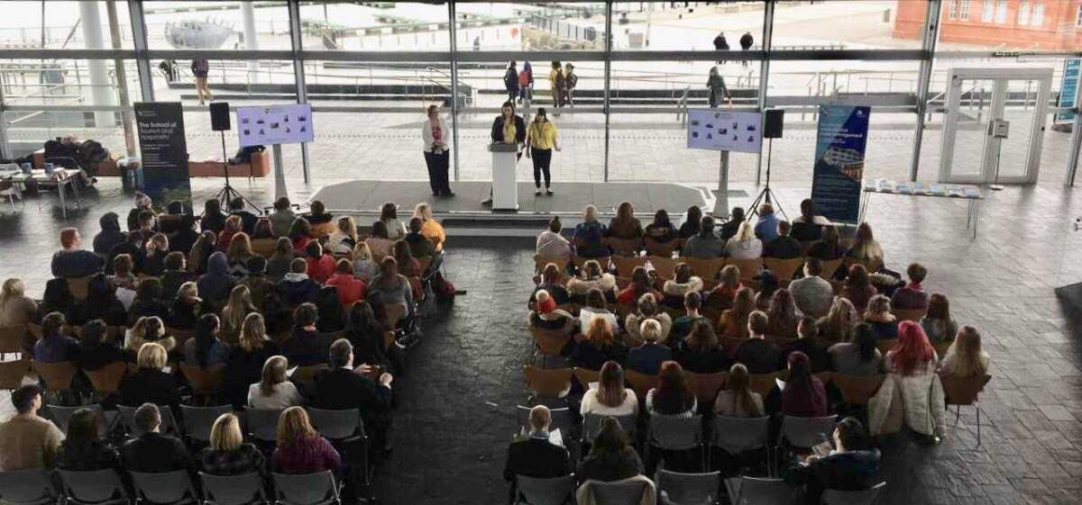
Figure 8 - Myself and Hannah on stage

Conference Feedback forms
On the 14/03/2018, Bronte created a feedback from and I suggested that I translate the form into Welsh.
Table 9 - Conference feedback forms Welsh/English

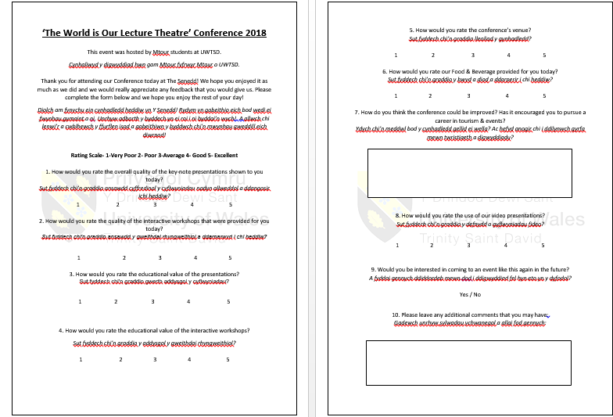

Workshop Guidance Sheet
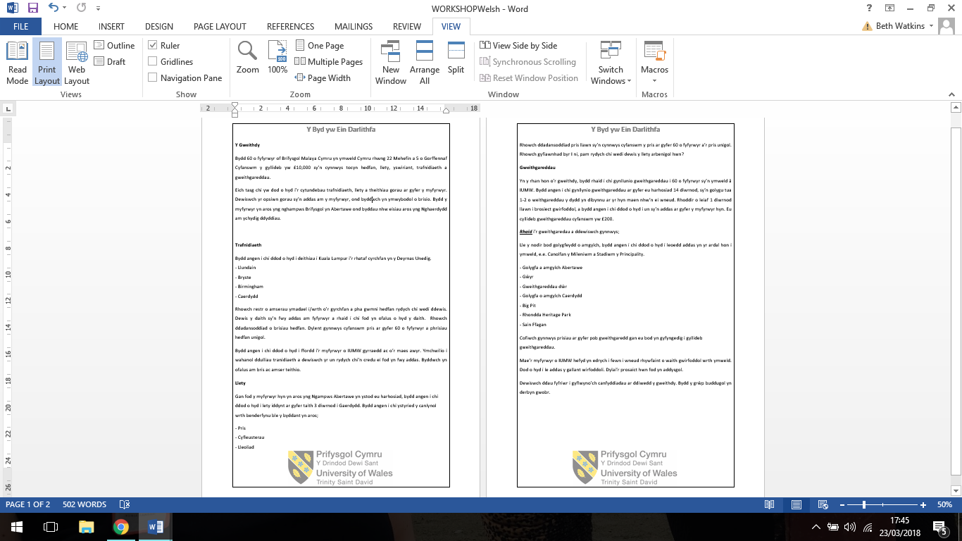
When the workshop guidance sheet was completed, I translated the whole document on the 19/03/2018 and printed in case any students wished to see the guidance sheet in Welsh.
Table 10 - Workshop Guidance Sheet (Welsh)

College Communications
At the beginning of planning this conference, that one student selected to liaise with different colleges. Due to miss-communication, I took it upon myself to contact Gareth Harvey, one of my ex-lecturers from Coleg Sir Gar.

Coleg Sir Gar
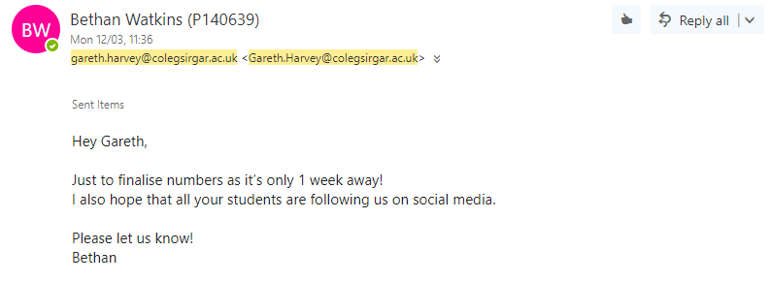
Emails exchanged between both parties on 12/03/2018 and 13/03/2018.

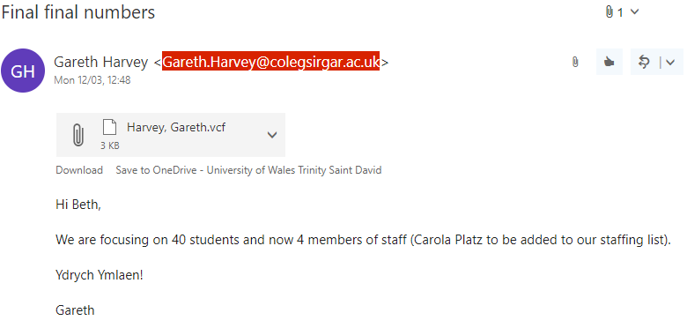

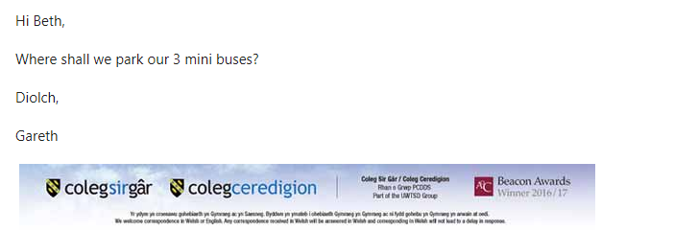

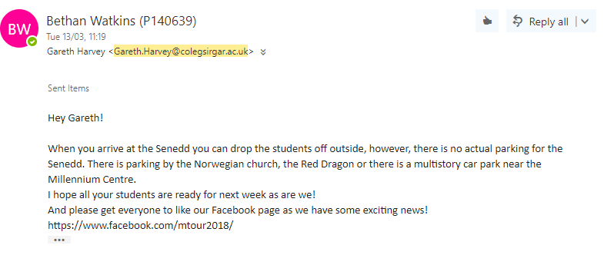
Figure 9 - Emails received and sent to Gareth Harvey (Coleg Sir Gar)

Weather Conditions
On Sunday 18/03/2018, Jacqui Jones sent a Facebook Message to all students involved with the conference to suggest we action the weather emergency plan.
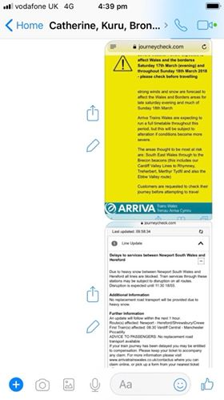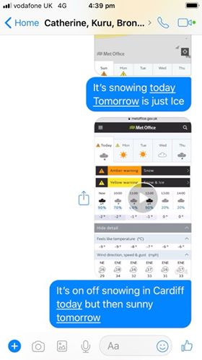

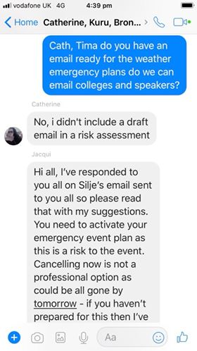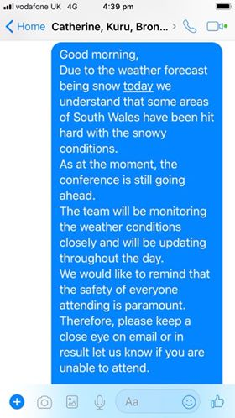
Figure 10 - Facebook Messenger discussion on weather emergency action plan
- Found information for the weather reports in Cardiff for the day of the conference
- Drafted email for Jacqui Jones to proof read before sending to colleges, presenters and volunteers.
Emails sent to from myself to the selected colleges: Coleg Sir Gar, Bridgend, Afan and Newport.
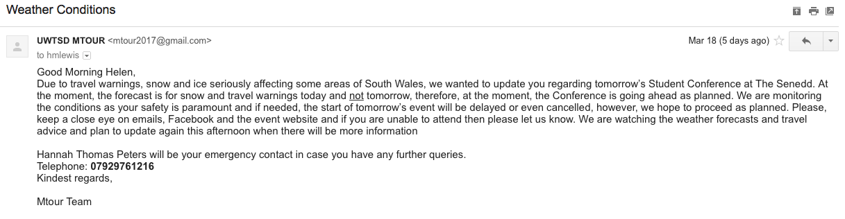
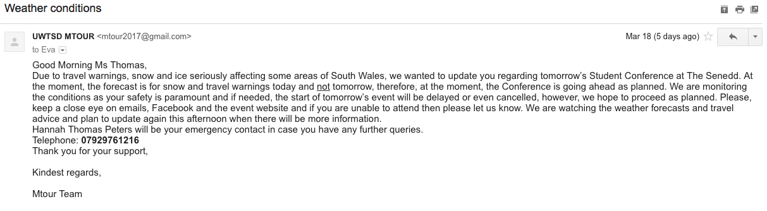
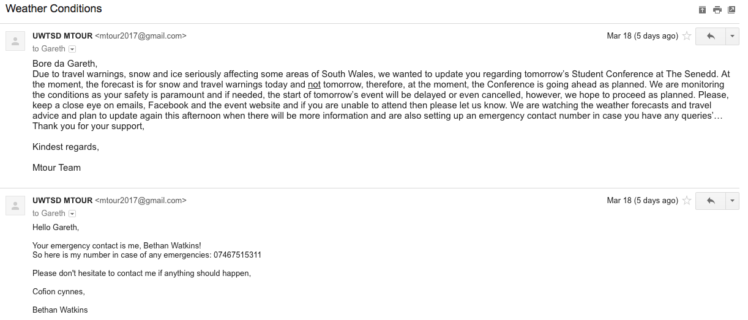
Figure 11 - Weather emergency action plan emails sent to colleges

Other documentation

Itinerary
After the second visit to The Senedd, Hannah, Silje, Billie, Jacqui and I all gathered and created the first draft of the itinerary and sent it to the other students on Facebook Messenger.
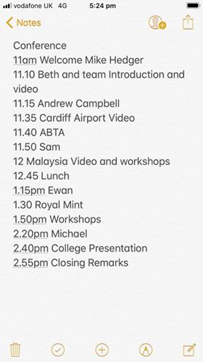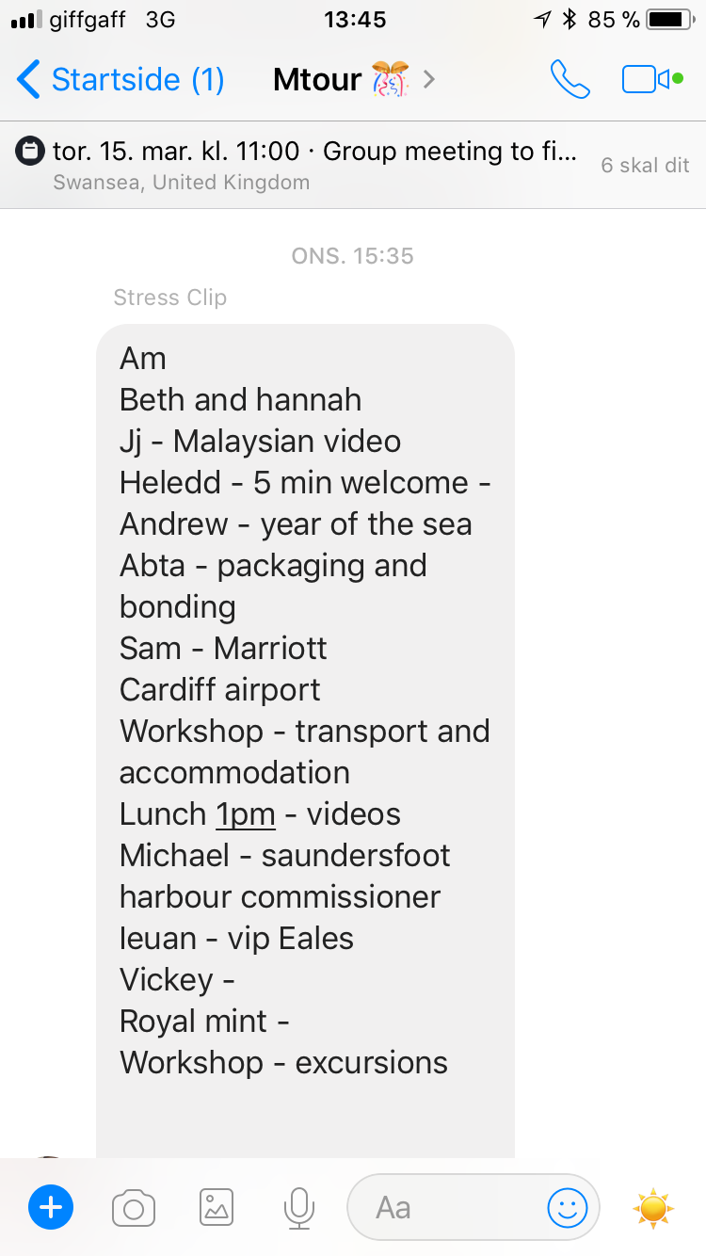
Figure 12 - First draft of Itinerary

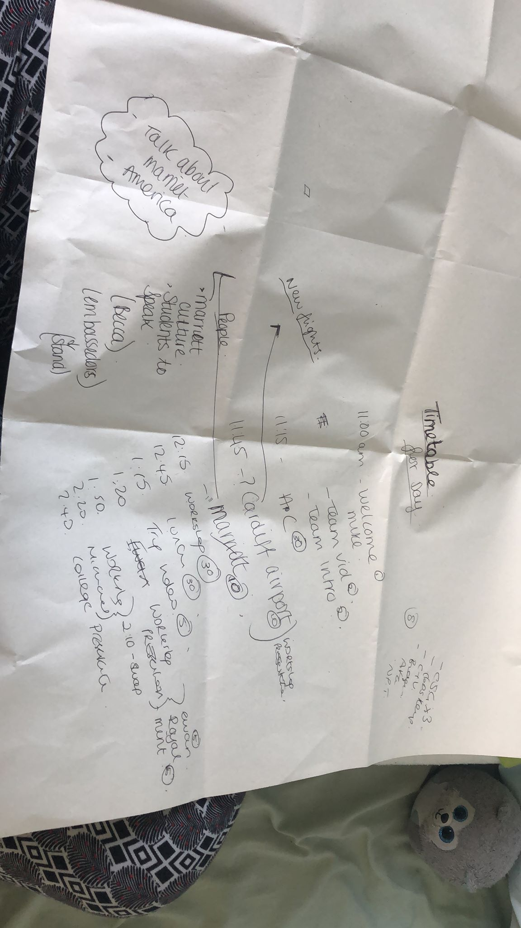
For third draft of the itinerary, Jacqui, Hannah, Billie and I realized we needed to create one more draft ant to ensure that this was the final draft this was created on the 12/03/2018.
Figure 13 - Third draft of itinerary

On the day of the conference (19/30/2018) there were issues with timing. When discussing with Jacqui I created a list of how the rest of the day will proceed and communicated with the other students.
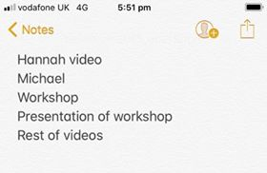

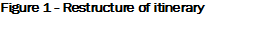

The Senedd

Email to The Senedd
On the week of the 23rd of October myself, Hannah, Silje and Jacqui created a new copy of an email that was sent to The Senedd.
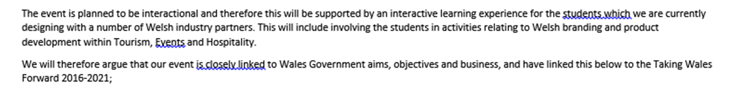
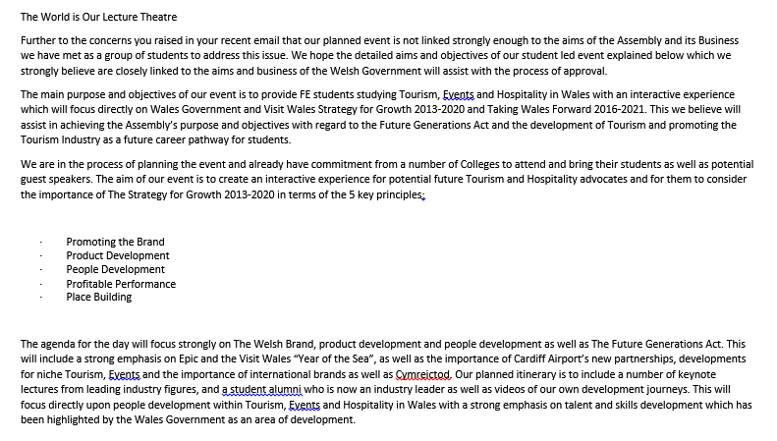

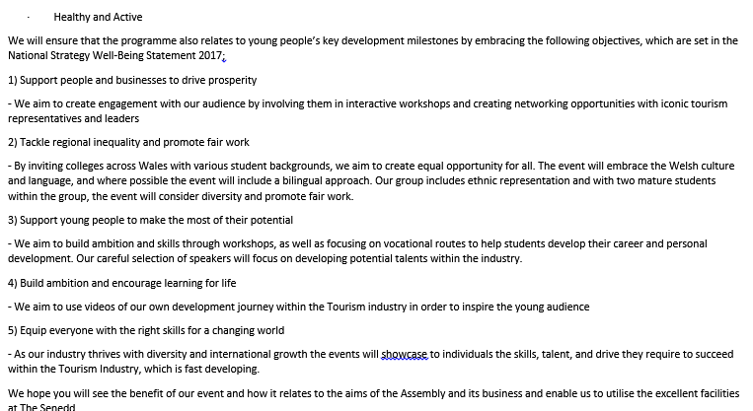
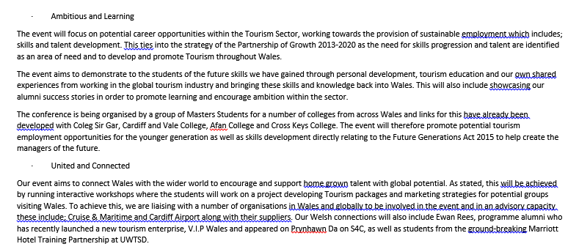
Figure 15 - Email sent to The Senedd

Visits
13.02.18 – This was our first visit to the venue where we discussed the seating arrangements, catering, health and safety, electronic devices and much more.
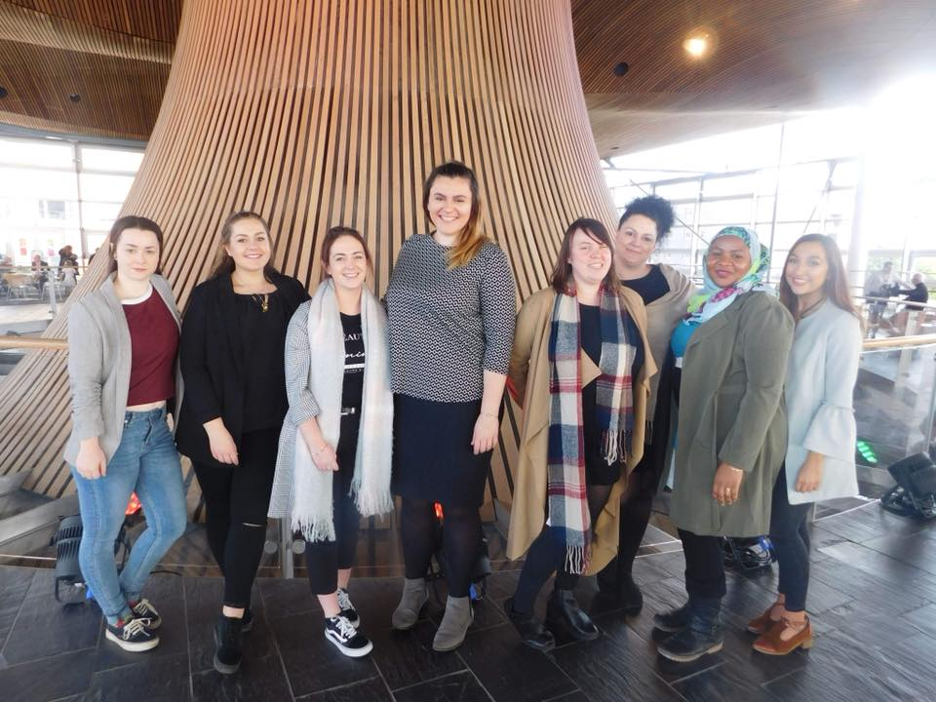
Figure 16 - First visit to The Senedd
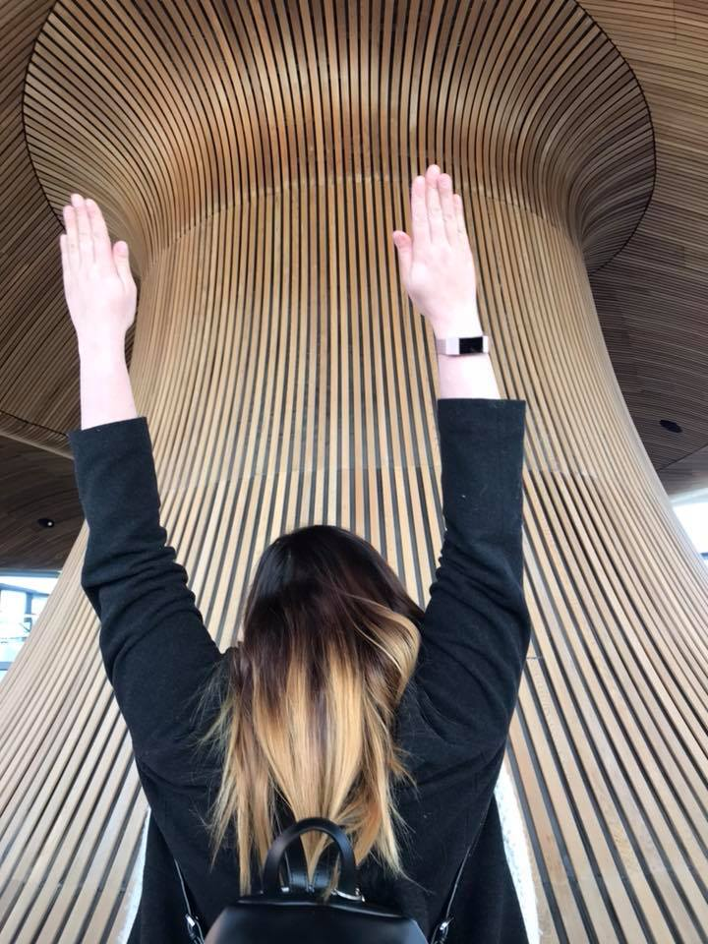
07/03/2018 – this was the second visit to the Senedd to finalise the event structure.

Figure 17 - Myself visiting The Senedd for the second time

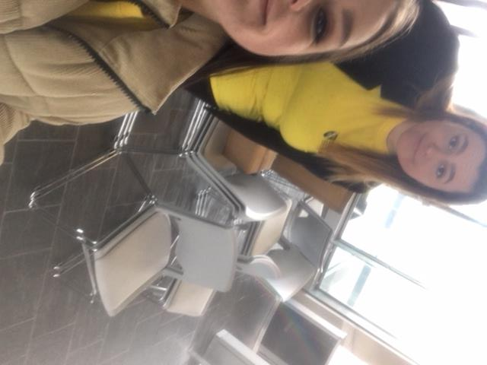
Venue Set-up
The day of the event (19/03/2018) proved to be difficult with set up, due to the fact there was miscommunication. Silje, Billie, Lydia, Emma and I all single handedly carried chairs that was borrowed from UWTSD to the venue.

Uniform ideas
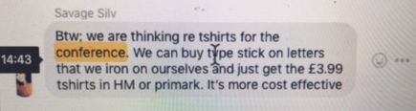
27/02/2018 –Silje, Billie, Hannah and myself discussing on what uniform we should wear on the day.
Figure 18 - Using Facebook Messenger to suggest ideas for uniform

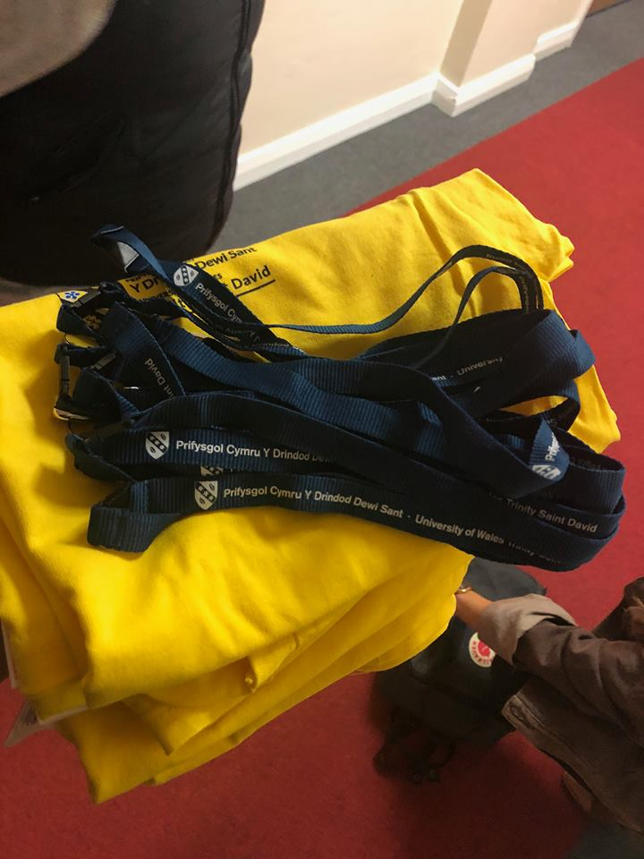
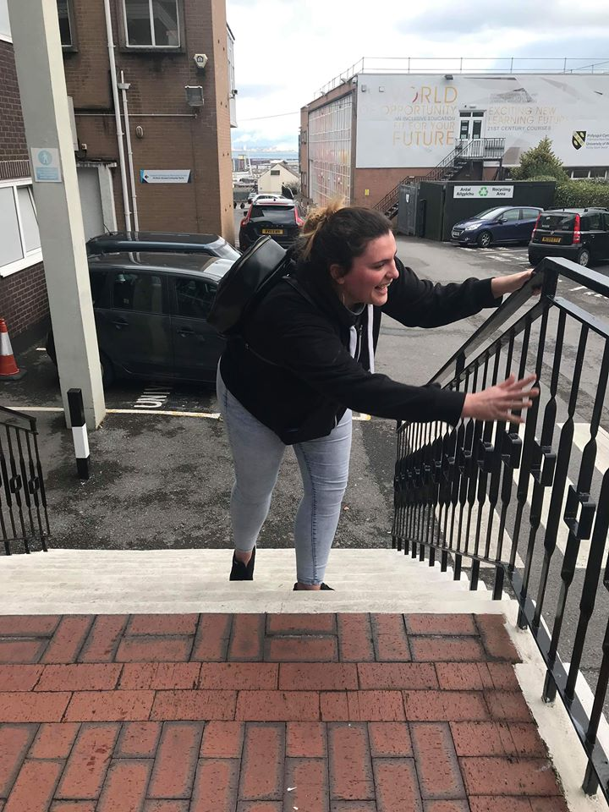
12.03.18 – Myself, Hannah and Billie Walking to Mount Pleasant to the SU to find t-shirts we can wear on the day.
Figure 19 - Myself walking up the stairs in Mount Pleasant
Figure 20 - T-shirts and Lanyard that the SU kindly gave us

Allocation of Steward Job roles
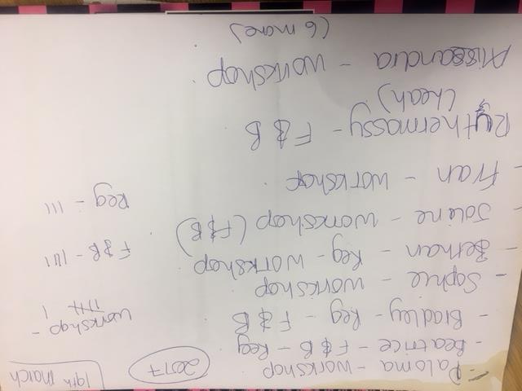
Whilst piloting the first workshop on the 28/02/2018, I personally went around the classroom to each student to question what he or she would like to do on the day of the conference. The decision to delegate students to roles on this day was a team decision.
Figure 21 - Rough Draft of Job Roles for Stewards

Creating Name Tags
13.03.2018 – Using the website Avery.com I created nametags for Mtour students. There were three options available and after reviewing the templates with Jacqui, a new template was created.
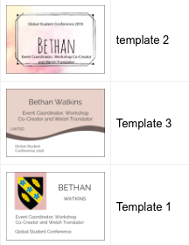

Figure 22 - Three templates that could possibly be used

On the 16/03/2018, the finalized nametag was completed and printed.
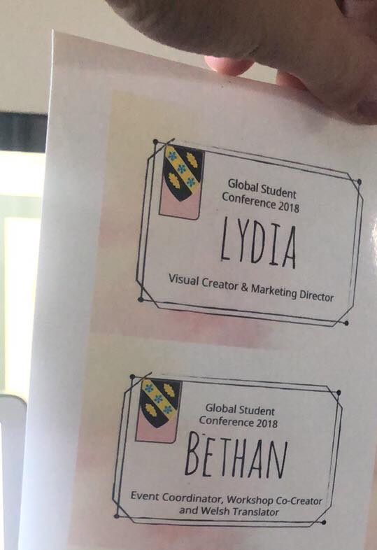
Figure 23 - Final copy and printed version of nametags

Visuals/Snapchat
On the day of the conference, there was one team member down for social media, therefore, I created a story where everyone who has snapchat is able to upload a picture and share it with the world.
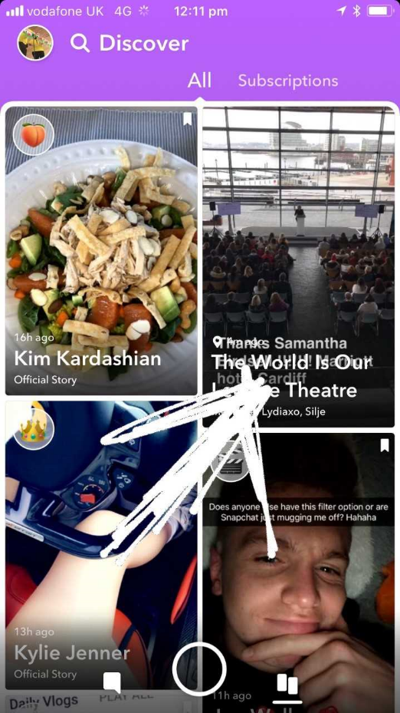
Figure 24 - Snapchat Story

UWTSD Minutes
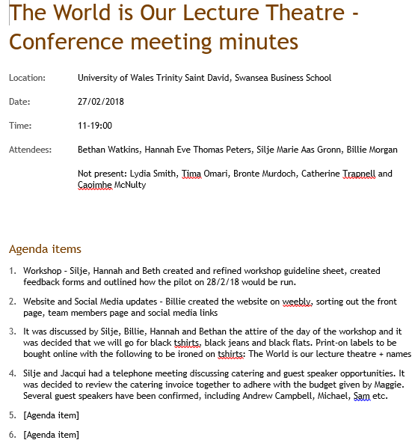
All minutes that are shown in the UWTSD Minutes are credited to Silje Gronn. The purpose of these minutes is evidence that I was present during these minutes.

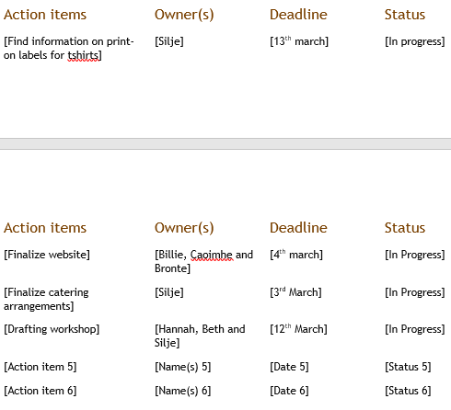

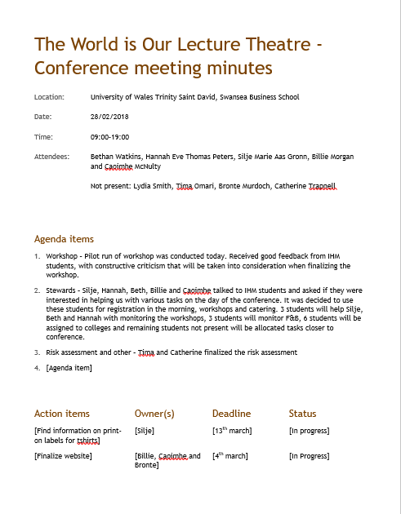
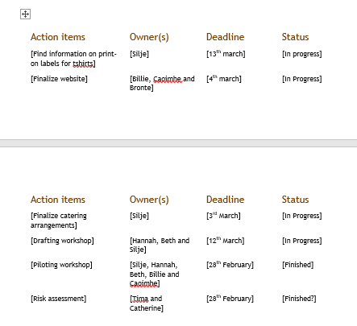

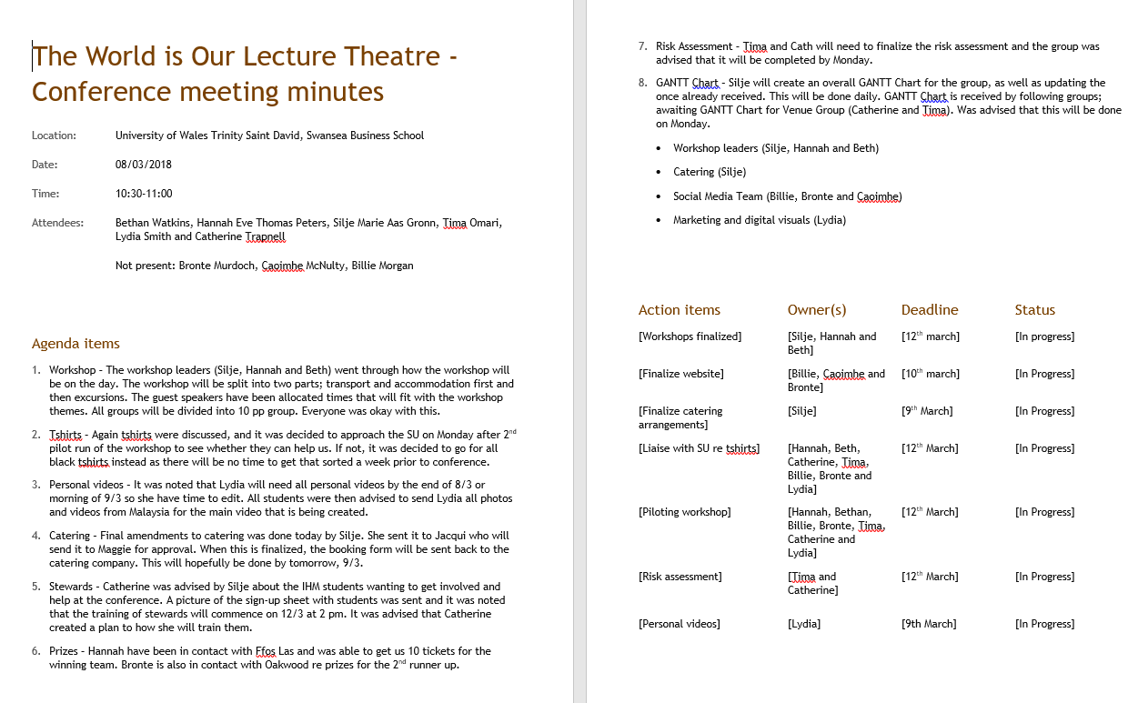
Table 11 – Silje Gronn Minute Taking

Figure 25- Amended job rolesTable 12 – Silje Gronn Minute Taking

Group Evaluation

Pre-conference Appraisal
On the third year, 2017, BA course 2017 in UWTSD students that were continuing the Mtour course for the fourth year were made aware that as part of the course the group must create a conference for colleges to attend to in 2018. The returning students started planning the Student Conference in October 2017, where only 3 students attending the 1st meeting. As discussed between the 3 students and the lecturer agreed that job roles were needed to be allocated immediately to understand the jobs that are required to ensure that conference is a success. Reflecting on this decision a group message was sent out to all students via Facebook Messenger, where the 3 members stated that if any students are unhappy with their job roles to state now as changing job roles. Discussing the job roles also brought the question of where should the group hold the conference? The answer was The Senedd. Billie took it upon herself to construct an email that was sent to The Senedd to see whether or not they would accept the university. After declining the university’s offer, myself, Hannah and Silje contracted an email that would provide The Senedd with our aims and objectives. This lead to the conversation whether or not the other team members should have been there to further understand the aims and objectives of the student conference. In relief, The Senedd finally accepted our conference to be held at The Senedd, the next phase was to contact the colleges, this is where there was a miscommunication. It is believed that only one team member should have been delegated the role of College Liaison. Resulting from this, there were many times where the group sent the number of emails to the college or no emails at all, whether it is checking final numbers, dietary requirements or any further requirements that the college would need.
The workshop was the main interactive activity that the college students would be able to join in and contribute towards the Malaysian students travelling to Wales. As a workshop group, many ideas were discussed. The first, the college students were to go to the stalls that were organised by us to gather information, however, I suggested that this may not be possible as crowd control may be an issue and after discussing with the team we decided that the first idea will not be feasible and change was due and all team members were agreed. Every meeting that was organised the workshop was discussed, however, we found that some group members continued to ask questions regarding the workshop, although being updated. As the workshop provided with a lot of information, the workshop team decided the guidance sheet would be applicable to the college students and a form of a helping tool. Two pilot workshops were planned to ensure the accuracy of the workshop, where the guidance sheet would take play but also a feedback form for the pilots were distributed the see if the workshop could be improved. After the first pilot was completed the University of Malaya sent through a video giving direct information and requirements which meant the guidance sheet needed to be altered. The 2nd pilot workshop took place for first-year students, resulting in mixed feedback with some students did not want to contribute towards the workshop where others were more than happy to complete the guidance sheet. As the conference days were commencing the final touches of the guidance form needed to be completed. I and Hannah were unable to attend the library, however, I skyped Silje to assist with completing the form. Silje printed the final draft of the guidance sheet, upon reading the guidance sheet there were spelling errors that needed to be completed.
During the times where the groups were not able to meet together, Facebook Messenger was used as the main source of communication of updates, however, Jacqui suggested that all teams must provide a daily update for all to see. This was done by Silje for a majority of the time, but no other teams did complete this task and once again there was a miscommunication with what other teams were doing during the times that meetings were to take place but nobody attended. We found that other group members were communicating but not updating other teams regarding their updates, and when asked the response received was that the team will inform everyone tomorrow, in which they never did.
The Thursday before the conference took place, Jacqui mentioned that there may be snow on the way and that the risk assessment team must prepare for the worst, ensuring that colleges were liaised with. Sunday morning snow was present in South Wales and the group needed to take action on the weather plan, however, the venue and risk assessment girls had no action to take place. I personally drafted an email that would be sent out to the colleges where Jacqui adjusted the email it is believed that the weather warning email should have been sent out that Thursday.

Conference Day Appraisal
As agreed with all individuals, all were to meet at The Senedd at 9:00 am to ensure the set-up for the conference was completed before the college students were to attend. After having trouble with getting to the front door of The Senedd, myself, Hannah, Silje, Billie and Lydia were left with bringing in the chairs and marketing items when other team members were standing inside and only realised after we brought everything in.
The set-up between 9:00 – 10:30 showed all team-members helping one another, setting up tables, putting marketing materials on display and other things. When the colleges arrived, the volunteers were found without doing many things other than meeting and greeting and Mtour students were gathered at the front of the entrance to meet and greet college lectures and presenters, this resulted into the entrance looking crowded.
The morning session proved to be a success. Hannah and I worked well on stage for the welcoming speakers, the feedback provided by the college lecturers were positive as they all started speaking Welsh to me. The presenters were able to manage their time on the stage and also the workshop session was successful. Job roles to the volunteers were confused as they were unsure what location they should be in at what times and also the time-keeping in the afternoon were not punctual as presenters were over their time resulting into the workshop and personal videos were pushed back. At 14:30, Coleg Sir Gar announced that they needed to leave the conference without any communication beforehand, resulting in this Bridgend College wished to leave as well. This was out of our control as this was something that we were not able to predict and no precautions were put in place.
The Student Conference overall was a success with positive feedback from Colleges, Presenters and public audiences.
Team Ratings
Social Media Team | Completed ratings
Team Member A (Bill) | 10/10
Team Member B (Keeva) | 4/10
Team Member C (Bronte) | 3/10
Overall group mark: 17/30
Workshop Team
Team Member A (Silje) | 10/10
Team Member B (Hannah) | 10/10
Team Member C | 10/10
Overall group mark: 30/30
Venue and Risk Assessment Team
Team Member A (Tima) | 4/10
Team Member B (Cath) | 4/10
Overall group mark: 8/20
Visuals
Team Member A (Lydia) | 9/10
Overall group mark: 9/10

I have created this system of ratings to individual mark group members by their;
- Participation in developing ideas and planning project,
- Willingness to discuss the ideas of others,
- Cooperation with other group members,
- Interest and enthusiasm in project,
- Participation in leading/facilitating discussion and ease and familiarity with discussion material,
- The group members assigned tasks for the group,
- The quality of this persons work,
- The accuracy of the work,
- Performance in the group,
- Timeliness of the completion of the work.

The next phase will be pinpointing what team members completed these following tasks.

Social Media Team
Team Member (A) – This team member received 10/10.
Team Member (B) –
- Willingness to discuss the ideas of others,
- Cooperation with other group members,
- The accuracy of the work,
- Performance in the group,

Team Member (C) -
- The quality of this persons work,
- The accuracy of the work,
- Timeliness of the completion of the work.
This group rated an overall 17/30. Team member A completed all tasks that were given and then some. Without Team member (A) creating and developing ideas in what to put on the social media, the other 2 members would not have content to put on their social media platforms.

Workshop Team
All team members were rated 10/10 as this group was able to complete all tasks that are given to them and also other tasks from other team members if they were not completed. It is believed that without this group working together the success of the conference may not have been to a high standard.

Venue and risk assessment
Team Member A –
- Participation in developing ideas and planning project,
- Cooperation with other group members,
- Interest and enthusiasm in project,
- The quality of this persons work,
Team Member B –
- Interest and enthusiasm in project,
- The group members assigned tasks for the group,
- The quality of this persons work,
- The accuracy of the work,
This team proved to be more difficult to rate. Throughout the process of the conference, there was constant miss-communication, untold work that nobody knew about and unnecessary work that the group was completing when other work needed to be done. Team Member A showed a passion for the conference throughout although not being able to communicate with other teams. Team B delayed tasks throughout the time of the conference, however, when a work needed to be completed will be.

Visuals
Team member A –
- Participation in developing ideas and planning project,
- Willingness to discuss the ideas of others,
- Interest and enthusiasm in project,
- Participation in leading/facilitating discussion and ease and familiarity with discussion material,
- The group members assigned tasks for the group,
- The quality of this persons work,
- The accuracy of the work,
- Performance in the group,
- Timeliness of the completion of the work.
This team member was working individually on their tasks and provided the team with excellent personal videos, however, there were times where cooperating with the group proved to be difficult as no communication was made throughout the Facebook Messenger.

Individual Evaluation

Event Coordinator
My overall role as the Event Coordinator I believe was successful. From the very start until the day of the conference I was involved with the majority of the meetings, the planning and on the day I showed that I was able to cope well under pressure and change.
This being said, at times I believe that on the day I may have come across as a perfectionist which is where “a person who wants everything to be perfect and demands the highest standards possible” (Cambridge Dictionary, 2018). I felt that I could always improve a situation, for example, organising the volunteers on the day of the conference when the catering needed organisation where I divided the group up into individual tasks. This proved once more, when the time-keeper for the presenters were not kept accordingly and I felt the need to organise the itinerary to the times and past this on to every single team member to ensure that everyone understood. In the morning of the conference as the Social Media Team were one team member did not come until the evening, I created a story on snapchat that all people can use, when in-fact this should have been done by the other Social Media Teams could have done this. Prior to the event, the personal videos were being recorded and the need to control the situation as there was 9 of us present, this is when I was willing to record the camera and also ask the teams question’s when this could have been done by the visual team. It’s possible to argue that I may have been a control-freak where “someone who is determined to make things happen in exactly the way they want and who tries to make other people do what they want” (Cambridge Dictionary, 2018) however, as many of the team members were not present, there was miss-communication time to time the need to continue other individuals job roles to ensure the conference was a success.

Workshop Co-Creator
There are 3 team members in the workshop co-creators, all three members are confident, bright but very forward with the way of thinking. There were 2 pilots that underwent with students from UWTSD, however, I believe that possibly there should have been a 3rd pilot on lower academic students, showing the true colours of the workshop, I did not express this to any other team members. As shown in the portfolio, I was awake most nights overthinking the workshop and worrying how the workshop may pan out. Personally, I feel as if all team members played to each other strengths and was able to communicate efficiently.

Welsh Translator
As my secondary job role was the Welsh Translator gathering documents to translate proved difficult as many documents were completed a week before the conference. The difficulty of having someone to proof-read my documents resulted into advice from my own family members. Documents were printed and ready to be handed out, and although nobody required a welsh document they were on stand-by. The second difficulty was translating the master PowerPoint, no fault of their own the master PowerPoint was later than expected, thus no time to translate the whole document.

Conclusion
The Student Conference, overall, was a complete success. From knowing the conference was happening from 2017 until now I have learnt a few things for myself;
- I can be a perfectionist and a control freak.
- I leave main pieces of work until the last minute.
- I enjoy working well within a group, however, at times enjoy my own individual pieces of work.
- Different personalities can clash and the main key to ensure the work is completed is by communication.
- Things may have gone smoother if all job roles were successfully completed.

I would like to give thanks to UWTSD for giving me the opportunity to run a major event such as this Student Conference. Thank you for letting me use my strengths and also improve on my weaknesses.

Bibliography
Cambridge Dictionary, 2018. Meaning of "perfectionist" in the English Dictionary. [Online]
Available at: https://dictionary.cambridge.org/dictionary/english/perfectionist

