Web and data base
By: Jahvon Genus
Student num:2532390
Module: Introduction to Web and Database Concepts ACCA4023

1 -In this scenario the Auto park management system was manually recording all the information about Parking site, parking slot, customer. Payment, vehicle and booking however when using such methods it cost them a lot of time and caused many errors and data duplication. However, using this new method which I creased called the Auto park management database eliminates that issue because it’s able to manage all the information swiftly and efficiently without making any mistakes. By implementing this solution to replace manual process with six linked tables which uses quires reports and integrity and by converting real life object into entity’s along with its relationships makes the data base run smoothly without any risk of any data duplication or causing errors.
2-This database management system needs to be able to accurately record many data such as
- who uses the auto parks services and which vehicle is owned by which customer
- show available parking slots at which parking site
- store payments
- show who has paid, cancelled or pending
- store customers information like name phone number and every important information about them
- should be able to store the customer vehicle information and link it back to the right customer and there booking and payment
- record parking bookings with start time and end time and status

3-
entity | Attributes | Purpose
Parking site | Site ID (Pk), sitename, location, capacity, contact number | Stores information about parking location this enable the system to manage multiple location
Parking slot | Slot ID (PK), slot number, slot type, status(available/occupied), site ID(FK) | Store information about available parking spaces
Customer | Customer ID(PK), first name, last name, phone number, email, address | Its store the customer person information to help identify the owner of the vehicle
Payment | Payment ID (PK), booking ID (FK), payment methos, payment status | Stores payment information for each customers booking to support tracking and payment management
booking | Booking ID (PK), vehicle ID(FK), slot ID(FK), entry date time, exit date time, parking duration, booking status | Stores information on the time availability and which person has booked it with there information
Vehicle | Vehicle ID (PK), registration number, vehicle brand, vehicle model, vehicle colour, customer ID(FK) | Its stores the detail of each customer vehicle information to help link it back to the owner

4 -Relationships

- Customer (1) to vehicle (M)- one customer can have many vehicles registered under his name.
- Parking site (1) to parking slot(M)- a parking site can contain many parking slots.
- Vehicle ID (1) to booking (M)-each booking is only for one vehicle and that one vehicle can have many booking over time.
- Parking slots (1) to booking(M)- each booking can only use one parking slot
- Booking (1) to payment (1) each payment belongs to one payment
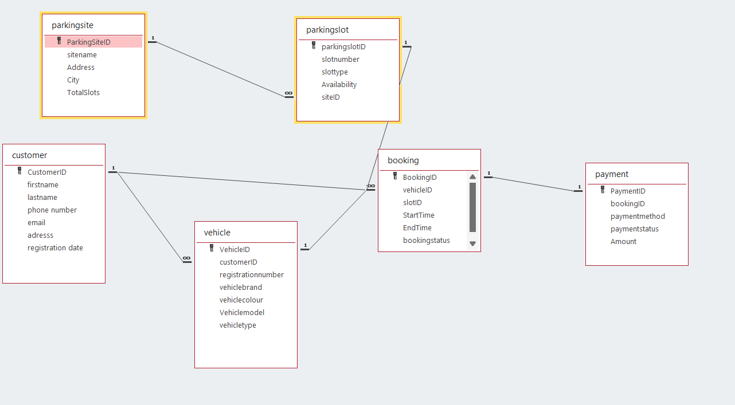

Entity relationship diagram 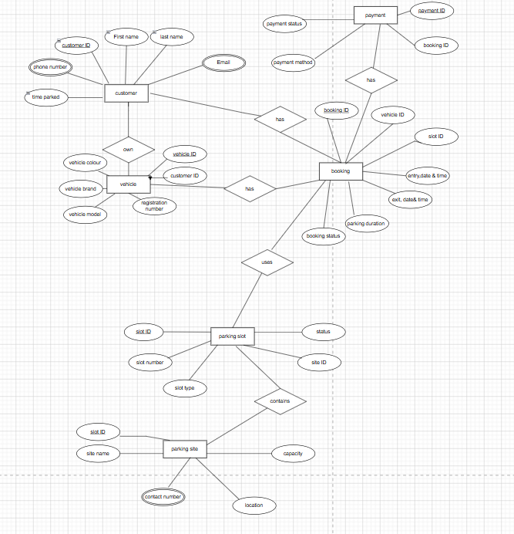
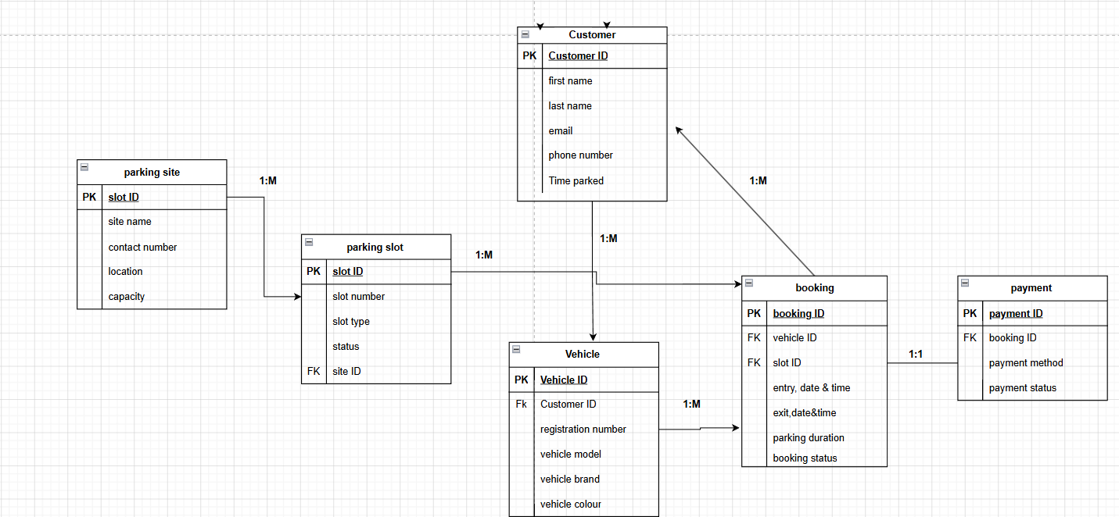

- For primary key is used to represent the auto data on the data type because it uses a unique identifier without anyone typing it in.

- For foreign key I used number for the data type

- Any start time and end times is used date/time for data type

- Anything that required just plan text I used short text in my data type

Booking
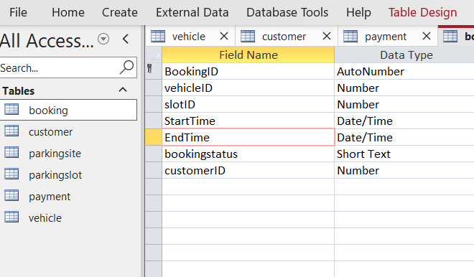
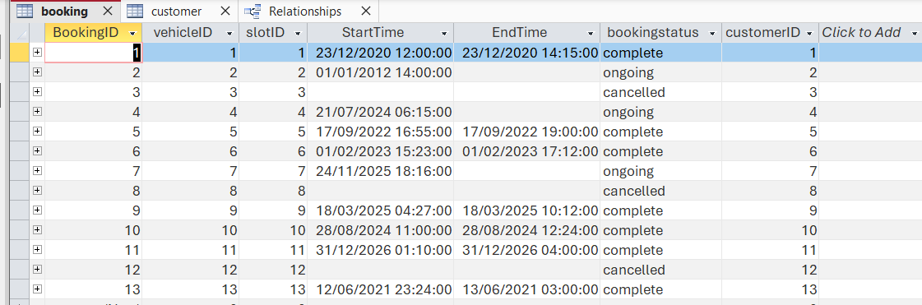
customer
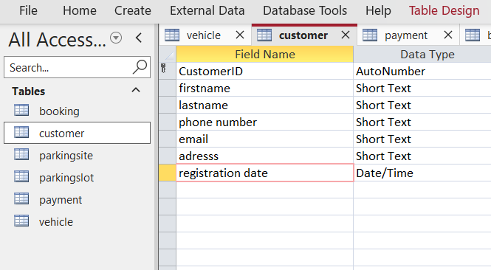
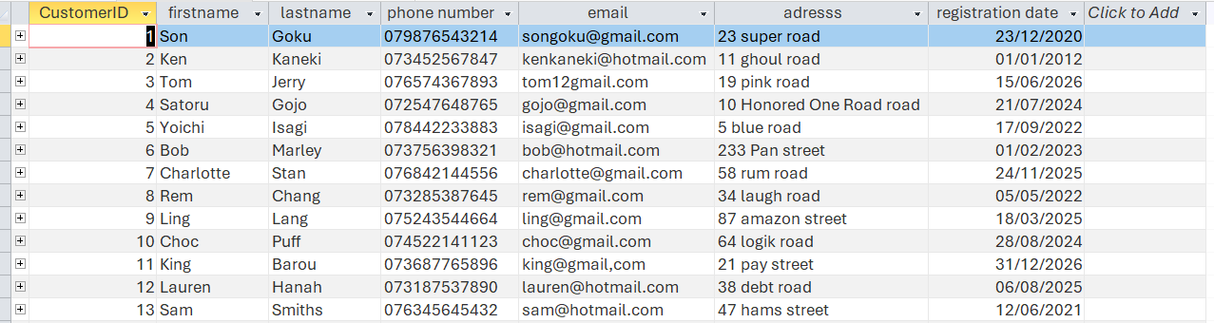

Parking site

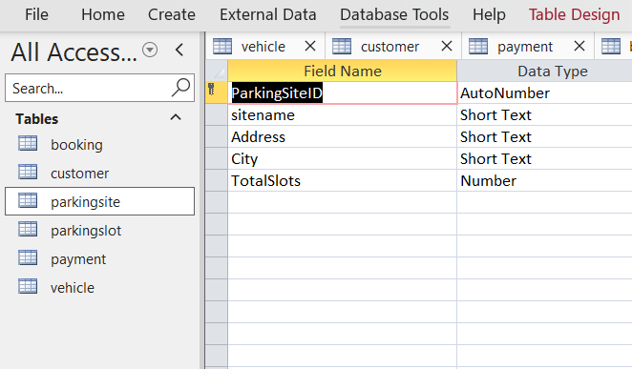
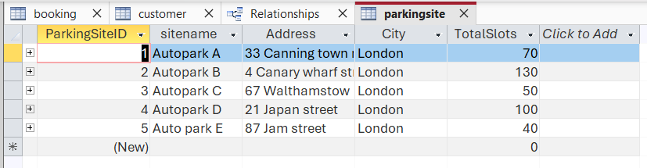

Parking slot
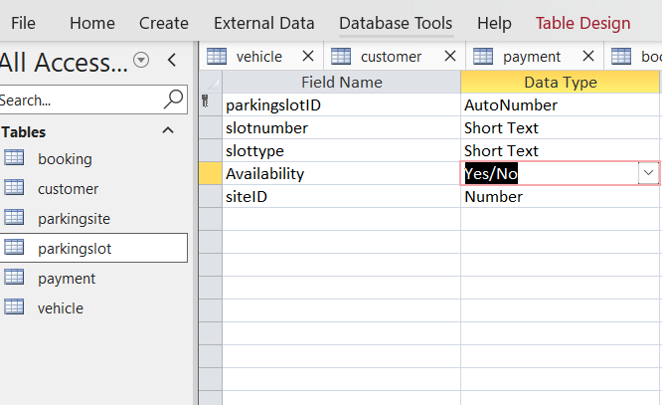
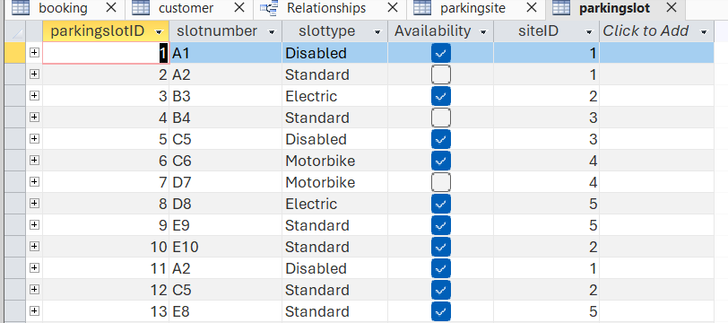

Payment
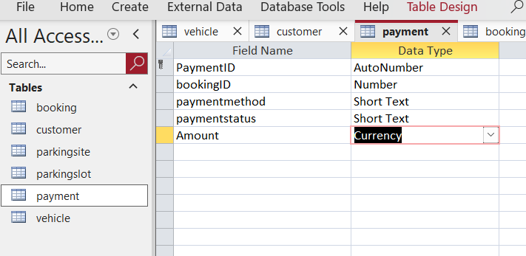
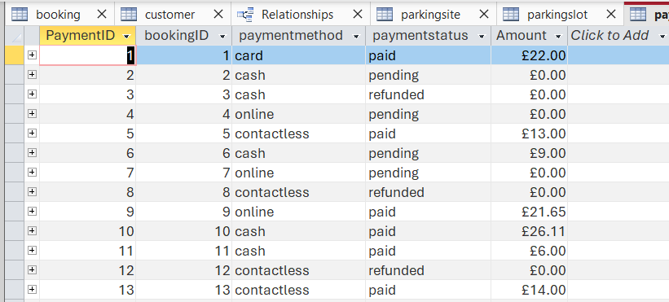

Vehicle
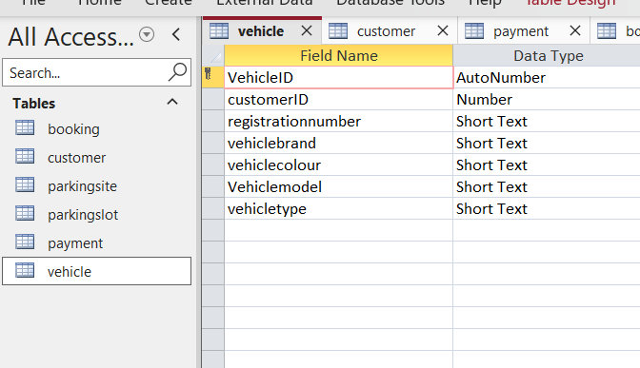
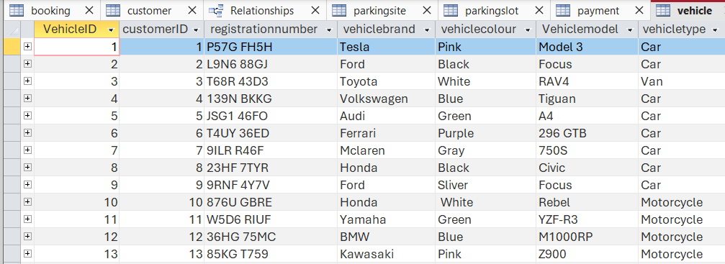

When I first tried to run the SQL it didn’t work at all howver after looking back at my work I realsed I add spaces in all on my field which cause the SQL Query not to run howver hafter fixing this isssue it was allowing me to select my customerID

The problem with this one was the my SQL Didn’t match the table name I wrote in the datababe so to fix that I didn’t add the space.
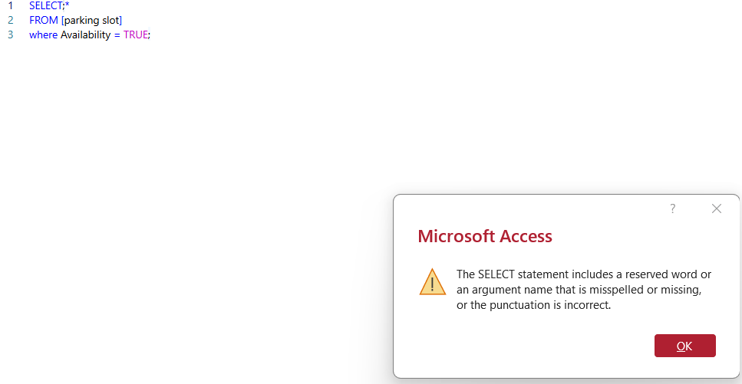

1-The purpose of this query is to see the booking information along with the payment details.

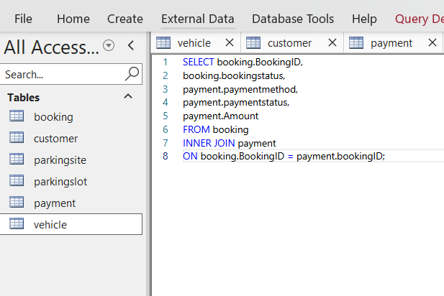
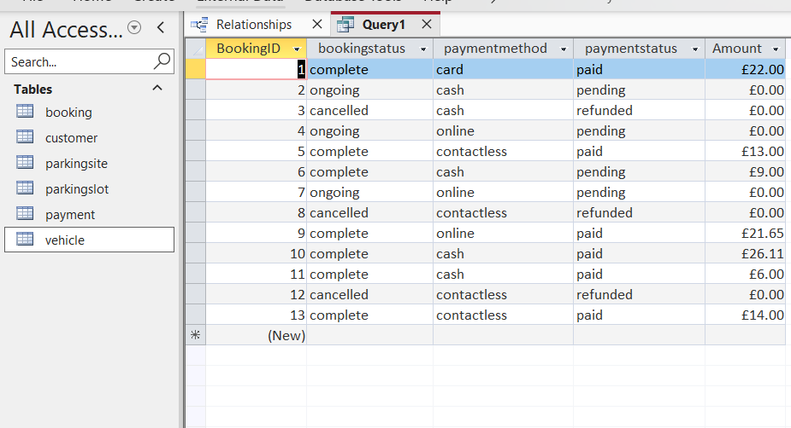

2-The purpose of this query is to find a customer by there last name
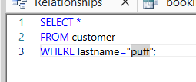
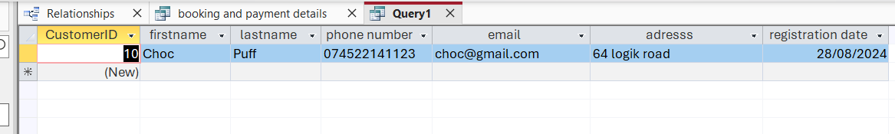

3-This is to show all the customers
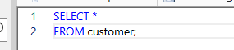
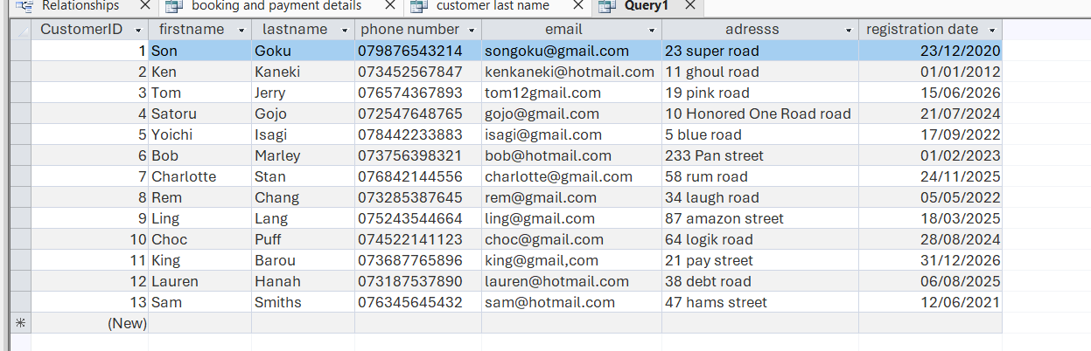

4-This is to show all the vehicles
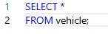
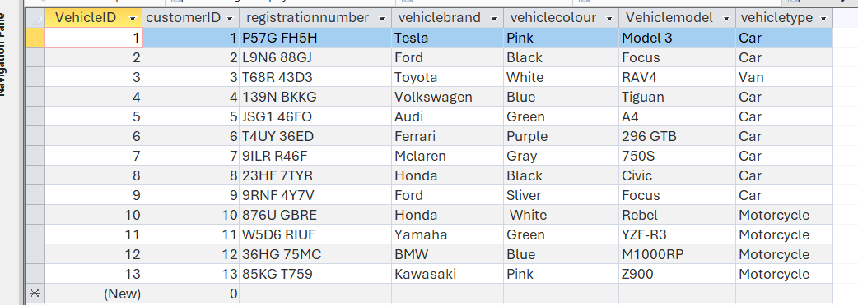

5-This is to show all pending payment
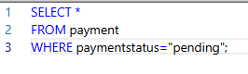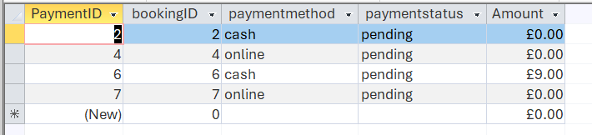

6- Shows all bookings
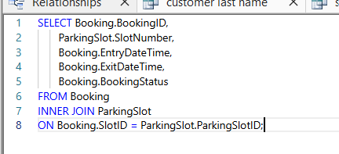
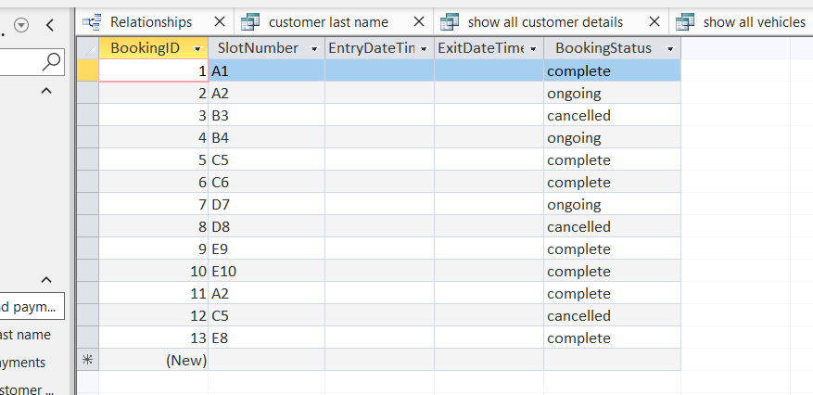

Test number | Test description | Expected results | Actual results | status
1 | Add a new customer | Cuter would be add successfully | Customer was added successfully | pass
2 | Add a new vehicle linked to existing customer ID | Vehicle is linked to the correct CustomerID | Vehicle saved with the correct CustomerID | Pass
3 | Add a parking slot to an existing parking site | Parking slot is linked to a valid SiteID | Parking slot saved successfully
4 | Open the Relationships window | All relationships are displayed correctly | Relationships displayed correctly | pass
5 | Run if you can get the Available parking slots from query | Only available parking slot are displayed | Query showed only available slots | pass

The completed database managing system demonstrates that it is far more reliable, swift and efficient manging the auto park operation compared to using old manual ways.

References

[1] Azcorra, "lighting guide to database with Microsoft access,"

