Max Jones (2305556)

Analyse and discuss network security
ACCA4024

Table of Contents
Introduction 1
Part 1: 1
a) 1
b) 2
c) 3
Part 2 5
a) 5
b) 5
Conclusion 6

Introduction
In the modern age data and personal information is a gold mine for bad actors who wish to cause harm to an individual or an organisation. This is why data security is paramount. I will discuss what are the basics of good cybersecurity, common attacks and how to prevent them as well as best precautions against possible data breaches or network failures.

Part 1:

a)
The NIST cybersecurity Framework is a collection of standards, guidelines, and best practices to assist organisations in managing and improving their cybersecurity risk management procedures. The five core functions of the framework consist of Identify, Protect, Detect, Respond and Recover.
The ‘Identify’ function refers to gaining a comprehensive understanding of the organisation’s cybersecurity environment. This includes its assets and any risks that the organisation may have. Having this basic understanding can help develop effective cybersecurity safeguarding that will help protect against any threats.
The ‘Protect’ function represents implementing any safeguarding techniques to ensure that the network and data is secure. This can help reduce the likelihood and how detrimental an attack is. One good preventative measure would be creating a comprehensive training regimen to ensure that all employees take cybersecurity as serious as possible. This makes attacks such as phishing less likely as employees will be more aware of what to look out for minimising the risk.
The ‘Detect’ function focuses on identifying any threats as soon as possible. By detecting an incident early an organization can minimise the damage caused and can respond effectively. To do this there must be constant monitoring of the networks, this allows the organization to detect any anomalies or deviations in normal traffic. With this information an organisation may be able to prevent an attack before it happens or at least minimise the effect that it will have.
The ‘Respond’ function refers to the capability of effectively and promptly responding to any breaches or incidents. This can be done by implementing response plans that outline the steps that need to be taken in the event of a breach. As well as having effective plans another effective response is to take appropriate mitigation measures, this would include disabling any compromised accounts or hardware to ensure that the attacker doesn’t have access through those means. The most important response is to learn from the attack and improve the security by identifying and fixing any gaps or weaknesses that can be used in future incidents.
The ‘Recover’ Function focuses on the ability an organisation has to recover from any incidents or breaches and restoring any affected systems or operations back to normal. Organisations may strengthen their resilience and preparedness to handle unforeseen future breaches by putting recovery plans into action, carrying out post-breach evaluations, and making any adjustments in light of the lessons learned from the evaluations.
These core five functions ensure that every organisation that follows this framework have a comprehensive and resilient. As well as being resilient it gives the organisation the ability to protect their data and in case of any cybersecurity threats they can be dealt with efficiently and effectively.

b)
Nmap and Wireshark are both very important tools that can be used in the reconnaissance stage of a cyber-attack due to their ability to gather information about the target and the network to identify any potential vulnerabilities. They both are used to gain any necessary information to help execute an attack more efficiently.
Nmap is a tool that is used to scan networks to discover what hosts are on the network and any services that may be running. Nmap works by sending packets to the target network and analysing its response [1]. In the reconnaissance stage of a cyber-attack Nmap is used to perform a variety of tasks one of which being port scanning to identify any open ports that could be potential weak points. Nmap also has the ability to detect services that may be running, this can be used by the attacker to use known vulnerabilities in those services. Nmap can also detect operating systems on target hosts which can be used to exploit any vulnerabilities [2].
Wireshark is a tool that is also used in the reconnaissance stage of a cyber-attack. Wireshark is used to analyse data traveling on a network in real-time. In the reconnaissance stage it can be used to capture packets and analyse them for any valuable information, this might include information that can be used to gain unauthorized access to a system. It can also be used to detect any improperly secured network services that can be exploited by the attacker [3]. Similarly to Nmap, Wireshark can map out a network and identify devices and other network elements which can provide insights of the network to the attacker.

c)
WannaCry is a ransomware that has infected hundreds of thousands of computers. It operates by exploiting the ‘EternalBlue’ vulnerability in Windows [4] .After infecting a system, it uses a strong encryption method to encrypt every file on the pc, making them inaccessible to the user. After encrypting the ransomware then displays a ransom note demanding a payment in Bitcoin so the user can obtain the decryption key. If no payment is received the encrypted files are permanently deleted. The way WannaCry propagates is by scanning for other systems on the network that have the EternalBlue vulnerability [5]
There are many ways to mitigate the WannaCry ransomware, one way would be to apply the security patch that addresses the ‘EternalBlue’ vulnerability that was used to help WannaCry spread. Another way to reduce the ability of WannaCry would be to implement a network monitoring tool that detects any suspicious activity and possible malware, if an organisation detects the infection early enough, they can mitigate the impact the infection would have. A final way to mitigate the effect a WannaCry infection would have is to regularly backup important files, however these backups must not be connected to the network as to not have the backups also be infected by the worm like nature of WannaCry.
TeleRAT is a remote access trojan virus used to target Android devices. It infects targets by pretending to be legitimate telecommunications apps. After TeleRAT has infected the target, it establishes a connection to a control server that is used by the attackers to remotely access the infected device, from here the attacker can execute commands and get data from the infected device. The data an attacker may retrieve may include photos and videos as well as passwords. Data taken through these means can be used in very nefarious means, in some cases even committing identity theft or financial fraud [6]
Mitigating TeleRAT attacks can be done by many strategies, you can be cautious of what you are downloading and the source and be careful of what permissions you give those applications. As well as that you can install a reputable mobile antivirus and security which can help block any malicious apps. And the most important would be to keep your device up to date on the security patches as these patches will squash any known vulnerabilities. In terms of an organisation keeping safe against a teleRAT attack one main measure would be to educate everyone on the dangers of downloading from untrusted sources and any suspicious links.
Whaling and Pharming are sophisticated ways to use a phishing attack [7]. They often have the intent of stealing sensitive information of victims be it individuals or an organisation.
Whaling is the act of targeting high level individuals with access to the information they are trying to gather, they then impersonate these individuals with the hope of tricking employees into giving away the information or even authorizing any fraudulent transactions. An attacker may achieve this by, a variety of tactics such as Spear phishing to gain access to the high-level individuals accounts to make the request seem more official, or they could potentially spoof their email address to make it appear as if they are the individual [8]
To help mitigate against whaling attacks an organisation can include a multitude of strategies one of which being training employees the risks of whaling attacks and how to spot them and or other phishing attacks, this would also include teaching employees to verify email requests before responding especially ones asking for sensitive information. Another way to mitigate whaling attacks would be to include multi-factor authentication for accessing accounts and other sensitive systems, be it using a verification application or SMS based authentication. This would provide another layer which would make it harder for unauthorized access to be obtained [9]

Pharming on the other hand is the act of impersonating a website and redirecting users to a fraudulent website where the user is prompted to enter their sensitive data or even download malware. This can pose a risk as any compromised accounts can be used to breach confidential data.
To mitigate against pharming attacks an organisation could make use of network monitoring to ensure that employees are not connecting to any suspicious or anomalous DNS requests. Network monitoring would also be able to spot signs of DNS spoofing and can prompt the user warning them that it may be a false web page. On top of network monitoring and like others mentioned before educating the user on the dangers and possibilities of pharming attacks can help mitigate the attacks, teaching users to look for HTTPS encryption and to be cautious when and where they are entering sensitive information.

Part 2
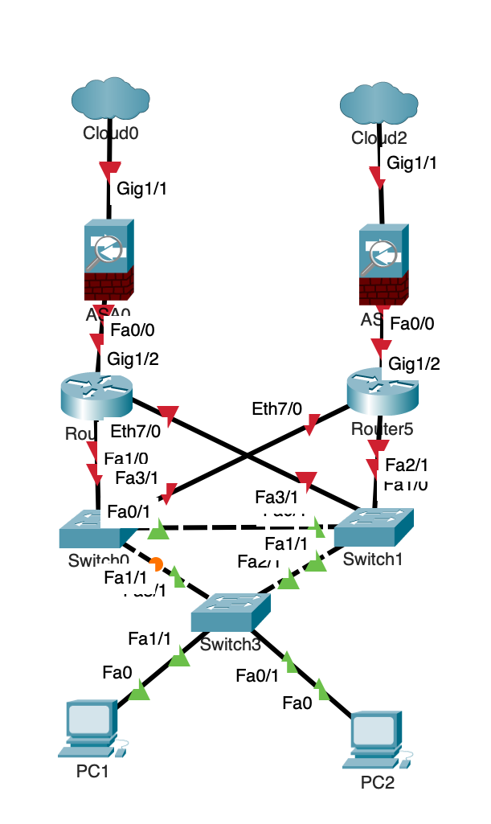

a)
Using packet tracer I have designed the above diagram; The network should provide high availability due to having multiples of each part which provides redundancy at each layer. Having redundancy like that shown above ensures that if any part fails, the network is still usable due to there being a backup available. I also included multiple paths so that the traffic can flow through. this ensures that there are pathways which can facilitate any crossover connections, this gives the network another form of redundancy.

b)
There are several software and hardware technologies that can be used to enhance network security. Firewalls can act as a first line of defence against a cyber-attack, fire walls can be both software and hardware. Hardware firewalls are can either be found as their own devices or built into the routers, they examine the traffic that is being sent through the network filtering it based upon predetermined criteria which blocks unauthorized access and threats. Software firewalls on the other hand, run on the individual end-point system which adds a layer of security on the device level [10]. More software-based technology that can be used to help enhance network security are Intrusion Detection and Prevention Systems. Intrusion detection systems monitor traffic and detects suspicious activity, if it detects an anomaly, it then logs and alerts the user. Intrusion Prevention Systems are very similar in the fact that they monitor network traffic for suspicious activity, however instead of just logging it the prevention systems automatically responds to the potential malicious activity by blocking the packets from coming into the network [11]. another technology that can be used to secure the network would be Data Loss Prevention appliances, they can help safeguard sensitive data and prevent data breaches by controlling and securing the flow of data within a network, they first detect what data is being sent and then uses predefined rules on how that data should be handled including if it can be transmitted or stored, they also monitor data transactions within the network allowing the ability to monitor the movement of the data, if any breach occurs or violation within the policies occur they provide alerts so the network administrator can investigate. Some DLP appliances can also offer data encryption to ensure that even if there is a breach the data cannot be viewed unless decrypted [12].

Conclusion
Overall, from my findings I believe that there are many ways to keep a network and its data secure. However, I believe that a strong and thorough training regimen is paramount. This is due to majority of attacks being down to negligence from employees or users of the network. Having training that is repeatedly refreshed and up to date ensures that everyone can be as vigilant as possible.

References
[1] S. Joshi, "What is Nmap And Why You Should Use It?", The Hack Report, http://thehackreport.com/what-is-nmap-and-why-you-should-use-it/ (accessed May 1, 2024).
[2] V. Muhungu. "Types of Nmap scans and best practices | TechTarget." Networking. https://www.techtarget.com/searchnetworking/tip/Types-of-Nmap-scans-and-best-practices (accessed May 1,).
[3] "What Is Wireshark and How to Use It | Cybersecurity." CompTIA. https://www.comptia.org/content/articles/what-is-wireshark-and-how-to-use-it (accessed May 1,).
[4] B. Gorman. "EternalBlue Exploit: What Is It and Is It Still a Threat?" EternalBlue Exploit: What Is It and Is It Still a Threat?. https://www.avg.com/en/signal/eternal-blue (accessed May 3,).
[5] A. McNeil. "How did the WannaCry ransomworm spread?" ThreatDown by Malwarebytes. https://www.threatdown.com/blog/how-did-the-wannacry-ransomworm-spread/ (accessed May 1,).
[6] R. N. Wilhoit Kyle, "TeleRAT: Another Android Trojan Leveraging Telegram’s Bot API to Target Iranian Users", Unit 42, https://unit42.paloaltonetworks.com/unit42-telerat-another-android-trojan-leveraging-telegrams-bot-api-to-target-iranian-users/ (accessed May 1, 2024).
[7] "What is a Whaling Attack? | Whaling Phishing." Mimecast. https://www.mimecast.com/content/whaling-phishing-attack/ (accessed May 1,).
[8] "Business email compromise: defending your organisation ," 30/04/ 2024. Available: https://www.ncsc.gov.uk/guidance/business-email-compromise-defending-your-organisation
[9] "The Importance of Multi-Factor Authentication." University of Arkansas News. https://news.uark.edu/articles/66470 (accessed May 1,).
[10] "Hardware Firewalls vs. Software Firewalls." Palo Alto Networks. https://www.paloaltonetworks.com/cyberpedia/hardware-firewall-vs-software-firewall (accessed May 2,).
[11] "What is Intrusion Prevention System? | VMware Glossary." VMware. https://www.vmware.com/topics/glossary/content/intrusion-prevention-system.html (accessed May 2,).
[12] "Standard vs Advanced Data Loss Prevention (DLP) Measures: What's the Difference." Logix Consulting Managed IT Support Services Seattle. https://logixconsulting.com/2021/05/13/standard-vs-advanced-data-loss-prevention-dlp-measures-whats-the-difference/ (accessed May 3,).

