DS 1 Template

My Screenshots/Photos
- Please add 4–6 screenshots or photos of your digital life.
- You can use your phone or laptop.
- For each screenshot, write one or two sentences explaining what it shows

Marina Gerard 2536735

Screenshot/Photo 1
[Insert Photo/Screenshot below]
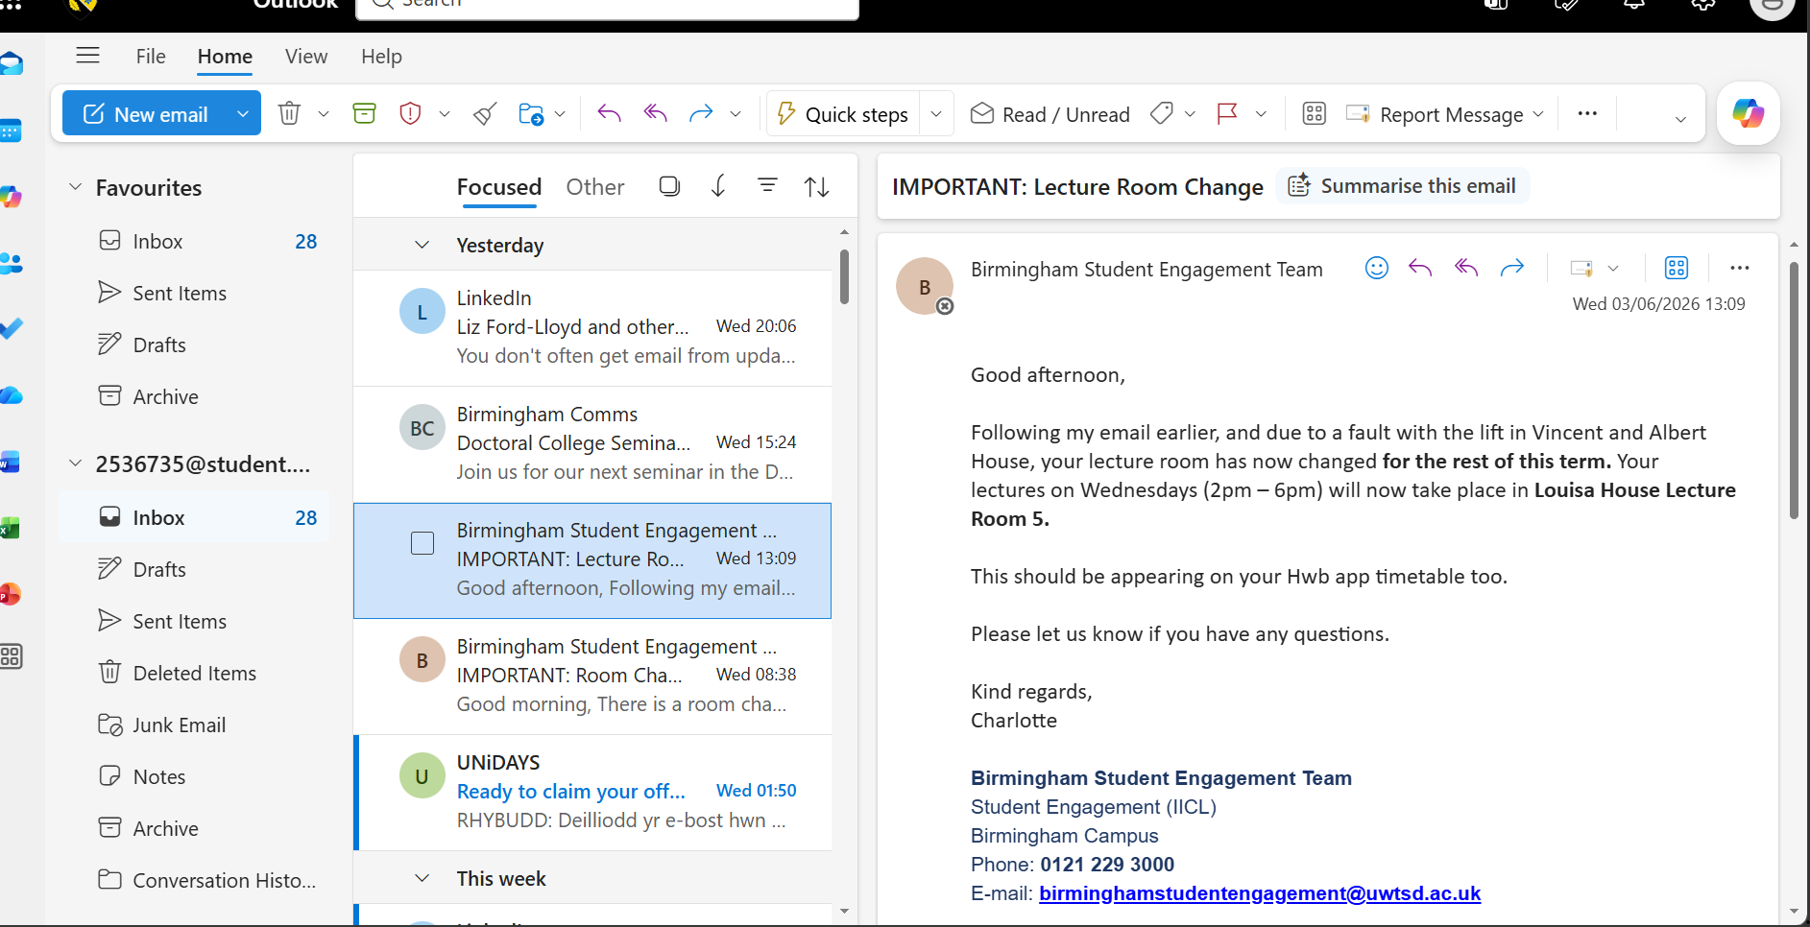
This photo shows how I use digital skills. Throughout Outlook, I receive important emails. Checking email regularly to communicate with my university and manage my studies. This particular email explains that my Wednesday lectures will take place in a different room.

Screenshot/Photo 2
[Insert Photo/Screenshot below]
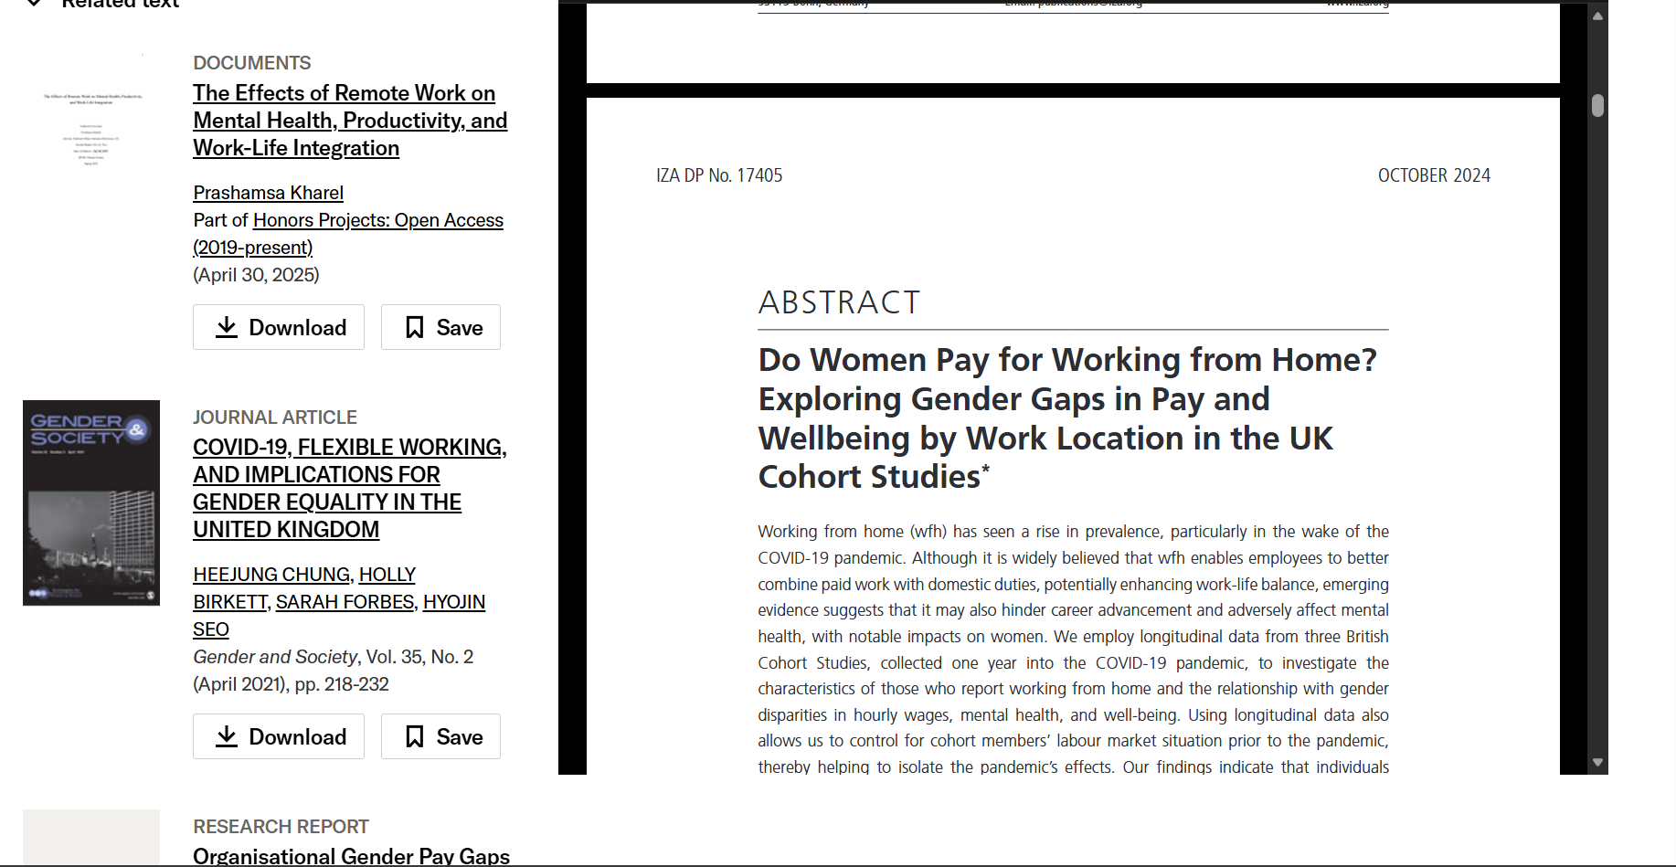
This shows the abstract of a research article that I found online. I use digital resources to help lean about topics and complete my university course work. This abstract discusses the effects of working from home, wellbeing and gender equality in the UK. Reding abstract help, me identify relevant sources before studying the full paper.

Screenshot/Photo 3
[Insert Photo/Screenshot below]
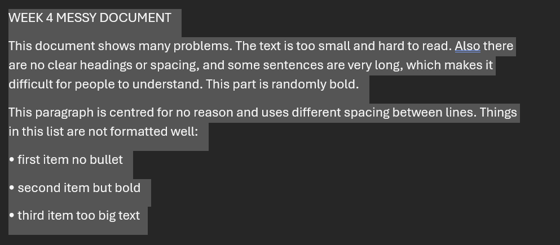
This contains a mixture of university work, download files, and personal documents.it shows how digital tools help me store and access information quickly.

Screenshot/Photo 4
[Insert Photo/Screenshot below]
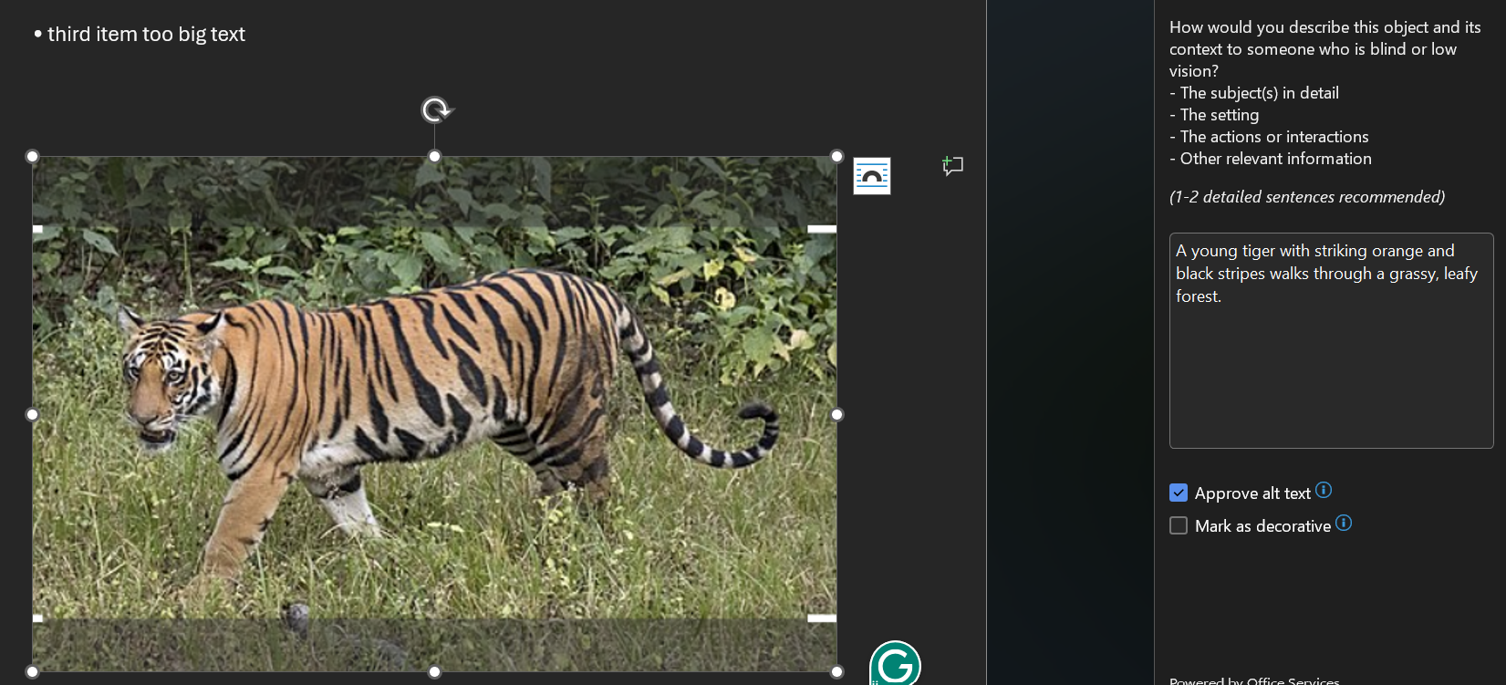
Writing alt text – the accessibility description used so people who are blind or have low vision can understand what the image is. The description is showing to translate an image into meaningful text without over explaining.

Screenshot/Photo 5
[Insert Photo/Screenshot below]
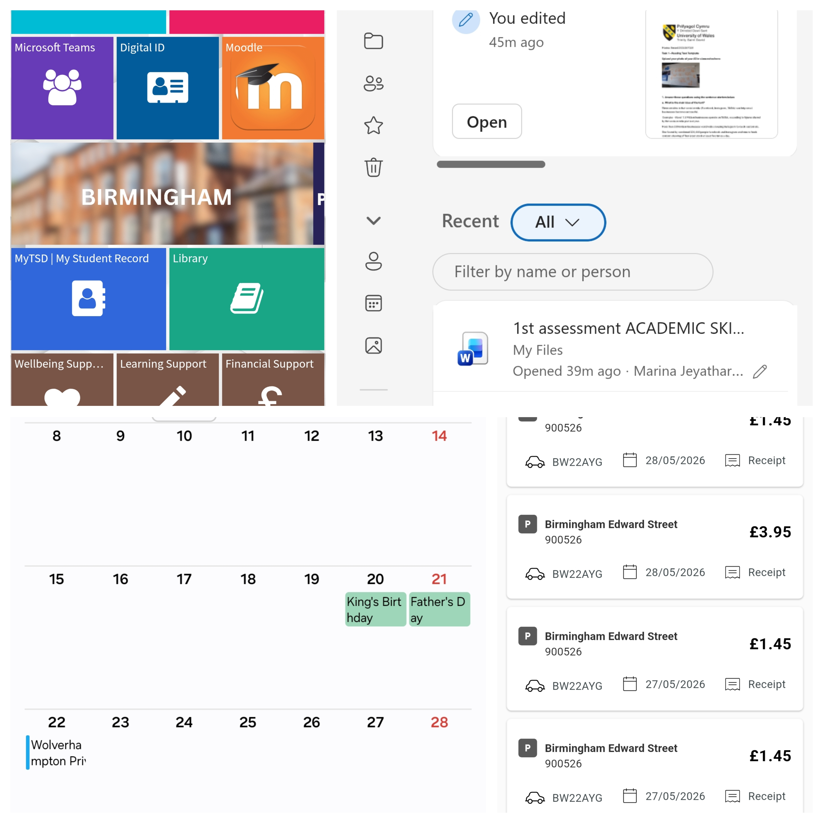
The collage looks like a collection of screenshots related to a student's daily life:
- University studies (Moodle, Teams, student records)
First picture showing HWB for university of Wales Trinity saint David Birminhagm campus.
- Document work
2nd document is file management like saving file, rename and assessment
- Personal scheduling
It’s a monthly calendar saving an appointment, remembering important dates
- Transportation or parking payments
It’s about parking payment. it’s showing how to use the digital skills in the daily life.

Screenshot/Photo 6
[Insert Photo/Screenshot below]
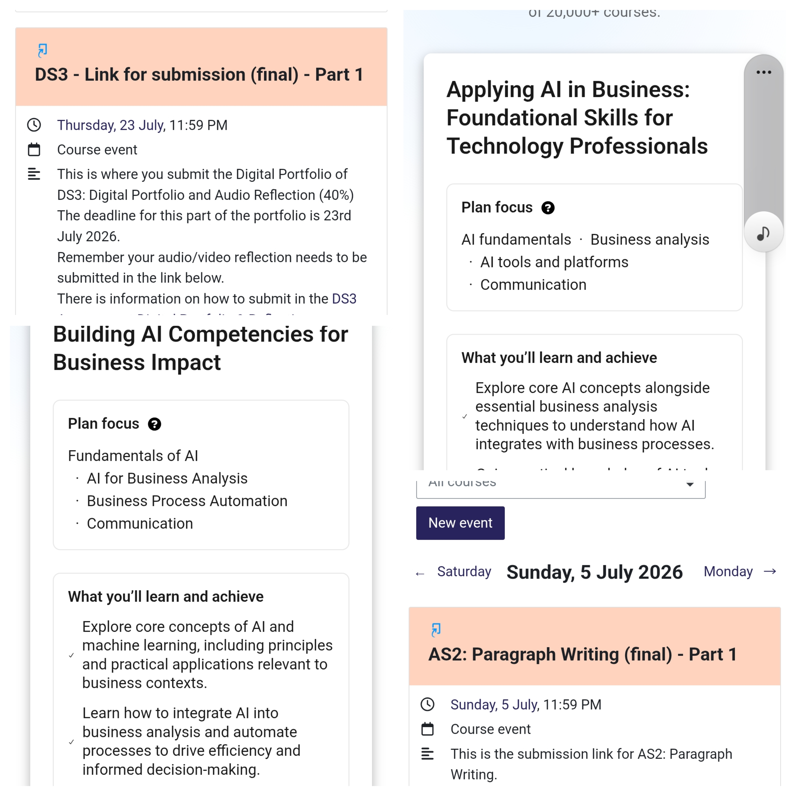
This screen shot talking about the assessment. when is deadline and how to submit the assessment. Part 1,due on 23 July 2026 at 11:59 PM. The description explains that students must submit their Digital Portfolio and Audio Reflection,and also telling about the AI focused learning .

My Short Reflection
- Write 5–8 simple sentences about your digital life.
- You can use the sentence starters below if helpful.
I often use digital skills for translation like Tamil to English or English to Tamil.
Get some help with car related issue.
I often use this tools banking, parking, translating, movie and social media
My digital language is Multilingual (English +Tamil mix)
Sometimes I’m feel nerves about my grammar and spelling. because English is my second language.
I feel confident when using map, google search ,creating emails and sharing files.

Overall, I used digital tools to manage studies, documents, schedules, and daily expenses.

Sentence starters
- I use digital tools to …
- I feel confident when I …
- I want to improve …
- I often use these tools: …
- I sometimes feel nervous about …
- I hope this module will help me …
- Digital skills are important for me because …
You can write more if you want.

Submission Checklist
Before you submit, please check:
​​​ ☒ I added 4–6 screenshots
☒ I wrote short sentences for each screenshot
☒ I wrote my short reflection
☒ My work is my own
☒ My file opens correctly
​​☒ My file opens correctly

