MSc Sustainable Construction
ACBA7002 – Construction Technology and BIM

Student Name: Md Ahsan Alahi Rafi
Student ID :2511326
Supervisor Name: Gavin Traylor
Date of Submission: 19/04/2026

BIM as a whole life process and a Building Management Tool

Table of Contents
Dylan Thomas Centre 4
THEME A: BIM for existing building stock 4
Introduction 4
How BIM Technologies Support Existing Buildings: 5
Creating Data-Rich Models for Existing Buildings: 6
Laser Scanning (LiDAR) 6
Point Cloud Capture (Laser Scanning) 6
Point Cloud to BIM (Scan-to-BIM Modelling) 6
Data Enrichment (Adding Non-Geometric Information) 7
Examples of data enrichment include: 7
Level of Detail (LOD) and Level of Information (LOI) 7
Industry Examples: 8
Maintenance regimes of the Facilities Management: 8
Digital Drawing and Modelling Tools 8
Opportunities for BIM Integration 8
Challenges Identified 9
Skills and Training 9
Interoperability 9
Resource Constraints 9
Theme B – Data Investigation & Discrepancies 11
Correction & Mitigation Through BIM 12
Conclusion: 13
THEME C: 14
INTRODUCTION: 14
Concept of Asset Tagging and Its Role in Proactive Maintenance: 14
Asset Tagging Workflow Using Revizto 14
Generating QR Codes in Revizto 14
Viewing Asset Properties 15
Integration with Revit for Enhanced Asset Data 15
Practical FM Workflow: QR-Enabled Maintenance 15
Conclusion: 16
References: 17

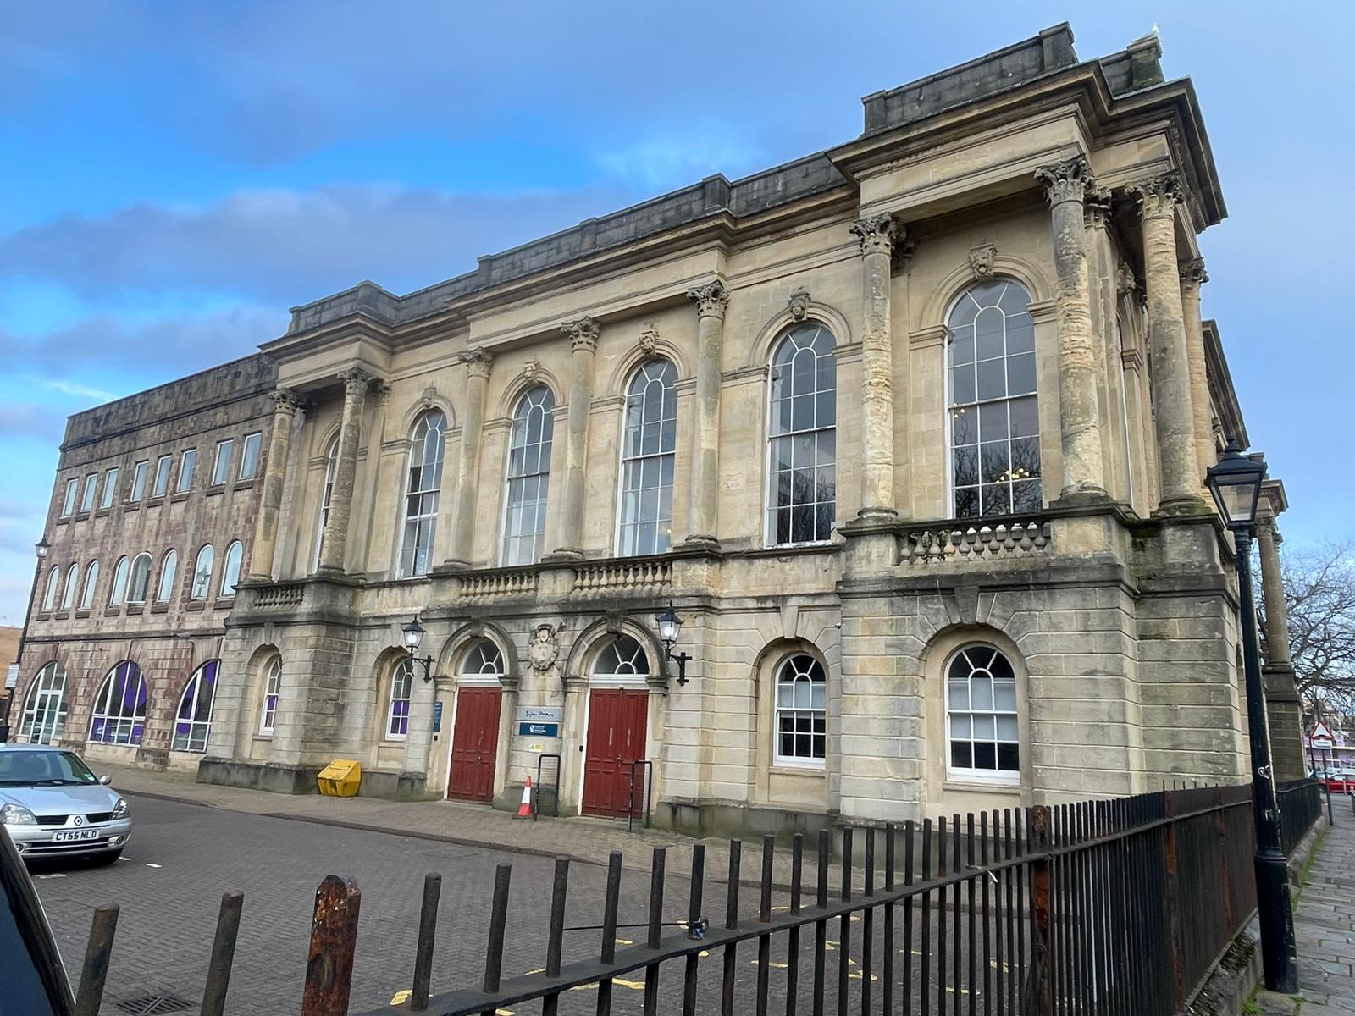
Dylan Thomas Centre

THEME A: BIM for existing building stock

Introduction
Building (Construction) Information Model (BIM) is defined by international standards as “shared digital representation of physical and functional characteristics of any built object, which forms a reliable basis for decisions”. BIMs originate from product models that are widely applied in the petrochemical, automotive. The building and construction industry has been driven to adopt green building strategies in light of increasing sustainability concerns such as reducing CO2 emission and energy dependency on fossil fuels. As a revolutionary technology and process, Building In formation Modeling (BIM) has been regarded by many as a significant opportunity in the architecture, engineering and construction (AEC) industry. The Dylan Thomas Centre is among the most difficult typologies; they were originally not designed to be very energy efficient, long-lasting, or whole-life performing.
Although fabric improvements and low-carbon technologies are mainly incorporated in the retrofit strategies, there is an increasing body of evidence, which shows that ineffective maintenance management and low operational controls can greatly harm the success of the retrofit strategies in a long-term perspective. The delivery of expected savings in the energy, carbon and benefits on occupants is not realized in retrofit measures that are not managed, monitored and maintained. As a result, it should not only focus on physical upgrades but also on the management and control systems according to which building operation and maintenance are provided during the lifecycle of the assets.
While UWTSD has successfully adopted BIM for new-build projects, the majority of its estate-such as the Dylan Thomas Centre-consists of older, pre-digital buildings. These buildings typically suffer from fragmented documentation, inconsistent drawings, and limited visibility of building services. BIM technologies offer a structured, data-driven approach to modernizing the management of these legacy assets.

How BIM Technologies Support Existing Buildings:
While BIM is often associated with new construction, its value for existing buildings is increasingly recognized in higher-education estates. BIM can support:
- Asset management and lifecycle planning
- Space utilization and timetable
- Energy modelling and sustainability planning
- Capital planning for refurbishment and compliance upgrades
- Maintenance scheduling and condition monitoring
- To address this challenge, the construction industry increasingly relies on the Scan-to-BIM process, which enables existing buildings to be captured, modelled, and enriched with data to create accurate digital twins. This approach is directly relevant to UWTSD, particularly in buildings such as the Dylan Thomas Centre, where laser scanning surveys have already been undertaken.

Creating Data-Rich Models for Existing Buildings:
The Scan-to-BIM process:

Laser Scanning (LiDAR)
- Produces a high-density point cloud
- Captures geometry with millimeter accuracy

Point Cloud Capture (Laser Scanning)
The first stage in digitizing an existing building is the collection of accurate geometric data. At UWTSD, this has been demonstrated through the laser scanning survey undertaken at the Dylan Thomas Centre. Terrestrial LiDAR scanners emit laser pulses that measure distances to surrounding surfaces, producing a high-density point cloud.
Key advantages include:
- Millimeter-level accuracy
- Rapid capture of complex or historic geometry
- Non-intrusive surveying suitable for occupied buildings
- Reliable documentation where existing drawings are outdated or missing
Laser scanning is widely used across the industry. For example, the Palace of Westminster Restoration Programmed relied on billions of scan points to document irregular heritage geometry, while airports such as Heathrow Terminal 2 used LiDAR to support refurbishment planning and MEP coordination.

Point Cloud to BIM (Scan-to-BIM Modelling)
Once the point cloud is captured, it is imported into BIM authoring software such as Autodesk Revit. The modeler interprets the scan data and reconstructs the building using parametric BIM elements.
This stage involves:
- Identifying walls, floors, roofs, windows, and structural elements
- Reconstructing MEP systems where visible
- Ensuring the model accurately reflects the as-built condition
The resulting BIM model becomes a reliable digital representation of the building, suitable for refurbishment planning, space management, and long-term asset management.

Data Enrichment (Adding Non-Geometric Information)
After the geometric model is complete, the next step is to enrich it with non-geometric data. This transforms the model from a visual representation into a functional asset management tool.

Examples of data enrichment include:
- Material specifications
- Condition assessments
- Asset performance data
- Manufacturer details and warranty information
- Maintenance intervals and replacement cycles
This process aligns with industry standards such as Cobie and supports the creation of a comprehensive digital twin.

Level of Detail (LOD) and Level of Information (LOI)
The usefulness of a Scan-to-BIM model depends on the required Level of Detail (LOD) and Level of Information (LOI).
- LOD defines the graphical accuracy of the model (e.g., simplified geometry vs. highly detailed heritage features).
- LOI defines the richness of the data attached to each element (e.g., basic descriptions vs. full asset metadata).
For UWTSD, appropriate LOD/LOI levels depend on the intended use:
- LOD 200–300 for general FM use and space planning
- LOD 350–400 for refurbishment or MEP coordination
- Higher LOI for lifecycle costing and maintenance planning

Industry Examples:
The University of the West of England (UWE Bristol) provides a leading industry example of how BIM can be systematically embedded to create a data-rich digital estate. Through its structured “digital recipe” approach, UWE has developed a repeatable methodology for defining, producing, and managing building information across the full asset lifecycle.

Maintenance regimes of the Facilities Management:
To understand how BIM could support the management of existing buildings within the UWTSD estate, it is essential to evaluate the current practices, digital tools, and operational challenges of the Facilities Management (FM) team. The survey responses provide valuable insight into the team’s present capabilities and highlight areas where BIM integration could enhance efficiency and decision-making.

Digital Drawing and Modelling Tools
The FM team relies on a combination of:
- AutoCAD for 2D plans and legacy drawing updates
- SketchUp for quick 3D visualizations
- Occasional Revit use, typically when engaging with new-build BIM models or consultant-provided files

Opportunities for BIM Integration
BIM can significantly enhance FM operations:
1. Asset Information Models (AIM)
- Centralized database of maintainable assets
- Cobie-structured data for import into CAFM
- Improved accuracy of asset registers
2. Preventative Maintenance
- BIM-linked schedules for HVAC, electrical, and plumbing systems
- Visualization of asset locations reduces time spent locating equipment
3. Space and Room Data Management
- Accurate room geometry for timetabling and utilization studies
- Integration with space-booking systems
4. Compliance and Safety
- Fire strategy models
- Accessibility audits
- Asbestos management overlays

5. Energy and Sustainability
- Digital twins for energy modelling
- Simulation of retrofit options

Challenges Identified
Despite the opportunities, several challenges must be acknowledged:

Skills and Training
- FM staff are familiar with AutoCAD but have limited experience with BIM tools. A structured training program would be required.

Interoperability
- Existing energy systems and CAD files would need to be integrated into a BIM-compatible platform.

Resource Constraints
- Scan-to-BIM modelling and data enrichment require investment in both time and budget.

Theme B – Data Investigation & Discrepancies
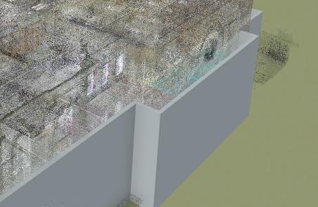
Figure :2d and 3d drawing of External wall
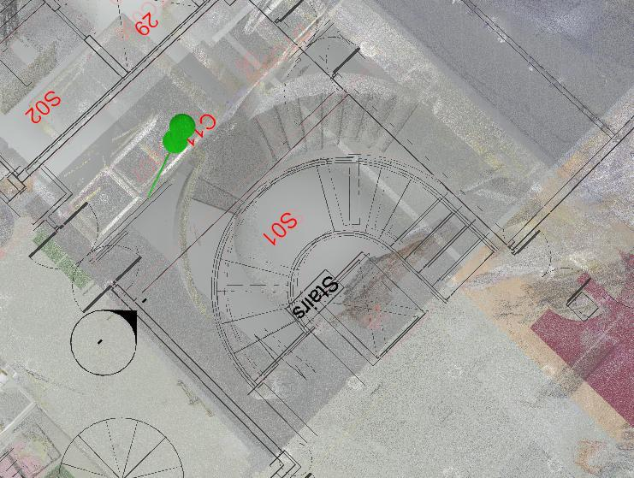
Figure:2d and 3d drawing of Stair section
The comparison between the existing 2D AutoCAD drawings and the 3D laser-scan model of the Dylan Thomas Centre reveals several significant discrepancies in the as-built information. The most noticeable issues relate to geometric inaccuracies, where wall positions, room dimensions, and the placement of windows and doors differ between the CAD plans and the verified 3D scan. These inconsistencies clearly show that the 2D drawings do not accurately represent the real on-site conditions. The FM team currently relies on these outdated CAD plans for area measurements and energy calculations, meaning that heating, cooling, and ventilation loads are being calculated using incorrect spatial data. This leads to inefficient system performance and inaccurate energy modelling.
Further discrepancies are evident in the alignment of major building elements. For example, the staircase shown in the 2D drawings does not match the position and geometry captured in the 3D model, indicating that either construction changes were never recorded or the original drawings were inaccurate. Similar misalignments can be seen in the external wall geometry, where the 2D representation fails to match the true shape and position shown in the point-cloud model. These issues confirm a lack of synchronisation between historical and current data sets, demonstrating that the existing as-built documentation is unreliable and requires correction through a BIM-based verification process.

Correction & Mitigation Through BIM
To correct the discrepancies identified between the 2D CAD drawings and the 3D laser-scan model of the Dylan Thomas Centre, BIM provides a structured and reliable method for updating and managing the building’s information. The verified point-cloud data should be adopted as the accurate “single source of truth,” allowing the BIM model to be rebuilt or corrected so that wall positions, room dimensions, stair alignments and external wall geometry accurately reflect real on-site conditions. Once the BIM model is updated, all historical information-such as legacy drawings, O&M manuals and asset register scan be coordinated within a Common Data Environment to ensure consistency across all data sets. This process enables errors to be flagged, reviewed and resolved systematically. To prevent future discrepancies, strong data governance must be implemented: all refurbishments should be recorded directly in the BIM model, FM teams should use digital asset tagging (QR/RFID) to maintain accurate asset information, and periodic verification surveys should be carried out to ensure the digital model remains aligned with the physical building. This BIM-based approach ensures that FM operations, energy calculations and compliance assessments are based on accurate, up-to-date information.

Conclusion:
The investigation of the Dylan Thomas Centre’s existing as-Built Information clearly demonstrate that the current 2D CAD drawings are no longer an accurate or reliable representation of the building. The comparison with the 3D laser-scan model revealed multiple geometric discrepancies- including incorrect wall positions, incorrect room dimensions, misaligned stair geometry and inconsistent window and door locations -which directly impact FM operations, energy modelling and assessments. Those findings highlight a long-standing lack of data coordination being used in decision-making. By adopting BIM as the central platform for verification, and data management, UWTSD can establish a single accurate source of truth for the building.

THEME C:

INTRODUCTION:
Asset tagging is a core maintenance management process that assigns a unique identifier to every physical building element and links it directly to its digital twin within the BIM model. For an existing UWTSD building, this approach provides a structured method for improving maintenance accuracy, reducing data fragmentation, and enabling proactive facilities management. By ensuring that each asset can be digitally located, interrogated, and updated, asset tagging becomes a foundational component of a modern strategy.

Concept of Asset Tagging and Its Role in Proactive Maintenance:
Asset tagging transforms traditional maintenance workflows by ensuring that every building component; whether architectural, structural, or MEP-has a traceable digital identity. This enables:
- Instant access to asset information (specifications, warranties, service history)
- Improved accuracy of maintenance records
- Faster fault diagnosis through precise asset identification
- Predictive and preventative maintenance based on real-time data
- Reduced duplication and data loss across FM systems
In a university estate with multiple buildings and thousands of assets, this level of control is essential for maintaining compliance, reducing operational risk, and extending asset life cycles.

Asset Tagging Workflow Using Revizto
Revizto provides a highly efficient method for generating asset tags and linking them to BIM model elements. The process is simple, repeatable, and scalable across the UWTSD estate.

Generating QR Codes in Revizto
- Select the object (e.g., wall, door, boiler) within the Revizto model.
- Right-click the object.
- Choose Generate QR Code.
- Select the sheet or view where the QR code will be placed.
Revizto instantly creates a QR code that is permanently linked to that specific model element. This QR code becomes the physical asset’s unique identifier.

Viewing Asset Properties
When an object is selected in Revizto, the Properties Panel displays all associated metadata, including:
- Asset number
- Manufacturer
- Model and serial number
- Installation date
- Warranty expiry
- Maintenance frequency
- Replacement cycle
- Linked documents (manuals, certificates, photos)
This ensures that the digital twin contains all information required for effective maintenance planning.

Integration with Revit for Enhanced Asset Data
Additional asset properties can be authored directly in Revit, where the BIM model is originally created or updated. These properties—such as installation dates, maintenance schedules, and manufacturer details—are automatically transferred into Revizto during model synchronisation.
This ensures:
- Consistency between design, construction, and FM data
- Accuracy of asset metadata
- Seamless updates when assets are replaced or upgraded
- Compliance with COBie and ISO 19650 information requirements

Practical FM Workflow: QR-Enabled Maintenance
In practice, the asset tagging workflow significantly improves on-site maintenance operations. For example:
- An FM technician approaches a boiler in the plant room.
- They scan the QR sticker attached to the boiler using a mobile device.
- Their phone automatically opens Revizto, displaying the digital twin of that exact boiler.
- The technician can instantly view:
  - Full maintenance history
  - Last service date
  - Outstanding tasks
  - Manufacturer documentation
  - Linked photographs or inspection notes
- The technician can update the record immediately after completing the task.
This eliminates the need to search through paper files, spreadsheets, or disconnected systems. It also ensures that maintenance decisions are based on accurate, real-time information.

Conclusion:
Asset tagging provides a clear and practical pathway for improving maintenance management across the UWTSD estate. By assigning each physical asset a unique QR-linked identifier and connecting it directly to its digital twin in Revizto, FM teams gain instant access to accurate, comprehensive, and up-to-date information. This includes maintenance history, installation details, manufacturer data, and statutory servicing requirements-all available through a single scan on a mobile device. Overall, asset tagging demonstrates how BIM technologies can deliver tangible operational benefits for existing buildings. It provides UWTSD with a scalable, future-proof method for managing its estate, enabling the university to transition from reactive maintenance practices to a more efficient, proactive, and digitally enabled FM strategy.

References:
Lua Y, Wub Z, Changa R, Lib Y,(2017) ‘Building Information Modeling (BIM) for green buildings: A critical review and future directions’ Automation in Construction 83, P.134-148 Building Information Modeling (BIM) for green buildings_ A critical review and future directions
Bortoluzzi B, Efremov I, Medina I, Sobieraj I, Arthur J, (2019) ‘Automating the creation of building information models for existing buildings’ Automation in Construction 105, Automating the creation of building information models for existing buildings - ScienceDirect
Xiong X, Adan A, Akinci B, Huber D, (2013) ‘Automatic creation of semantically rich 3D building models from laser scanner data’ Automation in Construction 31, P.325-337 Automatic creation of semantically rich 3D building models from laser scanner data
Abualdenien J, Borrmann A, (2022) ‘LEVELS OF DETAIL, DEVELOPMENT, DEFINITION, AND INFORMATION NEED: A CRITICAL LITERATURE REVIEW’ Journal of Information Technology in Construction 27, P.363-392 Prototype of a Construction Project Documentation Management System for Windows
Aziz N, Nawawi A, Ariff N, (2016) ‘Building Information Modelling (BIM) in Facilities Management: Opportunities to be Considered by Facility Managers’ Procedia - Social and Behavioral Sciences 234, P.353 – 362 Building Information Modelling (BIM) in Facilities Management: Opportunities to be Considered by Facility Managers
Groesen W, Pauwels P, (2022) ‘Tracking prefabricated assets and compliance using quick response (QR) codes, blockchain and smart contract technology’ Automation in Construction 141, P. Tracking prefabricated assets and compliance using quick response (QR) codes, blockchain and smart contract technology
Arayici y, (2008) ‘TOWARDS BUILDING INFORMATION MODELLING FOR EXISTING STRUCTURES’ International Journal of Building Pathology and Adaptation 26, p.210-214 Towards building information modelling for existing structures | International Journal of Building Pathology and Adaptation | Emerald Publishing
Hossain M, Yeoh J, (2018) ‘BIM for Existing Buildings: Potential Opportunities and Barriers’ IOP Conference Series: Materials Science and Engineering 317, BIM for Existing Buildings: Potential Opportunities and Barriers - IOPscience
Arayici Y, (2007) ‘An approach for real world data modelling with the 3D terrestrial laser scanner for built environment’ Automation in Construction 16, P.816-829 doi:10.1016/j.autcon.2007.02.008

