
hotel handbook for intercultural competence
Cultural awareness


Student name: Florentina Colindeata
Student number: 1706582
Module: Cultural awareness
Lecturer: Mike Davies
Due date: 17th March 2022.

Table of Contents

Introduction ………………………………………………………………… 2

Main body ……………………………………………………………………. 4

References …………………………………………………………………….7

Summary
The content of this report represents a short analysis about culture of two different countries and how a hotel guest could change the perspective and prototypes of someone who is having different behaviors.
Culture can be defined different from country to country, and it can be influenced by rituals, behaviors and traditions who are passed from generation to generation.
The content below is describing the situation of having a Spanish culture staying in a German Hotel, which could be a challenge because of the difference between their behaviors and traditions.
A do`s and don`ts chart will show the most important situations that should be taking in consideration.

Introduction
Culture can be definite different from country to country. But realistically can be defined as all life trending, behaviors, religion, institutions, language, and the traditions that are passed down from generation to generation.
A culture is a way of life, characteristics and knowledge of a group, country, or organization.
People`s behaviors are well influenced by their culture, and that’s the main reason why some people from different culture can end up in a conflict, thinking that they don`t respect each other but is rude for some cultures could be polite for others.
In the hospitality industry, having guests from different culture, speaking different language can be very challenging for the hospitality staff and not only.
The purpose of these report is to identify two different cultures among the hospitality industry, discuss the difference of their behaviors and how the hotel staff can implement to improve their services for a great experience of their guests.

Cultural intelligence and sensitivity
When working into an International Hotel, the expectations of successfully dealing with the diverse cultural situations are on a high demand.
The capacity of breaking the ice, make the guests feel welcome and wanted goes beyond and above culture and behaviors.
Into the other hand, having the skill of understanding cultural intelligence is not only about identifying different cultures is also about adopting, empathising, work effectively and help the others.

Main body

The Hotel of my choice is the Waldorf Astoria from Berlin- Germany and the guests are coming from Spain.
Germany and Spain are two different cultures with totally different behaviors and life perspective that can inspire the others because there is a such a large diversification into one small picture.
The situation is simple, every Hotel guest around the world is looking for a great welcome, privacy, clean room, good food, pleasant staff, and free amenities. In our situation, the demands are very predictable and for providing a great experience for their guest, the staff from Waldorf Astoria should do their homework before the Spanish guests arrive.
Knowing what they like and how they could be according to their culture can save the situation.
Starting with the grammar of their language, Spanish language has Latin roots which means is easy and simple to learn, comparing with the German language that has three gender forms and compound nouns which means is more difficult to learn.
Another aspect that should be taking in consideration represents the religion. Being a catholic country, Spanish people are more likely to prefer the collectivism and pace the tradition and family on the same high level. When Germany is the opus, they are a primarily individualistic society, and they prefer to be more individuals and not to share mush about their behaviors.
Even that Spain and Germany are both in Europe and part of UE for many years, culture is defining their characters and temperament and is making them unique.

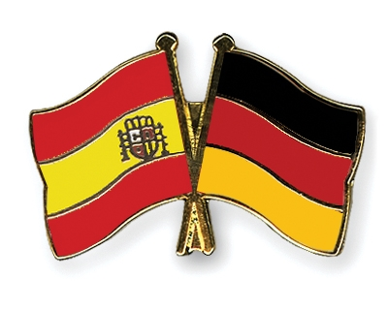
This Photo by Unknown Author is licensed under CC BY-NC-ND

The chart below represents the main characteristics of the people from each chosen country.

German characteristics | Spanish characteristics
- Hard working  - Well organised  - Punctual  - Respect the traditions  - Honest people  - They like beer  - Very serious people  - They have strict rules  - Known as negative people  - Respectful to their families  - They are efficient and disciplined  - They love quality  - They don`t smile too often | - Friendly  - Kind  - Active  - They love party and sangria  - They love dancing  - Strong characters  - Love traveling  - They love eating dinner after 10pm  - They are always late  - They don1t like early mornings  - Always kisses on the cheek when they meet a friend  - Very passionate

The Hotel Management should take a moment for quick research about their guest culture and behavior and find the key points that can help them to control the situation, prepare and organize before the Spanish guests arrive.
Key of success tips:
- A chocolate and a welcome card placed on their bed will make them feel welcome
- Learn how to say ``hi`` in Spanish will make them feel good
- Speak to the chef and keep the kitchen open until after 10pm because Spanish people love to eat late.
- Always smile- a little smile goes a long way
- Offer some extra amenities- when check in, staff should make sure they are told about all the free services that the hotel can provide.
- Staff- the Hotel should be fully staffed on arrival because first impression always weight the most.
- Welcome board- welcome personalised board placed by the entrance of the Hotel, that sign will bring a smile on their face.

Taking in consideration the power off mass media and how easily accessible the internet is those days, finding information about culture of the other countries is only one klick far distance.
The following scheme represents the summarizing of the above writing, and it can be considered as most common ``do`s`` and ``don`t`` that can be identified in the hotelier industry and in Waldorf Astoria -Berlin.

Do`s | Don’ts
- Be polite  - Be friendly  - Smile  - Be approachable  - Treat all guests the same  - Ask for feedback  - Constantly check if things are in place  - Make sure the room is perfectly clean  - Put 100% effort in every shift  - Behave like professional all the time  - Always keep safety in mind | - Don`t fake it  - Don`t enter in a room without permission  - Don`t argue- the customer is always right  - Do not share the confidential information  - Never take things for granted  - Do not expose your personal problems  - Do not act like you are nervous  - Do not give the key access of your guests to anyone unauthorised

References
Alfred Kohler: Charles V (1519-1556). In: The emperors of modern times. Munich 1990, p.35.
Alfred Kohler: Charles V, Emperor. In: Neue Deutsche Biographie. 11 (1977), p.196.
European Union. (2010). Europe 2010 strategy for smart, Sustainable eintegrador. Brussels: European Union.
GERMANY Eurydice (Lander) (1998). The education system in Germany.
Hofstede, G. (2001). Culture`s consequences: comparing values, behaviors, institutions and organizations across nations (2nd edn.).
Lewis, R. (2006). When cultures collide: leading across cultures. London: Brealey.
Monsalve, L. (2013). Educational policies in health education in the European Union. Comparative Study. 36 Doctoral Program in Education, Line 1 ``Historical, political and comparative education``. PhD thesis. University of Valencia.
Taras, V., Steel, P., & Kirman, B.L. (2016). Does country equate with culture? Beyond geography in the search for cultural boundaries. Management International Review, 56(4), 455-487.
Yin, J. (2002). Telling the truth? A cultural comparison of ``facilitating discussion`` in American talk. Discourse Processes, 33(3), 235-256.
Hotel Waldorf Astoria Berlin official website: http://www.hiltonhotels.com/waldorf_astoria accessed on the February 20, 2022

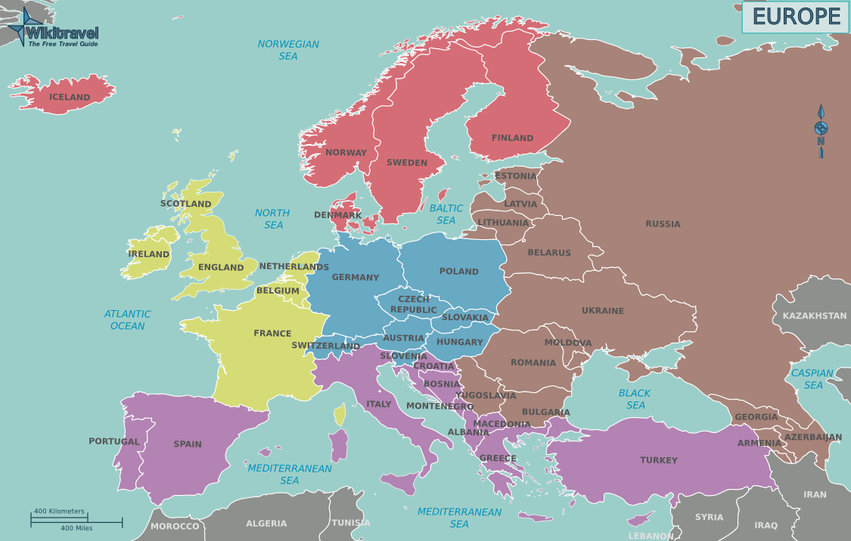
This Photo by Unknown Author is licensed under CC BY-SA

