Case Study Report: Diabetes Mellitus

Name: Abdul Shakoor Khan
Instructor name: Robert Nartowski
Student ID: 2407946
Programme: BSc Health and Social Care
Module code: BMHP5023
Word count: 2000

Table of Contents

Contents
List of figures 2
List of tables 2
Introduction 3
What is Diabetes andthis s Risk Factors 3
Pathophysiology of Diabetes Mellitus 5
Oxygen and Energy Production 6
Recording And Tracking Blood Sugar 7
Lifestyle intervention 8
Dietary interventions 9
Physical exercise and weight management 9
Smoking, alcohol, and stress management 9
Critical considerations and barriers 10
Conclusion 10
Reference list 12

List of figures

Figure 1: IDF Diabetes Atlas 4
Figure 2: pathophysiology (NHS, 2023)…………………………………………………………………………….6

List of tables
Table 1: Insulin therapy 4
Table 2: Blood glucose monitoring 7
Table 3: lifestyle change 8

CASE STUDY 1
Diabetes Mellitus

Introduction

Diabetes Mellitus is now one of the biggest global health problems. Diabetes is a worldwide health disaster with an expected 537 million adults living with in in 2021.Eexpected to rise to 783 million by 2045, according to (WHO) and (IDF). The disease has now emerged as a significant public health issue, as the World Health Organization (2023) approximates over 422 million individuals globally with diabetes, with rising prevalence rates being reported in developing and developed countries (WHO, 2023). In the UK, more than 5 million are known to have a diagnosis of diabetes, and a further 850,000 are estimated to have undiagnosed diabetes (Diabetes UK 2024). These statistics confirm the need for early education, prevention, and self-management approaches (Diabetes UK 2024, p. 2).
This report aims to produce a concise, evidence-based overview of diabetes, highlighting risk factors and also control of blood glucose, energy production, monitoring, and lifestyle change, highlighting practical use in primary care.

What is Diabetes andthis s Risk Factors

For the health practitioner in general practice, especially nurses, this is essential to explain the physiology of diabetes in terms that are understandable to patients (Skyler et al., 2017).
Figure 1: IDF Diabetes Atlas
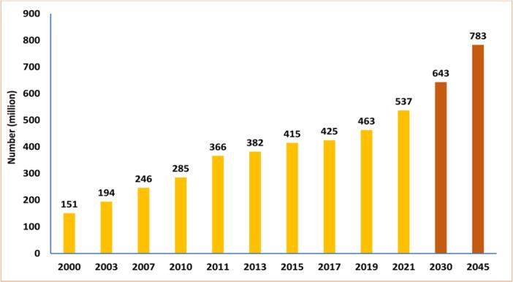
Source: (Magliano and Boyko, 2021)

The number (millions) of people aged 20−79 years having diabetes worldwide (projected numbers in 2030 and 2045) (Magliano and Boyko, 2021).

Diabetes mellitus is categorized under two wide categories, namely Type 1 and Type 2. Type 1 diabetes is an autoimmune condition where the immune system recognises and destroys pancreatic beta cells, which leads to absolute insulin deficiency (NHS, 2023).
Table 1: Insulin therapy
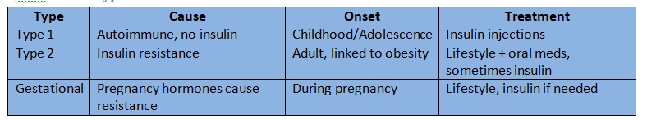
Source: Self-made (Skyler et al., 2017)
It typically presents in childhood or adolescence, and the treatment is lifelong insulin therapy. By contrast, Type 2 diabetes, which accounts for about 90% of diagnoses in the UK, is characterized by insulin resistance and progressive beta-cell failure (ADA, 2023).this has close associations with lifestyle and is therefore seen as being highly preventable or manageable with behavioral interventions.
Risk influences may be categorized as adaptable and not adaptable. Not adaptable risk issues are age, civilization, and genetic predisposition. There is evidence to suggest that South Asians, African-Caribbeans, and Black Africans have a greater risk of developing Type 2 diabetes, usually at a lower body mass index, than in White populations (World Health Organization, 2023). Age is also a contributing factor, with an acute rise in prevalence after the age of 40.
Modifiable risk factors, on the other hand, consist of obesity, unhealthy diet, physical inactivity, smoking, and heavy alcohol consumption. Visceral fat and central obesity are especially noteworthy because visceral fat is responsible for insulin resistance through the promotion of inflammatory pathways and hormonal derangements. Clinical trials, like the Diabetes Prevention Programme (DPP), have shown that a mild weight loss (5–10% of body weight) and moderate exercise can decrease the onset of Type 2 diabetes by as much as 58% (Public Health England, 2022). From the point of view of nursing practice, recognizing the difference between non-modifiable and modifiable risk factors is important for patient education. Although non-modifiable risks are unchangeable, they identify populations that need special screening and early intervention. Nurses can aim to promote lifestyle changes in high-risk individuals by highlighting the advantages of diet change, exercise, and smoking cessation.

Pathophysiology of Diabetes Mellitus

Blood glucose is kept within a small range (about 4–7 mmol/L) by the human body to provide sufficient energy to tissues, especially the brain, which depends nearly solely on glucose (Hall and Guyton, 2021). Regulation is mainly coordinated by insulin and glucagon hormones secreted by Langerhans' islets of the pancreas.
Following a meal, increased blood glucose triggers the beta cells in the pancreas to secrete insulin. Insulin enables glucose ingestion by muscle and fat tissue via the translocation of GLUT-4 transporters to cell membranes, stimulating glycogen combination in the liver and lowering blood glucose levels. In contrast, in times of fasting or when glucose is low, pancreatic alpha cells release glucagon, which encourages hepatic glycogenolysis and gluconeogenesis, providing a sustained supply of glucose (NHS, 2023).
Figure 2: pathophysiology
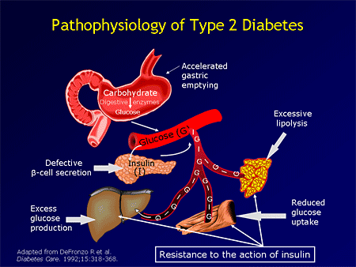
Source: (NHS, 2023)

Diabetes mellitus pathophysiology is a persistent metabolic disease defined by elevated blood sugar (hyperglycemia), caused by either the pancreas's failure to secrete sufficient insulin (Type 1 diabetes) or the body's inability to respond to insulin (Type 2 diabetes), where both can occur. In Type 1, there is autoimmune devastation of insulin-secreting beta cells, causing a deficiency. In Type 2, the body produces resilient to insulin, and the pancreas is no longer able to produce sufficient to keep up, resultant in a mixture of insulin resistance and insufficient secretion.

Oxygen and Energy Production

Oxidative phosphorylation takes place: electrons travel along a chain of protein complexes, and the energy released powers the production of great quantities of ATP. The last electron acceptor is oxygen, whichthis holds in combination with hydrogen ions to produce water. Without oxygen, this process stops, and cells use anaerobic metabolism, generating only small quantities of ATP and lactic acid as a waste product (Polonsky et al., 2021).
The reaction is in three general phases: glycolysis, the Krebs cycle, and oxidative phosphorylation (Nelson and Cox, 2021).
In glycolysis, glucose is oxidized to pyruvate in the cytoplasm, yielding a small amount of ATP and reduced nicotinamide adenine dinucleotide (NADH). Nurses can utilize simple metaphors — for example, using the term "fuel" to describe glucose and "the spark" to describe oxygen as the trigger that releases energy — to maximize patient comprehension and cooperation with lifestyle management.

Recording And Tracking Blood Sugar

Self-monitoring of blood glucose is the keystone of successful control of diabetes, allowing both patient and health care provider to observe patterns, alter treatment, and avoid complications. The two methodologies are most commonly used: capillary blood glucose testing and HbA1c testing.
Table 2: Blood glucose monitoring
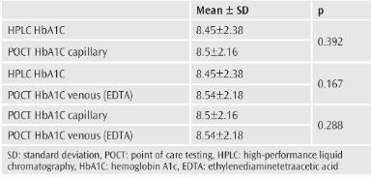
Source: (NHS 2023)
The average HbA1c value for this population determined by the HPLC assay, by POCT venous blood, and by POCT capillary blood was 8.45 ± 2.30, 8.54±2.18, and 8.50±2.16, respectively. HbA1c, in contrast, measures mean blood glucose during the past 8–12 weeks by quantifying the level of glucose bound to haemoglobin on red blood cells. The National Institute for Health and Care Excellence recommends a target HbA1c of 48 mmol/mol (6.5%) for most adults with Type 2 diabetes because achieving this will reduce the risk of microvascular complications (Polonsky, Fisher, Schikman, 2021).
Not only is monitoring blood glucose a diagnostic and monitoring tool, butthis is also a motivational strategy. When patients record results on diaries or mobile apps, they are seeing the impact of diet and exercise on their glucose levels and reinforcing compliance with self-management behavior. Systematic self-monitoring has been shown to enhance glycaemic control and allow patients to make educated adjustments (Polonsky et al., 2021).
From a nursing perspective, patient education is essential to make the patient aware of the clinical utility of monitoring devices and to read the results. The challenges of insufficient health literacy, apprehension of repeated testing, or device cost must be addressed by individualized assistance, plain language, and linking to community resources. The mean HbA1c levels of this group, analyzed by the HPLC method, by POCT from venous blood and by POCT capillary blood, were 8.45 ± 2.30, 8.54±2.18 and 8.50±2.16, respectively. Capillary monitoring uses a finger-prick glucometer or continuous glucose monitoring (CGM) systems (Polonsky, Fisher, Schikman, 2021).

Lifestyle intervention

Lifestyle interventions are alterations in everyday habits for the sake of health improvement, with outcomes such as lowered risk of chronic diseases, better mental well-being, and enhanced quality of life. The major interventions are a healthy diet, adequate exercise, stress reduction, adequate sleep, and abstention from harmful substances such as tobacco (Buse et al., 2020).

Table 3: lifestyle intervention

Lifestyle Change | Impact on Health | Evidence
Healthy diet | Improves HbA1c and weight | Buse et al. (2020)
Regular exercise | Improves insulin sensitivity | Chatterjee, et al. (2017)
Weight loss | Reduces risk of complications | Colberg et al. (2016)
Smoking cessation | Reduces cardiovascular risk | WHO (2023)
Source: NHS (2023)

Dietary interventions

Dietary interventions are customized modifications in eating habits to control health conditions, enhance nutrition, or address deficiencies. They can be specialized diets (e.g., ketogenic diet, low-FODMAP), avoiding particular foods (e.g., gluten), modifying caloric and nutrient consumption, or consuming nutritional supplements (WHO, 2023). These are frequently led by healthcare specialists such as dietitians to ensure that they are safe and effective for the individual's particular requirements (WHO, 2023).

Physical exercise and weight management

Regular physical exercise improves insulin sensitivity and glucose disposal by skeletal muscle. Aerobic exercise (e.g., cycling, brisk walking) and resistance exercise (e.g., weight training) both improve glycaemic control (Colberg et al., 2016). A reduction in weight of 5–10% improves blood glucose levels and cardiovascular risk significantly. The Diabetes Prevention Program showed lifestyle modification superior to metformin in halting progression from prediabetes to diabetes (Hall and Guyton, 2021). For individuals, the addition of activity to daily life — for example, walking to the workplace or taking stairs — can prove more accessible than traditional exercise programs.

Smoking, alcohol, and stress management
Smoking worsens insulin resistance and cardiovascular risk, and alcohol misuse can result in both hyperglycaemia and hypoglycaemia (Chatterjee, Khunti, and Davies, 2017).
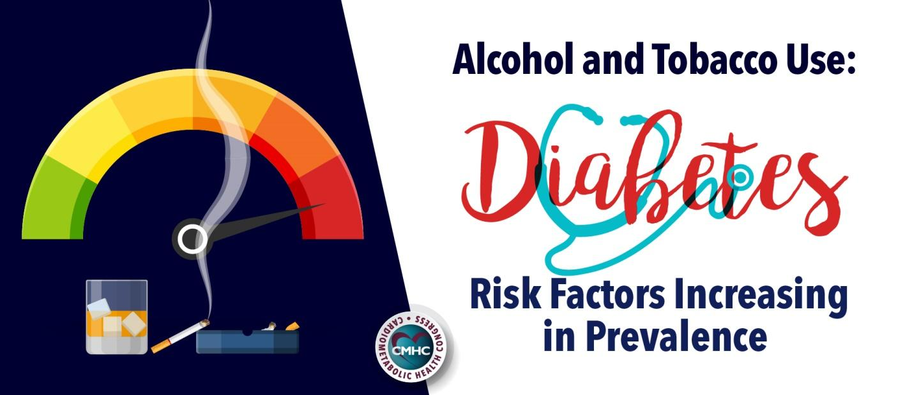
Encouraging smoking cessation and moderation is thus vital. Stress and sleep deprivation are also important but often underrated considerations; raised cortisol interferes with glucose metabolism, and poor rest is linked with reduced insulin sensitivity. Mindfulness techniques, stress management skills, and sleep hygiene promotion can be incorporated into the care of patients (Colberg et al., 2016).

Critical considerations and barriers
Although lifestyle change is extremely effective,this is by no means without problems. Barriers tothis include cultural eating habits, limited financial resources, low motivation levels, and difficulty in accessing safe places for exercise. A single-fit-for-all approach is unlikely to be successful. Nurses have to approachthis then with a patient-centred approach, working to the individual's needs, and using motivational interviewing to promote engagement. Digital technologies, including mobile apps and continuous glucose monitoring, can also maintain behavioural change through giving instant feedback (Chatterjee, Khunti, and Davies, 2017).

Conclusion
Long‐term diabetes complications can be prevented through intensive lifestyle modifications and treatments to control blood glucose levels. The evidence suggests the spread of diabetes requires embracing a unified health strategy, which complements the platform offered by the World Health Organization (WHO). Self-monitoring devices such as glucometers and HbA1c testing provide patients with information to monitor progress and prevent complications. Lifestyle modification, however, is the cornerstone of good control. Repeatedly, evidence attests to dietary modification, physical activity, weight reduction, stopping smoking, and stress management as effective means to maximize outcomes and reduce risk for cardiovascular disease and other complications.

Reference list

American Diabetes Association (ADA) (2023) Standards of Medical Care in Diabetes—2023. Diabetes Care, 46(Supplement_1), pp. S1–S291. Available at: https://diabetesatlas.org/
(Accessed: 4 October 2025).
Buse, J.B., Wexler, D.J., Tsapas, A., Rossing, P., Mingrone, G., Mathieu, C., D'Alessio, D.A., and Davies, M.J., 2020. 2019 update to: management of hyperglycemia in type 2 diabetes, 2018. A consensus report by the American Diabetes Association (ADA) and the European Association for the Study of Diabetes (EASD). Diabetes care, 43(2), pp.487-493. Available at: https://diabetesjournals.org/care/article-pdf/43/2/487/531086/dci190066.pdf (Accessed on 16 October 2025).
Chatterjee, S., Khunti, K. and Davies, M.J. (2017) 'Type 2 diabetes', The Lancet, 389(10085), pp. 2239–2251. Available at: https://doi.org/10.1016/S0140-6736(17)30058-2 (Accessed: 14 October 2025).
Colberg, S.R., Sigal, R.J., Yardley, J.E. et al. (2016) 'Physical activity/exercise and diabetes: A position statement of the American Diabetes Association', Diabetes Care, 39(11), pp. 2065–2079. Available at: https://doi.org/10.2337/dc16-1728 (Accessed: 1 October 2025).

Diabetes UK (2024) Diabetes prevalence 2024. Available at: https://www.diabetes.org.uk (Accessed: 14 October 2025).

Hall, J.E. and Guyton, A.C. (2021). Guyton and Hall Textbook of Medical Physiology. 14th edn. Philadelphia: Elsevier.

Holt, R.I.G., Cockram, C., Flyvbjerg, A. and Goldstein, B.J. (2021) Textbook of Diabetes. 5th edn. Chichester: Wiley-Blackwell.
Magliano, D.J. and Boyko, E.J., 2021. IDF diabetes atlas. https://diabetesatlas.org/
Ley, S.H., Ardisson Korat, A.V., Sun, Q. et al. (2021) 'Nutrition and type 2 diabetes: Dietary patterns, foods and nutrients', The Lancet Diabetes & Endocrinology, 9(6), pp. 413–428. Available at: https://doi.org/10.1016/S2213-8587(21)00035-2 (Accessed: 12 October 2025).
National Institute for Health and Care Excellence (NICE) (2023) Type 2 diabetes in adults: management (NG28). London: NICE. Available at: https://www.nice.org.uk/guidance/ng28 (Accessed: 7 October 2025).
NHS (2023) Types of diabetes. Available at: https://www.nhs.uk/conditions/diabetes (Accessed: 6 October 2025).
Public Health England (2022) Diabetes: risk factors and prevention. London: PHE. Available at: https://www.gov.uk/government/publications/diabetes-prevention-programme (Accessed: 4 October 2025).
Polonsky, W.H., Fisher, L., Schikman, C.H. et al. (2021) 'Structured self-monitoring of blood glucose significantly reduces A1C levels in poorly controlled, insulin-treated type 2 diabetes', Diabetes Care, 44(2), pp. 367–374. Available at: https://doi.org/10.2337/dc20-1036 (Accessed: 2 October 2025).
World Health Organization (2023) Diabetes fact sheet. Geneva: WHO. Available at: https://www.who.int/news-room/fact-sheets/detail/diabetes (Accessed: 13 October 2025).

