

Course: MBA International Business.

Module: Strategic Management (LCMB7003).

Topic: Emergence of Virtual Organisations.

Name of the Article: Virtual enterprise/organisation, evolution and control M.T. Martinez, P. Fouletier, K.H. Park, J. Favrel.

Name: Toushe kathawala (2309023).

Contents
1. Emergence of Virtual Organisations (2000 words): 3
1.1 Introduction. 3
1.2 Thesis Statement: 4
1.3 The Benefits of Virtual Organizations. 4
1.4 Strategic Management Challenges in Virtual Organizations. 5
1.5 Planning Challenges. 5
1.6 Design Challenges. 6
1.7 Leadership Challenges. 7
1.8 Recommendations for Successful Virtual Organizations 8
1.9 Conclusion. 9
2. Precis (500 words): 10
3. Summary (1000 words): 11
3.1 Virtual Enterprises: A Collaborative Approach to Manufacturing. 11
3.2 The Rise of Information-intensive Manufacturing: A Catalyst for Collaboration. 12
3.3 Understanding the Nuances of Virtual Enterprises. 13
3.4 The Motivations Behind Research on Control Structures for Consortium VEs. 13
3.5 Beyond the Technical: Exploring the Human and Social Implications of VEs. 14
3.6 The Human and Social Landscape of Virtual Enterprises. 15
4. Presentation Slides: 17
5. Reference: 18
5.1 Article reference: 19

1. Emergence of Virtual Organisations (2000 words):

1.1 Introduction.

In today's corporate world, moulded by fast technology breakthroughs and globalisation, the rise of virtual organisations (VOs) demonstrates the transformational potential of digital connectedness. Virtual organisations represent a paradigm change in traditional organisational structures, since they operate largely on digital platforms and use technology to enable remote communication among geographically dispersed teams. This tendency has gained traction in the information age, as firms rely more on digital infrastructures to expedite operations and stimulate innovation.
Virtual organisations have plethora of benefits that have accelerated their ascent to popularity in the commercial sector. One of the primary benefits is enhanced agility since VOs can respond swiftly to changing market conditions and client needs. Unlike traditional brick-and-mortar businesses, virtual organisations may quickly reallocate resources and modify strategy in response to emerging opportunities or problems, allowing them to remain competitive in changing contexts.

Moreover, virtual organizations often benefit from significant cost reductions compared to their conventional counterparts. By eliminating the need for physical office spaces and minimizing overhead expenses associated with maintenance and utilities, VOs can achieve substantial savings while maintaining operational efficiency. Additionally, VOs have unparalleled access to global talent pools, allowing them to harness diverse skill sets and perspectives from across the globe to drive innovation and creativity.

Scalability is another significant advantage of virtual organisations since they may readily grow or contract their operations in response to business requirements without being constrained by physical infrastructure. This scalability allows VOs to grab expansion opportunities and enter new markets with relative ease, enabling them for long-term success in a competitive environment.
However, despite the various benefits that virtual organisations provide, they do face strategic management issues. Planning, creating, and conducting VOs necessitates a sophisticated strategy that considers the complications of distant collaboration, communication, and coordination. Strategic managers must oversee difficulties such as creating clear goals, cultivating a coherent organisational culture, and guaranteeing effective leadership in virtual environments.

1.2 Thesis Statement:

This study critically assesses the advent of virtual organisations, concentrating on the strategic management problems connected with their planning, design, and leadership. This study attempts to give insights into successful strategic management methods for managing the complexity of virtual organisations in the digital age.

1.3 The Benefits of Virtual Organizations.

Virtual organisations (VOs) have numerous advantages, making them an appealing model for modern enterprises looking to prosper in an increasingly digital and linked world. We'll go over these advantages in further detail below, using examples from firms that have successfully used the VO model.
Increased Agility and Responsiveness to Market Changes:
Virtual organisations are naturally nimble, allowing them to quickly respond to changing market circumstances and client preferences. For example, Buffer, a social media management tool, has embraced remote work and distributed teams to increase agility. Buffer's decentralised structure allows workers to operate from any location in the world, allowing for quick decision-making and seamless strategy adjustments in reaction to market changes.

Cost Reduction through Reduced Overhead and Access to Lower-Cost Resources:
By functioning solely through digital platforms, VOs minimise the need for costly physical infrastructure, resulting in substantial cost reductions. Automattic, the firm behind WordPress.com, for example, uses a dispersed workforce to save office-related overhead costs. This lean strategy not only lowers costs, but also enables Automattic to invest in product development and innovation, resulting in long-term growth.

Access to a Global Talent Pool, Fostering Diversity and Expertise:
Virtual organisations cross geographical barriers, providing access to a broad pool of talent from across the world. GitHub, a software development collaboration site, exhibits this by hosting a global community of developers who contribute to projects remotely. The diversity of knowledge and opinions in GitHub's virtual community stimulates creativity and innovation, which improves the platform's value offering.

Scalability to Adapt to Changing Market Demands:
Virtual organisations are inherently scalable, allowing them to smoothly grow or shrink operations in response to market needs. Upwork, a worldwide freelancing platform, exhibits this scalability by linking businesses with freelancers from a variety of fields. As freelancer demand changes, Upwork's platform capacity may be dynamically adjusted to ensure optimal resource allocation and service delivery.

While the benefits of virtual organizations are substantial, it is essential to acknowledge potential limitations. Quality control issues may arise due to the decentralized nature of virtual teams, requiring robust monitoring mechanisms to maintain standards. Additionally, communication difficulties stemming from cultural differences or technological barriers may hinder collaboration and coordination within VOs. However, with proper planning and strategic management, these challenges can be mitigated effectively, enabling virtual organizations to realize their full potential in the digital age.

To summarise, the advantages of virtual organisations go beyond cost reductions, including increased agility, access to global talent, and scalability. Companies who use the VO model can position themselves for long-term success in an increasingly dynamic and competitive business environment.

1.4 Strategic Management Challenges in Virtual Organizations.

Virtual organizations (VOs) present unique strategic management challenges that require innovative approaches to planning, designing, and leading remote teams. In this section, we will examine three key challenges faced by VOs and discuss strategies for effectively addressing them.

1.5 Planning Challenges.

Developing a unified vision and goal in a geographically scattered organisation is difficult owing to a lack of face-to-face connection and cultural variations amongst team members. The value of cultural intelligence in promoting collaboration and alignment within heterogeneous virtual teams. Leaders must invest in cultural awareness training and encourage cross-cultural communication to ensure that the organization's vision and objectives are understood by all team members, regardless of geographic location.
Environmental scanning and market data collection provide additional issues in the context of VOs. The need of real-time data gathering and processing to stay up with fast changing market dynamics. Virtual organisations must use modern analytics tools and automated data collection methods to properly monitor industry trends and rival actions. Furthermore, building an information-sharing and collaboration culture is critical to ensuring that market insights are distributed throughout the organisation in a timely way.

Setting realistic and measurable goals for geographically dispersed teams requires careful planning and coordination. Kirkman and Shapiro (2001) suggest adopting a cascading goal-setting approach, where overarching organizational objectives are broken down into smaller, actionable targets for individual teams or departments. Clear communication channels and regular progress updates are essential to keep remote team members aligned with organizational goals and foster accountability.

1.6 Design Challenges.

Traditional hierarchical structures are ill-suited to the dynamic and decentralized nature of VOs. Flatter organizational structures, characterized by fewer layers of management and greater autonomy for individual contributors, are better aligned with the collaborative ethos of virtual organizations. Hansen et al. (1999) advocate for a networked organizational model, where decision-making authority is distributed based on expertise and domain knowledge rather than hierarchical rank.

Technology integration plays a crucial role in facilitating communication, collaboration, project management, and knowledge sharing within VOs. Advanced collaboration platforms, such as Slack or Microsoft Teams, enable real-time communication and document sharing among remote team members. Project management tools, such as Asana or Trello, facilitate task allocation and progress tracking across geographically dispersed teams. However, organizations must ensure that technology solutions are user-friendly and accessible to all team members, regardless of their technical proficiency or location.

Knowledge management poses significant challenges in VOs, where tacit knowledge may be difficult to capture and share across disparate teams. Effective knowledge capture and dissemination systems are essential to harnessing the collective expertise of remote team members. Hansen et al. (1999) suggest implementing online knowledge repositories and virtual communities of practice to facilitate knowledge sharing and collaboration. Additionally, fostering a culture of continuous learning and knowledge sharing is critical to ensuring that valuable insights are leveraged across the organization.

1.7 Leadership Challenges.

Building trust and relationships among virtual team members is a fundamental challenge for leaders in VOs. The absence of face-to-face interaction can hinder the development of interpersonal connections and mutual trust. Leaders must invest in relationship-building activities, such as virtual team-building exercises and social events, to foster a sense of camaraderie and belonging among remote team members. Regular check-ins and one-on-one meetings are also essential for building trust and addressing any concerns or conflicts that may arise within virtual teams.

Mastering virtual communication skills is essential for effective leadership in VOs. Kirkman and Shapiro (2001) emphasize the importance of clear and concise communication, as well as active listening, in virtual settings. Leaders must leverage a variety of communication channels, such as video conferencing, email, and instant messaging, to ensure that information is conveyed accurately and comprehensively to remote team members. Additionally, cultural differences in communication styles must be considered to avoid misunderstandings and misinterpretations.

Adapting traditional methods of motivation and performance management for geographically dispersed teams requires a tailored approach. Kirkman and Shapiro (2001) suggest setting clear performance expectations and providing regular feedback to remote team members to keep them engaged and motivated. Recognizing and rewarding individual and team achievements, regardless of geographic location, helps foster a culture of excellence and accountability within virtual organizations. Moreover, leaders must empower remote team members by providing opportunities for skill development and career advancement, thereby enhancing employee satisfaction and retention.

In conclusion, strategic management challenges in virtual organizations encompass planning, designing, and leading remote teams effectively. By addressing these challenges through innovative approaches and leveraging technology solutions, virtual organizations can unlock their full potential and achieve sustainable growth in an increasingly digital and interconnected world.

1.8 Recommendations for Successful Virtual Organizations

Building successful virtual organizations (VOs) requires proactive strategies to address the challenges inherent in remote collaboration and leadership. To ensure the effectiveness and sustainability of VOs, the following recommendations are proposed:

1. Investing in Building a Strong Organizational Culture:
Cultivating a coherent organisational culture is critical for promoting unity and alignment across geographically dispersed teams. Leaders should establish clear principles, standards, and behavioural expectations that apply to all team members, regardless of location. Encouraging regular encounters through virtual team-building activities, social gatherings, and informal communication channels promotes camaraderie and strengthens organisational links. Furthermore, recognising and appreciating multiple cultural viewpoints promotes diversity and strengthens team cohesiveness in VOs.

2. Developing Strong Communication Strategies:
Effective communication lies at the heart of successful virtual organizations. Employing a combination of synchronous and asynchronous communication channels, such as video conferencing, instant messaging, email, and collaboration platforms, facilitates seamless information flow and collaboration among remote team members. Establishing clear communication protocols, including guidelines for response times and meeting etiquette, helps minimize misunderstandings and ensures that everyone stays informed and engaged. Furthermore, promoting transparency and open dialogue encourages knowledge sharing and problem-solving, enhancing organizational agility and adaptability.

3. Implementing Effective Leadership Practices:
Leadership plays a pivotal role in shaping the culture and performance of virtual organizations. Leaders should prioritize building trust and relationships with remote team members through regular check-ins, one-on-one meetings, and active listening. Providing mentorship, coaching, and support to remote employees demonstrates commitment to their professional development and well-being. Moreover, adopting a transformational leadership approach, characterized by vision-setting, empowerment, and inspiration, motivates virtual teams to achieve their full potential. Implementing performance management systems that emphasize results, feedback, and recognition promotes accountability and fosters a culture of excellence within VOs.
4. Leveraging Technology for Collaboration and Knowledge Management:
Technology enables productive cooperation and information exchange in virtual organisations. Investing in sophisticated collaboration platforms, project management tools, and knowledge repositories helps distant teams coordinate and communicate more effectively. Leveraging artificial intelligence and machine learning technology allows for intelligent data analysis and decision assistance, helping virtual organisations to make educated strategic decisions and drive innovation. Furthermore, giving training and assistance for technology adoption guarantees that all team members can fully use digital technologies, hence increasing productivity and efficiency in virtual offices.
Implementing these guidelines can help virtual organisations overcome the inherent problems of distant collaboration and leadership, building a culture of creativity, resilience, and success in an increasingly digital environment.

1.9 Conclusion.

In conclusion, virtual organizations (VOs) offer numerous benefits, including increased agility, cost reduction, access to global talent, and scalability. However, they also present strategic management challenges, such as developing shared vision and goals, designing effective communication structures, and fostering trust and leadership in virtual settings.
Throughout this evaluation, we have highlighted the importance of strategic management in addressing these challenges and maximizing the potential of VOs. From planning and designing virtual structures to leading remote teams effectively, strategic management practices play a crucial role in navigating the complexities of virtual organizations.
Considering the rapid advancements in technology and the growing trend towards remote work, the future of VOs appears promising. As businesses continue to embrace digital transformation and global collaboration, VOs are poised to become increasingly prevalent in the business landscape. By adopting innovative strategies and leveraging technology solutions, VOs can drive innovation, enhance competitiveness, and unlock new opportunities for growth in the digital age.
In essence, the evolution of virtual organizations represents a paradigm shift in the way businesses operate and collaborate. With the right strategic management approach, VOs have the potential to revolutionize the business landscape and shape the future of work in profound ways. As we look ahead, it is clear that virtual organizations will play a pivotal role in driving innovation, fostering diversity, and reshaping traditional notions of organizational structures and boundaries.

2. Precis (500 words):

In the contemporary business landscape, characterized by unprecedented levels of complexity and uncertainty, traditional organizational structures often struggle to keep pace with the rapid changes and dynamic market demands. In response, the concept of virtual enterprises (VEs) has emerged as a transformative paradigm, offering a flexible and collaborative approach to project execution and resource utilization.

At the heart of the VE concept lies virtual engineering (VE), a framework that enables diverse companies to seamlessly collaborate on common projects by leveraging their collective resources and competencies. VE not only enhances adaptability, resource efficiency, and time-to-market responsiveness but also fosters innovation and strategic partnerships in an increasingly interconnected global economy.

Within the realm of virtual enterprises, three primary categories delineate the varying degrees of collaboration and organizational structure:

1. Short-term VEs: These agile entities are designed to capitalize on specific market opportunities or address short-term projects. With a lightweight and adaptable structure, short-term VEs empower partners to coordinate relatively independent sub-projects with minimal need for extensive co-engineering. This flexibility allows them to swiftly respond to emerging market trends and capitalize on fleeting opportunities.

2. Expanded Business VEs: Unlike their short-term counterparts, expanded business VEs transcend traditional organizational boundaries and involve complex interactions with a multitude of stakeholders, including suppliers, consumers, and partners. This type of VE requires sophisticated coordination mechanisms to manage high levels of synchronous and asynchronous cooperative engineering work across diverse stakeholders, ensuring alignment with overarching strategic objectives.

3. Consortium VEs: Consortium VEs represent long-term collaborations aimed at maximizing partner capabilities while retaining internal flexibility. These collaborations are characterized by distributed, non-hierarchical control mechanisms, enabling dynamic resource allocation and adaptation to changing market conditions. Consortium VEs prioritize resilience and adaptability, allowing partners to navigate fluctuations in demand and market dynamics effectively.
Central to the success of consortium VEs is the systematic process of task decomposition and allocation based on product functions. Partners evaluate each other's capabilities through internal bidding mechanisms, ensuring alignment with cost, quality, and timing criteria. A structured product development cycle, encompassing task allocation, co-engineering/manufacturing, co-maintenance, and feasibility pre-study stages, guides concurrent engineering efforts within the consortium.

However, implementing dynamic, real-time control mechanisms presents a significant challenge for consortium VEs. To address this challenge, the paper proposes the adoption of multi-agent systems (MAS) as an architectural solution. MAS leverages autonomous agents to represent production activities, resources, and final goods across partner companies. These agents utilize negotiation protocols to self-organize and dynamically allocate tasks in response to changing circumstances, thereby optimizing resource utilization, and enhancing adaptive capacity.

While MAS offers numerous advantages, including self-organization, distributed decision-making, and real-time reactivity, challenges persist in standardizing interface protocols, information sharing models, and cooperative engineering tools across diverse partner systems.

In conclusion, virtual enterprises, underpinned by virtual engineering principles, offer a promising avenue for collaborative innovation and resource optimization in today's dynamic business environment. By embracing the nuances of different VE types and leveraging advanced technologies like multi-agent systems, organizations can navigate complex collaboration landscapes with agility and resilience, driving sustainable growth and competitive advantage in an increasingly interconnected world.

3. Summary (1000 words):

3.1 Virtual Enterprises: A Collaborative Approach to Manufacturing.

Virtual Enterprises (VEs) are a growing trend in advanced manufacturing. They offer a collaborative approach where companies work together on projects, leveraging each other's expertise and resources. This paper explores the concept of VEs, focusing on the challenges and opportunities they present.
The chosen paper delves deeply into the realm of virtual enterprises (VEs) within the context of advanced manufacturing. It meticulously dissects the intricate challenges and opportunities that arise when multiple companies collaborate on projects. At its core, the paper grapples with the complex problem of orchestrating effective coordination, implementing robust control mechanisms, and ensuring real-time responsiveness within VE collaborations. By examining the characteristics of VEs and proposing a novel control structure specifically tailored for consortium VEs, the research seeks to enhance the efficiency, adaptability, and competitiveness of collaborative endeavours in the modern business landscape.
To fully appreciate the motivations driving this research, we must delve into the broader context of technological advancements and market dynamics shaping contemporary manufacturing practices. The paper meticulously acknowledges the evolution of manufacturing concepts such as Concurrent Engineering, Agile Manufacturing, and Virtual Enterprises, all of which underscore the growing need for information-intensive approaches in manufacturing processes. These developments reflect a broader trend towards streamlining production, reducing time-to-market, and adapting to the ever-changing demands of global markets.

3.2 The Rise of Information-intensive Manufacturing: A Catalyst for Collaboration.
Concurrent Engineering, for example, emphasizes the parallel development of different product aspects, such as design, engineering, and manufacturing, to significantly reduce time-to-market. Agile Manufacturing, on the other hand, focuses on rapid response to changing customer demands and market fluctuations through iterative development cycles and flexible production processes. Both these concepts necessitate a high degree of information sharing and collaboration across various departments and disciplines within a single company.
The concept of a VE takes this collaborative approach a step further. It represents a departure from traditional, self-contained manufacturing models. Instead, VEs advocate for a networked approach where companies operate as interconnected nodes within a collaborative ecosystem. The paper aptly defines the primary objective of a VE as enabling multiple organizations to swiftly develop a common working environment. Through this collaborative environment, VEs harness a collective pool of resources and expertise towards shared goals. This underscores a clear agenda to leverage collaborative potential for mutual benefit, emphasizing the critical importance of agility, resource optimization, and market responsiveness.

3.3 Understanding the Nuances of Virtual Enterprises.
The research delves further into the nuanced characteristics of VEs, categorizing them based on various factors including market dynamics, production processes, and strategic objectives. This comprehensive classification serves to highlight the diverse nature of VE structures. For instance, some VEs might be temporary alliances formed for a specific project, while others might be long-term, strategic partnerships. Production processes within VEs can also vary depending on the complexity of the product and the expertise of the participating companies.
By identifying and categorizing these characteristics, the paper lays the groundwork for understanding the intricacies of VE collaborations and tailoring approaches accordingly. This classification framework allows researchers and practitioners to better understand the specific challenges and opportunities associated with different types of VEs.

3.4 The Motivations Behind Research on Control Structures for Consortium VEs.
The chosen paper on control structures for Consortium Virtual Enterprises (VEs) is driven by a clear agenda to enhance the efficiency, adaptability, and competitiveness of collaborative manufacturing endeavours in the modern business landscape. Here's a closer look at the evidence suggesting this research agenda:
- Addressing Limitations of Traditional Manufacturing:
The paper meticulously acknowledges the evolution of manufacturing concepts beyond traditional, self-contained models. It highlights the limitations of these models in today's fast-paced, globalized market. Concurrent Engineering and Agile Manufacturing represent a shift towards information-intensive approaches, but even these concepts primarily focus on streamlining processes within a single company. VEs, on the other hand, offer a more collaborative approach, enabling companies to leverage a wider pool of resources and expertise. The research agenda focuses on overcoming the limitations of traditional, hierarchical control structures within VEs, aiming to unlock the full potential of collaborative manufacturing.
- Proposed Solution: A Multi-Agent Decision-Making System:
The introduction of a multi-agent decision-making system as a solution further underscores the research agenda. This system aims to:
- Facilitate efficient task allocation based on real-time availability and expertise.
- Enable real-time information sharing for improved coordination and decision-making.
- Promote adaptability to unforeseen events and changing project requirements.
These functionalities directly address the challenges of distributed decision-making, dynamic project scopes, and concurrent engineering within VEs. By proposing this solution, the research demonstrates its focus on enhancing the efficiency and responsiveness of VE collaborations.

3.5 Beyond the Technical: Exploring the Human and Social Implications of VEs.
While the paper meticulously explores the technical aspects of control and coordination within VEs, it's crucial to acknowledge the human and social implications that arise with such collaborative structures.

3.6 The Human and Social Landscape of Virtual Enterprises.
The paper on control structures for Consortium VEs provides a valuable framework for the technical aspects of collaboration. However, achieving successful VE partnerships extends beyond technology and delves into the human and social dynamics that influence these collaborations. Here, we explore some key areas for consideration:

1. Cultural Integration and Communication Challenges:
As the paper acknowledges, VEs often involve companies from diverse cultural backgrounds. Effective communication and collaboration become paramount in such settings. Here are some potential challenges and solutions:

- Communication Styles: Different cultures have varying communication styles, ranging from direct and assertive to indirect and relationship oriented.
- Language Barriers: Language fluency can be a significant hurdle. Utilizing standardized communication platforms with translation tools and encouraging language learning initiatives within VE partnerships can bridge this gap.
- Cultural Values and Norms: Training programs that promote cultural sensitivity can be highly beneficial.

2. Impact on Workforce and Skills:

The rise of VEs raises concerns about job displacement in certain sectors. However, it also creates opportunities for new skillsets:
- Job displacement: Some traditional manufacturing jobs might be automated or outsourced within VEs. Research can explore the potential impact on specific sectors and workforce demographics.
- New Job Roles: VE operations might create entirely new job roles focused on areas like managing VE platforms, facilitating communication, and ensuring intellectual property compliance.

3. Intellectual Property (IP) and Knowledge Sharing:

Collaboration within VEs necessitates the sharing of sensitive IP. This raises concerns about potential misuse or misappropriation of knowledge. Here are some points to consider:
- Legal Frameworks: Establishing clear legal agreements outlining IP ownership, usage rights, and confidentiality measures is vital.
- Selective Knowledge Sharing: Companies might choose to share certain knowledge selectively, focusing on aspects crucial for the VE project while protecting core competencies.

4. Ethical Considerations:

The increasing use of VEs raises ethical questions regarding:
- Data Privacy: Protecting sensitive data collected and shared within VEs is crucial.
- Responsible Sourcing: Companies participating in VEs should have ethical sourcing practices in place to ensure fair labour and environmental responsibility.
- Labour Standards: VEs should ensure adherence to fair labour practices across all participating countries to avoid exploitation and maintain ethical production standards.

The research agenda focuses on developing control structures that make VEs a more attractive option for companies, ultimately leading to a more collaborative and competitive manufacturing landscape.
In conclusion, the research on control structures for Consortium VEs is driven by a clear agenda to unlock the full potential of collaborative manufacturing. By addressing the limitations of traditional models and proposing solutions that enhance agility, resource optimization, and market responsiveness, the research aims to empower companies to thrive in the ever-evolving global marketplace.

4. Presentation Slides:

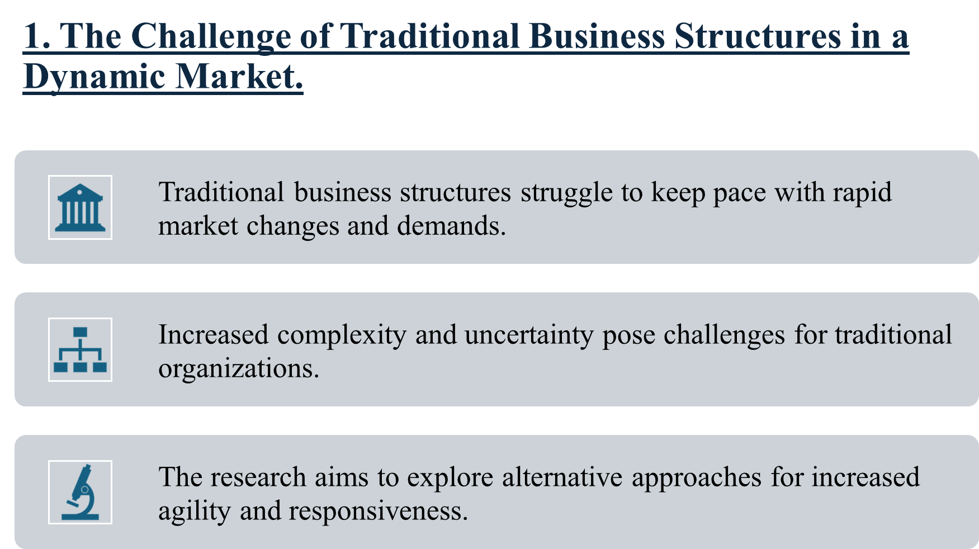
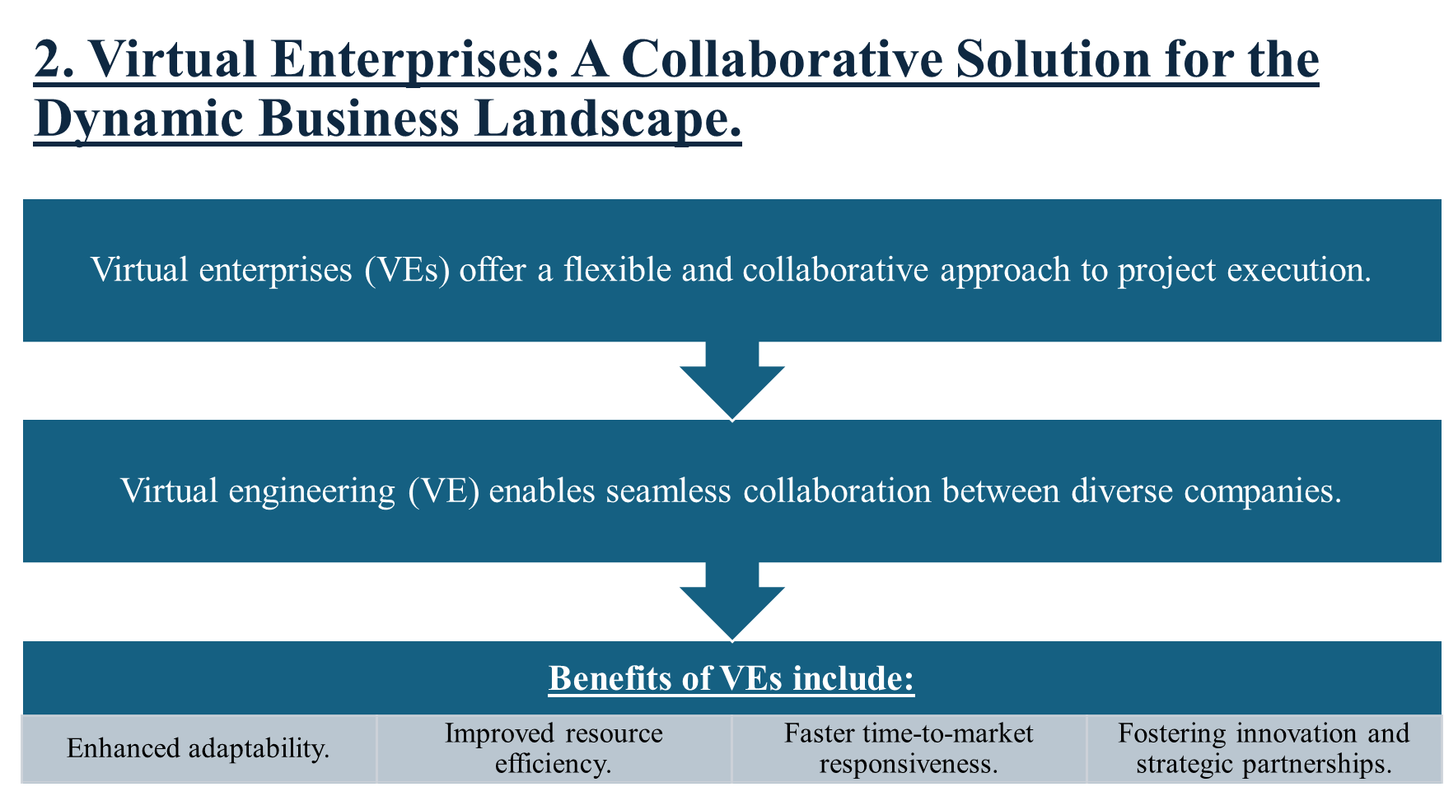

5. Reference:

- Cascio, W. F. (2000). Managing a virtual workplace. The Academy of Management Executive, 14(3), 81-90.
- Castells, M. and Volkmer, I. (2003) “The information age: economy, society and culture,” Development, pp. 119–119.
- Hartman, F. and Ashrafi, R. (1996) “Virtual organizations-an opportunity for learning,” in IEMC 96 Proceedings. International Conference on Engineering and Technology Management. Managing Virtual Enterprises: A Convergence of Communications, Computing, and Energy Technologies. IEEE, pp. 201–205. Available at: https://doi.org/10.1109/IEMC.1996.547815.
- Hertel, G., Geister, S., & Konradt, U. (2005). Managing virtual teams: A review of current empirical research. Human Resource Management Review, 15(1), 69-95.
- Hsieh, T. (2014). Delivering Happiness: A Path to Profits, Passion, and Purpose. Business Plus.
- Kane, G. C., Palmer, D., Phillips, A. N., Kiron, D., & Buckley, N. (2015). Strategy, not technology, drives digital transformation. MIT Sloan Management Review, 14(2), 1-24.
- Robertson, J. (2013). Holacracy: The New Management System for a Rapidly Changing World. Henry Holt and Company.
- Hansen, M. T., Nohria, N., & Tierney, T. (1999). What’s your strategy for managing knowledge? Harvard Business Review, 77(2), 106-116.
- Kirkman, B.L. and Shapiro, D.L. (2001) “The Impact of Cultural Values on Job Satisfaction and Organizational Commitment in Self-Managing Work Teams: The Mediating Role of Employee Resistance,” Academy of Management journal, 44(3), pp. 557–569. Available at: https://doi.org/10.5465/3069370.
- Malhotra, A., Majchrzak, A. and Rosen, B. (2007) “Leading Virtual Teams,” Academy of Management perspectives, 21(1), pp. 60–70. Available at: https://doi.org/10.5465/AMP.2007.24286164.

5.1 Article reference:

Martinez, M.T. et al. (2001) “Virtual enterprise – organisation, evolution and control,” International journal of production economics, 74(1), pp. 225–238. Available at: https://doi.org/10.1016/S0925-5273(01)00129-3.

