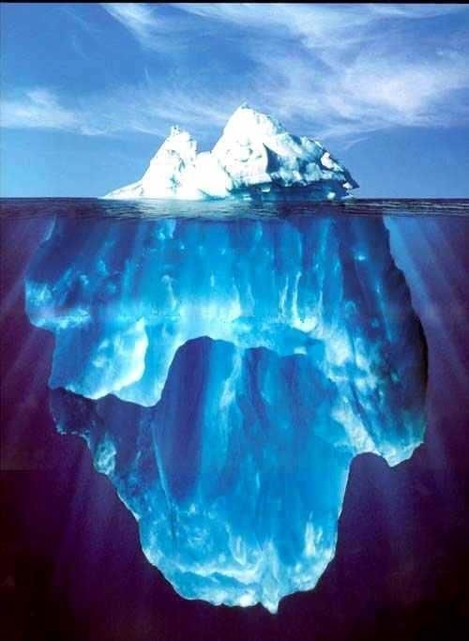

ASSIGMENT 1 REFLECTIVE REVIEW OF LEARNING JOURNEY

NATALIA MICHALAK | PROFESSIONAL CAREER DEVELOPMENT | 14.06.2019

Executive Summary
At the beginning, I need to mark that through report we are going to go with stages. Each of this stage are the most important parts of the journey that helped me to find answers for my questions. Subjects are supported with images, my diagrams and notes related to subjects of the journey.

TABLE OF CONTENTS
Executive Summary……………………………………………………………………………………………………………….1
Introduction……………………………………………………………………………………………………………..3
SELF-AWARENESS 1…………………………………………………………………………………………………..3
SELF-ASSESSMENT………………………………………………………………………………………………….4
SELF-AWARENESS 2………………………………………………………………………………………………..4
SWOT……………………………………………………………………………………………………………………………5,6,7
7 HABBITS AND JAHARI WINDOW………………………………………………………………………….7,8
SMART, 2 YEARS GOAL……………………………………………………………………………………………….9
WHAT IS THE LEARNING LOG……………………………………………………………………………………10
GO MAD………………………………………………………………………………………………………………………..11,12,13
KOLB……………………………………………………………………………………………………………………………..14,15
PERSONALITY PROFALING…………………………………………………………………………………………15
PERSONAL EFFECTIVENESS…………………………………………………………………………………………16
PERSONAL DEVELOPMENT PLAN(PDP)…………………………………………………………………….17
CONCLUSION………………………………………………………………………………………………………………..18
REFERENCES…………………………………………………………………………………………………………………..19,20
ACKNOWLEDGEMENTS…………………………………………………………………………………………………21

INDRODUCTION
My journey started in city that I live in, Swansea's UWTSD. It seemed to be a regular day, like every single one before. I was well, wrong. It was 2nd of May 2019 when I first met my rector, Miss Deborah Jenkins and the rest of my class group. I need to admit that I came in with ready life plan. I knew that I want to study and how my future looks like. I did even introduce my plans to rest of the class when we all tried to break the ice.

SELF-AWARENESS 1
I would like to call this an "introducing to myself". These are the first questions that we need to ask to get to know ourselves. The most important for me were this:
- Do you really know yourself, your preferences, need and desires?
- Do you have a clear perception of your personality, attitudes and behaviours, including strengths, weaknesses, thoughts, beliefs, motivation and emotions?
Of course my response was "YES I do":
First establishment
Q
U
E
S
T
I
O
N
INSTANT THOUGHT
INSTANT THOUGHT
‘You know what you want’
‘YES’

SELF-ASSESSMENT
It is a part of asking yourself more specific but without realizing those thoughts from
self-awareness.
- Think of something you are good at?
Second establishment
Q
U
E
S
T
I
O
N
INSTANT THOUGHT
INSTANT THOUGHT
‘I know myself’
‘It is easy’

SELF-AWARENESS
2 After quick thoughts, we started to speak why exactly each one of us started studies
As I mentioned earlier, I thought I have a plan:
Most important goals | Secondary goals | Third category goals
- Finish course  - Change job  - Continue my studies | - Do the driving license  - Open your business | - Save money  - Buy a car  - Recondition house

- All my goals meant to be achieved in the nearest future. Of course the most important was to finish the course which was a mandatory plot twist The other two are as important as the course.
- Rest of them falls on the further plan.

To better understand goals we need to analyze them with SWOT method.

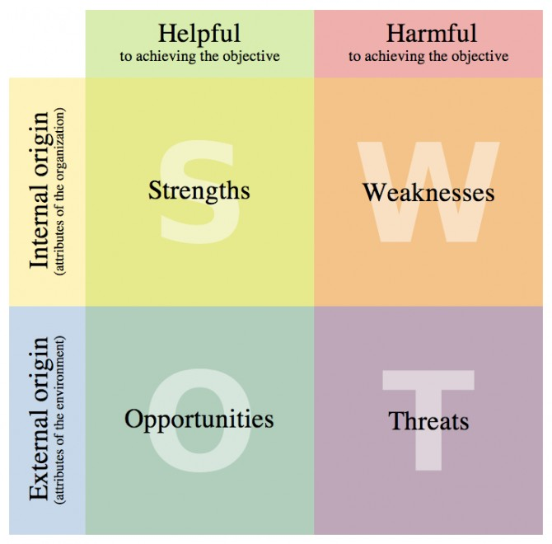
SWOT
SWOT analysis is a key part of any business and strategic plan. SWOT stands for:
S -strengths
W-weaknesses

O -opportunities

T -threats
Example draw 1.0
https://boagworld.com/digital-strategy/swot-analysis/attachment/screenshot-30112012-1235/
-Fast learning  -Priorities first  -Money saver  -Creativity | -Being shy  -Too friendly and helpful  -Language barrier  -Writing skills  -Procrastination
-Building trust  -Investing in myself  (courses, training)  -Contacts with people | -Take a strain  -Not enough money  -Too many competitors
SWOT analysis identifies weaknesses and strengths that have a direct impact on our organization. The one that impacts environment are opportunities and threats. Analyzing helps to show strengths, hide weaknesses, increase opportunities and avoiding threats.
______________________________________________________________________________
The most important SWOT to achieving my journey goal:
My draw of SWOT 1.1 analysis based on example draw 1.0 and my own notes
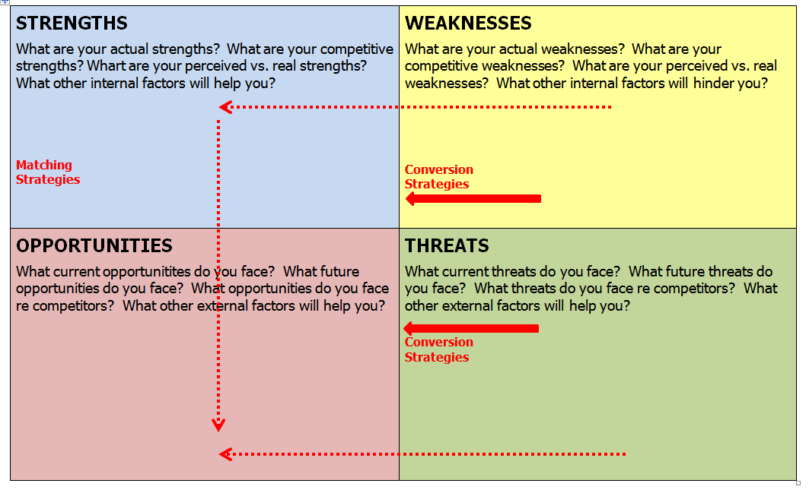
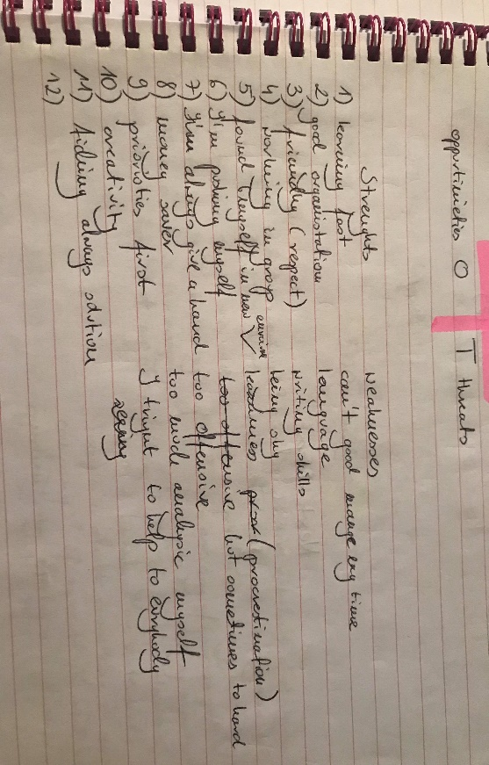
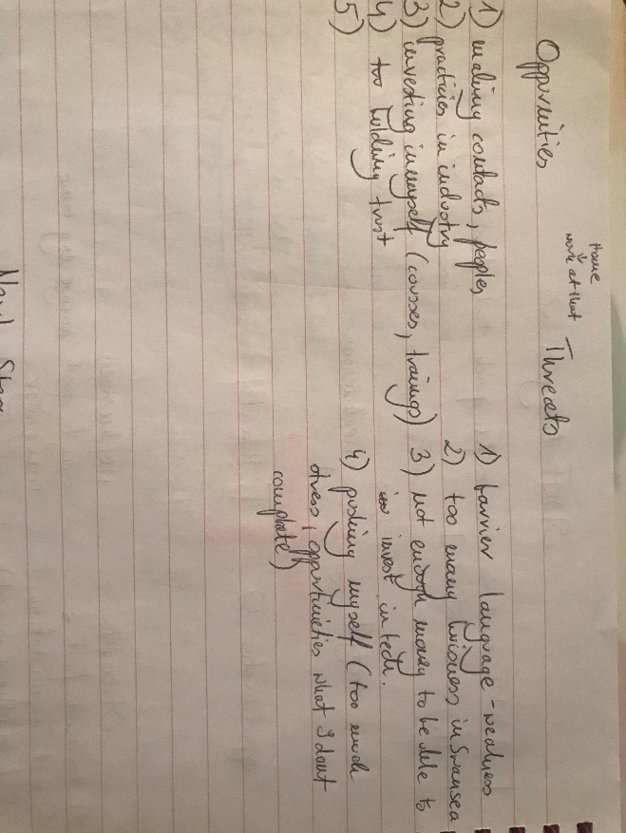
Notes:
___________________________________ On this stage, by asking correct questions I found out that I have equally same amount of strong weak sides. Also threats and opportunities were on similar level. By getting to know them all You can change your weaknesses to strengths and threats in opportunities.
And then again strengths in opportunities.
To understand that better let’s take one of my weaknesses and my threats to conversion strategies to strengths and opportunities. All of them are connected.
Strength:
Organisation skill
conversion strategies
Weakness:
Procrastination

matching
strategies

conversion strategies
Opportunities:
Time management
Threats:
Take a strain

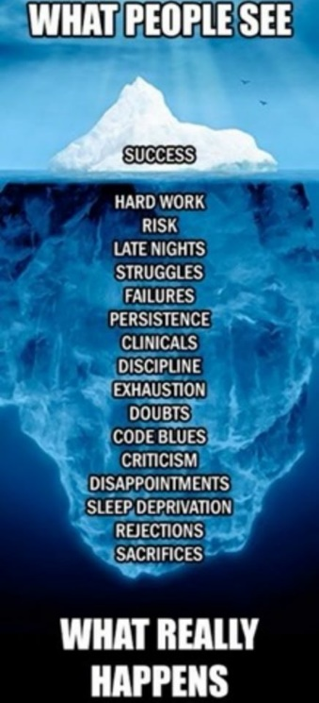
7 HABBITS AND JAHARI WINDOW
“I am what I am today because of the choices I made yesterday’’
- Stephen R. Covey, The 7 Habits of Highly Effective People: Powerful Lessons in Personal Change
http://www.poetry-of-the-day.com/2016/09/15/success-that-big-iceberg-that-you-dont-see/

People only see "the top of the iceberg". They do not see efforts and work that is a part of the success. They only see how do we look like not our character. This is the same with our good and bad sides because people do not see what we struggle with every day.

No one knows what You are made of.
That is why only I know myself so well to know about all of my sides. To reach success I do need to work on procrastination or to take a strain.

To better work on yourself we need this habits:

7 habits:
Accomplish

Be Proactive – Decisions determinate your life

Keep the End in Mind – Keep in mind final goal

First Things First – Priorities and organization first

Connect

Think Win-Win –All interaction has both side benefit.

Seek First to Understand and Then to be Understood – Listen what people saying

Synergize (to produce a joint effect greater than the sum of their separate effects).

Grow

Sharpen the Saw – to look into yourself.
______________________________________________________
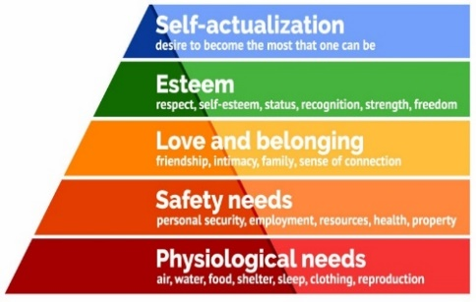
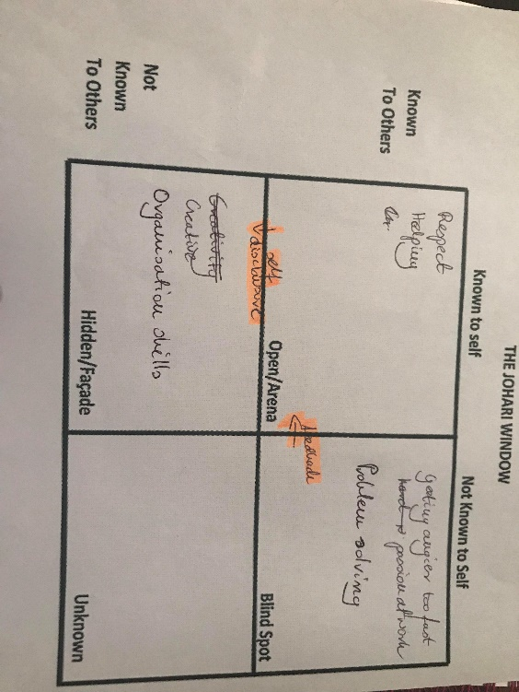
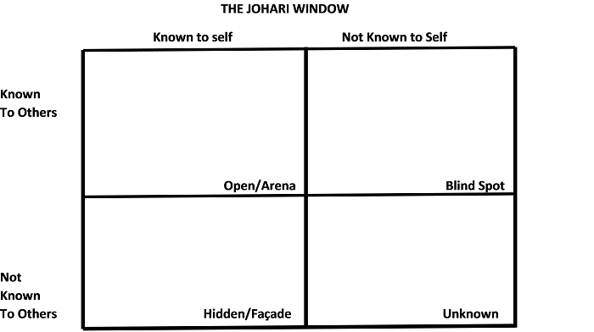
By using those 7 habits we can create a chart- Johari Window- in which is easier to see what relations are between people that surround us (draw A). and then get to the different model (draw B).
This model is named Maslow's Pyramid.
Abraham Maslow was famous American psychologist from XX century, author of his book “Motivation and Personality” (1954) with was continuation of the concept based on his theory of hierarchy psychological needs.
He refined his work from 5 stages of psychological human being (1943,1954) to expand to include aesthetic needs and cognitive.
According the Maslow's theory, self-actualization is the last stage that we can compare to previous "iceberg" as a success. Instead Johari's window have another important part which is love and belonging and that means to know relations around you is another but lesser important part.

Draw B
SMART, 2 YEARS GOAL
SMART It is simply plan which can develop your own goals.
It is means:
Specific – write out clear, concise goals
Measurable- the ability to track your progress
Achievable- set challenging, achievable goals
Realistic- set goals to realistic overall life plan
Time bound- goal has target, finish time attached
________________________________________________________________________
For the first time in my learning journey I realized that I do not know which of my goals can be analysed with SMART and I can't really achieve 2 years goal.
I lacked measurable or achievable element. Stages can be brought for final goal and I was between important decisions in which very important role had my work and money that would finally help me get over with decisions and not only them.
Third establishment
S
M
A
R
T
LONG TIME CONCLUSION
LONG TIME CONCLUSION
‘Can’t do SMART. I don’t know myself. I have no plans’
‘2 ways, different goals’

Reaching of the conclusion in first moment caused a pressure on me to faster achieve my target.
I thinks a helpful tool to return and to summarize was a Learning Log.

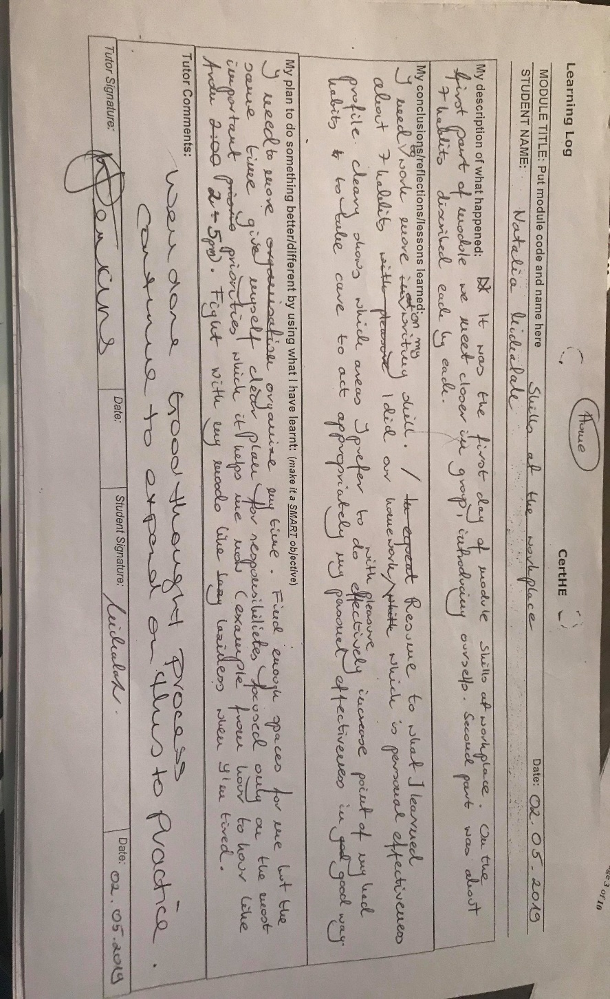
WHAT IS THE LEARNING LOG
This a type of note where you van critically rate your own progress and adapted knowledge. It is a kind of summary that allow you to analyze your experiences.
• Did it go well? Why? What did you learn?

• Did it go badly? Why? What did you learn?

• How can you improve for next time
My first log from 02.05.2019
IN my second Learning Log I tried to extend some thoughts about my doubts about 2 years’ goal or even 5 years. But GO MAD have shown me my thinking mistakes.

GO MAD
Mad ‘Start with better thinking’ © 2019 Go
A MAD Limited
Difference

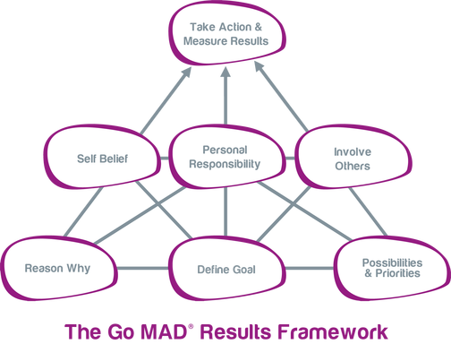
GO MAD is a method to precisely, step by step, reaching better productivity and increasing results in achieving success.
Profits:
- can increase sales
- reduce costs
- save time
- improve performance
- help you develop age others
_________________________________
By doing each steps from a task I wrote down my own plan in notes:

Framework has two modules like levels and steps.
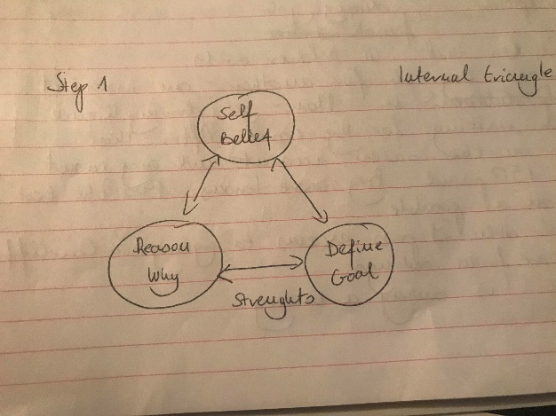
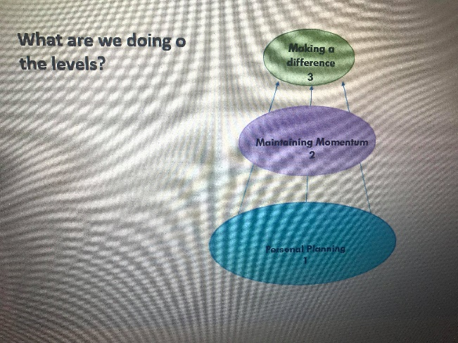
Step 1 level 1
Personal planning
Personal planning
NOTES-STEP 1

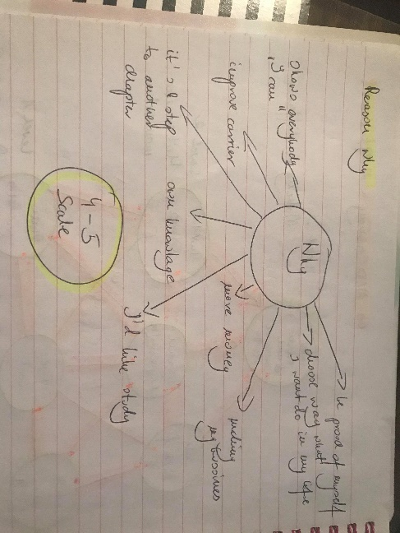
In this step I tried to found plan I answer for diagrams question to know WHY, DEFINE GOAL AND SELF-BELIEF:
WHY-be proud of myself, show ‘I can’, improve carrier, I’d like to study, own knowledge, choose way what I want in my life.
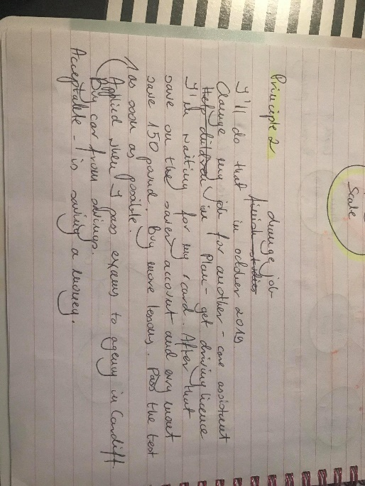
- All highlighted words will have important part in my own journey.
DEFINE- by SMART
S-Change job
M-Change job for care-assistant, get driving licence, save money
A-Save a 150 pound, buy more lessons, pass the test as soon as possible
R-Do overtimes, pass course
T-I’ll do that till October 2019
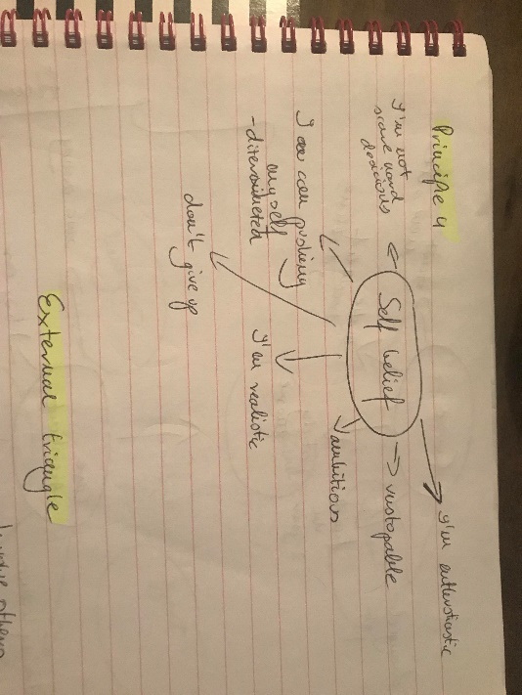
- For me finding new job became a priority to finish school and at the same time do flexible work.
SELF-BELIEF
- I’m ambitious
- Don’t give up
- Determinate

- From that point was easy to get reflection about my journey plan. Clean thoughts eliminate negatives happened to me before in previous statements logs to escalate in founding my SMART GOALS.

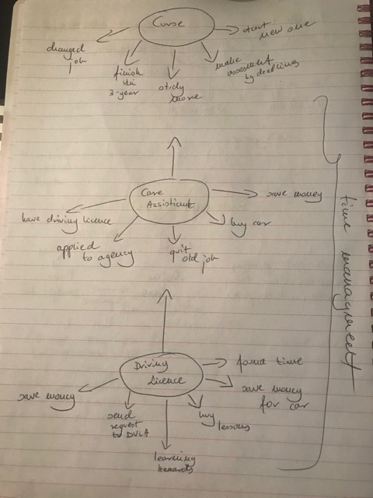
Time management

- Buy lessons
- Send request to DVLA
- Found time
- Save money for car

Driving Licence

- Save money
- Quit old job
- Applied to agency

Care Assistant
- More study
- Finish Uni- 3years goal
- Changed job
- Make assesments by deadline
- Start new one course
Course

_____________________________________
So it became obvious that changing order, back in
Self-Awareness2, and order of priorities
was mandatory. And so from the least important driving
license became one of the most important one, then changing
work place and at the end, as
a cherry on the top of a cake finishing this course.
But to make MAD sensible we need to have people that
will help you out:
- Mother, sister, boyfriend
- Agent, managers
- Future teaching driver

KOLB

His theory (1974) about 4 learning styles is an example that get conclusions and experiences from our basic life. But each one of this stands 4 different ways of getting conclusions and experiences coming only from a nature of a "student".

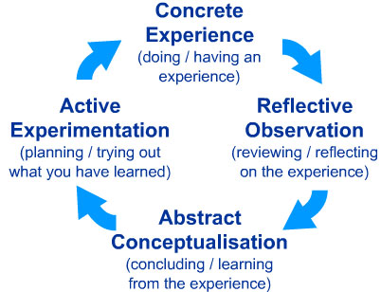
These are four examples:
To better understand this we were doing different types of test, which pushed me closer to my point where I find myself:

TEST 1 Learning Styles Questionnaire
Learning how to develop habits you can easier find some experiences to help benefit that from others. And to identify your personal preferences to suit in our lives. It is designed by Peter Honey and Alan Mumford (1982).

The higher score I get as REFLECTOR
According to my strong and weak sides I am giving an example in my NOTES that I am a person that is analysing too much.
Earlier it was considered by me as a weakness now i turns in to my learning style, showing me more of my strengths:
- Careful
- Thoughtful
- Good at listening to others etc.
MY AREA
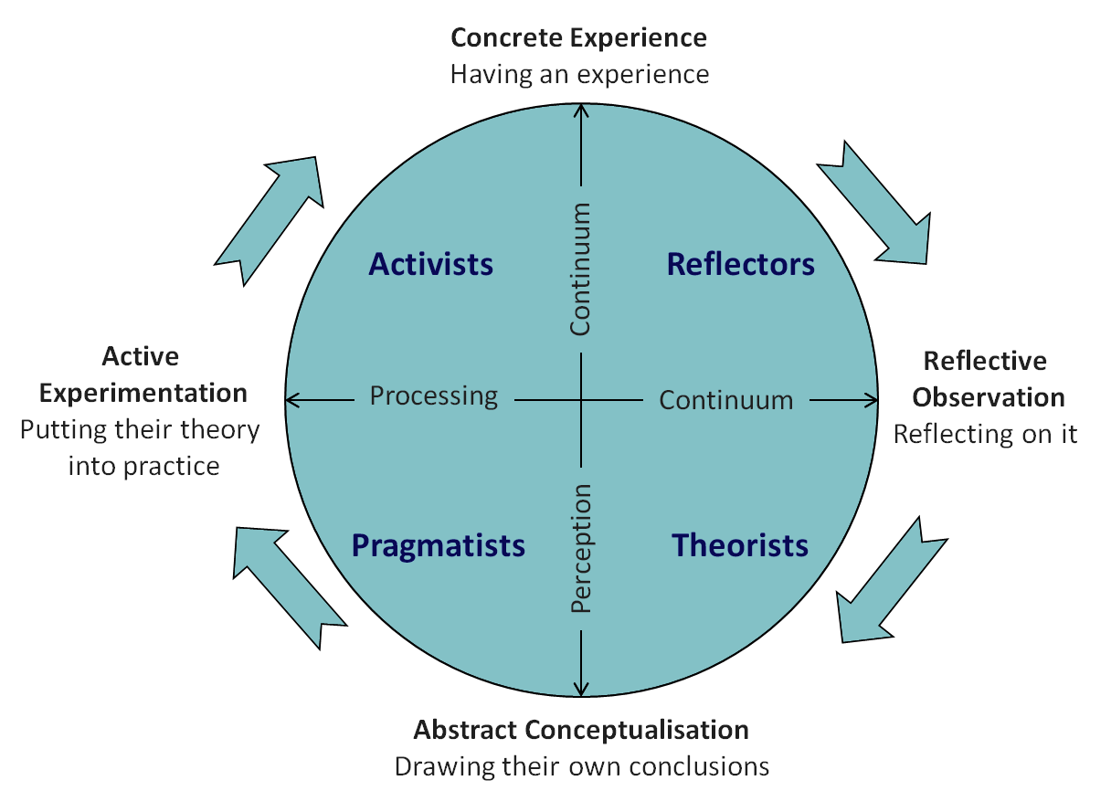
http://www.emtrain.eu/learning-styles/

PERSONALITY PROFALING
TEST 2 MYERS BRIGGS

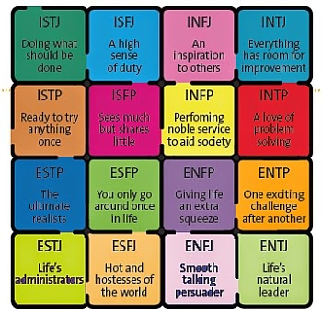
RESOULTS PUT ME IN CATEGORY:

I-INTROVERT

N-INTIUTIVE(N)

F-FEELING

J-JUDGING

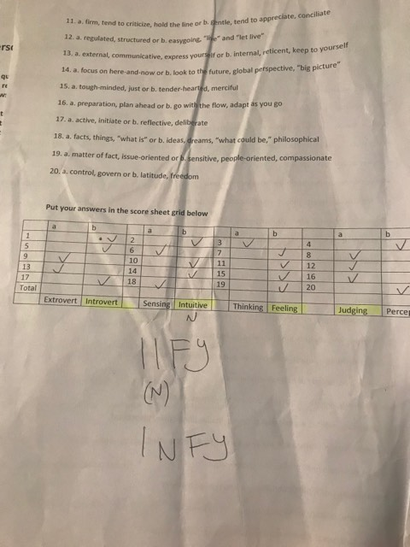
Which I’m an inspiration to others.

PERSONAL EFFECTIVENESS
TEST 3

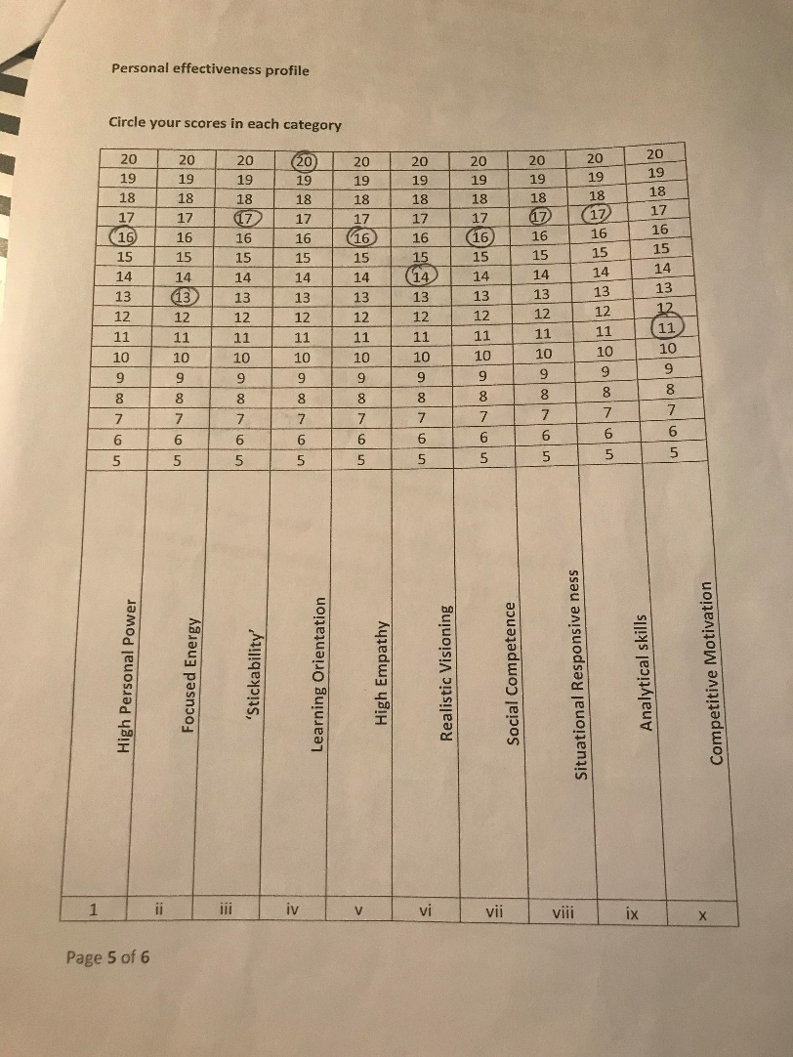
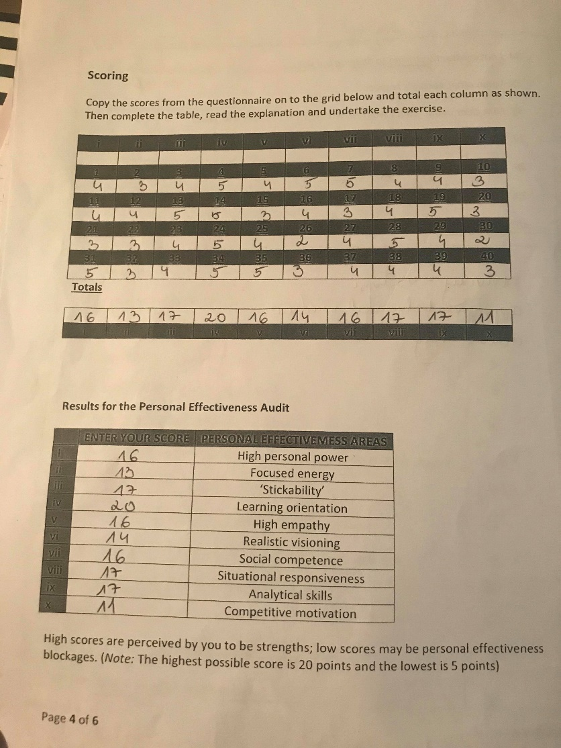
All resources which they are personal or professional have to bring you closer to perfection in its art. Test in its marking system determines category in which I manage better or worse..

Column iv- has max 20 points

Column x- has the lowest 11 poits with Column ii-has 13poits
Rest columns- has average from 14-17 points

PERSONAL DEVELOPMENT PLAN (PDP)

‘Any route to success must start with a plan. Making a personal development plan (PDP) will help you to recognise educational needs as well as personal aspirations and it will allow you to map out how you can achieve THESE.’- Fiona Tasker, a dermatology registrar in London

FIRST- MAKE YOUR GOAL SMART

SECOND- MATCH YOUR ACTIVIETIES TO OBJEVTIVIES

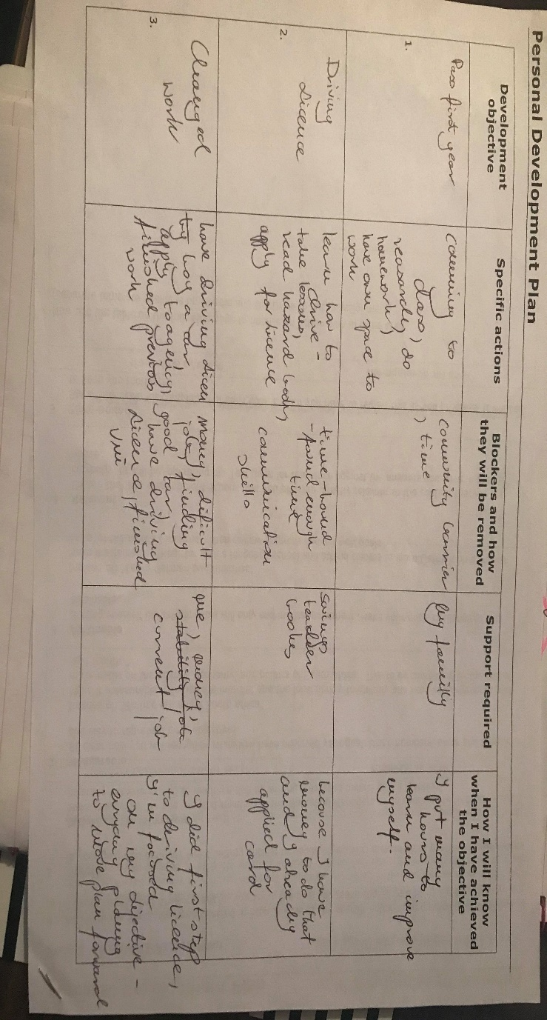
THIRD- PLANNING AND LEARNING

FOURTH- SHOW WHAT DO YOU ACHIEVED AND HOW

_______________________________________________________________
This steps helped me to create mutual image, which I enclosed in a table.
It is a summary of SWOT, SMART, MAD and Self-Awareness:
Fourth establishment
S
M
A
R
T
QUICK

CONCLUSION
INSTANT
CONCLUSION
‘Now I have plan and because of SMART is much easier to achieve goal’
‘ALL DONE’

CONCLUSION
CONCLUSION
As student I am put an immense amount of time and energy into my course and at the same in my learning journey. This can often be undirected, however, and can leave gaps in our skill sets. It can be time management, relationship goals, management tasks etc.
The ones that are with me from the beginning are:
• time management
• focused energy
• competitive motivation
• take a strain
I am really happy that I had a chance to speak with my tutor that gave me a lesson how to better manage with delaying things in time. It was because everything started to roll since we found strategy, solution.
Mine strategy was a Salami technique where You have small amount of free time, which was cut into small slices and regular doses couple times a day. It was mostly because of non-stable working hours.

In case of reaching designated target which I have set after a reflection with MAD strategy, finishing the most important the course, after that I will have to go through another important steps. But reflection about earlier mentioned Salami method also gave me feeling of confidence in completing my responsibilities.
Reflection itself is very important point for me, where I am marking it as my weakness. But after receiving Learning Style test results, where I was describing myself into a role of a person that is learning from observations and another
Johari Window analyse I realised that a glass is half full.

Because I went through steps with carrier developing I know how to collect correct information. I do think very important was my determination to fill the holes called unawareness.
Apparent confidence took away a possibility of acceptation and fixing some not perfect parts of my plan.

Even if my adventure started just couple weeks ago I feel very good with discovering every ingredient of it.
Because a recipe for a perfect cake is a formula where every single one of the components is precisely measured to finally bake fantastic cake of success.

REFERENCES:

Deborah Jenkins (2019) ‘Professional Career Development Session2’ [PowerPoint presentation], BMSK4005. Available at: https://libguides.ioe.ac.uk/c.php?g=482485&p=3299833 (Accessed: 12 June 2019).

Deborah Jenkins (2019) ‘Professional Career Development Session6’ [PowerPoint presentation], BMSK4005. Available at: https://libguides.ioe.ac.uk/c.php?g=482485&p=3299833 (Accessed: 12 June 2019).

Deborah Jenkins (2019) ‘Professional Career Development Week 2’ [PowerPoint presentation], BMSK4005. Available at: https://libguides.ioe.ac.uk/c.php?g=482485&p=3299833 (Accessed: 12 June 2019).

Deborah Jenkins (2019) ‘Professional Career Development Session1’ [PowerPoint presentation], BMSK4005. Available at: https://libguides.ioe.ac.uk/c.php?g=482485&p=3299833 (Accessed: 12 June 2019).

Adapted from C Miller, A Tomlinson, M Jones, Researching Professional Education 1994, University Of Sussex. Available at: file:///D:/Downloads/learninglogs_explained.pdf (Accessed: 12 June 2019).

Robert G. Dyson, 10 January 2002; accepted 9 September 2002, ‘Strategic development and SWOT analysis at the University of Warwick’, European Journal of Operational Research 152 (2004) 631–640

Lina Mileskaite (2018), ‘7 Things I Learned from The “7 Habits of Highly Effective People, Lina Mileskaite, 18th February, Available at: https://www.linamileskaite.com/7-things-learned-7-habits-highly-effective-people/ file:///D:/Downloads/learninglogs_explained.pdf (Accessed: 13 June 2019)

Covey, Stephen R. The 7 Habits of Highly Effective People: Restoring the Character Ethic. New York: Free Press, 2004. Print.

Wisdom For Life (2018), ‘The 7 Habits of Highly Effective People Summary’, Available at: https://www.youtube.com/watch?v=WFc08j9eorQ (Accessed: 12 June 2019)

Ruby McGuire (2019), ‘How to Use The "Johari Window" Tool for a New Perspective on The Inner Critic, By Ruby McGuire’, Simplicity Life Coaching, Available at: https://www.thecoachingtoolscompany.com/how-to-use-the-johari-window-tool-for-a-new-perspective-on-the-inner-critic-by-ruby-mcguire/ (Accessed: 12 June 2019)

Go MAD Limited (2019),’ What if you could improve performance in every area of your organisation?’, GO MAD Limited, viewed 12 June 2019, https://www.gomadthinking.com/

McLeod, S. A. (2013). Kolb - Learning Styles. Retrieved from www.simplypsychology.org/learning-kolb.html

LifeTrain (unknown), ‘Learning styles quiz’, UNKNOWN, Available at: http://www.emtrain.eu/learning-styles/ (Accessed: 12 June 2019)

Jane(2013-2019), ‘ What is the Personal Effectiveness And Self-Management’, Habitsforwellbeing.com, Available at: https://www.habitsforwellbeing.com/what-is-personal-effectiveness-self-management/ (Accessed: 11 June 2019)

Abi Rimmer(2018),’ How do I prepare a personal development plan?’, The BMJ, 13 November 2018, Available at: https://www.bmj.com/content/363/bmj.k4725 (Accessed: 11 June 2019)

ACKNOWLEDGEMENTS

I would to express special thanks for my Lecturer Deborah Jenkins for her guidance and support in completing my project.
14.06.2019

