Management & Operations

James Brooks
HND Student at Pembrokeshire College
Haverfordwest, United Kingdom
144818@Pembrokeshire.ac.uk

Table of Contents
Management & Operations 1
Team working & collaboration methods used 5
Skills needed to run your potential Tech Start-Up 6
Does the Business require premises? 6
Code of conduct 7
Appendix 8
Reflection 8
Networking 8
Team-working 8
References 9
Bibliography 9

Development
In this section of the assignment, the report generally had a small part in the development of the business’s website to promote the idea, the report for the most part was responsible for developing the HTML code for the index page of the website. Below is a screenshot of the HTML code of the said website as well as screenshots of the finished index page. The index page will mostly include the logo of the business as well as a short slogan reading “Bespoke Gaming Desk”.

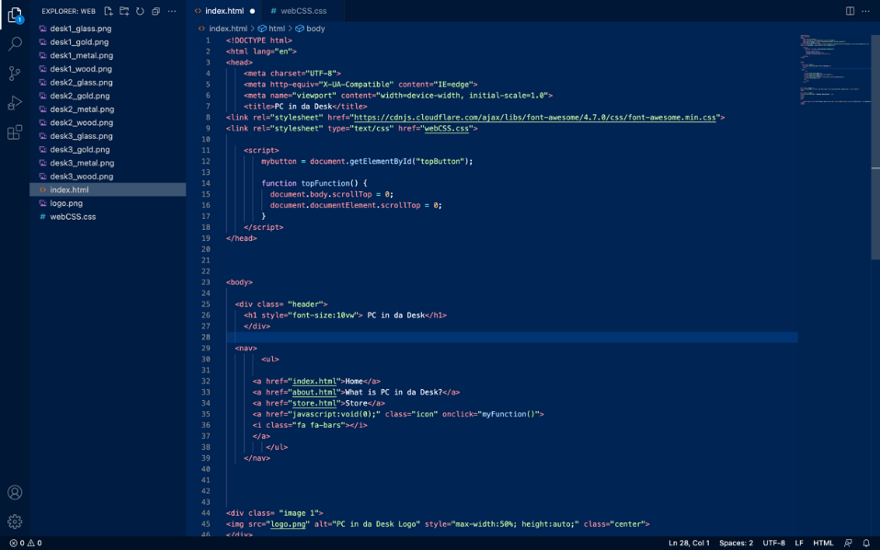
Fig 1. Screenshot of HTML file for index page.


Fig 2. Screenshot of top of index page with HTML and CSS files attached.


Fig 3. Screenshot of bottom of index page with HTML and CSS files attached.

Team working & collaboration methods used
In this section of the assignment, the report will discuss the collaboration and team working method that for the most part was used during the planning and initial pitch of the idea. Collaboration and teamwork involve people working together for the same goal. Working together is more than just finishing a task, rather it refers to collaborative work that takes place when people work together effectively. A team's strength comes from its members supporting each other, communicating well, and doing their part. The report found that different individuals communicate in different ways. Some prefer group meetings. Others prefer to speak one-on-one while others feel most comfortable in an online chatroom. One of the main ways the group found a way to work well together was through regular online meetings to really discuss duties and issues that each member faced. The report mostly found that this was effective as the group met regular enough as to not generally disturb each member’s tasks but not too far apart to generally impede the progress by lack of communication, overall, this essentially was a for all purposes a great alternative to face-to-face meetings that could not be carried out due to social restrictions. The report also found that online video calls were effective in the communication of the group as it provided participants with important nonverbal cues and encouraged them to stay engaged. [1]

Skills needed to run your potential Tech Start-Up

The process of starting a tech company is not easy. It is very easy to get swept up in the excitement of launching and building up a successful tech business and it is also easy to dismiss the skills necessary to succeed, however, this report for the most part has generally found that the skills needed to run the tech start-up are project management, front-end development, and communication skills. As a group this report feels that a lot of these required skills generally are already possessed by some of the members, for instance, all members generally have shown that they can communicate effectively through group meetings and general face to face interactions, also the author of this report specifically has found a way, for the most part, to manage the team even without previous management experience and also two of the group members have adequate knowledge and understanding of front end development as they are going to mostly be overseeing the software development of the project as these skills can definitely be improved upon such as project management but this report mostly feels that as this project evolves the skills will improve with it.

Does the Business require premises?

This report has also concluded that the company initially could run its business similarly to how university courses are being delivered now through each member working from home and communication through particularly social platforms and video conferences. However, this report realises that after a little while of the business starting it would need as for all intents and purposes a more permanent and bigger base of trading i.e., rented warehouse for production etc. The report has found that that getting funding for a start-up is the biggest hurdle. A business's success depends on its ability to raise funding. There are many ways to do this, including bank loans. This report feels that a bank loan would be the best method to obtain the funds to purchase the business’s trading and production premises. Also, the business would need an IT facility either within the warehouse or in its own premises as part of the business involves an application/program so that users can customise the requirements of their PC desk. So, this app/program will need technical upkeep in the form of updates and bug fixes.

Code of conduct
This report has also considered that as the business would be operating in a professional manner and code of conduct would specifically be needed to be established to ensure that all staff members work proactively together and essentially ensure the business succeeds and survives its active time trading. An organization's code of conduct is one of the most common policies. As employees and third parties interact with the organization, they are held to the company's principles, standards, and moral and ethical expectations. The report found that having a code of conduct in a business is essential as The Ethics & Compliance Initiative suggests that it clarifies an organisation’s mission, values, and principles, linking them with standards of very professional conduct in a generally big way. The code articulates the values the organization wishes to foster in leaders and employees and, in doing so, defines desired behaviour. As a result, written codes of conduct or ethics can become benchmarks against measuring individual and organizational performance.[2] for example, a zero-tolerance approach to harassment could prevent a manager from terminating an employee's employment, which could backfire on the business as it would have to find a replacement for that position quickly, wasting time and resources in promoting and interviewing.

Appendix

Reflection
In this assignment, the report has developed its technical and employability skills by working with a group and planning the assignment tasks out effectively and productively this has benefitted the report as it has increased its team-leading and group working skills greatly as well as increased the report’s ability to plan and productively utilise time. These skills are valuable to employers as they show that the individual can plan his/her time out accordingly and work cooperatively with a team.

Networking
During this assignment, the report along with the team attended a networking event organised by business wales, at the event the report got an opportunity to meet with other individuals who were starting a business and was attending the event to gain more insight on the factors needing consideration when starting a business. The report and the team also met with a group especially aimed towards helping young individuals in a. business setting, their aim was to offer support and advice to any students or other young individuals who were thinking of starting a business.

Team-working
Below is a copy of the reports team progress report visualising the productivity of the group. As seen in the report all group members made great progress on each of their tasks and were able to efficiently carry out the tasks set to them.
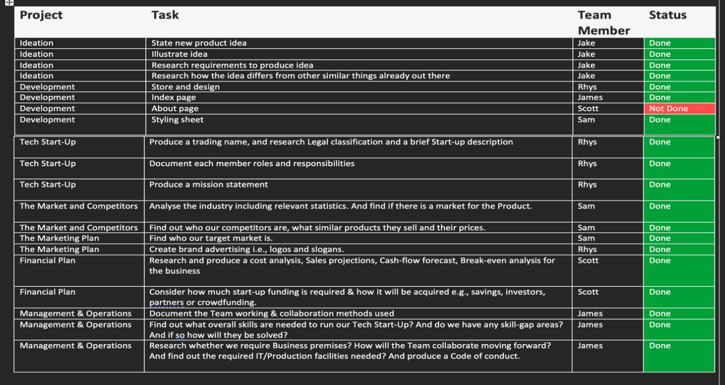

References

[1] Mindtools.com. 2022. How to Run Effective Virtual Meetings IT: Communicating Well With Technology. [online] Available at: <https://www.mindtools.com/pages/article/running-effective-virtual-meetings.htm> [Accessed 26 February 2022].

[2] Team, E., 2022. Why Have a Code of Conduct - Free Ethics & Compliance Toolkit. [online] Ethics and Compliance Initiative. Available at: <https://www.ethics.org/resources/free-toolkit/code-of-conduct/> [Accessed 26 February 2022].

Bibliography

[1] Monster.com.hk. 2022. 5 skills you need to land a tech startup job - Monster.com.hk. [online] Available at: <https://www.monster.com.hk/career-advice/5-skills-you-need-to-land-a-tech-startup-job-7339.html> [Accessed 26 February 2022].

[2] Indeed Career Guide. 2021. Code of Conduct Examples in the Workplace and Why To Use Them. [online] Available at: <https://uk.indeed.com/career-advice/career-development/code-of-conduct-examples#:~:text=A%20company%27s%20code%20of%20conduct,successful%20in%20their%20work%20environment> [Accessed 26 February 2022].

