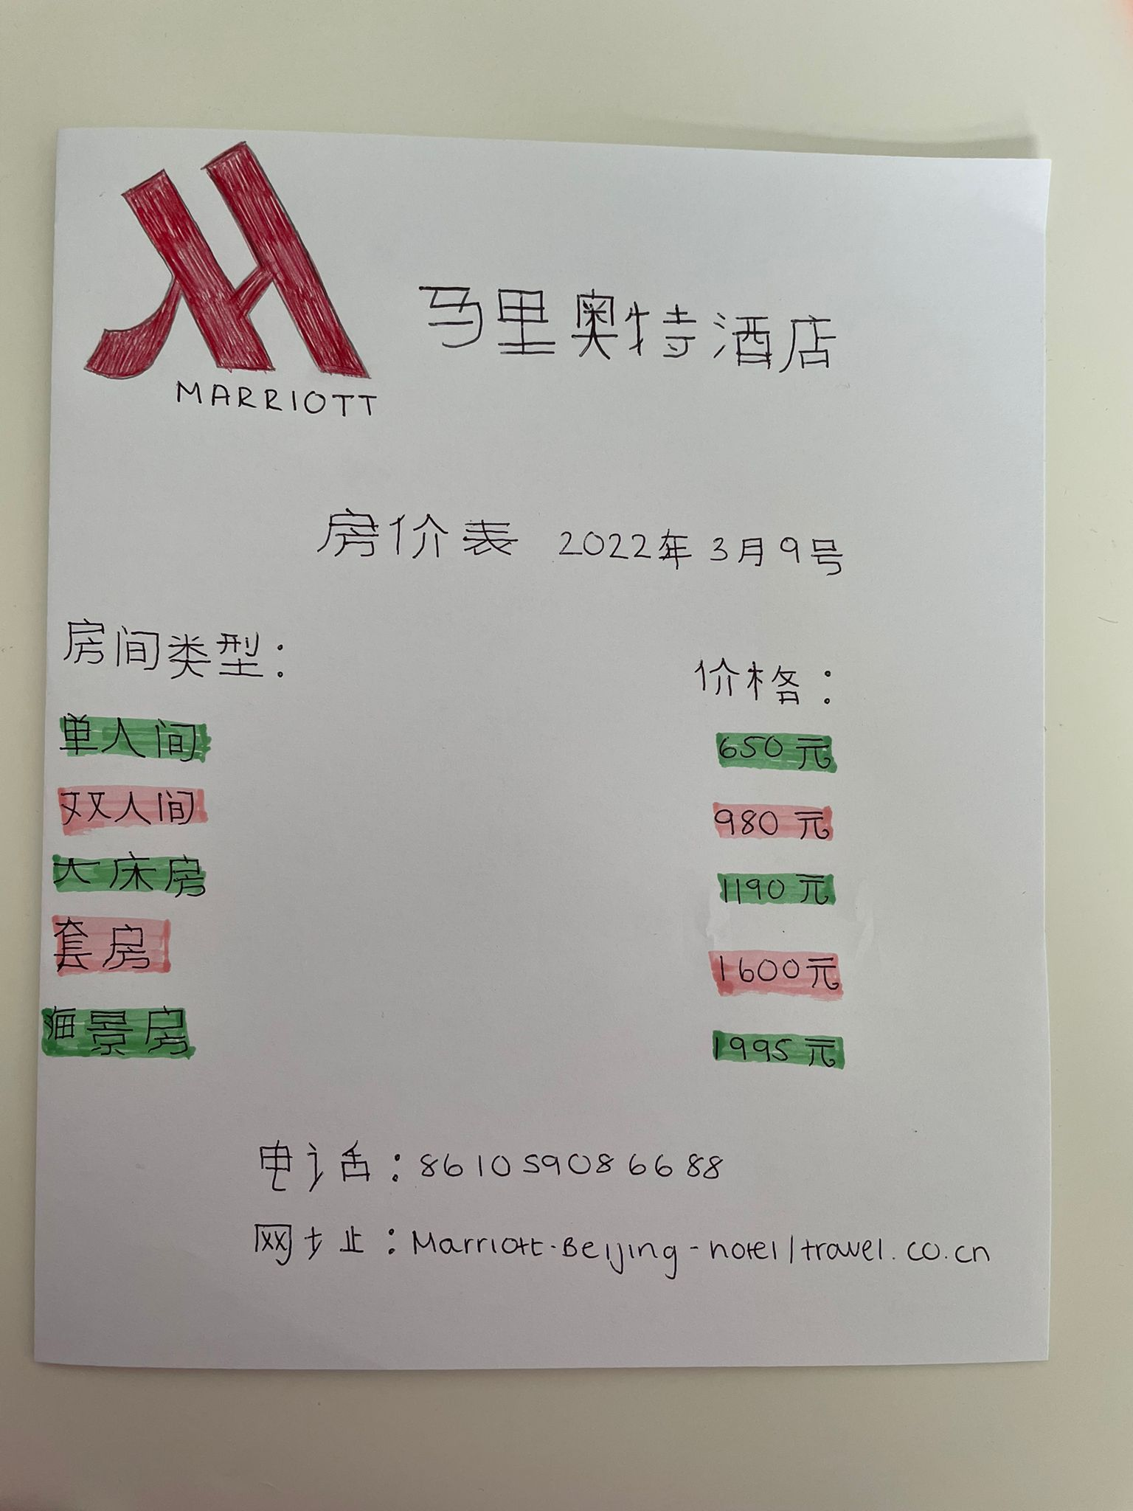
- Name: Khaled Ahmed Module: Foreign languages and culture awareness.
- The third assignment: Hotel display board. Due date: 11 march 2022
- Lecturer: Jinping li

