HAJRA NIAZ
2129740
BMHP 6026
DIGITAL TRANSFORMATION IN THE HEALTH AND CARE PROFESSIONALS
JOANNE DAVIES

Table of Contents
- Introduction ............................................................................. 1
- Overview of the NHS AI Lab ..................................................... 2
- Impact on Workforce .............................................................. 3
- Impact on Service Delivery ..................................................... 4
- Impact on Patients .................................................................. 5
- Impact on Communities ......................................................... 6
- Critical Analysis ..................................................................... 7
- Recommendations .................................................................. 8
- Conclusion ............................................................................ 9
- Reference List .................................................................... 10

Introduction
Artificial intelligence (AI) is increasingly recognised as a transformative force within global healthcare systems, offering opportunities to improve diagnostic accuracy, optimise service delivery, strengthen prevention strategies and alleviate workforce pressures. In England, the NHS AI Lab was proved in 2019 by NHS England and the Department of Health and Social Care to accelerate the safe, ethical and evidence-based adoption of AI technologies across the National Health Service (NHS England, 2019; Department of Health and Social Care, 2019). Rather than functioning as a technology developer, the Lab was designed as a national system level enabler, addressing persistent barriers such as fragmented procurement systems, regulatory complexity, limited digital infrastructure and inconsistent evaluation frameworks.
The initiative aligns with the government’s broader digital transformation strategy, which positions AI as central to improving quality of care, productivity and health equity (Department of Health and Social Care, 2019). Through structured funding programmes, staged evaluation pathways and the development of ethical governance frameworks, the NHS AI Lab looks to embed innovation within routine NHS practice while keeping public trust.

This Photo by Unknown Author is licensed under CC BY-SA-NC
This report adopts a thematic approach to critically evaluate the impact of the NHS AI Lab on public health in England. It examines its influence on workforce transformation, service delivery, patient outcomes and communities, before offering a critical appraisal of the current evidence base. Drawing upon emerging academic and policy literature, including research on generative AI in public services (Bright et al., 2024). health equity risks (Burger, 2020) and rural healthcare innovation (Balakrishnan et al., 2025). the analysis considers both opportunities and limitations. While AI presents substantial potential to enhance prevention, efficiency and access, its contribution to public health depends upon fair implementation, digital maturity and sustained governance.
2. Overview of the NHS AI Lab
The NHS AI Lab stands for a coordinated national initiative to embed artificial intelligence into healthcare delivery across England. Hosted within NHS England, it uses through structured funding programmes, regulatory support and partnerships with academic institutions (NHS England, 2019).
A central pillar of the Lab’s model is rigorous evaluation. An independent mixed-methods review conducted by the University of Edinburgh highlighted progress in fostering an innovation ecosystem while finding ongoing challenges in scaling technologies across diverse NHS contexts (University of Edinburgh, 2025). The evaluation emphasised that sustained national support is needed to translate pilot projects into system-wide transformation (Digital Health, 2025).
Ethical governance is another defining feature. Through the NHS AI Lab Ethics Initiative, hosted by NHS England Digital, frameworks have been developed to address algorithmic bias, data fairness and inclusive design (NHS England Digital, 2025a; 2025b). Collaboration with the Ada Lovelace Institute has further strengthened the use of algorithmic impact assessments to evaluate societal consequences before implementation.
Government announcements confirm that AI is being trialled at unprecedented scale within national screening programmes, supported by secure cloud infrastructure (Gov.UK, 2025). However, digital maturity stays uneven across NHS trusts. Reports show that outdated IT systems and limited interoperability restrict adoption in certain regions (Financial Times, 2024). Consequently, while governance and evaluation structures are strengthening, infrastructural disparities continue to shape uneven implementation.

3. Impact on Workforce
The adoption of AI technologies through the NHS AI Lab is reshaping workforce roles rather than replacing clinical professionals. Guidance from (NHS England 2023) emphasises that AI functions as a decision-support tool, with clinicians keeping responsibility for final judgement.
Generative AI tools are already widely used within public sector environments, particularly to aid with drafting, documentation and administrative workflows (Bright et al., 2024). Within the NHS, such applications may reduce bureaucratic burden and enable clinicians to dedicate more time to direct patient care.
However, workforce transformation needs digital upskilling. Clinicians must critically interpret algorithmic outputs, understand data limitations and address potential biases. Professional uncertainty about accountability and medico-legal liability has been reported, particularly in primary care settings where AI use has expanded organically (The Guardian, 2025).

This Photo by Unknown Author is licensed under CC BY
Workforce inequalities also reflect broader institutional disparities. Digitally mature trusts integrate AI more effectively, while under-resourced organisations face infrastructural constraints (Financial Times, 2024). Without fair training and infrastructure investment, AI adoption may widen capability gaps across regions.
Importantly, AI implementation encourages multidisciplinary collaboration between clinicians, data scientists and informatics specialists. This aligns with broader workforce development strategies articulated by NHS England (2023).
Overall, the workforce impact is transformative but conditional. Realising benefits requires sustained training, governance clarity and fair digital infrastructure to ensure safe and effective adoption.
4. Impact on Service Delivery.
AI-supported technologies have increasingly shaped NHS service delivery across diagnostics, screening and operational management. National policy developments show that AI is being trialled at unprecedented scale within screening programmes, particularly to accelerate cancer detection and enhance diagnostic accuracy (Gov.UK, 2025). These initiatives prove a shift from isolated pilots to more coordinated deployment within population-level services.
AI systems strengthen early detection and risk stratification by analysing imaging data and patient records with greater speed and consistency. This supports preventive interventions aligned with national public health priorities, including earlier diagnosis and improved survival outcomes (Department of Health and Social Care, 2019). In addition, research into rural healthcare delivery highlights AI’s capacity to bridge geographical barriers by supporting remote diagnostics and decision-making, thereby improving fair access to specialist services (Balakrishnan et al., 2025). Such applications are particularly significant in addressing regional inequalities in service provision.
Predictive analytics tools further contribute to service planning by examining electronic health records to forecast demand, find high risk populations and guide resource allocation. This enables a more proactive, data-driven approach to managing pressures within the NHS. Moreover, generative AI technologies are increasingly used to streamline administrative tasks, automate documentation and reduce clerical burden, thereby improving workflow efficiency and potentially releasing clinical time for patient care (Bright et al., 2024).
However, structural challenges continue to constrain scalability. Procurement complexity, fragmented digital systems and limited interoperability hinder consistent integration across NHS trusts (Financial Times, 2024). Furthermore, independent evaluation emphasises that sustainable scaling requires coordinated national leadership and long-term investment rather than short-term innovation funding (University of Edinburgh, 2025).
While service level benefits are clear, achieving consistent, population-level improvements stays an ongoing process dependent on infrastructure, governance and sustained strategic support.

Impact on patients.
For patients, the integration of artificial intelligence within NHS services influences diagnosis, access to care and continuity of treatment. Large-scale AI trials within national screening programmes aim to accelerate early disease detection, particularly in cancer pathways, potentially improving survival outcomes through faster and more correct identification of abnormalities (Gov.UK, 2025). Earlier diagnosis is strongly associated with better prognosis and reduced treatment complexity, aligning AI innovation with core public health aims.
AI also supports improved access and continuity of care. Research conducted by the University of Reading proves how predictive algorithms can find patients at risk of missing appointments, particularly within deprived communities, and enable targeted interventions to reduce non-attendance (Reading University, 2025). By addressing missed appointments, AI can help minimise disruptions in care pathways, reduce health deterioration linked to delayed treatment and support efforts to narrow health inequalities.
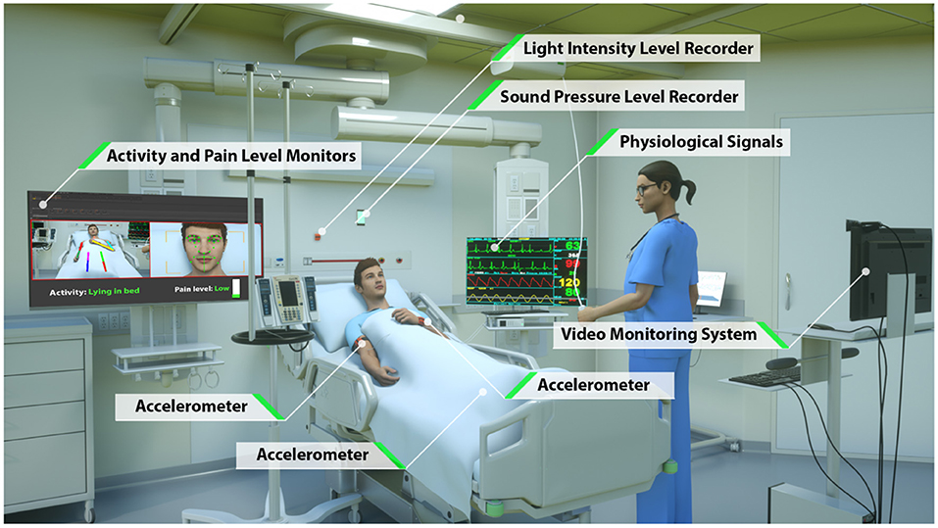
This Photo by Unknown Author is licensed under CC BY
Despite these potential benefits, risks stay. Algorithmic bias presents a significant concern, particularly where training datasets lack demographic diversity. Narrative reviews highlight that automated decision systems may inadvertently reinforce existing health disparities if they reproduce structural biases embedded within historical data (Burger, 2020). Such outcomes could undermine equity and compromise trust among already marginalised populations.
To address these risks, ethical oversight mechanisms developed by NHS England Digital aim to promote fairness, transparency and inclusive design in AI systems (NHS England Digital, 2025a; 2025b). However, patient trust stays central to sustainable implementation. Transparent communication about data usage, algorithmic influence on clinical decisions and governance safeguards is essential. Particularly among communities historically affected by structural inequities, sustained engagement and accountability are critical to ensuring AI enhances rather than diminishes fair patient care.

Impact on Communities
At community level, artificial intelligence has the potential to strengthen population health management through predictive analytics, targeted prevention strategies and improved service planning. By analysing large datasets across primary and secondary care, AI systems can find high-risk populations, expect service demand and support earlier intervention. Research focusing on rural healthcare innovation proves how AI-enabled diagnostics and remote decision-support tools can help bridge geographical service gaps, improving access for underserved communities and enhancing equity in healthcare delivery (Balakrishnan et al., 2025). Such applications are particularly relevant in areas where workforce shortages and distance from specialist services create structural barriers to care.
The NHS AI Lab’s Ethics Initiative places explicit emphasis on embedding health equity within algorithm design and deployment processes (NHS England Digital, 2025b). This includes encouraging inclusive datasets, fairness auditing and structured governance frameworks to minimise unintended bias. However, the benefits of AI at community level are not evenly distributed. Significant disparities in digital infrastructure, system interoperability and organisational readiness continue to limit uniform implementation across regions (Financial Times, 2024). Communities served by digitally mature trusts may experience more rapid improvements than those in under resourced areas.
Furthermore, broader socioeconomic factors shape engagement with AI-enabled services. Digital exclusion, lower health literacy and deprivation can restrict access to digital health platforms and reduce confidence in automated systems. Without parallel investment in addressing social determinants of health, technological innovation alone cannot resolve structural inequalities (Burger, 2020).
Therefore, meaningful community engagement, transparent governance and targeted infrastructure investment are essential to ensure that AI contributes to fair public health improvement rather than reinforcing existing disparities.

7. Critical Analysis
The NHS AI Lab has strengthened governance frameworks, evaluation standards and ethical oversight. However, robust evidence of sustained, large-scale public health improvement stays limited (University of Edinburgh, 2025).
Infrastructure inequalities (Financial Times, 2024), regulatory ambiguity (The Guardian, 2025) and equity risks (Burger, 2020) constrain full realisation of benefits. Although generative AI adoption is increasing (Bright et al., 2024), national standardisation and longitudinal outcome evaluation are still evolving.
Consequently, while the strategic foundations are strong, measurable population-level transformation requires continued investment, monitoring and inclusive policy development.

Recommendations for Future Improvement
To strengthen the long-term public health impact of the NHS AI Lab, a more coordinated and equity-focused implementation strategy is needed. While early innovation has been promising, future progress depends on embedding AI systematically across the NHS rather than relying on isolated pilots.
First, greater investment in digital infrastructure and interoperability is essential. Variations in digital maturity across NHS trusts continue to limit consistent AI adoption, particularly in under-resourced regions (Financial Times, 2024). Targeted national funding should prioritise upgrading outdated IT systems, improving secure data-sharing mechanisms and ensuring interoperability between electronic health records. Without this foundation, AI tools cannot be scaled effectively or equitably.
Second, stronger national governance and evaluation mechanisms are needed. Although the Lab has developed structured funding and ethical oversight pathways, evidence of sustained population-level impact stays limited (University of Edinburgh, 2025). Longitudinal mixed-methods research should be commissioned to evaluate clinical outcomes, cost-effectiveness, workforce implications and impacts on health inequalities. A standardised national accreditation framework for AI tools would also enhance safety, transparency and public trust.
Third, workforce development must be expanded. AI literacy should become embedded within medical education and continuing professional development, ensuring clinicians can critically interpret algorithmic outputs and keep accountability in decision-making. Clear professional guidance about liability and ethical use will further support confidence in adoption.
Finally, equity must remain central to future AI strategy. Routine bias auditing, representative datasets and meaningful community engagement are necessary to prevent the reinforcement of existing disparities. By combining infrastructure investment, governance clarity and inclusive policy design, the NHS AI Lab can transition from early-stage innovation support to delivering measurable, fair improvements in public health outcomes.

8. Conclusion
The NHS AI Lab is a significant strategic intervention in England’s digital health transformation. Through coordinated governance, evaluation and infrastructure development, it has supported advances in diagnostics, screening and service efficiency (NHS England, 2019; Gov.UK, 2025).
Thematic analysis proves multidimensional impacts across workforce development, service delivery, patient experience and community-level public health management. However, benefits stay uneven due to infrastructural disparities and socioeconomic inequalities (Financial Times, 2024; Burger, 2020).
Future progress depends on sustained national support, workforce training, infrastructure investment and rigorous longitudinal evaluation (University of Edinburgh, 2025; Digital Health, 2025). Importantly, AI must complement broader strategies addressing rural access and social determinants of health (Balakrishnan et al., 2025).
If implemented equitably, transparently and systematically, AI holds meaningful potential to contribute to a more preventive, efficient and fair public health system in England.

Reference.

Balakrishnan, K. et al. (2025) Artificial Intelligence in Rural Healthcare Delivery: Bridging Gaps and Enhancing Equity through Innovation, arXiv.
Bright, J. et al. (2024) Generative AI is already widespread in the public sector, arXiv. Available at: https://arxiv.org/abs/2401.01291 (Accessed: date).
Burger, M. (2020) The risk to population health equity posed by automated decision systems: A narrative review, arXiv.
Department of Health and Social Care (2019) The future of healthcare: our vision for digital, data and technology in health and care. London: DHSC.
Digital Health (2025) Evaluation of NHS AI Lab calls for national support for AI initiatives, Digital Health News, 29 April. Available at: https://www.digitalhealth.net/2025/04/evaluation-of-nhs-ai-lab-calls-for-national-support-for-ai-initiatives/ (Accessed: date).
Financial Times (2024) Operating in the Stone Age: NHS staff struggle with outdated tech.
Gov.UK (2025) AI to be trialled at unprecedented scale across NHS screening. Available at: https://www.gov.uk/government/news/ai-to-be-trialled-at-unprecedented-scale-across-nhs-screening (Accessed: date).
NHS England (2019) The NHS AI Lab: transforming healthcare through artificial intelligence. London: NHS England.
NHS England (2023) Artificial intelligence (AI) and machine learning, NHS England Guidance.
NHS England Digital (2025) NHS Lab AI Lab Ethics Initiative. Available at: https://digital.nhs.uk/services/ai-knowledge-repository/nhs-lab-ai-ethics-initiative (Accessed: date).
NHS England Digital (2025) Striving for health equity, NHS England Digital. Available at: https://digital.nhs.uk/services/ai-knowledge-repository/nhs-lab-ai-ethics-initiative/striving-for-health-equity (Accessed: date).
Reading University (2025) Using AI to tackle health inequalities, University of Reading Engagement and Impact.
The Guardian (2025) ‘From taboo to tool: 30% of GPs use AI tools.
University of Edinburgh (2025) Independent mixed-methods evaluation of the NHS AI Lab. Usher Institute.
PI_2023.06.20_best-worst-digital-2035_featured-jpg. web (1280×720)
19-3039.01.jpg (1920×1080)
https://www.frontiersin.org/files/Articles/640685/fdgth-03-640685-HTML/image_m/fdgth-03-640685-g001.jpg

