
A Costa coffee is more than a drink, it’s a connection.
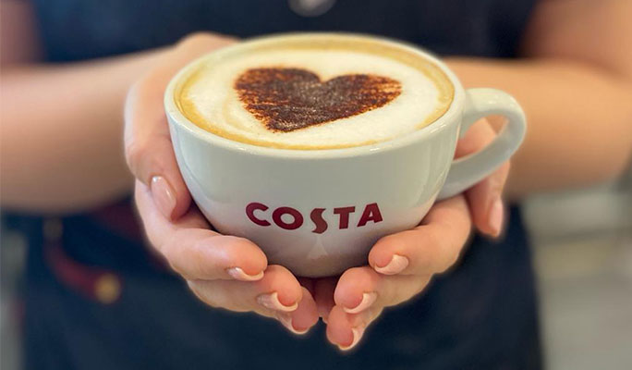

Individual Blog

Student Name: Maria Mahu
Student ID: 2115144
Module name: Marketing Fundamentals
Module Code: LCCB4004
Lecturer name: Piyumika Kithulgoda Gamage

Background/History of Costa
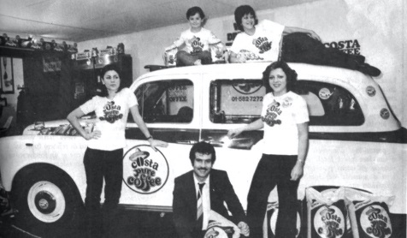
Costa coffee is a British multinational coffeehouse founded in 1971 by Italian brothers Bruno and Sergio Costa in London from Parma with a great ambition to introduce a new high-quality coffee into daily life. Before selecting their unique blend, they tasted 112 different coffees blindly. They named it “Mocha Italia” and it has remained the Costa signature blend. (Costa Coffee,2022).
After a relatively short period of time, the brand became well-known in London, and in 1978, the brothers opened the first Costa roastery in South London. The main goal was to serve customers high-quality coffee in porcelain cups, in this way customers could experience coffee at a high level of satisfaction.
Another important landmark in Costa Coffee was in 1995, when Whitbread, the country's largest hotel and coffee shop operator, purchased it and made it a wholly owned subsidiary.
In January 2019, the Coca-Cola Company paid $4.9 billion to acquire Costa Coffee, fee in order to expand its presence in the market for hot beverages (coffee), as the coffee company possessed very excellent worldwide potential before the acquisition. (Arthur, 2019).
As of January 2022, Costa Coffee was available in 2792 outlets in the UK, leading Greggs, and Starbucks which are in second and third place.

(Statista,2022)

Segmentation
According to Sharma (2023), market segmentation is essential for understanding your consumers' demands and identifying the proper audience along with your product's message. “Market segmentation divides a market into well-defined slices” (Kotler, 2000, p.268).
The segmentation of Costa coffee is based on demographic and behavioural factors.
Demographic segmentation is one of the simple methods based on age, income, gender, or occupation. Social class and professional level play an important role because Costa can adjust the flavour and selection of coffee to suit different age groups, teenagers usually prefer hot chocolate more than espresso since they adore drinks with a sweet flavour. On the other hand, adults prefer coffee caffeine is a stimulant that keeps adults alert at work, which may be one reason why adults like drinks with high levels of caffeine.
Costa coffee can learn more about what type of products people want by looking at social characteristics. This is the result of their suggestion of the customer’s income level, which has an impact on their capacity to purchase. The privileged class for sure, will drink coffee and spend more money each month compared with the other classes.
Behavioral segmentation remains the most essential sort of consumer segmentation since it is more closely linked to customer demands (Jones,2022).
Jim Slater mentioned that customers "find latte too weak and cappuccinos too frothy, and do not desire the robust flavour of an espresso or black Americano".
Moreover, Costa Coffee has figured out that some customers want a place to sit and enjoy their beverage while they work or catch up with friends, while others just want to "grab and go"(Costa Coffee,2022).

Targeting
According to Kotler (2000), targeting is the process of identifying and selecting a specific group of customers who are most likely to buy a company’s products or services.
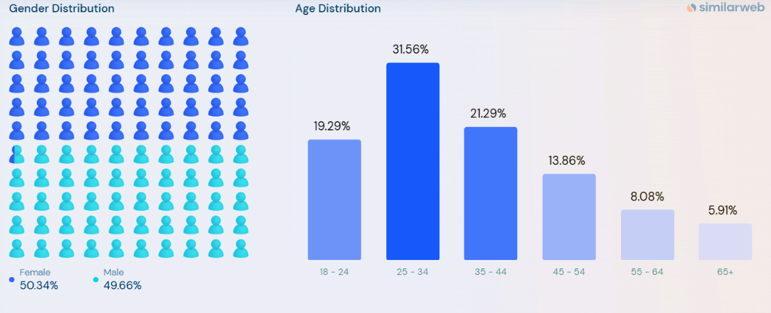
Costa’s target Market includes males and females aged between 18-45 years old. (Statista, 2022).
Especially in recent years, Costa Coffee has been actively targeting a new audience: young adults. The coffee chain has been opening new locations in college areas, introducing a reward program targeted at millennials, and even giving students discounts.
Position
Brand positioning is the unique value of strategic brand management. According to (Biel, 2006),"Building or rebuilding an image” creates a connection between the brand and its position on the market.
Costa coffee’s mission is to provide customers with the highest quality coffee experience possible and to build a strong relationship with its customers.
Costa Coffee is a globally recognized strong brand with fifty years of knowledge in crafting the finest quality of coffee. The quality of products and services is Costa Coffee's priority, as this will contribute to customer satisfaction and the positioning approach is compatible with global strategy. Costa Coffee holds a position in Global coffee. Another advantage of Costa Coffee is that it offers excellent coffee at a reasonable price.
Marketing mix of Costa Coffee(7Ps)
Costa Coffee helps to grow its brand and company by positioning itself competitively in the market and achieving business goals and objectives. In addition, to increase customer loyalty and become the number one coffee company in the United Kingdom. Even though the United Kingdom has always been a tea lover country, lately according to a new survey has found that drinking coffee has become popular more than drinking tea in the British population (Scott, 2019). Also, he mentions that about half (46%) of coffee drinkers and almost a third (39%) of tea, drinkers claimed that they needed the energy boost from coffee to get up in the morning. This trend is driven by the younger generations, who are becoming more and more interested in higher-quality coffees, consumption outside of the home and ready-to-drink coffees are becoming more and more popular.
Product strategies: Costa Coffee’s product strategies are focused on providing customers with a wide variety of high-quality drinks and food items. The full range of Costa products includes hot and cold drinks such as coffee, tea, and hot chocolate, also a variety of bakery items, sandwiches and other delicious products.
The selection of coffees and flavors provided by the company is extensive. Customization plays an important role by allowing customers to tailor their drinks depending on preference by adding flavours or toppings such as cream or chocolate shaving to create a unique drink that suits their taste. Costa Coffee also offers other beverages that are blended with ice, such as lemonade, coffee, and mocha cream. For vegetarians and vegans, Costa Coffee offers options, and many of its products are also free of gluten, nuts, and peanuts. With a variety of flavours and sizes available, it has something for everyone.
Pricing strategies of Costa Coffee: Regarding pricing, as with everything else, Costa Coffee is highly calculated. When determining the cost of its products, the company always takes into account the value of its brand. The exceptional quality of Costa Coffee's products and the prestige of the Costa Coffee brand both contribute to the company's ability to charge higher prices. Because of its standing as a premium product, its price tag typically matches that prestige. The price can vary depending on location, size of the drink and additional extras.
Its pricing is significantly higher compared to those of most of the other coffee shops in the area like Greggs but lower compared to Starbucks, Pret, or Caffe Nero. In the UK high-street caffeine levels test, Costa wins Starbucks.
Hot Drinks (medium size) | Greggs | Costa Coffee | Starbucks
Latte | £1.85 | £3.50 | £3.60
Cappuccino | £1.85 | £3.50 | £3.60
Mocha | £1.85 | £3.65 | £3.90
Americano | £1.60 | £3.00 | £3.30
Espresso | - | £2.10 | £2.60
Flat White | £1.85 | £3.30 | £3.30

Moreover, the coffee vending machine is sold under the brand name Costa express by Costa Coffee. The cost of purchasing items from this vending machine is reasonable when compared to those of its main rivals, such as Starbucks and Café Coffee Day.
Place/ Distribution strategies of Costa: Location plays a significant role in Costa Coffee's marketing strategy. The primary distribution strategy plan is to open stores in densely populated areas with easy access to transportation. It is convenient for customers looking for a quick cup of coffee.
More than 2100 Costa Coffee outlets are located in the UK, and there are more than 1200 worldwide. Costa Coffee typically serves wealthy and upper-middle-class customers. Its stores are primarily located in busy places like malls and airports. In order to draw in more customers, Costa Coffee also adapts its menu dependent on the nation in which it conducts business. (Costa Coffee,2022).
Similarly, to this, customers may select their favourite shops and the closest ones using the Costa Coffee app, where the goods are ready and waiting for them. This will be very useful for clients with a tight schedule. However, Starbucks is one of the largest coffee shops all around the world, but Costa has the highest number of store locations in the UK.
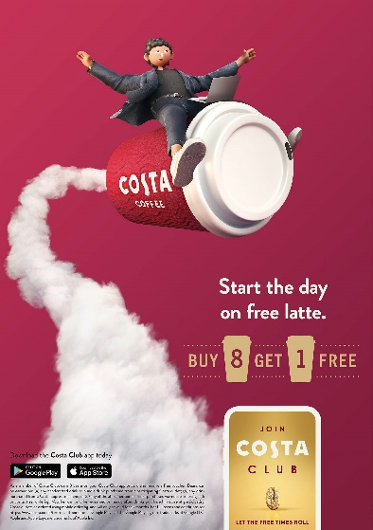
Promotional Strategies of Costa Coffee: To attract more customers, a diverse variety of marketing approaches Costa coffee use to promote its brand. Clients have the option to sign up for a loyalty program that would reward them with a free cup of coffee at the shop once they have purchased eight separate drinks.
According to Kotler and Keller (2013), satisfaction among consumers will lead to high consumer loyalty.
Costa Coffee frequently uses social media and television for advertising. Recently, it collaborated with Channel 4 UK on an initiative that featured some well-known Channel 4 hosts and performers having face-to-face chats in its retail locations.
Moreover, promotions can be conducted in accordance with seasons, and festivals such as Christmas, and Easter time.
People strategies of Costa Coffee: Each day, Costa Coffee employs thousands of people essential to providing exceptional customer service. The company is aware of it, and they reward staff members in accordance with their kindness, patience and professionalism.
Every client at Costa Coffee is treated with respect, and the staff play a key role in the establishment's entire experience. Because they must interact with a range of people, employees receive extensive training in communication skills.
To make consumers more comfortable and welcoming, Costa Coffee personnel interact with them in local languages. Also, all of its employees wear the same uniform, which is a deep black color.
Process strategies of Costa coffee: Costa coffee follows a standard procedure as another major coffee chain. To order their favourite foods via the Costa Coffee app or online delivery services, users must fulfil specific steps. Customers must download the Costa Coffee app and pick from a menu their favourite food and drink, once you've selected your goods and chosen your local shop, your order will be freshly made in-store and available for you to pick up and go.
When handling orders, staff members are required to follow specified standards.
All processes are described in a few steps: Coffee employees give customers menu cards when they settle in. The worker meets customers with a smile. After accepting the order, personnel ensures that consumers get the things they want quickly and well. Products are billed last. Costa Coffee accepts cash, credit/debit cards, and internet payments. Costa Coffee has a few self-service locations.
The physical environment of Costa Coffee: According to Ren et al. (2016), customer experience provides a subjective perception when interacting with physical aspects, environment, or humans. The provision of high-quality customer service is essential to delivering a positive experience to the customer. Its retail provides consumers with a great atmosphere in which they are made to feel welcome and where they are able to rest while shopping for their requirements within the same trip.
The goal of Costa Coffee is to make their shops attractive places where customers want to hang around and spend a lot of time. Its physical environment techniques include offering outstanding interior seats, appealing accents, and high-quality furnishings to increase client loyalty and spending. These qualities encourage consumer loyalty and enhance customer spending. Costa is the UK’s favourite coffee shop because they satisfy customer needs through products and services and has been named by customers to be the most ethical coffee shop (World Coffee Portal, 2019).

References
Arthur, R. (2019) Coca-Cola completes costa acquisition: 'our vision is to use Costa's platform to expand in the growing coffee category', beveragedaily.com. William Reed Ltd. Available at: https://www.beveragedaily.com/Article/2019/01/03/Coca-Cola-completes-Costa-coffee-acquisition#:~:text=The%20Coca%2DCola%20Company%20has,in%20the%20EU%20and%20China. (Accessed: March 29, 2023).
Costa Coffee (2022) Menu. Available at: https://www.costa.co.uk/menu/.
Costa Coffee (2023) The Nation's Favourite Coffee Shop | Costa Coffee. Available at: https://www.costa.co.uk/ (Accessed: March 29, 2023).
Dibb, S., Ferrell, O. C., Simkin, L., Pride, W. M. (2006). Marketing: Concepts and Strategies. United Kingdom: Houghton Mifflin, pp 229-232.
Ferrell, O.C. and Hartline, M.D. (2008) in Marketing strategy. Mason, OH: Thomson South-Western, pp. 172–173.
Greggs (2023) Menu. Available at: https://www.greggs.co.uk/menu?category=drinks-snacks (Accessed: March 31, 2023).
Gonçalves, M. (2022) Costa Coffee commits to net zero emissions from direct operations by 2040, World Coffee Portal. Available at: https://www.worldcoffeeportal.com/Latest/News/2022/March/Costa-Coffee-commits-to-net-zero-emissions-from-di (Accessed: March 10, 2023).
Jones, N. (2022) Behavioral Segmentation Defined with 4 Real-Life Examples. Available at: https://www.yieldify.com/blog/behavioral-segmentation-definition-examples/.
Kotler, P. (2000) in Marketing management: The millennium edition. London: Prentice Hall.
Kotler, P., and Keller K. L. (2013). MARKETING MANAGEMENT, Fourteenth Edition, Horizon Edition, England PEARSON Education Limited.
Ren, L. et al. (2016) “Exploring customer experience with budget hotels: Dimensionality and satisfaction,” International Journal of Hospitality Management, 52, pp. 13–23. Available at: https://doi.org/10.1016/j.ijhm.2015.09.009.
Scott, E. (2019) Treasonous British people now prefer coffee to tea, Metro. Metro.co.uk. Available at: https://metro.co.uk/2017/09/29/treasonous-british-people-now-prefer-coffee-to-tea-6965063/ (Accessed: March 10, 2023).
Sharma, R. (2023) What is market segmentation? what are its types and benefits?, Emeritus. Available at: https://emeritus.org/in/learn/sales-and-marketing-what-is-market-segmentation/ (Accessed: March 12, 2023).
Starbucks (2023) Menu. Available at: https://www.starbucks.co.uk/menu/product/2369 (Accessed: March 31, 2023).
Sky (2021) Costa coffee dishes out 5% pay rise to 14,500 staff in return for pandemic hard work, Sky News. Sky. Available at: https://news.sky.com/story/costa-coffee-dishes-out-5-pay-rise-to-14500-staff-in-return-for-pandemic-hard-work-12403442 (Accessed: March 13, 2023).
World Coffee Portal (2019) Costa Coffee named the nation's favourite coffee shop by UK consumers, World Coffee Portal. Available at: https://www.worldcoffeeportal.com/Latest/News/2019/Costa-Coffee-named-Nation-s-Favourite-coffee-shop (Accessed: March 13, 2023).
Statista (2022) Leading Coffee Shop Chains UK 2022, Statista. Available at: https://www.statista.com/statistics/297863/leading-coffee-shop-chains-in-the-united-kingdom-uk-store-number/ (Accessed: March 29, 2023).

