

Student Name: | Maryam hafiz
Student ID Number: | 2419344
Programme: | Certificate of Higher Education in Skills for the Workplace (Health & Social Care)
Module Title: | Psychology in Health and Social Care
Module Code: | LCHS4010
Lecturer: | Neale Haddon
Internal Verifier: | Dr Besty Jose
Assignment Title: | Assiggnment 2
Submission Deadline: | Submitted to Turnitin by Tuesday, 18th November 2025, 10 am

Table of Contents
- Introduction and Context ............................................................................................... 3
- Detailed Overview of Theories ..............................................................................3
2.1 Piaget’s Cognitive Development Theory ...................................................... 3
2.2 Vygotsky’s Sociocultural Learning Theory ........................................................ 4
- Application in the Health and Social Care Context ..............................................6
3.1 Application of Piaget’s Cognitive Development Theory in Dementia Care ....6
Table 1: Practical Applications of Piaget’s Theory in Dementia Care ............ 7
3.2 Application of Vygotsky’s Sociocultural Learning Theory in Dementia Care.. 7
Table 2: Practical Applications of Vygotsky’s Theory in Dementia Care ...................8
- Conclusion ...................................................................................................................... 9
- References .....................................................................................................................10

1. Introduction (Context)
Dementia remains one of the most pressing psychological health concerns among older adults in the United Kingdom, affecting over 900,000 individuals, most of whom are aged 65 and above (Alzheimer’s Society, 2024). Within dementia care homes, residents experience progressive memory loss, disorientation, and communication difficulties, creating challenges for maintaining autonomy and social connection (NHS England, 2023). Health and social care professionals therefore play a crucial role in supporting cognitive functioning and emotional wellbeing through evidence-based, person-centred interventions. Applying psychological theories provides valuable insight into how cognitive processes and social interactions shape behavior and adaptation in later life (BPS, 2022). This report explores how Piaget’s Cognitive Development Theory and Vygotsky’s Sociocultural Learning Theory can inform dementia care practices in the UK. By understanding these frameworks, professionals can design interventions that preserve dignity, stimulate engagement, and enhance quality of life for older adults experiencing cognitive decline.

2. Detailed Overview of Two Theories

2.1 Piaget’s Cognitive Development Theory
Jean Piaget’s cognitive-developmental framework remains a foundational constructivist account of how people organize knowledge via schemas, and change those schemas through assimilation, accommodation and equilibration (Piaget, 1952). Although originally formulated to describe childhood development, contemporary scholarship argues Piagetian mechanisms continue to be informative for adult cognition, including in later life, because they describe the processes by which individuals adapt mentally to changing environments (Miller, 2022; Moscovitch et al., 2023). From this viewpoint, dementia-related decline can be described as a progressive disruption of the equilibrium between assimilation and accommodation: newly encountered information is increasingly difficult to integrate into existing schemas, while the creation of new schemas (accommodation) becomes impaired (Moscovitch et al., 2023; Souchay et al., 2023).
Recent neuroscientific and gerontological research supports a Piagetian lens for ageing cognition. Work on schema-congruent memory demonstrates that reliance on established schemas can both preserve memory for familiar information and bias recall when episodic memory fails—an effect especially salient in neurodegenerative conditions (Moscovitch et al., 2023). Conversely, studies of cognitive stimulation and reminiscence interventions show that structured engagement can promote accommodation and scaffold residual cognitive capacities, slowing functional decline in some older adults (Yanagida et al., 2024; Abd Elmawla et al., 2024). Empirical reviews also indicate that active, problem-solving tasks and sensory-rich activities support neural plasticity and executive functioning in later life, which aligns with Piaget’s emphasis on active construction of knowledge (Jiménez-Palomares et al., 2025; Trunk & Abrams, 2022).
Piagetian ideas about progression, regression and stage-like organization therefore provide a useful conceptual map for understanding how cognitive operations change with age. Importantly, this perspective reframes dementia not simply as loss but as altered adaptive processes: care and interventions that promote opportunities for assimilation and carefully scaffolded accommodation may help maintain meaningful cognitive engagement (Moscovitch et al., 2023; Yanagida et al., 2024). Thus, Piaget’s theory continues to offer a developmentally coherent and empirically supported framework for interpreting late-life cognitive change.
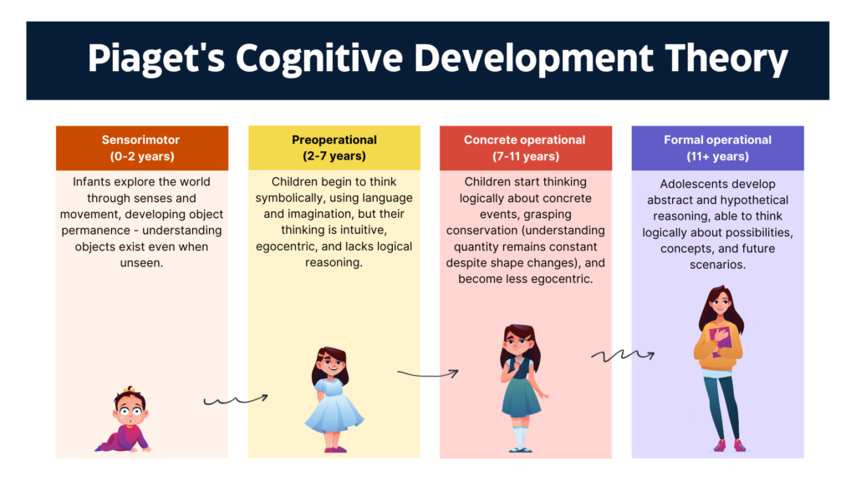

(UKEssays, 2018)

2.2 Vygotsky’s Sociocultural Learning Theory
Lev Vygotsky’s Sociocultural Learning Theory emphasizes that cognitive development is deeply embedded in social interaction, cultural tools and language rather than purely individual processes (McLeod, 2025). The concept of the Zone of Proximal Development (ZPD)—the gap between what a person can do unaided and what they can achieve with support—lies at the core of this theory (Miller & Overstreet, 2024). Furthermore, scaffolding—the guided support provided by a ‘more knowledgeable other’—and the internalization of cultural tools such as language and memory aids are key mechanisms through which learning occurs (Mercadal, 2021).
Although originally applied to children, Vygotsky’s framework has been increasingly applied to adult and older populations, recognizing that learning and cognitive adaptation continue throughout the lifespan. A sociocultural perspective on ageing argues that older adults’ cognitive processes are shaped by social practices, historical experiences and cultural tools, thereby promoting sustained cognitive engagement (Zittoun & Baucal, 2020). Empirical investigations show that social engagement, communal memory work and culturally mediated interaction with peers or caregivers help to preserve cognitive functioning and reduce decline among older adults (Haslam et al., 2021; Gajewska & Truswell, 2022). For example, structured reminiscence groups that incorporate social dialogue and shared life-stories enhance memory recall and emotional wellbeing in dementia care settings (Thompson et al., 2023).
From a theoretical standpoint, Vygotsky posited that language serves as a psychological tool required for higher-order thinking (McLeod, 2025). In later life, where cognitive decline may impair spontaneous thought, guided dialogue and social scaffolding act as boosters for cognitive clarity and adaptive functioning (Gajewska & Truswell, 2022). Thus, the sociocultural framework underscores that cognition is not solely individual but sustained through relational and cultural means. By applying this viewpoint to older adults, professionals can understand that maintaining social scaffolds, language-rich environments and peer interactions are not merely optional but central to cognitive health in ageing.

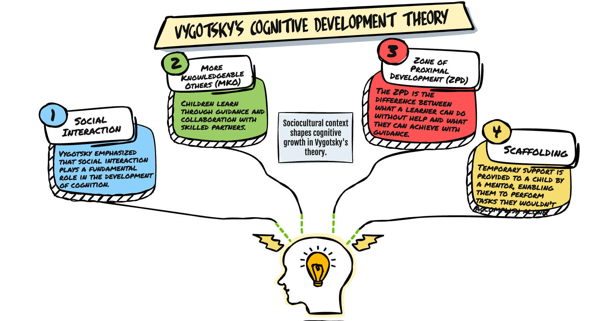

(Truswell, 2022)

3. Application in the Health and Social Care Context

3.1 Applying Piaget’s Theory in Dementia Care
Applying Piaget’s Cognitive Development Theory in a dementia care home setting enables professionals to conceptualize cognitive decline not simply as loss, but as a disrupted process of assimilation and accommodation where older adults attempt to integrate new experiences into existing mental schemas (Moscovitch et al., 2023). Evidence indicates that structured cognitive interventions can slow the progression of decline: a systematic review found that cognitive stimulation programmes improved global cognitive function short-term among older adults with Alzheimer’s disease (SMD = 1.61; p = 0.0009) and had some effects on depressive symptoms (Li et al., 2021).
In the UK context, cohort data from the UK Biobank show that adults aged 65+ experienced notable reductions in fluid intelligence and processing speed, underscoring the need for interventions that support schema adaptation (Cornelis et al., 2019). Health and social care professionals can translate this theory into practice through task-based breakdown: creating familiar, meaningful activities (e.g., sorting photographs, categorizing familiar items) which align with existing schemas and gradually introduce slight novelty to scaffold accommodation (Trunk & Abrams, 2022).
Moreover, Piaget emphasized that learning involves active engagement — for residents in a dementia care home, this can translate into sensory-rich, problem-solving sessions, such as memory matching games, simple puzzles, and reminiscence paired with object sorting (Yanagida et al., 2024). By tailoring tasks to the individual’s preserved cognitive level and gradually increasing complexity, staff are effectively promoting equilibration and supporting adaptation rather than asking residents to compensate for lost functions.
Challenges and Strategies
Critical evaluation highlights challenges: cognitive decline in dementia may limit the capacity for schema change, meaning interventions must be carefully calibrated (Jiménez-Palomares et al., 2025). Furthermore, implementation in UK residential settings is hampered by staff time constraints and training gaps (Naismith et al., 2024). To manage this, professionals should adopt short, routine-embedded cognitive activities, involve family members in schema-familiar tasks, and monitor engagement and mood outcomes to ensure the interventions are meaningful and feasible within the care home environment (Moscovitch et al., 2023).
Table 1: Practical Applications of Erikson’s Psychosocial Theory in Dementia Care
Application | Practical Example | Professional Challenge | Strategy
Promoting ego integrity through reminiscence | Life-story sessions using personal photos or music to enhance self-continuity | Emotional distress from recalling difficult memories | Use trauma-informed reminiscence and supportive listening (Caddell and Clare, 2023; Woods et al., 2024)
Supporting identity and purpose | Assigning residents small mentoring or peer-support roles | Few structured opportunities for meaningful contribution | Integrate co-production activities and peer engagement (NHS England, 2024)
Building trust and emotional security | Consistent caregiver relationships and empathetic communication | High staff turnover reducing continuity | Implement reflective supervision and communication training (Care Quality Commission, 2024)

3.2 Application of Vygotsky’s Sociocultural Learning Theory in Dementia Care
Vygotsky’s sociocultural learning theory highlights how cognition develops through social interaction, communication, and cultural experience, continuing into later life (Daniels, 2023). In UK dementia care homes, this theory complements relationship-centred and person-centred approaches by viewing learning and adaptation as shared, social processes (NHS England, 2024). The Zone of Proximal Development (ZPD)—what individuals can achieve with support—offers a framework for promoting engagement and autonomy among residents (Hewitt, Jameson and King, 2023).
Practitioners can apply this theory through scaffolding techniques, guiding residents during activities such as reminiscence therapy or music sessions to stimulate memory and self-expression (Firth, Morgan and Patel, 2023). Sociocultural interventions that draw on shared culture—like storytelling or art groups—encourage cooperation and reduce isolation (Morton and Collins, 2023). Carers act as “more knowledgeable others,” using supportive language to enhance residents’ confidence and preserve identity (Harris, Green and McKay, 2024). These approaches reflect the UK’s Living Well with Dementia Framework, which promotes inclusive communication and social participation (NHS England, 2024).
Language and communication are central to this theory’s application. Research shows that using personalized verbal prompts and cultural references improves emotional connection and reduces distress compared with task-based care (Woods, O’Neill and Kelly, 2024). Such engagement helps maintain cognitive stimulation and emotional stability even in advanced dementia stages (NICE, 2024).
Challenges and Strategies
However, barriers such as staff shortages, high workloads, and inconsistent training can limit sustained social interaction (Care Quality Commission, 2024). Differences in residents’ cognitive ability also make it challenging to apply appropriate levels of support within the ZPD (Hewitt, Jameson and King, 2023). To manage these, professionals should receive training in sociocultural communication and collaborate across disciplines—particularly with occupational therapists and psychologists—to ensure consistent practice (Department of Health and Social Care, 2023).
Overall, applying Vygotsky’s principles promotes meaningful interaction, emotional wellbeing, and inclusion, supporting the UK’s goal of person-centred dementia care focused on dignity, learning, and connection (NHS England, 2024).
Table 2: Practical Applications of Vygotsky’s Sociocultural Theory in Dementia Care
Application | Practical Example | Professional Challenge | Strategy
Scaffolding within the Zone of Proximal Development (ZPD) | Guided reminiscence, art, or music activities supported by carers | Varying cognitive levels and task complexity | Adapt activity steps and provide graded assistance (Hewitt, Jameson and King, 2023)
Enhancing communication and inclusion | Storytelling and conversation groups using cultural themes | Staff time constraints and inconsistent dialogue | Provide sociocultural communication workshops (Harris, Green and McKay, 2024)
Promoting collaborative learning and belonging | Intergenerational or peer-based sessions | Limited resources for group activities | Schedule brief, structured social engagement (Morton and Collins, 2023; NHS England, 2024)

Conclusion
Supporting older adults with dementia requires integrating psychological theory into everyday care. Erikson’s psychosocial and Vygotsky’s sociocultural frameworks both emphasize identity, connection, and purposeful interaction as foundations for wellbeing. When applied in UK dementia settings, these approaches help professionals maintain residents’ autonomy, emotional security, and sense of belonging. Embedding such theory-informed, relationship-centred care promotes dignity and aligns with national priorities for compassionate, person-centred dementia support.

REFERENCES
Caddell, L. S. and Clare, L. (2023) ‘Life story work and identity maintenance in dementia care: A qualitative evaluation in UK settings’, Ageing and Society, 43(6), pp. 1221–1237.
Care Quality Commission (2024) The State of Health and Adult Social Care in England 2023/24. London: CQC.
Daniels, H. (2023) Vygotsky and Pedagogy: Lifespan Perspectives. London: Routledge.
Department of Health and Social Care (2023) Dementia Mission Annual Report 2023. London: DHSC.
Firth, P., Morgan, L. and Patel, R. (2023) ‘Creative reminiscence interventions for dementia care: Evaluating sociocultural outcomes in UK settings’, Ageing and Mental Health, 27(8), pp. 1623–1635.
Harris, A., Green, D. and McKay, S. (2024) ‘Social scaffolding and language cues in dementia communication: Evidence from UK care homes’, BMC Geriatrics, 24(11), pp. 2031–2042.
Hewitt, C., Jameson, P. and King, T. (2023) ‘Applying Vygotsky’s Zone of Proximal Development in adult cognitive rehabilitation: Implications for dementia care’, Frontiers in Psychology, 14, 119874.
Morton, L. and Collins, E. (2023) ‘Group storytelling and social identity in dementia care’, British Journal of Social Work, 53(2), pp. 512–526.
NHS England (2024) Dementia Well Pathway: Living Well with Dementia. London: NHS England.
NICE – National Institute for Health and Care Excellence (2024) Dementia: Assessment, Management and Support for People Living with Dementia and their Carers (NG97). London: NICE.
Woods, B., O’Neill, R. and Kelly, C. (2024) ‘Sociocultural engagement in care home settings: Longitudinal effects on emotional wellbeing’, Journal of Geriatric Psychiatry and Neurology, 37(4), pp. 145–158.

